Appendices

Appendix 1 Assessment of overall cardiovascular risk according to the SCORE chart of the European Society of Cardiology.¹⁶

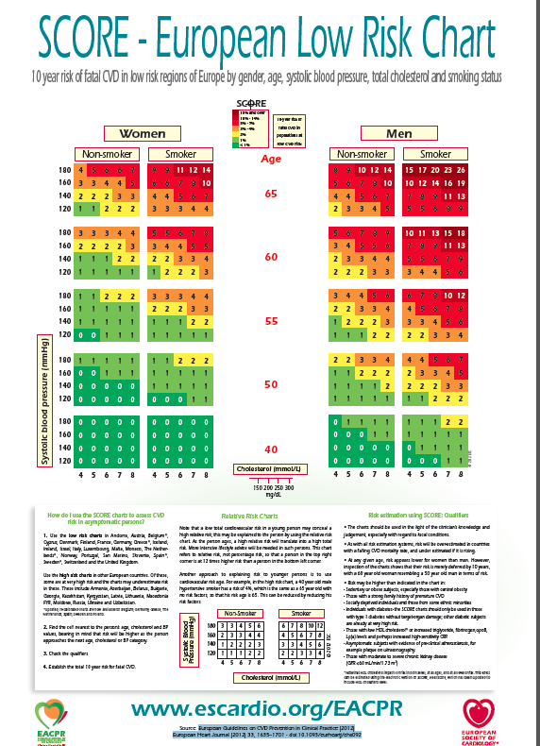

With permission of Oxford University Press on behalf of the European Society of Cardiology. This figure is not covered by the terms of the Creative Commons licence of this publication. For permission to reuse, please contact the rightsholder.

Appendix 2 Algorithm published by the Portuguese Directorate-General of Health (DGS) to assess overall cardiovascular risk according to the SCORE chart of the European Society of Cardiology (Norma da DGS, Nº 005/2013, published 19/3/2013, updated 21/01/2015).

