Supplementary information
Fig. S1 XRD patterns of TiO₂ precursor calcined at different temperatures.
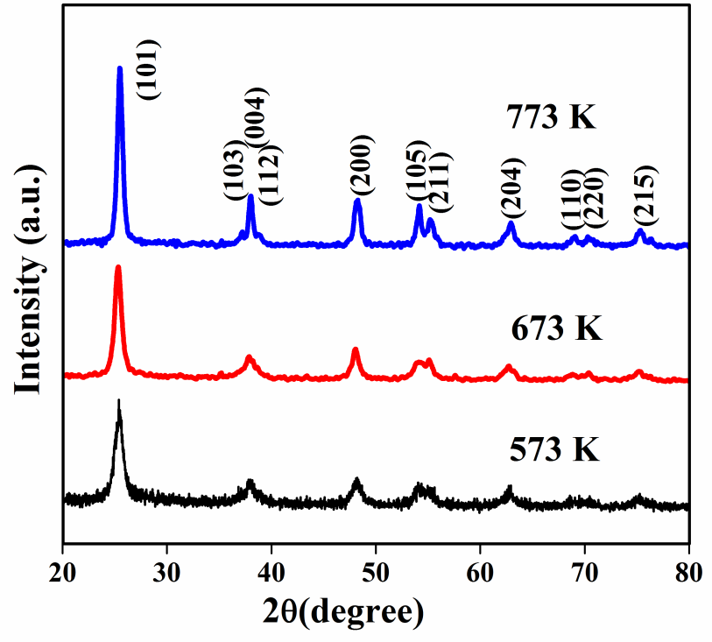
Fig. S2 EDX spectra of undoped TiO₂ precursor (a) and TiO₂ precursor with (b) 1.16 (c) 2.01 (d) 3.08 (e) 4.87 and (f) 6.68 % of Fe calcined at 573K.
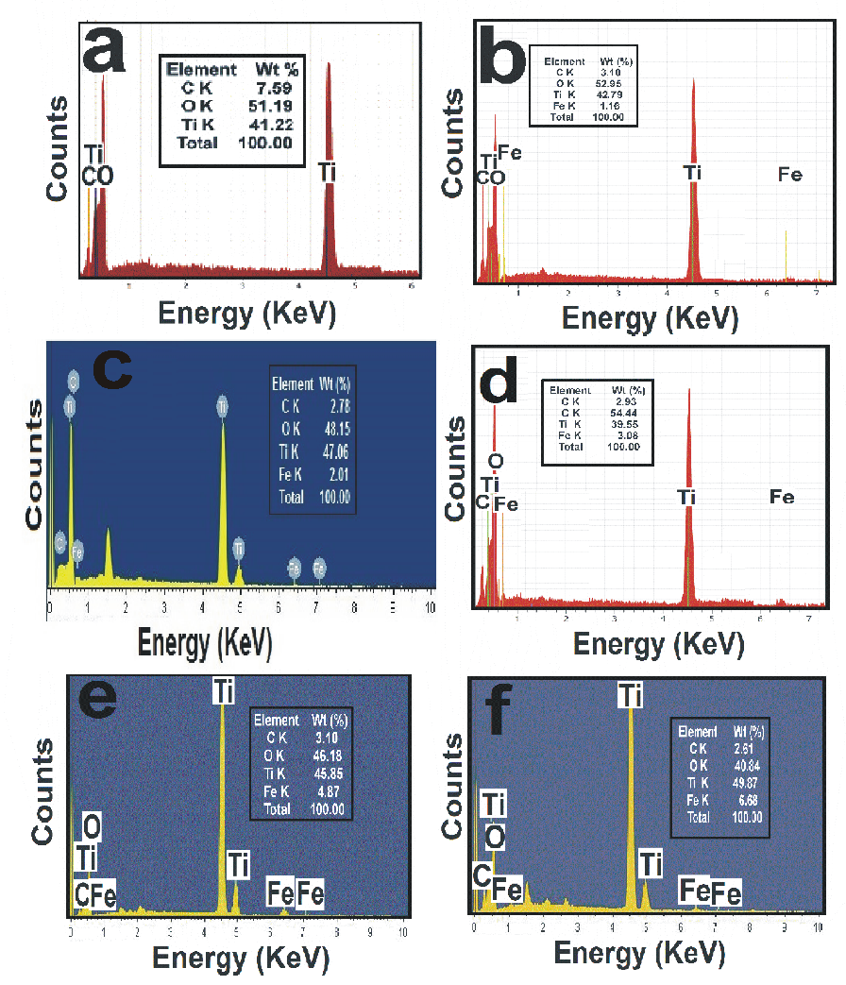

Fig. S3 Diffuse reflectance UV-Visible spectra of undoped TiO₂ precursor calcined at (a) 773K, (b) 573K and TiO₂ doped with (c) 1.16 (d) 2.01 (e) 3.08 (f) 4.87 (g) 6.68% Fe precursor and calcined at 573K.

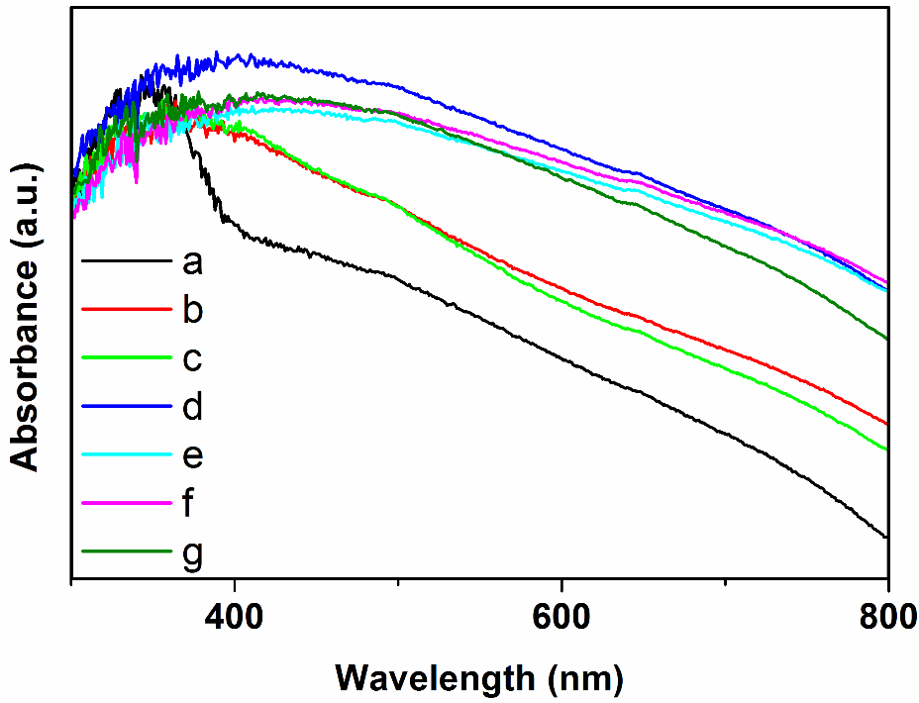

Table S1. Particle size and morphology of photocatalyst.
No. | Sample | Particle size  [nm] ª | Particle size  [nm] ^{b} | Morphology
1 | Pure TiO₂ | 16.2 | 15.5 | Spherical
2 | C doped TiO₂ | 13.4 | 11.0 | Spherical
4 | C, Fe codoped TiO₂ | 10.1 | 7.1 | Spherical
a Particle size determined from XRD pattern using Debye-Scherrer equation.
b Particle size determined from TEM micrographs.

Table S2. Elemental composition of photocatalyst from XPS measurement.

No. | Sample | Particle size  [nm] ª | Elemental composition  (Wt %)^{b}
 |  |  | C | O | Ti | Fe
1 | Pure TiO₂ | 16.2 | 0.00 | 63.87 | 36.13 | 0.00
2 | C doped TiO₂ | 13.4 | 7.71 | 49.93 | 42.36 | 0.00
3 | C, Fe codoped TiO₂ | 12.3 | 3.04 | 50.53 | 45.31 | 1.12
4 | C, Fe codoped TiO₂ | 10.1 | 2.83 | 48.87 | 46.29 | 2.01
5 | C, Fe codoped TiO₂ | 12.1 | 2.85 | 53.04 | 41.07 | 3.04
6 | C, Fe codoped TiO₂ | 13.1 | 3.06 | 46.00 | 46.08 | 4.86
7 | C, Fe codoped TiO₂ | 13.8 | 2.55 | 41.01 | 49.76 | 6.68
a Particle size determined from XRD pattern using Debye-Scherrer equation.
b Weight percentage determination by using XPS analysis.

