Supplementary Information

Rapid fabrication of diffusion barrier between metal electrode and thermoelectric materials using current-controlled spark plasma sintering technique
Xavier Reales Ferreres¹, Sima Aminorroaya Yamini^{1, 2*}
¹ Australian Institute for Innovative Materials (AIIM), Innovation Campus, University of Wollongong, Squire Way, North Wollongong , NSW 2500, Australia.
² Department of Engineering and Mathematics, Sheffield Hallam University, Sheffield S1 1WB, UK.
Corresponding author: Sima Aminorroaya Yamini, email: S.Aminorroaya@shu.ac.uk

Assembly for SPS method
Figure 1 presents the assembly used to bond bulk PbTe and Ni plate. Both pieces are sandwiched between graphite punches with intervening disks of graphite foil. The common graphite die in SPS, which contains the sintering powders, has been removed. The position of the thermocouple to measure the bonding temperature is roughly 3 mm below the Ni/PbTe contact area. This location hinders accurate temperature measurements due to radiation losses during bonding from the sample to the walls of the chamber and heat conduction through the bottom punch.
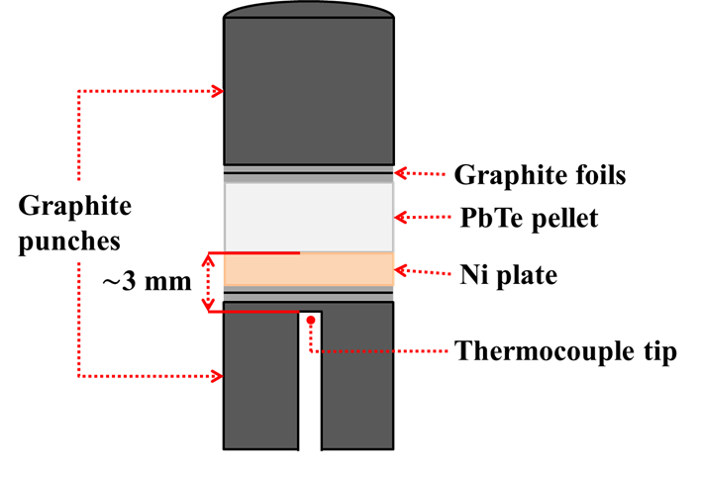
Figure S1: Experimental assembly for bonding between PbTe and Ni solid bulks. The thermocouple tip is sitting approximately 3 mm below the contact surface of the PbTe/Ni.
Solid-state bonding using temperature-controlled SPS bonding method
The previous work referred to in the article entails bonding of the Ni plate to the PbTe disk using temperature-controlled spark plasma sintering equipment with the assembly presented in Figure S1, where the PbTe pellet and Ni plate stand without the graphite die. The temperature selected for the optimum bonding was 648 K. Oscillations caused by short bursts of heat released during the procedure, however, caused the value of the thermocouple temperature to increase to nearly 665 K, as seen during the holding time phase in Figure S2(b).
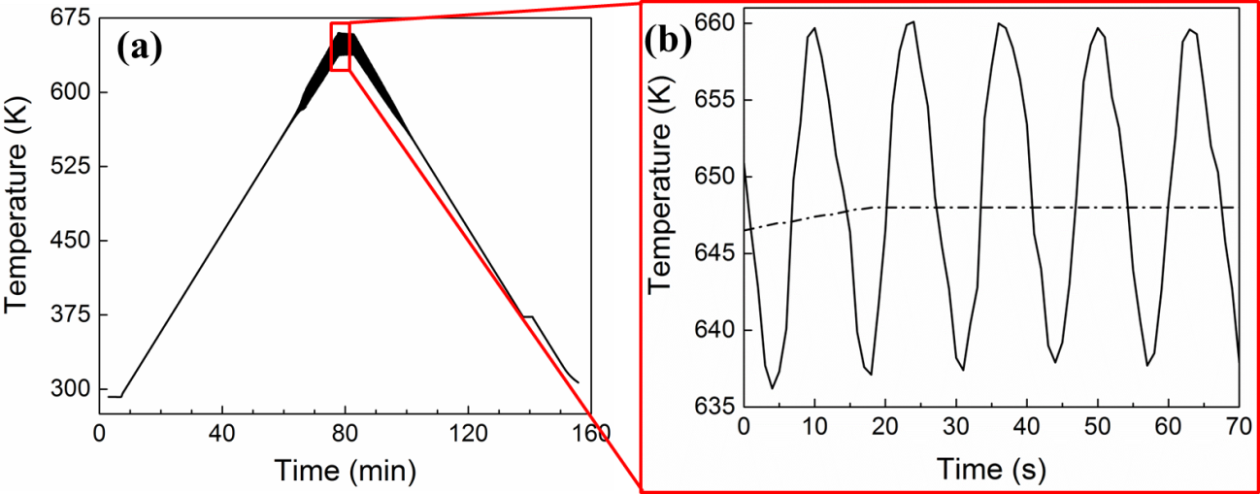
Figure S2: (a) Experimental temperatures taken during SPS temperature-controlled optimum bonding procedure at 648 K, 20 MPa, and 5 minutes. (b) Oscillations of temperature (solid line) around the temperature set-point (dashed line)

The sample obtained from the above temperature conditions is shown in Figure S3. The generation of a 7.5 µm interphase can be observed, although there are cracks originating in the vicinity of interlayer that are caused by the aforementioned oscillations.
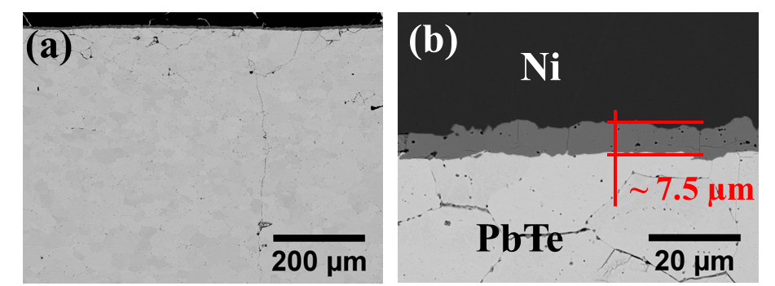
Figure S3: (a) Micrograph of bonded sample during temperature-controlled SPS conditions of 648 K, 20 MPa, and 5 minutes. (b) Higher magnification SEM image of sample in (a)

