This supplementary material consists of the following:
- Optical micrograph of carbon steel sample
- OCP measurement of carbon steel in 3.75 M NH₄Cl solution containing Na₂S₂O₃ of varied concentrations
- FESEM micrographs of carbon steel after immersion in pure 1 M S₂O₃²⁻ solution for 12 hours
- EDS analysis inside the pit, formed on the carbon steel surface after immersion in 3.75 M NH₄Cl solution containing 1 M S₂O₃²⁻, for a period of 72 hours
- The impedance data is validated with KKT and the results are shown below. It clearly shows that the transformed data maps well with the experimental data
- FESEM micrographs of (a) pure 3.75 M NH₄Cl (b) 3.75 M NH₄Cl + 0.01 M S₂O₃²⁻ (c) 3.75 M NH₄Cl + 0.1 M S₂O₃²⁻ and (d) 3.75 M NH₄Cl + 1 M S₂O₃²⁻ solutions, corresponding to EDS spectra presented in Figure 9
- pH values of electrolyte media for various Cl⁻:S₂O₃²⁻ ratio

Figure S1: Optical micrograph of carbon steel sample

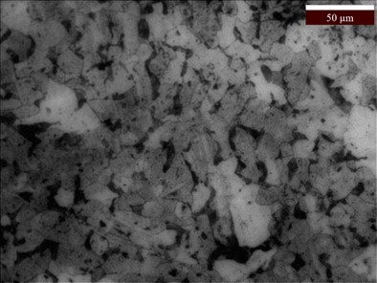
Figure S2: OCP measurement of carbon steel in 3.75 M NH₄Cl solution containing Na₂S₂O₃ of varied concentration
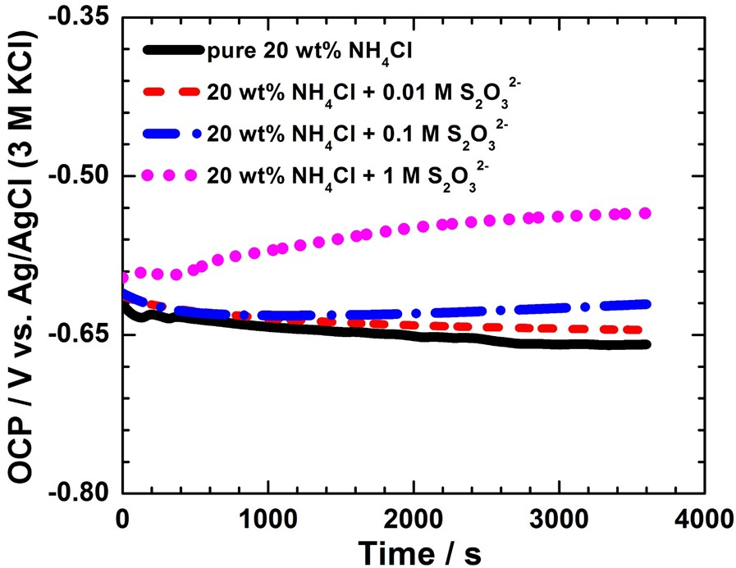

Figure S3: FESEM micrographs of carbon steel after immersion in pure 1 M S₂O₃²⁻ solution for 12 hours

Figure S4: EDS analysis inside the pit, formed on the carbon steel surface after immersion in 3.75 M NH₄Cl solution containing 1 M S₂O₃²⁻ for a period of 72 hours

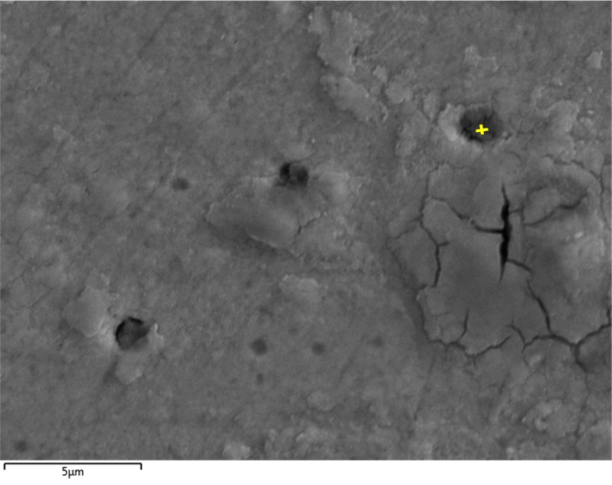
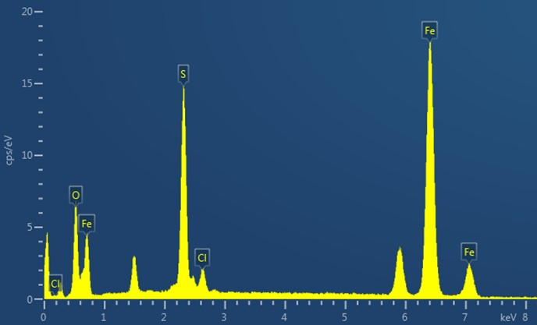

Figure S5: KKT impedance vs. frequency plots along with experimental values for: (a) pure 3.75 M NH₄Cl, (b) 3.75 M NH₄Cl + 0.01 M S₂O₃²⁻ solution, (c) 3.75 M NH₄Cl + 0.1 M S₂O₃²⁻ solution, and (d) 3.75 M NH₄Cl + 1 M S₂O₃²⁻

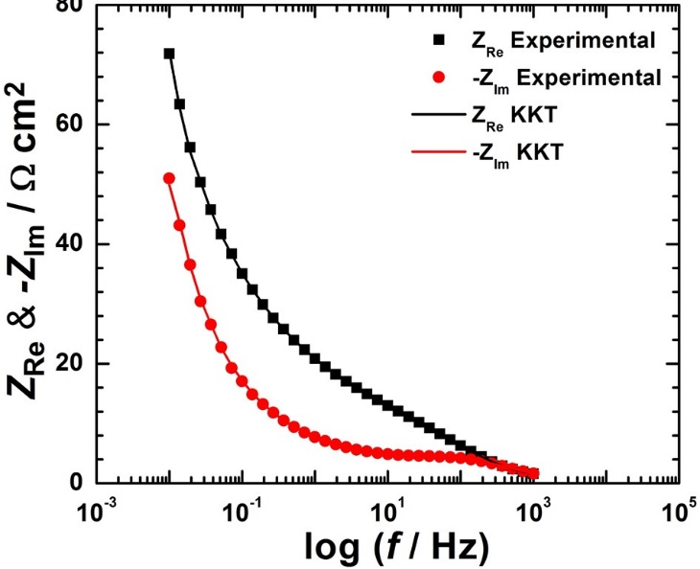 | 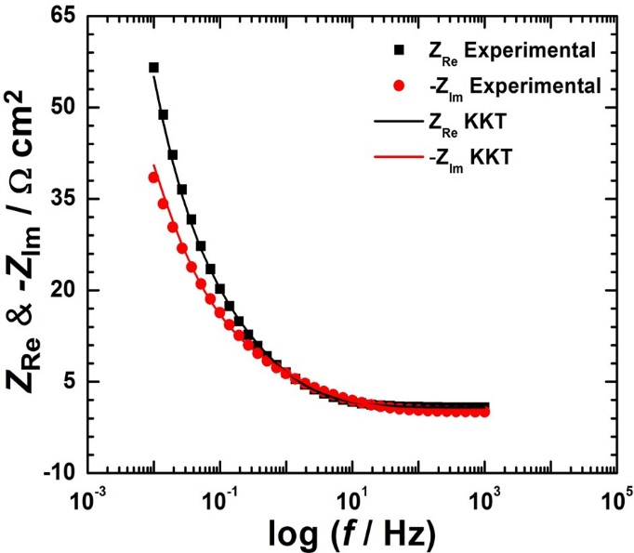
(a) | (b)
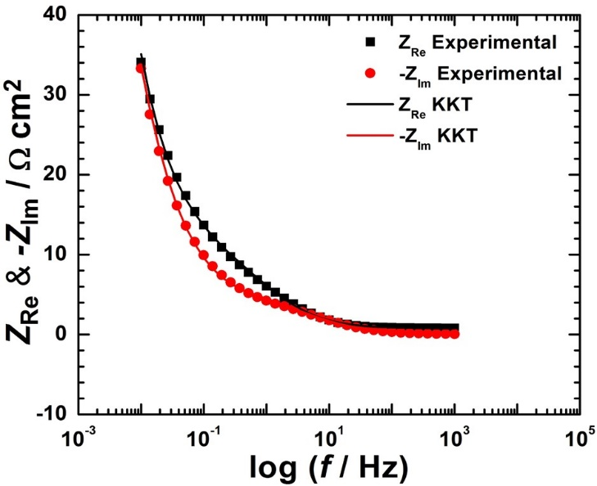 | 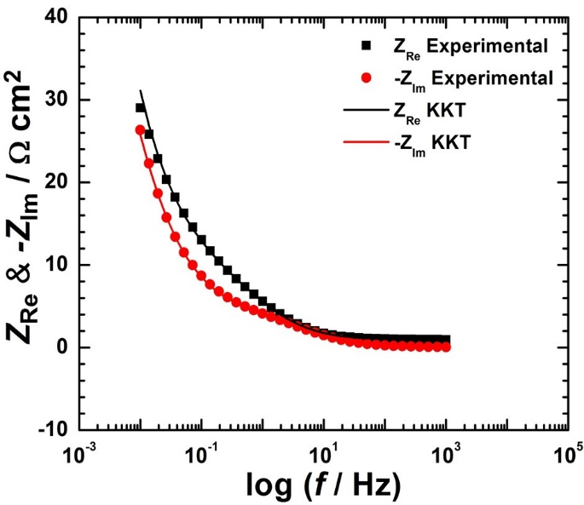
(c) | (d)

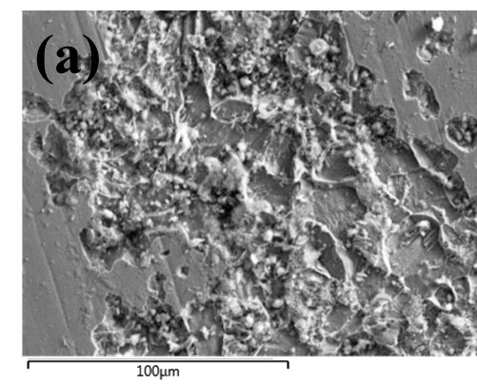 | 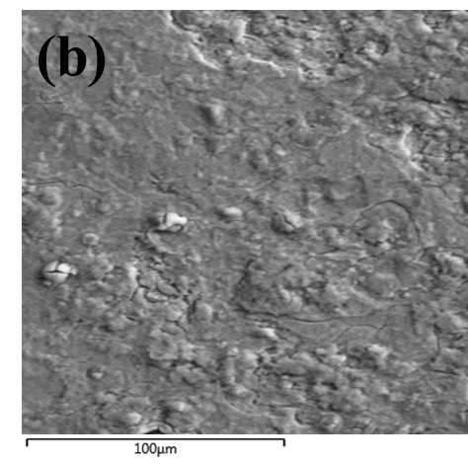
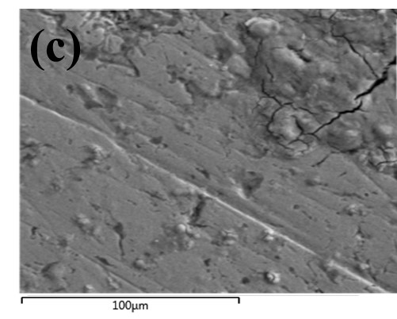 | 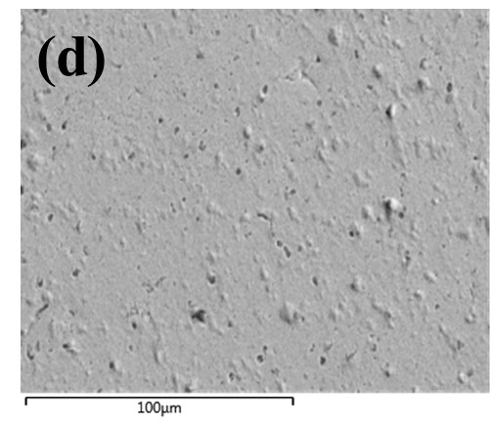

Figure S6: FESEM micrographs of (a) pure 3.75 M NH₄Cl (b) 3.75 M NH₄Cl + 0.01 M S₂O₃²⁻ (c) 3.75 M NH₄Cl + 0.1 M S₂O₃²⁻ and (d) 3.75 M NH₄Cl + 1 M S₂O₃²⁻ solutions, corresponding to EDS spectra presented in Figure 9

Table S1: pH values of electrolyte media for various Cl⁻:S₂O₃²⁻ ratio

Electrolyte media | pH
Cl⁻:S₂O₃²⁻ = 1:0.13 | 6.17
Cl⁻:S₂O₃²⁻ = 1:0.26 | 6.46
Cl⁻:S₂O₃²⁻ = 1:0.53 | 6.76
Cl⁻:S₂O₃²⁻ = 1:1 | 6.99
Cl⁻:S₂O₃²⁻ = 1:1.33 | 7.13

