Photocatalytic performance of N-doped TiO2nano-SiO2-HY nanocomposites immobilized over cotton fabrics

Salmon Landi Jr.^{a,b,*}, Joaquim Carneiroª, Olivia S. G. P. Soares^{c}, Manuel F. R. Pereira^{c}, Andreia C. Gomes^{d}, Artur Ribeiro^{e}, António M. Fonseca^{e,f}, Pier Parpot^{e,f} and Isabel C. Neves^{e,f}

ªDepartment of Physics, University of Minho, Azurém Campus, Guimarães, 4800-058, Portugal
^{b}Instituto Federal Goiano, 75901-970, Rio Verde, Goiás, Brazil
^{c}Laboratory of Catalysis and Materials – Associate Laboratory LSRE/LCM, Faculty of Engineering, University of Porto, 4200-465, Porto, Portugal
^{d}Centre of Molecular and Environmental Biology, University of Minho, 4710 – 057, Braga, Portugal
^{e}Centre of Biological Engineering, University of Minho, 4710-057 Braga, Portugal
^{f}Centre of Chemistry, Chemistry Department, University of Minho, Gualtar Campus, Braga, 4710-057, Portugal

*corresponding author. E-mail address: salmon.landi@ifgoiano.edu.br

Fig. S1. FTIR spectrum of HY zeolite and some prepared composites. The dashed violet line denotes the wavenumber used to calculate the framework silicon/aluminium ratio of HY.
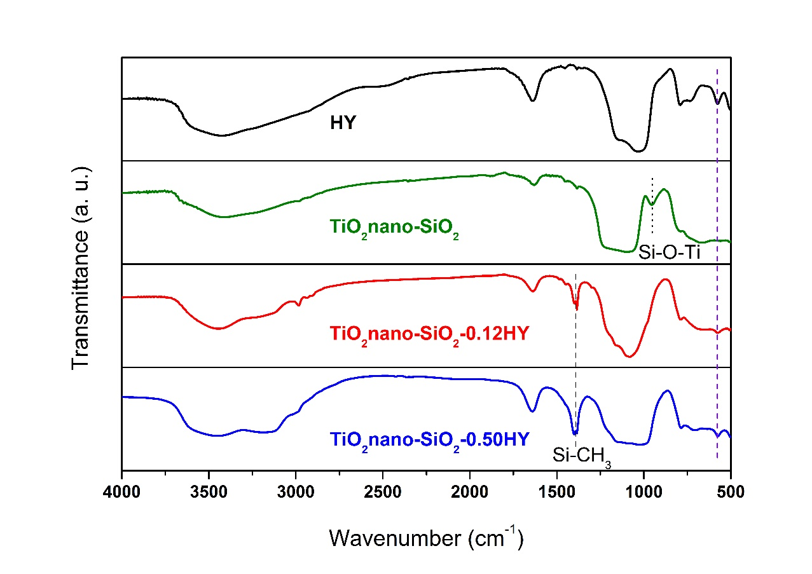

Fig. S2. X-ray diffraction pattern of HY zeolite compared to the patterns of other composites. The three specified peaks refer to those used to calculate the silicon/aluminium ratio of HY.
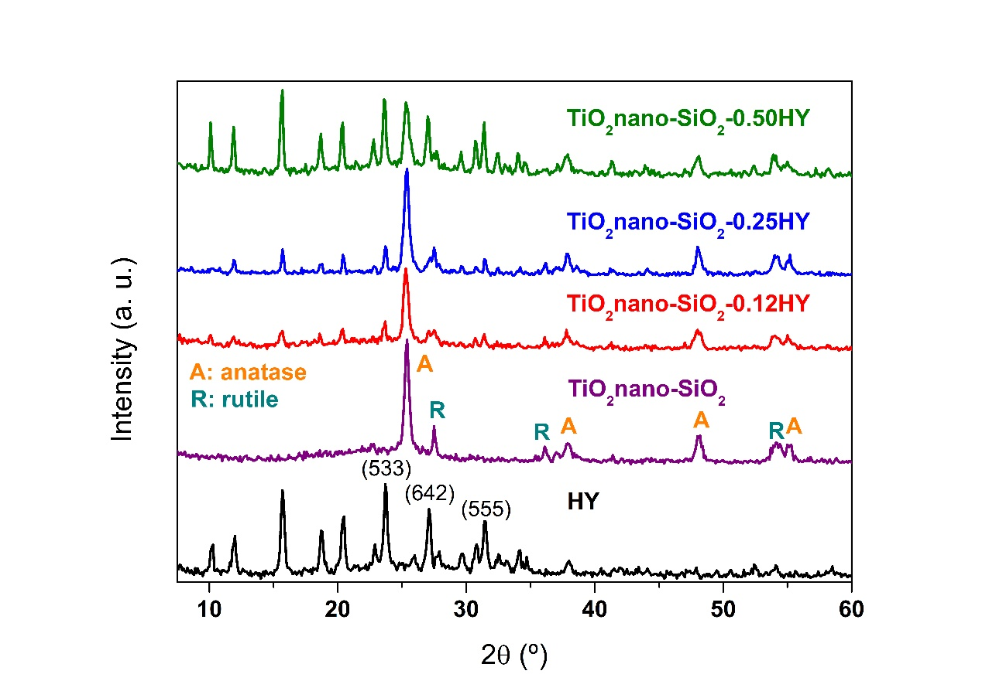

Fig. S3. Histogram of TiO₂ nanoparticles concerning it size distribution. This histogram was obtained from the enlarged SEM micrograph shown in Fig. 2(d).
