Effective adsorptive removal of azo dyes over spherical ZnO nanoparticles

Muhammad Nadeem Zafarª*, Qamar Darª, Faisal Nawaz^{b}, Muhammad Naveed Zafar^{c}, Munawar Iqbal^{d,e}, Muhammad Faizan Nazarª

ªChemistry Department, University of Gujrat, Gujrat, Pakistan
^{b}Basic Sciences & Humanities Department, University of Engineering and Technology Lahore (Faisalabad Campus), Lahore, Pakistan
^{c}Chemistry Department, Quaid-e-Azam University Islamabad, Islamabad, Pakistan
^{d}Chemistry Department, The University of Lahore, Lahore, Pakistan
^{e}Chemistry Department, Qurtuba University of Science and Information Technology, Peshawar, Pakistan

Table S1 – Properties and structure of MO and AM dyes.
Characteristics | Methyl Orange | Amaranth
Chemical formula | C₁₄H₁₄N₃NaO₃S | C₂₀H₁₁N₂Na₃O₁₀S₃
Molecular weight | 327.27 g/mole | 604.49 g/mole
Main hazard | Toxic | Toxic
LD₅₀ (rat) | 60 mg/kg | 1 g/kg
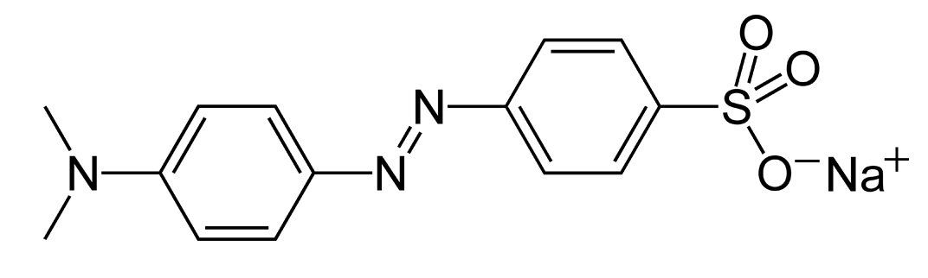  Molecular structure |  | 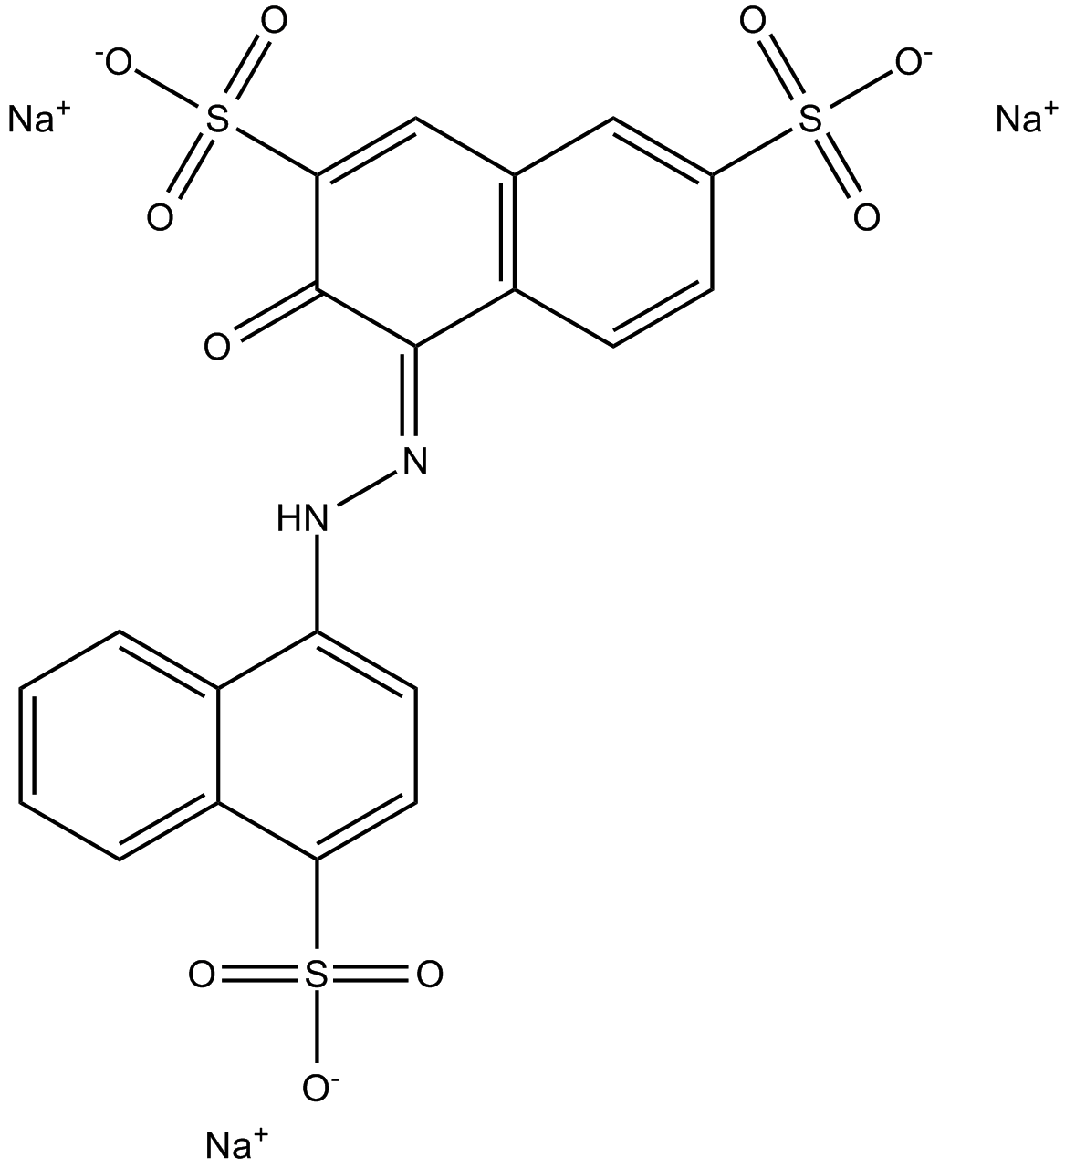

Figure S1 – BET isotherm of ZnO-NPs

S1.1. Effect of initial concentration of dye
The initial dye concentration is another parameter, which can influence the adsorption process. To study the effect of initial adsorbate concentrations the adsorption experiments were carried out by shaking the 0.3 g of ZnO-NPs with an aqueous solutions of MO and AM dyes at pH 6 and 35°C. The effect of initial dye concentrations is studied in the range of 10 to 70 ppm. The results presented in Fig S2 showed that MO percentage removal slightly decreased from around 75 % at a concentration of 20 ppm to 58 % when the concentration was increased to 70 ppm. In the case of AM, the percentage removal was almost constant at greater than 91.5 - 98.6 % over the whole range from 10 to 70 ppm revealing the independency of AM dye adsorption from the initial concentration. This indicates that ZnO-NPs nanoparticles have high affinity for AM than MO possibly due to the higher molecular weight and size of AM as compared to MO. The increased concentration cause increase in adsorbed dyes per unit mass of adsorbent and overcome the mass transfer resistance of dyes between solution and adsorbent surface. The competition between increased dye molecules for less adsorption sites also could be the reason of decrease in percentage removal [1].

Figure S2 – Effect of initial dye concentration on adsorption of AM and MO dyes by ZnO-NPs

S1.2. Effect of contact time
The contact time between solid nanoparticles and dye is an important parameter to design a low cost adsorbent and to predict the mechanism of removal process. The adsorption of MO and AM dyes onto ZnO-NPs was investigated as a function of contact time to determine the equilibrium time. The solution pH and ZnO-NPs dosage were fixed at their obtained optimum values. The initial dye concentrations for all test solutions were 40 ppm. Fig. S3 shows percentage removal for the two dyes as a function of contact times ranging between 5 and 100 min. The data indicate that adsorption started immediately upon adding the ZnO-NPs to both dyes solutions. The percentage removal of AM rapidly increased from 60 % in the first minute of contact to 91 % as the stirring was increased to 10 min. The percentage of maximum adsorption was 98.5% at 100 min. The percentage removal of MO was increased from 30 % to 68 % as the contact time increased from 5 to 30 min. Thus, the contact time required to achieve the equilibrium for MO and AM was 20 and 30 min respectively and the optimum contact time for ZnO-NPs in the model dyes was considered to be 25 min. The fast removal of MO and AM dyes at short contact time reveals that film diffusion is predominant step.

Figure S3 – Effect of time on adsorption of AM and MO dyes by ZnO-NPs

Figure S4 – Kinetics of adsorption on ZnO-NPs (A) pseudo first order for MO, (B) pseudo first order for AM, (C) pseudo second order for MO and (D) pseudo second order for AM
[1] M. Ghaedi, B. Sadeghian, A.A. Pebdani, R. Sahraei, A. Daneshfar, C. Duran, Kinetics, thermodynamics and equilibrium evaluation of direct yellow 12 removal by adsorption onto silver nanoparticles loaded activated carbon, Chem. Eng. J., 187 (2012) 133-141.

