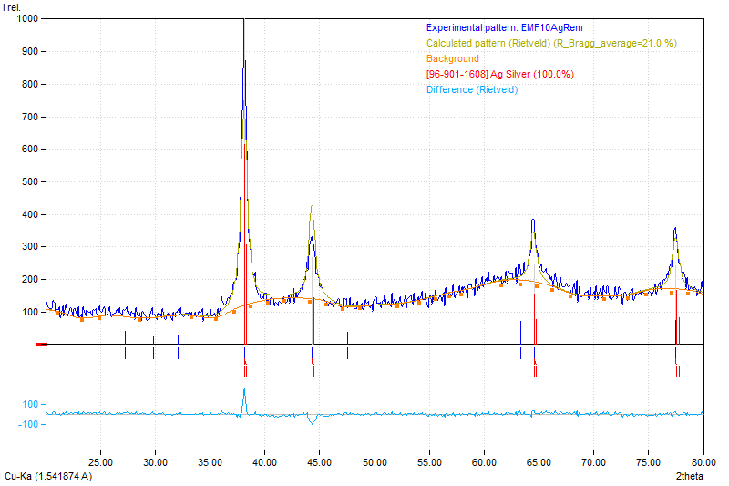
Figure 1. Rietveld Refinement Ag-Pa

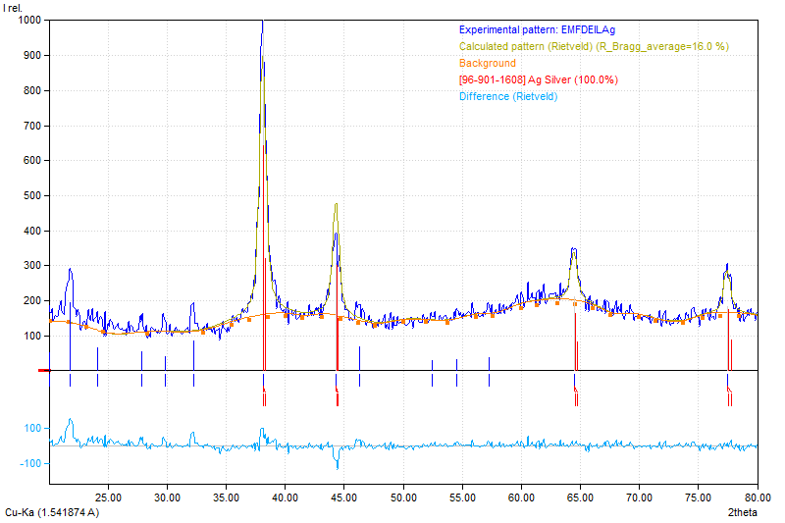
Figure 2. Rietveld Refinement Ag-Pa[EMIm][Tos]
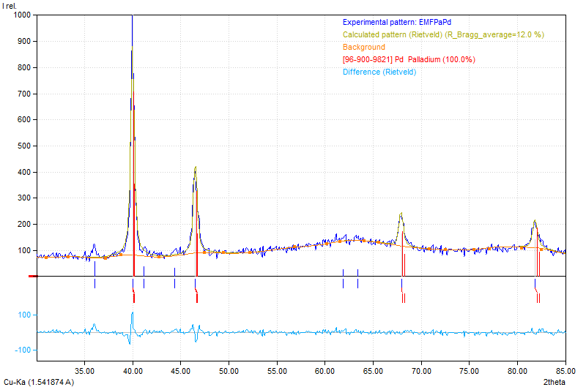
Figure 3. Rietveld Refinement Pd-Pa

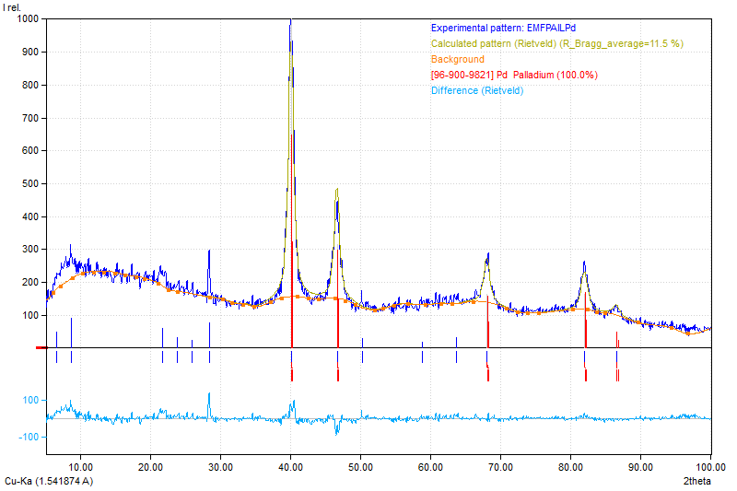
Figure 4. Rietveld Refinement Pd-Pa[EMIm][Tos]

