Synthesis of g-C₃N₄ /N-doped CeO₂ composite for photocatalytic degradation of an herbicide
Mohan Kumar Kesarlaª, Manuel Octavio Fuentez Torres^{b}, Manuel Antonio Alcudia Ramos^{b}, Filiberto Ortiz Chi^{c}, Claudia Guadulupe Espinosa Gonzalez^{c}, M.Aleman^{d}, Jose Gilberto Torres Torres^{b}, Srinivas Godavarthi^{c*}

Supplementary material

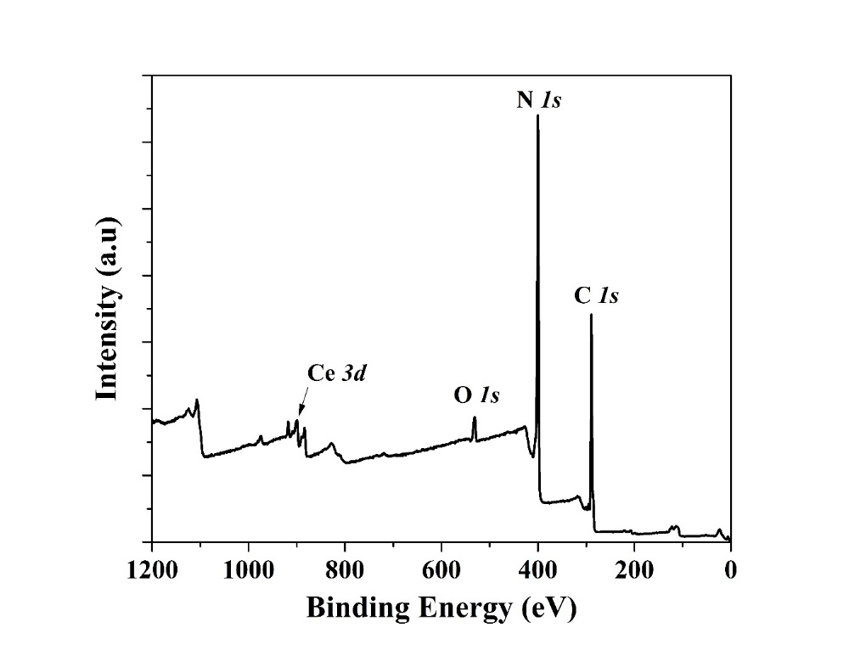

Fig. S1. XPS survey scan for the g-C₃N₄/ceria composite

