Supporting information
Optical analysis
- Optical Microscopy

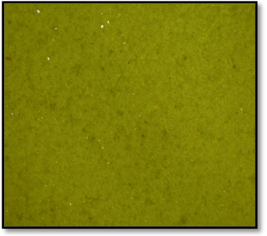
(b)

(b)
Surface morphology, as observed under optical microscope, of (a) CuI- thin film (b) CuI-MBT thin film
The surface morphology of drop casted films were analysed under optical microscope. The images shows that the coating were uniform and well adhere to the substrate and did not fall off for long time. This may be helpful for fabrication of smooth surfaced junction of energy harvesting device.
Supporting Information S2:
Table:1
Parameters | CuI | CuI-MBT
C1 | -232.907 | -17.22
C2 | 7.8355E-8 | -17.22
R1 | -1309052.13 | 61.1721
R2 | 91.9101 | 61.1725
R3 | 67.0835 | 67.4740
R4 | 39.2765 | 54.6201
Qy1 | -0.001307 | -0.000149
Qa1 | 0.21847 | 0.36666

Table:2 R₁=R_{ct}
 | Electrical conductivity (S/cm) | ∆G#
CuI (σ₀) | 3.6377*10⁻⁷ | -25kJ/mol
CuI-MBT (σ) | 0.01022

Table:3 R₂=R_{IC}
 | Ionic conductivity (S/cm) | ∆G#
CuI (σ₀) | 5.1810*10⁻³ | 20kJ/mol
CuI-MBT (σ) | 0.010217

Table:4 ∆G# (From EIS)
 | CuI | CuI-MBT | ∆G#
 |  |  | CuI | CuI-MBT
C1 | -232.907 | -17.22
C2 | 7.8355E-8 | -17.22
R1 | -1309052.13 | 61.1721 | 145.39 kJ |  | 120.68 kJ
R2 | 91.9101 | 61.1725 | 121.69 kJ |  | 120.68 kJ
R3 | 67.0835 | 67.4740 | 120.91 kJ |  | 120.93 kJ
R4 | 39.2765 | 54.6201 | 119.58 kJ |  | 120.40 kJ
Qy1 | -0.001307 | -0.000149
Qa1 | 0.21847 | 0.36666

Table 5: ∆G# (From Cyclic voltammetry)
i_{p} of CuI (µA) | ∆G# | i_{p} of CuI-MBT (µA) | ∆G#
0.0256 | 68 kJ/mol | 2.7062 | 133 kJ/mol
0.0272 | 122 kJ/mol | 2.9482 | 133 kJ/mol
0.4360 | 126 kJ/mol | 0.1083 | 130 kJ/mol
0.0587 | 120 kJ/mol

