Supplementary Information (SI)

Porous NbAl₃/TiAl₃ intermetallic composites with controllable porosity and pore morphology prepared by two-step thermal explosion
Xiaoping Cai^{a,b}, Xiang Bo^{c}, Peizhong Feng^{a,*}, Xuanru Renª, Xueqin Kangª, Cheng Xuª, Ping Zhang^{a,*}
ªSchool of Materials Science and Engineering, China University of Mining and Technology, Xuzhou 221116, PR China; ^{b}School of Chemical Engineering and Technology, China University of Mining and Technology, Xuzhou 221116, PR China; ^{c}Department of Materials Science and Engineering, China University of Mining and Technology (Beijing), Beijing 100083, PR China

*Corresponding author: Peizhong Feng, Ping Zhang
Tel: 0086-516-83591939
E-mail address: pzfeng@cumt.edu.cn; fengroad@163.com (P.Z. Feng)
zhangping0095@cumt.edu.cn (P. Zhang)

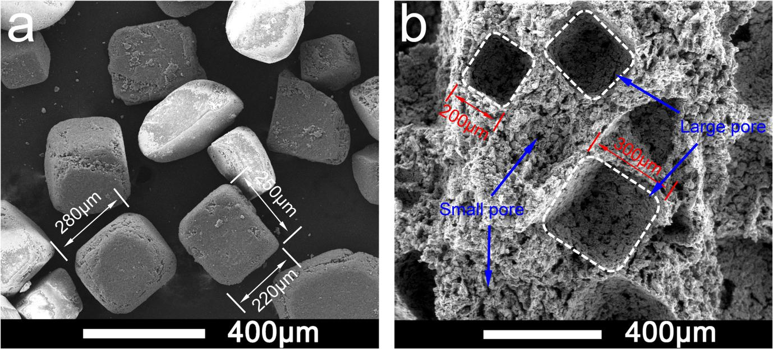
Fig. S1. SEM images of (a) NaCl space holder particles and (b) fracture surface of product.
In the present study, the open porosity was increased from 48.15% to 78.85% with the increase of space holder of NaCl content. Moreover, the small pore with size about 20 μm originated from thermal explosion reaction, whereas the large pore with size about 200-300 μm derived from the replication the NaCl particles (200-300 μm, purity 99.8%), as shown in Fig. S1. Therefore, the porosity and pore size of product can be tailored by adjusting the content and dimension of NaCl particles. In fact, the space holder (or leachable template) technology is a common way to adjust the porosity and pore morphology/size of product. Shu et al [1] fabricated porous NiAl intermetallic with hierarchical porous structure using NaCl as space holder, the porosity reached 84% when the content of NaCl was 80%, and the large pore of size 30-50 μm was associated with the NaCl particles. Gasemi et al [2] studied the synthesis of porous NiTi with NaCl space holder, the results suggesting that the controllable pores was gained by addition of the spacers.

References
[1] Shu YM, Suzuki A, Takata N, Kobashi M. Fabrication of porous NiAl intermetallic compounds with a hierarchical open-cell structure by combustion synthesis reaction and space holder method. J Mater Process Technol 2019;264:182-9.
[2] Ghasemi A, Hosseini SR, Sadrnezhaad SK. Pore control in SMA NiTi scaffolds via space holder usage. Mater Sci Eng C 2012;32(5):1266-70.

