Appendix A. Supplementary Material
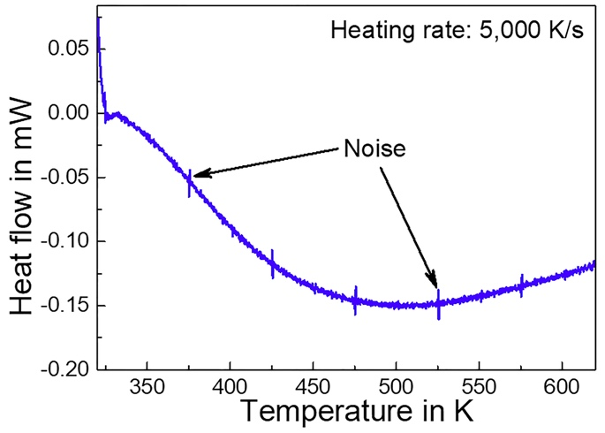
Fig. S1 Nanocalorimetry heating curve of silicone oil. There are no possible peaks that can affect the glass transition and crystallization of Ce₆₈Al₁₀Cu₂₀Co₂ in this curve.
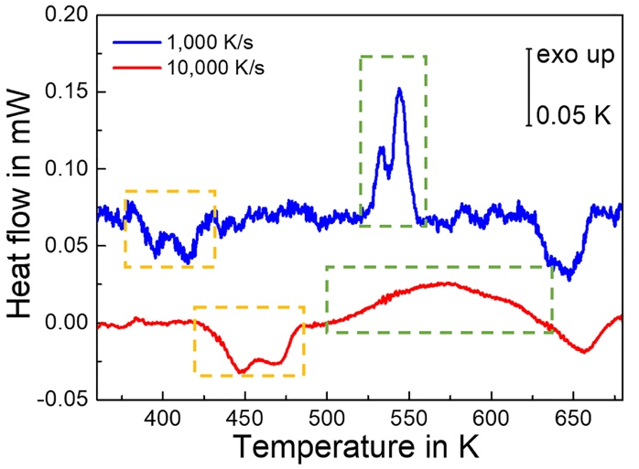

Fig. S2 Nanocalorimetry heating curves of Ce₆₈Al₁₀Cu₂₀Co₂ at 1,000 and 10,000 K/s.

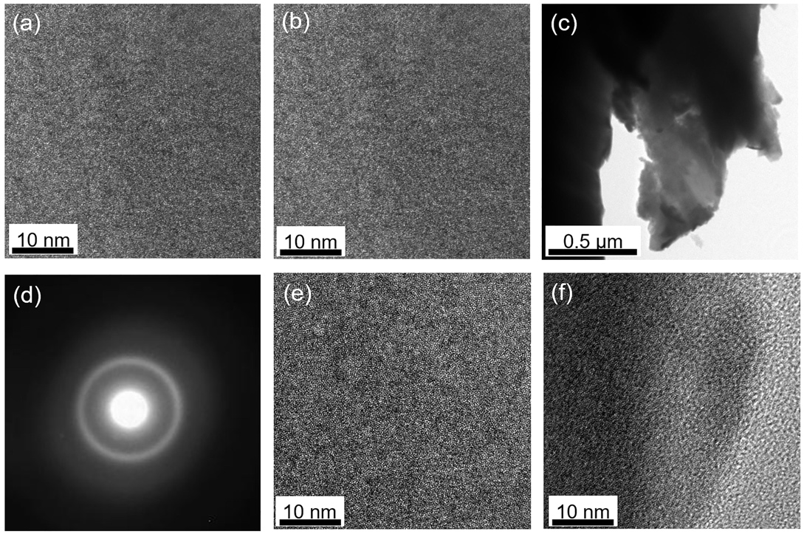
Fig. S3 TEM images of the as-cast sample. (a) and (b) HRTEM images corresponding to the bright areas in Fig. 6b of the manuscript. (c) Bright-field image of the as-cast sample. (d) SAED pattern of the as-cast sample. (e) and (f) are HRTEM images correspond to the areas with various contrasts.

