**Supplementary data**

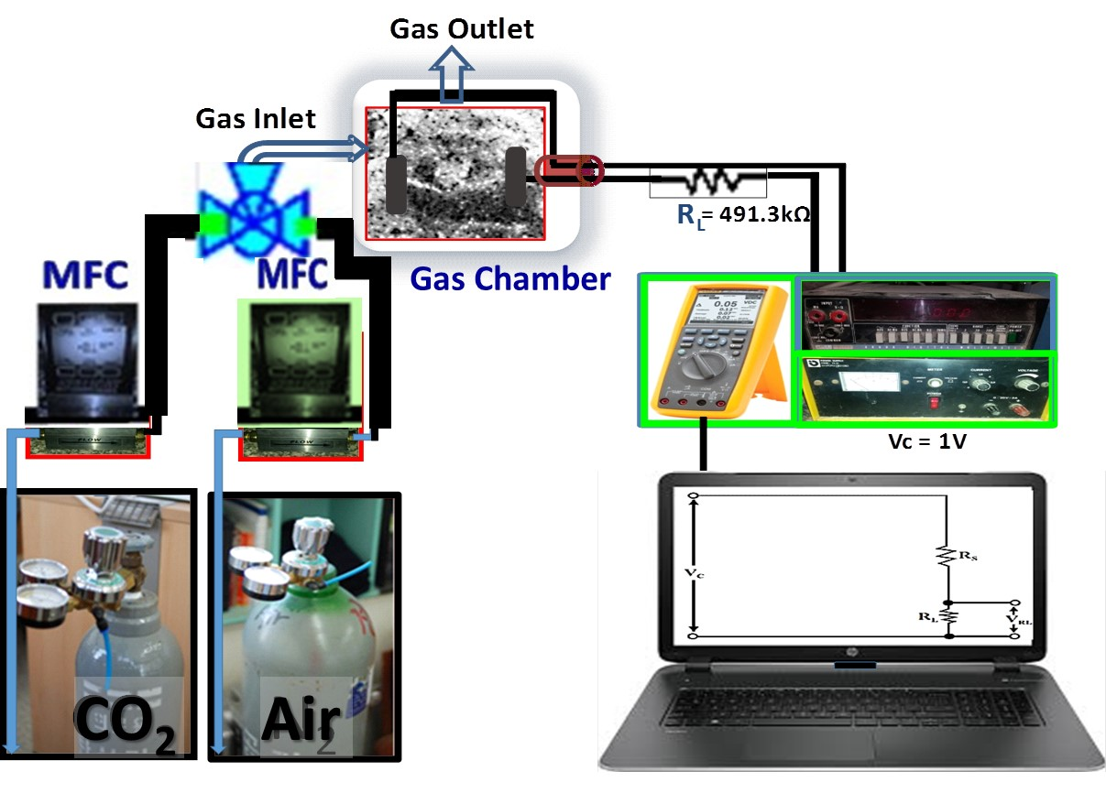

**Fig. S1.**  Schematic diagram of the measurement system for different gases using the NGO film sensor.



**Fig. S2.** (a) Top-view SEM image of GO (width = 3.303± 0.65 μm and length = 5.145 ± 1.108 μm) and (b) height profile of two GO sheets obtained using atomic force microscope (AFM) (Height= 3.92 ± 0.46 and 3.19± 0.26 nm).

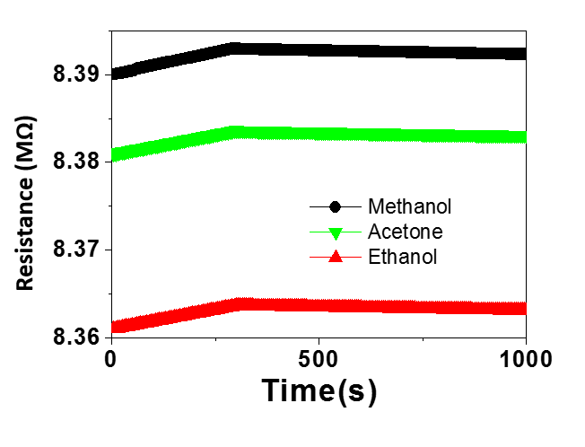

**ON**

**OFF**

**ON**

**OFF**

**Fig. S3.** Resistance variation versus operation time at RT (20 oC) of the GO film sensor in the presence of 60 SCCM methanol, acetone, or ethanol.



**(a)**

**(b)**

**Fig. S4.** (a) Effect of humidity in NGO sensor response at 60 SCCM CO2 gas, and (b) effect of the interfering 10 SCCM NO2 gas in the NGO response toward CO2.