The deconvolution process of ²⁹Si nuclear magnetic resonance (NMR) spectra

The software PeakFit 4 is used for separating and quantifying the spectral resolution for silicon. Take the “Initial geopolymer” sample for example.
1. Open the PeakFit 4, then read the date of initial geopolymer sample.
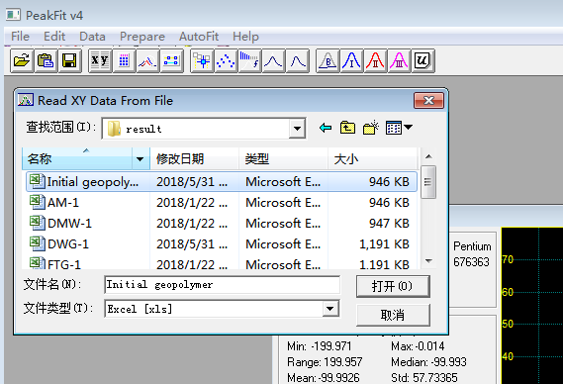

2. Choose the X Column and Y Column, and then click “OK”.

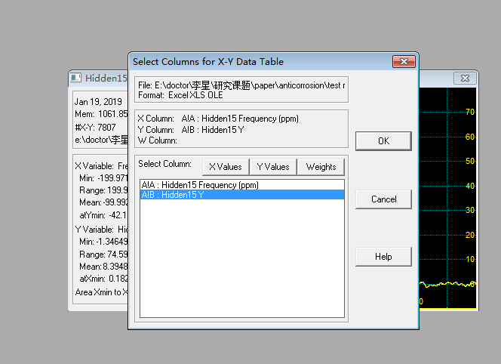

3. Click “OK”
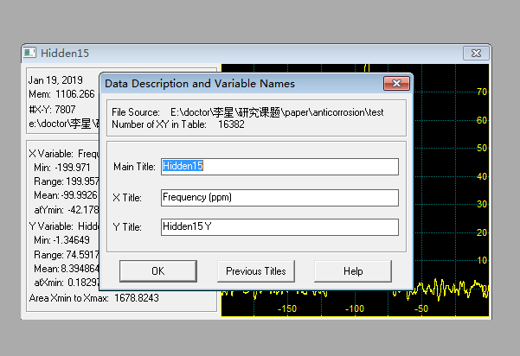

4. Click
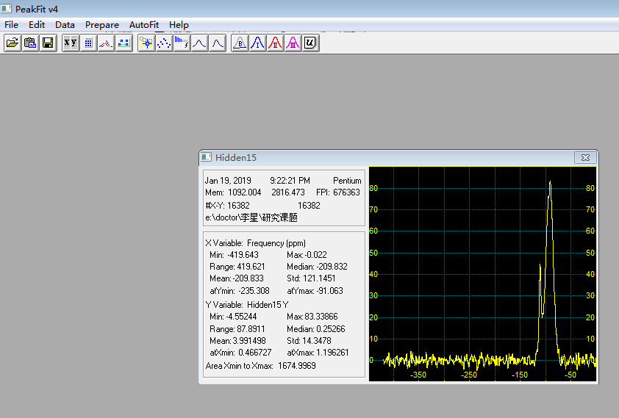

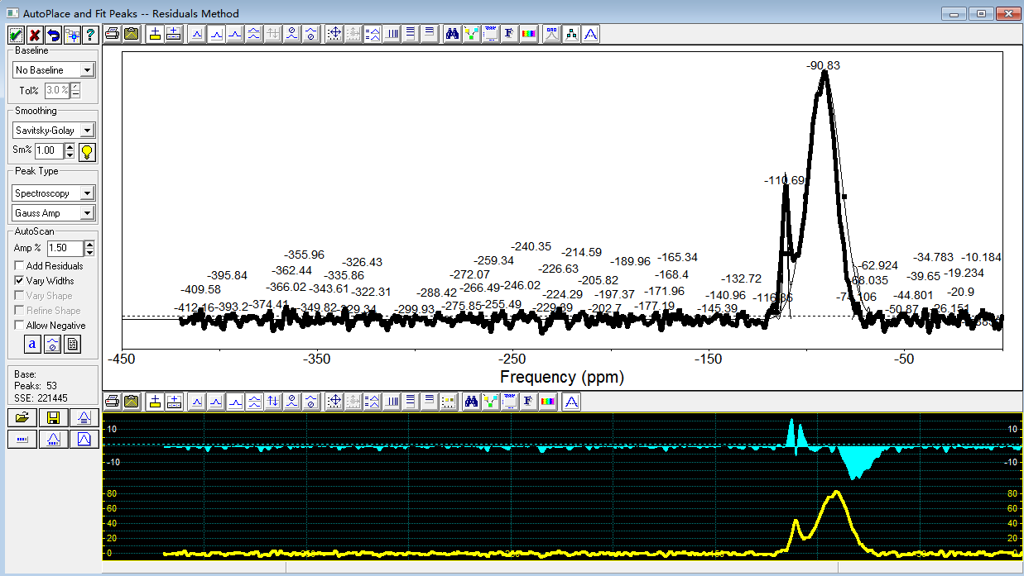

5. Click , choose the range of the silicon spectral and then click “OK”. Delete the excess fit line.
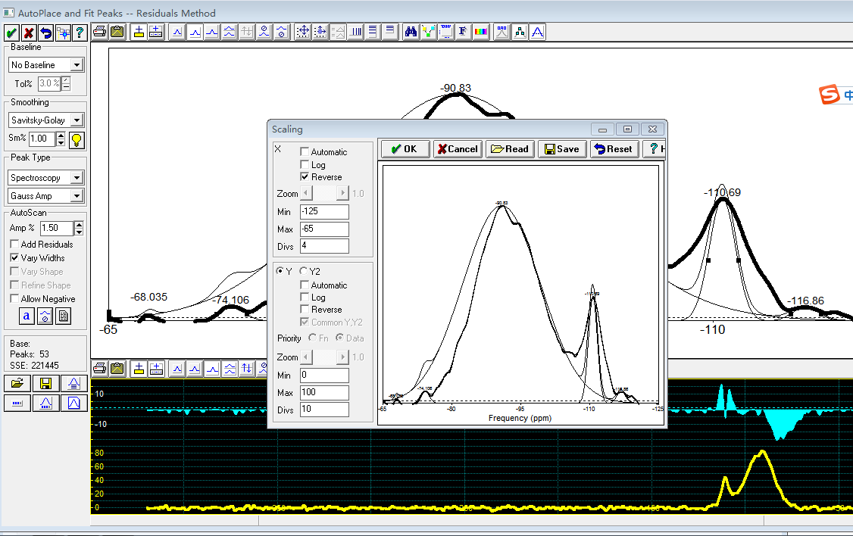

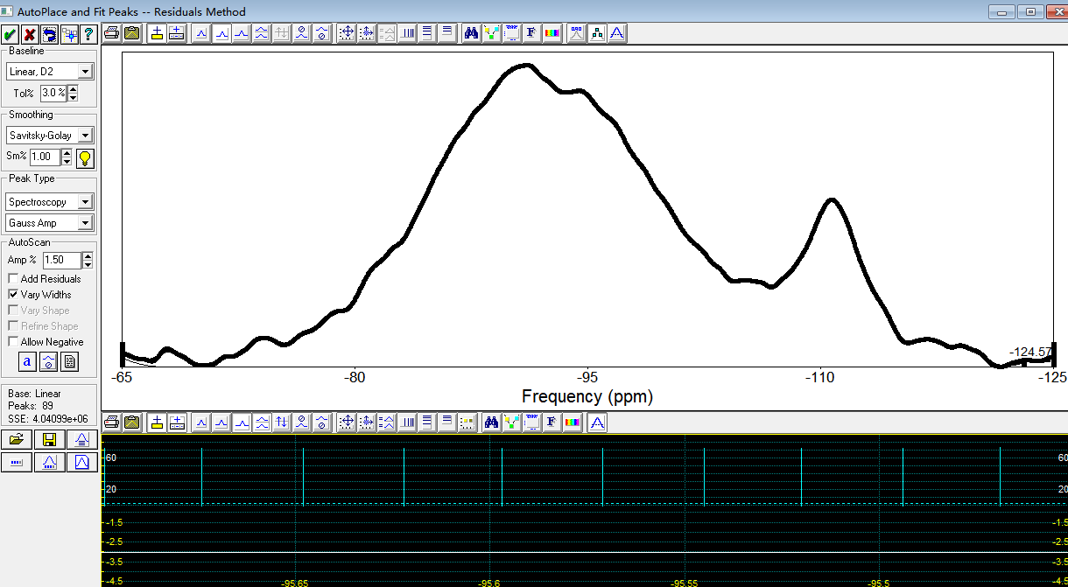

6. A Gaussian fit curve appears when clicked within the spectral range, and then right click on the vertices of the fitted curve to choose the position and the width of the δ. The positions of δ are as follows.
Q1, Q2 and Q3 resonate at approximately -79, -85 and -95 ppm, respectively. And Q4(4Al), Q4(3Al), Q4(2Al), Q4(1Al), Q4(0Al) resonate at approximately -84, -89, -93, -99 and -108 ppm, respectively. In addition, the peak with resonance at -112 ppm is attributed to the remained cristobalite in the geopolymers.
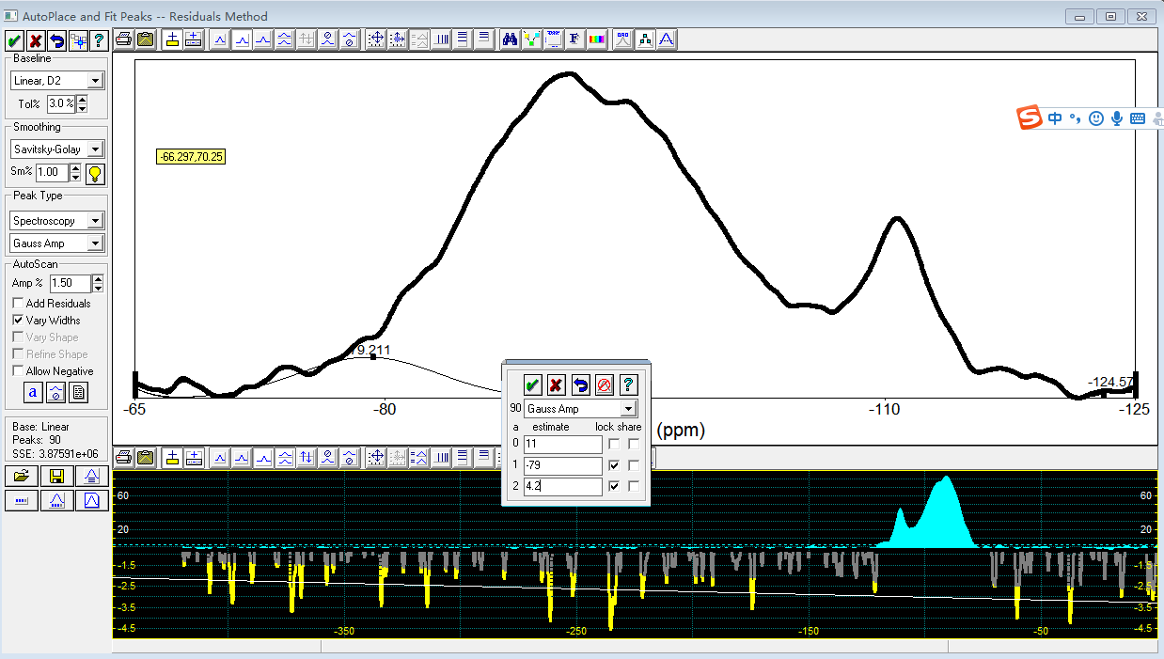

7. After all the fitted curves are finished, click to further fit.
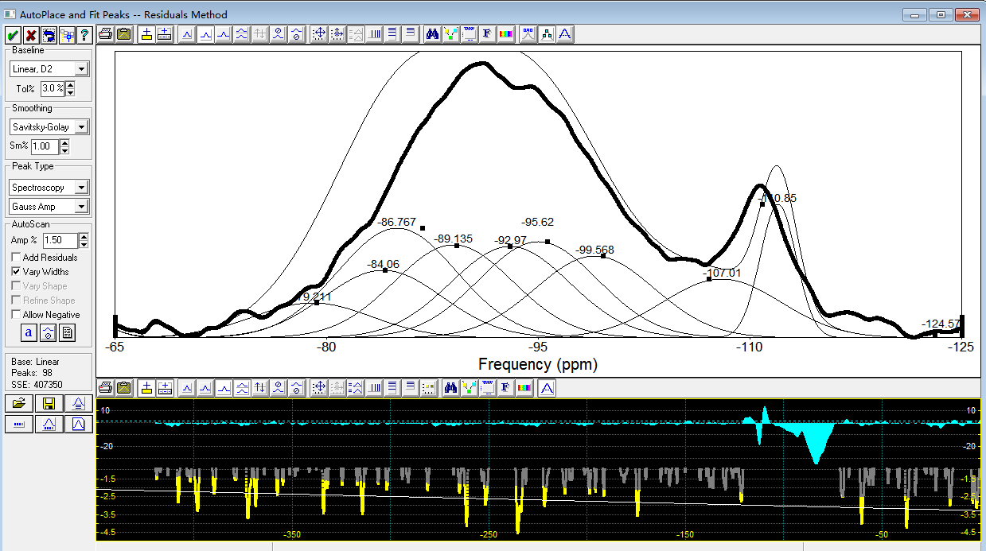
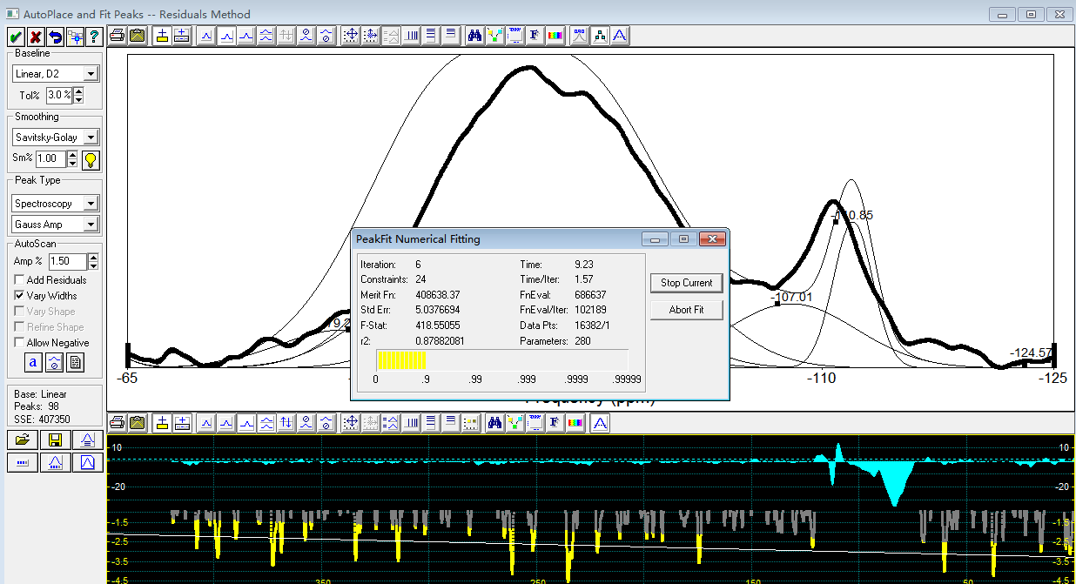

8. After several adjustments, the fitting results are as follows.
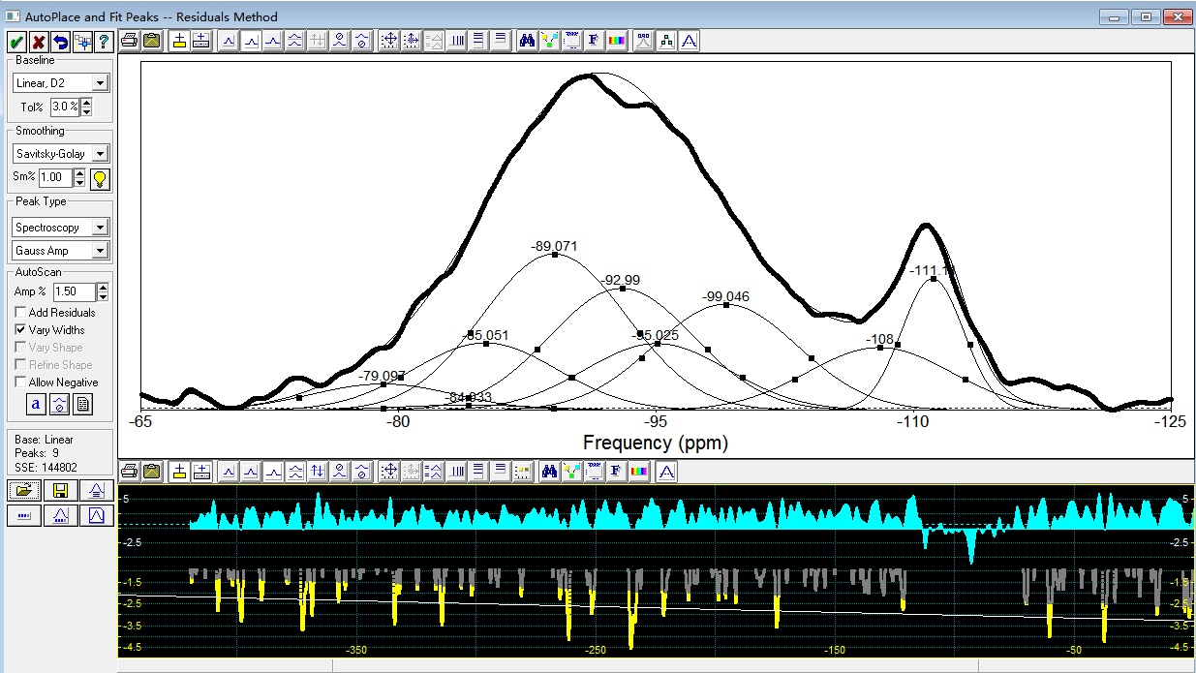

9. Click to look over the peaking results. Use the Areas of the peaks to calculate the percentage of each resonance.
