Supporting information

The influence of calcination and reduction treatments on the adhesive and biocompatibility properties of TiZr nanotubes fabricated via anodizing

Maria Vardaki^{1,2}, Shiva Mohajernia², Aida Pantazi³, Ionela Cristina Nica⁴, Marius Enachescu³, Anca Mazare², Ioana Demetrescu^{1,5,*}, Patrik Schmuki^{2,*}
1 General Chemistry Department, University POLITEHNICA of Bucharest, Str. Polizu 1-7, 011061, Bucharest, Romania
2 WW4-LKO, Department of Materials Science, Friedrich Alexander University of Erlangen Nurnberg, Martensstr. 7, 91058, Erlangen, Germany
3 Center for Surface Science and Nanotechnology University POLITEHNICA of Bucharest, SplaiulIndependentei nr. 313, 060042, Bucharest, Romania
4 Department of Biochemistry and Molecular Biology, Faculty of Biology, University of Bucharest,SplaiulIndependentei91-95 , 050095, Bucharest, Romania
5 Academy of Romanian Scientists, SplaiulIndependentei 54, 050094 Bucharest, Romania
* corresponding authors

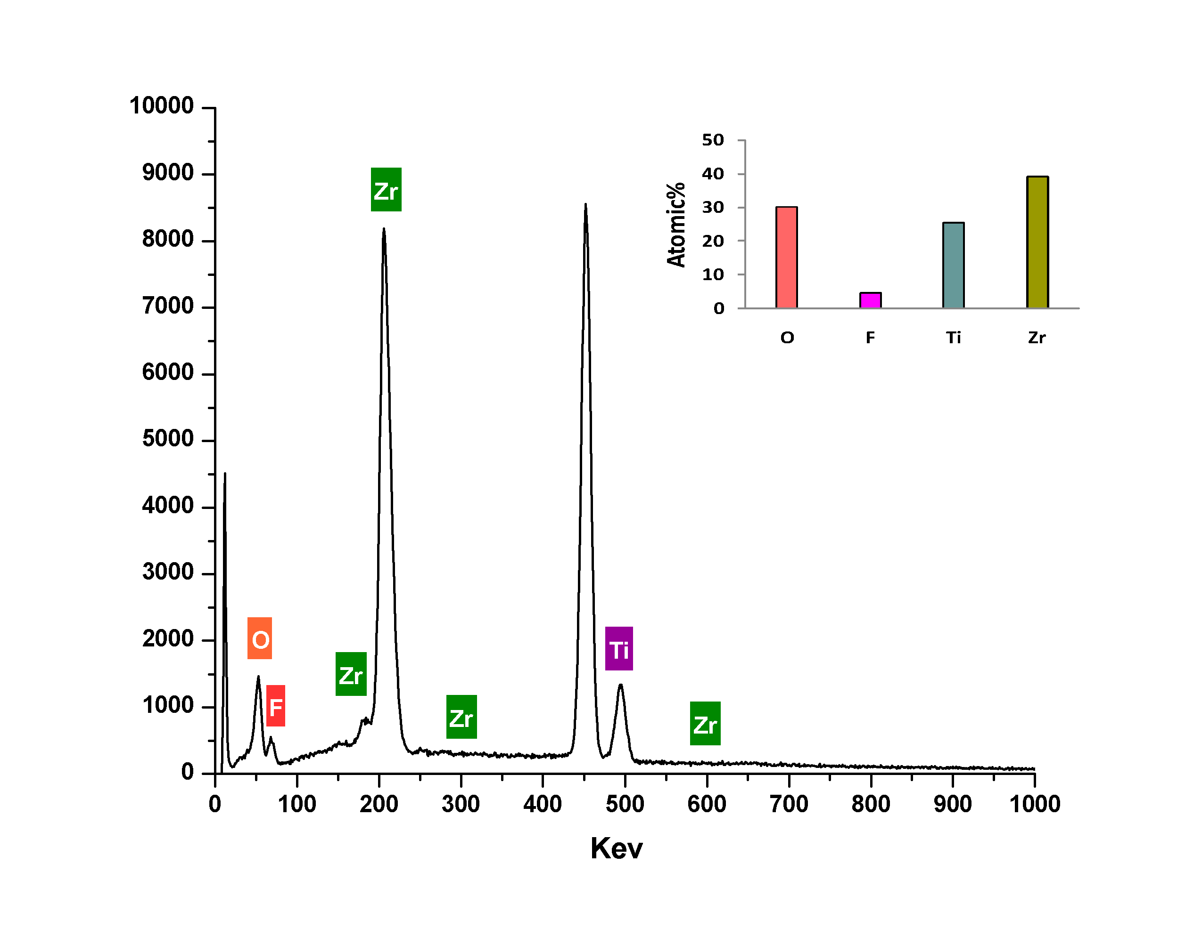
Fig. S1 EDX spectra of as formed nanotubes on TiZr alloy

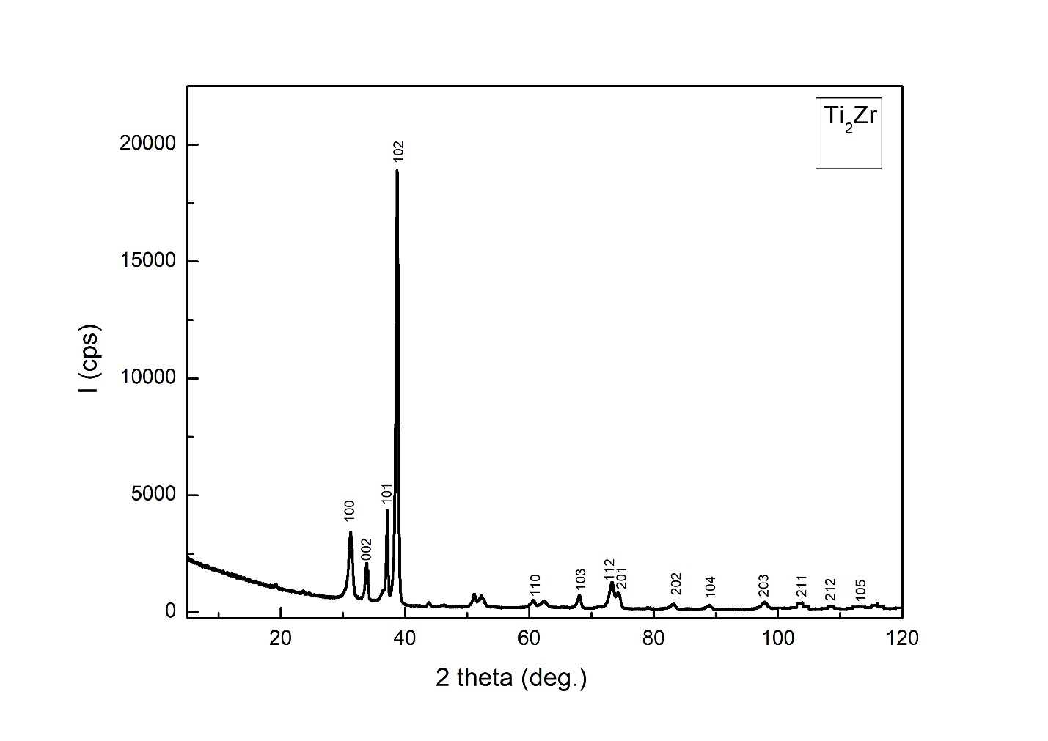
Fig. S2 XRD spectra of the TiZr alloy substrate (substrate is Ti₂Zr)

In the following figures the steps involved in the AFM investigation are shown, as an example for the reduced nanotubes.
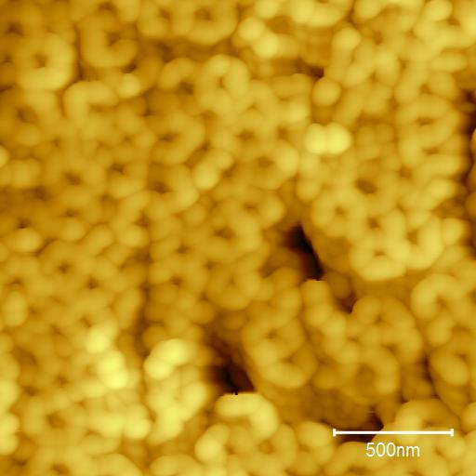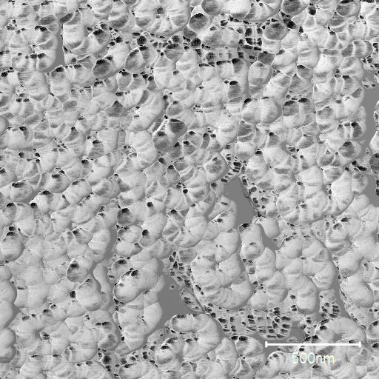
Fig. S3 2x2 um 2D AFM images of reduced nanotubes: a) Topography; b) Phase contrast
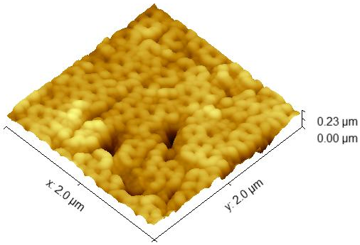
Fig. S4 2x2 um 3D AFM image of the reduced nanotubes
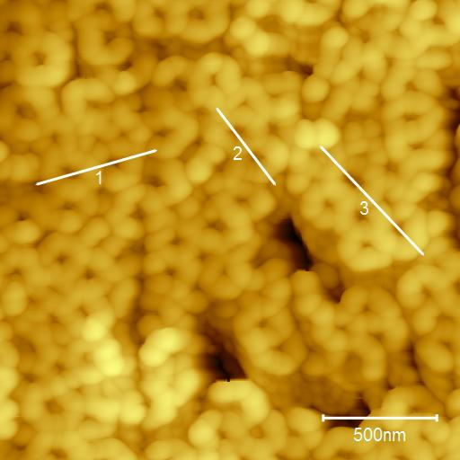
Fig. S5 Directions of the traced profiles on the AFM 2D topography image shown in Fig S3.

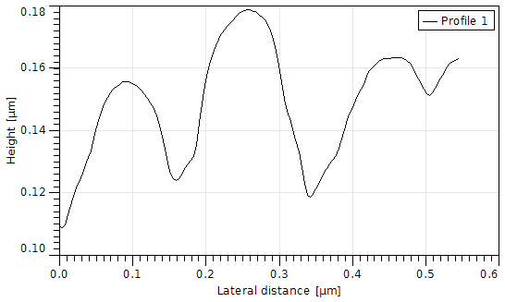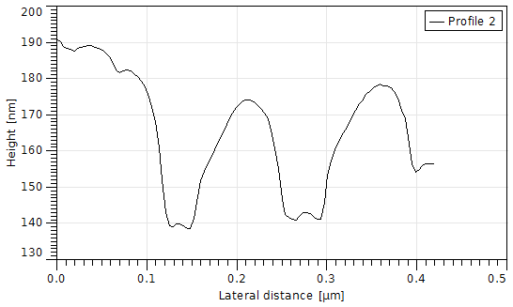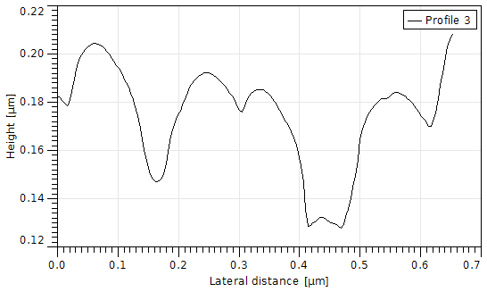
Fig. S6 Graphical representations of the profiles marked in the figure S5

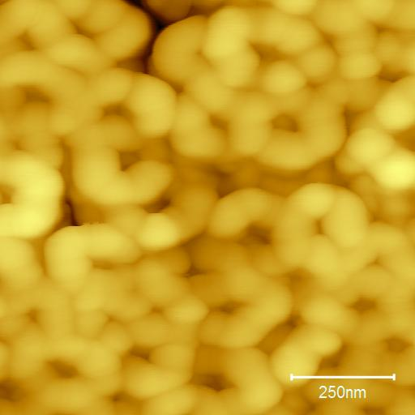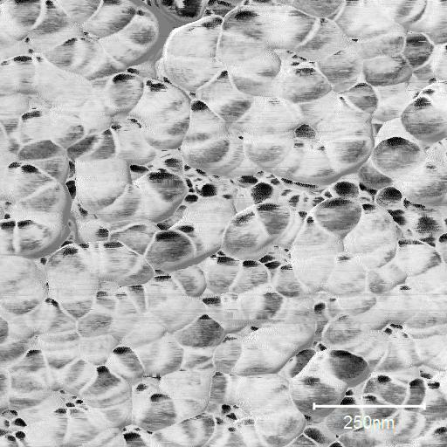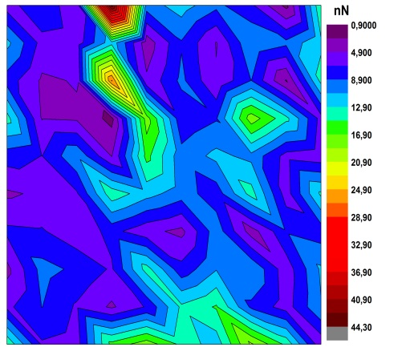
Fig. S7 1x1 um 2D AFM images of reduced nanotubes: a) Topography; b) Phase contrast; c) Adhesion Force Map

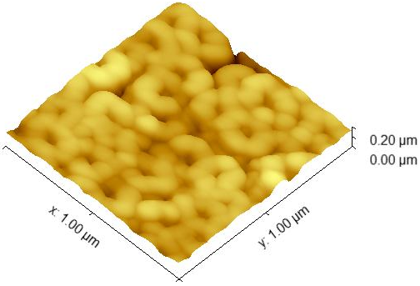
Fig. S8 1x1 um 3D AFM image of reduced nanotubes
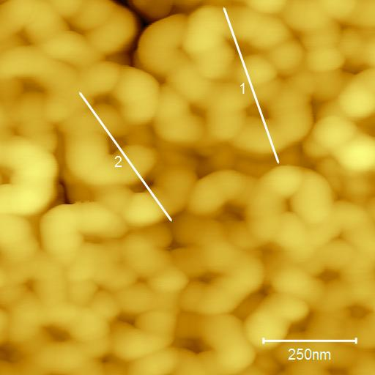
Fig. S9 Directions of the traced profiles on the AFM 2D topography image

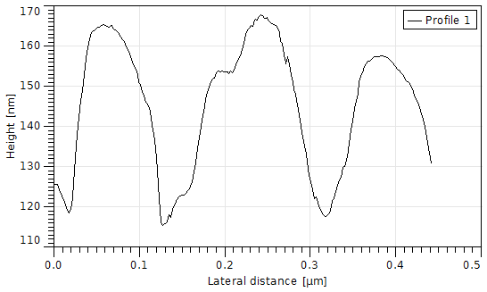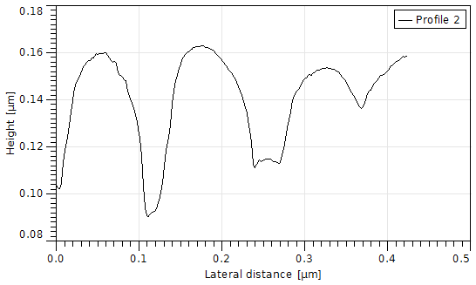
Fig. S10 Graphical representations of the marked profiles

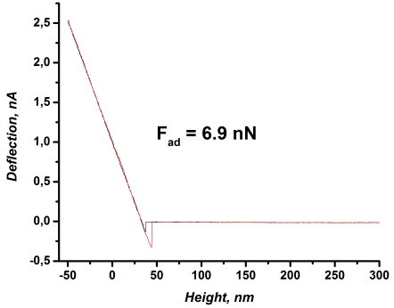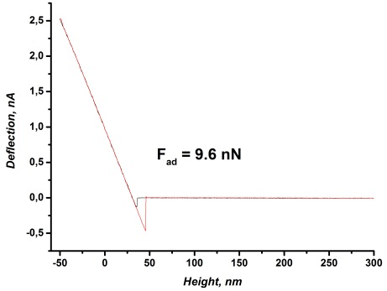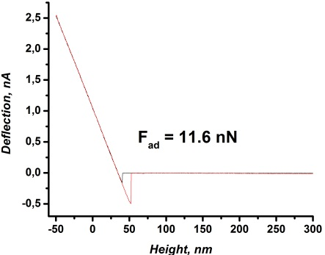
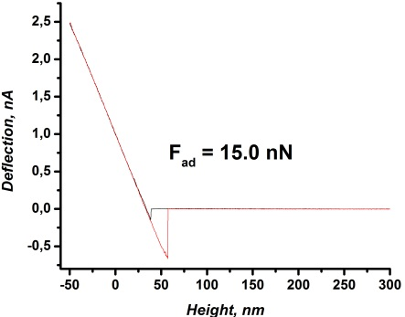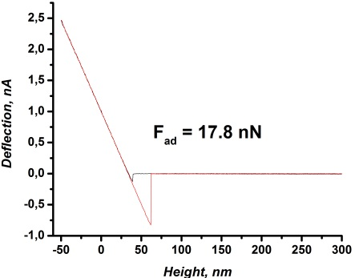
Fig. S11 . Force-distance curves

Analysis of the substrate – reduced TiZr
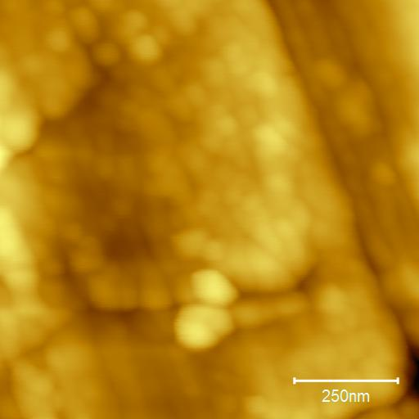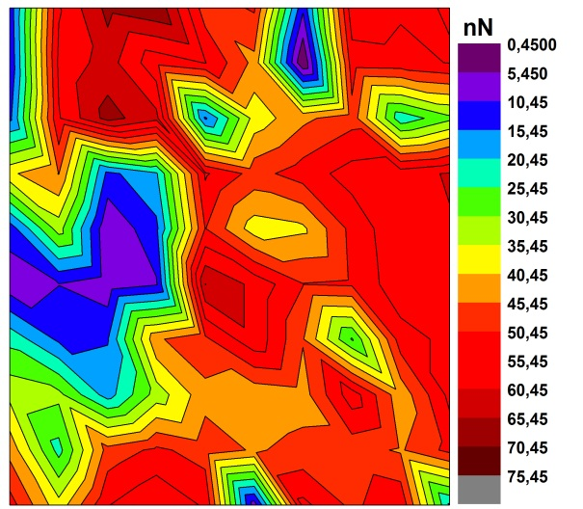
Fig. S12 1x1 um 2D AFM images of the reduced TiZr substrate: a) Topography; b) Adhesion Force Map
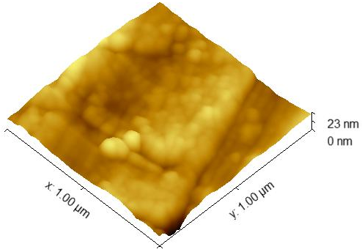
Fig. S13 1x1 um 3D AFM image of reduced TiZr substrate.
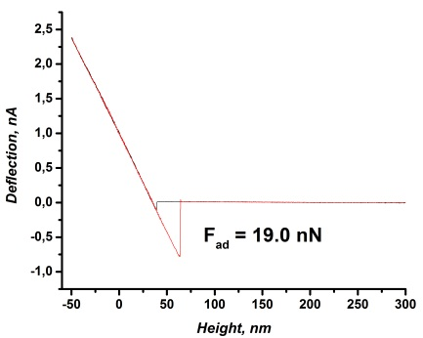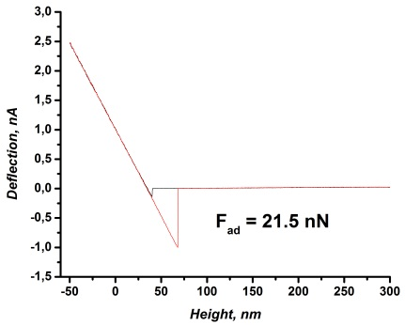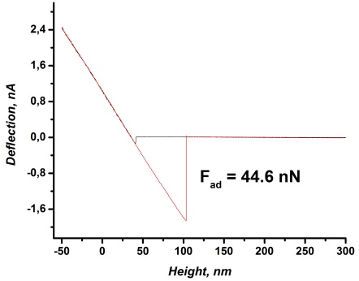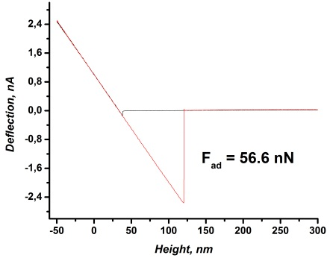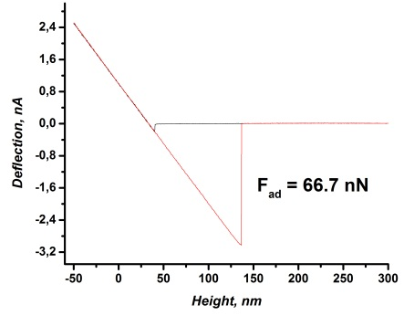
Fig. S14 Force-distance curves for the reduced TiZr substrate.

