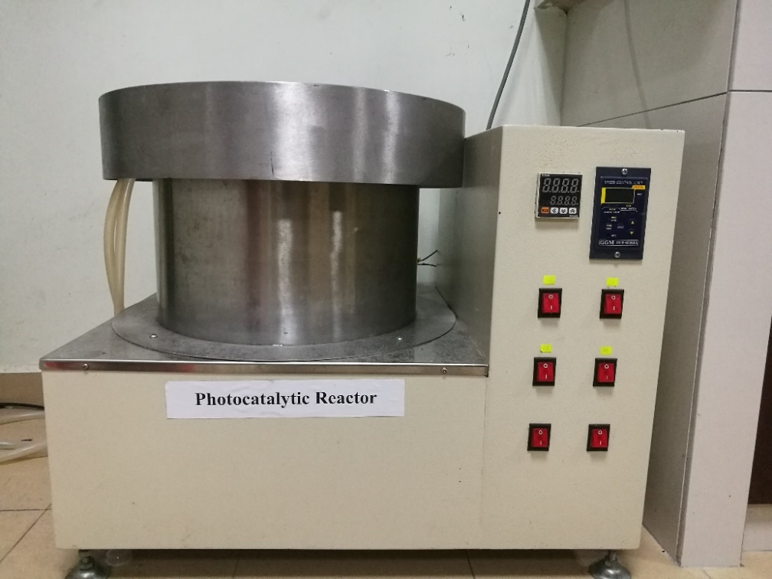
Light source control
Temperature controller
Circulating water jackets
Cooling fan control
Photocatalytic reactor
Stirring control unit
(a)

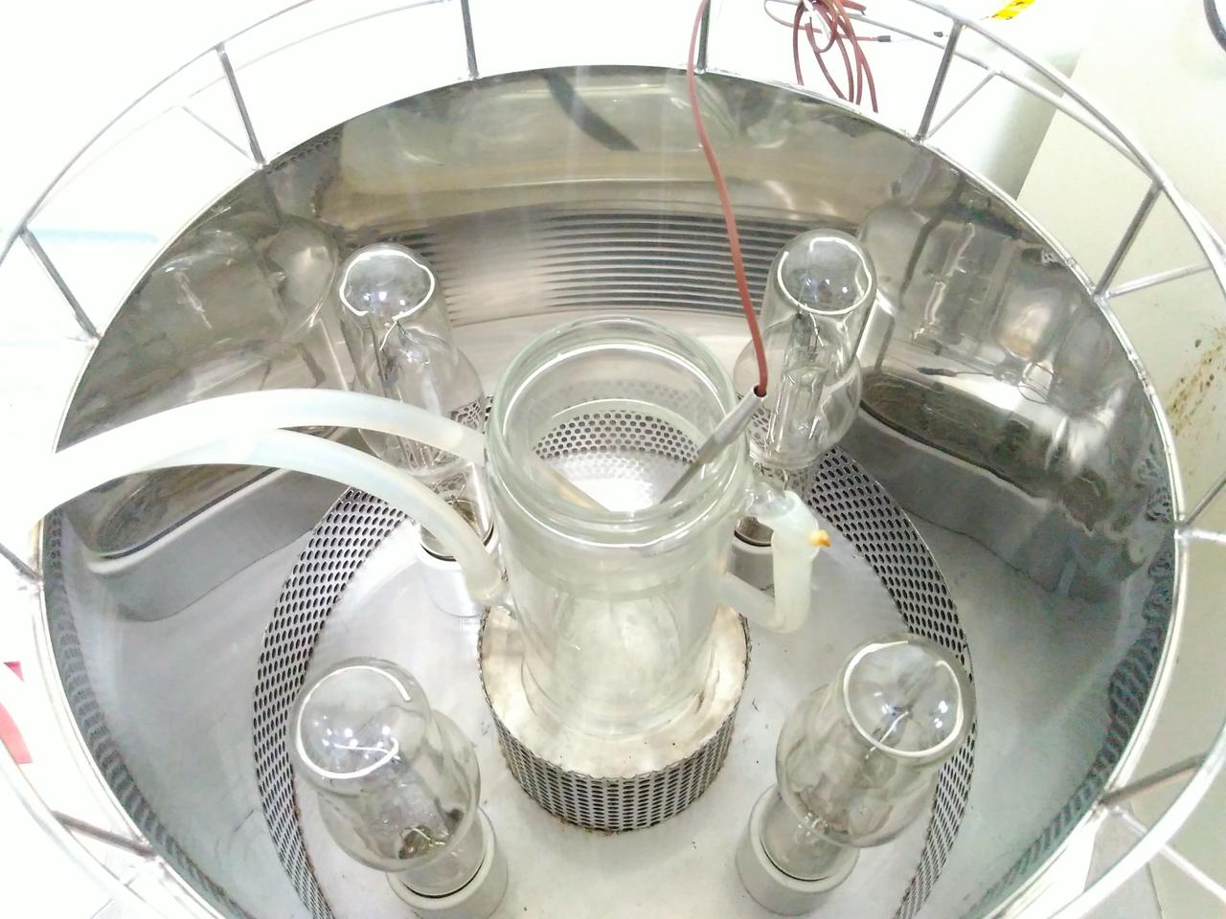
Magnetic stirrer
Quartz reactor
Thermocouple
Light source
Circulating water jackets
(b)

Supplemental Fig. 1. (a) Exterior view and (b) interior view of self-assembled photocatalytic setup.

