Supplementary Data

Synthesis and characterization of MgO supported Fe-Co-Mn nanoparticles with exceptionally high adsorption capacity for Rhodamine B dye

Somayeh Rahdar¹, Abbas Rahdar²*, Muhammad Nadeem Zafar³*, Syed Salman Shafqat⁴

¹Department of Environmental Health, Zabol University of Medical Sciences, Zabol, Iran
²Department of Physics, University of Zabol, Zabol, P. O. Box 98613-35856, Iran
³Department of Chemistry, University of Gujrat, Gujrat, 50700 Pakistan
⁴Department of Chemistry, University of Education, Lahore, 54770 Pakistan

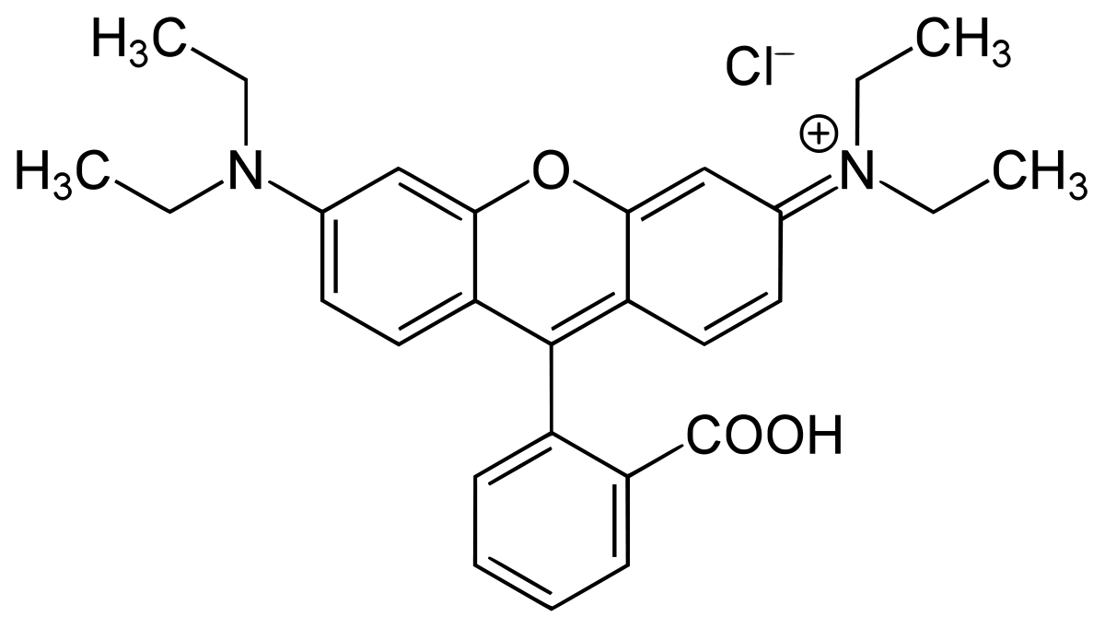
Fig. S1 - Structure of Rhodamine B (RhB)

Fig. S2 - BET isotherm of MgO-FCM-NPs

Fig. S3 - Regeneration of MgO-FCM-NPs for RhB by 5% acetic acid/ethanol (v/v)

