SUPPLEMENTARY INFORMATION
Figure Captions
Fig. S1. | E_{OCP}-time curves for MS in uninhibited and inhibited 1M HCl solution.
Fig. S2. | Effect of immersion time on the inhibition performance of optimum concentration of NaCMC/m-E2-m system at 30 °C.
Fig. S3. | Langmuir adsorption isotherm plots for MS in 1M HCl solution containing various concentrations of studied inhibitors at 30 °C.
Fig. S4. | PP curves for MS in 1M HCl solution without and with different concentrations of (a) NaCMC (b) NaCMC+1ppm 12-E2-12 (c) NaCMC+1ppm 14-E2-14.
Fig. S5. | Nyquist and Bode curves for MS in 1M HCl solution without and with different concentrations of (a) NaCMC (b) NaCMC+1ppm 12-E2-12 (c) NaCMC+1ppm 14-E2-14.
Fig. S6. | Equivalent circuit model used to fit the impedance measurement data for MS in 1M HCl.
Fig. S7. | FT-IR spectra of pure NaCMC, pure 16-E2-16, and adsorbed Fe-NaCMC, Fe-16-E2-16 and Fe-NaCMC/16-E2-16.
Fig. S8. | SEM images of the MS after 6 h immersion in 1M HCl solution: (a) Polished surface (b) in 1M HCl, (c) in 1M HCl solution with NaCMC (d) NaCMC+12-E2-12 (e) NaCMC+14-E2-14 (f) NaCMC+16-E2-16.
Fig. S9. | Side and top view of the final adsorption of 12-E2-12, 14-E2-14, 16-E2–E2 and NaCMC on the Fe(110) surface in solution.

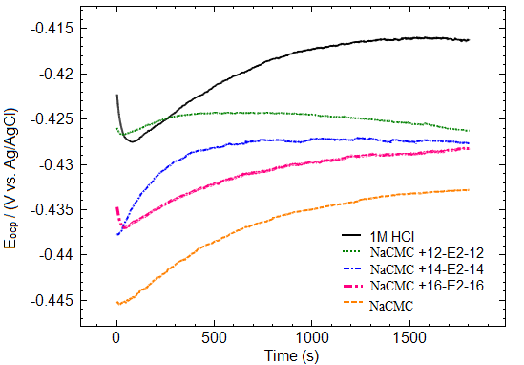
Fig. S1.
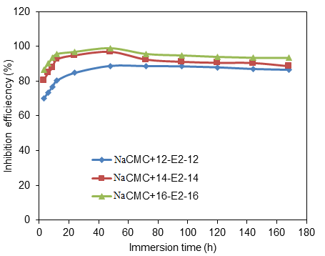
Fig. S2.

Fig. S3.

Fig. S4.

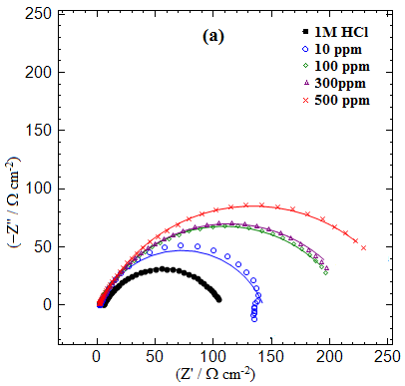 | 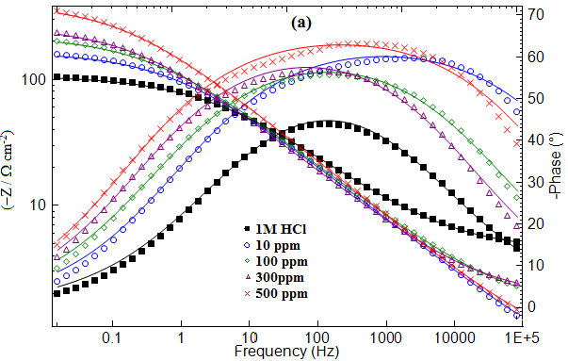
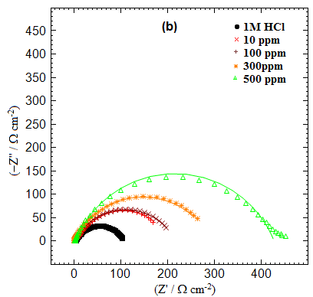 | 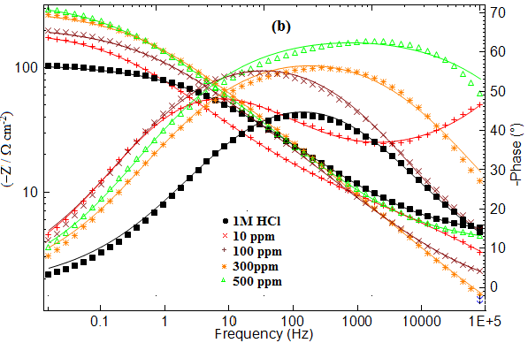
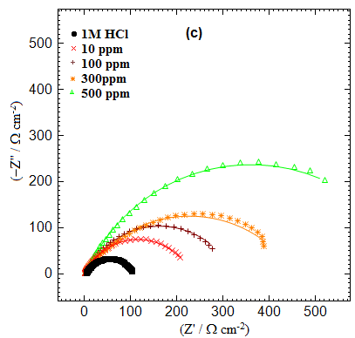 | 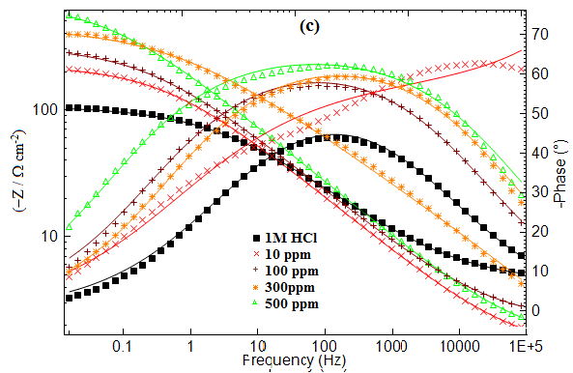
Fig. S5.
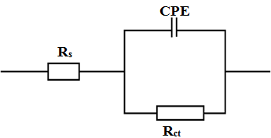
Fig. S6.
Fig. S7.

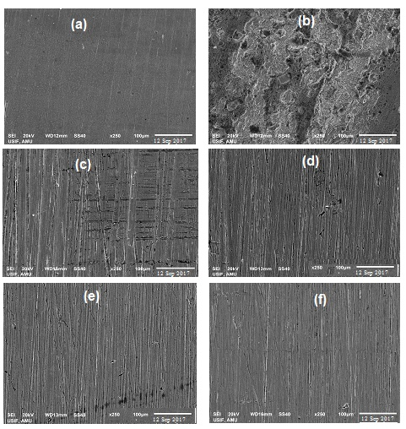
Fig. S8.

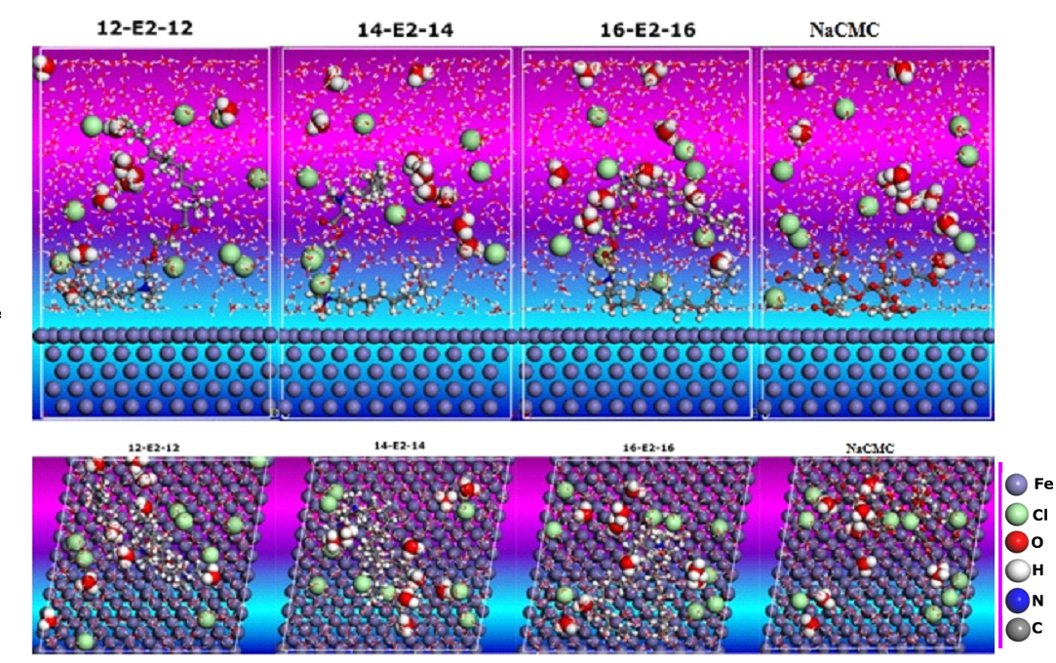

Fig. S9.

