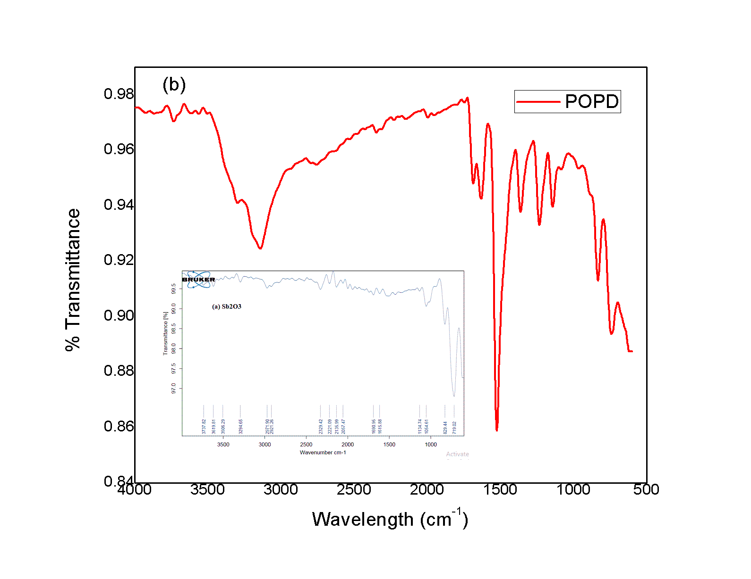



**Figure S1 FTIR spectra of (a) (Sb2O3 shown in inset) , (b) POPD and (c-f) POPD/Sb2O3 nanohybrids**



**Fig.S2 C/Co vs. time plot of IB drug degradation using 30%-POPD/Sb2O3 (inset shows 1/C vs. time plot)**

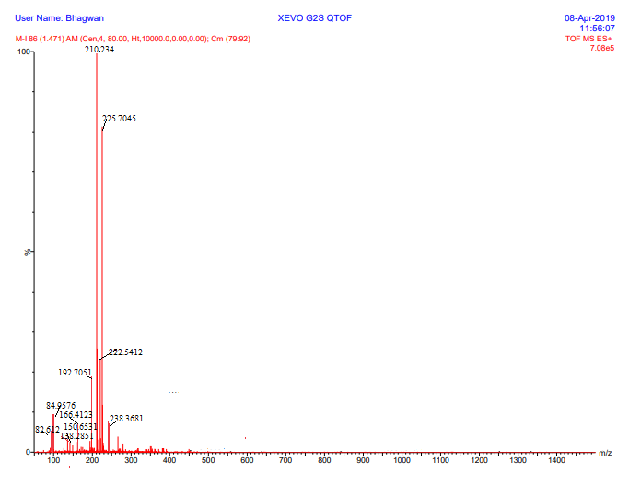

**Figure S3 LCMS profile of IB drug degraded using 24%- POPD/Sb2O3 retentiontime (20 min)**