**Supporting Information**

**Evaluating of the methylene blue removal on plasma activated palygorskites**

Heldeney Rodrigues de Sousaa, Lucinaldo dos Santos Silvab, Patrícia Alves de Abreu e Sousaa, Rômulo Ribeiro Magalhães de Sousac, Maria Gardênnia Fonsecad, Josy Anteveli Osajimaa, Edson Cavalcanti da Silva Filhoa,*

aInterdisciplinary Laboratory for Advanced Materials – LIMAV, UFPI, 64049-550, Teresina, PI, Brazil,

bFederal Institute of Maranhão, Açailândia Campus, IFMA, 65930-000, Maranhão, MA, Brazil,

cDepartment of Mechanics, [Federal Institute of Piauí, IFPI,](https://avs.scitation.org/action/doSearch?field1=Affiliation&text1=Federal%20Institute%20of%20Education&field2=AllField&text2=&Ppub=&Ppub=&AfterYear=&BeforeYear=&access=) 64000-040, Teresina, PI, Brazil and Department of Mechanical Engineering, Federal University of Piauí, UFPI, 64049-550, Teresina, PI, Brazil

dResearch and Extension Center - Fuel and Materials Laboratory (NPE – LACOM), Federal University of Paraíba, UFPB, 58051-900, João Pessoa, PB, Brazil

*Corresponding author: Tel/Fax: +55-86-32215710. E-mail: [edsonfilho@ufpi.edu.br](mailto:edsonfilho@ufpi.edu.br)

**Fig. S1.** Scheme of experimental setup, Ar – argon, H2 – hydrogen and N2 – nitrogen bottles, M1, M2 and M3 – mass flow controller, PV – pump vacuum, AE – air entrance, T- thermostate and VC – vacuum camera.

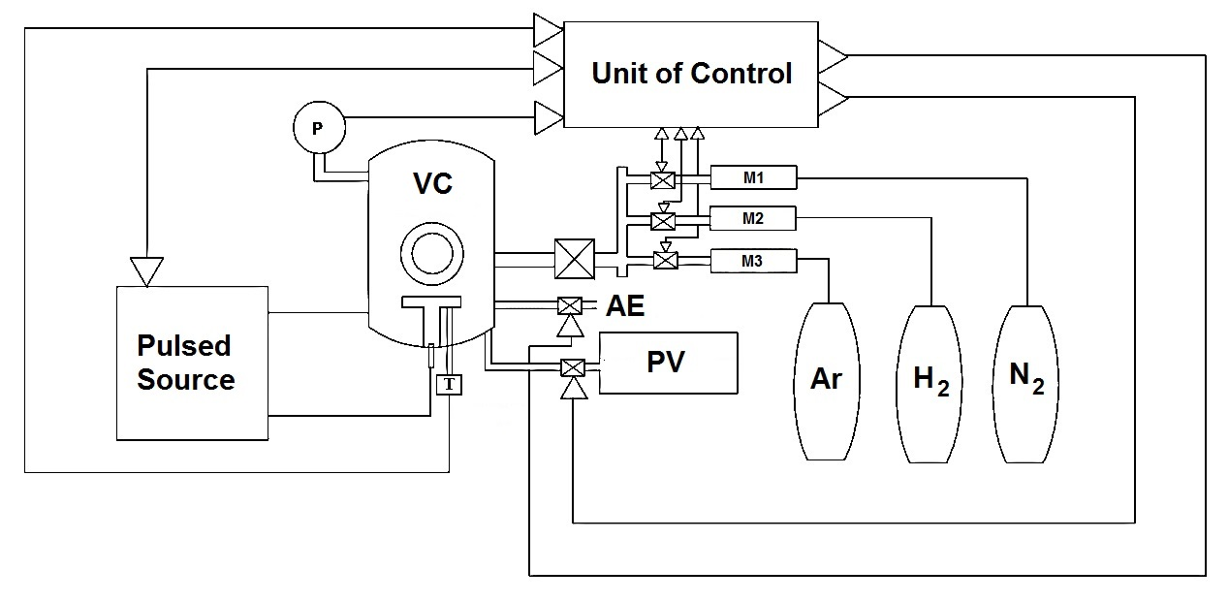

**Fig. S2.** X-ray dispersive energy spectra for the pristine and plasma activated palygorskites.

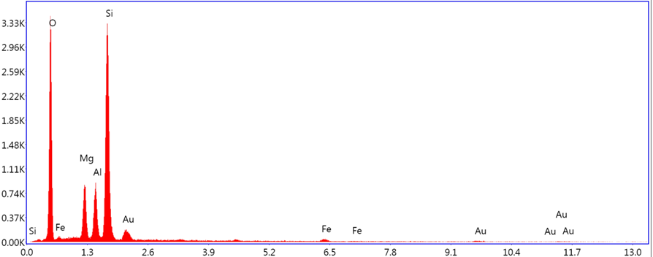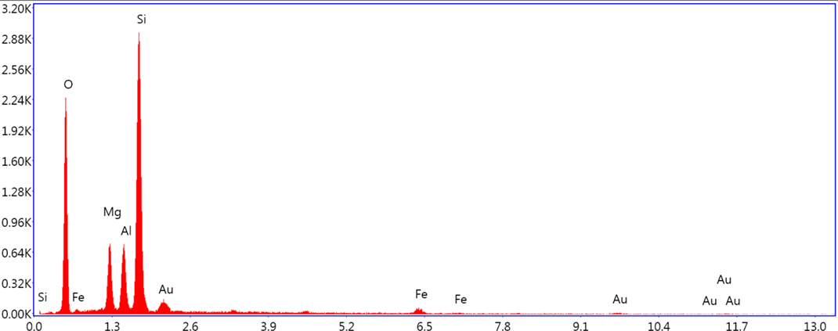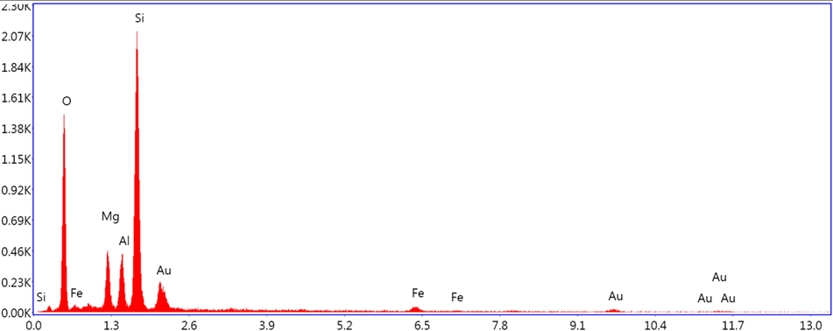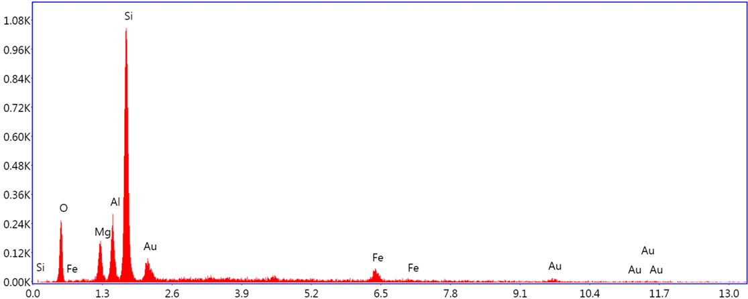

**PAL-6H**

**PAL-4H**

**PAL-2H**

**PAL-N**

|  |  |  |  |  |
| --- | --- | --- | --- | --- |
| **Fig. S3.** Effect of adsorbent mass (m) on MB adsorption for the pristine and plasma activated palygorskites.   |  |  | | --- | --- | |  |  | |  |  | |

**Fig. S4.** Effect of pH on MB adsorption by pristine and plasma activated palygorskites



**Fig. S5.** (a) Distribution of MB species at different pHs and (b) proposal for MB adsorption on the plasma activated palygorskites.

|  |  |
| --- | --- |
|  | |
| (1)    (2) | (3)    (4) |

**(**a)



(b)

**Fig. S6.** Linear fitting of the influence of time (t) on adsorption to the pseudo-first-order model for the methylene blue adsorption by PAL-N, PAL-2H, PAL-4H and PAL-6H.

|  |  |
| --- | --- |
|  |  |
|  |  |

**Fig. S7** Linear fitting of the influence of time (t) on adsorption to the pseudo-second-order model for the methylene blue adsorption by PAL-N, PAL-2H, PAL-4H and PAL-6H.

**PAL-4H**

|  |  |
| --- | --- |
|  |  |
|  |  |

**Fig. S8.** Linear fitting of the influence of time (t) on adsorption to intraparticle diffusion model for the methylene blue adsorption by PAL-N, PAL-2H, PAL-4H and PAL-6H.

|  |  |
| --- | --- |
|  |  |
|  |  |

**Fig. S9.** Linear fitting of the adsorption data to Langmuir model for the methylene blue adsorption by PAL-N, PAL-2H, PAL-4H and PAL-6H.

|  |  |
| --- | --- |
|  |  |
|  |  |

**Fig. S10.** Linear fitting of the adsorption data to Freundlich model for the methylene blue adsorption by PAL-N, PAL-2H, PAL-4H and PAL-6H.

|  |  |
| --- | --- |
|  |  |
|  |  |