Supplementary Information

Ultra-light and compressible 3D BiOCl/RGO aerogel with enriched synergistic effect of adsorption and photocatalytic degradation of oxytetracycline
Jing Zhang^{a,b}, Zongwu Wangª, Mengge Fanª, Peipei Tongª, Jingyu Sun^{c},
Shuying Dongª∗, Jianhui Sun^{a*}

ª School of Environment, Henan Normal University, Key Laboratory for Yellow River and Huai River Water Environmental and Pollution Control, Ministry of Education, Henan Key Laboratory for Environmental Pollution Control, Xinxiang, Henan 453007, PR China
^{b} Sanmenxia Polytechnic, Sanmenxia, Henan 472000, PR China
^{c}College of Energy, Soochow Institute for Energy and Materials InnovationS (SIEMIS), Key Laboratory of Advanced Carbon Materials and Wearable Energy Technologies of Jiangsu Province, Soochow University, Suzhou, Jiangsu 215006, PR China

1. Experimental Section
1.1 Materials
All the reagents were purchased from Aladdin and used as received without further purification. In addition to the use of ultra-pure water in HPLC, deionized water was used in throughout this study.
1.2 Characterization
The crystal phase of synthesized composites was analyzed by X-ray diffraction (XRD; Bruker-D8-AXS). The morphologies were inspected by field emission scanning electron microscope (FESEM; Zeiss SUPRA40) and Transmission electron microscopy (TEM; JEM-2100). Fourier transform infrared (FT-IR) spectra were detected on a FTIR Analyzer (NEXUS, Spectrum 400) with KBr as a reference sample. Raman spectra were recorded using a SPEX-1403 laser Raman spectrometer. X-ray photoelectron spectroscopy (XPS) was conducted by ESCALA-260Xi microprobe. Nitrogen adsorption-desorption was proceeded on a nitrogen adsorption apparatus (BEL, JAPAN) to determine the Brunauer-Emmett-Teller specific surface areas and pore volume.
The cyclic voltammetry measurement (CV) and electrochemical impedance spectroscopy (EIS) were conducted on the electrochemical system (Zahner, Germany) with a standard three-electrode cell with a working electrode, a platinum wire counter electrode, and a standard calomel electrode (SCE) reference electrode. PBS (0.5 M) was used as the electrolyte solution. CV was detected at the scan rate of 5 mv⋅s⁻¹ in the potential range between -0.2-0.3V. Electrochemical impedance spectroscopy (EIS) was carried out at the open-circuit potential; a sinusoidal ac perturbation of 5 mV was applied to the electrode over the frequency range 0.01 to 1 × 10⁵ Hz.

2. Results and disscussion

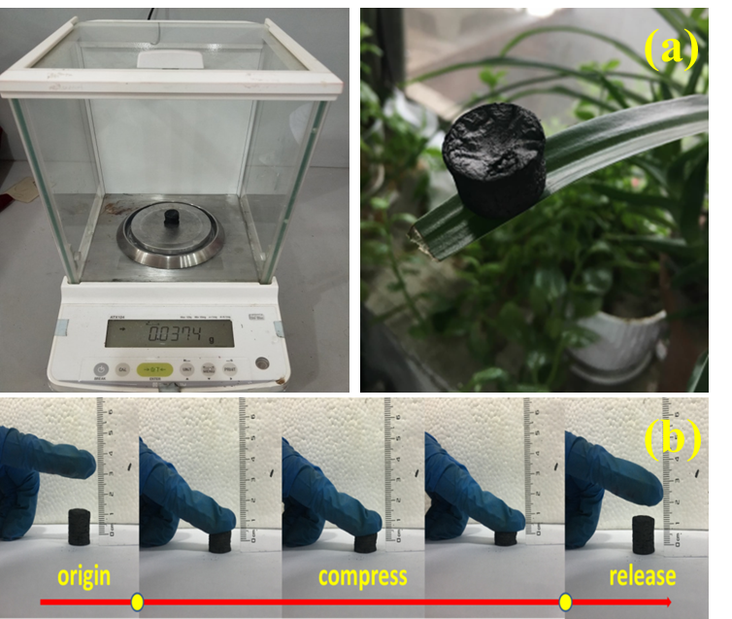

Fig S1. (a)The weight measurement processes for the 40% BGA with a density of 8.45 mg⋅cm⁻³ (37.4 mg in 4.42 cm⁻³). (b) Snapshots of BGA under compression and recovering process,

Table S1 Experimental content of Raman peaks
Sample | D peak | G peak | ID/IG
 | Positions(cm⁻¹) | Positions(cm⁻¹)
GO | 1344 | 1590 | 0.93
GA | 1346 | 1580 | 1.02
20% BGA | 1344 | 1588 | 1.17
40% BGA | 1340 | 1584 | 1.37
60% BGA | 1344 | 1587 | 1.15

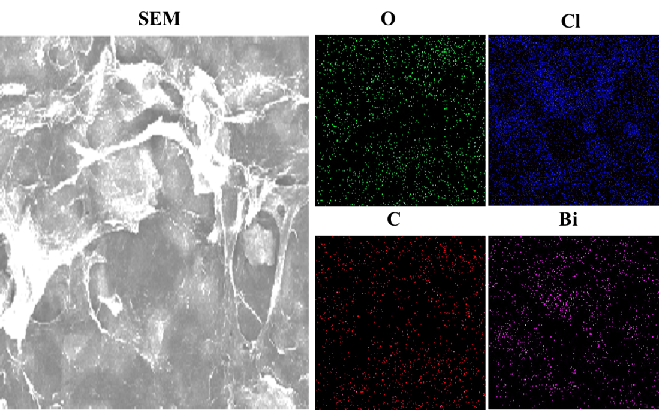
Fig. S2. Corresponding elemental mapping of 40% BGA

Fig S3 Degradation efficiencies of the different types dye and antibiotic-contained wastewater over 40% BGA;

Table S2 Comparison of various aerogels for simulated wastewater treatment
Hybrid materials | Synthesis method | Simulated wastewater | Degradation efficiency | Reference
Bi₂WO₆/graphene aerogel  graphene/PDI aerogel  graphene/Fe_{x}O_{y} /nitrogen-doped carbon layer aerogel  graphitic carbon nitride/reduced graphene  Ag/AgBr/g-C₃N₄@NGA  g-C₃N₄/GO aerogel  BiOBr/RGO aerogel  BiOCl/graphene aerogel | hydrothermal  low-  temperature hydrothermal  two-step  pyrolyzation  reduction self-assembly  hydrothermal  reduction self-assembly  two steps hydrothermal  hydrothermal | MB  40 mg⋅L⁻¹  Phenol  5 mg⋅L⁻¹  RhB  10 mg⋅L⁻¹  RhB  20 mg⋅L⁻¹  Methyl orange  10 mg⋅L⁻¹  BPA 10 mg⋅L⁻¹  Methyl orange  20 mg⋅L⁻¹  Methyl orange  10 mg⋅L⁻¹  RhB 10 mg⋅L⁻¹  OTC 20 mg⋅L⁻¹  RhB 20 mg⋅L⁻¹  CAP 10 mg⋅L⁻¹  SMM10 mg⋅L⁻¹ | 50.6%  92%  96%  95.2%  96%  92%  90%  80%  50%  93.3%  92.9%  79.1%  87.8% | [1]  [2]  [3]  [4]  [5]  [6]  [7]  This work

Reference
[1]Yang J J, Chen D M, Zhu Y, Zhang Y M and Zhu Y F. 3D-3D porous Bi₂WO₆/graphene hydrogel composite with excellent synergistic effect of adsorption-enrichment and photocatalytic degradation. Appl Catal B-Environ 2017;205:228-237.
[2]Yang J, Miao H, Wei Y X, Li W L and Zhu Y F. pi-pi Interaction between self-assembled perylene diimide and 3D graphene for excellent visible-light photocatalytic activity. Appl Catal B-Environ 2019;240:225-233.
[3]Yao T J, Jia W J, Feng Y, Zhang J S, Lian Y F, Wu J and Zhang X. Preparation of reduced graphene oxide nanosheet/Fe_{x}O_{y}/nitrogen-doped carbon layer aerogel as photo-Fenton catalyst with enhanced degradation activity and reusability. J Hazard Mater 2019;362:62-71.
[4]Xu C, Wang J, Gao B, Dou M and Chen R. Synergistic adsorption and visible-light catalytic degradation of RhB from recyclable 3D mesoporous graphitic carbon nitride/reduced graphene oxide aerogels. J Mater Sci 2019;
[5]Chen Y X, Wang P L, Liang Y, Zhao M J, Jiang Y Y, Wang G T, Zou P, Zeng J, Zhang Y S and Wang Y. Fabrication of a three-dimensional porous Z-scheme silver/silver bromide/graphitic carbon nitride@nitrogen-doped graphene aerogel with enhanced visible-light photocatalytic and antibacterial activities. J Colloid Interf Sci 2019;536:389-398.
[6]Tang L, Jia C T, Xue Y C, Li L, Wang A Q, Xu G, Liu N and Wu M H. Fabrication of compressible and recyclable macroscopic g-C₃N₄/GO aerogel hybrids for visible-light harvesting: A promising strategy for water remediation. Appl Catal B-Environ 2017;219:241-248.
[7]Yu X, Shi J J, Feng L J, Li C H and Wang L. A three-dimensional BiOBr/RGO heterostructural aerogel with enhanced and selective photocatalytic properties under visible light. Appl Surf Sci 2017;396:1775-1782.

∗ Corresponding authors E-mail addresses: shidashuying@163.com (S. Dong), sunjhhj@163.com (J. Sun).

