Enhanced interfacial strength of carbon fiber/PEEK composites using a facile approach via PEI&ZIF-67 synergistic modification
(Appendix A. Supplementary data)
Hansong Liu, Yan Zhao*, Na Li, Xiaoran Zhao, Xiao Han, Shuang Li, Wenkuo Lu, Kai Wang*, Shanyi Du
School of Materials Science and Engineering, Beihang University, Beijing 100191, China
*Corresponding Author: jennyzhaoyan@buaa.edu.cn, wangkai@buaa.edu.cn

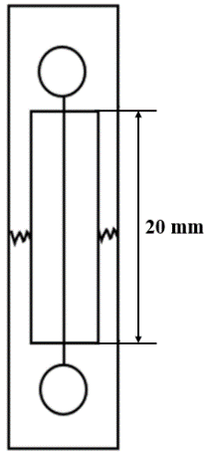
Fig. A.1 - Schematic illustration of single fiber tensile test sample.

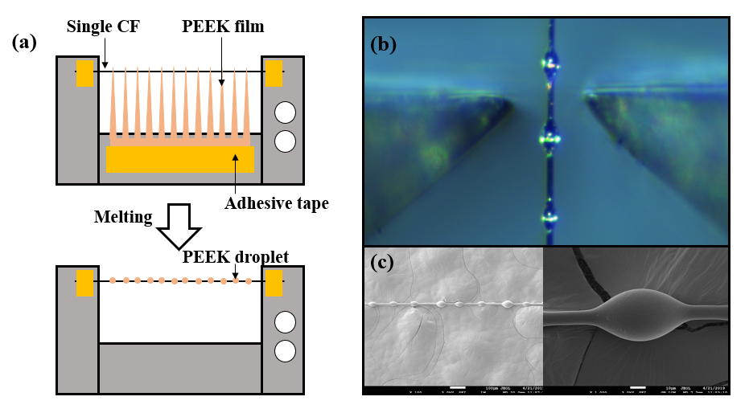
Fig. A.2 - (a) Schematic illustration of the microbond test sample, (b) microbond test process, (c) SEM images of PEEK droplets.

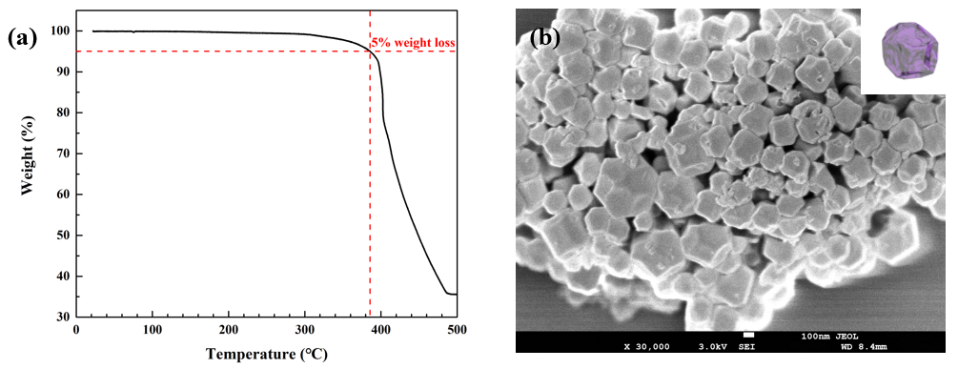
Fig. A.3 - (a) TGA curves of ZIF-67 in air; (b) SEM image of ZIF-67 under thermal treatment.

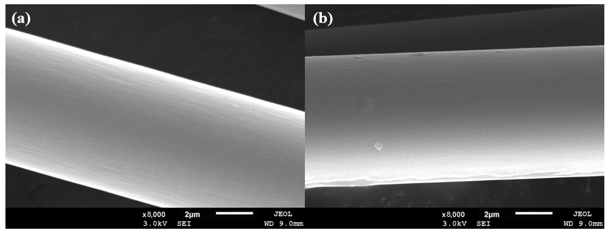
Fig. A.4 - SEM images of PEI sizing CF (without ZIF-67) at PEI concentration of (a) 0.010 g/ml, (b) 0.025 g/ml.

Tensile strength of single CF
The two-parameter Weibull equation [1,2] is used to describe the statistical distribution of fiber strengths.
$P_{f\left(L\right)}=1-exp⁡\left[-L{(\frac{σ}{σ_{0}})}^{w }\right]$ (A.1)
with $P_{f\left(L\right)}$, the probability of failure of a fiber and$σ$, the failure stress. $σ_{0}$ is the Weibull scale parameter or characteristic stress, and w is the shape parameter or Weibull modulus which describes the variability of the failure strength. L is the length of fiber [3].
After rearrangement and simple linear regression, $\overline{σ}$ (average tensile strength) of single CF can be determined through the equation:
$\overline{σ}=σ_{0}L^{-1/w}Г\left(1+\frac{1}{w}\right)$ (A.2)
where $Г$ is gamma function.
As a kind of brittle materials, CF tensile strength was controlled by various defects, including surface defects and internal defects. These defects may be caused from protofilaments or manufacturing processes. CF defects were randomly distributed and showed polydispersity [4]. Hence the two-parameter Weibull equation is used to describe the statistical distribution of fiber strengths. Tensile strength data of single bare CF and single CF-PEI&ZIF (c_{PEI} = 0.010 g/ml) were measured respectively. Fig. A.5 illustrated that tensile strength data of CF and CF-PEI&ZIF were in accord with Weibull distribution. As shown in Table A.1, tensile strength of single CF increased slightly from 4369.92 MPa to 4411.92 MPa, which illustrated that as-proposed interfacial modification method could maintain the single fiber tensile strength because the surface flaws were healed and the microcrack initiation was inhibited. Compared to other surface treatments of CF surface such as oxidation treatments and plasma treatments [5] which observably decreases tensile strength taken by fabric tows, the method of thermoplastic resin sizing provides high-quality coating without serious deterioration of fiber, which shows huge potentials in many applied fields and conditions requiring superior material performance.
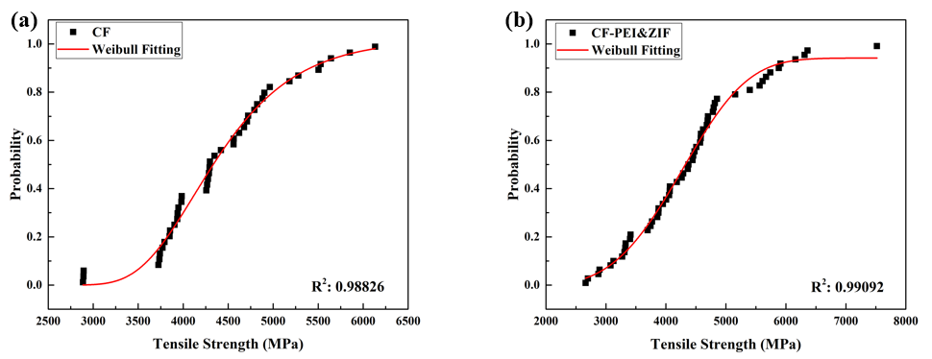
Fig. A.5 - Weibull plots of (a) CF, (b) CF-PEI&ZIF.
Table A.1 - Tensile strength of single CF and CF-PEI&ZIF.
Samples | Tensile strength of single CF / MPa
CF | 4396.62
CF-PEI&ZIF | 4411.92

References
[1] Weibull W. A statistical theory of strength of materials. R Swedish Inst Eng Res 1939:1-45.
[2] Weibull W. A statistical distribution function of wide applicability. J Appl Mech 1951;18:293-7.
[3] Pickering KL, Murray TL. Weak link scaling analysis of high-strength carbon fibre. Compos Part A 1999;30:1017-21.
[4] Chand S. Review carbon fibers for composites. J Mater Sci 2000;35(6):1303-13.
[5] Tiwari S, Bijwe J. Surface treatment of carbon fibers-a review. Procedia Technology 2014;14:505-12.

