**Electronic Supplementary Information**

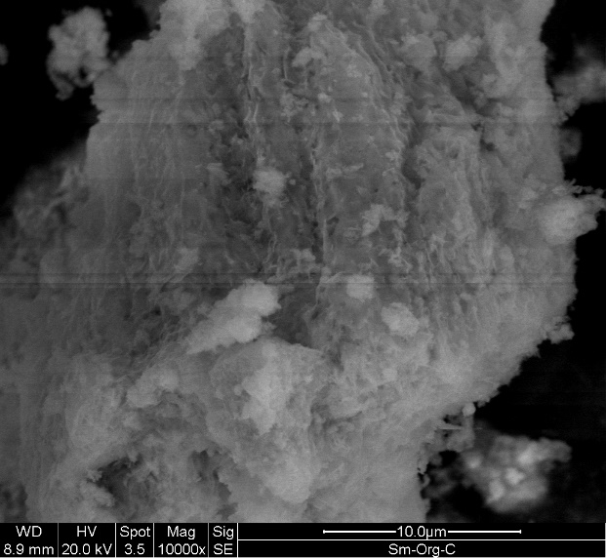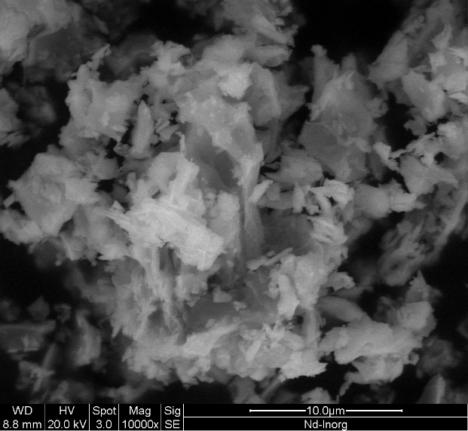

**Ho-inorg**

**100nm**

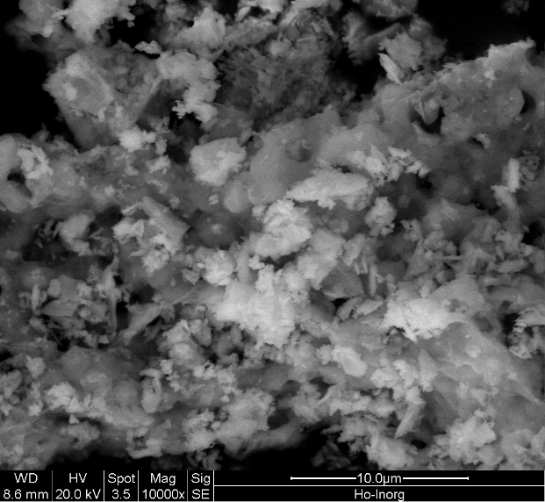

**Nd-inorg**

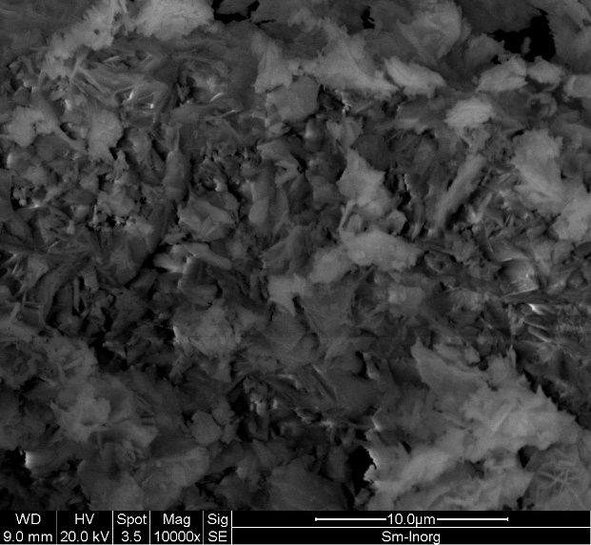

**Sm-org**

**100nm**

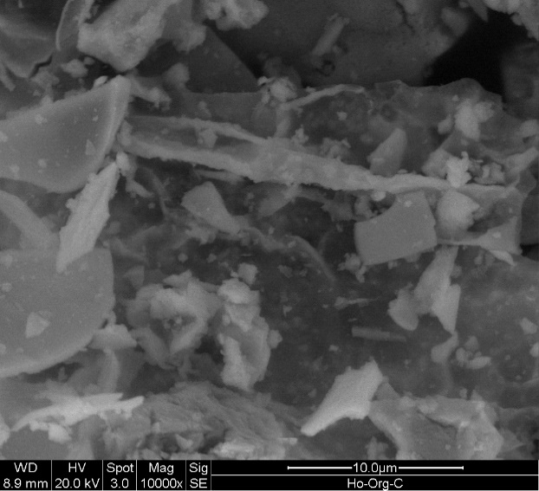

**Sm-inorg**

**100nm**

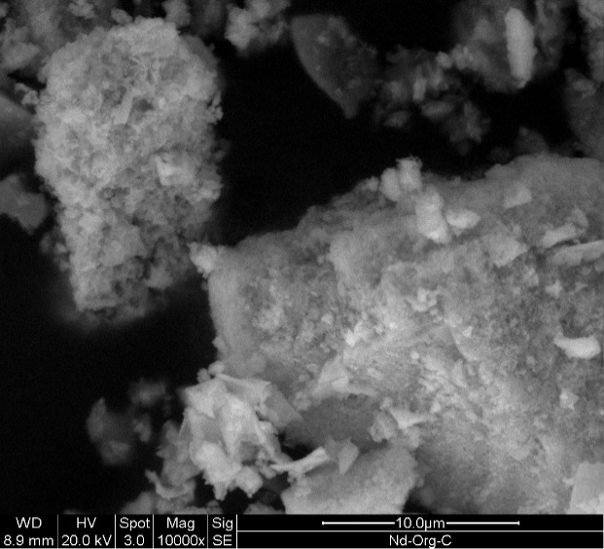

**Nd-org**

**100nm**

**Ho-org**

**100nm**

**100nm**

**Fig. S1:** SEM images of synthesized rare earth oxides using organic and inorganic routes.

 

 



**Fig. S2:** Tauc plots for synthesized rare earth oxides using organic and inorganic routes.