Supplementary material

Supplementary table 1. Diagnoses of subjects with premature acute cardiovascular disease attended to in the Hospital Universitario Miguel Servet (Zaragoza, Spain) between October 1, 2017 and September 30, 2018 (n=367).

Type of event | n (%)
ST-Elevation Myocardial Infarction (STEMI) | 145 (55.8)
Non-ST Elevation Myocardial Infarction (NSTEMI) | 48 (13.1)
Coronary artery dissection | 3 (0.8)
Coronary vasospasm | 1 (0.3)
Subarachnoid hemorrhage-brain aneurysm complication | 50 (13.6)
Cerebral arteriovenous fistula | 4 (1.1)
Cerebral vasospasm | 2 (0.5)
Carotid artery dissection | 1 (0.3)
Atherothrombotic stroke | 48 (13.1)
Cardioembolic stroke | 12 (3.3)
Lacunar stroke | 7 (1.9)
Transitory ischemic attack | 7 (1.9)
Peripheral artery disease | 18 (4.9)
Aortic dissection/aneurysm | 13 (3.5)
Carotid artery stenosis without cerebral infarction | 8 (2.2)

Supplementary figure 1. Flow chart for selecting subjects included in the study.

520 hospitalizations for premature cardiovascular disease according to ICD codes
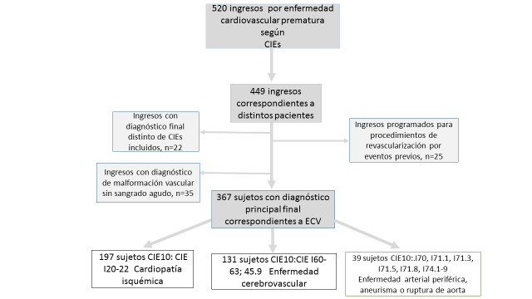
Hospitalizations with a diagnosis of vascular malformation without acute bleeding, n=35
Hospitalizations with a final diagnosis different from the ICD codes included, n=22
39 subjects with ICD 10: I70, I71.1, I71.3, I71.5, I71.8, I74.1-9 Peripheral artery disease, aneurysm, or aortic rupture
131 subjects with ICD 10: ICD I60-63; 45.9 Cerebrovascular disease
197 subjects with ICD 10: ICD I20-22 Ischemic heart disease
367 subjects with a final principal diagnosis of a CVE
Scheduled hospitalizations for revascularization procedures due to previous events, n=25
449 hospitalizations corresponding to different patients

