Appendix – Figures

Appendix figure 1. Evolution of clinical and laboratory test values upon hospital admission according to days elapsed from symptoms onset to hospital admission.

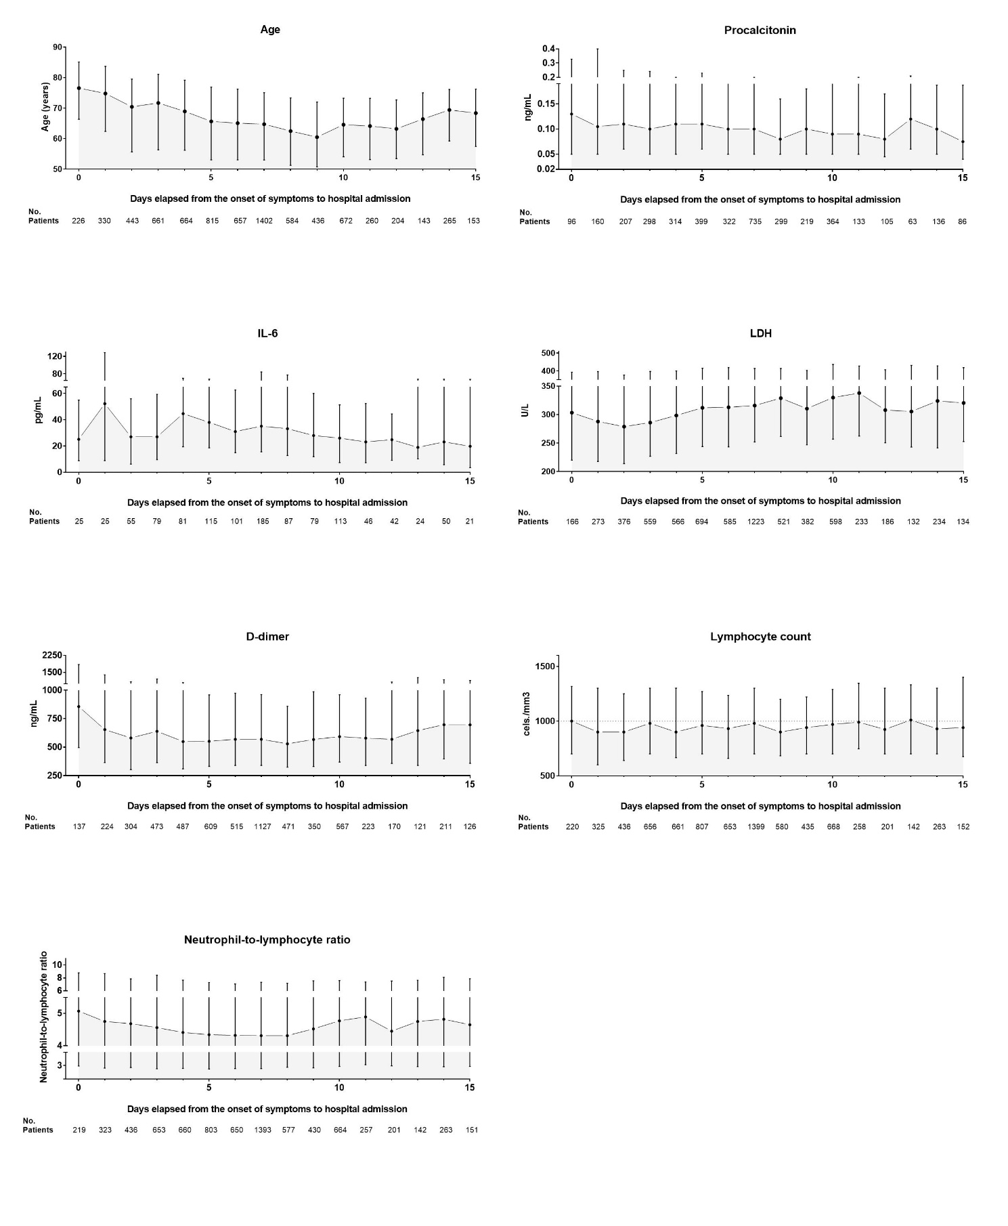

Appendix figure 2. Random Forest plot.

AST = Aspartate aminotransferase; CRP = C-reactive protein; CV = cardiovascular; eGFR (CKD-EPI) = estimated glomerular filtration rate measured using the Chronic Kidney Disease Epidemiology Collaboration equation; LDH = Lactate dehydrogenase; Neut.-to-lymph. ratio = Neutrophil-to-lymphocyte ratio; SpO2/FiO2 = Oxygen saturation to fraction of inspired oxygen ratio.
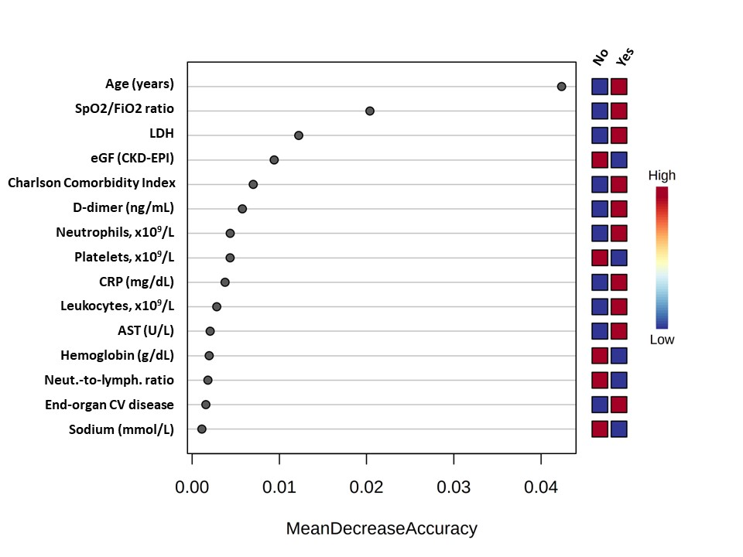

Appendix – Tables
Appendix
table 1. Relevant drugs received during hospitalization
 | Total  (n = 7915) | Early-presenting  (n = 2324) | Late-presenting  (n = 5591) | p
LPVr, no./total no. (%) | 5371/7855 (68.4) | 1432/867 (62.3) | 3939/5556 (70.9) | < .001
Remdesivir, no./total no. (%) | 42/7781 (0.5) | 8/2280 (0.4) | 34/5501 (0.6) | .143
Immunotherapies (tocilizumab, anakinra, or both), no./total no. (%) | 801/7734 (10.4) | 197/2256 (8.7) | 604/5478 (11.0) | .003
Tocilizumab | 782/7832 (10.0) | 191/2293 (8.9) | 591/5539 (10.7) | .002
Anakinra | 41/7735 (0.5) | 10/2256 (0.4) | 31/5479 (0.6) | .500
Corticosteroids, no./total no. (%) | 2684/7825 (34.3) | 770/2290 (33.6) | 1914/5535 (34.6) | .418
Hydroxychloroquine, no./total no. (%) | 7019/7869 (89.2) | 1957/2307 (84.8) | 5062/5562 (91.0) | < .001
Anticoagulants (oral anticoagulants or LMWH), no./total no. (%) | 6606/7756 (85.2) | 5024/5926 (84.8) | 1582/1830 (86.4) | .079
Oral anticoagulants¹ | 222/7810 (2.8) | 88/2287 (3.8) | 134/5523 (2.4) | .001
LMWH² | 6621/7810 (84.8) | 1884/2282 (82.6) | 4737/5528 (85.7) | .001
LPVr = Lopinavir/Ritonavir; LMWH = low-molecular-weight heparin
¹ Either vitamin K antagonists or direct oral anticoagulants.
² Either at a prophylactic or anticoagulant dose.

Appendix
table 2. Outcomes during and after hospitalization
 | Total  (n = 7915) | Early-presenting  (n = 2324) | Late-presenting  (n = 5591) | p
In-hospital mortality, no./total no. (%) | 1237/7915 (15.6) | 508/2324 (21.9) | 729/5591 (13.0) | < .001
Moderate or severe acute respiratory distress syndrome (SpO2/FiO2 < 235 or PaO2/FiO2 < 200), no./total no. (%) | 1817/7858 (23.1) | 611/2304 (26.5) | 1206/5554 (21.7) | < .001
Intensive care unit admission, no./total no. (%) | 732/7902 (9.3) | 205/2318 (8.8) | 527/5584 (9.4) | .407
Length of hospital stay (days), median (IQR) | 9 (6-14)  7915 | 9 (6-15)  2324 | 9 (6-13)  5591 | < .001

Appendix table 3. Univariate Cox regression analysis of in-hospital mortality
 | HR | Lower limit  (CI 95%) | Upper limit  (CI 95%) | p
Baseline characteristics of patients hospitalized with COVID-19
Days elapsed from the onset of symptoms to hospital admission | 0.935 | 0.920 | 0.950 | < .001
Age (each year) | 1.077 | 1.071 | 1.082 | < .001
Sex (male) | 1.319 | 1.171 | 1.485 | < .001
BMI | 1.028 | 1.013 | 1.043 | < .001
Current smoker | 1.013 | 0.789 | 1.302 | .917
Race
Caucasian | 2.756 | 2.122 | 3.580 | < .001
Hispanic | 0.382 | .287 | .508 | < .001
African | 0.270 | 0.067 | 1.080 | .018
Asian | 0.440 | 0.142 | 1.365 | .100
Charlson Comorbidity Index score | 1.198 | 1.171 | 1.226 | < .001
Charlson Comorbidity Index ≥ 1 | 2.396 | 2.116 | 2.714 | < .001
Functional status, moderately dependent | 3.240 | 2.781 | 3.774 | < .001
Hypertension | 2.397 | 2.122 | 2.707 | < .001
Any vascular disease (coronary artery disease, stroke or TIA, or PAD) | 2.030 | 1.784 | 2.310 | < .001
Coronary artery disease² | 2.048 | 1.743 | 2.406 | < .001
Previous stroke or transient ischemic attack | 1.791 | 1.465 | 2.190 | < .001
Peripheral artery disease | 2.107 | 1.714 | 2.590 | < .001
Congestive heart failure | 2.519 | 2.123 | 2.989 | < .001
Atrial fibrillation | 2.299 | 1.983 | 2.664 | < .001
Diabetes mellitus | 1.715 | 1.514 | 1.943 | < .001
Diabetes with diabetes-related complications | 2.153 | 1.774 | 2.613 | < .001
Insulin-dependent diabetes | 1.886 | 1.549 | 2.297 | < .001
COPD | 2.161 | 1.846 | 2.530 | < .001
Asthma | 0.770 | 0.615 | 0.963 | .018
Obstructive sleep apnea | 1.184 | .968 | 1.449 | .109
Chronic kidney disease | 2.494 | 2.096 | 2.966 | < .001
Advanced chronic kidney disease | 2.526 | 2.123 | 3.006 | < .001
Patient on dialysis | 1.739 | 1.118 | 2.706 | .024
Chronic liver disease (any stage) | 1.436 | 1.118 | 1.843 | .005
Advanced chronic liver disease | 1.411 | .874 | 2.278 | .182
Malignancy | 1.816 | 1.562 | 2.112 | < .001
Solid tumor | 1.685 | 1.425 | 1.992 | < .001
Metastatic solid tumor | 1.577 | 1.148 | 2.166 | .005
Blood cancer | 2.060 | 1.556 | 2.726 | < .001
HIV infection | 0.686 | 0.326 | 1.443 | .290
Systemic rheumatic diseases | 1.544 | 1.146 | 2.080 | .004
Solid organ transplantation | 1.569 | 1.064 | 2.315 | .034
Chronic use of glucocorticoids | 2.146 | 1.761 | 2.615 | < .001
Chronic use of anticoagulants | 2.529 | 2.199 | 2.908 | < .001
Chronic use of antiplatelet therapy | 1.947 | 1.708 | 2.219 | < .001
Chronic use of statins | 1.668 | 1.490 | 1.868 | < .001
Chronic use of ACE inhibitors | 1.664 | 1.460 | 1.896 | < .001
Chronic use of ARBs | 1.478 | 1.304 | 1.674 | < .001
Symptoms, vital signs, and laboratory tests at admission
Dyspnea | 1.672 | 1.478 | 1.892 | < .001
Cough | 0.763 | .672 | .867 | < .001
Anosmia or dysgeusia | 0.318 | .220 | .461 | < .001
Arthralgia or myalgia | 0.549 | .479 | .629 | < .001
Headache | .441 | .348 | .558 | < .001
Abdominal pain | 1.024 | .817 | 1.283 | 0.838
Diarrhea | .702 | .608 | .810 | < .001
Crackles | 1.511 | 1.341 | 1.703 | < .001
Wheezing | 1.626 | 1.342 | 1.971 | < .001
Vital signs (no./total no. (%) or median (IQR))
Temperature on admission | 1.059 | 0.999 | 1.122 | 0.550
Systolic blood pressure | 1.000 | 0.998 | 1.003 | 0.784
Heart rate | 0.999 | 0.996 | 1.003 | 0.704
Altered mental status | 3.397 | 2.940 | 3.925 | < .001
Respiratory rate ≥ 20 breaths/min | 2.571 | 2.293 | 2.883 | < .001
SpO2/FiO2 | 0.995 | 0.995 | 0.996 | < .001
qSOFA ≥ 2 | 3.385 | 2.903 | 3.947 | < .001
Admission studies (no./total no. (%) or median (IQR))
Lymphocyte count, x 10⁹/L | 0.990 | 0.961 | 1.019 | 0.489
Neutrophil count, x 10⁹/L | 1.034 | 1.028 | 1.039 | < .001
Neutrophil-to-lymphocyte ratio | 1.008 | 1.007 | 1.010 | < .001
Platelet count, x 10⁹/L | 0.998 | 0.998 | 0.999 | < .001
Hemoglobin, g/dL | 0.887 | 0.861 | 0.913 | < .001
Sodium (mmol/L) | 0.985 | 0.971 | 0.999 | 0.033
Creatinine (mg/dL) | 1.330 | 1.285 | 1.375 | < .001
eGFR (CKD-EPI) | 0.972 | 0.970 | 0.974 | < .001
LDH (U/L) | 1.001 | 1.001 | 1.001 | < .001
AST (U/L) | 1.001 | 1.001 | 1.002 | < .001
ALT (U/L) | 0.999 | 0.998 | 1.001 | 0.197
AST/ALT ratio | 1.257 | 1.219 | 1.296 | < .001
Creatine kinase (U/L) | 1.000 | 1.000 | 1.000 | 0.211
Venous lactate > 2 mmol/L | 1.480 | 1.259 | 1.741 | < .001
Procalcitonin (ng/mL) | 1.217 | 1.171 | 1.264 | < .001
Ferritin (ng/mL) | 1.000 | 1.000 | 1.000 | < .001
CRP (mg/dL) | 1.038 | 1.033 | 1.043 | < .001
Interleukin 6 (pg/mL) | 1.001 | 1.000 | 1.001 | 0.027
D-dimer (ng/mL) | 1.000 | 1.000 | 1.000 | < .001
Fibrinogen (mg/dL) | 1.000 | 1.000 | 1.000 | 0.592
Activated partial thromboplastin time (s) | 1.012 | 1.008 | 1.017 | < .001
Lung infiltrates on chest x-ray | 1.395 | 1.133 | 1.718 | 0.002
ACE = Angiotensin-converting enzyme; ARB = Angiotensin II receptor blocker; BMI = Body mass index, calculated as the ratio of weight (kg)/height² (m); COPD = Chronic obstructive pulmonary disease; HIV = Human immunodeficiency virus.

