Supplemental Digital Content 1: Pediatric Sequential Organ Failure Assessment (pSOFA) score
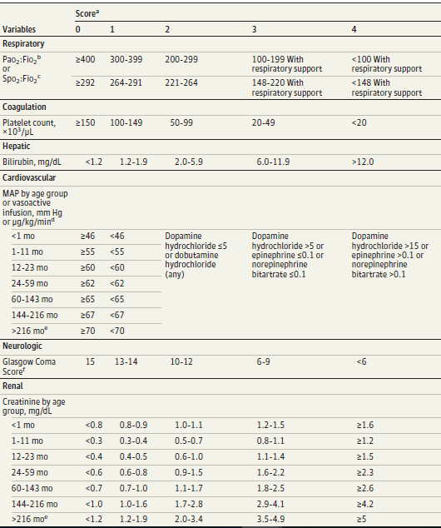

Matics TJ, Sanchez-Pinto LN. Adaptation and Validation of a Pediatric Sequential Organ Failure Assessment Score and Evaluation of the Sepsis-3 Definitions in Critically Ill Children. JAMA Pediatr. 2017; 171(10):e172352.

