Annex 1. Ranking of most referred Marketing journals per number of articles
Journal title | Nr. of articles
Business Horizons | 13
Journal of Business Research | 11
Journal of Retailing and Consumer Services | 9
Electronic Commerce Research and Applications | 8
Industrial Marketing Management | 7
Journal of Interactive Marketing | 7
Journal of Destination Marketing Management | 7
International Journal of Research in Marketing | 5
International Journal of Forecasting | 5
Australasian Marketing Journal | 4
Public Relations Review | 4
Journal of Consumer Psychology | 2
International Business Review | 2

Annex 2. Number of articles per year
 | 2010 | 2011 | 2012 | 2013 | 2014 | 2015 | Total
Nr. | 48 | 61 | 92 | 168 | 393 | 798 | 1560

Annex 3. Number of articles per Continent and year by Products
Continents\  Products | 2010 |  | 2011 |  | 2012 |  | 2013 |  | 2014 |  | 2015
 | services | goods | services | goods | services | goods | services | goods | services | goods | services | goods
Europe | 26 | 27 | 24 | 26 | 44 | 47 | 83 | 83 | 172 | 187 | 354 | 369
North America | 15 | 15 | 25 | 24 | 35 | 35 | 58 | 58 | 132 | 138 | 203 | 216
Asia | 11 | 12 | 18 | 20 | 25 | 27 | 54 | 56 | 134 | 140 | 323 | 334
Oceania | 1 | 1 | 7 | 7 | 5 | 5 | 15 | 15 | 30 | 31 | 61 | 64
South America | 2 | 2 | 1 | 1 | 2 | 3 | 3 | 3 | 10 | 10 | 13 | 14
Africa | 0 | 0 | 1 | 2 | 1 | 1 | 0 | 0 | 4 | 4 | 8 | 9
Central America and Caribbean | 1 | 1 | 0 | 0 | 1 | 1 | 1 | 1 | 0 | 1 | 0 | 0

Annex 4. Frequency of Top 5 Big Data terms per year by Products
Nr | Term\Products | 2010 |  | 2011 |  | 2012 |  | 2013 |  | 2014 |  | 2015
 |  | services | goods | services | goods | services | goods | services | goods | services | goods | services | goods
1 | architecture | 1397 | 1400 | 1338 | 1371 | 1413 | 1478 | 4154 | 4162 | 7018 | 7103 | 14446 | 14544
2 | analytics | 335 | 342 | 1035 | 1062 | 1614 | 1693 | 2100 | 2122 | 5642 | 6166 | 11042 | 11552
3 | algorithm | 196 | 215 | 545 | 534 | 669 | 724 | 1083 | 1089 | 2283 | 2676 | 4812 | 5189
4 | Big Data | 46 | 47 | 56 | 56 | 85 | 91 | 396 | 399 | 1784 | 1825 | 4631 | 4663
5 | prediction | 54 | 56 | 220 | 230 | 254 | 255 | 319 | 358 | 1591 | 1896 | 3082 | 3538

Annex 5. Number of articles per year by Sector
Sectors\Year | 2010 | 2011 | 2012 | 2013 | 2014 | 2015
basic materials | 7 | 9 | 12 | 24 | 42 | 103
consumer goods | 34 | 39 | 60 | 120 | 280 | 565
energy | 16 | 19 | 26 | 50 | 125 | 294
financials | 15 | 30 | 41 | 81 | 171 | 374
healthcare | 34 | 40 | 61 | 105 | 257 | 525
industrials | 23 | 32 | 48 | 89 | 202 | 403
technology | 48 | 58 | 88 | 162 | 378 | 764
telecommunications | 17 | 16 | 31 | 73 | 147 | 275
tourism | 13 | 24 | 34 | 62 | 151 | 285
utilities | 9 | 10 | 16 | 32 | 98 | 180

Annex 6. Frequency of Top 5 Big Data terms per year by Sectors
Nr. | basic materials | 2010 | 2011 | 2012 | 2013 | 2014 | 2015
1 | analytics | 60 | 343 | 126 | 576 | 1022 | 1807
2 | architecture | 77 | 170 | 207 | 483 | 560 | 473
3 | machine learning | 76 | 192 | 85 | 67 | 191 | 803
4 | algorithm | 55 | 195 | 45 | 186 | 308 | 588
5 | prediction | 16 | 16 | 26 | 169 | 167 | 681
Nr. | consumer goods | 2010 | 2011 | 2012 | 2013 | 2014 | 2015
1 | architecture | 1071 | 1135 | 1070 | 2708 | 5255 | 10189
2 | analytics | 221 | 711 | 804 | 1552 | 4566 | 8796
3 | algorithm | 136 | 417 | 372 | 702 | 1738 | 3092
4 | Big Data | 33 | 39 | 66 | 332 | 1624 | 3924
5 | prediction | 37 | 205 | 143 | 176 | 1207 | 2715
Nr. | energy | 2010 | 2011 | 2012 | 2013 | 2014 | 2015
1 | architecture | 556 | 772 | 489 | 1583 | 3730 | 7061
2 | analytics | 146 | 370 | 639 | 777 | 1818 | 4484
3 | algorithm | 102 | 246 | 224 | 348 | 924 | 1608
4 | prediction | 32 | 174 | 67 | 151 | 1054 | 1170
5 | Big Data | 17 | 11 | 20 | 107 | 493 | 1953
Nr. | financials | 2010 | 2011 | 2012 | 2013 | 2014 | 2015
1 | architecture | 677 | 861 | 663 | 1940 | 3193 | 6374
2 | analytics | 90 | 614 | 904 | 1068 | 2552 | 5370
3 | Big Data | 9 | 29 | 49 | 272 | 1246 | 2638
4 | prediction | 15 | 190 | 215 | 211 | 834 | 2398
5 | algorithm | 29 | 276 | 105 | 265 | 769 | 1463
Nr. | healthcare | 2010 | 2011 | 2012 | 2013 | 2014 | 2015
1 | architecture | 1106 | 1017 | 1168 | 2759 | 5557 | 10305
2 | analytics | 288 | 727 | 1427 | 1616 | 4264 | 8634
3 | algorithm | 205 | 354 | 589 | 815 | 2019 | 3811
4 | Big Data | 33 | 40 | 46 | 256 | 1448 | 3464
5 | prediction | 50 | 214 | 138 | 298 | 1726 | 2808
Nr. | industrials | 2010 | 2011 | 2012 | 2013 | 2014 | 2015
1 | architecture | 869 | 867 | 845 | 2553 | 3796 | 8285
2 | analytics | 144 | 850 | 959 | 1351 | 3597 | 5926
3 | algorithm | 77 | 360 | 344 | 720 | 1487 | 2427
4 | prediction | 33 | 66 | 200 | 284 | 1141 | 2334
5 | Big Data | 22 | 42 | 41 | 156 | 1053 | 2556
Nr. | technology | 2010 | 2011 | 2012 | 2013 | 2014 | 2015
1 | architecture | 1400 | 1371 | 1470 | 4148 | 7087 | 14505
2 | Analytics | 342 | 1029 | 1622 | 2098 | 5893 | 11140
3 | Algorithm | 215 | 550 | 709 | 1185 | 2552 | 4961
4 | Big data | 47 | 56 | 89 | 393 | 1811 | 4637
5 | prediction | 56 | 222 | 255 | 393 | 1659 | 3329
Nr. | telecommunications | 2010 | 2011 | 2012 | 2013 | 2014 | 2015
1 | architecture | 739 | 363 | 769 | 1419 | 3845 | 6410
2 | analytics | 148 | 248 | 230 | 807 | 1871 | 3780
3 | Big Data | 22 | 8 | 26 | 155 | 1050 | 2125
4 | algorithm | 88 | 102 | 67 | 343 | 959 | 1262
5 | prediction | 7 | 7 | 50 | 103 | 590 | 700
Nr. | tourism | 2010 | 2011 | 2012 | 2013 | 2014 | 2015
1 | architecture | 469 | 732 | 576 | 1160 | 3239 | 5356
2 | analytics | 60 | 572 | 734 | 731 | 2188 | 3594
3 | Big Data | 15 | 20 | 25 | 185 | 1026 | 2207
4 | prediction | 11 | 23 | 62 | 130 | 983 | 2007
5 | algorithm | 8 | 225 | 116 | 207 | 726 | 952
Nr. | utilities | 2010 | 2011 | 2012 | 2013 | 2014 | 2015
1 | architecture | 240 | 269 | 248 | 755 | 2280 | 3685
2 | analytics | 68 | 161 | 136 | 651 | 1406 | 2503
3 | prediction | 22 | 13 | 61 | 101 | 996 | 897
4 | algorithm | 33 | 23 | 36 | 184 | 648 | 901
5 | Big Data | 9 | 4 | 8 | 36 | 607 | 941

Annex 7. Frequency of Geographical information by continents
Continents | Africa | Asia | Central America and Caribbean | Europe | North America | Oceania | South America
Africa |  | 5 | 0 | 10 | 5 | 1 | 1
Asia | 5 |  | 0 | 97 | 128 | 38 | 6
Central America and Caribbean | 0 | 0 |  | 3 | 3 | 0 | 0
Europe | 10 | 97 | 3 |  | 124 | 53 | 16
North America | 5 | 128 | 3 | 124 |  | 37 | 11
Oceania | 1 | 38 | 0 | 53 | 37 |  | 4
South america | 1 | 6 | 0 | 16 | 11 | 4

Annex 8. World map with authors’ affiliation frequency by country
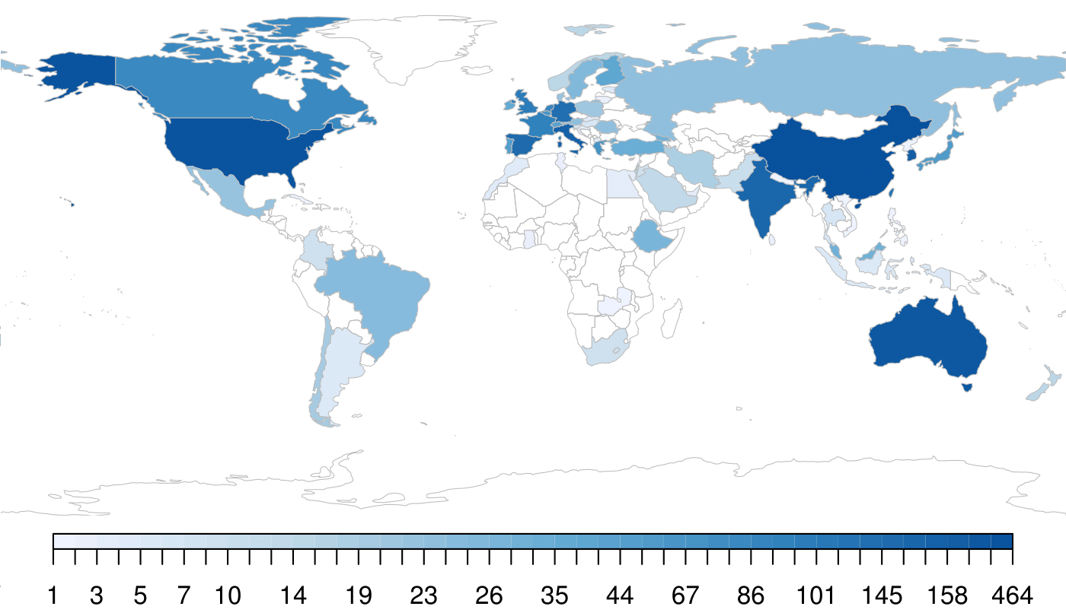

Annex 9. Products frequency by continent
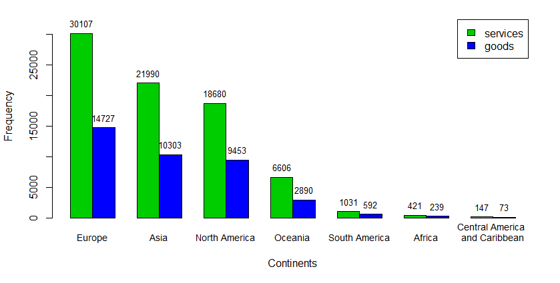

Annex 10. Sectors frequency by continent
