Annexes

Annex 1 - List of input features used for model.
Feature | Description | Origin
nr.products | Nr. of products presented on each publication. | Source
prod.price | Price of all products presented on the publication. | Source
nr.days.since.publish | Nr. of days between the date on which the publication was collected and the date the publication was published. | Source
fb.comments | Nr. of comments on Josefinas’ Facebook publications | Computed
positive.emoticons | Represents four types of emoticons (likes, loves, haha and wow) presented on Josefinas’ Facebook publications | Computed
fb.shares | Nr. of times the publication was shared on Josefinas’ Facebook English and Portuguese pages | Computed
fb.video.views | Nr. of times a video was visualized on Josefinas’ Facebook | Computed
price.base | Price of each product individually and without extra products. When the publication has more than one product, the price base equals the mean of the products’ price. | Source
nr.days.mag.next | Nr. of days between the date on which a news about Josefinas was published in a magazine (after the publication in social networks has been made) and the date on which the post on was made. | Source
nr.days.evt.next | Nr. of days between the date on which an event about Josefinas has occurred (after the publication in social networks has been made) and the date on which the post was made. | Source
pi.pins | Nr. of pins on each publication on Josefinas’ Pinterest. | Source
nr.days.mag.last | Nr. of days between the date on which the publication was published and date on which a news about Josefinas was published in a magazine (before the publication in social networks has been made). | Source
nr.days.evt.last | Nr. of days between the date on which the publication was published and date on which an event about Josefinas occurred (before the publication in social networks has been made). | Source
fb.followers | Nr. of people who follows and likes Josefinas’ Facebook | Computed
tweet | Identifies if a publication was published on Josefinas’ Twitter or not | Computed

Annex 2 - List of collected input features.

Feature | Description | Source
data.collection | The date on which the data was collected. | Josefinas’ Facebook  (PT Page)
data.published | The date on which the data was published.
name | The name that Josefinas gave to their publications.
fb.en.shares | Nr. of times the publication was shared. | Josefinas’ Facebook  (EN Page)
fb.en.likes | Nr. of likes on the publication.
fb.en.loves | Nr. of “loves” on the publication.
fb.en.haha | Nr. of “haha” on the publication.
fb.en.wow | Nr. of “wow” on the publication.
fb.en.comments | Nr. of “comments” on the publication.
fb.en.video.views | Nr. of times a video was visualized.
fb.en.followers | Nr. of people who follows and likes the Facebook page.
fb.en.sad | Nr. of people who feel “sad” about the publication.
fb.en.angry | Nr. of people who feel “angry” about the publication.
fb.en.content.type | The two types of content (photo or video) presented on the publication.
fb.pt.shares | Nr. of times the publication was shared. | Josefinas’ Facebook  (PT Page)
fb.pt.likes | Nr. of likes on the publication.
fb.pt.loves | Nr. of “loves” on the publication.
fb.pt.haha | Nr. of “haha” on the publication.
fb.pt.wow | Nr. of “wow” on the publication.
fb.pt.comments | Nr. of “comments” on the publication.
fb.pt.video.views | Nr. of times a video was visualized.
fb.pt.followers | Nr. of people who follows and likes the Facebook page.
fb.pt.sad | Nr. of people who feel “sad” about the publication.
fb.pt.angry | Nr. of people who feel “angry” about the publication.
fb.pt.content.type | The two types of content (photo or video) presented on the publication.
tw.like | Nr. of likes of each publication. | Josefinas’ Twitter Page
tw.retweet | Nr. of retweets of each publication.
tw.tweets | Total number of tweets.
tw.likes | Total number of likes.
tw.followers | Total number of followers.
inst.likes | Total number of likes. | Josefinas’ Instagram Account
inst.posts | Total number of publications.
inst.followers | Total number of followers.
inst.views | Nr. of times a video was visualized on the publication.
inst.comments | Nr. of comments on the publication.
inst.cnt.type | The two types of content (photo or video) presented on the publication.
nr.products | Total number of products presented on each publication. | Josefinas’ Website
prod.price | Price of all the products presented on the publication.
price.base | Price of each product individually. When the publication has more than one product, the price base equals the mean of the products’ price.
price.extras | Price of extra products (faux fur or stickers).
prod.type | Four types of products (shoe, bag, keychain or stickers) presented on each publication.
post.type | Three types of posts (brand, product or commemoration) presented on each publication.
special.edition | Identifies if the products on each publication belong to a special edition or not.
pi.global.albuns | Total number of albums. | Josefinas’ Pinterest Page
pi.global.pins | Total number of pins.
pi.global.likes | Total number of likes.
pi.global.followers | Total number of followers.
pi.comments | Nr. of comments on the publication.
pi.pins | Nr. of pins on the publication.
tmb.posted | Total number of posts. | Josefinas’ Tumblr Page
tmb.reblogged | Nr. of reblogs on the publication.
tmb.liked | Nr. of likes on the publication.
gplus.followers | Total number of followers. | Josefinas’ Google Plus Page
gplus.like | Nr. of likes on the publication.
gplus.comment | Nr. of comments on the publication.
gplus.share | Nr. of times the publication was shared.
event.dt.last.pub | The date on which an event about Josefinas occurred before the publication date on Josefinas’ social networks. | Josefinas’ Website
magazine.dt.last.pub | The date on which a news about Josefinas was published in a magazine before the publication date on Josefinas’ social networks.
event.dt.next.pub | The date on which an event about Josefinas occurred after the publication date on Josefinas’ social networks.
magazine.dt.next.pub | The date on which a news about Josefinas was published in a magazine after the publication date on Josefinas’ social networks.
nr.days.since.publish | Nr. of days between the date on which the publication was collected and the date the publication was published.
nr.days.evt.last | Nr. of days between the date on which the publication was published and date on which a news about Josefinas was published in a magazine (before the publication in social networks has been made).
nr.days.evt.next | Nr. of days between the date on which an event about Josefinas has occurred (after the publication in social networks has been made) and the date on which the post was made.
nr.days.mag.last | Nr. of days between the date on which the publication was published and date on which an event about Josefinas occurred (before the publication in social networks has been made).
nr.days.mag.next | Nr. of days between the date on which a news about Josefinas was published in a magazine (after the publication in social networks has been made) and the date on which the post on was made.
pi.published | Identifies if a publication was published on Pinterest or not. | Josefinas’ Pinterest Page
gplus.published | Identifies if a publication was published on Google Plus or not. | Josefinas’ Google Plus Page

Annex 3 - Five samples posts information and model evaluation for “Instagram Likes”.
Feature | Sample 1 | Sample 2 | Sample 3 | Sample 4 | Sample 5
nr.products | 16 | 4 | 2 | 1 | 1
fb.video.views | 3187 | 4134 | 0 | 0 | 0
fb.shares | 4 | 15 | 1 | 4 | 132
fb.comments | 1 | 6 | 1 | 1 | 161
nr.days.since.publish | 358 | 329 | 125 | 291 | 61
positive.emoticons | 75 | 199 | 67 | 104 | 6176
prod.price | 5120 | 1500 | 2535 | 540 | 295
nr.days.mag.next | 31 | 1 | 3 | 82 | 12
price.base | 320 | 375 | 1267,5 | 540 | 295
nr.days.evt.next | 16 | 104 | 27 | 65 | 27
pi.pins | 0 | 0 | 2 | 5 | 3
nr.days.mag.last | 1 | 31 | 11 | 3 | 33
nr.days.evt.last | 59 | 14 | 39 | 53 | 3
fb.followers | 115648 | 116133 | 116947 | 116278 | 131505
tweet | no | no | yes | yes | yes
Real | 102 | 103 | 284 | 184 | 1400
Predicted | 125.049 | 126.039 | 260.921 | 206.992 | 571.487
Absolute difference | 23.049 | 23.039 | 23.079 | 22.992 | 828.513
% difference | 23% | 22% | 8% | 12% | 59%

Full
Data Collected
Posts |  | 588 |  | 519 |  | 556 |  | 469 |  | 232 |  | 168 |  | 20

Annex 4 - Publications collected initially from each social network.

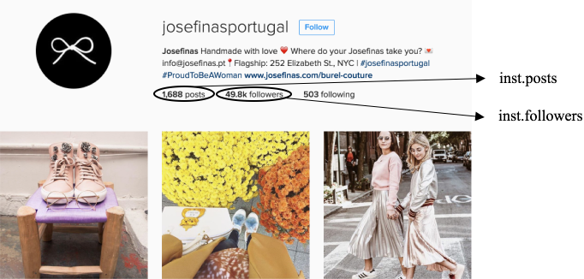
Annex 5 - Snapshot of Josefinas’ Instagram.

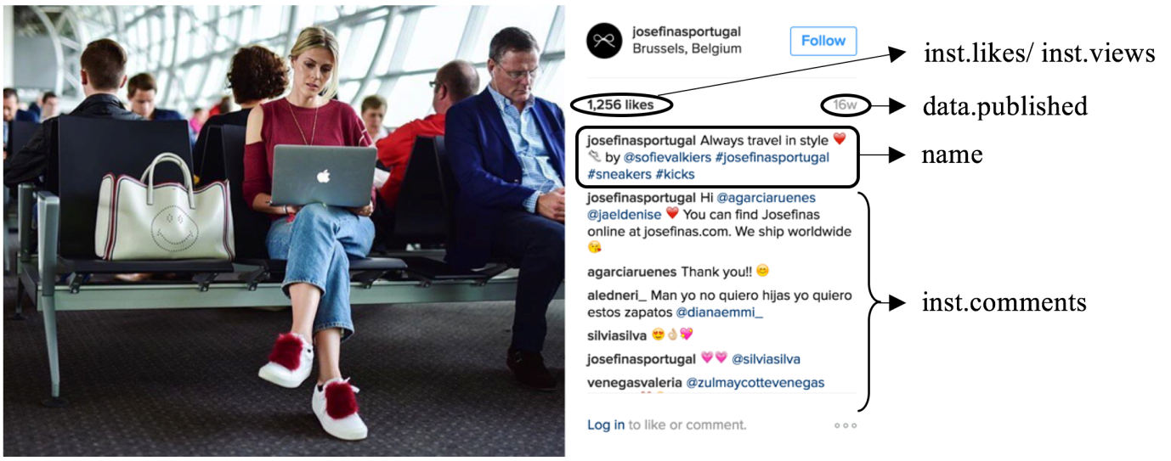
Annex 6 - Snapshot of an Instagram post.

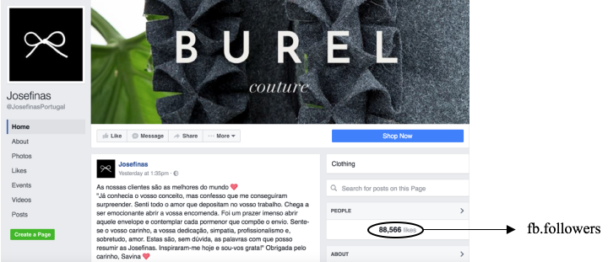
Annex 7 - Snapshot of Josefinas’ Facebook.

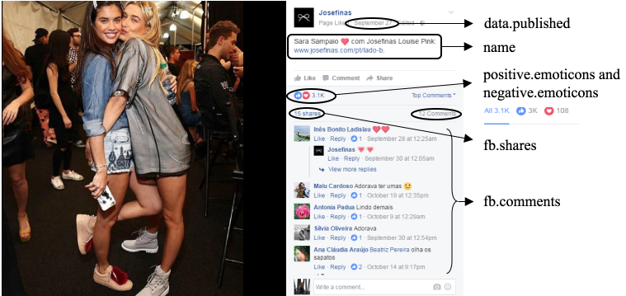
Annex 8 - Snapshot of a Facebook post.

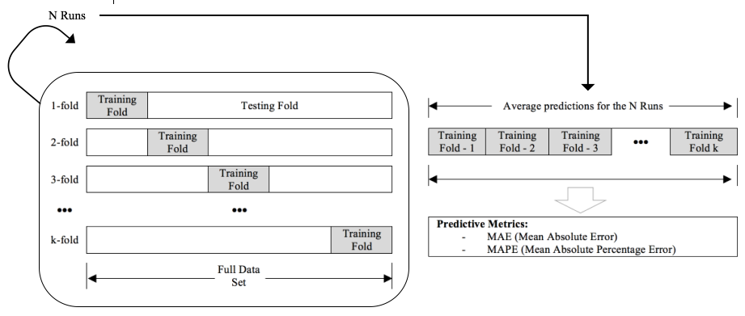
Annex 9 - Modeling performance assessment.

