Supplementary Material
Introducing digital cameras to monitor plant phenology in the tropics: applications for conservation
Bruna Alberton, Ricardo da S. Torres, Leonardo F. Cancian, Bruno D. Borges, Jurandy Almeida, Greice Mariano, Jefersson dos Santos, Leonor Patricia C. Morellato

A PROTOCOL FOR THE APPLICATION OF REPEATED PHOTOGRAPHY TO MONITOR VEGETATION CHANGES

1 Camera installation and settings…………………………………………..................2
1.1 Location choice and camera field of view……………………………..3
1.2 Camera orientation and distance from the target vegetation..3
1.3 Camera choice and settings………………………………….………………..3
1.4 Power supply………………………………………………………………………...4
1.5 Reference panel…………………………………………………....................4
1.6 Association with climatic sensors…………………………………..………4
2 Image Acquisition……………………………………………………………………………….…5
3 Image Processing…………………………………………………………………………..……..5
3.1 Renamed images and Visual filter………………………….………………5
3.2 Regions of Interest (ROIs)………………………………………………………5
3.3 Vegetation indices………………………………………………………..……….6

Digital cameras are reliable tools for monitoring vegetation because they have low-price and easy setup installation, while they can provide high frequency and resolution data. In order to clarify this method, we introduce a simple protocol demonstrating in some steps the main basics and important settings to start a repeat photography monitoring.
1 Camera installation and settings
1.1 Location choice and camera field of view
In general, the camera is placed in a tower – we named phenology tower - built in the middle of vegetation. The choice of the site and the field of view must maximize the vegetation to be monitored. Hemispherical lens cameras are reliable for capturing images from the canopy, reducing crown cover among individual species. We recommend set up those cameras on the top of the phenology tower with a mean distance of 10m higher than vegetation canopy and placed in an arm structure at least two meters distant from the tower. Cameras can be set up on small towers, close to the ground in order to capture a better view and representation of the ecosystem. Landscape images are advantageous in the case of shrublands, grasslands, or other kinds of vegetation with short canopies and across heterogeneous landscapes as rupestrian grasslands.
1.2 Camera orientation and distance from the target vegetation.
The camera should be positioned facing North and Northeast to maximize the light over the canopy and to minimize lens flare. East or West can be an alternative direction if there are constraints in the field, but avoid camera facing the south due to the high loss of images because of inappropriate lightning conditions. For above-canopy cameras, the mean distance from the camera to the canopy is 10 meters. The distance on landscape images is hard to determine and it will depend on the place, vegetation density, and study question, whether focusing on vegetation types or particular species. When monitoring multiple sites, try to choose the same distance and cardinal direction in a way to standardize image processing and analysis.
1.3 Camera choice and settings
Different digital cameras have been used in repeated photography monitoring. There are even studies with comparisons made for them (see Sonnentag et al. 2012). Here, we cited the main cameras used nowadays and some aspects to be considered.
The most used digital camera is the Internet Protocol (IP) camera StarDot, especially because it is the standard camera for two of the major phenocam networks, the Phenocam (https://phenocam.sr.unh.edu/webcam/ - US) and the EuroPhen (http://european-webcam-network.net/ - Europe). It provides landscape images and it is reliable for temperate ecosystems. Hemispherical images have been used by the PEN (http://pen.agbi.tsukuba.ac.jp/index_e.html - Japan) and for the e-Phenology network (http://www.recod.ic.unicamp.br/ephenology - Brazil). The fish-eye lens (360º) improve the selection of crowns with more precision and less covered areas, providing an edge area of the image with less quality, but that may reflect the same community pattern (see Alberton et al. 2014). The hemispherical lens camera used by the e-Phenology network is an IP camera (Mobotix Q24), which has been reliable for tropical ecosystems monitoring and has a strong sealing, important for wet conditions and preventing bugs invasion. IP cameras can be connected to a network and the images download can be performed remotely.
A low-cost investment option, but keeping good quality and frequency of data, is the use of time-lapse cameras. The Plant Cam (Wingscapes, WSCA04 Outdoor Timelapse Plant Cam) lacks a more robust body, but it is of easy set-up installation and does not require a solar module, as it can be ordered with a solar panel among kit accessories. Images download must be done manually.
Moreover, Exposure (aperture, shutter speed and ISO) and White balance are recommended to be set up in the Automatic. Camera time and date should be set for the local site, and the use of daylight saving time should be avoided.
1.4 Power supply
Given the impossibility of having electricity in the field, a common situation for tropical environments with long-distance and hard accessible vegetation sites, we recommend the use of solar energy. It is important to design a solar module based on the consuming features of the camera.
1.5 Reference panel
A color panel is used as reference to calibrate images that might be suffering issues of light artifacts. It allows to evaluate day-to-day variability in image color balance and to verify the consistency of the image sensor. Reference panel should be placed in a fixed point of the image, preferably close to the vegetation and being affected by the direct light conditions (see Fig.S1). However, its use is not mandatory, since there are post-processing approaches to smooth light heterogeneity in the images due to weather conditions and the time of day (see Section 3.3).
1.6 Association with climatic sensors
A complete meteorological station or at least some minimum set of sensors (rain gauge, thermometers, and Photosynthetically Active Radiation (PAR) sensors) are an important additional component to phenology towers to answer plant phenology questions related to climatic factors triggering plant phenophases. Therefore, we recommend a complete meteorological station associated with the camera. Usually, one way to save investments and to improve the collaborative research is to install the digital cameras in ongoing monitoring towers, as local meteorological and atmospheric-surface flux towers. If that is not possible, and you cannot acquire one station, it is important to search for the closest meteorological station to the site.
2 Image Acquisition
We recommend capturing five images per hour from 6 a.m. to 6 p.m. This is a high frequency of images (65 images per day) and provides not only fine-tuned information about phenology but also a high volume of data for the development of computational tools (Alberton et al. 2014, Almeida et al. 2015, 2016). When it is not possible due to storage constraints, we recommend taking at least 5 images per hour during the midday hours (10 a.m. to 2 p.m.). A study comparing RAW and JPEG images has shown no considerable difference in data results (Sonnentag et al. 2012), which allows the choice for JPEG images. As most of the cameras generate JPEG file format, the images must be saved in the higher quality of JPEG format available.
3 Image Processing
3.1 Renamed images and Visual filter
We recommend the use of specific image naming procedures. For example, the image filenames must contain: YEAR_DAY-OF-YEAR_HOUR-OF-DAY_COUNTER, where the day of year must be in the Julian day format, and the counter is the order of that image for that hour (1st, 2nd, 3t^{h}…) when several images are taken. We also recommend the use of a visual filter, which consists in manually verifying and removing images with problems, such as black days, fog, and rain. The visual filter is also a good way for aiding researchers to know their data and to follow changes in phenophases according to their experience.
3.2 Regions of Interest (ROIs)
The image analysis usually depends on the definition of regions of interest (ROI). The ROI is a region within the input images defined for analysis. By defining an ROI, we can remove irrelevant areas such as those with lack of vegetation or those depicting the tower structure. Also, we can define the sample size that the research intends to analyze as a crown of species, a population, some portion of the canopy, a community profile or a habitat in a heterogeneous landscape. Usually, the ROI is defined in terms of a mask with the same dimensions of the input image. The mask is a binary image composed of black and white pixels, where white pixels represent the selected region. Typical image editing software tools (e.g., Photoshop) may be used to define ROI masks.
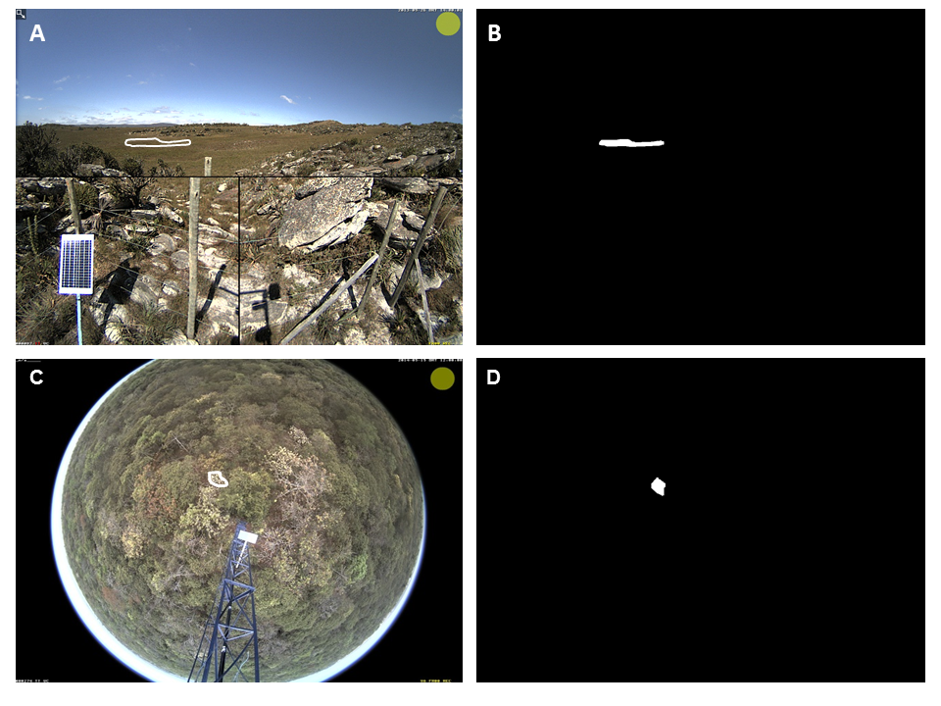
Figure S1 Examples of Regions of Interest (ROIs) in (a-b) defining a sandy grassland region in a heterogeneous landscape and its mask; and (c-d) defining one species crown of a woody savanna and its mask.
3.3 Vegetation indices
Several indexes have been applied to detect leaf color changes in time series of digital images exploring the RGB color channels (Richardson et al. 2007, Nagai et al. 2011, Sonnentag et al. 2012, Zhao et al. 2012, Zhou et al. 2013). Woebbecke (1995) was one of the first to calculate several indexes using RGB channels of digital images to evaluate which are better to detect weeds considering different types of soil, residue, and light conditions. A normalized index called RGB chromatic coordinates (RGB_{cc}) was developed by Gilespie et al. (1987) and it is considered up to now the most efficient to detect the color of plants in relation to their background (Sonnentag et al. 2012).
The RGB chromatic coordinates (R_{cc}, G_{cc}, and B_{cc}) is a normalized index, defined by respectively dividing each component (R, G, or B) by the sum of all components (R + G + B):
(1)
$$R_{cc}=\frac{R}{R+G+B}$$
$$G_{cc}=\frac{G}{R+G+B}$$
$$B_{cc}=\frac{B}{R+G+B}$$

The Excess Green (ExG) index is also applied in color time series analysis. This metric has proved to be a consistent color index, able to distinguish between green plants and their background (soil, residue), as well as to minimize variations in illumination, enhancing the green signal of the plants (Woebbecke 1995).
(2)
$$ExG=2G-\left(R+B\right)$$

After the RGB color extraction and the vegetation index computation have been performed, it is necessary to filter time series data information. That is because we have hourly color information (from 6 a.m to 6 p.m), which have to be aggregated in a daily value. There are several ways to filter time series daily values, such as by averaging all the values or from the midday hours, by choosing the midday hour as a daily value, etc. Midday hours may change depending on the direction that camera is placed, as well as they can carry too much noise due to daily illumination changes. One effective method to minimize noise in the time series information (RGB_{cc}) caused by illumination effects of seasonal changes and time of day is to calculate the 90th percentile value from all daily values in a 3-day window (Sonnentag et al. 2012). The data filter is an important step to follow with the phenological analysis. All the image processing can be implemented in different programming languages, like MATLAB, Python, C/C++, and R. For R, researchers may use the Phenopix Package, recently created for imagery data in phenological analysis (Filippa et al. 2016).
Once the filters are applied over the RGB time series in order to eliminate outliers and smooth the data, the researcher can start to work with data analysis. With the goal of vegetative phenology monitoring, for example, the time series calculated from Gcc index represent leaf development changes over time of the ROI selected. Through daily color changes information in association with daily measurements of climatic variables, a wide range of questions can be investigated.

REFERENCES
Alberton B, et al., 2014. Using phenological cameras to track the green up in a cerrado
savanna and its on-the-ground validation. Ecol. Inform., 19:62–70.

Almeida J, et al., 2015. Deriving Vegetation Indices for Phenology Analysis using
Genetic Programming. Ecol. Inform., 26:61–69.

Almeida J, et al., 2016. Phenological visual rhythms: Compact representations for fine-
grained plant species identification. Pattern Recognit. Lett., 81:90–100.

Filippa G, 2016. Phenopix: A R package for image-based vegetation phenology. Agric.
For. Meteorol., 220:141–150.

Gillespie AR, Kahle AB & Walker RE, 1987. Color enhancement of highly correlated
images. II. Channel ratio and “chromaticity” transformation techniques. Remote Sens. Environ., 22:343–365.

Nagai S, 2011. Using digital camera images to detect canopy condition of deciduous broad-leaved trees. Plant Ecol. Divers., 4:79–89.

Richardson AD, 2007. Use of digital webcam images to track spring green-up in a deciduous broadleaf forest. Oecologia, 152:323–334.

Sonnentag O, 2012. Digital repeat photography for phenological research in forest ecosystems. Agric. For. Meteorol., 152:159–177.

Woebbecke DM, 1995. Color indices for weed identification under various soil, residue, and lighting conditions. Trans. ASAE, 38:259–269.

Zhao J, 2012. Using digital cameras for comparative phenological monitoring in an evergreen broad-leaved forest and a seasonal rain forest. Ecol. Inform., 10:65–72.

Zhou L, 2013. Modeling winter wheat phenology and carbon dioxide fluxes at the ecosystem scale based on digital photography and eddy covariance data. Ecol. Inform., 18:69–78.

