Supporting information:
Appendix S1: Research station management and analyses of the effect of grazing on habitat structure.
Figure S1.1: Temperature (ºC) and maximum precipitation (mm.) during the course of the study. Each point shows the mean daily temperature (ºC), and point size represents the maximum daily rainfall (mm) (from 2015-12-01 to 2017-03-15). Data was obtained from the Brazilian National Institute of Meteorology (INMET; http://www.inmet.gov.br/portal/). The horizontal line segments indicate the periods of rodent sampling in each season.
Figure S1.2: Principal Coordinate Analysis plot showing the between-season and between-paddock variation in habitat. Variation captured by the two first ordination axes is included within the axes labels. Convex hulls delimit paddock groups according to their grazing intensity; the lines inside each convex hull link the paddock centroid with the habitat of each season. We used the continuous value of the paddock centroid as the quantitative measurement of the grazing intensity. Black circles indicate centroids from EEA (Eldorado do Sul, RS) paddocks, and white circles indicate centroids from EMBRAPA (Bagé, RS) paddocks.
Table S1.1: Habitat covariates collected at trapping points distributed across grazing paddocks from two livestock research stations in the Pampa biome, Brazil. A point refers to one Sherman, one tomahawk or one tracking tunnel. For the data analysis, covariates were averaged by paddock. Covariates marked with * had low or moderate correlation and were used to extract the multivariate gradient of grazing intensity (Fig S1.2).
Table S1.2: Habitat covariates by grazing paddock. * Grazing intensity was derived from the paddock’s position along the disturbance gradient (Fig. S1.2). We present the total number of live-trap captures and recaptures per species in each paddock. Detections derived from tracking tunnels are presented in bold and italic.
Table S1.3: Correlations between habitat covariates and the axes of the Principal Coordinate Analysis (Fig. S1.2).
Table S1.4: Candidate models potentially explaining rodent detection (p) and site occupation (ψ).
Table S1.5: Sampling effort and number of detections presented according to species, site, trap type and season. In Eldorado do Sul (EEA), we sampled from winter 2016 to summer 2017 using tracking tunnels only. Within parenthesis, we present the number of recaptures for live-trap sampling. In bold, we present the number of tracking tunnels with detections.
Table S1.6: AICc ranking of all candidate models for Azara’s grass mouse (Akodon azarae).
Table S1.7: AICc ranking of all candidate models for the yellow pigmy rice rat (Oligoryzomys flavescens).
Table S1.8: AICc ranking of all candidate models for the long-nosed hocicudo (Oxymycterus nasutus).
Appendix S2: Sensitivity analyses using the EMBRAPA data.
Fig. S2.1: Principal coordinate analysis plot showing the between-season and between-paddock variation in habitat structure. Variation captured by the two first ordination axes is included within the axes labels. Convex hulls delimit paddock groups according to their grazing intensity; the lines inside each convex hull link the paddock centroid with the habitat of each season. We used the continuous value of the paddock centroid as the quantitative measurement of the grazing intensity. Data was collected from EMBRAPA (Bagé, RS).
Fig. S2.2: Occupation probability (ψ) of Akodon azarae, given as a function of the gradient of grazing intensity. Values of the multivariate gradient of grazing intensity were extracted from Axis 1 of the Principal Coordinate Analysis (Fig. S2.1). The lowest negative values indicate the highest grazing intensities, whereas the highest positive values indicate the absence of grazing.
Fig. S2.3: Occupation probability (ψ) of Oxymycterus nasutus, given as a function of the gradient of grazing intensity. Values of the multivariate gradient of grazing intensity were extracted from Axis 1 of the Principal Coordinate Analysis (Fig. S2.1). The lowest negative values indicate the highest grazing intensities, whereas the highest positive values indicate the absence of grazing.
Table S2.1: Correlations between habitat covariates and the axes of the Principal Coordinate Analysis (Fig S2.1).
Table S2.2: Model-selection table for Akodon azarae, with candidate models ranked according to their AICc. p = detection probability; ψ = occupation probability. PCO1= gradient of grazing intensity (Fig. S2.1). The models with stronger support are those with Delta AICc ≤ 4 (in bold).
Table S2.3: Estimates of the detection probabilities of Akodon azarae, given as a function of the sampling occasion covariates.
Table S2.4: Model-selection table for Oligoryzomys flavescens, with candidate models ranked according to their AICc. p = detection probability; ψ = occupation probability. PCO1= gradient of grazing intensity (Fig. S2.1). The models with stronger support are those with Delta AICc ≤ 4 (in bold).
Table S2.5: Estimates of the detection probabilities (p) of Oligoryzomys flavescens, given as a function of the sampling occasion covariates.
Table S2.6: Model-selection table for Oxymycterus nasutus, with candidate models ranked according to their AICc. p = detection probability; ψ = occupation probability. PCO1= gradient of grazing intensity (Fig. S2.1). The models with stronger support are those with Delta AICc ≤ 4 (in bold).
Table S2.7: Estimates of the detection probabilities (p) of Oxymycterus nasutus, given as a function of the sampling occasion covariates.

Appendix S1: Research station management and analyses of the effect of grazing on habitat structure.
In the research stations where the study took place, grazing intensity is manipulated to experimentally evaluate the production of beef from the cattle breeds of Aberdeen Angus and Brangus-Ibagé (Nabinger et al., 2009; Trindade et al., 2012). Researchers from EEA manage grasslands according to daily forage allowances (i.e., the amount of forage available on a daily basis for cattle in relation to their live weight) and adjust the stocking rate according to potential pasture growth (i.e., paddocks support less cattle in winter because vegetation growth is slower). Each EEA paddock with continuous grazing occupied ≈ 5 hectares. The highest forage allowance is 16%, meaning that around 16 kg of dry matter is available daily per 100 kg of live weight (Nabinger et al., 2009; Trindade et al., 2012). Moderate forage allowance is 8-12%, while the lowest allowance is 4% (i.e., overgrazing where many animals eat a small quantity of food) (Nabinger et al., 2009; Trindade et al., 2012).
EMBRAPA paddocks have 5-70 ha under continuous grazing. The lowest food allowance is 6-8% in EMBRAPA (as seen in Fig. S1.2), which occurs around cattle troughs and in thin soils. EMBRAPA researchers mow the vegetation in the spring and autumn to remove dry and senescent biomass which accumulated during growth periods, as well as to increase the regrowth of palatable leaves (Nabinger et al., 2009). In both sites, researchers maintain ungrazed areas (for 6 years in EMBRAPA and 11 years in EEA). Cattle only access the ungrazed areas and forest patches to forage and find shelter during harsh weather (Nabinger et al., 2009; Frank et al., 2012). The climate was similar between the two research stations (Fig. S1.1). The presence of trees is very rare outside ungrazed areas at EEA, while solitary trees and forest patches are scattered throughout EMBRAPA (as perceived in Table S1.2). Neither site is managed using burning.
We performed multivariate analysis to explore habitat differences within (Test for Homogeneity of Multivariate Dispersion, Betadisper; Anderson, 2006) and between (Multivariate Analysis of Variance, Permanova; Legendre and Legendre, 2012) paddocks. We did not use trap distance to the nearest tussock, shrub and tree (Table S1.1) in any analysis, because they were inversely correlated with tussock, shrub and tree height. First, we explored habitat data through Principal Coordinate Analysis (PCO), based on Euclidean distance between standardized covariates (Legendre and Legendre, 2012). The position of paddocks along the grazing gradient revealed three groups with low overlap (high, moderate/low, ungrazed; Table S1.2; Fig. S1.2). Groups were then used to test habitat differences within (seasonal variation) and between paddocks (spatial variation) through Betadisper and Permanova (999 permutations) tests. Permutations were used to generate random F-statistic values. P-values were derived by counting the number of times that random F-statistic values were higher than the observed F-statistic values (Legendre and Legendre, 2012). Since we measured the covariates for each trap in EMBRAPA (24 points/paddock) and in each tunnel in EEA (6 points/paddock), we also ran analyses controlling for differences in the number of points by restricting permutations with a ‘site’ block factor. We did not find any differences in the results when considering the blocking factor ‘site’ in the multivariate analyses. We performed a post-hoc contrast analysis with Bonferroni correction of P-values to test for pairwise differences in habitat within and between the three grazing intensities.
Results for these analyses revealed significant within-paddock differences in vegetation structure and heterogeneity over the seasons (Betadisper’s F= 8.27, P ≤ 0.012), with the contrast analysis revealing that paddocks under moderate/low grazing intensities are seasonally less variable than ungrazed paddocks (P < 0.001) (Fig. S1.2). These results were also evidenced by the habitat data collected only from the tracking tunnel points (Betadisper’s F= 11.13, P ≤ 0.001). As observed in the field, seasonal changes in the habitat structure in ungrazed areas resulted from the rapid and ephemeral appearance of shrub and tree saplings, which might have promoted changes in microhabitat characteristics over very short time scales. Furthermore, the increase in stature and in green leaf production during the reproduction of rosette (Eryngium horridum) and tussock species (e.g., Aristida laevis, Saccharum angustifolium) in the spring and summer largely contributed to the changes in vegetation structure in grazed paddocks (Table S1.2).
Vegetation structure also varied between paddocks, with highly grazed paddocks and ungrazed areas representing the extreme end-points of the disturbance gradient (Fig. S1.2; Permanova’s F= 20.36; R²= 0.35; P≤ 0.001). Post-hoc contrast analysis revealed that the habitat provided by ungrazed areas differed significantly from the habitat of low/moderately and highly grazed paddocks, and that the habitat provided by low/moderately grazed paddocks significantly differed from those under intense grazing (Bonferroni adjusted P-values= 0.003). The results were similar when using the habitat data from tracking tunnel points (Permanova’s F= 18.21; R²= 0.32; P≤ 0.001). In the Principal Coordinate Analysis (Fig. S1.2), high positive scores for axis I reveals increases for litter depth and the height of trees, shrubs and tussock grasses, while the high negative scores for axis I indicates increases in the amount of cattle dung (Table S1.3). The axis 2 revealed a within-paddock gradient for the ungrazed areas, characterizing differences in the amount of bare ground and tree height (Table S1.3).

References
Anderson, M.J., 2006. Distance-based tests for homogeneity of multivariate dispersions. Biometrics 62, 245–253.
Frank, A.S.K., Dickman, C.R., Wardle, G.M., 2012. Habitat use and behaviour of cattle in a heterogeneous desert environment in central Australia. Rangeland J. 34, 319–328.
Legendre, P., Legendre, L., 2012. Numerical Ecology. Elsevier, Amsterdam.
Nabinger, C., Ferreira, E.T., Freitas, A.K., et al., 2009. Produção animal com base no campo nativo: aplicações de resultados de pesquisas. In: Pillar, V.D., Müller, S.C., Castilhos, Z.M.D.S., et al., (Eds.). Campos Sulinos: conservação e uso sustentável da biodiversidade. Ministério do Meio Ambiente, Brasília, Brazil. pp 175–198.
Trindade, J.K., Pinto, C.E., Neves, F.P., et al., 2012. Forage allowance as a target of grazing management: implications on grazing time and forage searching. Rangeland Ecol. Manag. 65, 382–393.

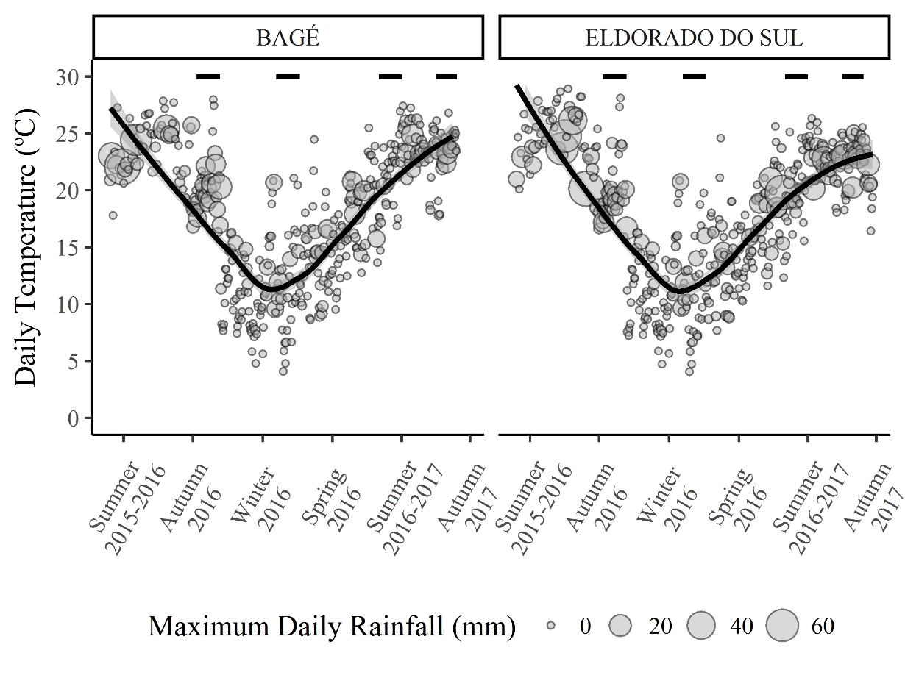
Figure S1.1: Temperature (ºC) and maximum precipitation (mm.) during the course of the study. Each point shows the mean daily temperature (ºC), and point size represents the maximum daily rainfall (mm) (from 2015-12-01 to 2017-03-15). Data was obtained from the Brazilian National Institute of Meteorology (INMET; http://www.inmet.gov.br/portal/). The horizontal line segments indicate the periods of rodent sampling in each season.

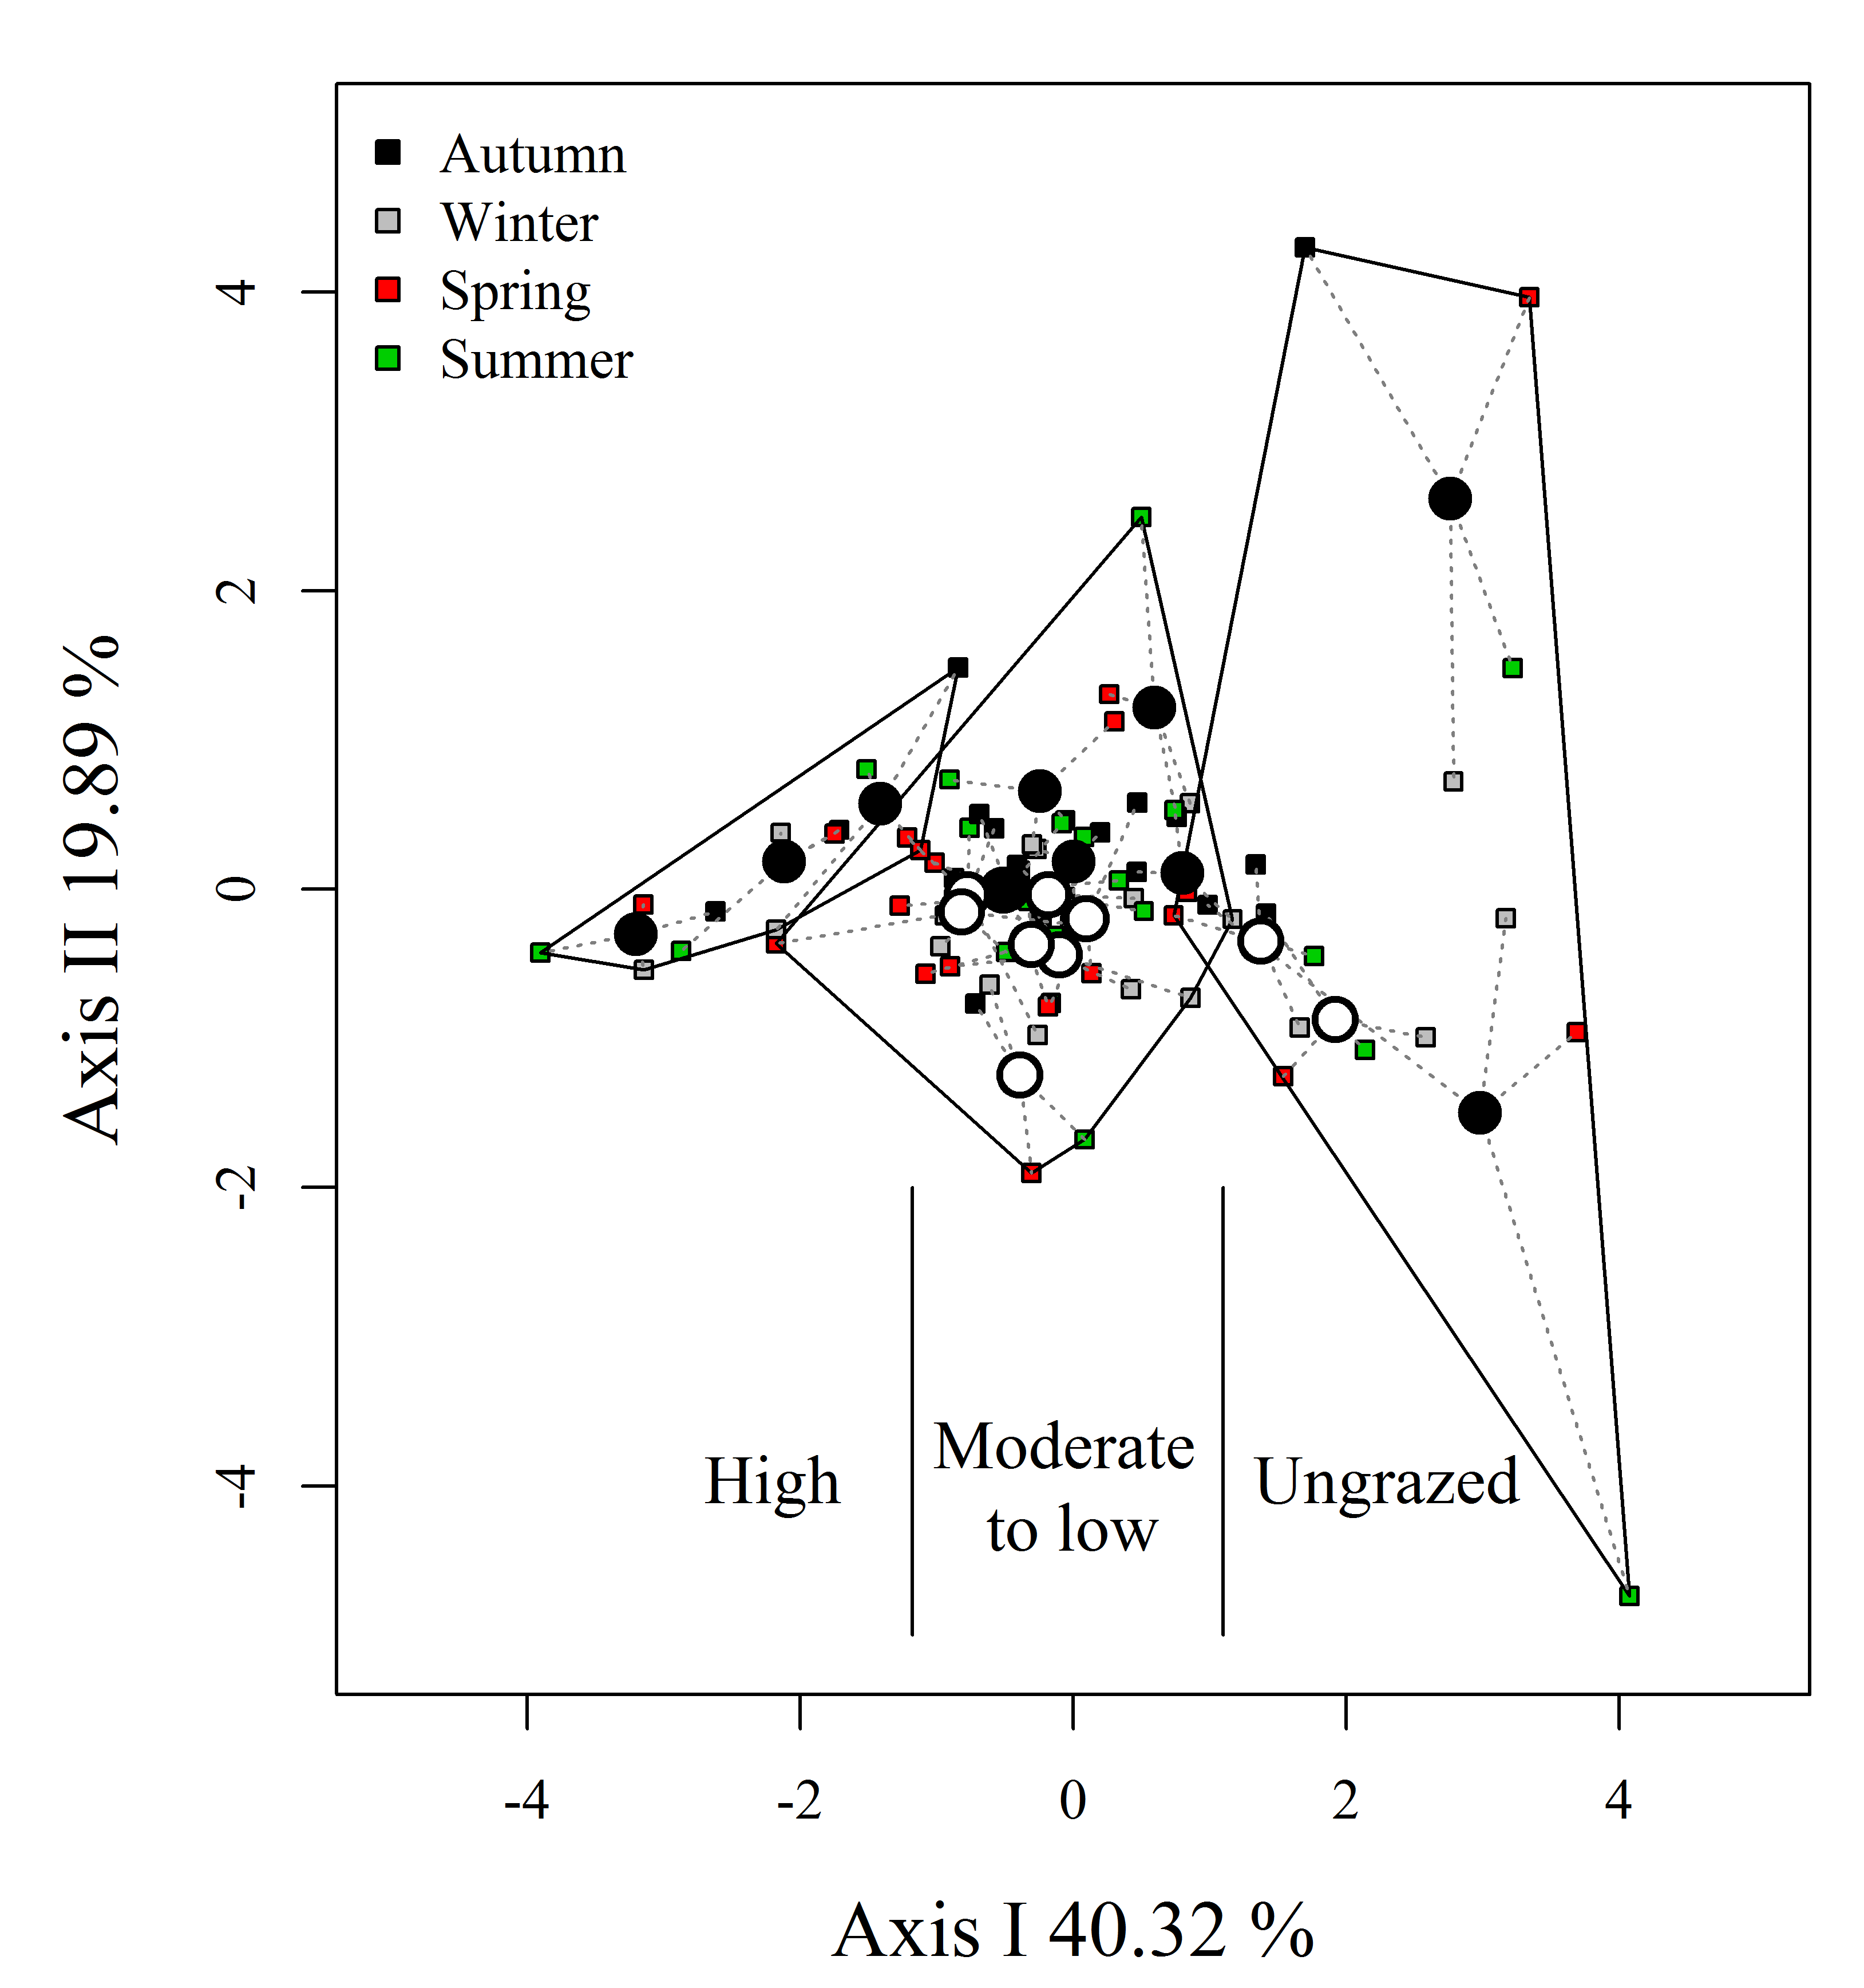
Figure S1.2: Principal Coordinate Analysis plot showing the between-season and between-paddock variation in habitat. Variation captured by the two first ordination axes is included within the axes labels. Convex hulls delimit paddock groups according to their grazing intensity; the lines inside each convex hull link the paddock centroid with the habitat of each season. We used the continuous value of the paddock centroid as the quantitative measurement of the grazing intensity. Black circles indicate centroids from EEA (Eldorado do Sul, RS) paddocks, and white circles indicate centroids from EMBRAPA (Bagé, RS) paddocks.
Table S1.1: Habitat covariates collected at trapping points distributed across grazing paddocks from two livestock research stations in the Pampa biome, Brazil. A point refers to one Sherman, one tomahawk or one tracking tunnel. For the data analysis, covariates were averaged by paddock. Covariates marked with * had low or moderate correlation and were used to extract the multivariate gradient of grazing intensity (Fig S1.2).

Variable (unity)
Site covariates
Vegetation composition and height (cm)
Herbaceous height (cm): The amount of a graduated pole touching herbaceous plants, which included the leaves and reproductive structures of prostrated species (Paspalum notatum, Paspalum dilatatum, Axonopus affinis, Axonopus argentinum, Dichondra sericea, Andropogon lateralis) that generally occur under high grazing intensity.
Tussock height (cm) *: The amount of a graduated pole touching tussock species, which form a dense canopy of dry biomass above the ground. The maximum tussock height was reached when leaves were mostly erect (i.e., no dense structure). The main tussock species were Saccharum angustifolium, Paspalum quadrifarium, Stipa spp., Aristida jubata, Aristida laevis, Andropogon lateralis and the exotic plant Eragrostis plana (which form a dense cover very near to the soil). Rosette species (Eringyum horridum, E. pandanifolium) were regarded as tussocks because these plants form a dense above-ground structure.
Shrub height (cm) *: The amount of a graduated pole touching the stems, leaves and branches of shrubs (e.g., Baccharis dracuncunifolia, Heterotalamus alienus, Heterothalamus rupestris, Baccharis trimera, Achyrocline alata, Eupatorium buniifolium, Senecio brasiliensis).
Tree height (cm) *: The amount of a graduated pole touching the stems, leaves and branches of trees (e.g., Schinus polygamus, Quilaja brasiliensis, Lithrea brasiliensis, Zanthoxylum rhoifolium).
Litter depth (cm) *
The depth of litter (senescent leaves and stems) at a given point.
Bare ground * and cattle dung (%) *
The amount of bare ground and cattle dung at a given point, measured using a 1 m² plot divided into 100 subplots.
Distance to nearest tussock, shrub, and tree (meters)
Distance between a given point and the nearest tussock, shrub and tree.
Slope (degrees)
The slope at a given point. Vegetation composition and structure differ according to slope and relief.
Sampling-occasion covariates
Total vegetation height (cm): the total height reached by the vegetation, regardless of type (herbs, tussocks, shrubs or trees), measured using a graduated pole. This covariate represents the total vegetation over a given trapping point in a given season.
Moon phases: trapping occurred under full moon (1) or not (0)
Season: winter (1) or not (0)
Type of trap: tracking tunnel (1) or live-trap (0)

Table S1.2: Habitat covariates by grazing paddock. * Grazing intensity was derived from the paddock’s position along the disturbance gradient (Fig. S1.2). We present the total number of live-trap captures and recaptures per species in each paddock. Detections derived from tracking tunnels are presented in bold and italic.
Site | Grazing intensity* | Akodon azarae | Oligoryzomys flavescens | Oxymycterus nasutus | Total height (cm) | Herbaceous height (cm) | Shrub height (cm) | Tree height (cm) | Tussock height (cm) | Litter depth (cm) | Bare ground (%) | Cattle dung (%) | Distance to nearest tussock (m) | Distance to nearest shrub (m) | Distance to nearest tree (m) | Slope (°)
EMBRAPA | NO | 7 | 7 | 14 | 189.33±11.12 | 2.59±1.99 | 62.08±9.06 | 24.28±15.23 | 38.35±10.58 | 1.78±0.24 | 0±0 | 0±0 | 0.04±0.05 | 0.25±0.14 | 3.06±0.4 | 8.14±0.96
EMBRAPA |  | 8 | 15 | 15 | 166.38±10.45 | 3.58±2.71 | 66.42±12.22 | 9.6±9.38 | 36.28±6.89 | 1.61±0.41 | 0.01±0.01 | 0.01±0.01 | 0.16±0.11 | 0.22±0.14 | 4.72±0.58 | 5.1±0.98
EEA |  | 2 | 2 | 0 | 237.62±81.5 | 1.33±1.97 | 101.29±69.26 | 52.5±73.09 | 35.67±9.08 | 2.02±0.38 | 0.01±0.01 | 0±0 | 0±0 | 0.23±0.12 | 2.89±1.67 | 4.38±2.23
EEA |  | 1 | 1 | 1 | 206.24±58.09 | 0.42±0.83 | 120.54±72.13 | 1.25±2.5 | 39.32±8.41 | 1.49±0.38 | 0.08±0.05 | 0±0 | 0.05±0.09 | 0.26±0.17 | 3.92±2.19 | 12.76±2.54
EMBRAPA | LOW TO INTERMEDIARY | 3 | 0 | 0 | 91.5±35.43 | 2.56±1.1 | 15.15±6.3 | 0±0 | 23.46±8.79 | 0.96±0.11 | 0.01±0.01 | 0.02±0.02 | 0.11±0.1 | 0.71±0.38 | 79.51±17.99 | 4.97±1.06
EMBRAPA |  | 6 | 1 | 0 | 102.97±27.25 | 1.22±0.56 | 11.99±5.5 | 1.56±3.12 | 36.11±10.21 | 1.07±0.28 | 0.01±0.01 | 0.03±0.02 | 0.04±0.05 | 1.31±0.48 | 18.6±2.05 | 3.56±0.51
EMBRAPA |  | 25 | 1 | 0 | 92.85±21 | 2.09±0.78 | 11.69±4.24 | 6.47±6.42 | 25.97±8.23 | 1.32±0.51 | 0±0 | 0.02±0.01 | 0.16±0.12 | 1.27±0.99 | 24.95±3.2 | 4.52±0.62
EMBRAPA |  | 9 | 0 | 0 | 77.38±10.65 | 2.94±1.41 | 12.77±9.33 | 0±0 | 21.22±5.17 | 1.49±0.39 | 0.01±0 | 0.03±0.02 | 0.24±0.37 | 0.68±0.58 | 19.68±0.81 | 6.46±0.69
EMBRAPA |  | 6 | 1 | 3 | 97.39±32.74 | 4.46±2.33 | 23.98±4.74 | 3.65±4.76 | 21.88±9.7 | 1.58±0.28 | 0.02±0.01 | 0.03±0.02 | 0.21±0.11 | 0.25±0.13 | 10.71±1.18 | 8.08±1.99
EMBRAPA |  | 0 | 0 | 0 | 77.79±19.06 | 4.55±1.88 | 25.58±8.44 | 8.2±9.74 | 12.24±4.64 | 0.86±0.28 | 0.01±0.01 | 0.02±0.01 | 0.68±0.26 | 0.07±0.05 | 7.89±0.61 | 8.66±1.6
EMBRAPA |  | 7 | 5 | 1 | 83.21±15.31 | 4.16±2.49 | 13.73±6.4 | 1.93±1.29 | 20.9±8.09 | 1.01±0.34 | 0.01±0.01 | 0.03±0.02 | 0.47±0.56 | 1.17±0.74 | 13.78±0.95 | 7.05±0.79
EMBRAPA |  | 1 | 9 | 0 | 123.04±20.95 | 6.85±2.76 | 16.59±5.23 | 39.52±19.06 | 12.98±3.85 | 1.08±0.06 | 0.01±0.01 | 0.03±0 | 1.2±0.51 | 0.27±0.1 | 10.35±0.85 | 7.94±0.71
EEA |  | 0 | 0 | 0 | 86.25±16.38 | 4.62±5.46 | 17.83±7.06 | 0±0 | 34.46±6.58 | 0.57±0.25 | 0.01±0.01 | 0.01±0.02 | 0±0 | 0.88±0.59 | 96.67±6.67 | 5.21±1.66
EEA |  | 0 | 0 | 0 | 106.12±21.25 | 0±0 | 6.5±7.52 | 0±0 | 43.5±6.25 | 0.86±0.45 | 0.03±0.02 | 0±0 | 0±0 | 25.87±49.42 | 100±0 | 7.29±1.67
EEA |  | 0 | 0 | 0 | 106.12±20.72 | 0.42±0.83 | 12.04±2.15 | 0±0 | 42.67±3.05 | 1.25±0.32 | 0±0 | 0±0 | 0±0 | 0.73±0.22 | 73.12±34.6 | 8.25±2.03
EEA |  | 0 | 0 | 0 | 107.54±14.3 | 0±0 | 2.42±4.83 | 0±0 | 41.58±3.6 | 0.92±0.33 | 0±0.01 | 0.02±0.02 | 0±0 | 27.29±48.5 | 100±0 | 1.62±1.01
EEA |  | 0 | 0 | 0 | 74.88±14.88 | 3.83±2.16 | 28.08±18.63 | 3.25±6.5 | 25.21±12.75 | 0.77±0.29 | 0±0.01 | 0.02±0 | 0.25±0.31 | 0.51±0.37 | 100±0 | 5.54±1.44
EEA | HIGH | 0 | 0 | 0 | 60.17±20.36 | 4±1.97 | 3.21±6.42 | 0±0 | 17.79±8.08 | 0.31±0.19 | 0.02±0.01 | 0.02±0.02 | 0.17±0.2 | 8.95±12.95 | 100±0 | 6.71±2.1
EEA |  | 0 | 0 | 0 | 7.96±5.07 | 5.79±1.38 | 2.46±4.92 | 0±0 | 0±0 | 0.38±0.11 | 0.01±0.01 | 0.03±0.03 | 49.17±14.17 | 12.11±7.59 | 100±0 | 3.62±1.86
EEA |  | 0 | 0 | 0 | 6.73±3.31 | 3.1±2.07 | 1.79±3.58 | 0±0 | 0±0 | 0.22±0.06 | 0.01±0.01 | 0.07±0.02 | 33.38±19.51 | 6.99±3.7 | 100±0 | 4.03±1.55

Table S1.3: Correlations between habitat covariates and the axes of the Principal Coordinate Analysis (Fig. S1.2).
 | PCO 1 (40.32%) | PCO 2 (19.89%)
Shrub height | 0.72 | 0.03
Tree height | 0.40 | -0.66
Tussock height | 0.73 | 0.17
Litter depth | 0.79 | -0.32
Bare ground | 0.25 | 0.74
Cattle dung | -0.75 | -0.25

Table S1.4: Candidate models potentially explaining rodent detection (p) and site occupation (ψ).
Model | Number of parameters
p(.) ψ (.) | 2
p(.) ψ (PCO1) | 3
p(Season) ψ (.) | 3
p(Total height) ψ (.) | 3
p(Season) ψ (PCO1) | 4
p(Moon) ψ (PCO1) | 4
p(Trap) ψ (PCO1) | 4
p(Total height) ψ (PCO1) | 4
p(Total height^2) ψ (PCO1^2) | 4
p(Total height^3) ψ (PCO1^3) | 4
p(Season+total height) ψ (PCO1) | 5
p(Season:total height) ψ (PCO1) | 5
p(Season: total height^2) ψ (PCO1^2) | 5
p(Season: total height^3) ψ (PCO1^3) | 5

Table S1.5: Sampling effort and number of detections presented according to species, site, trap type and season. In Eldorado do Sul (EEA), we sampled from winter 2016 to summer 2017 using tracking tunnels only. Within parenthesis, we present the number of recaptures for live-trap sampling. In bold, we present the number of tracking tunnels with detections.
 |  | Live-trap†/  tunnel  effort |  |  |  | Akodon azarae | Oligoryzomys flavescens | Oxymycterus nasutus | TOTAL
BAGÉ (EMBRAPA) |  |  | 4,239  240 | 39 (33)  34 |  |  | 28 (10)  11 | 21 (12)  5 | 88 (55)  50
 | Autumn 2016 |  | 1,104  60 | 10 (5)  5 |  |  | 1  1 | 2  2 | 13 (5)  8
 | Winter 2016 |  | 1,065  60 | 23 (27)  26 |  |  | 24 (7)  9 | 12 (8)  1 | 59 (42)  36
 | Spring 2016 |  | 1,031  60 | 5 (1)  0 |  |  | 0  0 | 1  0 | 6 (1)  0
 | Summer 2017 |  | 1,039  60 | 1  3 |  |  | 3 (3)  1 | 6 (4)  2 | 10 (7)  6
ELDORADO DO SUL (EEA) |  |  | 728  240 | 0  3 |  |  | 0  3 | 0  1 | 0  7
 | Autumn 2016 |  | 728  60 | 0  0 |  |  | 0  1 | 0  1 | 0  2
 | Winter 2016 |  | -  60 | -  2 |  |  | -  2 | -  0 | -  4
 | Spring 2016 |  | -  60 | -  0 |  |  | -  0 | -  0 | -  0
 | Summer 2017 |  | -  60 | -  1 |  |  | -  0 | -  0 | -  1
TOTAL (Live-traps) |  |  | 4,967 |  | 39 (33) |  | 28 (10) | 21 (12) | 88 (55)
TOTAL (Tracking tunnels) |  |  | 480 | 37 |  |  | 14 | 6 | 57
† Net sampling effort (trap/nights) for live traps, calculated by discounting the number of unavailable traps (armed and unbaited, disarmed and baited/unbaited or switched) from the total sampling effort. The total sampling effort calculated per site and season was: 24 traps x 10 paddocks x 5 nights = 1,200 trap/nights. Since we only conducted live-trap sampling in EEA in the autumn, the total effort in this site was 1,200 trap/nights. Since we conducted live-trap sampling in EMBRAPA across the four seasons, the total sampling effort for this site was 4,800 trap/nights.

Table S1.6: AICc ranking of all candidate models for Azara’s grass mouse (Akodon azarae). p = detection probability; ψ = occupation probability. PCO1= gradient of grazing intensity (Fig. S1.2). The models with stronger support are those with Delta AICc ≤ 4 (in bold).
Model | df | LogLik | AICc | Delta AICc | Weight
p(Season) ψ (PCO1) | 4 | -128.487 | 267.6 | 0 | 0.552
p(Season+total height) ψ (PCO1) | 5 | -127.435 | 269.2 | 1.52 | 0.259
p(Season) ψ (.) | 3 | -131.138 | 269.8 | 2.14 | 0.19
p(Total height^3) ψ (PCO1^3) | 4 | -152.873 | 316.4 | 48.77 | 0
p(Season: total height^3) ψ (PCO1^3) | 5 | -151.749 | 317.8 | 50.14 | 0
p(Season: total height^2) ψ (PCO1^2) | 5 | -153.491 | 321.3 | 53.63 | 0
p(.) ψ (PCO1) | 3 | -157.317 | 322.1 | 54.49 | 0
p(Season:total height) ψ (PCO1) | 5 | -154.703 | 323.7 | 56.05 | 0
p(Trap) ψ (PCO1) | 4 | -156.531 | 323.7 | 56.09 | 0
p(Moon) ψ (PCO1) | 4 | -156.615 | 323.9 | 56.26 | 0
p(Total height) ψ (PCO1) | 4 | -156.953 | 324.6 | 56.93 | 0
p(.) ψ (.) | 2 | -159.967 | 324.6 | 57 | 0
p(Total height^2) ψ (PCO1^2) | 4 | -157.087 | 324.8 | 57.2 | 0
p(Total height) ψ (.) | 3 | -159.606 | 326.7 | 59.07 | 0

Table S1.7: AICc ranking of all candidate models for the yellow pigmy rice rat (Oligoryzomys flavescens). p = detection probability; ψ = occupation probability. PCO1= gradient of grazing intensity (Fig. S1.2). The models with stronger support are those with Delta AICc ≤ 4 (in bold).
Model | df | LogLik | AICc | Delta AICc | Weight
p(Season) ψ (PCO1) | 4 | -81.06 | 172.8 | 0 | 0.737
p(Season+total height) ψ (PCO1) | 5 | -80.921 | 176.1 | 3.34 | 0.139
p(Season) ψ (.) | 3 | -84.429 | 176.4 | 3.57 | 0.124
p(Season:total height^3) ψ (PCO1^3) | 5 | -91.476 | 197.2 | 24.45 | 0
p(Total height^3) ψ (PCO1^3) | 4 | -94.445 | 199.6 | 26.77 | 0
p(Season:total height) ψ (PCO1) | 5 | -93.297 | 200.9 | 28.09 | 0
p(Trap) ψ (PCO1) | 4 | -95.242 | 201.2 | 28.36 | 0
p(Season: total height^2) ψ (PCO1^2) | 5 | -93.654 | 201.6 | 28.81 | 0
p(.) ψ (PCO1) | 3 | -97.183 | 201.9 | 29.08 | 0
p(Moon) ψ (PCO1) | 4 | -97.048 | 204.8 | 31.98 | 0
p(Total height) ψ (PCO1) | 4 | -97.183 | 205 | 32.24 | 0
p(.) ψ (.) | 2 | -100.53 | 205.8 | 32.98 | 0
p(Total height) ψ (.) | 3 | -100.526 | 208.6 | 35.76 | 0
p(Total height^2) ψ (PCO1^2) | 4 | -99.129 | 208.9 | 36.14 | 0

Table S1.8: AICc ranking of all candidate models for the long-nosed hocicudo (Oxymycterus nasutus). p = detection probability; ψ = occupation probability. PCO1= gradient of grazing intensity (Fig. S1.2). The models with stronger support are those with Delta AICc ≤ 4 (in bold).
Model | df | LogLik | AICc | Delta AICc | Weight
p(Season) ψ (PCO1) | 4 | -66.661 | 144 | 0 | 0.448
p(Season) ψ (.) | 3 | -68.588 | 144.7 | 0.69 | 0.317
p(Season+total height) ψ (PCO1) | 5 | -66.333 | 147 | 2.96 | 0.102
p(.) ψ (PCO1) | 3 | -70.709 | 148.9 | 4.93 | 0.038
p(.) ψ (.) | 2 | -72.637 | 150 | 5.99 | 0.022
p(Total height^3) ψ (PCO1^3) | 4 | -70.048 | 150.8 | 6.77 | 0.015
p(Trap) ψ (PCO1) | 4 | -70.14 | 150.9 | 6.96 | 0.014
p(Total height) ψ (PCO1) | 4 | -70.233 | 151.1 | 7.14 | 0.013
p(Moon) ψ (PCO1) | 4 | -70.382 | 151.4 | 7.44 | 0.011
p(Total height) ψ (.) | 3 | -72.118 | 151.7 | 7.75 | 0.009
p(Season:total height) ψ (PCO1) | 5 | -69.172 | 152.6 | 8.64 | 0.006
p(Season: total height^3) ψ (PCO1^3) | 5 | -70.11 | 154.5 | 10.52 | 0.002
p(Total height^2) ψ (PCO1^2) | 4 | -72.265 | 155.2 | 11.21 | 0.002
p(Season: total height^2) ψ (PCO1^2) | 5 | -71.563 | 157.4 | 13.42 | 0.001

Appendix S2: Sensitivity analyses using EMBRAPA data.
We re-ran the analyses using the data from the EMBRAPA locality, collected from rodents sampled in ten grazing paddocks across one year, using both tunnels and live traps. We evaluated the between-paddock (spatial) and within-paddock (seasonal) variation in habitat structure using Permanova and Betadisper (Test for Homogeneity of Multivariate Dispersions) tests, respectively. P-values were generated through randomizations (similarly to the analyses using EEA and EMBRAPA data; Appendix S1). We used the habitat covariates as response variables and grazing level as the predictor variable; we blocked randomizations according to the type of trap (live-traps or tracking tunnel) we used.
The Permanova analysis we ran showed between-paddock variations in habitat structure (F= 17.57, R²= 0.31, P≤ 0.001). However, the Betadisper analysis did not identify within-paddock (seasonal) variation in habitat structure (F= 0.08, P=0.908). We observed pairwise differences in the habitat characteristics between all combinations of ungrazed, lowly and moderately grazed paddocks (Bonferroni adjusted P= 0.003), although the lowly and moderately grazed paddocks had a similar habitat according to the principal coordinate analysis (Fig. S2.1). The habitat of ungrazed paddocks was characterized by a deeper layer of litter and taller tussocks, shrubs and trees (Table S2.1). Paddocks subjected to low to moderate grazing intensities were characterized by a higher percentage of both bare ground and cattle dung in a square meter (Table S2.1).

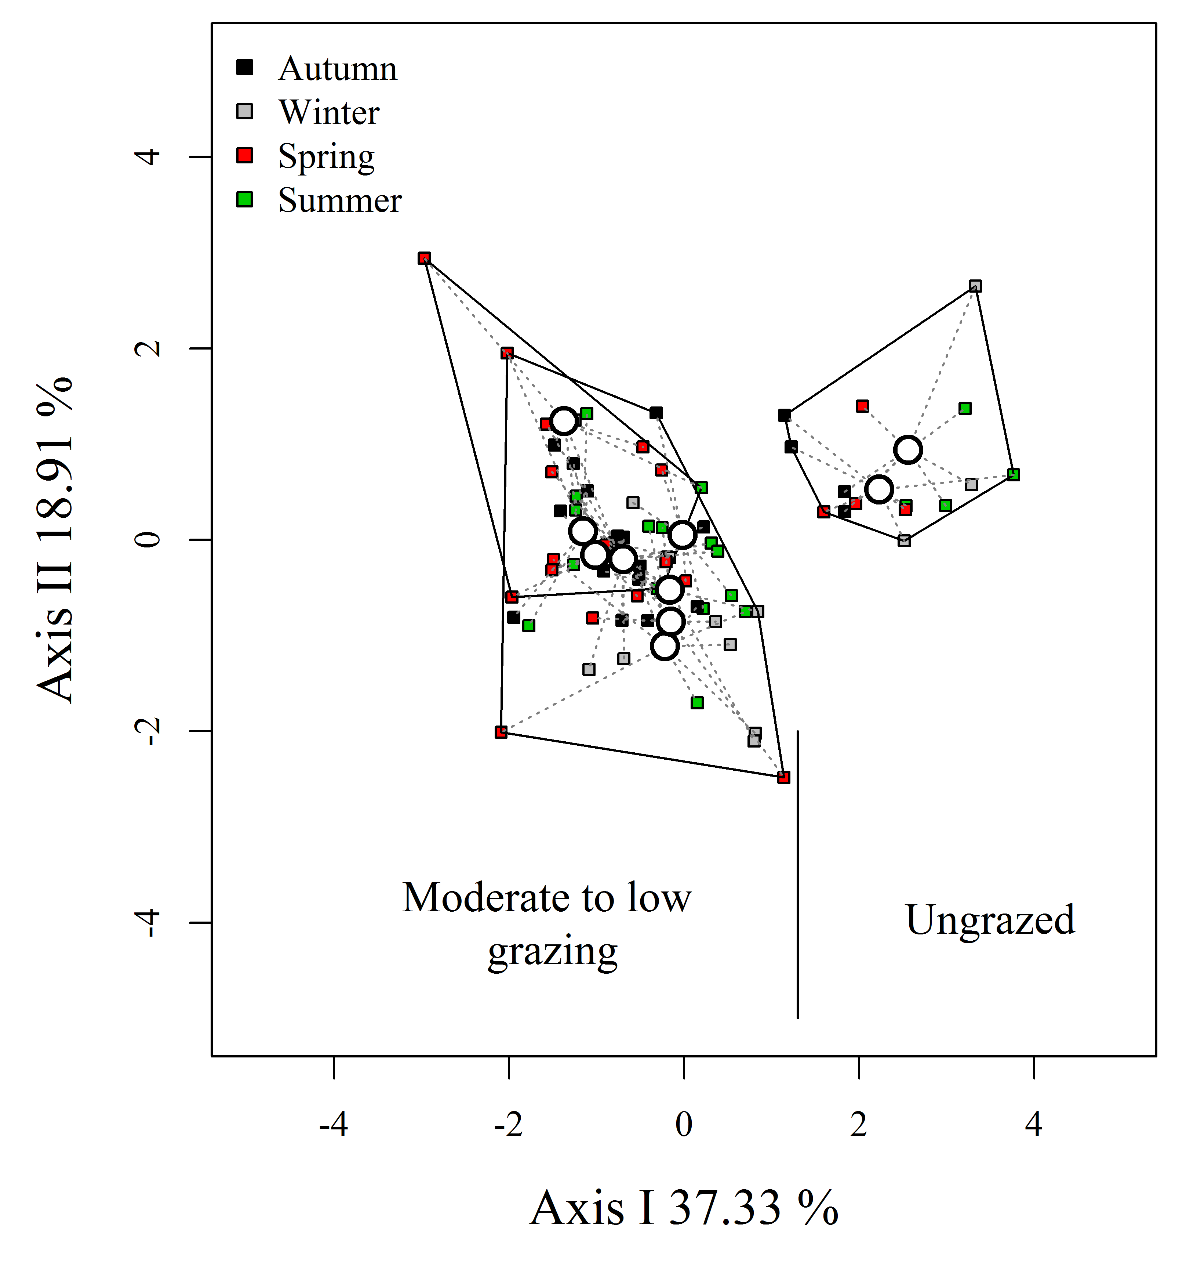
Fig. S2.1: Principal coordinate analysis plot showing the between-season and between-paddock variation in the habitat structure. Variation captured by the two first ordination axes is included within the axes labels. Convex hulls delimit paddock groups according to their grazing intensity; the lines inside each convex hull link the paddock centroid with the habitat of each season. We used the continuous value of the paddock centroid as the quantitative measurement of the grazing intensity. Data was collected from EMBRAPA (Bagé, RS).

Table S2.1: Correlations between habitat covariates and the axes of the Principal Coordinate Analysis (Fig S2.1).
 | Pcoa1 (37.33%) | Pcoa2 (18.91%)
Shrub height | 0.82 | 0.29
Tree height | 0.46 | 0.29
Tussock height | 0.72 | -0.3
Litter depth | 0.73 | -0.17
Bare ground | -0.41 | 0.69
Cattle dung | -0.39 | -0.62

The results of the single-season occupancy models run using the EMBRAPA data showed that, for Akodon azarae, the models that were more strongly supported included season as the covariate explaining the probability of detection (Table S2.1). The probability of detection was higher in the winter than in the non-winter months (Table S2.3). The probability of occupation increased with decreasing grazing intensity, although the confidence intervals were very wide (Fig S2.2).

Table S2.2: Model-selection table for Akodon azarae, with candidate models ranked according to their AICc. p = detection probability; ψ = occupation probability. PCO1= gradient of grazing intensity (Fig. S2.1). The models with stronger support are those with Delta AICc ≤ 4 (in bold).
Model | df | LogLik | AICc | Delta AICc | Weight
p(Season) ψ (.) | 3 | -100.294 | 210.6 | 0 | 0.875
p(Season) ψ (PCO1) | 4 | -99.263 | 214.5 | 3.94 | 0.122
p(Season+total height) ψ (PCO1) | 5 | -98.338 | 221.7 | 11.09 | 0.003
p(Trap) ψ (PCO1) | 4 | -116.29 | 248.6 | 37.99 | 0
p(.) ψ (.) | 2 | -122.456 | 250.6 | 40.04 | 0
p(Season: total height^2) ψ (PCO1^2) | 5 | -113.173 | 251.3 | 40.76 | 0
p(.) ψ (PCO1) | 3 | -121.431 | 252.9 | 42.27 | 0
p(Moon) ψ (PCO1) | 4 | -118.765 | 253.5 | 42.94 | 0
p(Total height) ψ (.) | 3 | -121.892 | 253.8 | 43.2 | 0
p(Total height^3) ψ (PCO1^3) | 4 | -120.816 | 257.6 | 47.04 | 0
p(Total height) ψ (PCO1) | 4 | -120.879 | 257.8 | 47.17 | 0
p(Total height^2) ψ (PCO1^2) | 4 | -121.42 | 258.8 | 48.25 | 0
p(Season: total height^3) ψ (PCO1^3) | 5 | -118.431 | 261.9 | 51.27 | 0
p(Season:total height) ψ (PCO1) | 5 | -120.012 | 265 | 54.44 | 0

Table S2.3: Estimates of the detection probabilities (p) of Akodon azarae, given as a function of the sampling occasion covariates.
Season | Detection probability | Standard Error | Linear combination  (logit scale)
Non-winter | 0.088 | 0.029 | -2.335
Winter | 0.592 | 0.067 | 0.374

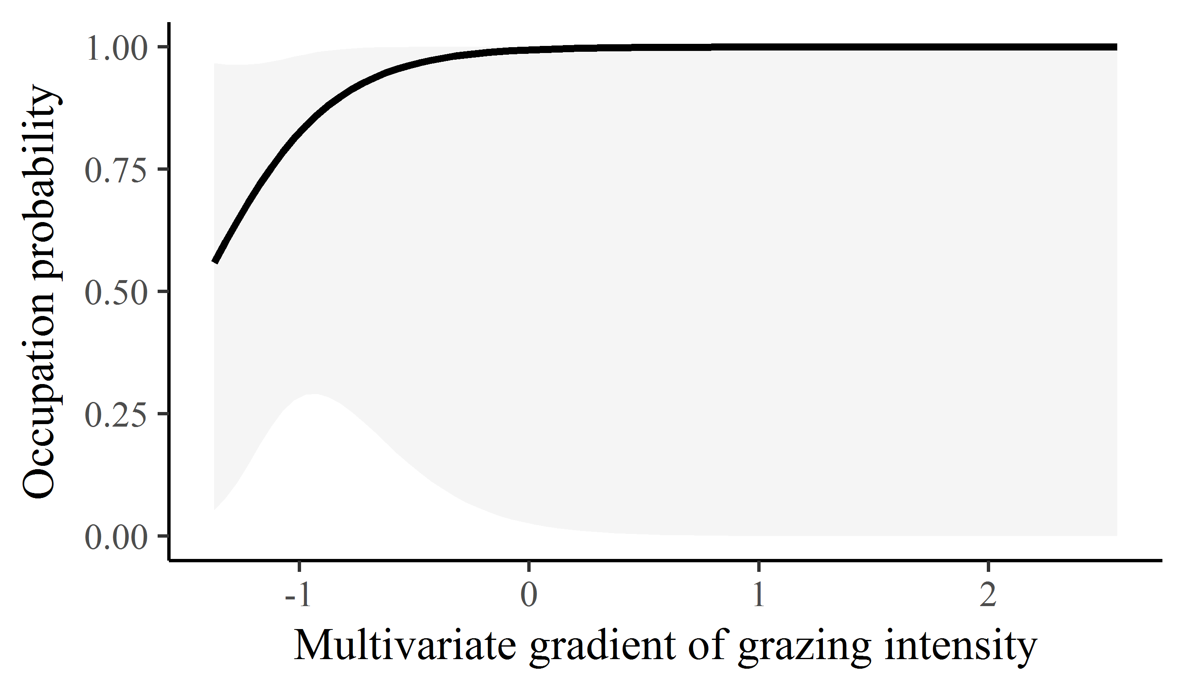
Fig. S2.2: Occupation probability (ψ) of Akodon azarae, given as a function of the gradient of grazing intensity. Values of the multivariate gradient of grazing intensity were extracted from Axis 1 of the Principal Coordinate Analysis (Fig. S2.1). The lowest negative values indicate the highest grazing intensities, whereas the highest positive values indicate the absence of grazing.

The results of the single-season occupancy models run using the EMBRAPA data showed that, for Oligoryzomys flavescens, the models that were more strongly supported included season as the covariate explaining the probability of detection (Table S2.4). The probability of detection was higher in the winter than in the non-winter months (Table S2.5). The probability of occupation was constant across the gradient of grazing intensity (Table S2.4).

Table S2.4: Model-selection table for Oligoryzomys flavescens, with candidate models ranked according to their AICc. p = detection probability; ψ = occupation probability. PCO1= gradient of grazing intensity (Fig. S2.1). The models with stronger support are those with Delta AICc ≤ 4 (in bold).
Model | df | LogLik | AICc | Delta AICc | Weight
p(Season) ψ (.) | 3 | -59.933 | 129.9 | 0 | 0.906
p(Season) ψ (PCO1) | 4 | -59.259 | 134.5 | 4.65 | 0.088
p(Season+total height) ψ (PCO1) | 5 | -57.463 | 139.9 | 10.06 | 0.006
p(.) ψ (.) | 2 | -71.533 | 148.8 | 18.91 | 0
p(Total height) ψ (.) | 3 | -70.015 | 150 | 20.16 | 0
p(.) ψ (PCO1) | 3 | -70.866 | 151.7 | 21.87 | 0
p(Total height^2) ψ (PCO1^2) | 4 | -68.975 | 154 | 24.08 | 0
p(Total height) ψ (PCO1) | 4 | -69.422 | 154.8 | 24.98 | 0
p(Total height^3) ψ (PCO1^3) | 4 | -69.699 | 155.4 | 25.53 | 0
p(Season: total height^2) ψ (PCO1^2) | 5 | -66.158 | 157.3 | 27.45 | 0
p(Trap) ψ (PCO1) | 4 | -70.675 | 157.3 | 27.48 | 0
p(Season:total height) ψ (PCO1) | 5 | -68.213 | 161.4 | 31.56 | 0
p(Season: total height^3) ψ (PCO1^3) | 5 | -68.718 | 162.4 | 32.57 | 0
p(Moon) ψ (PCO1) | 4 | -118.765 | 253.5 | 123.66 | 0

Table S2.5: Estimates of the detection probabilities (p) of Oligoryzomys flavescens, given as a function of the sampling occasion covariates.
Season | Detection probability | Standard Error | Linear combination  (logit scale)
Non-winter | 0.0914 | 0.0413 | -2.297
Winter | 0.441 | 0.084 | -0.237

The results of the single-season occupancy models run using the EMBRAPA data showed that, for Oxymycterus nasutus, the models with the stronger support included season and total vegetation height as the covariates explaining the probability of detection (Table S2.6). The probability of detection was higher in the winter than in the non-winter months (Table S2.7), and it was also higher in areas with taller vegetation (Table S2.7). The probability of occupation increased with decreasing grazing intensity, although the confidence intervals were very wide (Fig S2.3).

Table S2.6: Model-selection table for Oxymycterus nasutus, with candidate models ranked according to their AICc. p = detection probability; ψ = occupation probability. PCO1= gradient of grazing intensity (Fig. S2.1). The models with stronger support are those with Delta AICc ≤ 4 (in bold).
Model | df | LogLik | AICc | Delta AICc | Weight
p(Total height) ψ (.) | 3 | -55.178 | 120.4 | 0 | 0.316
p(Season+total height) ψ (PCO1) | 5 | -47.871 | 120.7 | 0.38 | 0.261
p(Season) ψ (.) | 3 | -55.804 | 121.6 | 1.25 | 0.169
p(Total height) ψ (PCO1) | 4 | -53.269 | 122.5 | 2.18 | 0.106
p(Season) ψ (PCO1) | 4 | -53.779 | 123.6 | 3.2 | 0.064
p(Total height^3) ψ (PCO1^3) | 4 | -54.627 | 125.3 | 4.9 | 0.027
p(Total height^2) ψ (PCO1^2) | 4 | -55.042 | 126.1 | 5.73 | 0.018
p(.) ψ (.) | 2 | -60.71 | 127.1 | 6.78 | 0.011
p(.) ψ (PCO1) | 3 | -58.686 | 127.4 | 7.02 | 0.009
p(Season:total height) ψ (PCO1) | 5 | -51.234 | 127.5 | 7.11 | 0.009
p(Season: total height^3) ψ (PCO1^3) | 5 | -51.81 | 128.6 | 8.26 | 0.005
p(Season: total height^2) ψ (PCO1^2) | 5 | -51.978 | 129 | 8.6 | 0.004
p(Moon) ψ (PCO1) | 4 | -58.412 | 132.8 | 12.47 | 0.001
p(Trap) ψ (PCO1) | 4 | -58.494 | 133 | 12.63 | 0.001

Table S2.7: Estimates of the detection probabilities (p) of Oxymycterus nasutus, given as a function of the sampling occasion covariates.
Detection probability | Standard Error | Linear combination  (logit scale) | Season | Total vegetation height (cm)
0.0117 | 0.0132 | -4.438 | Non-winter | 4
0.0272 | 0.0241 | -3.575 |  | 42
0.0622 | 0.0415 | -2.713 |  | 104.3
0.2712 | 0.1153 | -0.988 |  | 166
0.4685 | 0.176 | -0.126 |  | 228
0.657 | 0.1992 | 0.65 |  | 284
0.0411 | 0.0457 | -3.149 | Winter | 4
0.0922 | 0.0759 | -2.287 |  | 42
0.1939 | 0.1062 | -1.425 |  | 104.3
0.5744 | 0.1159 | 0.3 |  | 166
0.7617 | 0.1071 | 1.162 |  | 228
0.8742 | 0.085 | 1.938 |  | 284

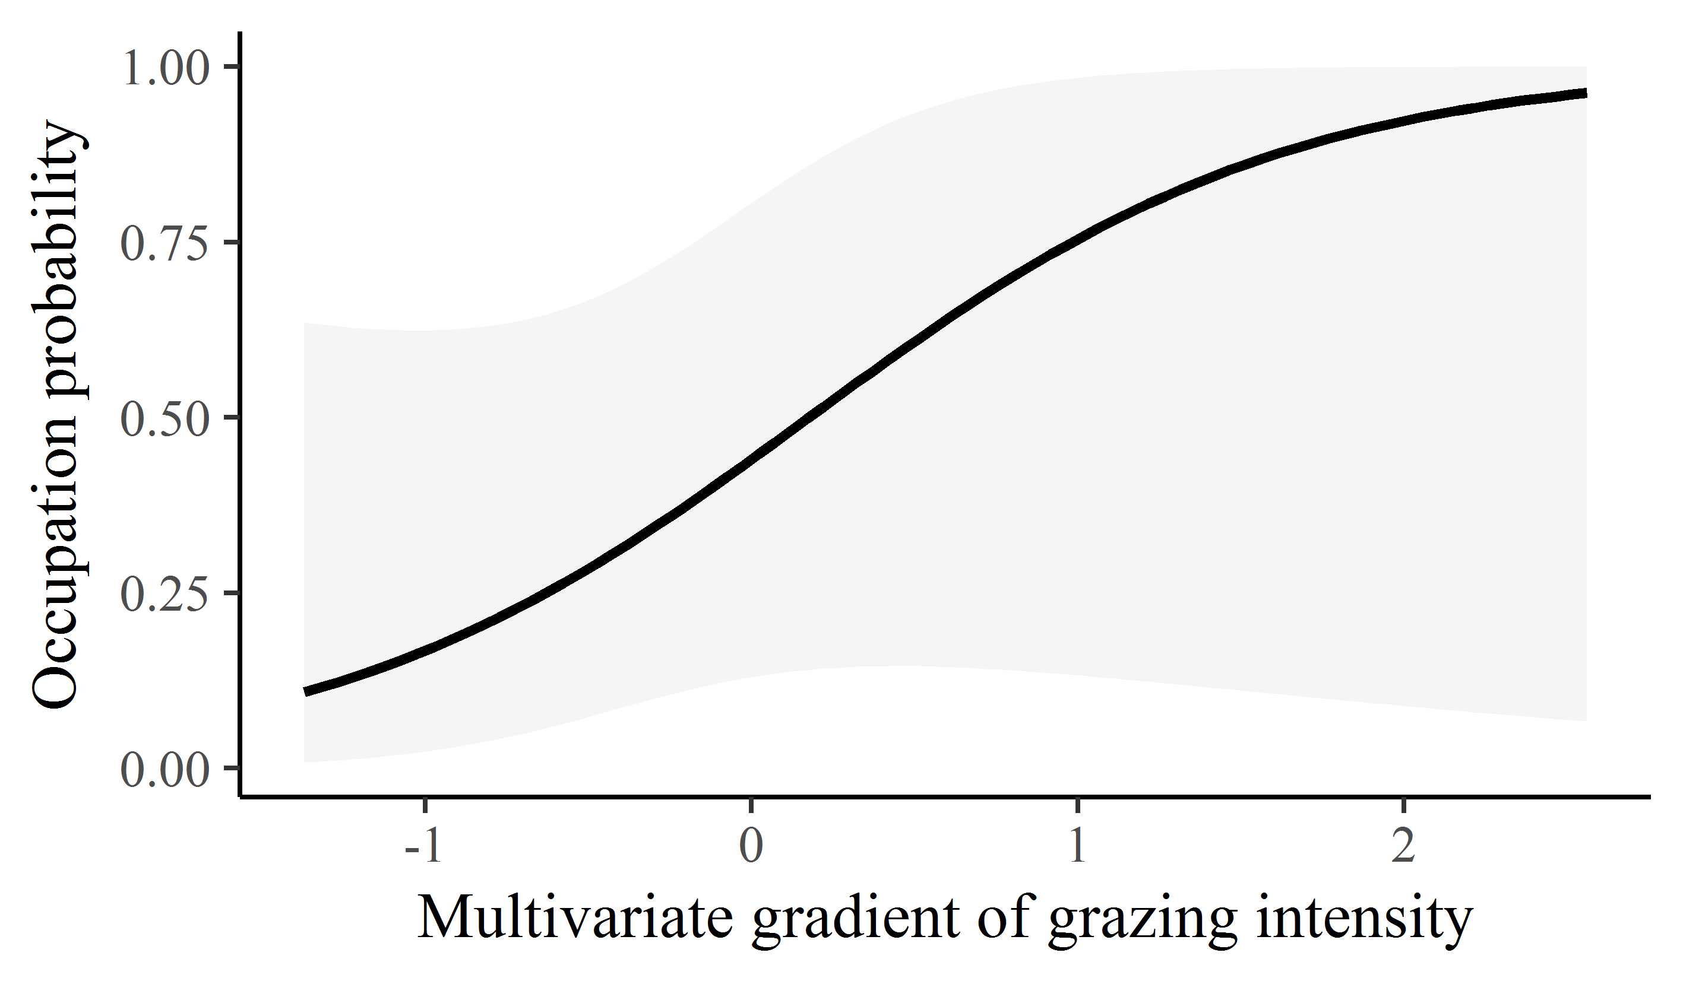
Fig. S2.3: Occupation probability (ψ) of Oxymycterus nasutus as a function of the gradient of grazing intensity. Values of the multivariate gradient of grazing intensity were extracted from Axis 1 of the Principal Coordinate Analysis (Fig. S2.1). The lowest negative values indicate the highest grazing intensities, whereas the highest positive values indicate the absence of grazing.

