Supporting information to the paper Baggio et al. Effects of initial disturbances and grazing regime on native grassland invasion by Eragrostis plana in southern Brazil

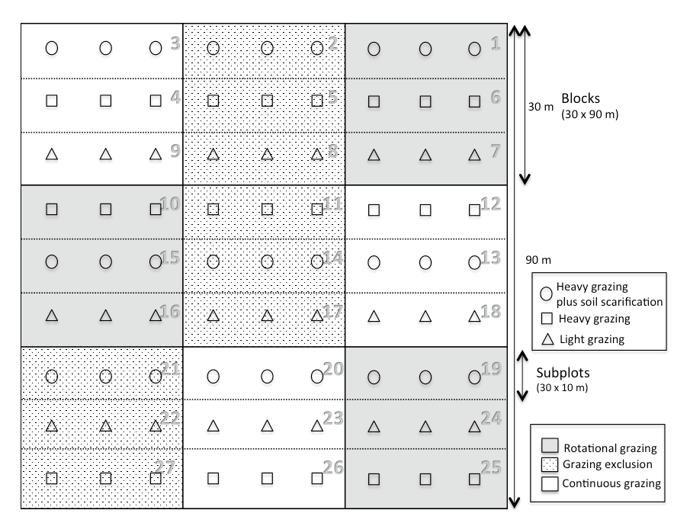
Appendix S1. Experimental design used in this work, which was a split-plot design with three complete blocks of 30 x 90 m. Management regime treatments, namely continuous grazing, rotational grazing, and grazing exclusion, were applied in the main plots of 30 x 30 m. Levels of initial disturbance, namely light grazing (triangle), heavy grazing (circle), and heavy grazing plus soil scarification (square) were applied in subplots of 30 x 10 m. The 27 subplots were the actual experimental units evaluated during the experiment, which were subsampled by three permanent quadrats of 0.5 x 0.5 m.

