Supplementary Material for

From Hotspot to Hopespot: an Opportunity for the Brazilian Atlantic Forest

C. L. Rezende*, F. R. Scarano, E. D. Assad, C. A. Joly, J. P. Metzger, B. B. N. Strassburg, M. Tabarelli, G. A. Fonseca, R. A. Mittermeier

Correspondence to: clrezende@fbds.org.br

**Accuracy Assessment**

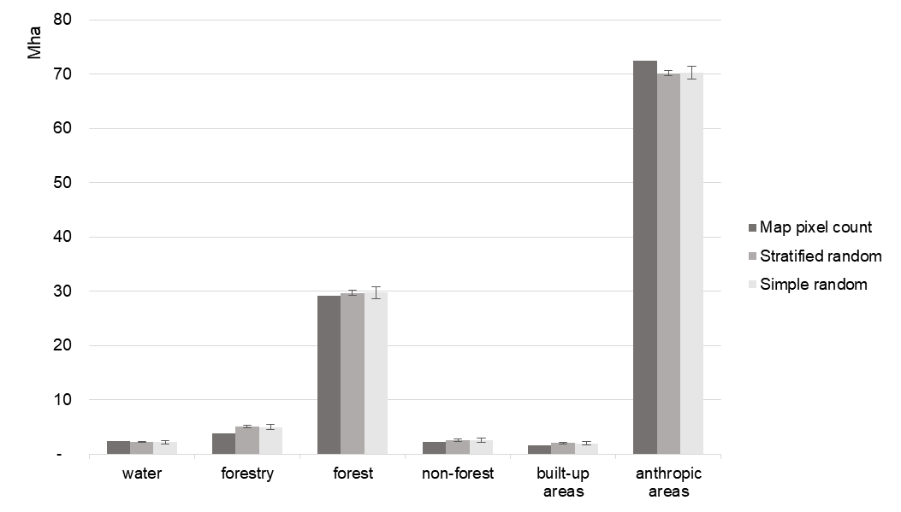

**Fig. S1. Area estimates from map, stratified and simple random sampling designs.** Darker grey bars represent measured areas; medium and light grey bars represent estimated areas based on stratified and simple random sampling approach respectively, with 95% confidence interval.

**Table S1. Confusion matrix of the accuracy assessment of the land use and cover mapping.**

|  |  |  |  |  |  |  |
| --- | --- | --- | --- | --- | --- | --- |
|  | Water | Forestry | Forest | Non-forest | Built-up areas | Anthropic  areas |
| Water | 39 | 0 | 0 | 1 | 0 | 0 |
| Forestry | 0 | 66 | 0 | 0 | 0 | 0 |
| Forest | 0 | 16 | 482 | 3 | 0 | 15 |
| Non-forest | 0 | 0 | 6 | 31 | 0 | 3 |
| Built-up areas | 0 | 0 | 1 | 0 | 26 | 1 |
| Anthropic areas | 0 | 6 | 35 | 10 | 9 | 1220 |
| **Sum** | **40** | **90** | **527** | **49** | **40** | **1245** |

**Estimation of Areas of Permanent Preservation (APP)**

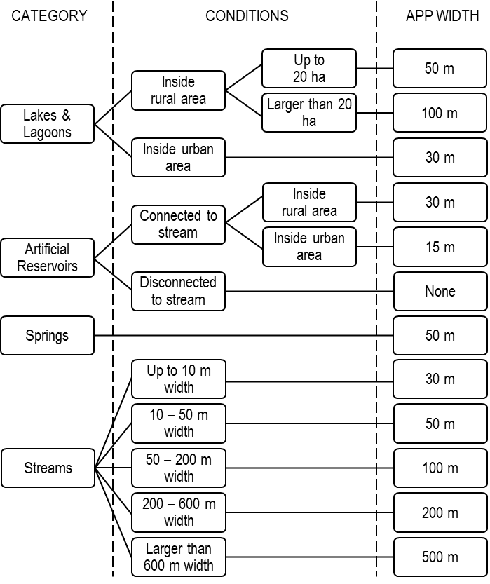

**Fig. S2. Marginal strip values used for the estimation of Areas of Permanent Preservation (APP), as defined by the Brazilian Law.** Adapted from Rezende et al.(2018).

**Map Comparison**

We compared our map to the one produced by SOS Mata Atlântica & INPE (2015) for the same period (2013-2014) by creating a 10 x 10 km cell grid for the biome, and calculating the total amount of native cover (including forest and non-forest formations) mapped respectively by both initiatives in each cell. We then subtracted the total amount of native cover in our mapping by the total of the SOS Mata Atlântica & INPE´s map. Result shows that we mapped more native cover in most part of the biome (95% of total cells). In 85.7% of the cells we found a difference of up to 3,000 hectares, 9.2% of the cells presented a difference of 3,000 to 6,000 and 0.5% presented a difference of more than 6,000 hectares (Fig. S3). We also selected three localities, considering different forest cover conditions, that illustrates the mains types of differences found between both studies and plotted these maps as examples (Figs. S4 – S6).

For this comparison, we considered the limits of the biome established by the Brazilian Ministry of Environment, which was used to delimit our mapping area. The study area of SOS Mata Atlântica & INPE´s mapping also considers transition areas to other biomes, which were not considered for this analysis.

In order to analyze fragments sizes distribution, we converted the polygons of native vegetation to binary matrices, respecting the original resolution of each data (5 meters for this study and 30 meters for SOS Mata Atlântica & INPE). Then we run a cluster analysis in GRASS GIS v7.4, using an 8-pixel neighboring rule to identify patches in each matrix. Size classes where then summarized and plotted against their total area.

The results of this analysis indicate that the pattern of double vegetation cover mapped applies for fragments of all sizes, with few exceptions. For the great majority of size classes – considering intervals of 50, 500, 5,000, and 50,000 – this study mapped approximately twice more vegetation cover (Fig. S7). This pattern reflects in absolute number of fragments mapped by both studies: considering the size classes mapped by SOS Mata Atlântica & INPE (above 3 ha), our study mapped 2.3 times more fragments than the SOS Mata Atlântica & INPE map. Regarding total area mapped in fragments above 3 ha, our study mapped 1.9 times more area than the SOS Mata Atlântica & INPE map.

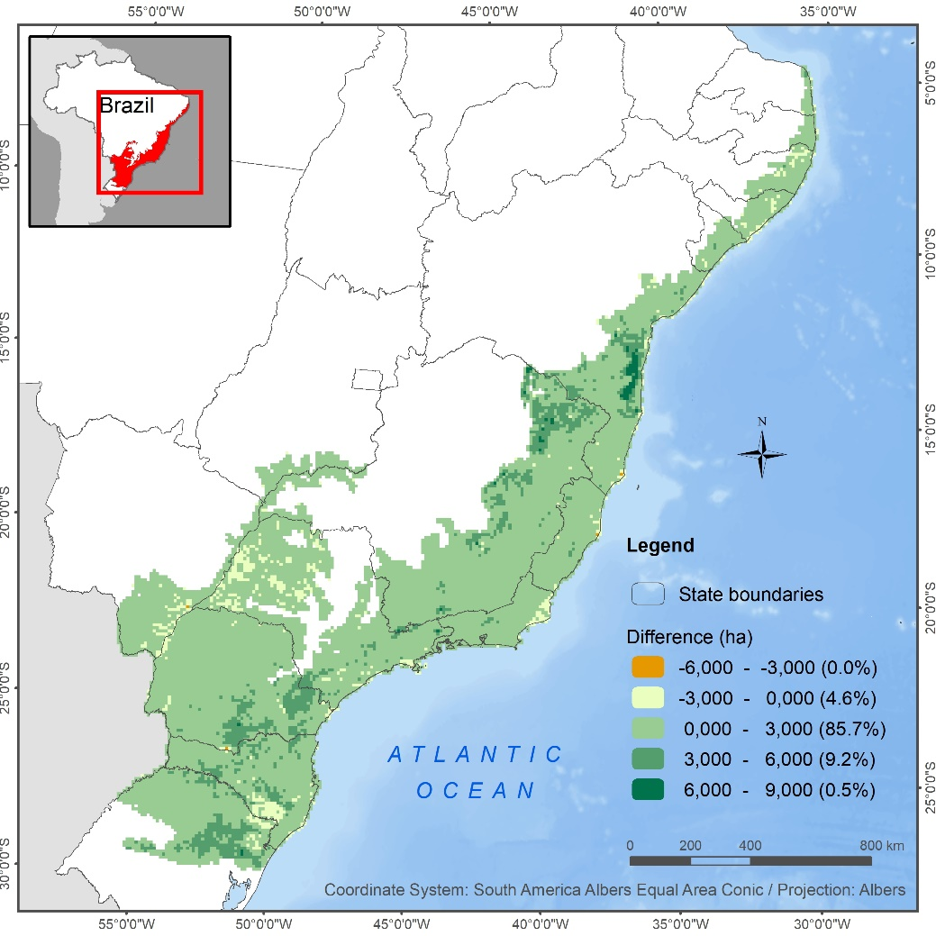

**Fig. S3.** **Comparison of native vegetation cover mapped by this study and SOS Mata Atlântica & INPE for the year 2013, using 10 x 10 km cells.** Color scale shows the results of the difference between the total native cover mapped by our initiative and that of SOS Mata Atlântica & INPE´s. Green areas show the regions where our study identified larger areas of native cover as compared to SOS Mata Atlântica & INPE.

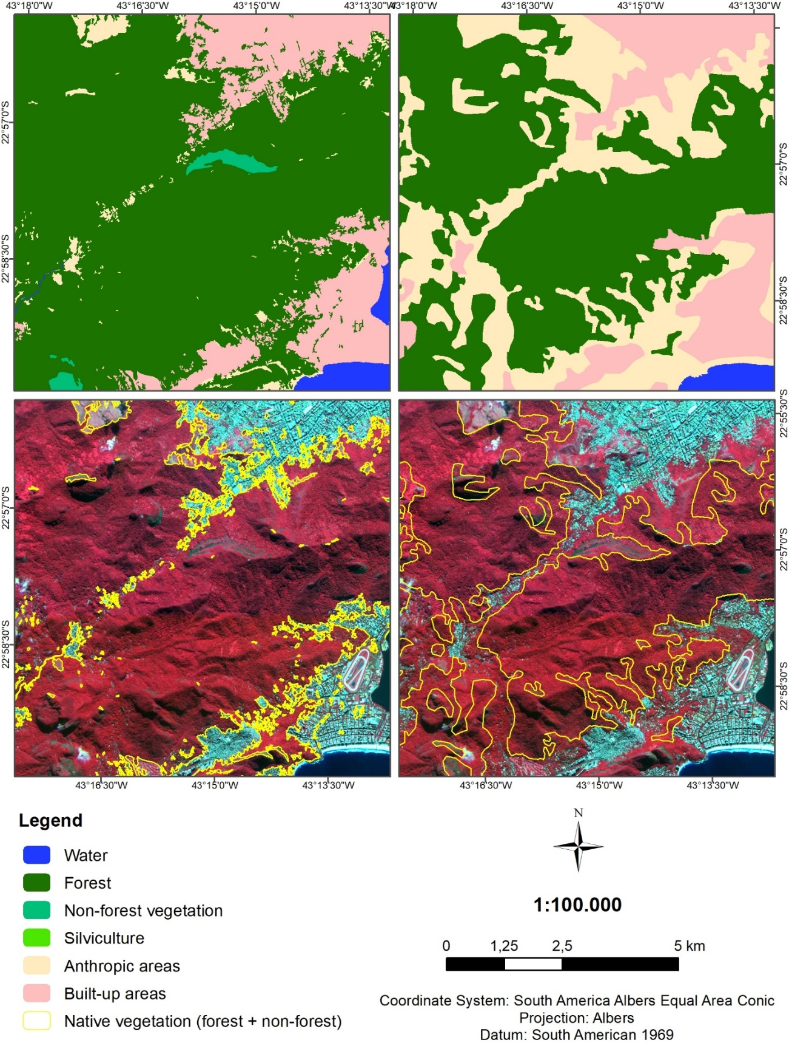

**A**

**B**

**C**

**D**

**Fig. S4. Comparative of maps produced of this study (A, C) and SOS Mata Atlântica & INPE (B, D) for the base year 2013, in the Tijuca Forest, Rio de Janeiro, RJ, Brazil.** Satellite imagery used in C and D is a RapidEye composition in RGB 532. Main differences in this area are due to the detection of non-native forest formations (rupicolous vegetation) and larger areas of forest by this study.

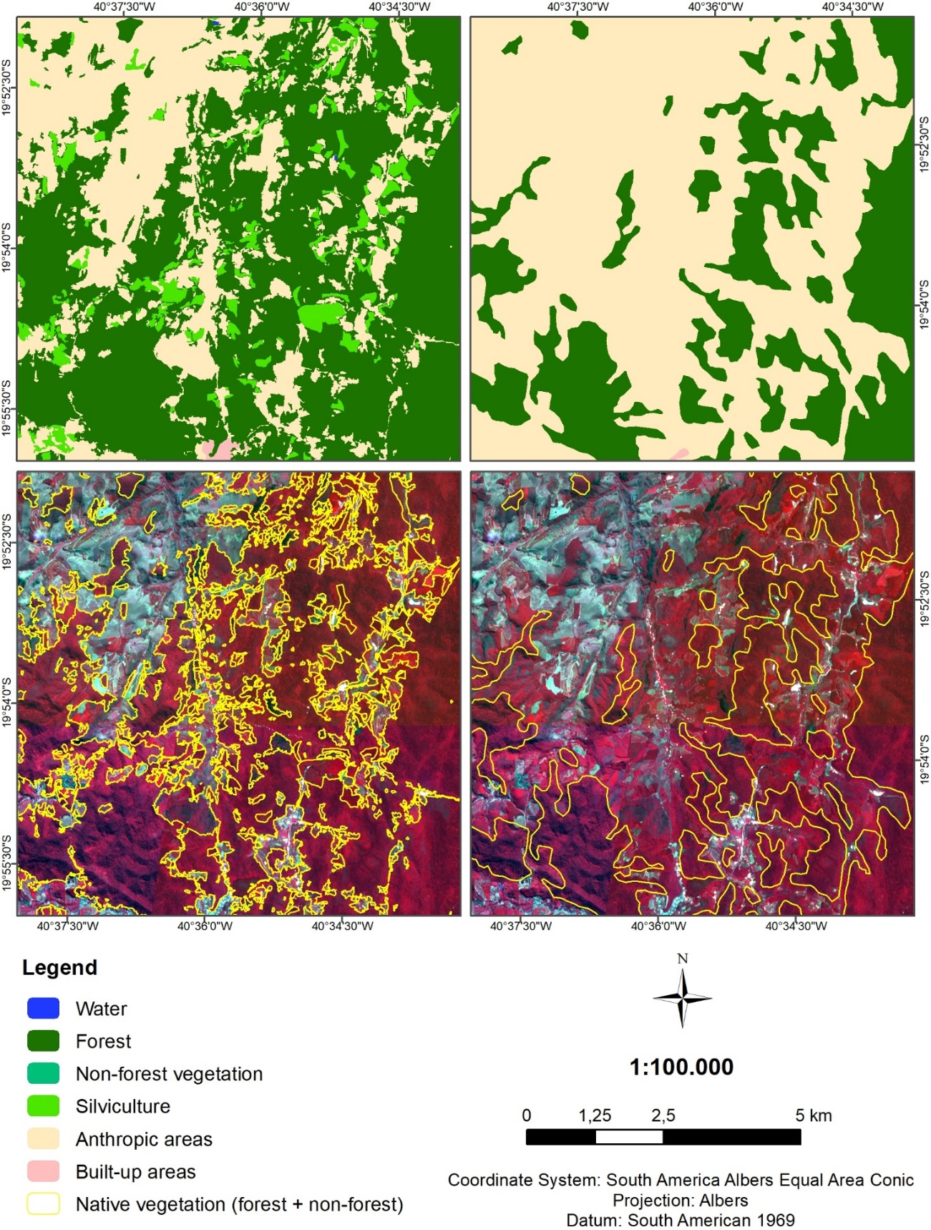

**A**

**B**

**C**

**D**

**Fig. S5. Comparative of maps produced of this study (A, C) and SOS Mata Atlântica & INPE (B, D) for the base year 2013, in the municipality of Santa Teresa, ES, Brazil.** Satellite imagery used in C and D is a RapidEye composition in RGB 532. Main differences in this area are due to the inclusion of larger areas of forest by this study.

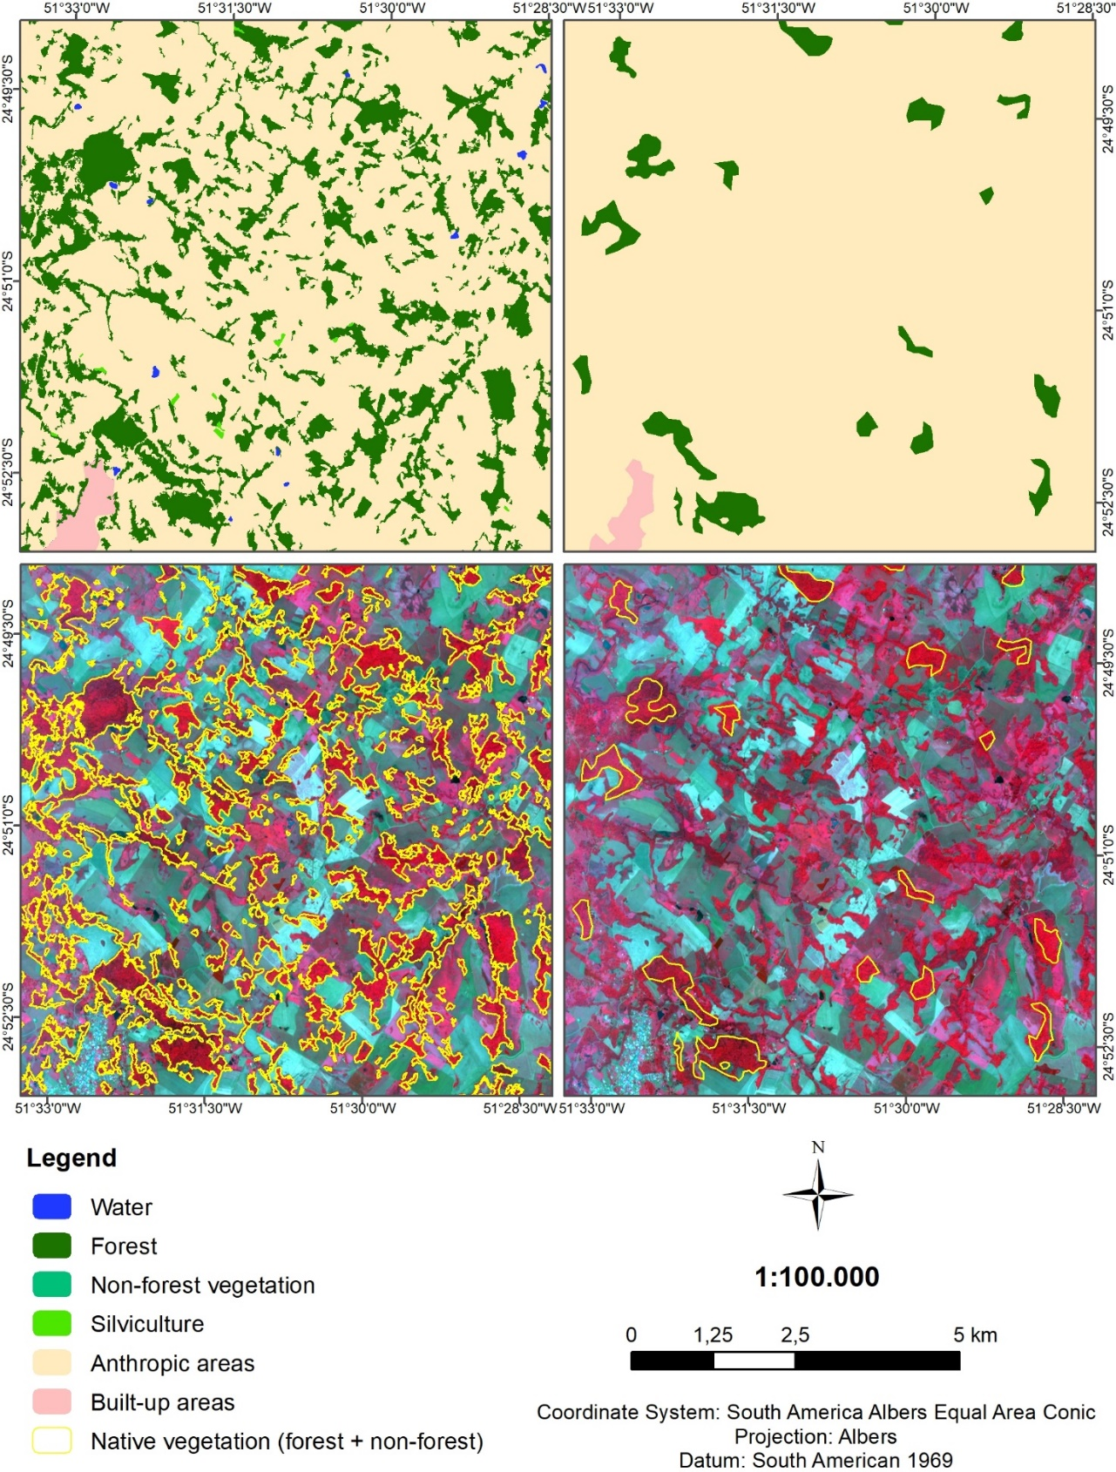

**A**

**B**

**C**

**D**

**Fig. S6. Comparative of maps produced of this study (A, C) and SOS Mata Atlântica & INPE (B, D) for the base year 2013, in the municipality of São Roque de Boa Ventura, PR, Brazil.** Satellite imagery used in C and D is a RapidEye composition in RGB 532. Main differences in this area are due to the detection of small fragments (4.2 ha in average) by this study.

|  |
| --- |
|  |
|  |

**Fig. S7. Class size distribution of native vegetation cover mapped by this study (dark grey) and SOS Mata Atlântica & INPE (light grey).** The graphs show total area covered by each fragments size class, with intervals of 50 ha (A) and 500 ha (B). Numbers on top of the bars shows the proportion between the area mapped by this study and SOS Mata Atlântica & INPE.

**References**

Rezende, C.L., Fraga, J.S., Sessa, J.C., Souza, G.V.P. de, Assad, E.D., Scarano, F.R., 2018. Land use policy as a driver for climate change adaptation: A case in the domain of the Brazilian Atlantic forest. Land Use Policy. https://doi.org/10.1016/j.landusepol.2018.01.027

SOS Mata Atlântica, INPE, 2015. Atlas dos remanescentes florestais da Mata Atlântica: período 2013 - 2014. São Paulo.