Appendix S1 – Similar effects of landscape metrics on primary production considering landscapes of 400 ha.
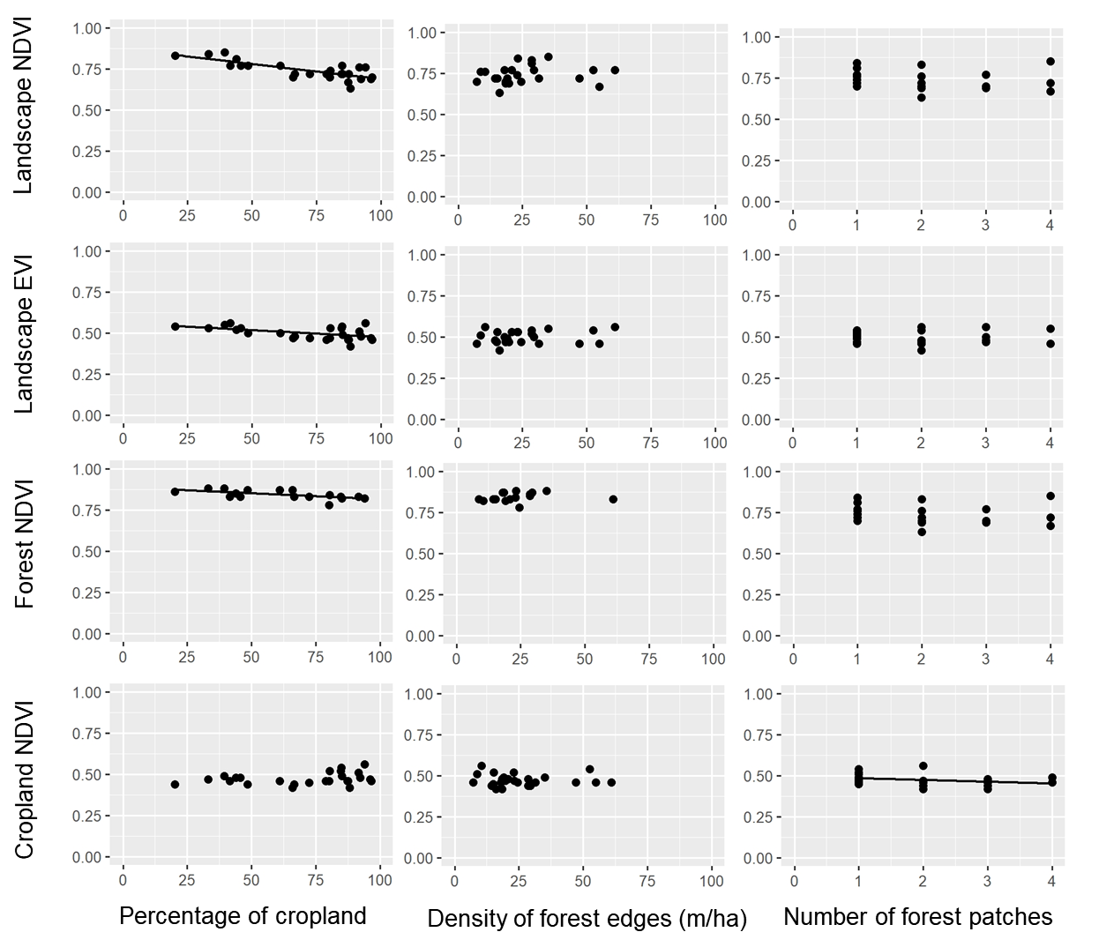
Figure 1. Relationships between the percentage of croplands, density of forest edges, number of forest patches and the mean value of the vegetation indices (NDVI and EVI) of croplands, forests and the entire landscape during the rainy seasons of 2011-2016. Statistical significance of the relationships is shown in Table 1. The significant relationships are represented by a fitted line in the plots.
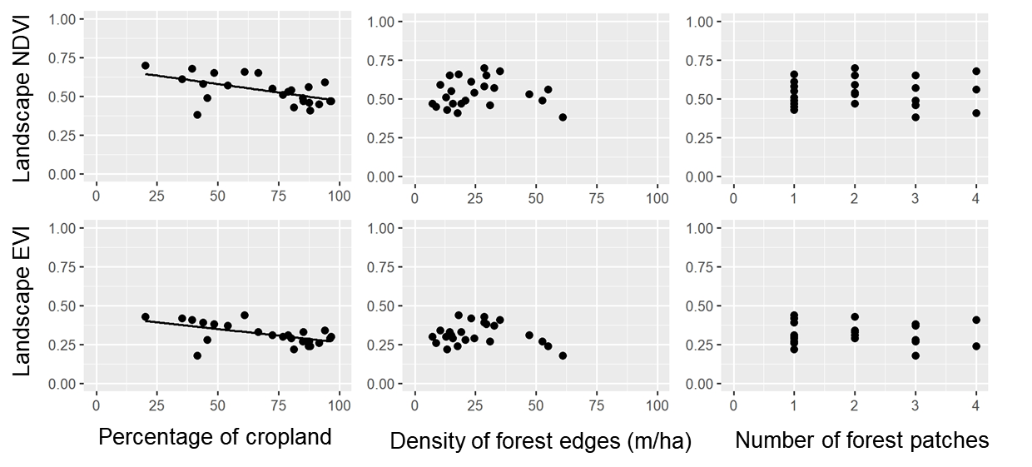
Figure 2. Relationships between the percentage of croplands, density of forest edges, number of forest patches and the mean value of the vegetation indices (NDVI and EVI) of the entire landscape during the dry seasons of 2011-2016. Statistical significance of the relationships is shown in Table 1. The significant relationships are represented by a fitted line in the plots.

Table 1. Results of generalized linear models examining the effect of the percentage of croplands, density of forest edges and number of forest patches on the mean value of the vegetation indices NDVI and EVI and their coefficient of variation during the rainy and dry seasons of 2011-2016. The estimate of model terms is shown in bold for significant relationships only (see also Figures 1 and 2). Chi-squared and R² values are reported. Models were based on 25 landscapes of 400 ha.
Model factors
Response variable | Full model |  | Percentage of  croplands |  |  | Density of  forest edges |  |  | Number of  Forest patches
 | χ² | R² | χ² | P | est | χ² | P | est | χ² | P | est
Rainy season
Landscape NDVI | 24.68 | 0.62 | 22.61 | <0.001* | (-0.001) | 0.13 | 0.71^{n.s.} |  | 1.83 | 0.17^{n.s.}
Landscape EVI | 9.83 | 0.32 | 6.61 | <0.01* | (-0.001) | 1.06 | 0.30 ^{n.s.} |  | 2.23 | 0.13^{n.s.}
Forest NDVI | 12.14 | 0.51 | 10.65 | <0.001* | (-0.001) | 3.75 | 0.05^{n.s.} |  | 1.82 | 0.17^{n.s.}
Forest EVI | 2.51 | 0.13 | 2.11 | 0.14^{n.s.} |  | 1.58 | 0.20^{n.s.} |  | 0.00 | 0.97^{n.s.}
Cropland NDVI | 6.68 | 0.23 | 3.41 | 0.06^{n.s.} |  | 1.54 | 0.21^{n.s.} |  | 4.17 | 0.04* | (-0.013)
Cropland EVI | 2.78 | 0.10 | 0.01 | 0.89 ^{n.s.} |  | 0.79 | 0.37^{n.s.} |  | 2.68 | 0.10^{n.s.}
Forest CV NDVI | 0.70 | 0.04 | 0.09 | 0.75^{n.s.} |  | 0.25 | 0.61^{n.s.} |  | 0.51 | 0.47^{n.s.}
Forest CV EVI | 1.89 | 0.11 | 0.02 | 0.87^{n.s.} |  | 0.18 | 0.66^{n.s.} |  | 1.68 | 0.19^{n.s.}
Cropland CV NDVI | 2.35 | 0.08 | 0.42 | 0.51^{n.s.} |  | 1.68 | 0.19^{n.s.} |  | 1.59 | 0.20^{n.s.}
Cropland CV EVI | 1.72 | 0.06 | 0.04 | 0.83^{n.s.} |  | 1.48 | 0.22^{n.s.} |  | 0.96 | 0.32^{n.s.}
Dry season
Landscape NDVI | 9.83 | 0.33 | 9.73 | <0.001* | (-0.002) | 1.08 | 0.29^{n.s.} |  | 0.01 | 0.90^{n.s.}
Landscape EVI | 14.30 | 0.44 | 13.29 | <0.001* | (-0.002) | 3.20 | 0.07^{n.s.} |  | 0.52 | 0.47^{n.s.}
Forest NDVI | 5.84 | 0.25 | 3.13 | 0.07^{n.s.} |  | 3.82 | 0.05^{n.s.} |  | 0.92 | 0.33^{n.s.}
Forest EVI | 4.59 | 0.20 | 3.10 | 0.07^{n.s.} |  | 2.64 | 0.10^{n.s.} |  | 0.19 | 0.65^{n.s.}
Cropland NDVI | 1.12 | 0.04 | 1.04 | 0.30^{n.s.} |  | 0.08 | 0.77^{n.s.} |  | 0.08 | 0.77^{n.s.}
Cropland EVI | 6.04 | 0.22 | 2.10 | 0.14^{n.s.} |  | 2.36 | 0.12^{n.s.} |  | 1.12 | 0.28^{n.s.}
Forest CV NDVI | 1.48 | 0.07 | 0.31 | 0.5 ^{n.s.} |  | 0.00 | 0.97^{n.s.} |  | 0.87 | 0.35^{n.s.}
Forest CV EVI | 3.30 | 0.16 | 2.16 | 0.14^{n.s.} |  | 2.18 | 0.13^{n.s.} |  | 0.15 | 0.69^{n.s.}
Cropland CV NDVI | 3.46 | 0.13 | 1.36 | 0.24^{n.s.} |  | 0.01 | 0.90^{n.s.} |  | 2.33 | 0.12^{n.s.}
Cropland CV EVI | 3.92 | 0.15 | 0.42 | 0.51^{n.s.} |  | 0.31 | 0.57^{n.s.} |  | 3.66 | 0.05^{n.s.}

