Appendix

Can we produce more beef without increasing its environmental impact? Argentina as a case study
Carlos Gonzalez Fischer and David Bilenca

Table I: Description of cow-calf systems for the study area in Argentina. *’Other’ includes grain, silage and hay. Adapted from: MAyDS, 2017. Segundo Informe Bienal de Actualización de la Republica Argentina a la Convencion Marco de las Naciones Unidas sobre el Cambio Climatico.
 | Region | System | Weaning rate | Weaning age (months) | Replacement rate | Age at first service (months) | Diet (% of dry matter intake)
 |  |  |  |  |  |  | Natural vegetation | Pastures | Summer grazing crops | Winter grazing crops | Other*
1 | South-eastern Pampa | high productivity | 81% | 6 | 22% | 15 | 55% | 10% | 15% | 20% | -
2 | South-eastern Pampa | medium productivity | 80% | 7 | 17% | 27 | 75% | 5% | 10% | 10% | -
3 | South-eastern Pampa | low productivity | 73% | 8 | 14% | 27 | 100% | - | - | - | -
4 | South-western Pampa | high productivity | 84% | 6 | 22% | 15 | 15% | 45% | 40% | - | -
5 | South-western Pampa | medium productivity | 80% | 7 | 17% | 22 | 65% | 30% | 5% | - | -
6 | South-western Pampa | low productivity | 63% | 8 | 14% | 27 | 80% | 20% | - | - | -
7 | Western Pampa | high productivity | 83% | 6 | 22% | 15 | 70% | 20% | - | - | 10%
8 | Western Pampa | medium productivity | 66% | 7 | 17% | 22 | 85% | 10% | - | - | 5%
9 | Western Pampa | low productivity | 49% | 8 | 14% | 27 | 90% | 10% | - | - | -
10 | Northern Pampa | high productivity | 76% | 6 | 22% | 15 | 90% | 2% | 5% | - | 3%
11 | Northern Pampa | medium productivity | 63% | 7 | 17% | 22 | 95% | 1% | 2% | - | 2%
12 | Northern Pampa | low productivity | 39% | 8 | 14% | 27 | 100% | - | - | - | -
13 | North-eastern Argentina | high productivity | 80% | 6 | 22% | 24 | 80% | 15% | - | 5% | -
14 | North-eastern Argentina | medium productivity | 72% | 7 | 17% | 24 | 95% | 4% | - | 1% | -
15 | North-eastern Argentina | low productivity | 34% | 8 | 14% | 36 | 100% | - | - | - | -
16 | North-western Argentina | high productivity | 83% | 6 | 22% | 27 | 40% | 60% | - | - | -
17 | North-western Argentina | medium productivity | 76% | 7 | 17% | 27 | 80% | 20% | - | - | -
18 | North-western Argentina | low productivity | 34% | 8 | 14% | 36 | 100% | - | - | - | -
19 | Semiarid region | high productivity | 83% | 6 | 22% | 20 | 55% | 45% | - | - | -
20 | Semiarid region | medium productivity | 68% | 7 | 17% | 24 | 90% | 10% | - | - | -
21 | Semiarid region | low productivity | 58% | 8 | 14% | 27 | 100% | - | - | - | -

Table II: Description of finishing systems for the study area in Argentina. *’Other’ includes grain, silage and hay. Adapted from: MAyDS, 2017. Segundo Informe Bienal De Actualización de la Republica Argentina a la Convencion Marco de las Naciones Unidas sobre el Cambio Climatico.
 | Region | System | Type of system | Initial live weight (kg) | Final live weight (kg) | Length of finishing stage (days) | Diet (% of dry matter intake)
 |  |  |  |  |  |  | Natural vegetation | Pastures | Summer grazing crops | Winter grazing crops | Other*
1 | North-eastern Argentina | SE2 - corr + past liviano | mixed | 160 | 390 | 420 | - | 50% | - | - | 50%
2 | North-eastern Argentina | SE3 - past + corr liviano | mixed | 180 | 430 | 480 | - | 60% | - | - | 40%
3 | North-eastern Argentina | SE1 - Pastoril Liviano | grazing | 160 | 350 | 300 | - | 50% | 35% | - | 15%
4 | North-eastern Argentina | SE4 - pastoril liviano | grazing | 180 | 440 | 720 | 45% | 40% | - | - | 15%
5 | North-eastern Argentina | SE5 - past pesado corto | grazing | 180 | 480 | 720 | 60% | - | 25% | - | 15%
6 | North-eastern Argentina | SE6 - past pesado largo | grazing | 180 | 520 | 1080 | 100% | - | - | - | -
7 | North-eastern Argentina | SE7 - Pastoril Corto | grazing | 160 | 320 | 270 | - | 35% | 55% | - | 10%
8 | North-eastern Argentina | SE8 - Pastoril Largo | grazing | 160 | 350 | 360 | 60% | 25% | - | - | 15%
9 | North-western Argentina | SE1 - corral corto | confined | 170 | 320 | 180 | - | - | - | - | 100%
10 | North-western Argentina | SE2 - past.+corral | mixed | 180 | 350 | 360 | - | 70% | - | - | 30%
11 | North-western Argentina | SE3 - Past.+corral | mixed | 160 | 320 | 330 | - | 45% | - | - | 55%
12 | Northern Pampa | SE1 - Silo + Corral | confined | 160 | 350 | 210 | - | - | - | - | 100%
13 | Northern Pampa | SE2 - Past + Corral | mixed | 160 | 400 | 270 | - | 20% | - | 30% | 50%
14 | Northern Pampa | SE3 - Past + Corral | mixed | 170 | 400 | 480 | 70% | - | - | - | 30%
15 | Northern Pampa | SE6 - Isla + Corral | mixed | 170 | 480 | 720 | 70% | - | - | - | 30%
16 | Northern Pampa | SE4 - Pastoril | grazing | 170 | 420 | 330 | - | 65% | - | 25% | 10%
17 | Northern Pampa | SE5 - Pastoril | grazing | 150 | 460 | 690 | - | 65% | - | 20% | 15%
18 | Northern Pampa | SE7 - Silo + Corral | confined | 160 | 340 | 270 | - | - | - | - | 100%
19 | Northern Pampa | SE8 - Pastoril | grazing | 150 | 350 | 330 | - | 20% | - | 25% | 55%
20 | Western Pampa | SE1 - Solo Corral | confined | 190 | 320 | 150 | - | - | - | - | 100%
21 | Western Pampa | SE2 - Recría Pastoril + Corral | mixed | 160 | 340 | 270 | - | - | - | 35% | 65%
22 | Western Pampa | SE3 - Corral Recría + Pastura | mixed | 150 | 350 | 330 | - | 35% | - | - | 65%
23 | Western Pampa | SE 4 - Pastoril + Corral | mixed | 150 | 390 | 360 | 40% | 20% | - | - | 40%
24 | Western Pampa | SE 6 - Pastoril + Corral Pesados | mixed | 150 | 450 | 480 | - | 60% | - | - | 40%
25 | Western Pampa | SE 5 - Pastoril - Cabeza Pesados | grazing | 160 | 420 | 420 | - | 80% | - | 12% | 8%
26 | Western Pampa | SE 7 - Corral | confined | 150 | 320 | 180 | - | - | - | - | 100%
27 | Western Pampa | SE 8 - Pastoril + Corral | mixed | 150 | 320 | 270 | - | 20% | - | 40% | 40%
28 | Western Pampa | SE 9 - Pastoril | grazing | 150 | 300 | 300 | - | 75% | - | 10% | 15%
29 | South-eastern Pampa | SE1 - Corral | confined | 170 | 350 | 210 | - | - | - | - | 100%
30 | South-eastern Pampa | SE2 - Pastoril + Corral Liviano | mixed | 170 | 320 | 210 | - | - | - | 50% | 50%
31 | South-eastern Pampa | SE4 - Corral Recría + Pastoril | mixed | 170 | 420 | 360 | - | 18% | 18% | 35% | 30%
32 | South-eastern Pampa | SE5 - Pastoril + Corral Pesado | mixed | 160 | 390 | 390 | - | - | 50% | 30% | 20%
33 | South-eastern Pampa | SE3 - Pastoril Liviano | grazing | 180 | 320 | 270 | - | - | 40% | 40% | 20%
34 | South-eastern Pampa | SE6 - Pastoril Liviano | grazing | 170 | 340 | 360 | - | 100% | - | - | -
35 | South-eastern Pampa | SE7 - Pastoril + Corral | mixed | 160 | 310 | 180 | - | - | - | 50% | 50%
36 | South-eastern Pampa | SE9 - Pastoril + Corral Colas | mixed | 170 | 320 | 360 | - | 18% | 18% | 35% | 30%
37 | South-eastern Pampa | SE8 - Pastoril | grazing | 160 | 340 | 330 | - | 23% | 23% | 45% | 10%
38 | South-western Pampa | SE1 - Corral Recría + Pastoril | mixed | 190 | 420 | 360 | - | 60% | - | - | 40%
39 | South-western Pampa | SE2 - Pastoril + Corral | mixed | 190 | 420 | 420 | - | 45% | - | 30% | 25%
40 | South-western Pampa | SE4 - Pastoril + Corral Largo | mixed | 150 | 420 | 600 | 70% | - | - | - | 30%
41 | South-western Pampa | SE3 - Pastoril Pesado | grazing | 180 | 450 | 510 | - | 60% | - | 30% | 10%
42 | South-western Pampa | SE5 - Pastoril Corto | grazing | 160 | 340 | 270 | - | 40% | - | 60% | -
43 | South-western Pampa | SE6 - Pastoril Largo | grazing | 160 | 380 | 480 | - | 100% | - | - | -
44 | Semiarid region | SE1 - past.+corral liviano | mixed | 140 | 380 | 390 | - | 45% | - | 25% | 30%
45 | Semiarid region | SE2 - past.+corral pesado | mixed | 140 | 430 | 450 | - | - | - | 15% | 85%
46 | Semiarid region | SE3 - past. pesado | grazing | 170 | 450 | 540 | - | 50% | - | 40% | 10%
47 | Semiarid region | SE4 - past.+corral liviano | mixed | 140 | 320 | 300 | - | 45% | - | 25% | 30%

Table III: Manure management systems for finishing systems for the study area in Argentina. Adapted from: MAyDS, 2017. Segundo Informe Bienal De Actualización de la Republica Argentina a la Convencion Marco de las Naciones Unidas sobre el Cambio Climatico.
 | Region | System | Type of system | Manure Management System
 |  |  |  | Pasture/ Range/ Paddock | Daily spread | Dry lot
1 | Northeastern Argentina | SE2 - corr + past liviano | mixed | 50% | 50% | -
2 | Northeastern Argentina | SE3 - past + corr liviano | mixed | 60% | 40% | -
3 | Northeastern Argentina | SE1 - Pastoril Liviano | grazing | 85% | 15% | -
4 | Northeastern Argentina | SE4 - pastoril liviano | grazing | 85% | 15% | -
5 | Northeastern Argentina | SE5 - past pesado corto | grazing | 85% | 15% | -
6 | Northeastern Argentina | SE6 - past pesado largo | grazing | 100% | - | -
7 | Northeastern Argentina | SE7 - Pastoril Corto | grazing | 90% | 10% | -
8 | Northeastern Argentina | SE8 - Pastoril Largo | grazing | 85% | 15% | -
9 | Northwestern Argentina | SE1 - corral corto | confined | - | - | 100%
10 | Northwestern Argentina | SE2 - past.+corral | mixed | 70% | 30% | -
11 | Northwestern Argentina | SE3 - Past.+corral | mixed | 45% | 55% | -
12 | Northern Pampa | SE1 - Silo + Corral | confined | 0% | 100% | -
13 | Northern Pampa | SE2 - Past + Corral | mixed | 50% | 50% | -
14 | Northern Pampa | SE3 - Past + Corral | mixed | 70% | 30% | -
15 | Northern Pampa | SE6 - Isla + Corral | mixed | 70% | 30% | -
16 | Northern Pampa | SE4 - Pastoril | grazing | 90% | 10% | -
17 | Northern Pampa | SE5 - Pastoril | grazing | 85% | 15% | -
18 | Northern Pampa | SE7 - Silo + Corral | confined | - | - | 100%
19 | Northern Pampa | SE8 - Pastoril | grazing | 45% | 55% | -
20 | Western Pampa | SE1 - Solo Corral | confined | - | - | 100%
21 | Western Pampa | SE2 - Recría Pastoril + Corral | mixed | 35% | 65% | -
22 | Western Pampa | SE3 - Corral Recría + Pastura | mixed | 35% | 65% | -
23 | Western Pampa | SE 4 - Pastoril + Corral | mixed | 60% | 40% | -
24 | Western Pampa | SE 6 - Pastoril + Corral Pesados | mixed | 60% | 40% | -
25 | Western Pampa | SE 5 - Pastoril - Cabeza Pesados | grazing | 92% | 8% | -
26 | Western Pampa | SE 7 - Corral | confined | - | - | 100%
27 | Western Pampa | SE 8 - Pastoril + Corral | mixed | 60% | 40% | -
28 | Western Pampa | SE 9 - Pastoril | grazing | 85% | 15% | -
29 | Southeastern Pampa | SE1 - Corral | confined | - | - | 100%
30 | Southeastern Pampa | SE2 - Pastoril + Corral Liviano | mixed | 50% | 50% | -
31 | Southeastern Pampa | SE4 - Corral Recría + Pastoril | mixed | 70% | 30% | -
32 | Southeastern Pampa | SE5 - Pastoril + Corral Pesado | mixed | 80% | 20% | -
33 | Southeastern Pampa | SE3 - Pastoril Liviano | grazing | 80% | 20% | -
34 | Southeastern Pampa | SE6 - Pastoril Liviano | grazing | 100% | - | -
35 | Southeastern Pampa | SE7 - Pastoril + Corral | mixed | 50% | 50% | -
36 | Southeastern Pampa | SE9 - Pastoril + Corral Colas | mixed | 70% | 30% | -
37 | Southeastern Pampa | SE8 - Pastoril | grazing | 90% | 10% | -
38 | Southwestern Pampa | SE1 - Corral Recría + Pastoril | mixed | 60% | 40% | -
39 | Southwestern Pampa | SE2 - Pastoril + Corral | mixed | 75% | 25% | -
40 | Southwestern Pampa | SE4 - Pastoril + Corral Largo | mixed | 70% | 30% | -
41 | Southwestern Pampa | SE3 - Pastoril Pesado | grazing | 90% | 10% | -
42 | Southwestern Pampa | SE5 - Pastoril Corto | grazing | 100% | - | -
43 | Southwestern Pampa | SE6 - Pastoril Largo | grazing | 100% | - | -
44 | Semiarid | SE1 - past.+corral liviano | mixed | 70% | 30% | -
45 | Semiarid | SE2 - past.+corral pesado | mixed | 15% | 85% | -
46 | Semiarid | SE3 - past. pesado | grazing | 90% | 10% | -
47 | Semiarid | SE4 - past.+corral liviano | mixed | 70% | 30% | -

Figure I: Model of the beef production cycle (cow-calf stage) used for the herd model in this study.
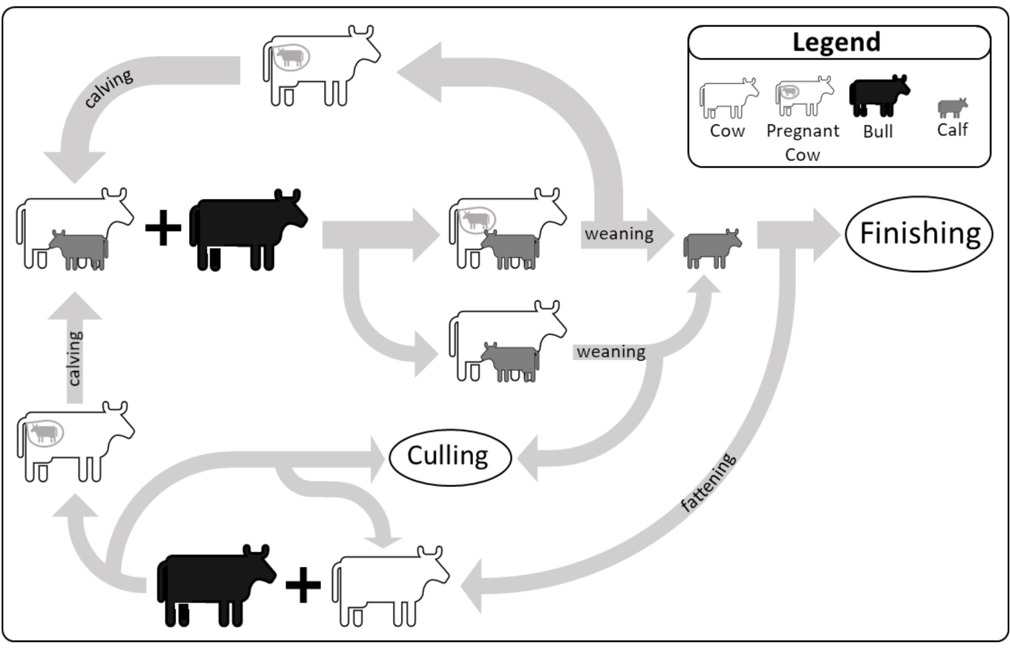
Figure II: Calculation of beef production in each production system for cow calf (a) and finishing (b) stages.
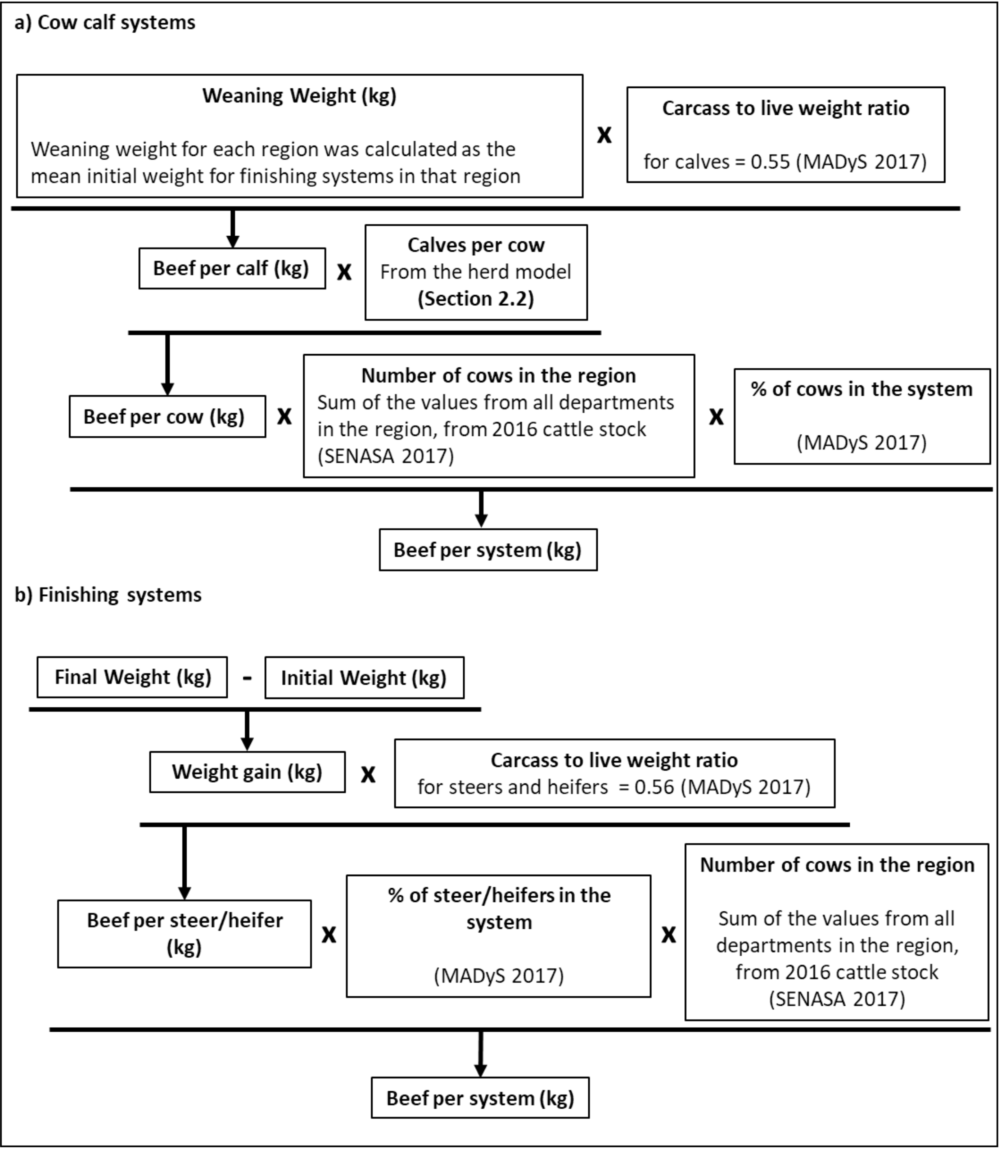
Figure III: Flowchart showing the calculations for the four impact dimensions (GHG emissions, Soil Erosion, Impact on Biodiversity and Pesticide Ecotoxicity) for beef production systems in Argentina.
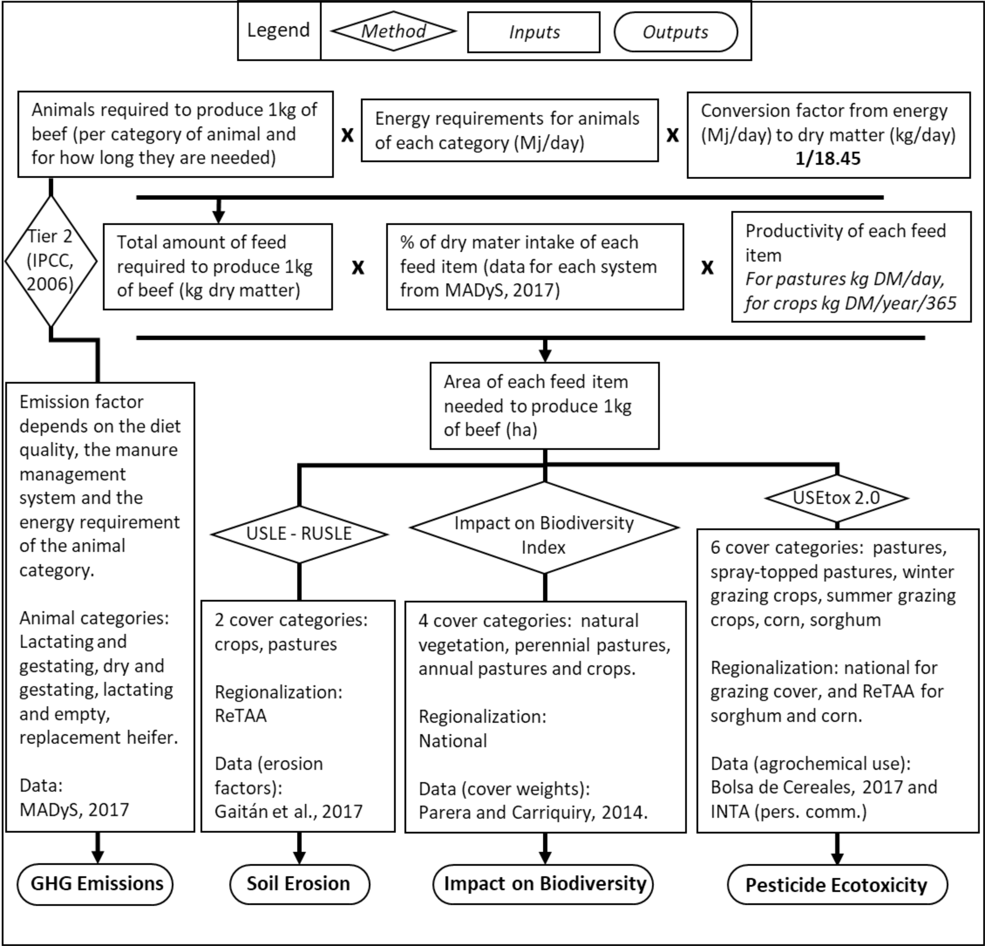
Figure IV: Regionalization of the 2017 edition of the Applied Agricultural Technology Survey (ReTAA, after its Spanish initials). Source: Bolsa de Cereales, 2017. Relevamiento de Tecnologia Agricola Aplicada: campaña 2016/2017. Buenos Aires.
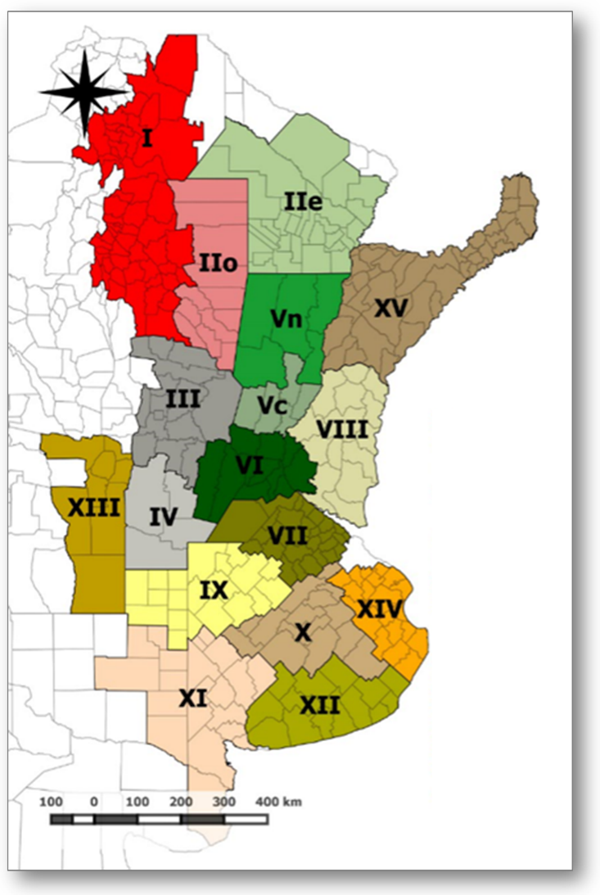
Table IV: Feed items used for this study, showing the yield values, and the categories each feed item was considered for different estimations. Adapted from: MAyDS, 2017. Segundo Informe Bienal De Actualización de la Republica Argentina a la Convencion Marco de las Naciones Unidas sobre el Cambio Climatico.
Feed item | Feed production (kg DM.ha⁻¹.year⁻¹) | Impact on biodiversity |  | Soil erosion | Pesticide ecotoxicity
Natural grasslands - SEP | 5228 |  | natural grasslands | pasture | natural vegetation
Lowland pastures - SEP | 8763 |  | perennial pasture | pasture | pasture
Winter grazing crops - SEP | 4800 |  | annual pasture | crop | winter grazing crops
Grazing sorghum - SEP | 7700 |  | annual pasture | crop | summer grazing crops
Natural grasslands - SWP | 3865 |  | natural grasslands | pasture | natural vegetation
Agropyron - SWP | 4100 |  | perennial pasture | pasture | pasture
Alfalfa - SWP | 7700 |  | perennial pasture | pasture | pasture
Grazing sorghum - SWP | 7500 |  | annual pasture | crop | summer grazing crops
Natural grassland - WP | 4500 |  | natural grasslands | pasture | natural vegetation
Agropyron (good quality) - WP | 5500 |  | perennial pasture | pasture | pasture
Agropyron (degraded) - WP | 3000 |  | perennial pasture | pasture | pasture
Natural grassland - NP | 4079 |  | natural grasslands | pasture | natural vegetation
Pastures - NP | 8521 |  | annual pasture | pasture | pasture
Oats or Rye grass - NP | 3945 |  | annual pasture | crop | winter grazing crops
Grazing Sorghum -NP | 3940 |  | annual pasture | crop | summer grazing crops
Natural vegetation - NEA | 3830 |  | natural grasslands | pasture | natural vegetation
Setaria - NEA | 6280 |  | perennial pasture | pasture | pasture
Winter grazing crops - NEA | 6400 |  | annual pasture | crop | winter grazing crops
Natural vegetation - NWA | 1262 |  | natural grasslands | pasture | natural vegetation
Gatton panic - NWA | 8500 |  | perennial pasture | pasture | pasture
Buffel grass - NWA | 3627 |  | perennial pasture | pasture | pasture
Natural grassland - SA | 2546 |  | perennial pasture | pasture | natural vegetation
Weeping grass - SA | 7330 |  | perennial pasture | pasture | pasture
Alfalfa - SA | 6500 |  | perennial pasture | pasture | pasture
Festuca - SEP | 9963 |  | perennial pasture | pasture | pasture
Spray-topped Rye grass - SEP | 4353 |  | annual pasture | pasture | spray-topped pastures
Grazing sorghum - SEP | 7700 |  | annual pasture | crop | summer grazing crops
Alfalfa - SWP | 7700 |  | perennial pasture | pasture | pasture
Winter grazing crop - SWP | 3400 |  | annual pasture | crop | winter grazing crops
Pastures - WP | 6630 |  | perennial pasture | pasture | pasture
Winter grazing crops - WP | 6313 |  | annual pasture | crop | winter grazing crops
Pastures - NP | 8521 |  | perennial pasture | pasture | pasture
Winter grazing crops - NP | 3945 |  | annual pasture | crop | winter grazing crops
Natural grassland - NP | 4079 |  | natural grasslands | pasture | natural vegetation
Oats - NEA | 3460 |  | annual pasture | crop | winter grazing crops
Alfalfa -NEA | 6500 |  | perennial pasture | pasture | pasture
Gatton panic - NWA | 8500 |  | perennial pasture | pasture | pasture
Alfalfa - SA | 6500 |  | perennial pasture | pasture | pasture
Winter grazing crops - SA | 4058 |  | annual pasture | crop | winter grazing crops
Grain | 7677 |  | crop | crop | corn
Corn silage | 19817 |  | crop | crop | corn
Sorghum silage | 20506 |  | crop | crop | sorghum
Hay (good quality) | 6941 |  | annual pasture | pasture | pasture
Hay (low quality) | 6941 |  | annual pasture | pasture | pasture

Table V: factors used for the USLE-RUSLE equation for each ReTAA region. Adapted from: Gaitán, J., Navarro, M.F., Tenti Vuegen, L., Pizarro, M.J., Carfagno, P., Rigo, S., 2017. Estimación de la pérdida de suelo por erosión hídrica en la República Argentina. Ediciones INTA.

AATS region | Mean annual precipitation | R factor | K factor | LS factor | C factor | C factor | Crop erosion | Pasture erosion
 | (mm) | (MJ.mm.ha⁻¹.h⁻¹.year⁻¹) | (tn.MJ⁻¹.mm⁻¹) |  | (crops) | (pastures) | (tn.ha⁻¹.year⁻¹) | (tn.ha⁻¹.year⁻¹)
I | 702 | 370 | 0.20 | 0.25 | 0.102 | 0.0502 | 1.9 | 0.93
II-e | 977 | 538 | 0.36 | 0.25 | 0.102 | 0.0502 | 5.0 | 2.46
II-o | 716 | 379 | 0.28 | 0.25 | 0.102 | 0.0502 | 2.7 | 1.35
III | 797 | 427 | 0.29 | 0.25 | 0.102 | 0.0502 | 3.2 | 1.55
III-e | 834 | 450 | 0.29 | 0.25 | 0.102 | 0.0502 | 3.3 | 1.63
III-w | 760 | 405 | 0.29 | 0.25 | 0.102 | 0.0502 | 3.0 | 1.47
IV | 785 | 420 | 0.32 | 0.25 | 0.102 | 0.0502 | 3.4 | 1.66
IX | 849 | 459 | 0.32 | 0.25 | 0.102 | 0.0502 | 3.7 | 1.82
V-c | 982 | 541 | 0.33 | 0.25 | 0.102 | 0.0502 | 4.5 | 2.21
V-n | 988 | 545 | 0.32 | 0.25 | 0.102 | 0.0502 | 4.4 | 2.19
VI | 936 | 512 | 0.36 | 0.25 | 0.102 | 0.0502 | 4.7 | 2.31
VII | 988 | 545 | 0.36 | 0.25 | 0.102 | 0.0502 | 5.0 | 2.48
VIII | 1105 | 618 | 0.27 | 0.25 | 0.102 | 0.0502 | 4.2 | 2.08
X | 951 | 522 | 0.36 | 0.25 | 0.102 | 0.0502 | 4.8 | 2.34
XI | 577 | 297 | 0.29 | 0.25 | 0.102 | 0.0502 | 2.2 | 1.10
XII | 826 | 445 | 0.39 | 0.25 | 0.102 | 0.0502 | 4.4 | 2.18
XIII | 499 | 252 | 0.20 | 0.25 | 0.102 | 0.0502 | 1.3 | 0.63
XIV | 960 | 527 | 0.29 | 0.25 | 0.102 | 0.0502 | 3.9 | 1.94
XV | 1442 | 834 | 0.23 | 0.25 | 0.102 | 0.0502 | 5.0 | 2.44

Table VI: Pesticide use in pastures and rangelands. Source: J. Otondo (INTA), personal communication

 |  | Unit | Pasture | Spray-topped pastures | Winter grazing crops | Summer grazing crops
Frequency |  | years⁻¹ | 4 | 4 | 1 | 1
Product
Flumetsulan | Herbicide | l/ha | 0.225 |  | 0.5 | 0.5
Glyphosate | Herbicide | l/ha | 1 | 0.75 | 4 | 4
2,4-D | Herbicide | l/ha | 0.225 | 0.125 | 0.5 | 0.5
atrazine | Herbicide | kg/ha |  |  |  | 2

Table VII: Pesticide use for corn in each ReTAA region. Adapted from: Bolsa de Cereales, 2017. Relevamiento de Tecnologia Agricola Aplicada: campaña 2016/2017. Buenos Aires.
 |  |  | AATS Region
Product | Function | Unit | I | IIe | IIo | III | IV | Vc | Vn | VI | VII | VIII | IX | X | XI | XII | XIII | XIV | XV
Glyphosate | herbicide | l/ha | 19.4 | 7.6 | 17.2 | 15.3 | 16.8 | 17.5 | 18.0 | 15.5 | 18.8 | 14.2 | 15.6 | 9.3 | 19.1 | 13.4 | 14.4 | 11.3 | 11.9
2-4D | herbicide | l/ha | 2.8 | 1.6 | 3.3 | 2.7 | 1.9 | 22.2 | 2.6 | 2.8 | 1.9 | 1.8 | 2.3 | 2.1 | 2.2 | 1.8 | 2.2 | 2.1 | 0.8
Dicamba | herbicide | l/ha | 0.4 | 0.2 | 0.5 | 0.7 | 0.5 | 0.4 | 0.4 | 0.5 | 0.4 | 0.4 | 0.6 | 0.5 | 0.5 | 0.6 | 0.4 | 0.2 | 0.0
Atrazine | herbicide | l/ha | 6.2 | 4.7 | 10.7 | 10.2 | 8.9 | 7.5 | 14.3 | 12.1 | 7.5 | 5.8 | 11.1 | 8.1 | 8.9 | 9.1 | 8.7 | 8.0 | 7.9
Acetochlor | herbicide | l/ha | 2.8 | 2.9 | 6.2 | 6.5 | 4.6 | 4.6 | 4.5 | 6.8 | 5.2 | 4.2 | 4.9 | 5.2 | 5.0 | 4.2 | 1.4 | 5.8 | 2.8
Glufosinate - Ammonium | herbicide | l/ha | 3.8 | 0.0 | 1.4 | 2.6 | 0.0 | 5.2 | 0.0 | 0.0 | 0.0 | 0.0 | 0.0 | 0.0 | 0.0 | 0.0 | 0.0 | 0.0 | 0.0
Metolachlor | herbicide | l/ha | 3.3 | 1.2 | 5.5 | 5.9 | 4.3 | 3.9 | 4.2 | 4.3 | 4.0 | 3.3 | 4.6 | 3.9 | 5.4 | 3.4 | 3.1 | 2.8 | 0.0
Isoxaflutole | herbicide | l/ha | 0.7 | 1.1 | 0.7 | 0.8 | 0.4 | 0.4 | 0.4 | 0.7 | 0.3 | 0.6 | 0.0 | 0.0 | 0.0 | 0.2 | 0.5 | 0.0 | 0.3
Nicosulfuron | herbicide | g/ha | 0.0 | 0.0 | 0.0 | 66.9 | 0.0 | 87.5 | 0.0 | 46.0 | 0.0 | 0.0 | 0.0 | 0.0 | 0.0 | 0.0 | 0.0 | 0.0 | 0.0
Picloram | herbicide | l/ha | 0.0 | 0.0 | 0.3 | 0.3 | 0.3 | 0.3 | 0.2 | 0.3 | 0.3 | 0.2 | 0.3 | 0.3 | 0.3 | 0.4 | 0.3 | 0.2 | 0.0
Flumioxazin | herbicide | g/ha | 0.1 | 0.1 | 0.2 | 0.3 | 0.2 | 0.0 | 0.0 | 0.1 | 0.1 | 0.0 | 0.0 | 0.0 | 0.0 | 0.1 | 0.0 | 0.0 | 0.0
Imazapir + Imazetapir (CL) | herbicide | g/ha | 0.0 | 169.7 | 0.0 | 111.9 | 0.0 | 199.5 | 0.0 | 308.9 | 129.1 | 226.9 | 0.0 | 174.7 | 190.9 | 0.0 | 0.0 | 147.6 | 0.0
S-metolaclhor | herbicide | l/ha | 0.0 | 0.0 | 0.0 | 0.0 | 2.1 | 0.0 | 0.0 | 1.6 | 2.1 | 0.0 | 0.0 | 0.0 | 0.0 | 0.0 | 0.0 | 0.0 | 0.0
Cis-permethrin | insecticide | l/ha | 0.0 | 0.1 | 0.0 | 0.1 | 0.1 | 0.1 | 0.0 | 0.1 | 0.0 | 0.0 | 0.0 | 0.0 | 0.0 | 0.0 | 0.0 | 0.03 | 0.0
Lambda-cyhalotrhin | insecticide | l/ha | 0.2 | 0.2 | 0.3 | 0.2 | 0.1 | 0.1 | 0.0 | 0.1 | 0.1 | 0.1 | 0.1 | 0.04 | 0.1 | 0.0 | 0.0 | 0.01 | 0.0
Chloropyrifos | insecticide | l/ha | 1.7 | 0.5 | 0.8 | 2.0 | 0.7 | 0.5 | 0.0 | 0.6 | 0.2 | 0.7 | 0.7 | 0.1 | 0.0 | 0.2 | 0.0 | 0.0 | 0.0

Table VIII: Pesticide use for sorghum in each ReTAA region. Adapted from: Bolsa de Cereales, 2017. Relevamiento de Tecnologia Agricola Aplicada: campaña 2016/2017. Buenos Aires.
 |  |  | AATS Region
Product | Function | Unit | I | IIe | IIo | III | IV | Vc | Vn | VI | VII | VIII | IX | X | XI | XII | XIII | XIV | XV
2-4D | herbicide | l/ha | 0.0 | 0.0 | 0.0 | 0.7 | 0.0 | 1.0 | 1.7 | 0.0 | 3.6 | 0.0 | 0.5 | 0.7 | 0.0 | 0.0 | 0.0 | 0.7 | 0.0
Dicamba | herbicide | l/ha | 5.9 | 4.1 | 2.0 | 2.9 | 3.5 | 3.9 | 2.7 | 3.9 | 6.8 | 4.3 | 5.2 | 3.9 | 2.0 | 0.0 | 3.1 | 2.5 | 5.9
Atrazine | herbicide | l/ha | 1.1 | 1.1 | 0.7 | 1.0 | 1.1 | 0.9 | 0.9 | 1.2 | 1.1 | 1.0 | 0.7 | 1.0 | 0.5 | 0.0 | 1.6 | 0.8 | 0.0
Acetochlor | herbicide | l/ha | 0.0 | 0.0 | 0.2 | 0.3 | 0.1 | 0.3 | 0.3 | 0.2 | 0.3 | 0.3 | 0.0 | 0.0 | 0.0 | 0.0 | 0.0 | 0.0 | 0.0
Glufosinate - Ammonium | herbicide | l/ha | 6.4 | 5.7 | 0.0 | 4.3 | 2.8 | 4.9 | 3.8 | 5.0 | 7.0 | 4.8 | 4.4 | 6.1 | 0.0 | 0.0 | 5.5 | 2.9 | 5.0
Metolachlor | herbicide | l/ha | 3.9 | 4.4 | 0.0 | 3.3 | 3.2 | 3.2 | 3.5 | 3.0 | 3.7 | 3.9 | 0.0 | 4.4 | 0.0 | 0.0 | 0.0 | 2.4 | 0.0
Nicosulfuron | herbicide | g/ha | 1.3 | 2.1 | 0.0 | 1.8 | 1.7 | 1.5 | 1.6 | 1.4 | 1.1 | 1.7 | 1.9 | 2.0 | 0.0 | 0.0 | 1.7 | 0.9 | 2.3
Imazapir + Imazetapir (CL) | herbicide | g/ha | 0.0 | 0.0 | 0.0 | 0.0 | 0.0 | 0.1 | 0.2 | 0.1 | 0.0 | 0.2 | 0.0 | 0.0 | 0.0 | 0.0 | 0.0 | 0.0 | 0.0
Chloropyrifos | insecticide | l/ha | 0.1 | 0.04 | 0.0 | 0.0 | 0.0 | 0.0 | 0.1 | 0.0 | 0.0 | 0.0 | 0.0 | 0.0 | 0.003 | 0.0 | 0.0 | 0.0 | 0.0

Figure V: Flowchart showing the scenario building process for a) sub-scenario for the cow-calf stage, b) sub-scenarios for the finishing stage and c) scenarios for beef production systems in Argentina
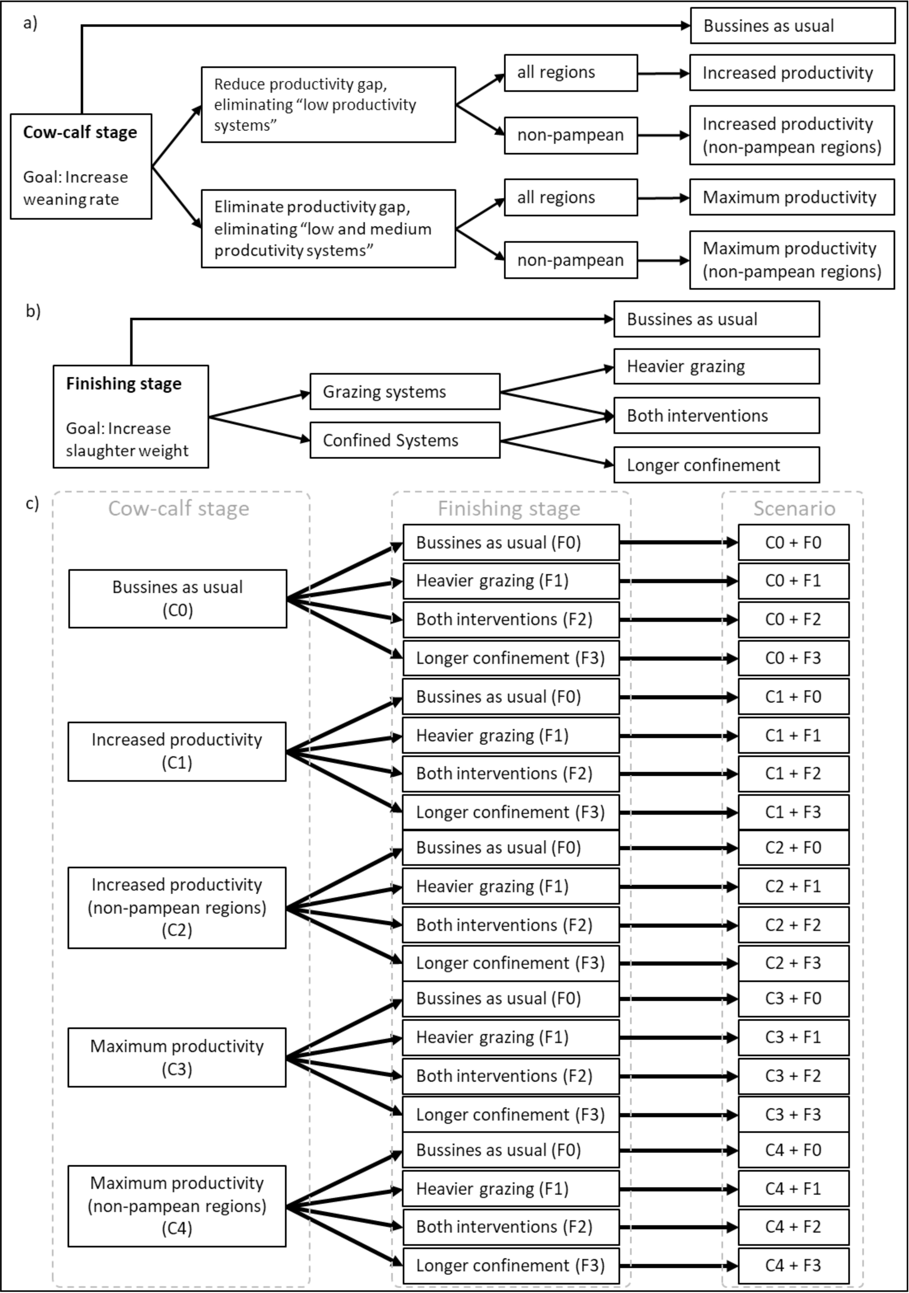
Table IX: Average weaning rate in Argentina under different scenarios for the cow-calf stage
Scenario |  | Weaning rate
C0 | Business as usual | 70%
C1 | Increased productivity (all regions) | 76%
C2 | Increased productivity (non-pampean regions) | 73%
C3 | Maximum productivity (all regions) | 81%
C4 | Maximum productivity (non-pampean regions) | 81%

Table X: Average final weight and length of finishing stage in Argentina under different scenarios for the finishing stage.
Scenario |  | Final live weight (kg) | Length of finishing stage (days)
F0 | Business as usual | 383 | 425
F1 | Heavier grazing | 391 | 455
F2 | Both Interventions | 398 | 458
F3 | Longer confinement | 390 | 429

Table XI: Changes in beef production and in the intensity of impacts relative to the Business as Usual scenario. Dotted line highlights the best performing scenario (i.e., the one that managed to increase beef production while increasing the smallest number of absolute impacts).
 |  |  | Beef production | Soil erosion | GHG emissions | Pesticide ecotoxicity | Impact on Biodiversity
Scenarios | C0+F0 | BAU + BAU | 0% | 0% | 0% | 0% | 0%
 | C0+F1 | BAU + Heavier grazing | 1% | -2% | 1% | -4% | -9%
 | C0+F2 | BAU + Both Interventions | 3% | -3% | -1% | 5% | -8%
 | C0+F3 | BAU + Longer confinement | 2% | -1% | -1% | 9% | 1%
 | C1+F0 | Increased productivity + BAU | 21% | -13% | -15% | 8% | 4%
 | C1+F1 | Increased productivity + Heavier grazing | 22% | -14% | -14% | 4% | -5%
 | C1+F2 | Increased productivity + Both Interventions | 25% | -15% | -15% | 13% | -3%
 | C1+F3 | Increased productivity + Longer confinement | 23% | -13% | -16% | 17% | 5%
 | C2+F0 | Increased productivity (NP) + BAU | 13% | -9% | -9% | 4% | -2%
 | C2+F1 | Increased productivity (NP) + Heavier grazing | 15% | -11% | -8% | 0% | -12%
 | C2+F2 | Increased productivity (NP) + Both Interventions | 17% | -12% | -10% | 8% | -10%
 | C2+F3 | Increased productivity (NP) + Longer confinement | 15% | -10% | -11% | 12% | -1%
 | C3+F0 | Maximum productivity + BAU | 31% | -20% | -24% | 7% | 13%
 | C3+F1 | Maximum productivity + Heavier grazing | 33% | -21% | -22% | 4% | 4%
 | C3+F2 | Maximum productivity + Both Interventions | 36% | -22% | -24% | 13% | 5%
 | C3+F3 | Maximum productivity + Longer confinement | 34% | -21% | -25% | 17% | 14%
 | C4+F0 | Maximum productivity (NP) + BAU | 25% | -17% | -16% | 12% | 1%
 | C4+F1 | Maximum productivity (NP) + Heavier grazing | 27% | -19% | -15% | 8% | -8%
 | C4+F2 | Maximum productivity (NP) + Both Interventions | 30% | -19% | -16% | 18% | -6%
 | C4+F3 | Maximum productivity (NP) + Longer confinement | 28% | -18% | -17% | 22% | 3%

