SUPPORTING INFORMATION
Critical shifts on spatial traits and the risk of extinction of Andean anurans: an assessment of the combined effects of climate and land-use changes in Colombia
Appendices
Appendix S1. Pre-processing of presence data and list of species of anurans selected for the modeling of their distribution in the Andes of Colombia.
Each occurrence datum was reviewed by WA in a GIS to reduce the uncertainty associated with geographic errors following the protocol proposed by Escobar et al., (2014). We used Colombian national cartography at a scale of 1:100,000 (IGAC 2015) and a DEM at 90 m resolution. The altitudinal ranges reported in the literature (Bernal and Lynch 2008; Acosta 2015), and the unpublished data on the altitudinal ranges of the species reported in the databases were considered. Only species with more than eight records (after cleaning) were modelled .We prepared the final list of the species assigning the scientific name, updated according to the taxonomic classification proposed by Frost (2019) Amphibian Species of the World V. 5.1 (http://research.amnh.org/vz/herpetology/amphibia/index.php). According to orographic distributions, 5 species inhabit the Eastern Cordillera, 13 species inhabit the Central Cordillera, 6 species inhabit the Western Cordillera and 1 species has been recorded in both the Central and Western Cordillera.
References
Acosta-Galvis A.R. (2015). Una nueva especie del genero Pristimantis (Anura: Craugastoridae) del complejo de páramos Merchán-Iguaque (Boyacá, Colombia). Biota Colombiana, vol. 6, núm. 2. pp. 107-127.
Bernal, M., & Lynch, J. (2008). Review and analysis of altitudinal distribution of the Andean anurans in Colombia. Zootaxa (Vol. 1826). https://doi.org/10.11646/zootaxa.1826.1.1
Escobar, D., Diaz, S., Jojoa, L., Rudas, E., & Saavedra, J. (2014). Georreferenciación de localidades: Una guía de referencia para colecciones biológicas. Versión 2.0, 96.
Frost DR. 2019. Amphibian Species of the World: an online reference. Version 6.0 http://research.amnh.org/herpetology/amphibia/index.php
Instituto Geografico Agustin Codazzi (2015). Cartografia basica de Colombia, Escala 1:100.000. (http://datos.igac.gov.co/datasets?q=escala%201%3A100.000)
van Proosdij, A. S. J., Sosef, M. S. M., Wieringa, J. J., & Raes, N. (2015). Minimum required number of specimen records to develop accurate species distribution models. Ecography, 39(MAY), n/a-n/a. https://doi.org/10.1111/ecog.01509

Appendix S2: Atmosphere-Ocean General Circulation Models selection
We downloaded 28 AOGCMs at a resolution of ~1km2 from Worldclim (www.worldclim.org) and from the Research Program on Climate Change, Agriculture and Food Security(www.ccafs-climate.org). Each AOGCMS contains the same number of bioclimatic variables considered for model calibration. To cover the climatic variability of the Andean region, the layers were cut for the Andean zone of Colombia, Venezuela and Ecuador. We created two databases with the average values of three biologically important climate variables for amphibians: mean annual temperature (Bio1), mean annual precipitation (Bio12) (Sodhi et al. 2008; Whitton et al. 2012), and an extreme climate variable or physiological limitation for ectotherm species, i.e. the maximum temperature of the warmest month (Bio5) (Sunday et al. 2014) (Table S3). These three variables were only used to objectively select a subset of AOGCMS. The calibration and projection of the final models were made using the 19 bioclimatic variables. We analyzed databases using the k-mean method. This method iteratively partitions n objects, described by p variables, into k clusters in which each object belongs to the cluster with the nearest cluster centroid. A hierarchical grouping using Ward's minimum variance method is applied from a climatic distance matrix (euclidean) elaborated with the three selected variables (more information on the method in Casajus et al., 2016). The selection of the groups is represented in a Rsq profile graphic (Figure S1) and Table S4. Once we obtained the subset of AOGCMS, we used the 19 bioclimatic variables to project the calibrated models for each species into the future. The selection of the scenarios was made in R using the command lines provided by the authors of the method (Casajus et al. 2016).
Reference
Casajus, N., Périé, C., Logan, T., Lambert, M.-C., Blois, S. de, & Dominique Berteaux. (2016). An Objective Approach to Select Climate Scenarios when Projecting Species Distribution under Climate Change. PloS One, 11(3), 1–17. https://doi.org/10.1371/journal.pone.0152495

Sodhi, N. S., Bickford, D., Diesmos, A. C., Lee, T. M., Koh, L. P., Brook, B. W., … Bradshaw, C. J. a. (2008). Measuring the meltdown: Drivers of global amphibian extinction and decline. PLoS ONE, 3(2), 1–8. https://doi.org/10.1371/journal.pone.0001636

Whitton, F. J. S., Purvis, A., Orme, C. D. L., & Olalla-Tárraga, M. Á. (2012). Understanding global patterns in amphibian geographic range size: Does Rapoport rule? Global Ecology and Biogeography, 21(2), 179–190. https://doi.org/10.1111/j.1466-8238.2011.00660.x
Sunday, J. M., Bates, A. E., Kearney, M. R., Colwell, R. K., Dulvy, N. K., Longino, J. T., & Huey, R. B. (2014). Thermal-safety margins and the necessity of thermoregulatory behavior across latitude and elevation. Proceedings of the National Academy of Sciences, 111(15), 5610–5615. https://doi.org/10.1073/pnas.1316145111

Appendix S3. Additional description of model calibrations
For each species we construed a set of models with the combinations of different values for the parameters FC and RM (β). The Feature Classes used were: linear (L), linear and quadratic (LQ), hinge (H), linear-quadratic and hinge (LQH), linear-quadratic-hinge and product (LQHP) and linear-quadratic-hinge-threshold and product (LQHTP). The values of β ranged from 0.5 to 5 with intervals of 0.5 (0.5; 1; 1.5; 2; 2.5; 3; 3.5; 4; 4.5; 5), for a total of 60 combinations for each species. Modeling and evaluation were developed in R using the ENMeval package (Muscarella et al. 2014). The final parameters for the modeling of each species were selected from the recommendations made by Warren and Seifert (2011) and Galante et al., (2018).
References
Galante, P. J., Alade, B., Muscarella, R., Jansa, S. A., Goodman, S. M., & Anderson, R. P. (2018). The challenge of modeling niches and distributions for data-poor species: a comprehensive approach to model complexity. Ecography, 41(5), 726–736. https://doi.org/10.1111/ecog.02909

Muscarella, R., Galante, P. J., Soley-Guardia, M., Boria, R. A., Kass, J. M., Uriarte, M., & Anderson, R. P. (2014). ENMeval: An R package for conducting spatially independent evaluations and estimating optimal model complexity for Maxent ecological niche models. Methods in Ecology and Evolution, 5(11), 1198–1205. https://doi.org/10.1111/2041-210X.12261
Warren, D. L., & Seifert, S. N. (2011). Ecological niche modeling in Maxent: the importance of model complexity and the performance of model selection criteria. Ecological Applications, 21(2), 335–342. https://doi.org/10.1890/10-1171.1

Appendix S4. Methodology for selecting the potential or accessible dispersal area for the species
We first constructed a geographic distribution model α-hull (Burgman and Fox, 2003) for each species, a method commonly recommended by the IUCN for the calculation of the extension of occurrence area (EOO) for species with restricted or discontinuous distributions (IUCN 2017; Pena et al. 2014). We combined this with the elaboration of a buffer area whose distance is equivalent to the longest line reported in the polygon α-hull. The polygon α-hull was drawn from lines that connect all the points of occurrence of the species (Triangulation of Delaunay). The external lines that join the points of occurrence of the polygon are equivalent to the construction of a Minimal Convex Polygon (MPC) (IUCN, 2017). The lines connecting the points do not intercept. The length of each of the lines was measured and the average length of the set of vertices was calculated. We applied a multiple (usually ≥2x) to the average value of the lines to obtain a value α, this value was used as a criterion to exclude the lines greater than that value of the polygon, leaving a set of triangles giving rise to a new polygon more delimited (Burgman y Fox, 2003). In this case the multiple for the average lines ranged from 3-5, depending on the species obtaining the value α. That is, a polygon for a species with average lines of 50 km was multiplied by the multiple that best delimits the polygon, for example 3, resulting in 150 km, while lines greater than this value were excluded.
From this new set of lines, we selected the value of the longest line to build the buffer area around the polygon α-hull, using the following adjustment rules: 1) lines of length ≤ at 50 km: buffer = 50 km; 2) lines of length between 51-100 km: buffer = 100 km, and 3) lines >100 km: buffer = the length of the line. If the longest line was 45 km, we adjusted the distance to 50 km and applied this distance as a buffer to the polygon α-hull to obtain the potential area of dispersion or M. In addition and given the proximity of the cordilleras in some areas, the new buffer area was limited to the cordillera that the species inhabits, thus excluding inter-Andean valleys and other mountain formations that are not suitable habitat for each species and where there is no possibility of natural dispersion. This new polygon representing the M area was used as a mask for the extraction of environmental variables and to perform distribution modeling analyses.
Reference
Burgman, M. A., & Fox, J. C. (2003). Bias in species range estimates from minimum convex polygons: implications for conservation and options for improved planning. Animal Conservation, 6(1), 19–28. https://doi.org/10.1017/S1367943003003044
IUCN Standards and Petitions Subcommittee. (2017). Guidelines for Using the IUCN Red List Categories and Criteria. Version 13. Prepared by the Standards and Petitions Subcommittee. Downloadable from http://www.iucnredlist.org/documents/RedListGuidelines.pdf.
Pena, J. C. de C., Kamino, L. H. Y., Rodrigues, M., Mariano-Neto, E., & de Siqueira, M. F. (2014). Assessing the conservation status of species with limited available data and disjunct distribution. Biological Conservation, 170, 130–136. https://doi.org/10.1016/j.biocon.2013.12.015

RCP4.5 | RCP8.5
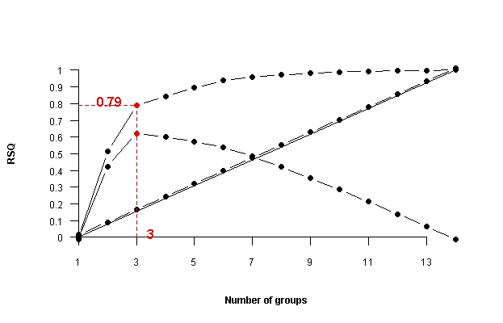
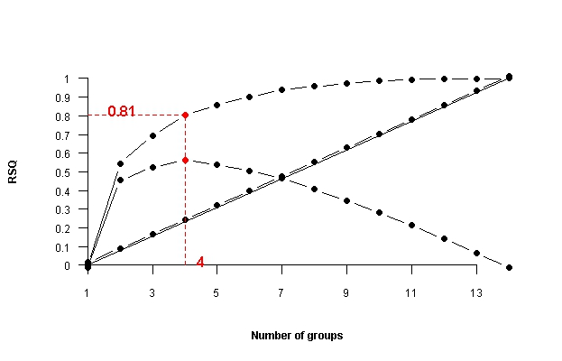

Figure S1. Rsq profile graphs (sum of squares) that determine the optimal number of clusters under a trade-off-based logic between costs (cluster number) and profit (variance explained) and that identify the number of clusters in which the net profit decreases. Number of clusters optimal for PCR 4.5 2050 and PCR 8.5 2050.

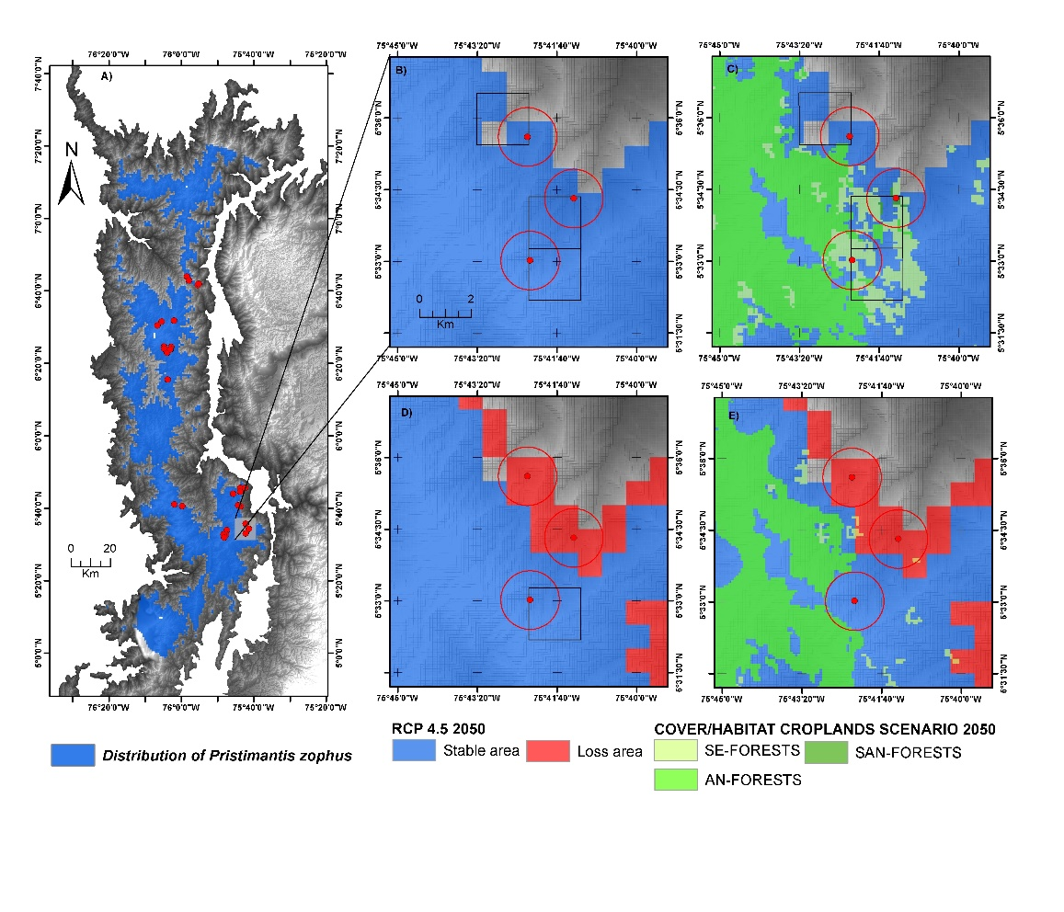
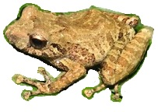

Figure S2. Example of the assessment of the collapse or loss of the AOO due to the combined effect of climate change and the loss of potential extent of suitable habitat due to changes in land use. SE-FOREST: Secondary forest; SAN-FORESTS: Sub-Andean forest; AN-FOREST: Andean forest. A) potential range for the species Pristimantis zophus; B) three occurrence and AOO data per grid and circular superimposed on the potential range; C) AOO, potential range and natural cover where the species lives. It is evident that the extent of suitable habitat to 2005 in one of the AOO is collapsed by the absence of natural cover, in spite of having ideal climatic conditions; D) potential distribution area: stable and loss due to climate change in the RCP4.5 to 2050 scenario. It is observed that two AOO are collapsed due to the loss of suitable climatic conditions; E) under the same climatic scenario but combined with the crop intensification scenario in 2050, it is observed that the AOO for this species collapsed due to the absence of climatic and habitat conditions in 2050

Table S1. List of species of selected anurans and their habitat preference. Status IUCN: LC= Least Concern; NT= Near Threatened; VU= Vulnerable; EN= Endangered. Cordilleras: C-OO= Cordillera Occidental; C-CEN= Cordillera Central and C-ORI= Cordillera Oriental.
FAMILY/Species | STATUS  IUCN | Cordillera | N° Occ/No filter | Habitats preference  (IUCN) | Population trend
BUFONIDAE
Rhinella macrorhina | VU | C-CEN | 23 | Sub-andean/Andean forests | Unknown
Atelopus marinkellei | EN | C-ORI | 20 | Páramos/Andean forests | Decreasing
Atelopus muisca | EN | C-ORI | 19 | Páramos/Andean forests | Decreasing
Osornophryne percrassa | VU | C-CEN | 31 | Páramos/Andean forests | Decreasing
CENTROLENIDAE
Centrolene notostictum | LC | C-ORI | 17 | Sub-andean/Andean forests | Stable
Nymphargus ignotus | LC | C-OCC | 26 | Sub-andean forests | Decreasing
CRAUGASTORIDAE
Hypodactylus babax | LC | C-OCC | 12 | Sub-andean/Andean forests | Decreasing
Hypodactylus latens | VU | C-CEN | 12 | Sub-páramos/Andean forests | Decreasing
Pristimantis alalocophus | EN | C-CEN | 10 | Sub-páramos/Andean forests | Decreasing
Pristimantis angustilineatus | EN | C-OCC | 19 | Sub-andean/Andean forests | Unknown
Pristimantis anolirex | NT | C-ORI | 23 | Páramos/Andean forests | Stable
Pristimantis bacchus | EN | C-ORI | 15 | Sub-andean/Andean forests | Stable
Pristimantis bicolor | VU | C-OCC | 18 | Sub-andean/Andean forests | Decreasing
Pristimantis calcaratus | VU | C-OCC | 22 | Sub-andean/Andean forests | Decreasing
Pristimantis dorsopictus | VU | C-CEN | 26 | Sub-páramos/Andean forests | Decreasing
Tachiramantis douglasi | VU | C-ORI | 18 | Páramos/Andean forests | Decreasing
Pristimantis elegans | VU | C-ORI | 31 | Páramos/Andean forests | Decreasing
Pristimantis factiosus | LC | C-CEN | 22 | Sub-andean/Andean forests | Stable
Pristimantis gracilis | VU | C-OCC; C-CEN | 36 | Sub-andean/Andean forests | Decreasing
Pristimantis lynchi | DD | C-ORI | 25 | Páramos/Andean forests | Decreasing
Pristimantis merostictus | EN | C-ORI | 18 | Sub-andean/Andean forests | Decreasing
Pristimantis miyatai | LC | C-ORI | 31 | Sub-andean/Andean forests | Stable
Pristimantis peraticus | LC | C-CEN | 19 | Sub-páramos/Páramo | Stable
Pristimantis piceus | LC | C-CEN | 26 | Páramos/Andean forests | Stable
Pristimantis racemus | LC | C-CEN | 18 | Páramos/Andean forests | Stable
Pristimantis simoteriscus | EN | C-CEN | 11 | Sub-páramos/Páramo | Decreasing
Pristimantis simoterus | NT | C-CEN | 30 | Sub-páramos/Páramo | Decreasing
Pristimantis zophus | NT | C-OCC | 29 | Andean forests | Stable
HYLIDAE
Dendropsophus norandinus | LC | C-CEN | 16 | Sub-andean forests | Stable
Hyloscirtus antioquia | VU | C-CEN | 15 | Páramos/Andean forests | Stable

Table S2. Bioclimatic variables considered.
Source: Wordlclim v 1.4 (Hismant et al., 2005)
No | Variable | Units | No | Variables | Units
Bio1 | Annual mean temperature | °C | Bio11 | Mean temperature of the coldest quarter | °C
Bio2 | Mean diurnal range | °C | Bio12 | annual precipitation | mm
Bio3 | Isothermality | % | Bio13 | Precipitation of the wettest period | mm
Bio4 | Temperature seasonality | °C | Bio14 | Precipitation of the driest period | mm
Bio5 | Maximum temperature of the warmest period | °C | Bio15 | Precipitation seasonality | mm⁻¹
Bio6 | Minimum temperature of the coldest period | °C | Bio16 | Precipitation of the wettest quarter | mm
Bio7 | Temperature annual range | °C | Bio17 | Precipitation of the driest quarter | mm
Bio8 | Mean temperature of the wettest quarter | °C | Bio18 | Precipitation of the warmest quarter | mm
Bio9 | Mean temperature of the driest quarter | °C | Bio19 | Precipitation of coldest quarter | mm
Bio10 | Mean temperature of the warmest quarter | °C

Scenario | RCP4.5 |  |  | RCP8.5
Year | 2050 |  |  | 2050
AOGCM | Bio1 | Bio5 | Bio12 | Bio1 | Bio5 | Bio12
CCCMA CANESM2 | 18.9 | 25.5 | 1648.6 | 19.8 | 26.5 | 1490.5
CESM1 CAM5 | 18.2 | 24.2 | 1974.7 | 18.9 | 25.1 | 2000.5
CNRM-CM5 | 17.4 | 23.3 | 1927.7 | 17.9 | 23.6 | 1909.8
CSIRO ACCESS 1.0 | 18.1 | 24.0 | 1988.6 | 18.9 | 24.9 | 2001.3
CSIRO MK3 6.0 | 18.2 | 24.2 | 1974.7 | 18.7 | 24.6 | 1982.9
GFDL CM3 | 19.0 | 25.6 | 1818.5 | 19.6 | 26.2 | 1801.9
GISS E2 R | 17.7 | 23.5 | 1900.9 | 18.2 | 24.2 | 1840.2
INM CM4 | 17.1 | 22.8 | 1813.7 | 17.5 | 23.3 | 1809.4
IPSL CM5A MR | 17.5 | 23.0 | 2055.7 | 19.2 | 24.9 | 2183.0
MIROC ESM | 17.9 | 24.0 | 1771.0 | 18.7 | 24.9 | 1908.0
MIROC MIROC5 | 17.6 | 23.4 | 1909.1 | 18.1 | 24.0 | 2019.0
MOHC HADGEM2 ES | 18.4 | 24.1 | 2118.6 | 19.0 | 25.0 | 2101.4
MPI ESM LR | 17.2 | 22.2 | 2022.4 | 19.0 | 25.3 | 2024.3
MRI CGCM3 | 17.6 | 23.9 | 1869.8 | 18.2 | 24.6 | 1866.4
Table S3. Average values of the three bioclimatic variables selected as important for the Andean anurans in k-mean analysis in two climate change scenarios (RCP4.5 and RCP8.5) by 2050. BIO1 and BIO5 units in °C and BIO12 units in mm of rainfall.

Table S4. Results of selection of AOMCGs by k-media analysis and percentage of variation summarizing for two climate change scenarios (RCP4.5 and 8.5) to 2050.
N° of Models | AOMCG | Cluster | Number of AOMCG grouping | Summary Percentage of Variance
RCP4.5 2050
1 | CSIRO_ACCESS1.0 | 1 | 4 | 81 %
2 | GISS_E2_R | 2 | 6
3 | ESM_LR | 3 | 2
4 | GFDL_CM3 | 4 | 2
RCP8.5 2050
10 | CSIRO_ACCESS1.0 | 1 | 2 | 79 %
11 | CNRM-CM5 | 2 | 7
12 | GFDL_CM3 | 3 | 5

Table S5. Final parameters for run Maxent and development of the Species Distribution Models for each Anuran specie and evaluation metrics (omission rate, sensibility and partial ROC)
SPECIES | N° Occ filter to 4km | FC | RM | AUC_{TEST} | AUC_{DIFF} | Parameter number | AICc | Omission rate | Sensibility | pROC
BUFONIDAE
Rhinella macrorhina | 13 | H | 1.5 | 0.955 | 0.024 | 7 | 253.037 | 0.000 | 1.000 | 1.876
Atelopus marinkellei | 15 | L | 0.5 | 0.952 | 0.025 | 6 | 273.359 | 0.050 | 0.950 | 1.848
Atelopus muisca | 11 | LQHP | 1.5 | 0.947 | 0.019 | 3 | 180.65 | 0.052 | 0.948 | 1.829
Osornophryne percrassa | 23 | LQHP | 1.5 | 0.942 | 0.022 | 7 | 438.131 | 0.068 | 0.932 | 1.796
CENTROLENIDAE
Centrolene notostictum | 14 | LQHP | 2.5 | 0.808 | 0.086 | 4 | 328.006 | 0.000 | 1.000 | 1.551
Nyrphagus ignotus | 16 | LQH | 3 | 0.866 | 0.083 | 4 | 337.432 | 0.153 | 0.847 | 1.481
CRAUGASTORIDAE
Hypodactylus babax | 9 | H | 2.5 | 0.776 | 0.096 | 2 | 204.759 | 0.000 | 1.000 | 1.601
Hypodactylus latens | 11 | H | 2 | 0.933 | 0.028 | 3 | 207.414 | 0.083 | 0.917 | 1.767
Pristimantos alalocophus | 8 | LQ | 3 | 0.884 | 0.044 | 3 | 169.234 | 0.100 | 0.900 | 1.687
Pristimantis angustilineatus | 9 | H | 1.5 | 0.893 | 0.058 | 4 | 162.469 | 0.157 | 0.843 | 1.695
Pristimantis anolirex | 14 | LQ | 1.5 | 0.909 | 0.048 | 5 | 265.111 | 0.000 | 1.000 | 1.642
Pristimantis bacchus | 11 | LQHP | 2.5 | 0.843 | 0.090 | 3 | 216.638 | 0.000 | 1.000 | 1.536
Pristimantis bicolor | 14 | H | 2.5 | 0.872 | 0.070 | 5 | 304.433 | 0.055 | 0.945 | 1.523
Pristimantis calcaratus | 17 | LQHPT | 2.5 | 0.812 | 0.093 | 4 | 327.26 | 0.095 | 0.905 | 1.482
Pristimantis dorsopictus | 20 | LQH | 2.5 | 0.903 | 0.058 | 7 | 385.895 | 0.384 | 0.616 | 1.400
Tachiramantis douglasis | 12 | LQ | 3.5 | 0.825 | 0.075 | 3 | 241.106 | 0.000 | 1.000 | 1.634
Pristimantis elegans | 24 | LQ | 1 | 0.922 | 0.041 | 7 | 458.116 | 0.258 | 0.742 | 1.467
Pristimantis factiosus | 15 | H | 4 | 0.887 | 0.075 | 4 | 272.983 | 0.000 | 1.000 | 1.674
Pristimantis gracilis | 25 | LQ | 0.5 | 0.925 | 0.043 | 11 | 528.763 | 0.055 | 0.945 | 1.558
Pristimantis lynchi | 21 | LQ | 4 | 0.855 | 0.063 | 3 | 416.722 | 0.280 | 0.720 | 1.303
Pristimantis merostictus | 11 | LQHP | 2.5 | 0.867 | 0.060 | 3 | 236.555 | 0.312 | 0.688 | 1.502
Pristimantis miyatai | 22 | LQH | 2.5 | 0.896 | 0.050 | 8 | 447.708 | 0.142 | 0.858 | 1.482
Pristimantis peraticus | 11 | LQHP | 2.5 | 0.937 | 0.031 | 3 | 206.973 | 0.052 | 0.948 | 1.745
Pristimantis piceus | 18 | LQ | 1 | 0.853 | 0.060 | 5 | 379.776 | 0.115 | 0.885 | 1.516
Pristimantis racemus | 11 | LQ | 2 | 0.924 | 0.037 | 3 | 201.133 | 0.111 | 0.889 | 1.753
Pristimantis simoteriscus | 10 | LQ | 4 | 0.921 | 0.027 | 2 | 174.964 | 0.182 | 0.818 | 1.730
Pristimantis simoterus | 18 | LQHP | 4.5 | 0.936 | 0.016 | 1 | 303.702 | 0.033 | 0.967 | 1.781
Pristimantis zophus | 14 | H | 4 | 0.889 | 0.041 | 1 | 255.522 | 0.172 | 0.828 | 1.505
HYLIDAE
Dendropsophus norandinus | 9 | H | 2.5 | 0.878 | 0.050 | 3 | 188.072 | 0.133 | 0.867 | 1.741
Colomascirtus antioquia | 12 | LQ | 1.5 | 0.922 | 0.033 | 5 | 248.214 | 0.187 | 0.813 | 1.748

 |  |  | RCP4.5 |  | RCP8.5
Species | RCP4.5 2050 | RCP8.5 2050 | IPS | CIS | IPS | CIS
Atelopus marinkellei | 0.7222 | 0.6667 | 0.9286 | 0.9286 | 1.0000 | 0.9286
Atelopus muisca | 0.1250 | 0.3750 | 0.1875 | 0.1875 | 0.2500 | 0.2500
Osornophryne percrassa | 0.2000 | 0.3600 | 0.5000 | 0.4545 | 0.5909 | 0.5909
Rhinella macrorhina | 0.3571 | 0.4286 | 0.2727 | 0.5455 | 0.2727 | 0.5455
Centrolene notostictum | 0.2353 | 0.4118 | 0.7692 | 0.6154 | 0.8462 | 0.6923
Nymphargus ignotus | 0.7368 | 0.8421 | 0.8824 | 0.8235 | 0.8824 | 0.8824
Hypodactylus babax | 0.4545 | 0.7273 | 0.5455 | 0.5455 | 0.8182 | 0.7273
Hypodactylus latens | 0.6000 | 0.9000 | 0.6667 | 0.6667 | 0.8889 | 0.8889
Pristimantis alalocophus | 0.1111 | 0.2222 | 0.6667 | 0.6667 | 0.7778 | 0.7778
Pristimantis angustilineatus | 0.2000 | 0.2667 | 0.1429 | 0.4286 | 0.2143 | 0.5000
Pristimantis anolirex | 0.7727 | 0.9091 | 0.7500 | 0.7500 | 0.9000 | 0.9000
Pristimantis bacchus | 0.4615 | 0.8462 | 0.5000 | 0.5000 | 0.8333 | 0.8333
Pristimantis bicolor | 0.1250 | 0.6875 | 0.3846 | 0.4615 | 0.6923 | 0.7692
Pristimantis calcaratus | 0.4444 | 0.7778 | 0.5000 | 0.5556 | 0.7778 | 0.8333
Pristimantis dorsopictus | 0.3500 | 0.5500 | 0.5000 | 0.5833 | 0.5000 | 0.5000
Pristimantis elegans | 0.7500 | 1.0000 | 0.7917 | 0.7917 | 1.0000 | 1.0000
Pristimantis factiosus | 0.0000 | 0.0500 | 0.1176 | 0.2941 | 0.1176 | 0.3529
Pristimantis gracilis | 0.3333 | 0.5152 | 0.5556 | 0.5185 | 0.7037 | 0.7037
Pristimantis lynchi | 0.1765 | 0.2941 | 0.3636 | 0.3636 | 0.6364 | 0.6364
Pristimantis merostictus | 0.5000 | 0.9167 | 0.1818 | 0.6364 | 1.0000 | 1.0000
Pristimantis miyatai | 0.3846 | 1.0000 | 0.4500 | 0.6000 | 1.0000 | 1.0000
Pristimantis peraticus | 0.3077 | 0.7692 | 0.6154 | 0.6154 | 0.8462 | 0.7692
Pristimantis piceus | 0.3750 | 0.5833 | 0.4545 | 0.4545 | 0.5909 | 0.5909
Pristimantis racemus | 0.5714 | 1.0000 | 0.6154 | 0.5385 | 1.0000 | 1.0000
Pristimantis simoteriscus | 0.1000 | 0.9000 | 0.0000 | 0.0000 | 0.8889 | 0.8889
Pristimantis simoterus | 0.6400 | 0.8000 | 0.6667 | 0.6667 | 0.8095 | 0.8095
Pristimantis zophus | 0.1852 | 0.2222 | 0.2800 | 0.2800 | 0.2800 | 0.2800
Tachiramantis douglasi | 0.1667 | 0.1667 | 0.2778 | 0.6667 | 0.2778 | 0.6667
Dendropsophus norandinus | 0.3077 | 0.6154 | 0.3333 | 0.5833 | 0.5000 | 0.5000
Hyloscirtus antioquia | 0.8462 | 1.0000 | 1.0000 | 1.0000 | 1.0000 | 1.0000
Table S6. Percentage of loss of the Area of Occupancy for climate only and combined scenarios (climate change + changes in land use). The values were calculated with respect to the current AOO values in the climate only and combined scenarios. Filled purple values indicate species with potential extinction status in wildlife.

