Supplementary data:
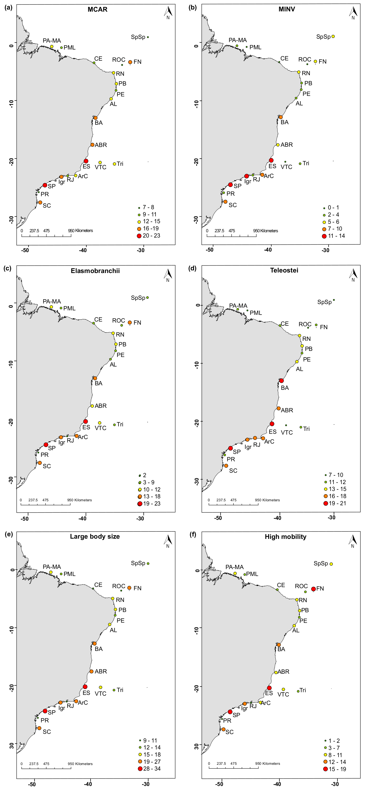

Figure S1. The distribution of threatened reef fish species richness in different biological attributes along the Brazilian Province. (a) Macrocarnivores (MCAR); (b) Mobile invertivores (MINV); (c) Elasmobranchii; (d) Teleostei; (e) Large-bodied species; (f) High-mobility species. The color gradient represents the percentage of threatened species with each attribute. Sites: SC, state of Santa Catarina; PR, state of Paraná; SP, state of São Paulo; RJ, state of Rio de Janeiro; Igr, Ilha Grande Bay; ArC, Arraial do Cabo; ES, state of Espírito Santo; Abr, Abrolhos; BA, state of Bahia; Tri, Trindade-Martin Vaz insular complex; VTC, Vitória-Trindade chain; AL, state of Alagoas; PB, state of Paraíba; PE, state of Pernambuco; RN, state of Rio Grande do Norte; CE, state of Ceará; PA-MA, states of Pará and Maranhão; PML, Manuel Luís Parcel; SpSp, São Pedro and São Paulo Archipelago; FN, Fernando de Noronha Archipelago; ROC, Rocas Atoll.
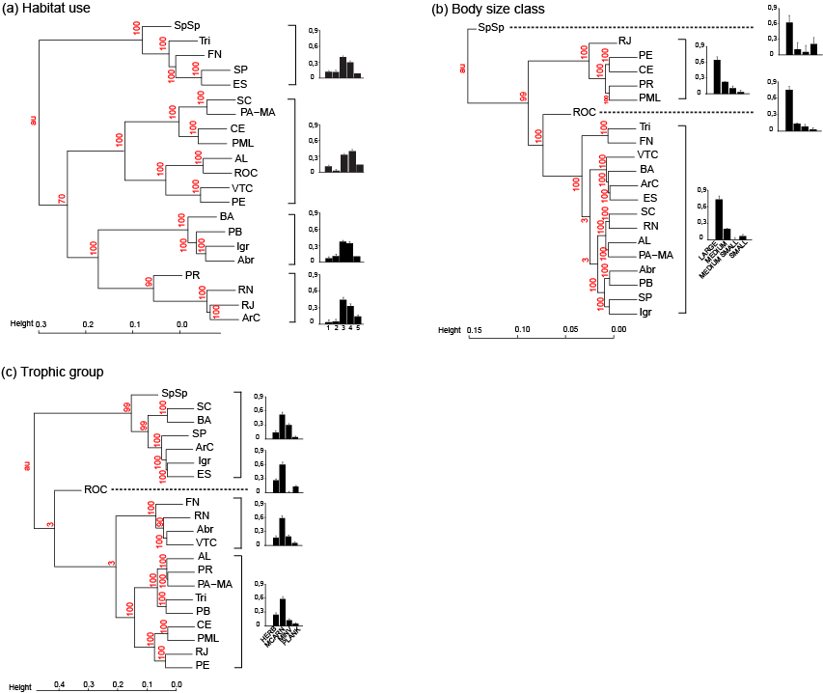
Figure S2. Cluster analyses based on the proportions of threatened species in different biological traits. Barplots in cluster branches represent the distribution of threatened species in biological trait categories. Values at cluster nodes correspond to approximately unbiased significance values (AU). (a) habitat use; (b) body-size class; (c) trophic group categories. Locations: SC, Santa Catarina State; PR, Paraná State; SP, São Paulo State; RJ, Rio de Janeiro State; Igr, Ilha Grande Bay; ArC, Arraial do Cabo; ES, Espírito Santo State; Abr, Abrolhos; BA, Bahia State; Tri, Trindade-Martin Vaz insular complex; VTC, Vitória-Trindade chain; AL, Alagoas State; PB, Paraíba State; PE, Pernambuco State; RN, Rio Grande do Norte State; CE, Ceará State; PA-MA, Pará and Maranhão State; PML, Manuel Luís Parcel; SpSp, São Pedro and São Paulo Archipelago; FN, Fernando de Noronha Archipelago; ROC, Rocas Atoll.

Table S1. List of 56 non-threatened species cited in the Brazilian Red List of Threatened species (Brasil, 2018), which present the set of attributes that are good predictors of extinction risk. As a consequence, these species may be categorized as threatened in the near future, needing more attention from the authorities.

Species | Family | Author | Trophic group | Body size | Mobility | Habitat use | MMA 2018 | IUCN Trend 2019/2
Acanthocybium solandri | Scombridae | Cuvier, 1832 | MCAR | LARGE | HMO | 3 | LC | Stable
Albula nemoptera | Albulidae | Fowler, 1911 | MINV | LARGE | ROV | 4 | LC | Unknown
Alectis ciliaris | Carangidae | Bloch, 1787 | MCAR | LARGE | HMO | 3 | LC | Unknown
Brotula barbata | Ophidiidae | Bloch & Schneider, 1801 | MINV | LARGE | ROV | 3 | DD | Unknown
Calamus bajonado | Sparidae | Bloch & Schneider, 1801 | MINV | LARGE | ROV | 3 | NA | Unknown
Calamus calamus | Sparidae | Valenciennes, 1830 | MINV | LARGE | ROV | 4 | NA | Unknown
Caranx hippos | Carangidae | Linnaeus, 1766 | MCAR | LARGE | HMO | 3 | LC | Stable
Carcharhinus brevipinna | Carcharhinidae | Müller & Henle, 1839 | MCAR | LARGE | HMO | 3 | DD | Unknown
Carcharhinus falciformis | Carcharhinidae | Müller & Henle, 1839 | MCAR | LARGE | HMO | 3 | NT | Decreasing
Carcharhinus leucas | Carcharhinidae | Müller & Henle, 1839 | MCAR | LARGE | HMO | 3 | NT | Unknown
Carcharhinus limbatus | Carcharhinidae | Müller & Henle, 1839 | MCAR | LARGE | HMO | 4 | NT | Unknown
Caulolatilus chrysops | Malacantidae | Valenciennes, 1833 | MCAR | LARGE | ROV | 3 | LC | Unknown
Centropomus parallelus | Centropomidae | Poey, 1860 | MCAR | LARGE | HMO | 4 | DD | Unknown
Channomuraena vittata | Muraenidae | Richardson, 1845 | MCAR | LARGE | ROV | 3 | LC | Unknown
Coryphaena equiselis | Coryphaenidae | Linnaeus, 1758 | MCAR | LARGE | HMO | 1 | LC | Stable
Coryphaena hippurus | Coryphaenidae | Linnaeus, 1758 | MCAR | LARGE | HMO | 1 | LC | Stable
Dasyatis hypostigma | Dasyatidae | Santos & Carvalho, 2004 | MINV | LARGE | ROV | 4 | DD | Unknown
Dermatolepis inermis | Epinephelidae | Valenciennes, 1833 | MCAR | LARGE | ROV | 3 | DD | Decreasing
Echidna catenata | Muraenidae | Bloch, 1795 | MCAR | LARGE | ROV | 3 | LC | Unknown
Echiophis intertinctus | Ophichthidae | Richardson, 1848 | MINV | LARGE | ROV | 1 | LC | Unknown
Echiophis punctifer | Ophichthidae | Kaup, 1859 | MINV | LARGE | ROV | 1 | NA | Unknown
Elagatis bipinnulata | Carangidae | Quoy & Gaimard, 1825 | MCAR | LARGE | HMO | 3 | LC | Stable
Epinephelus adscensionis | Epinephelidae | Osbeck, 1765 | MCAR | LARGE | ROV | 4 | DD | Stable
Fistularia petimba | Fistulariidae | Lacepède, 1803 | MCAR | LARGE | ROV | 4 | LC | Unknown
Fistularia tabacaria | Fistulariidae | Linnaeus, 1758 | MCAR | LARGE | ROV | 4 | LC | Unknown
Gymnothorax miliaris | Muraenidae | Kaup, 1856 | MCAR | LARGE | ROV | 4 | LC | Unknown
Gymnothorax polygonius | Muraenidae | Poey, 1875 | MCAR | LARGE | ROV | 4 | DD | Unknown
Gymnura micrura | Gymnoridae | Bloch & Schneider, 1801 | MINV | LARGE | ROV | 3 | NT | Unknown
Halichoeres radiatus | Labridae | Linnaeus, 1758 | MINV | LARGE | ROV | 3 | LC | Unknown
Hyporthodus mystacinus | Epinephelidae | Poey, 1852 | MCAR | LARGE | ROV | 3 | DD | Unknown
Istiophorus albicans | Istiophoridae | Latreille, 1804 | MCAR | LARGE | HMO | 1 | LC | Not evaluate by IUCN
Lachnolaimus maximus | Labridae | Walbaum, 1792 | MINV | LARGE | ROV | 3 | NA | Decreasing
Lobotes surinamensis | Lobotidae | Bloch, 1790 | MCAR | LARGE | ROV | 4 | LC | Stable
Lutjanus vivanus | Lutjanidae | Cuvier, 1828 | MCAR | LARGE | ROV | 4 | NT | Decreasing
Muraena pavonina | Muraenidae | Richardson, 1845 | MCAR | LARGE | ROV | 4 | LC | Unknown
Narcine sp | Narcinidae | A descrever por Marcelo Carvalho | MCAR | LARGE | ROV | 3 | NA | Not evaluate by IUCN
Odontaspis ferox | Odontaspididae | Risso, 1910 | MCAR | LARGE | HMO | 1 | DD | Decreasing
Ophichthus ophis | Ophichthidae | Linnaeus, 1758 | MINV | LARGE | ROV | 3 | LC | Unknown
Paralichthys brasiliensis | Paralichthyidae | Ranzani, 1842 | MINV | LARGE | ROV | 3 | LC | Not evaluate by IUCN
Pinguipes brasilianus | Pinguipedidae | Cuvier, 1829 | MINV | LARGE | ROV | 1 | LC | Not evaluate by IUCN
Rhinobatos percellens | Rhinobatidae | Walbaum, 1792 | MINV | LARGE | ROV | 3 | DD | Unknown
Rhizoprionodon lalandii | Carcharhinidae | Müller & Henle, 1839 | MCAR | LARGE | HMO | 3 | NT | Unknown
Rhomboplites aurorubens | Lutjanidae | Cuvier, 1829 | MCAR | LARGE | ROV | 4 | NT | Decreasing
Scomberomorus cavalla | Scombridae | Cuvier, 1829 | MCAR | LARGE | HMO | 4 | LC | Stable
Scomberomorus regalis | Scombridae | Bloch, 1793 | MCAR | LARGE | HMO | 3 | LC | Unknown
Selene setapinnis | Carangidae | Mitchil, 1815 | MCAR | LARGE | HMO | 3 | LC | Stable
Seriola dumerili | Carangidae | Risso, 1810 | MCAR | LARGE | HMO | 4 | LC | Unknown
Seriola fasciata | Carangidae | Bloch, 1793 | MCAR | LARGE | HMO | 4 | DD | Unknown
Seriola lalandi | Carangidae | Valenciennes, 1833 | MCAR | LARGE | HMO | 4 | LC | Stable
Seriola rivoliana | Carangidae | Valenciennes, 1833 | MCAR | LARGE | HMO | 4 | LC | Stable
Sphyraena barracuda | Sphyraenidae | Edwards, 1771 | MCAR | LARGE | HMO | 4 | LC | Unknown
Thunnus albacares | Scombridae | Bonnaterre, 1788 | MCAR | LARGE | HMO | 1 | LC | Decreasing
Thunnus atlanticus | Scombridae | Lesson, 1831 | MCAR | LARGE | HMO | 1 | LC | Stable
Trichiurus lepturus | Trichiuridae | Linnaeus 1758 | MCAR | LARGE | HMO | 4 | LC | Stable
Tylosurus acus | Belonidae | Lacepède, 1803 | MCAR | LARGE | HMO | 4 | LC | Unknown
Tylosurus crocodilus | Belonidae | Péron & Lesueur, 1821 | MCAR | LARGE | HMO | 3 | LC | Unknown

Legend: Trophic Group: Macrocarnivores (MCAR) and Mobile Invertivores (MINV); Body Size: Large; High mobility (HMO); Roving mobility (ROV); Habitat use: Specialist (1), Intermediate generalists (3,4)

