Supplementary Material 3. Bioclimatic variables range and combinations novelty under climate change scenarios. There was no bioclimatic combination novelty under any scenario or time, but there was novelty in bioclimatic variables range. Dark blue= there is no novelty in bioclimatic range, Other colors= represent the variable which range is being changed under a specific scenario: bio01: Annual mean temperature, bio04: Temperature seasonality, bio05: Maximum temperature of warmest month, bio07: Temperature annual range, bio10: Mean temperature of warmest quarter, bio11: Mean temperature of coldest quarter, bio12: Annual precipitation, bio13: Precipitation of wettest month, bio15: Precipitation seasonality.

Short-term
(2015-2039)
RCP 4.5

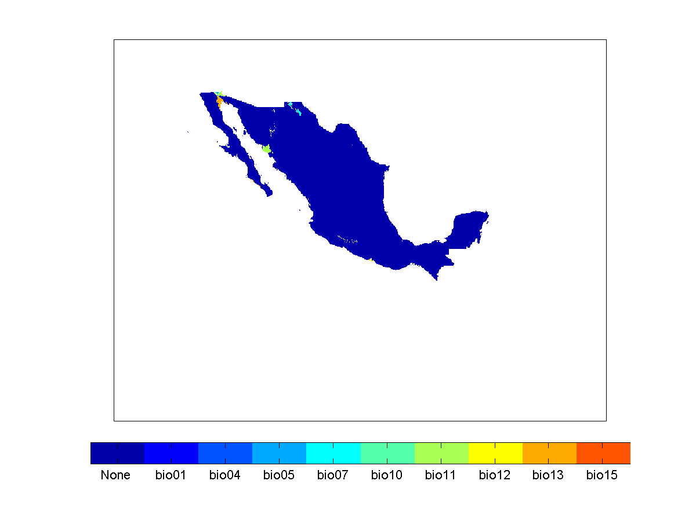

Short-term
(2015-2039)
RCP 8.5

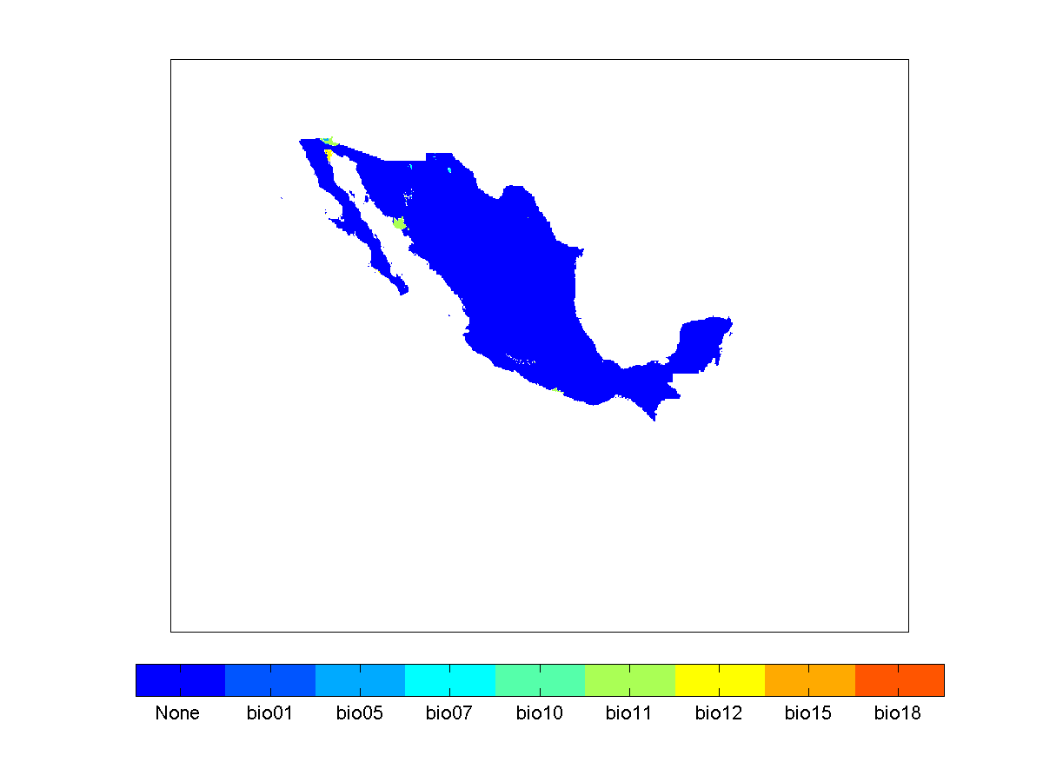

Long-term
(2075-2099)
RCP 4.5
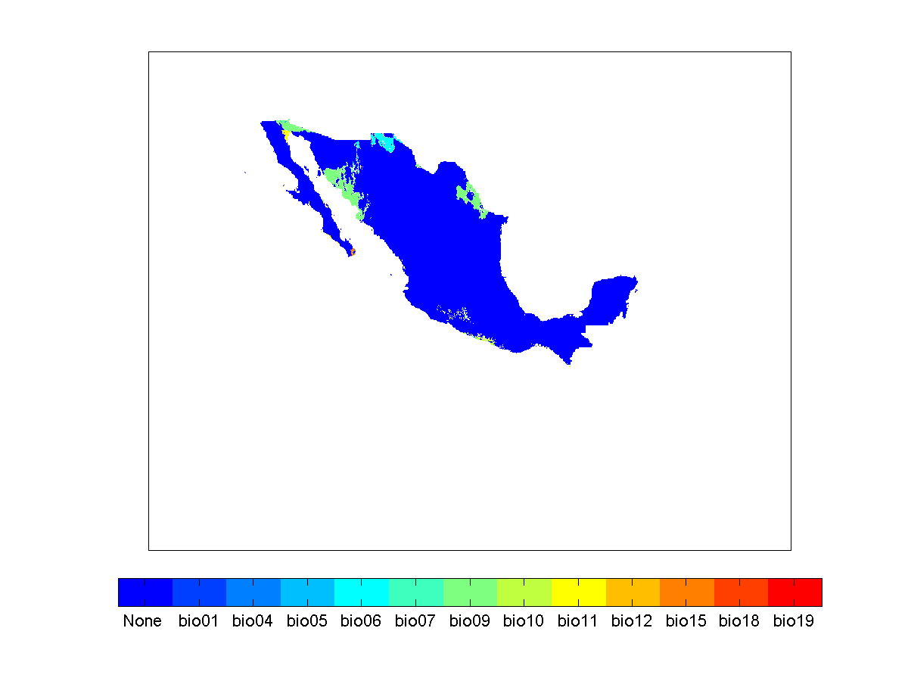

Long-term
(2075-2099)
RCP 8.5
