Supplementary Material 4. Potential Distribution Area under current and future climatic conditions for each evaluated species. Gray area= Natural Protected Areas (NPA), Red triangles= species’ records and Blue area= Potential Distribution Area (PDA).

Centuroides baergi
- Records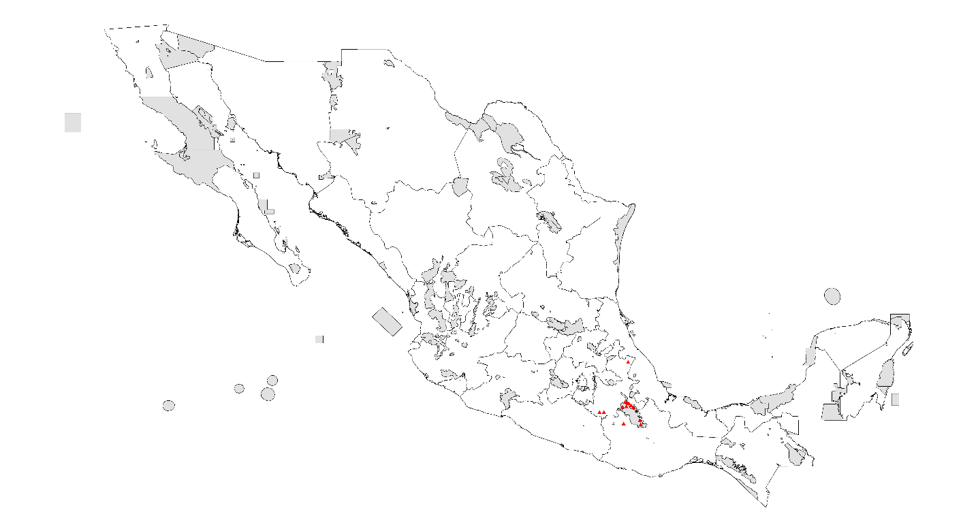
- PDA under current climatic conditions

- PDA 2020 RCP 4.5 W/m²

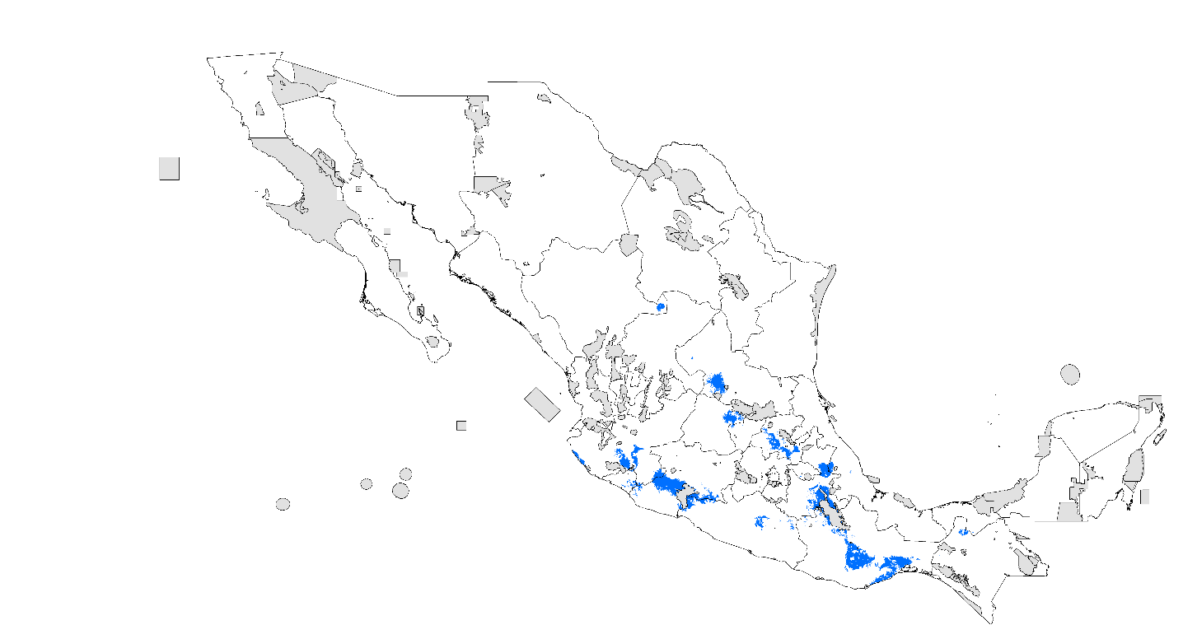
- PDA 2020 RCP 8.5 W/m²

- PDA 2080 RCP 4.5 W/m²
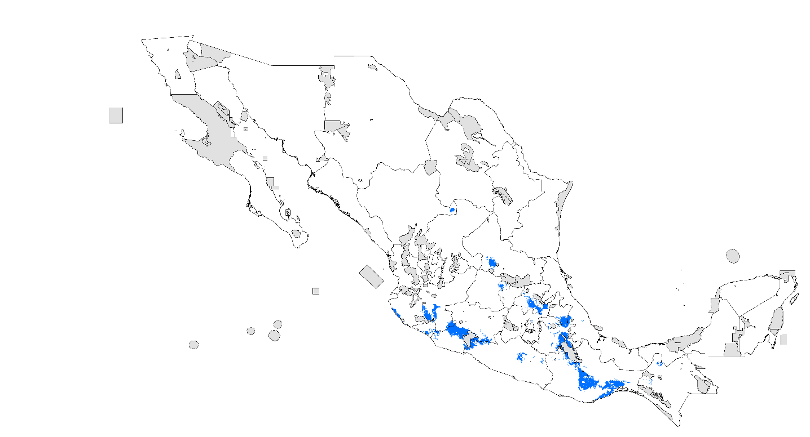
- PDA 2080 RCP 8.5 W/m²

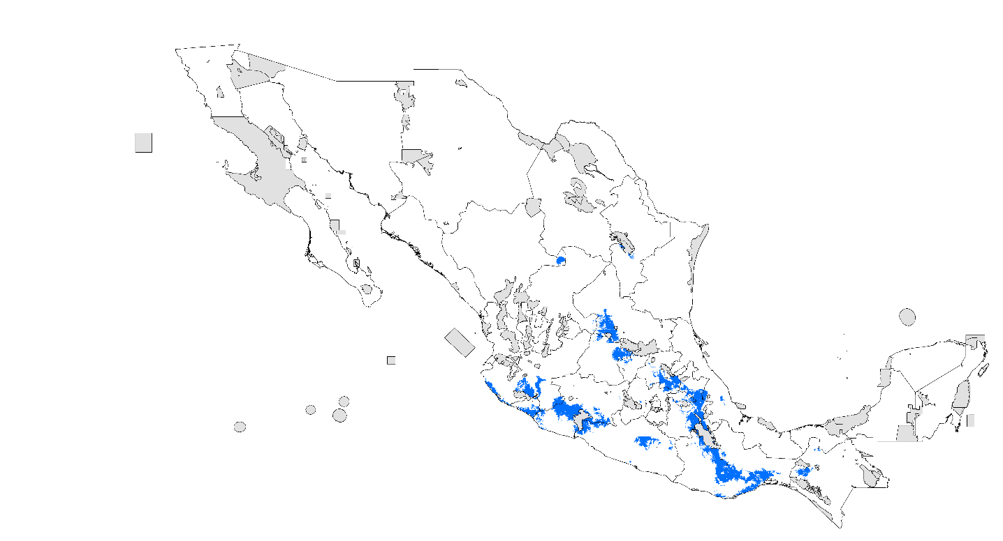

Centuroides balasenesis
- Records
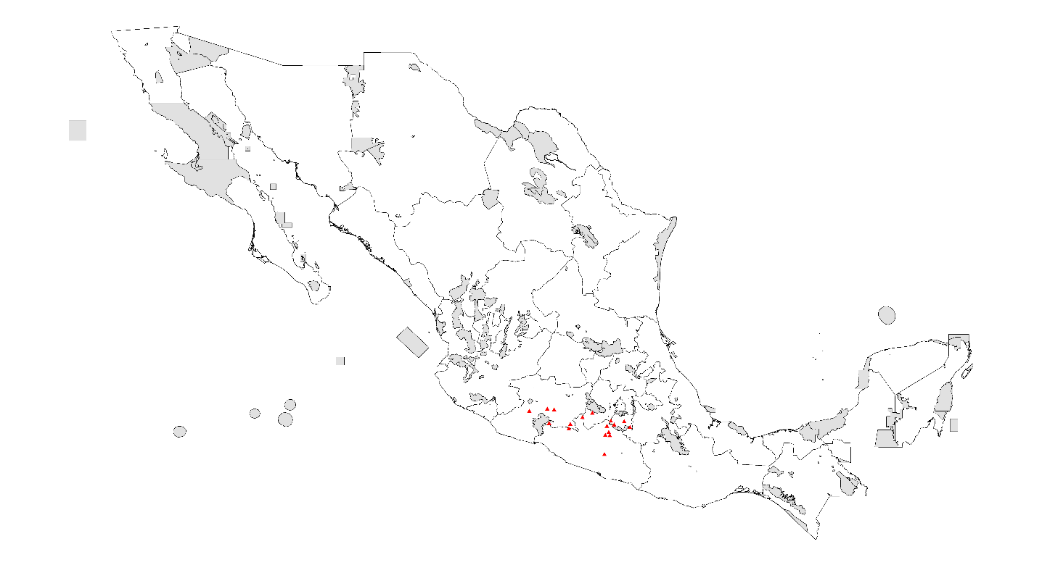
- PDA under current climatic conditions

- PDA 2020 RCP 4.5 W/m²

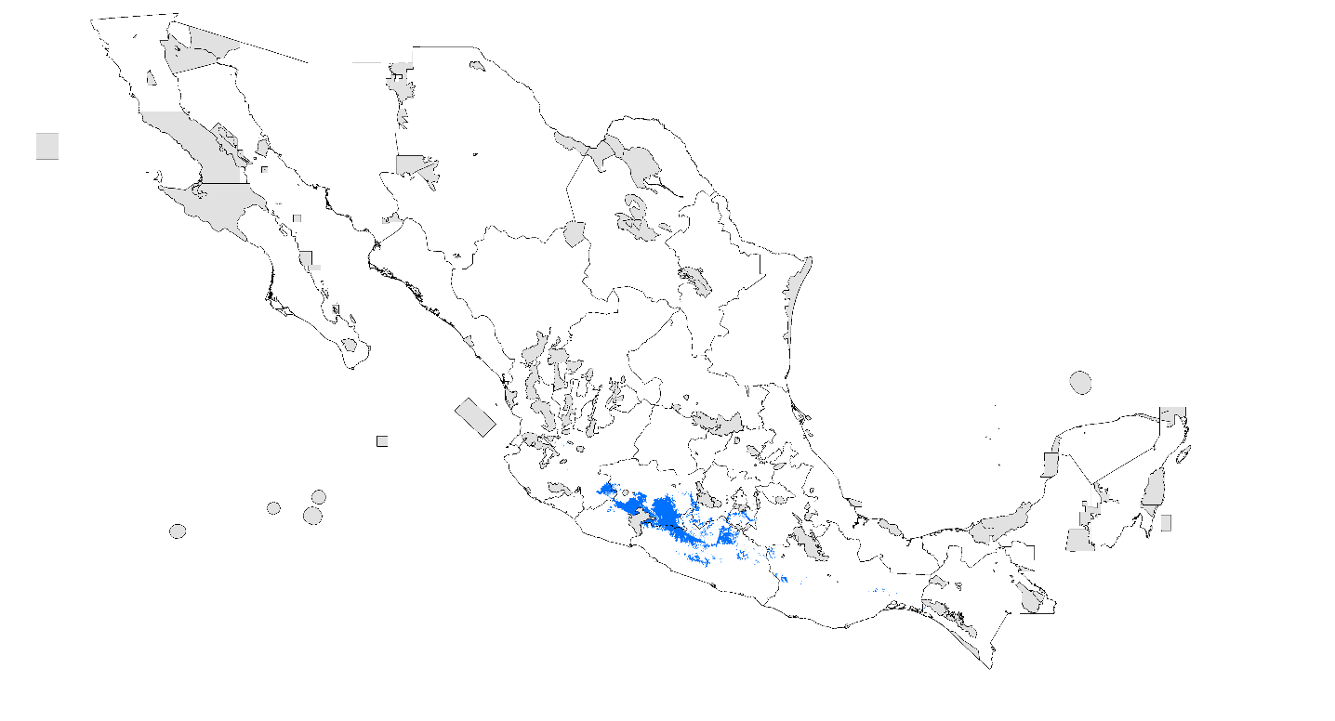
- PDA 2020 RCP 8.5 W/m²

- PDA 2080 RCP 4.5 W/m²

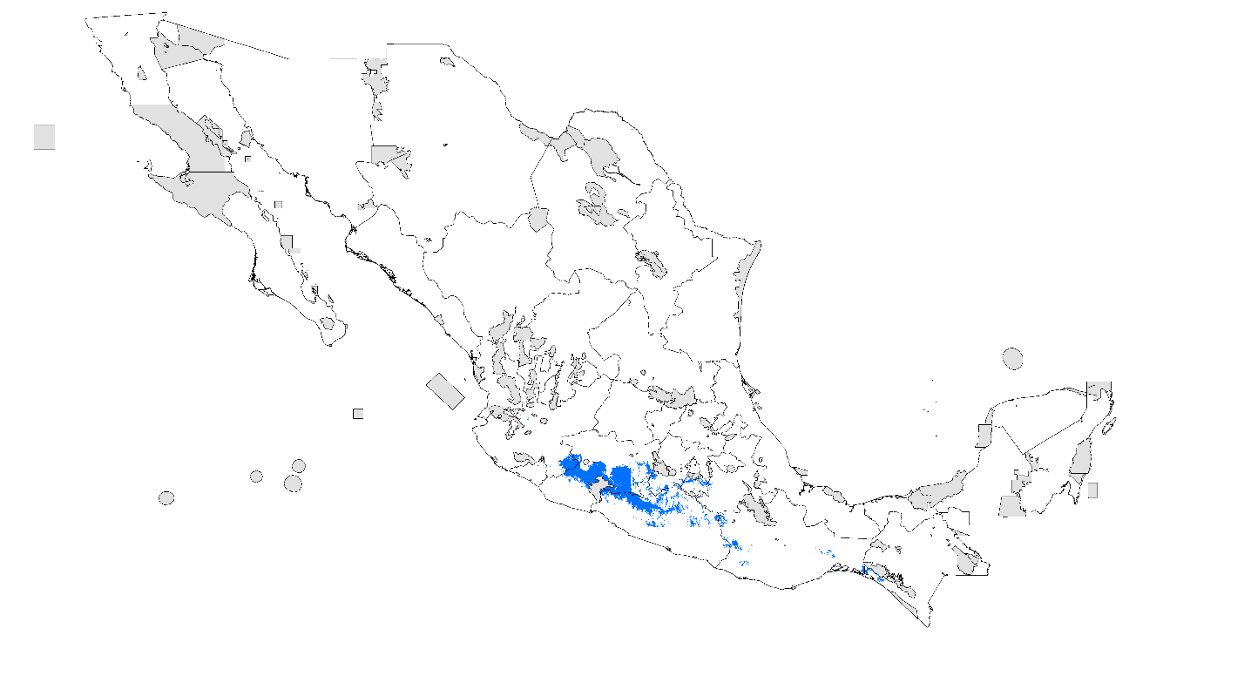
- PDA 2080 RCP 8.5 W/m²
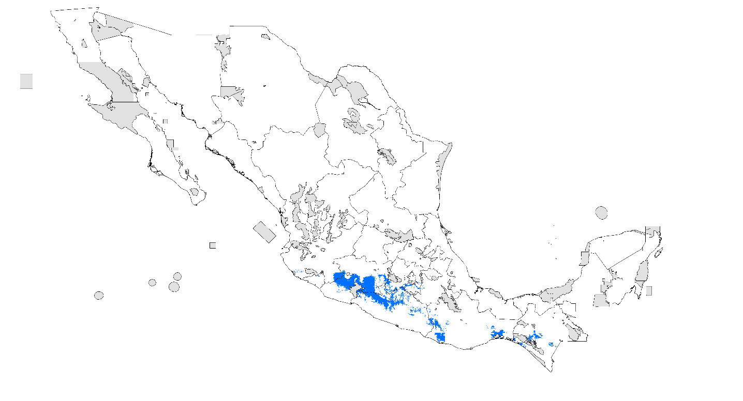

Centuroides gracilis
- Records
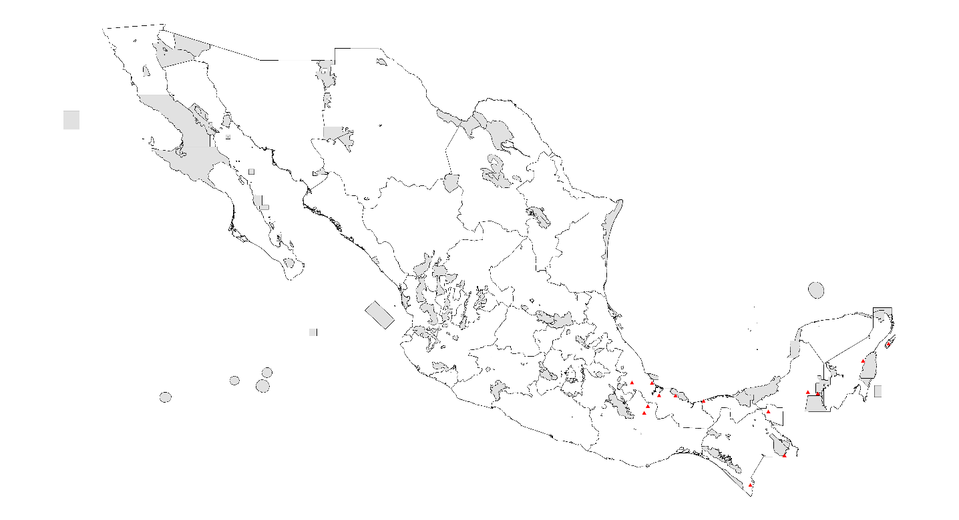
- PDA under current climatic conditions

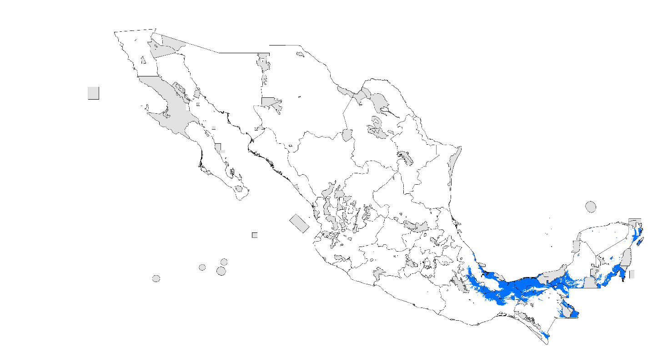

- PDA 2020 RCP 4.5 W/m²
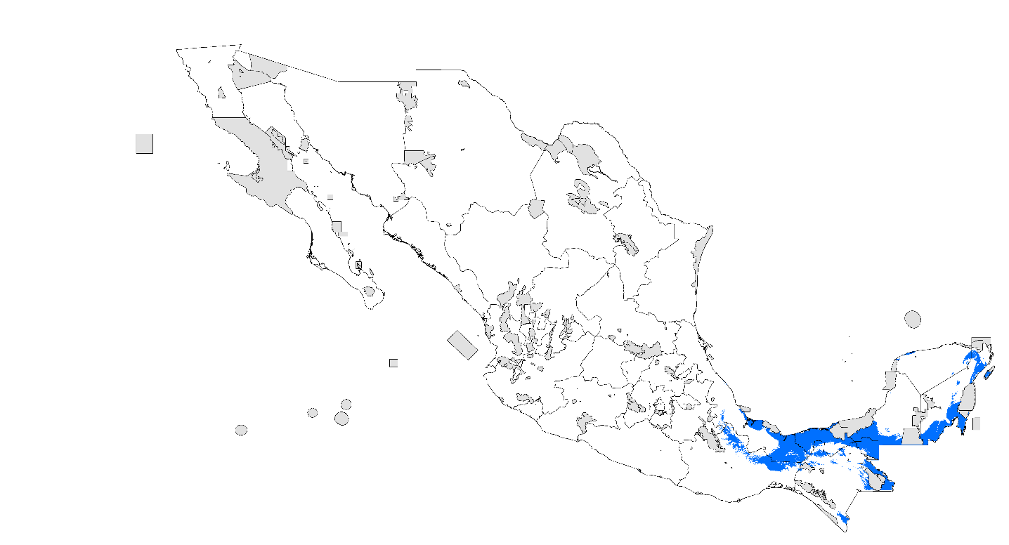

- PDA 2020 RCP 8.5 W/m²

- PDA 2080 RCP 4.5 W/m²
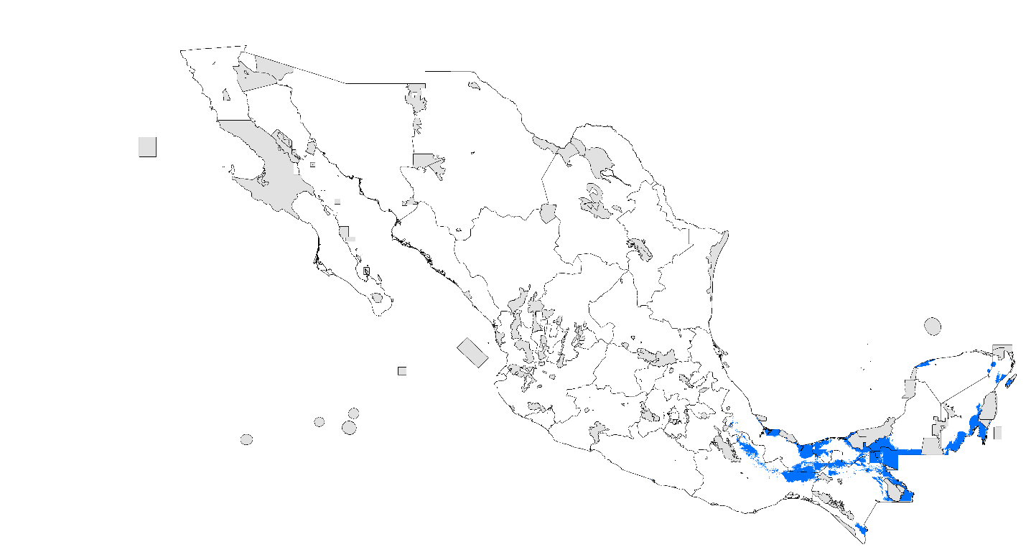

- PDA 2080 RCP 8.5 W/m²

Centuroides limpidus
- Records
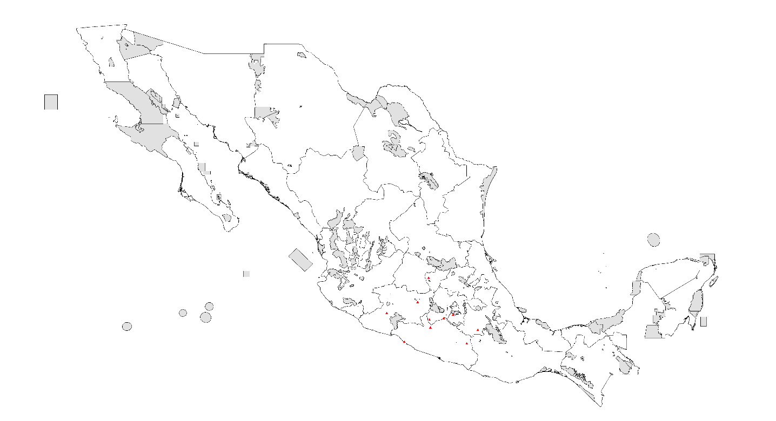
- PDA under current climatic conditions

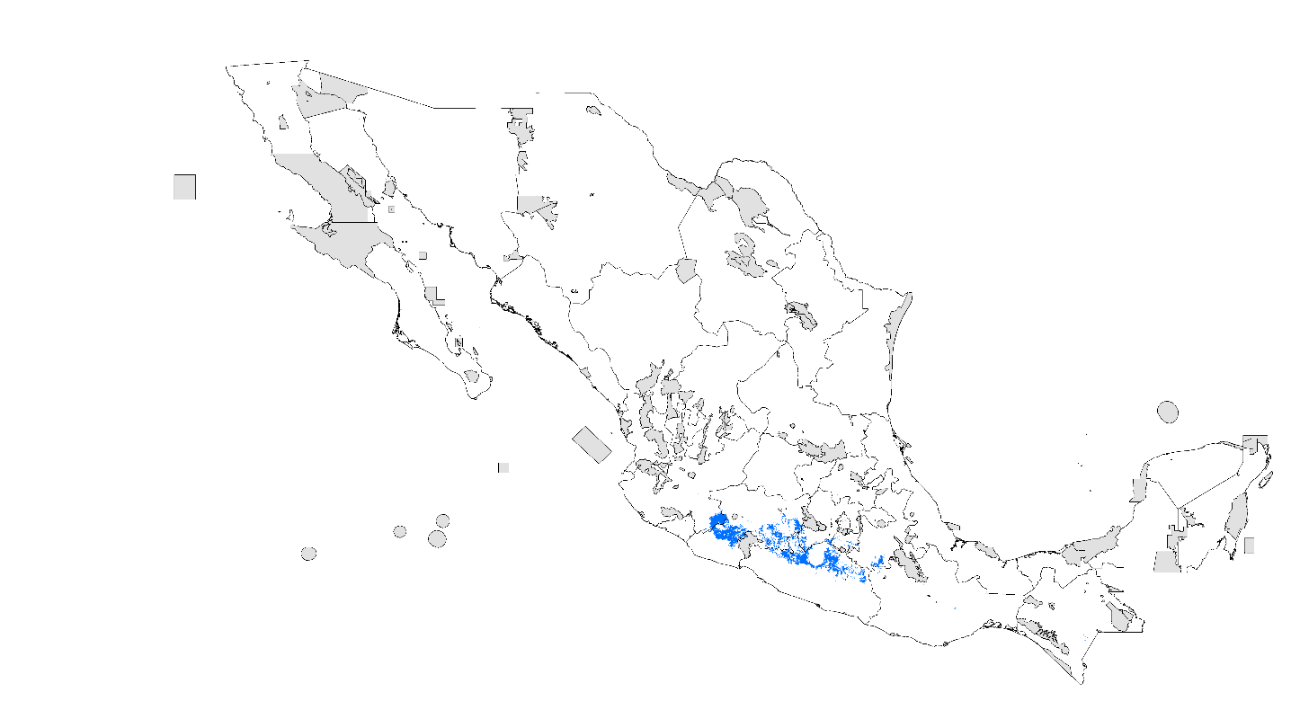

- PDA 2020 RCP 4.5 W/m²
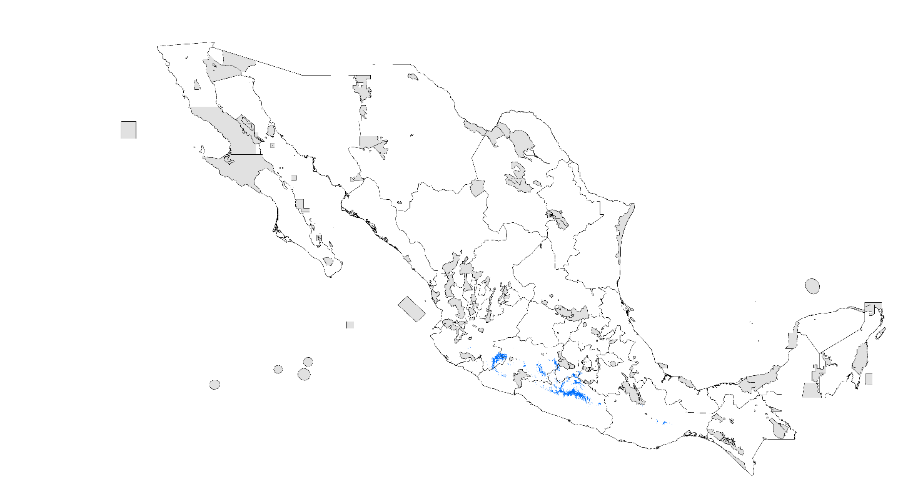
- PDA 2020 RCP 8.5 W/m²

- PDA 2080 RCP 4.5 W/m²
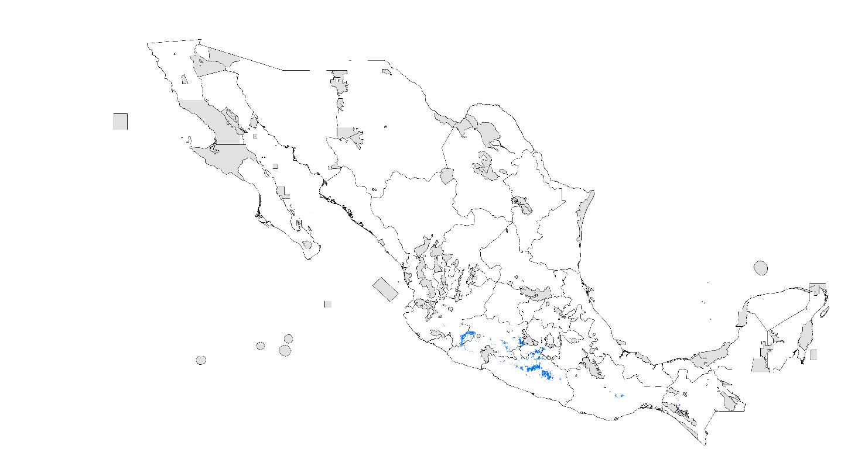
- PDA 2080 RCP 8.5 W/m²
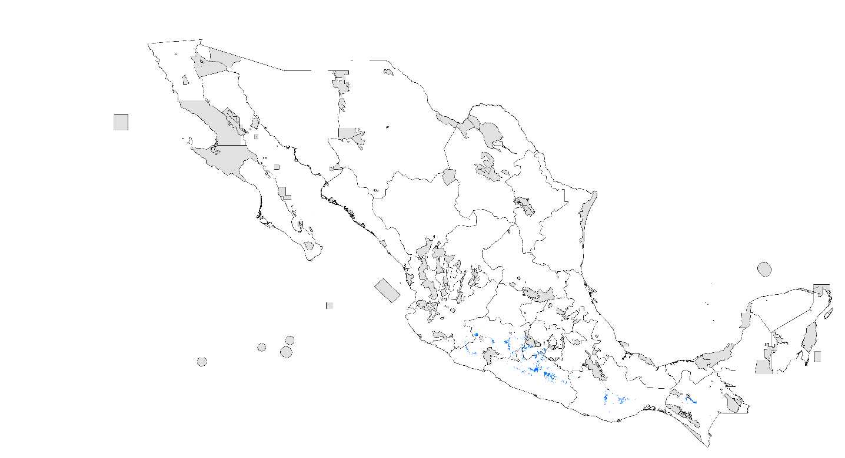

Centuroides ornatus
- Records

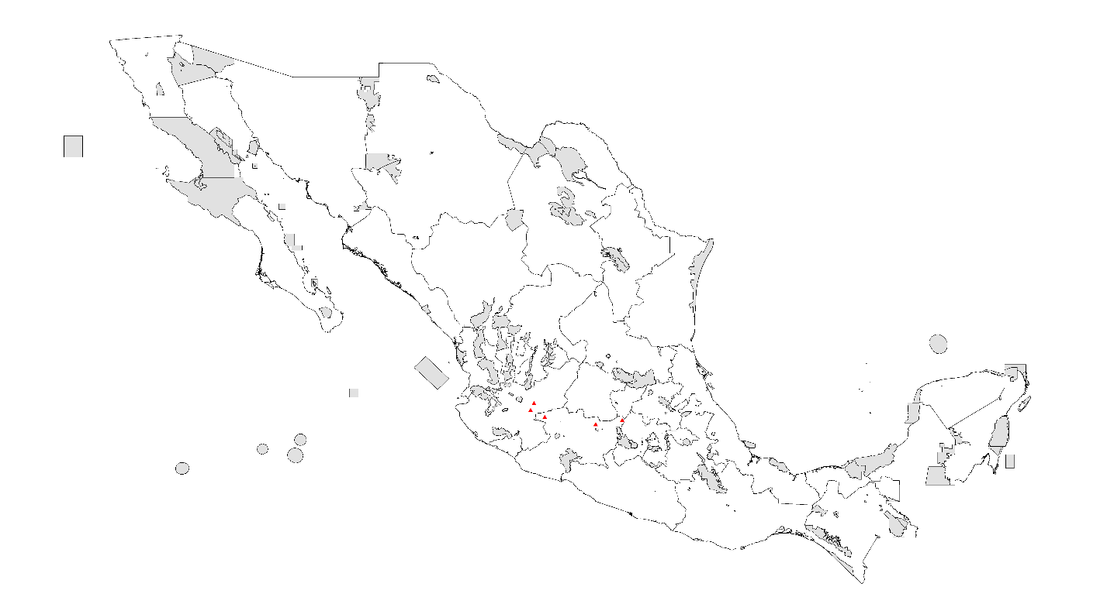
- PDA under current climatic conditions

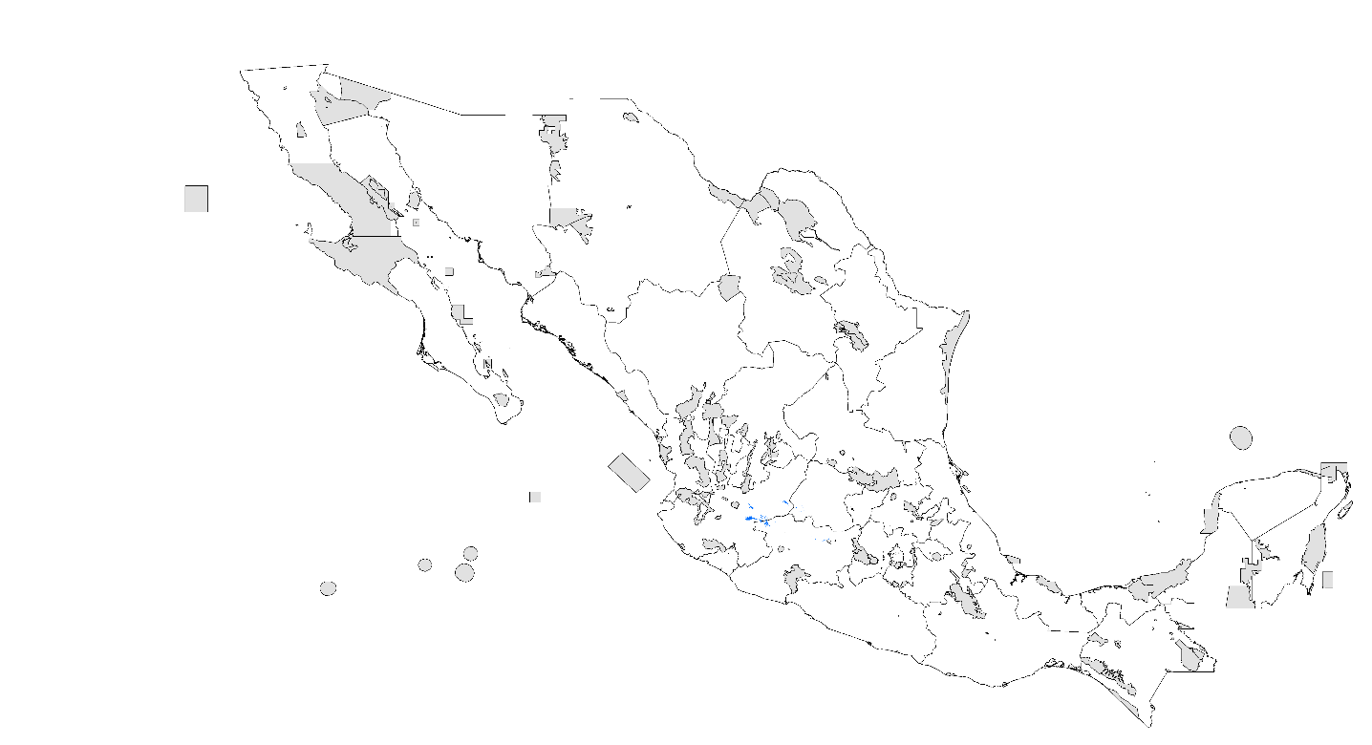

- PDA 2020 RCP 4.5 W/m²
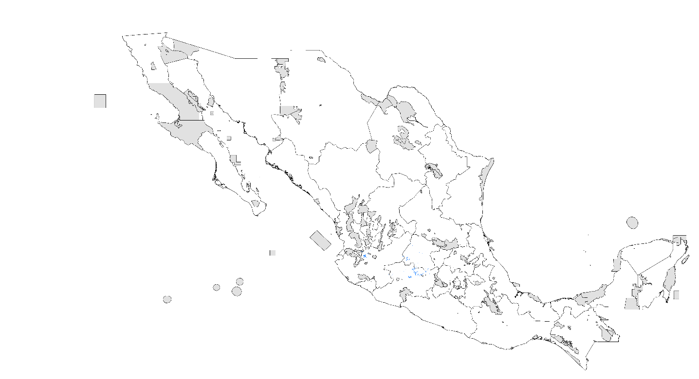
- PDA 2020 RCP 8.5 W/m²

- PDA 2080 RCP 4.5 W/m²
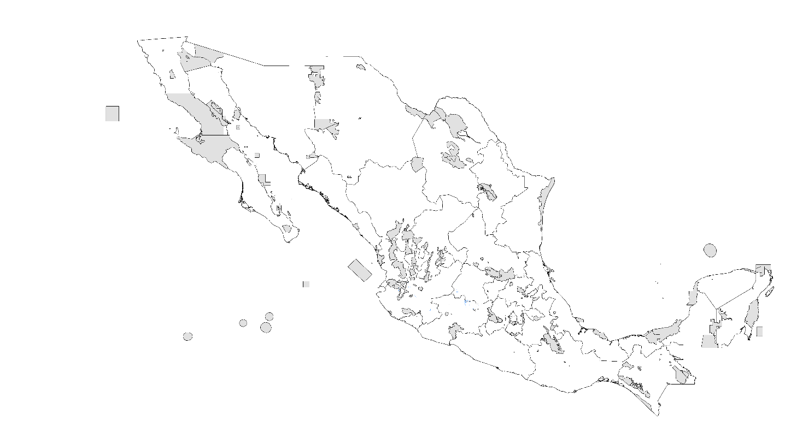
- PDA 2080 RCP 8.5 W/m²
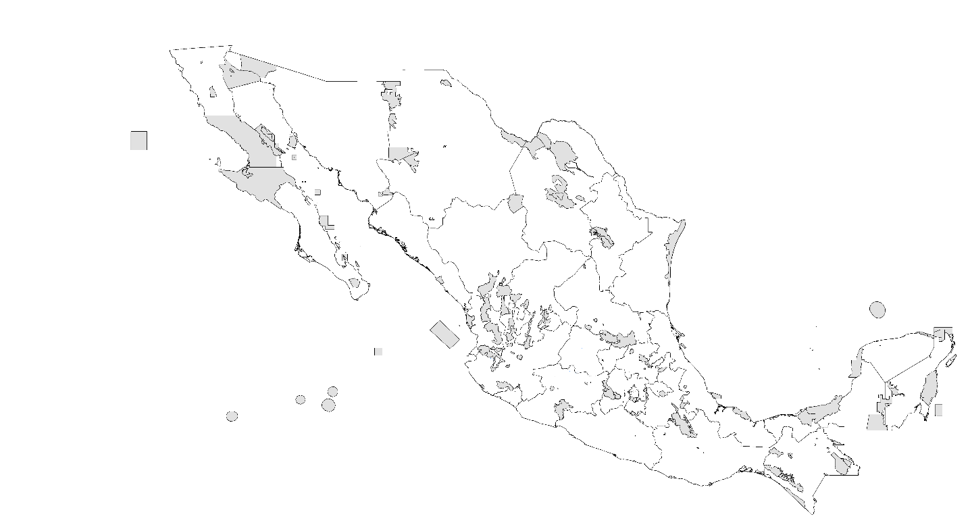

Chihuahuanus bilineatus
- Records

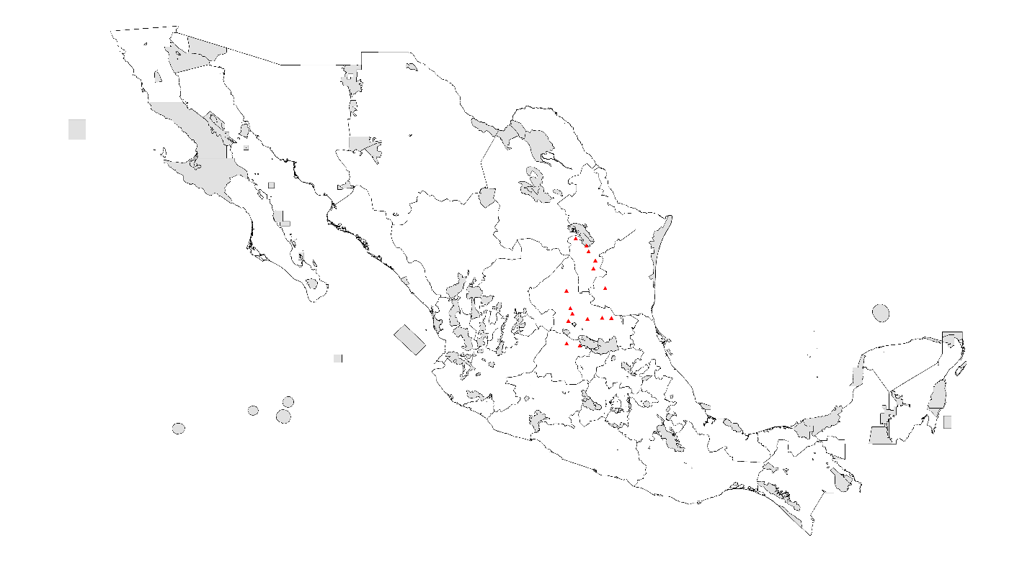
- PDA under current climatic conditions

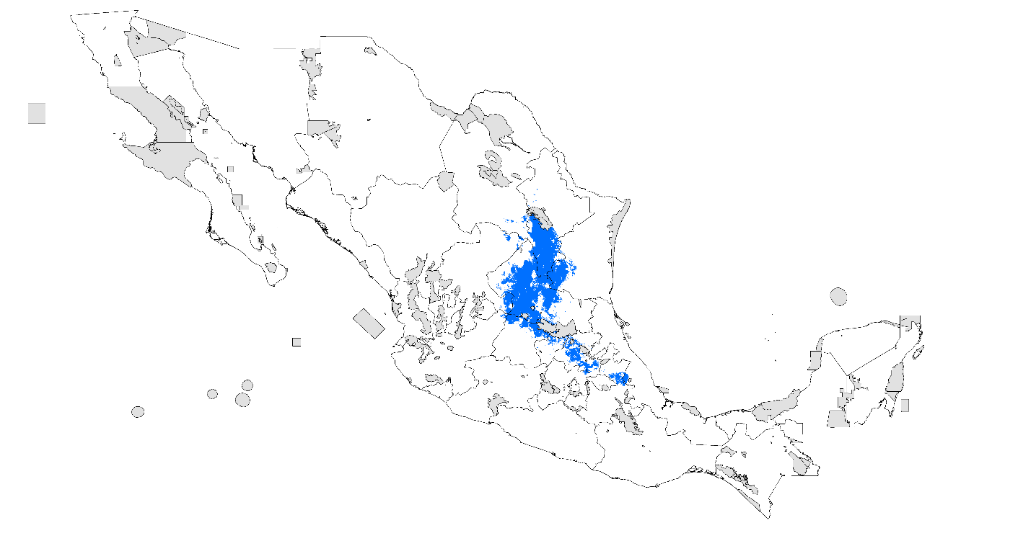

- PDA 2020 RCP 4.5 W/m²

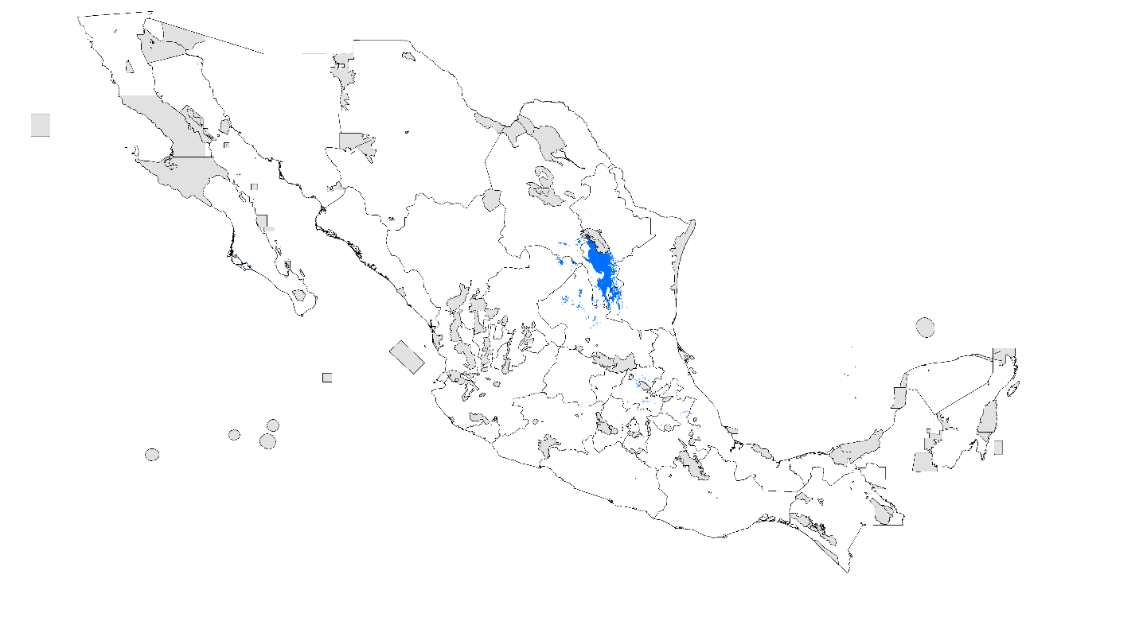
- PDA 2020 RCP 8.5 W/m²

- PDA 2080 RCP 4.5 W/m²
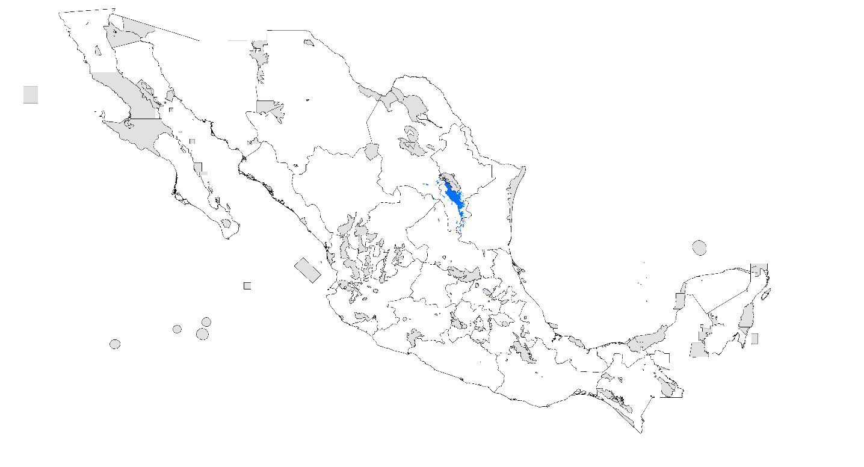
- PDA 2080 RCP 8.5 W/m²
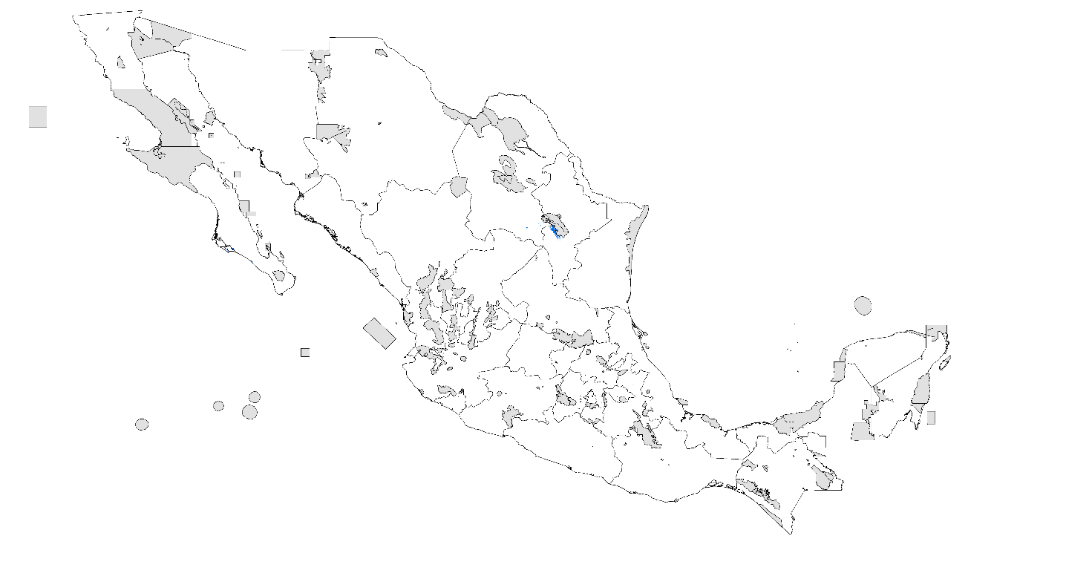

Chihuahuanus crassimanus
- Records
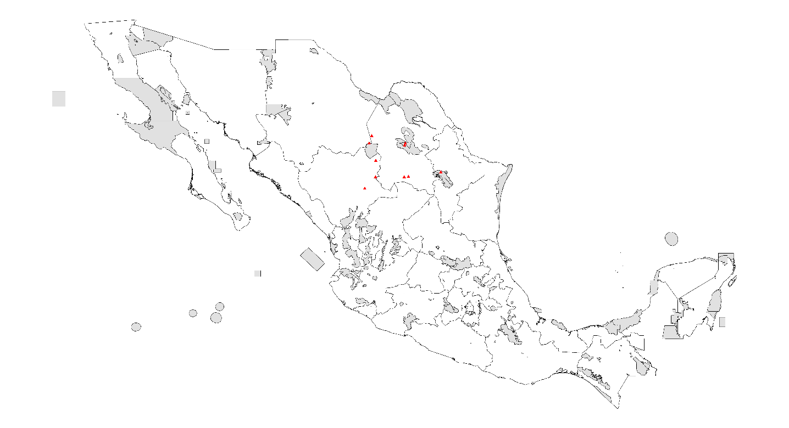
- PDA under current climatic conditions

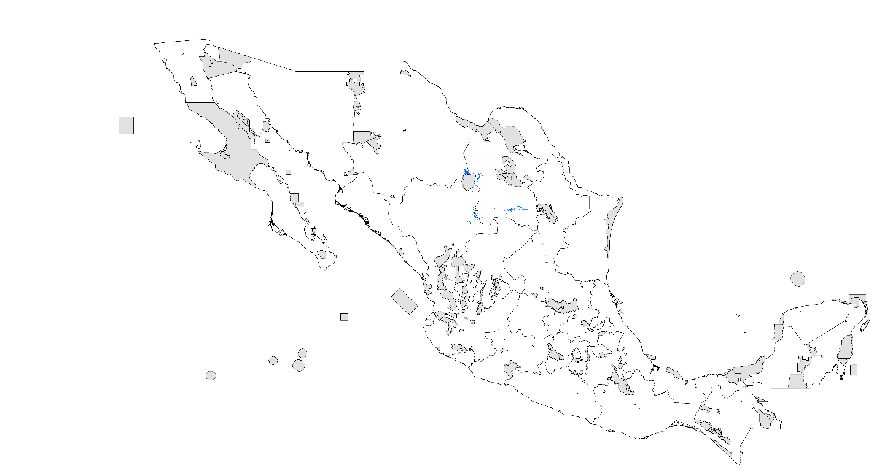

- PDA 2020 RCP 4.5 W/m²

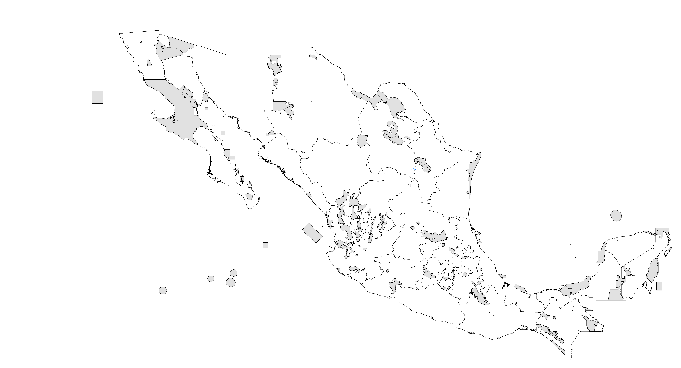
- PDA 2020 RCP 8.5 W/m²

- PDA 2080 RCP 4.5 W/m²

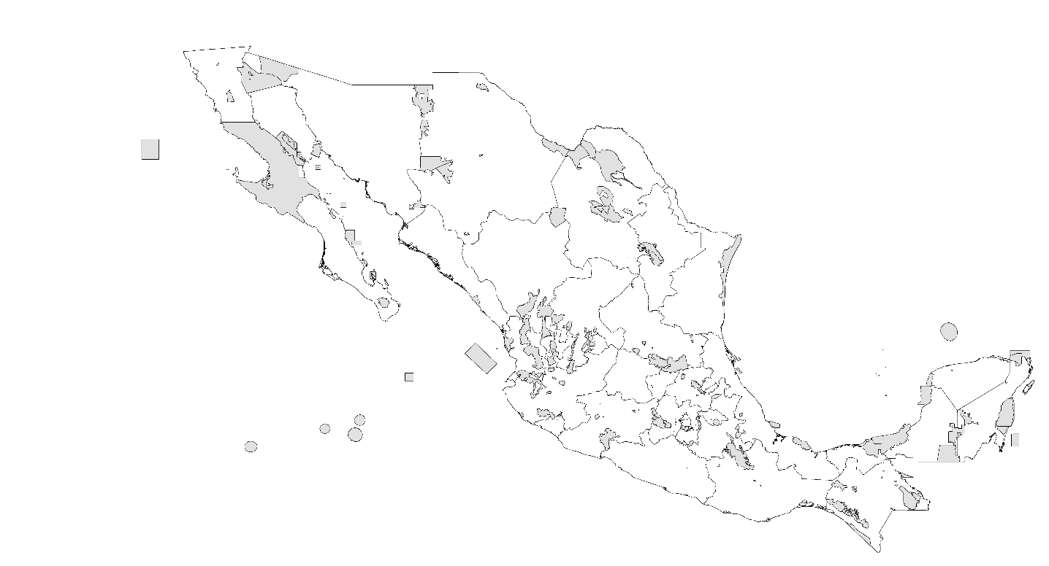
- PDA 2080 RCP 8.5 W/m²

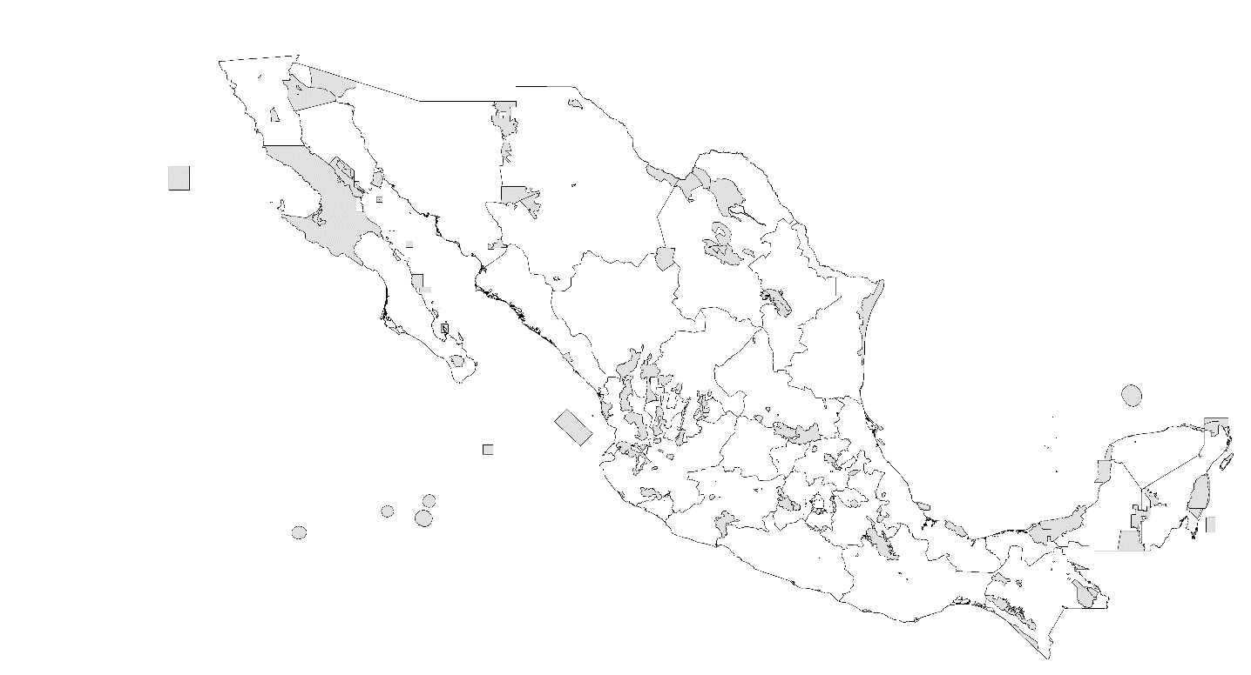

Chihuahuanus glabrimanus
- Records

- PDA under current climatic conditions

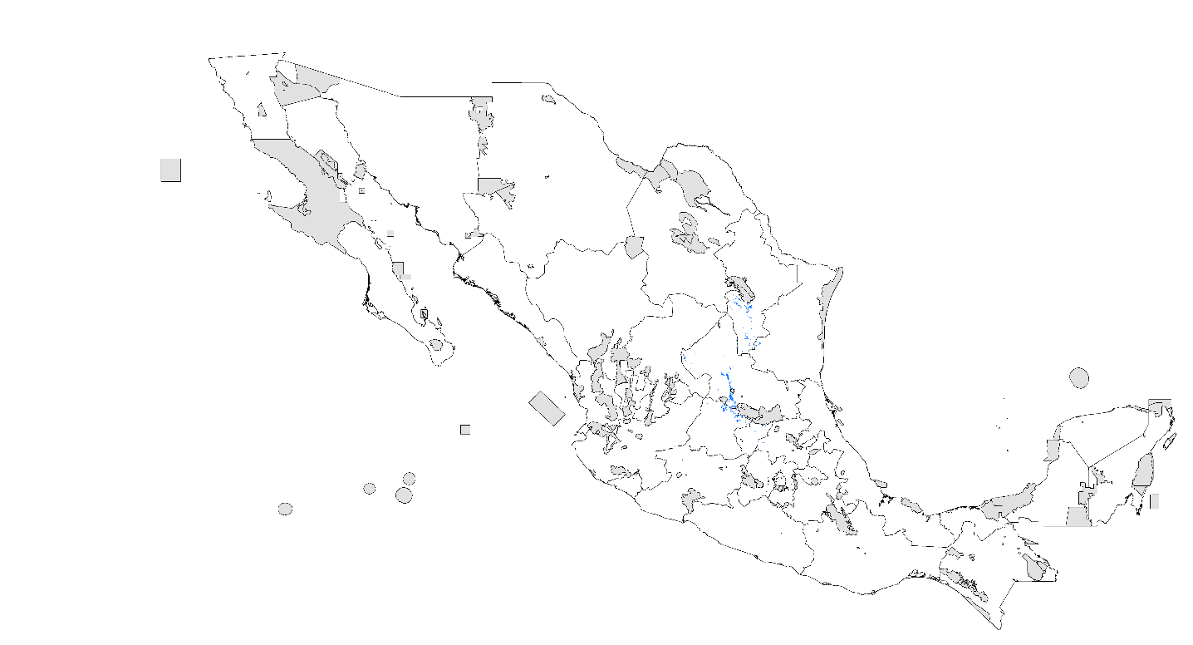

- PDA 2020 RCP 4.5 W/m²

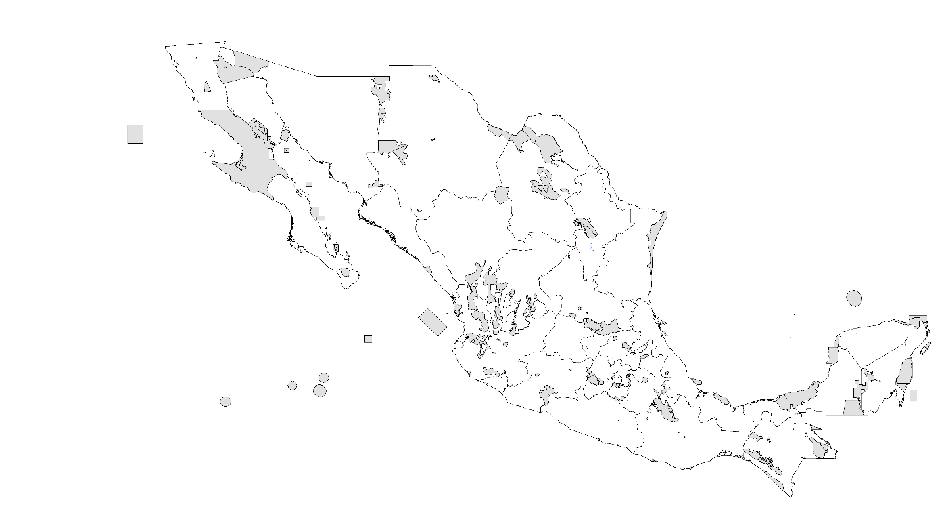

- PDA 2020 RCP 8.5 W/m²

- PDA 2080 RCP 4.5 W/m²

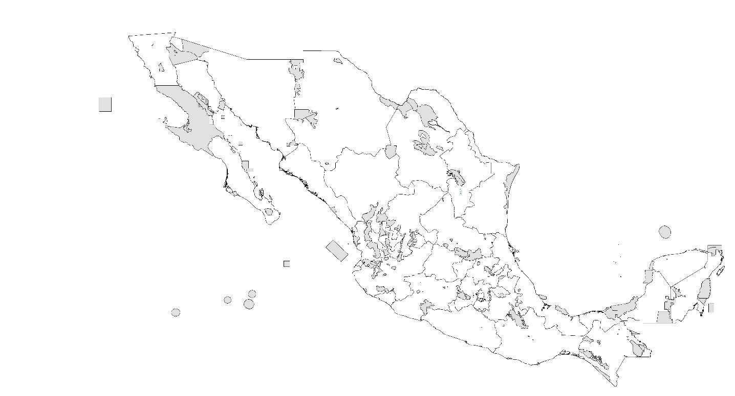

- PDA 2080 RCP 8.5 W/m²

Diplocenrus zacatecanus
- Records

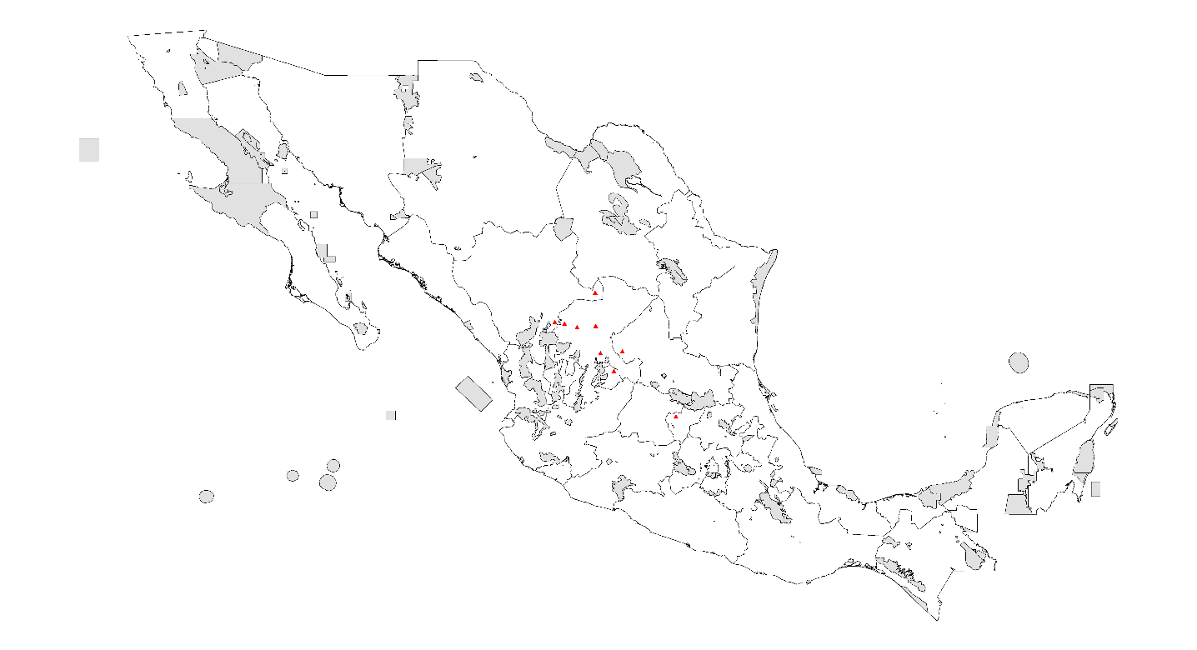

- PDA under current climatic conditions

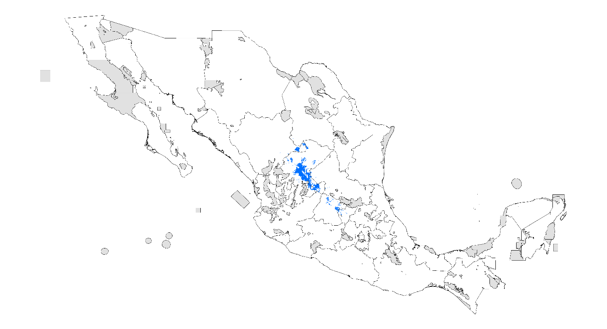

- PDA 2020 RCP 4.5 W/m²

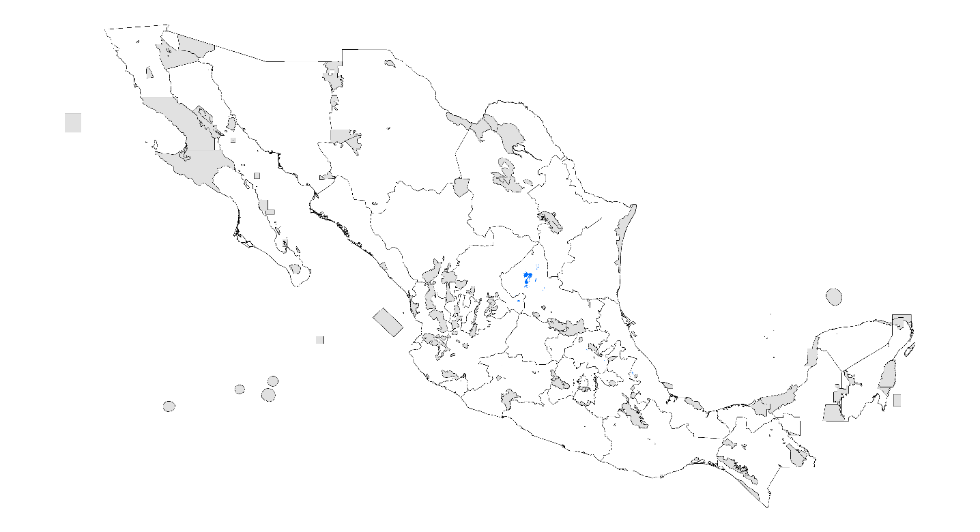

- PDA 2020 RCP 8.5 W/m²

- PDA 2080 RCP 4.5 W/m²

- PDA 2080 RCP 8.5 W/m²

Diplocentur reddelli
- Records

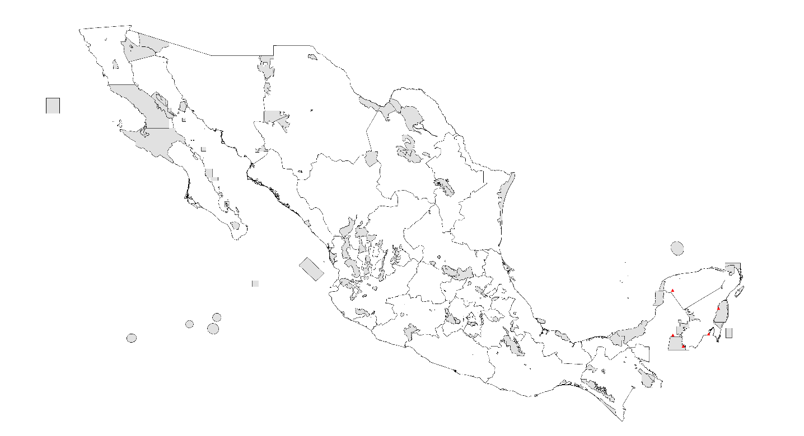

- PDA under current climatic conditions

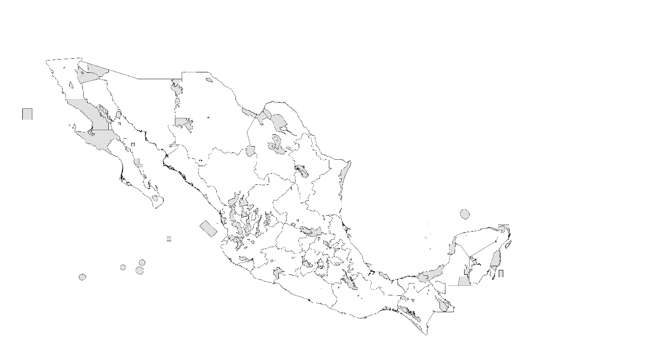

- PDA 2020 RCP 4.5 W/m²

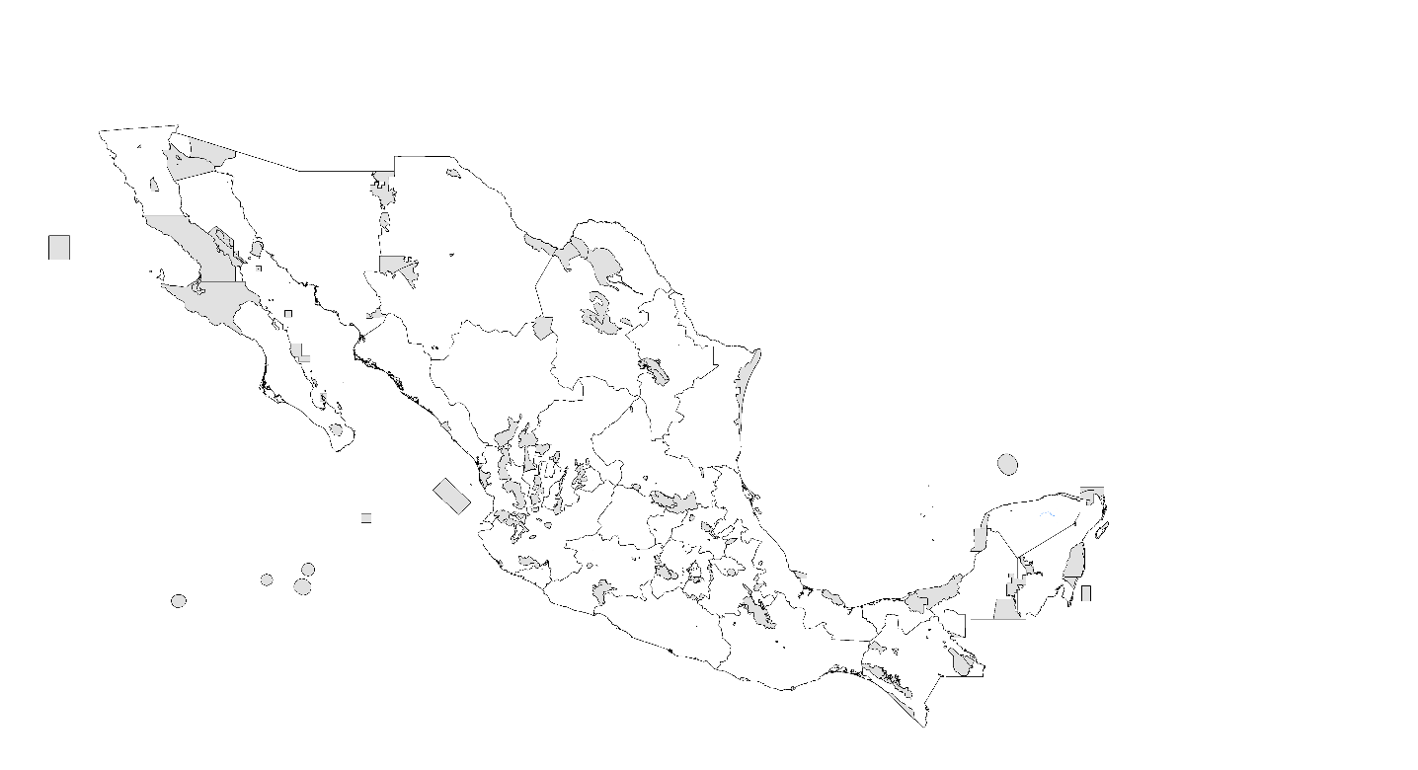

- PDA 2020 RCP 8.5 W/m²

- PDA 2080 RCP 4.5 W/m²

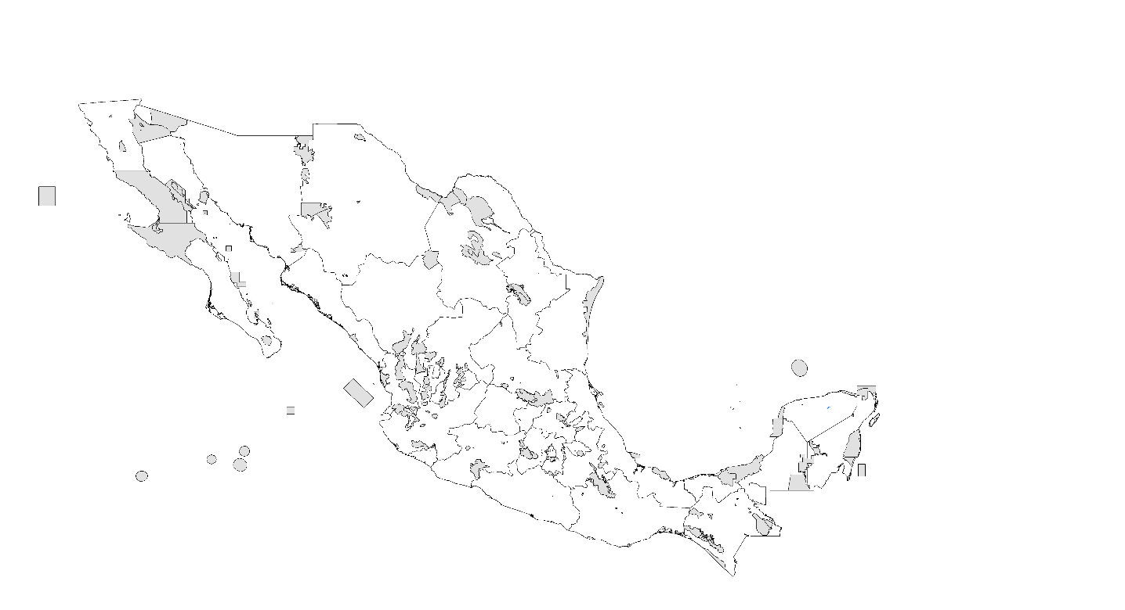

- PDA 2080 RCP 8.5 W/m²

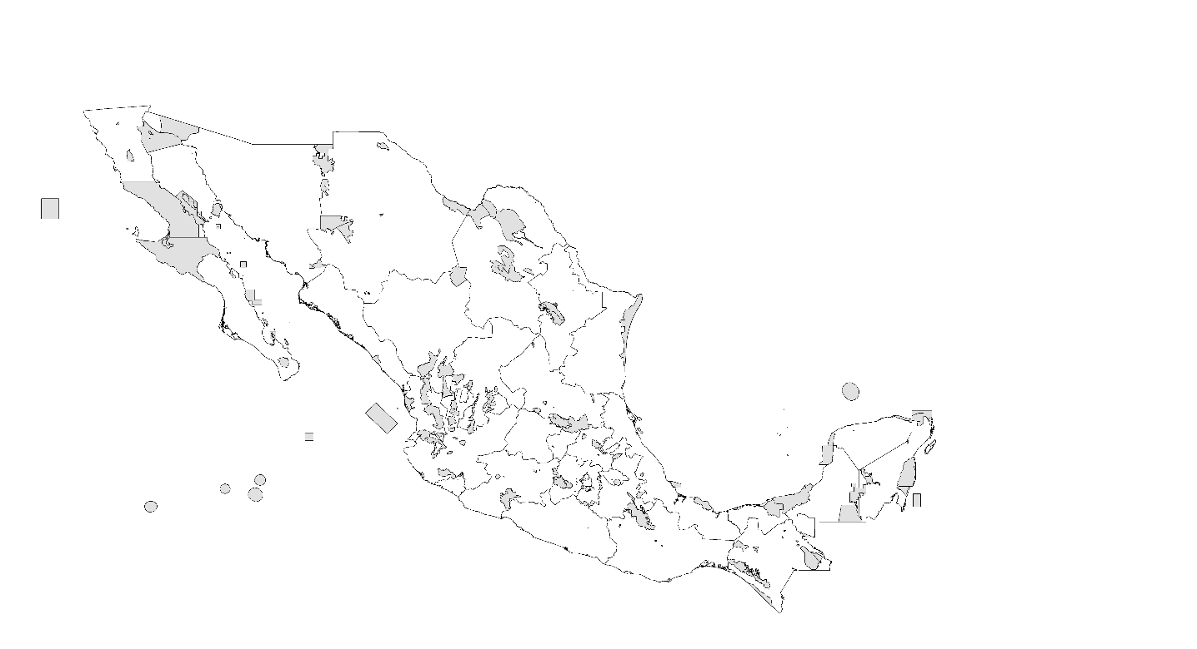

Hadrurus concolorus
- Records

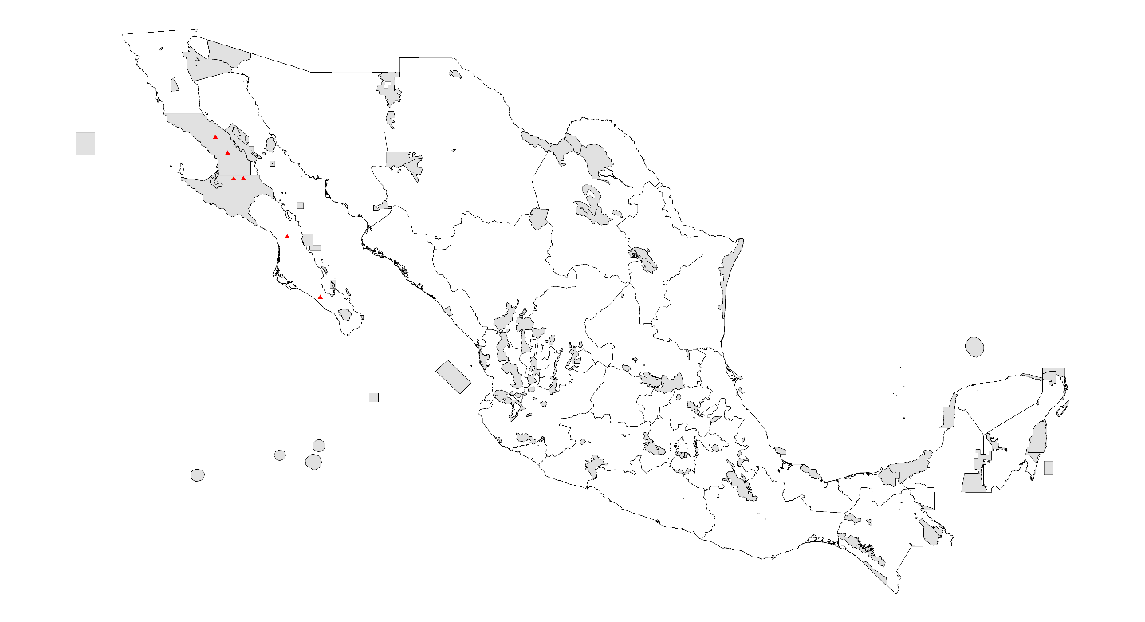

- PDA under current climatic conditions

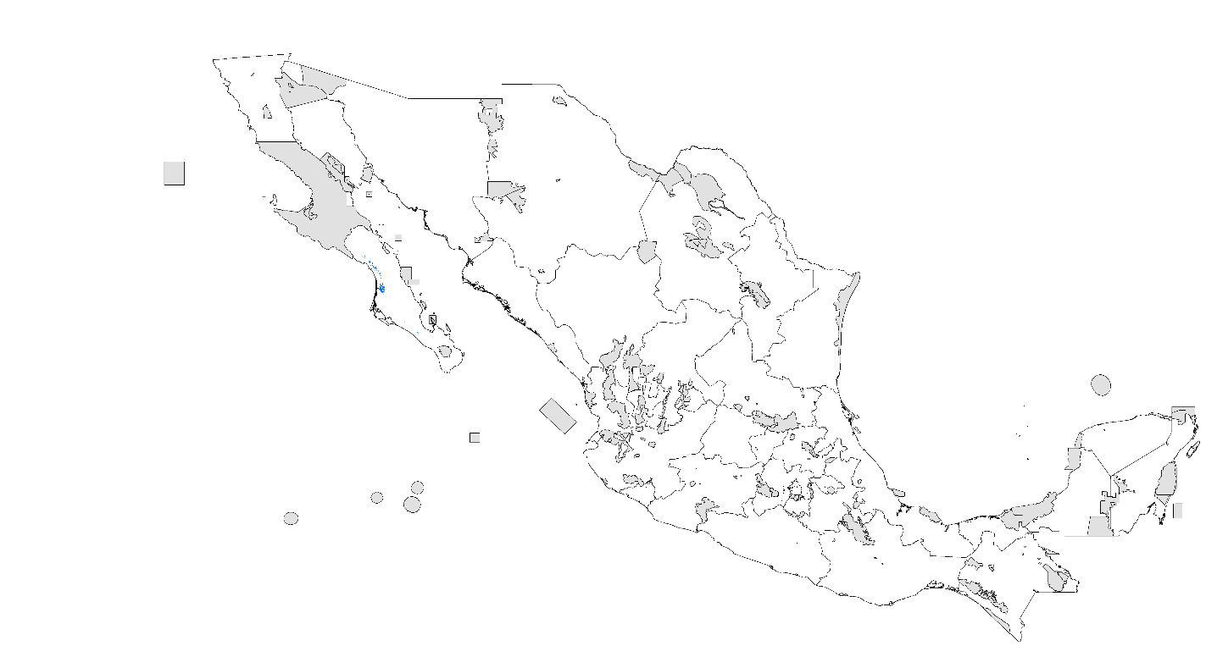

- PDA 2020 RCP 4.5 W/m²

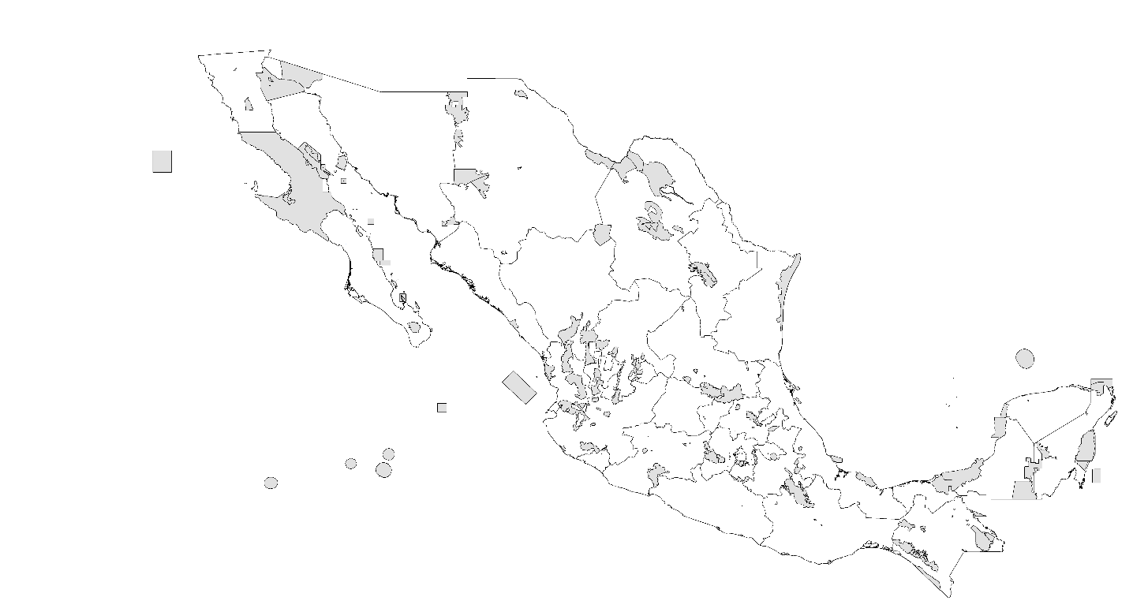

- PDA 2020 RCP 8.5 W/m²

- PDA 2080 RCP 4.5 W/m²

- PDA 2080 RCP 8.5 W/m²
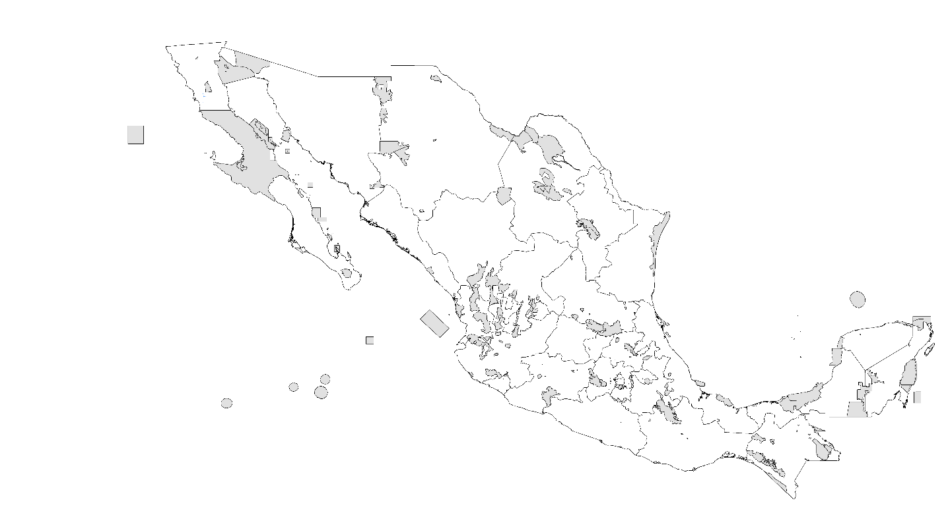

Kochius sonorae
- Records

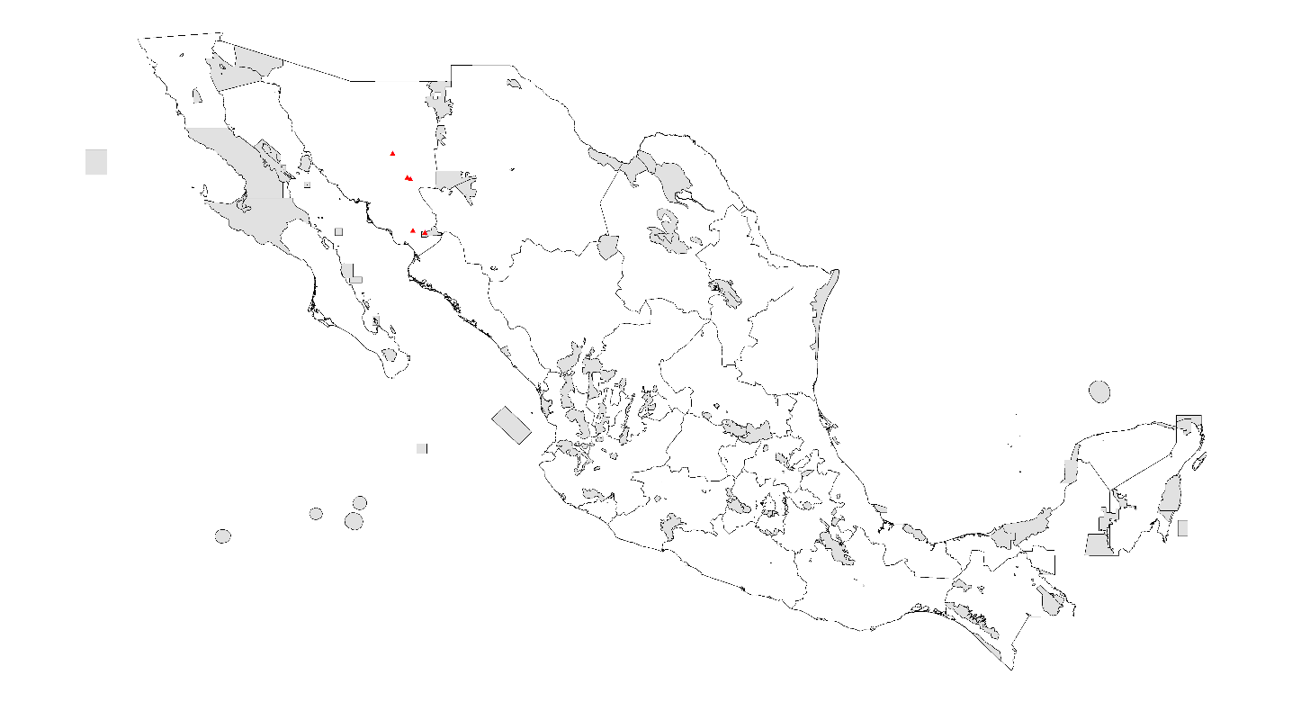

- PDA under current climatic conditions

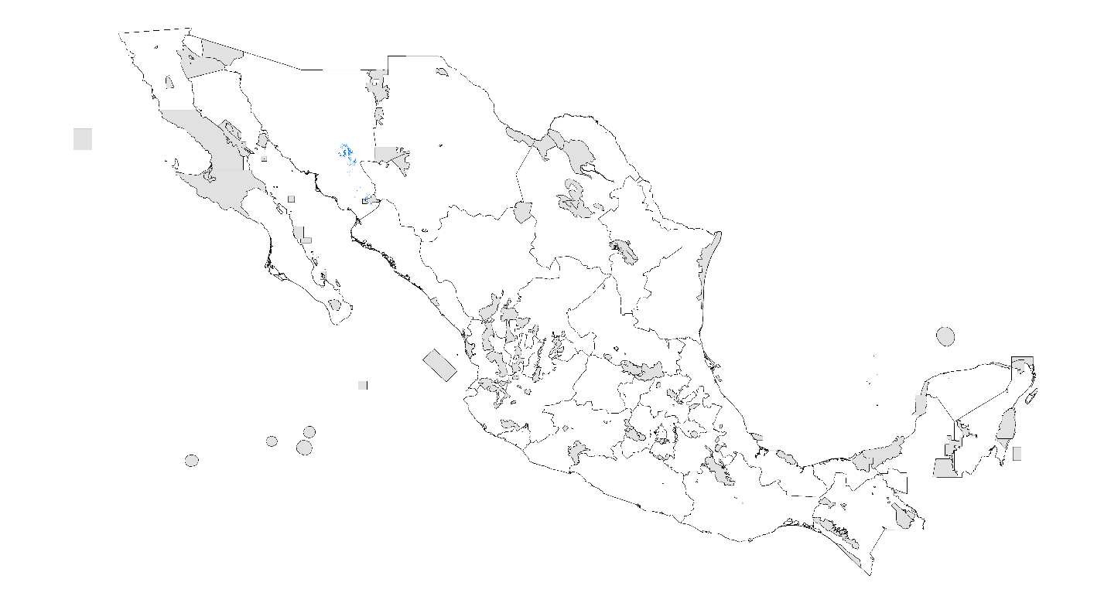

- PDA 2020 RCP 4.5 W/m²

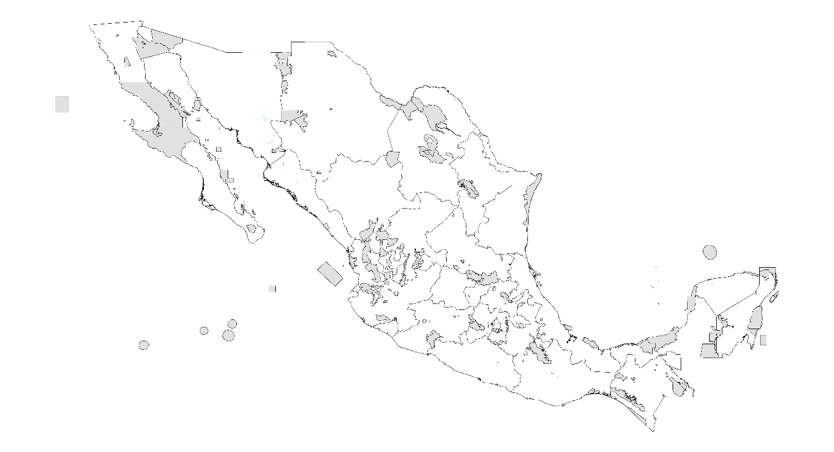

- PDA 2020 RCP 8.5 W/m²

- PDA 2080 RCP 4.5 W/m²

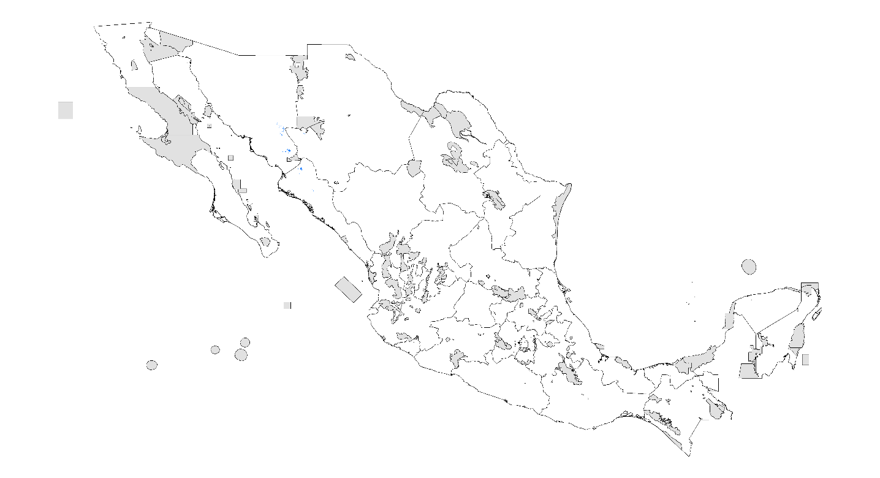

- PDA 2080 RCP 8.5 W/m²

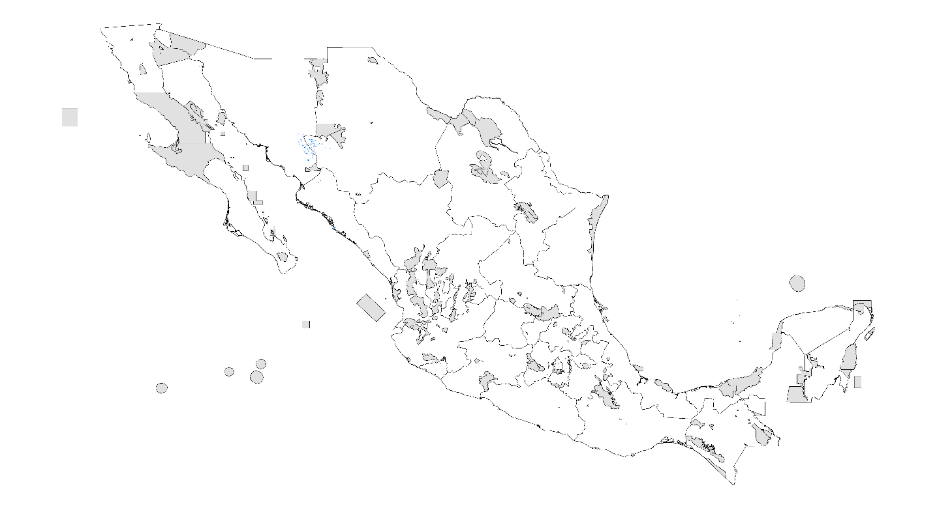

Megacormus grubbsi
- Records

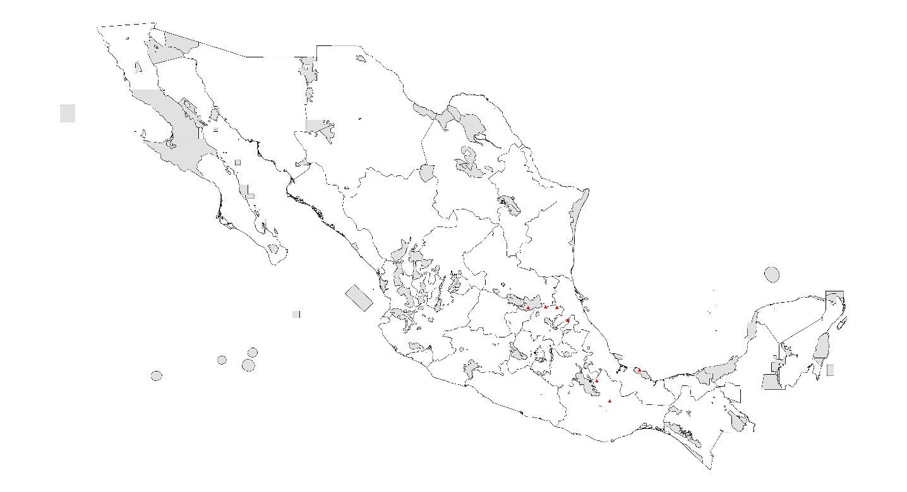

- PDA under current climatic conditions

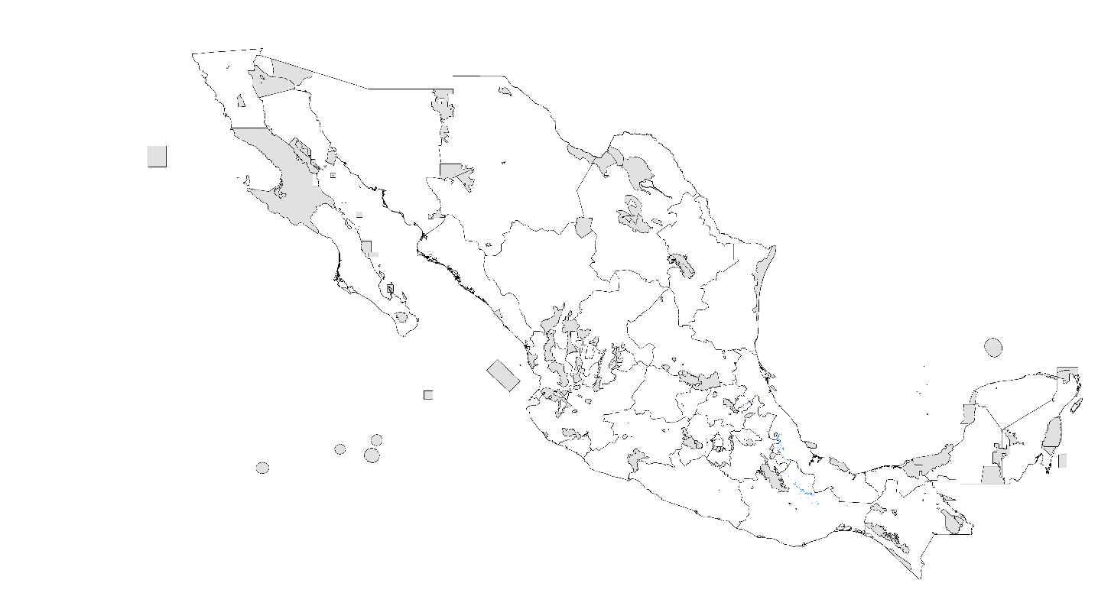

- PDA 2020 RCP 4.5 W/m²

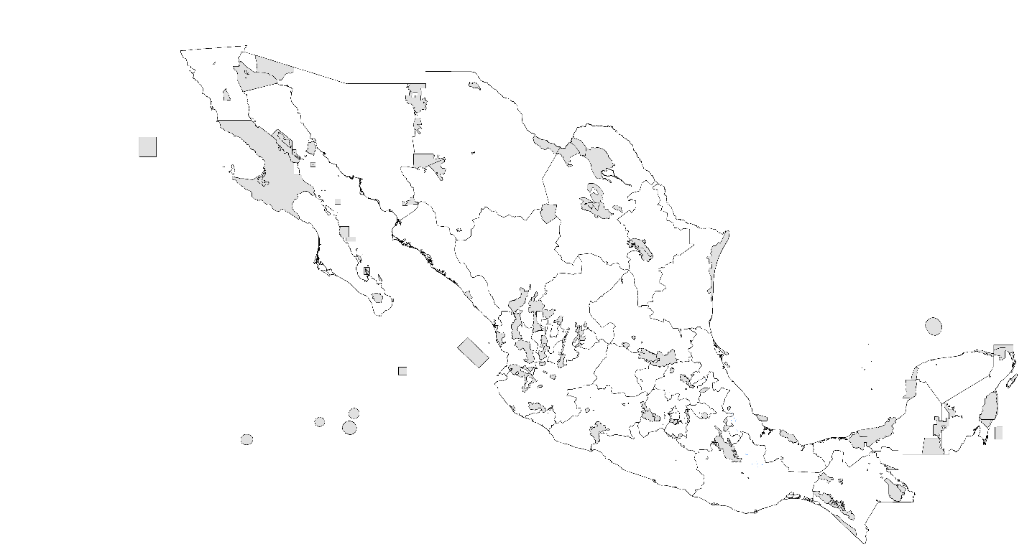

- PDA 2020 RCP 8.5 W/m²

- PDA 2080 RCP 4.5 W/m²

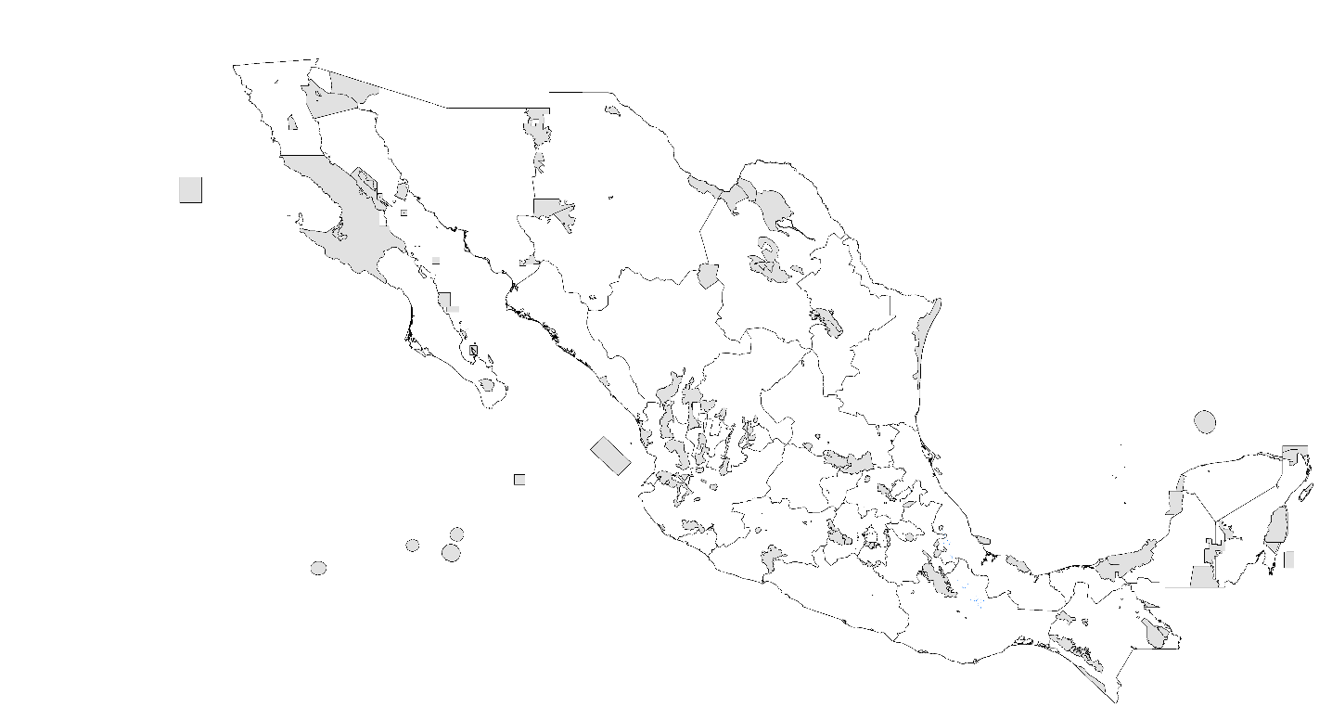

- PDA 2080 RCP 8.5 W/m²

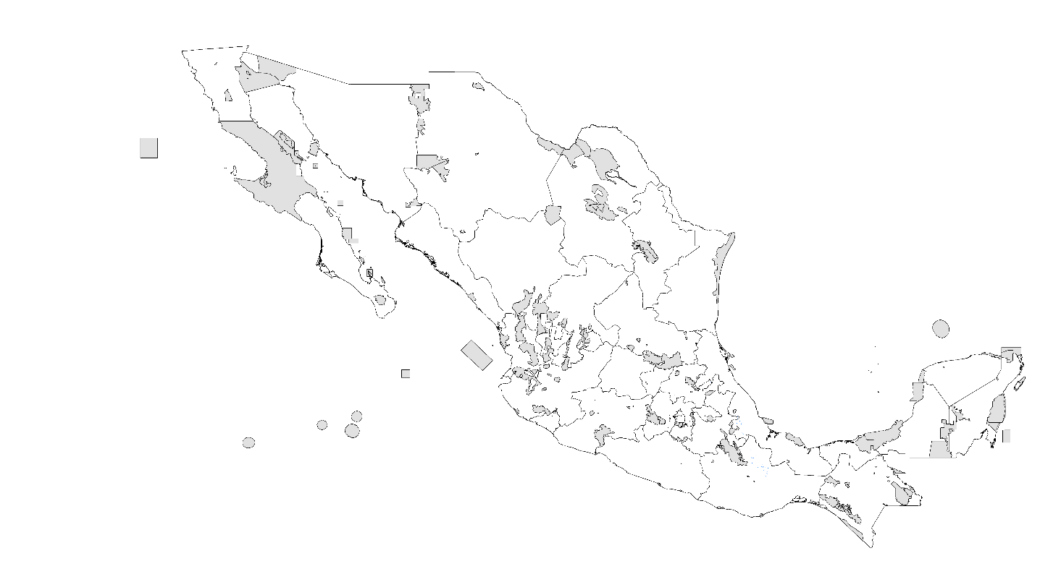

Mesomexovis oaxaca
- Records

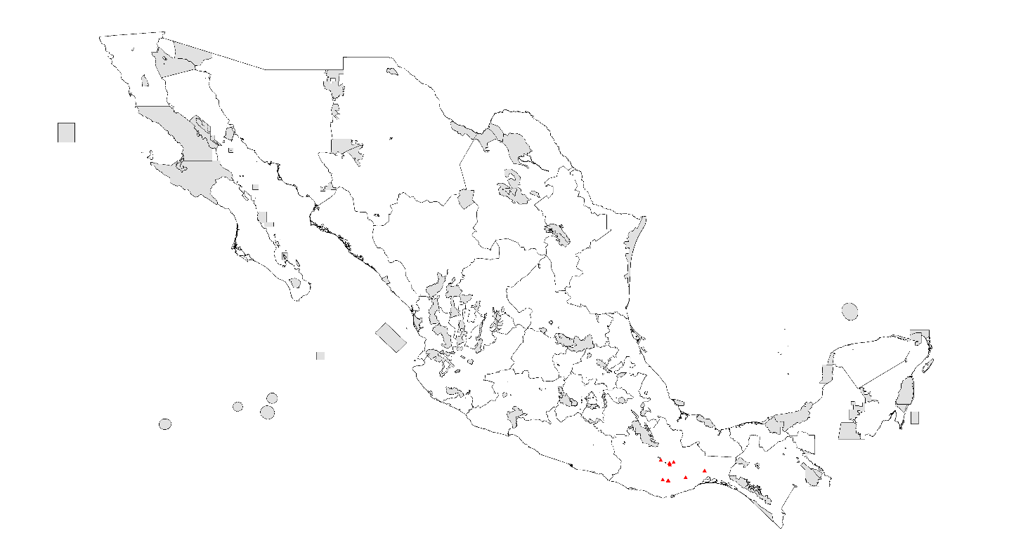

- PDA under current climatic conditions

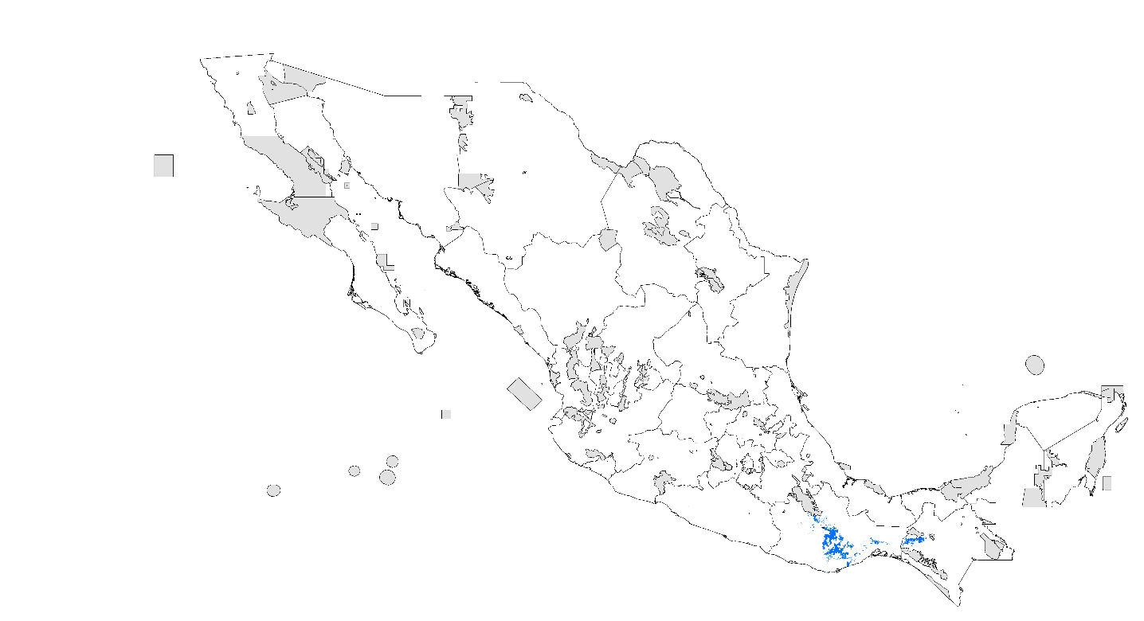

- PDA 2020 RCP 4.5 W/m²

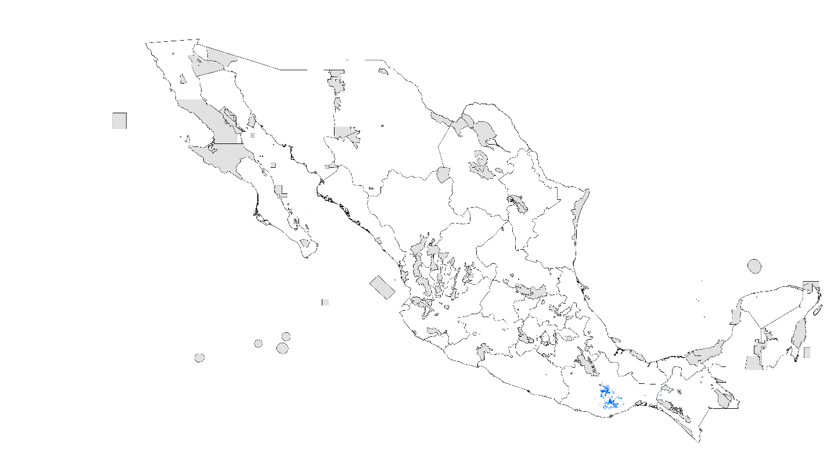

- PDA 2020 RCP 8.5 W/m²

- PDA 2080 RCP 4.5 W/m²

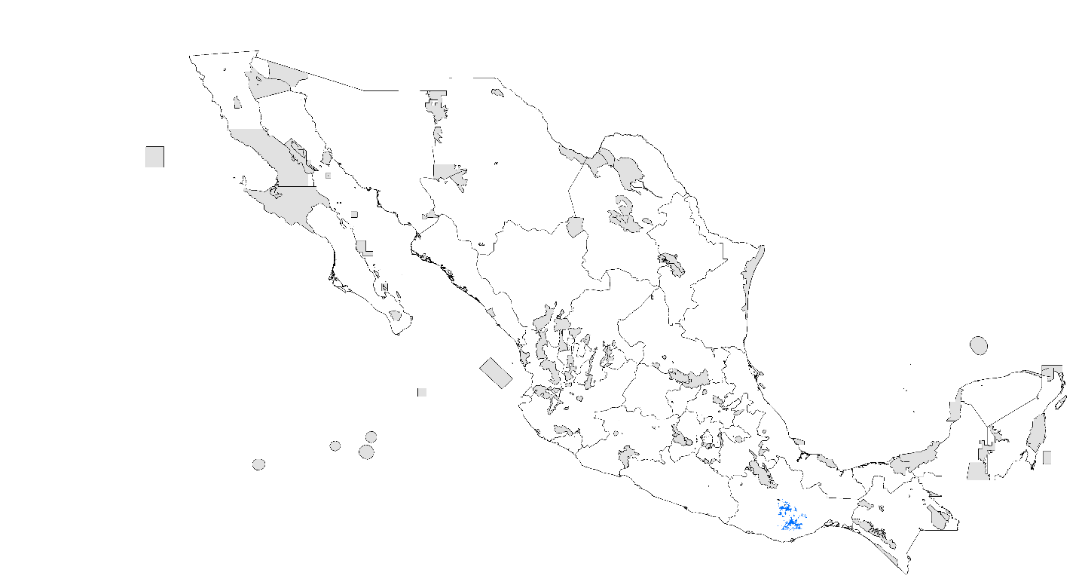

- PDA 2080 RCP 8.5 W/m²

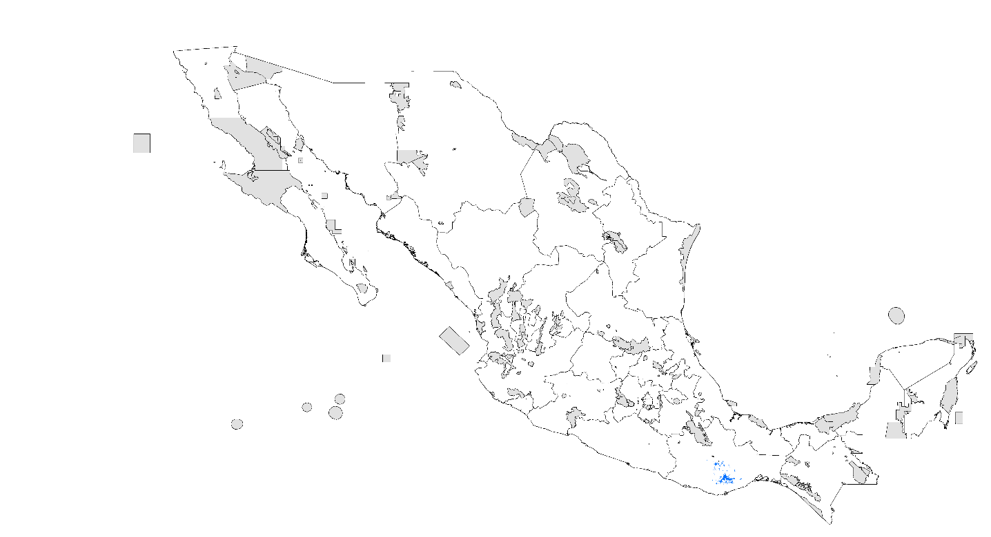

Mesomexovis occidentalis
- Records

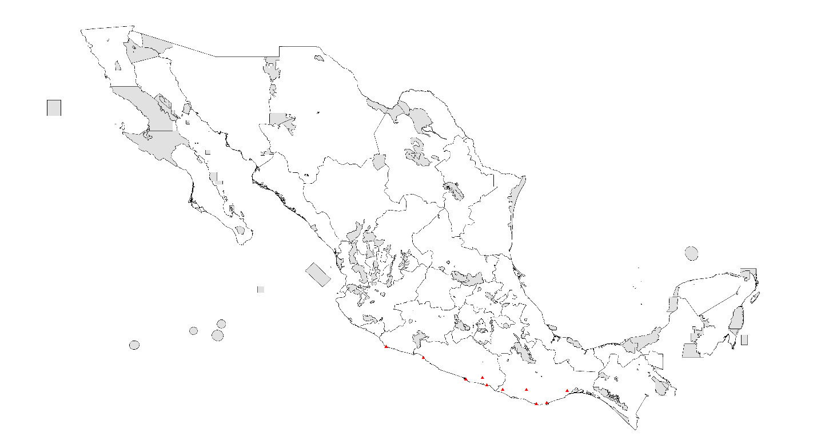

- PDA under current climatic conditions

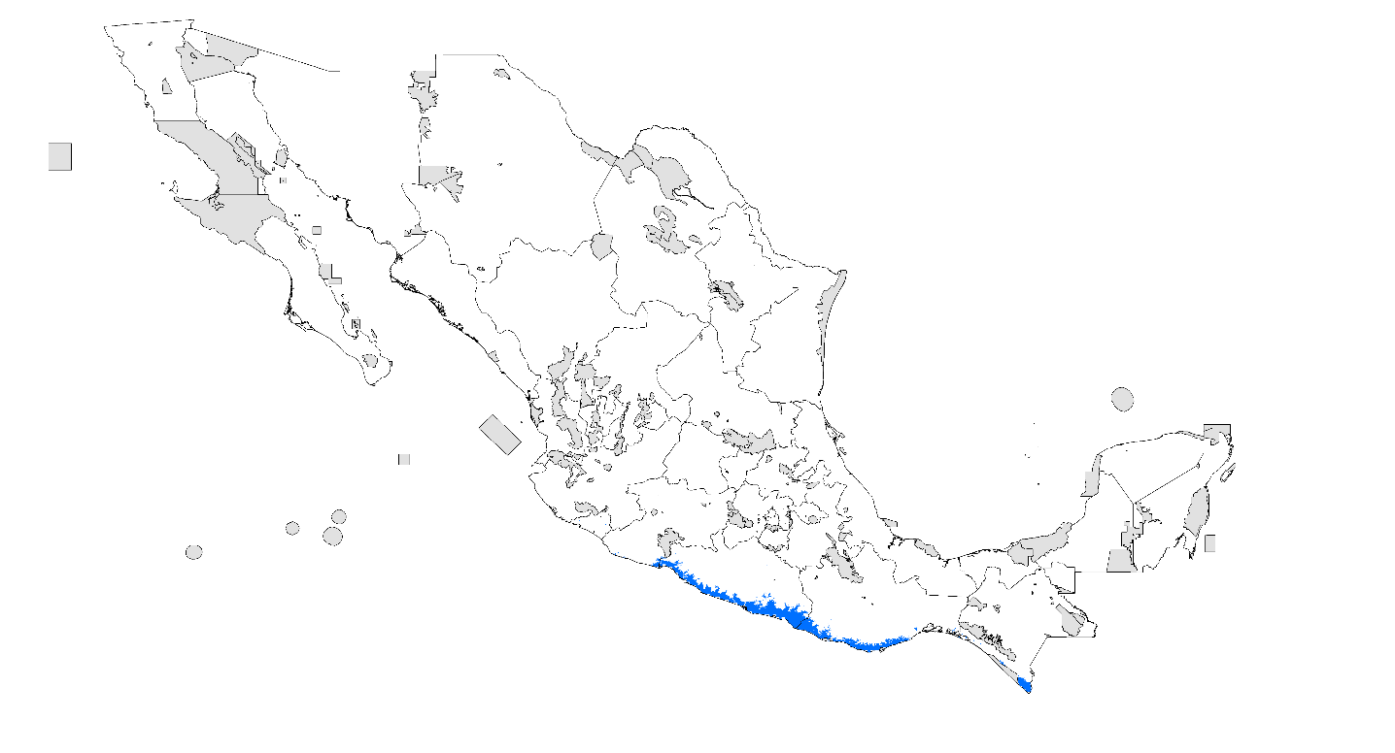

- PDA 2020 RCP 4.5 W/m²

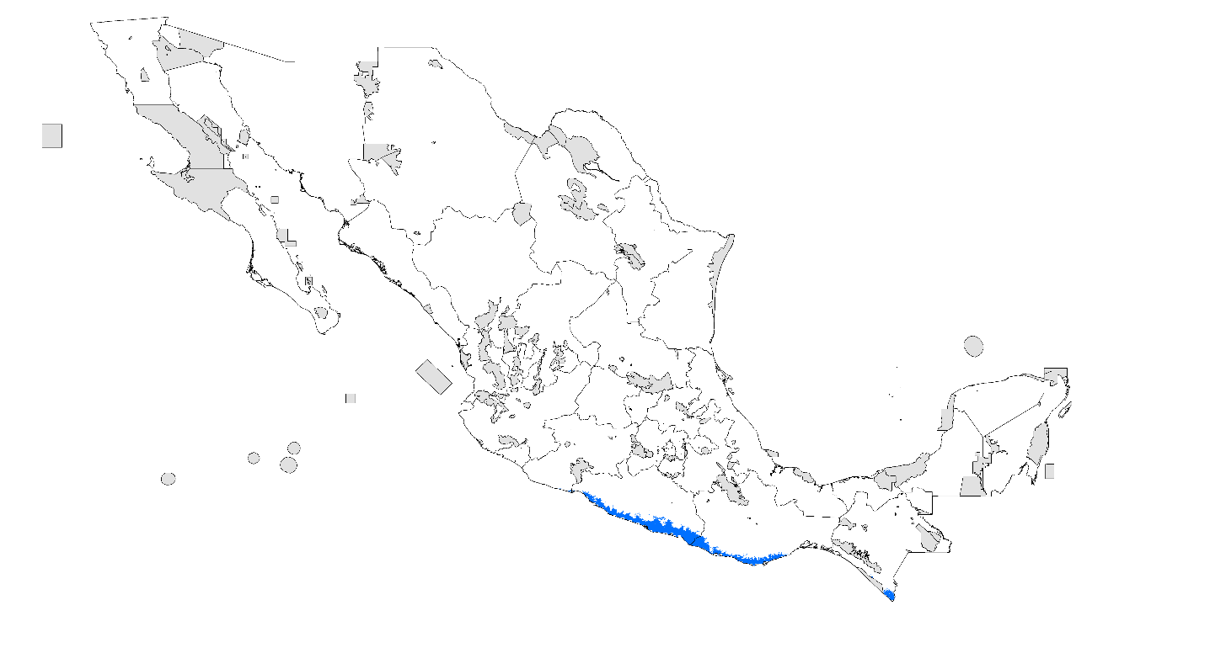

- PDA 2020 RCP 8.5 W/m²

- PDA 2080 RCP 4.5 W/m²

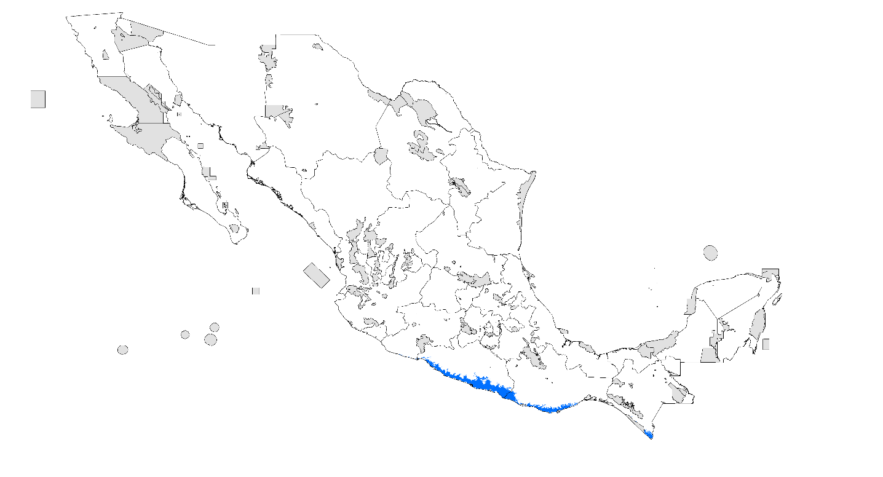

- PDA 2080 RCP 8.5 W/m²

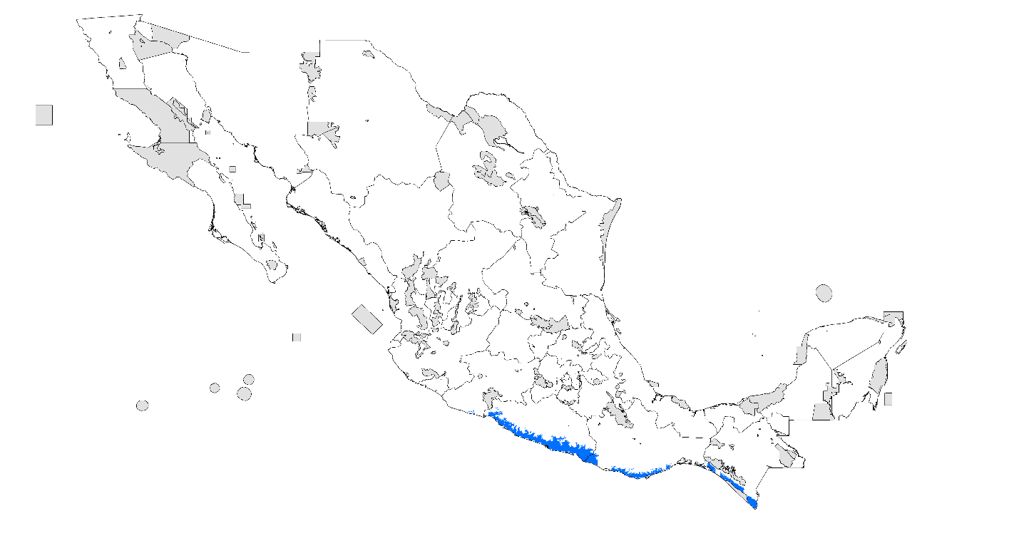

Mesomexovis subscritatus
- Records

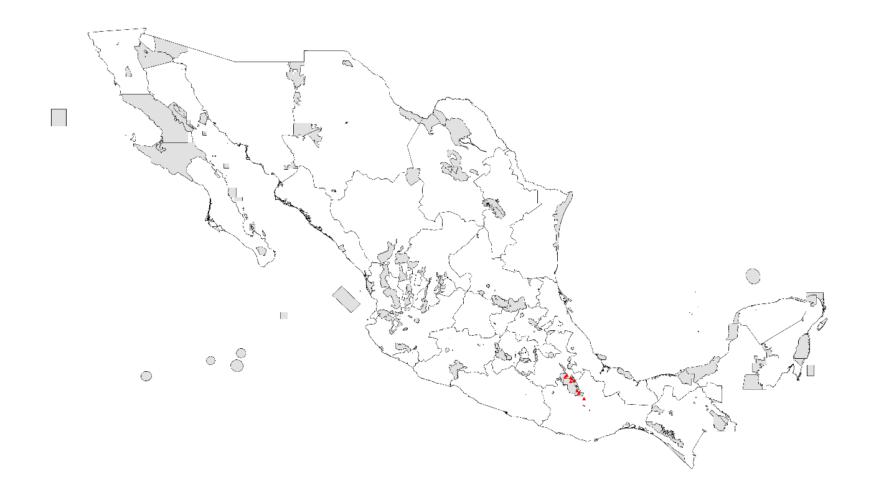

- PDA under current climatic conditions

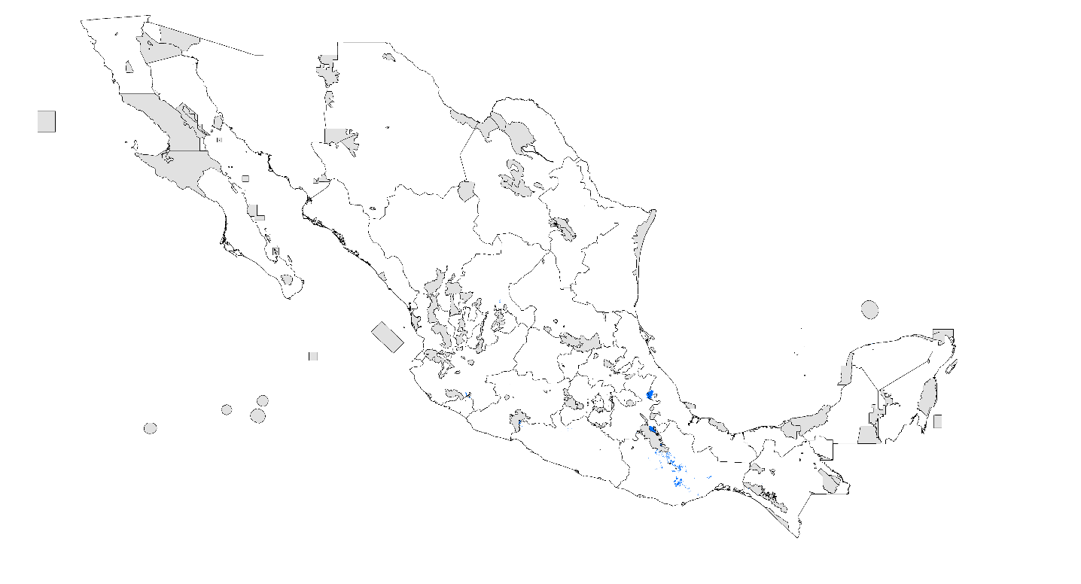

- PDA 2020 RCP 4.5 W/m²

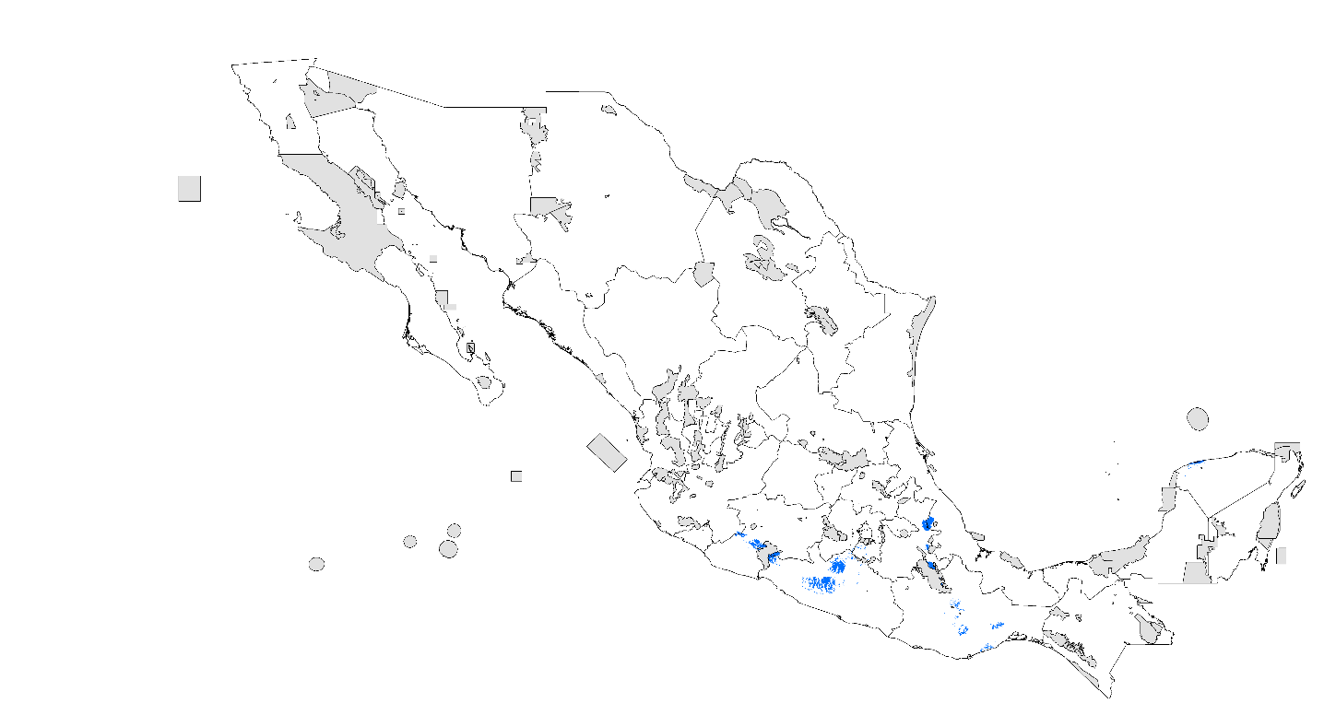

- PDA 2020 RCP 8.5 W/m²

- PDA 2080 RCP 4.5 W/m²

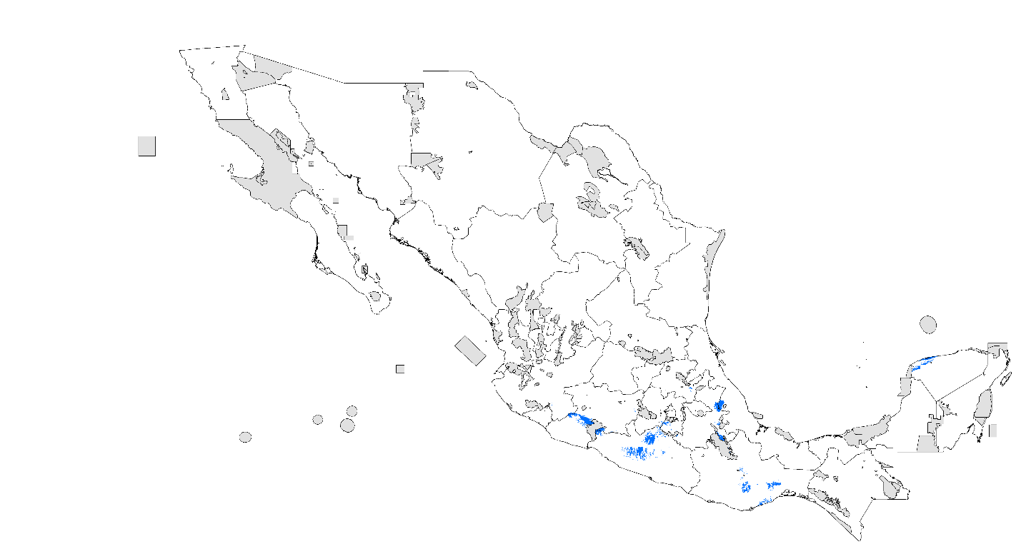

- PDA 2080 RCP 8.5 W/m²
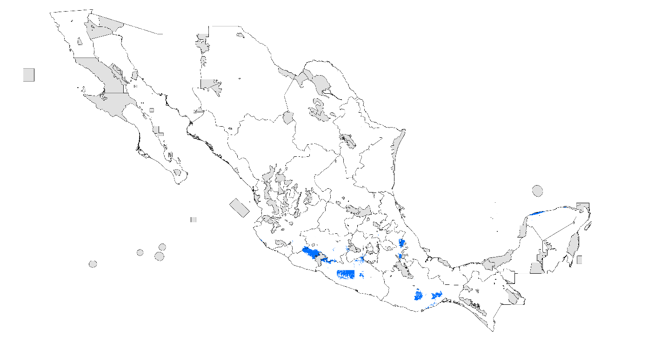

Mesomexovis variegatus
- Records

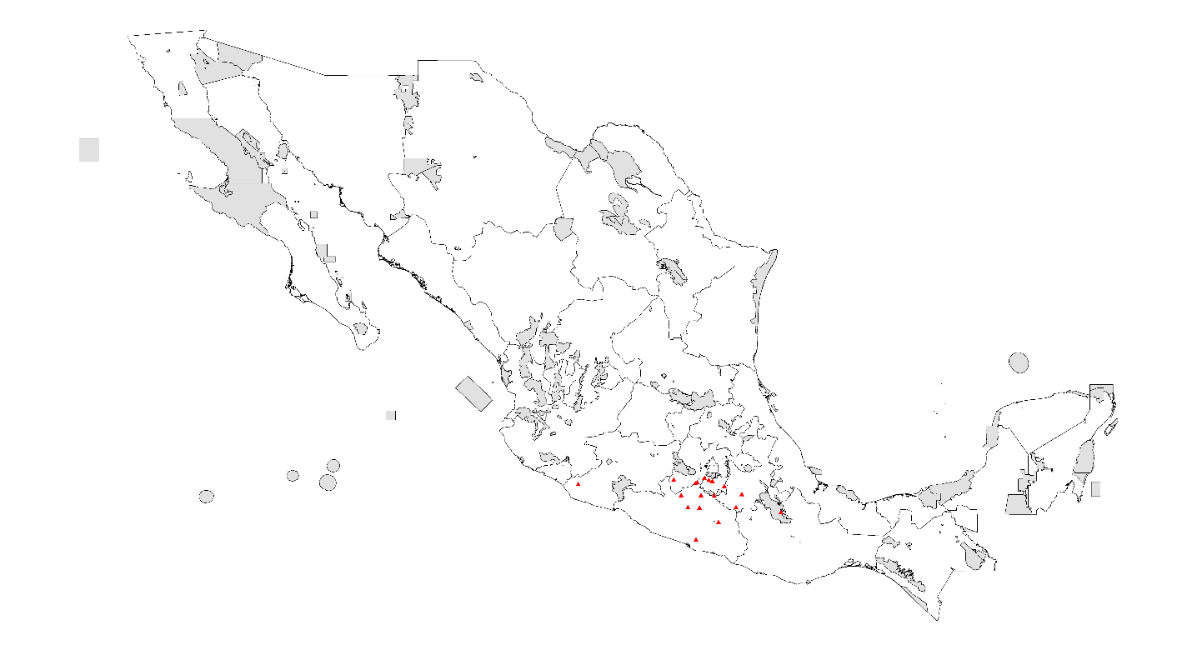

- PDA under current climatic conditions

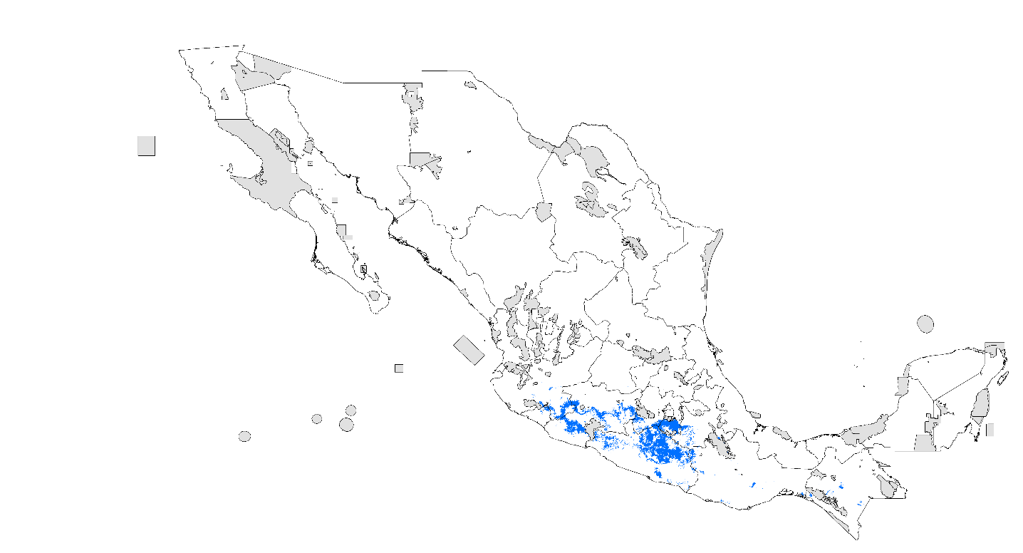

- PDA 2020 RCP 4.5 W/m²

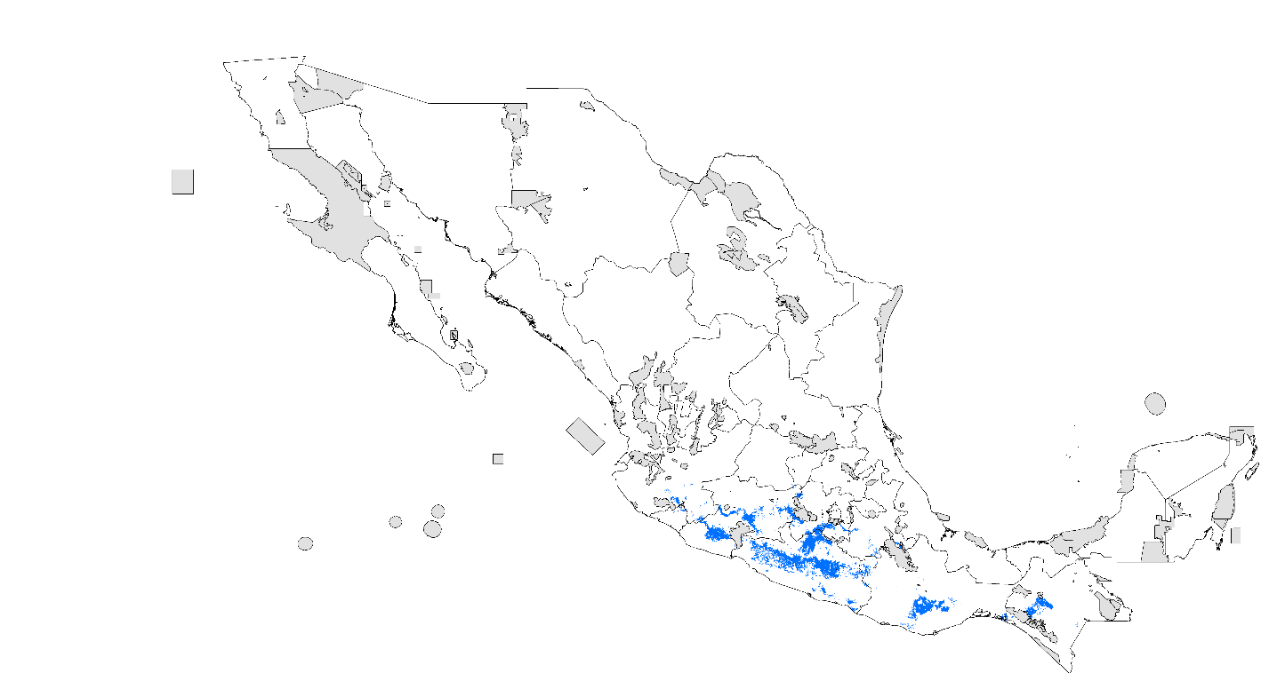

- PDA 2020 RCP 8.5 W/m²

- PDA 2080 RCP 4.5 W/m²

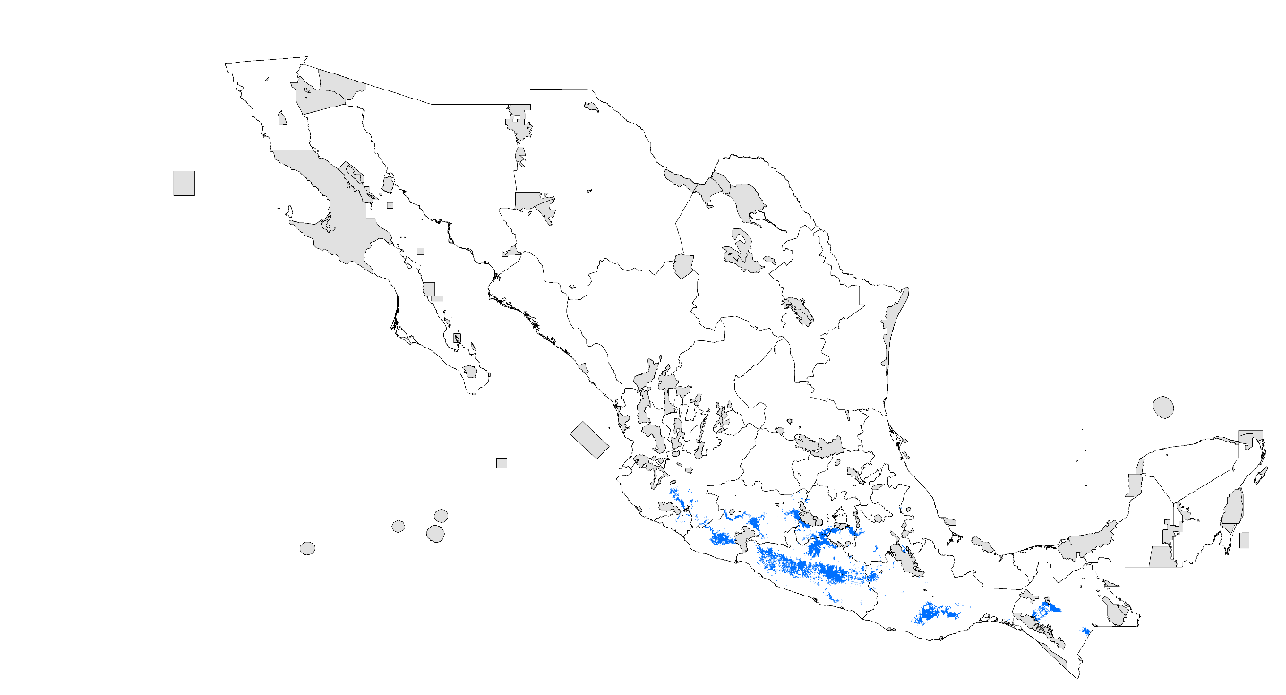

- PDA 2080 RCP 8.5 W/m²

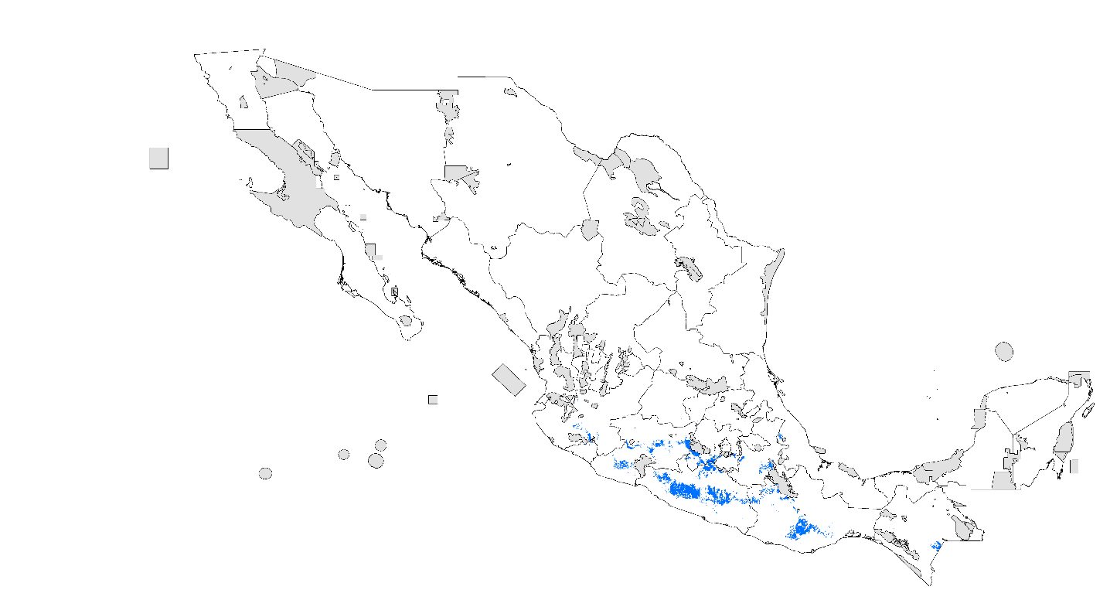

Paravaejovis spinigerus
- Records

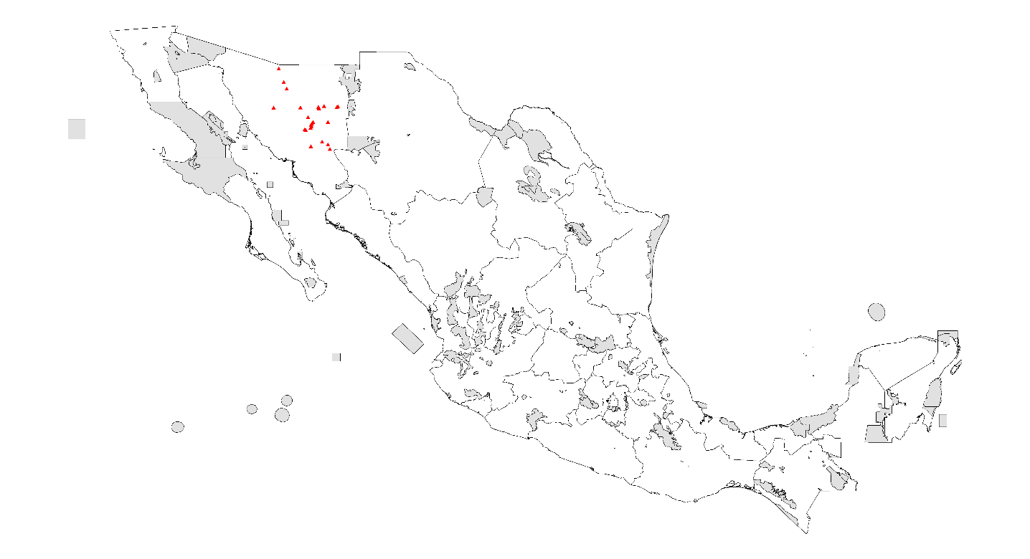

- PDA under current climatic conditions

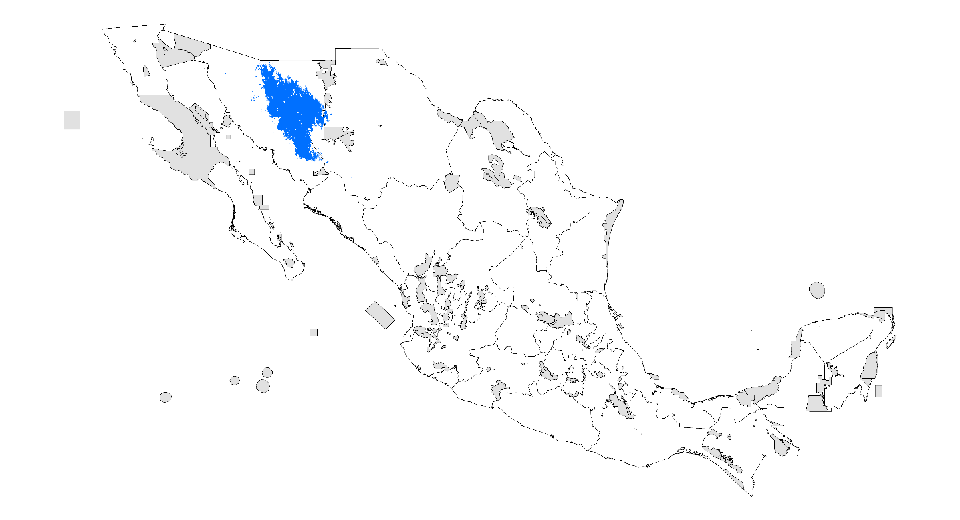

- PDA 2020 RCP 4.5 W/m²

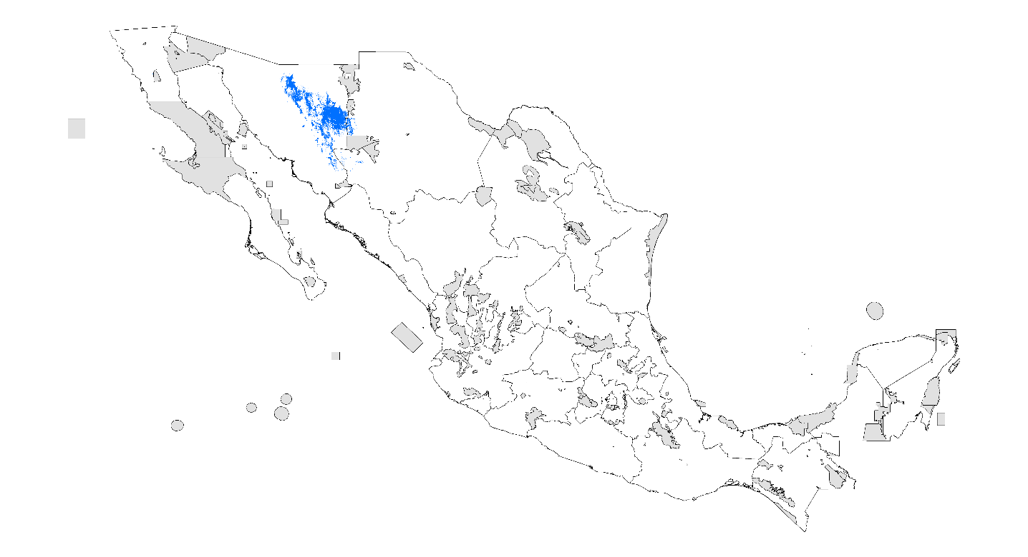

- PDA 2020 RCP 8.5 W/m²

- PDA 2080 RCP 4.5 W/m²

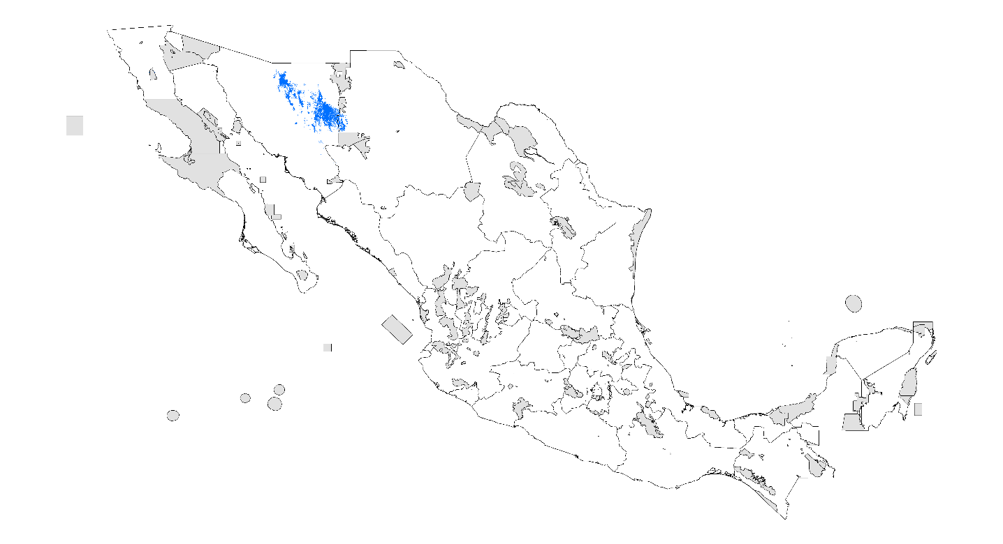

- PDA 2080 RCP 8.5 W/m²
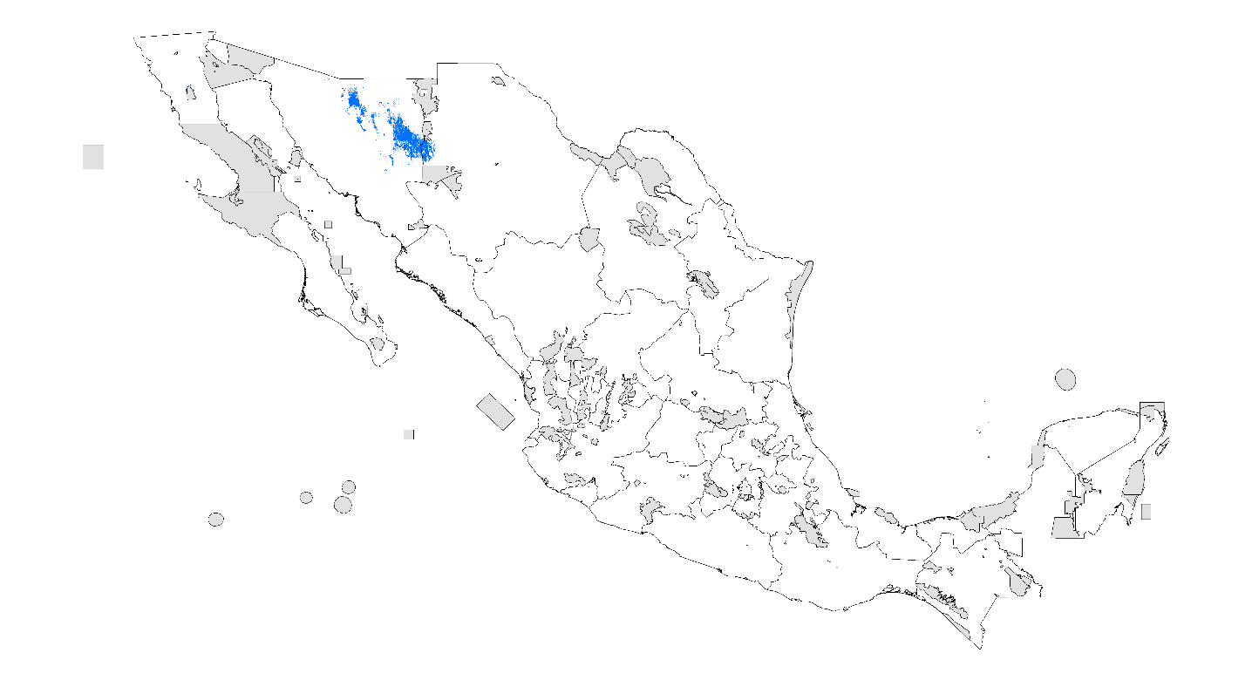

Superstitiona donesis
- Records

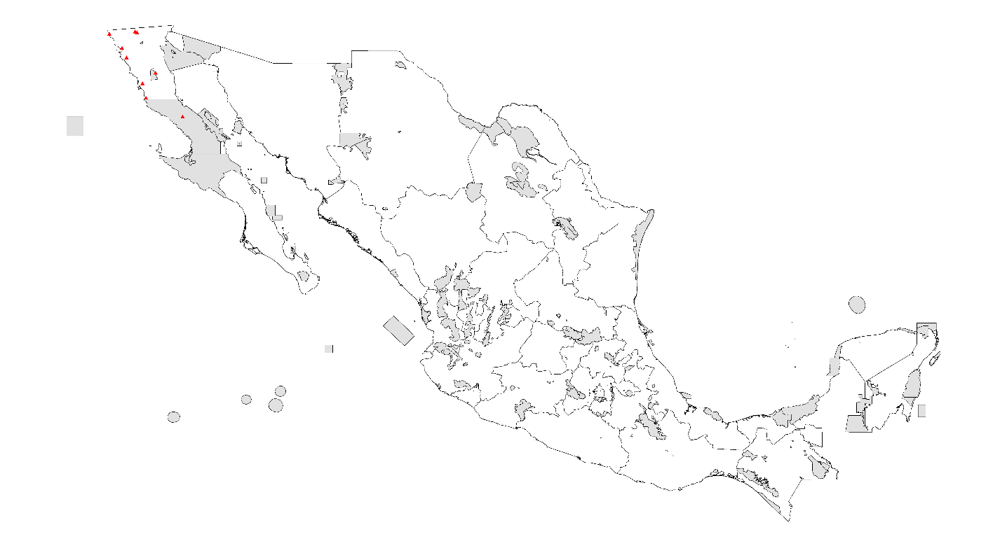

- PDA under current climatic conditions

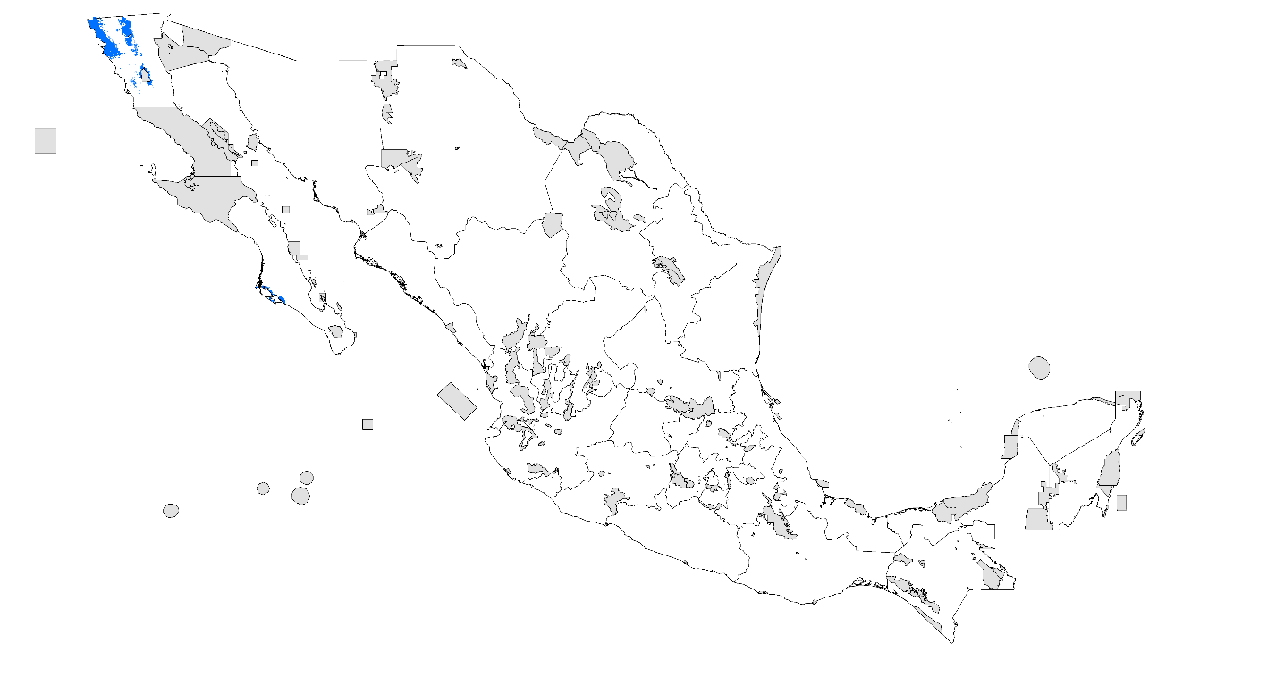

- PDA 2020 RCP 4.5 W/m²

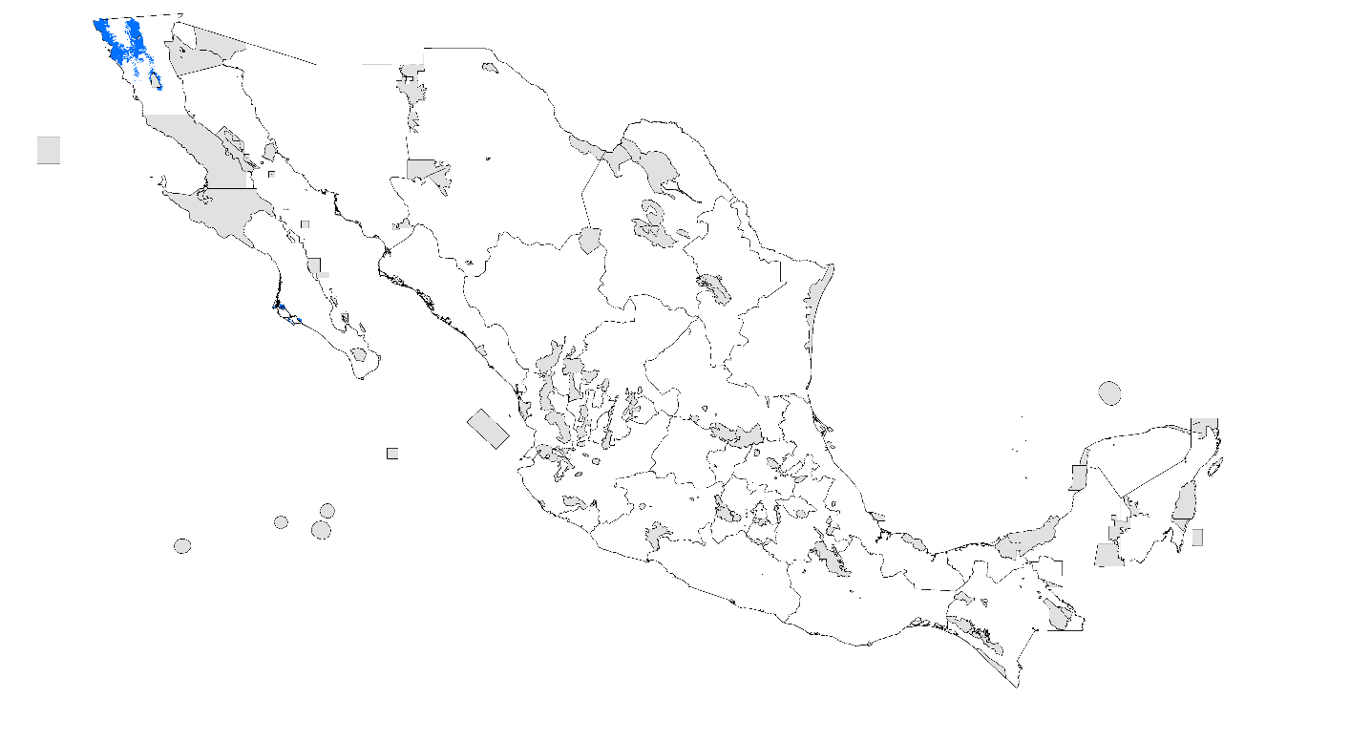

- PDA 2020 RCP 8.5 W/m²

- PDA 2080 RCP 4.5 W/m²

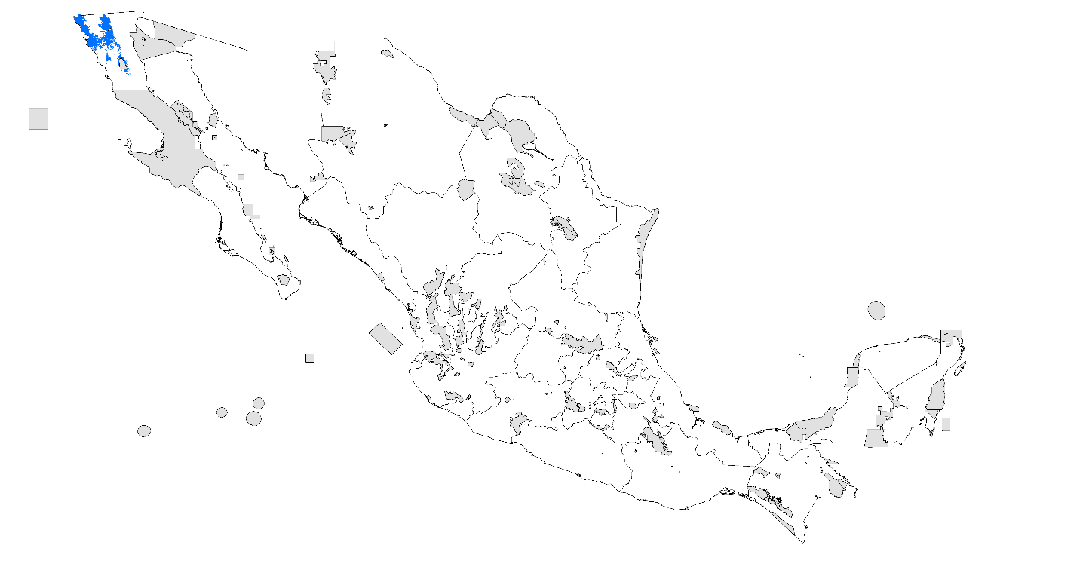

- PDA 2080 RCP 8.5 W/m²

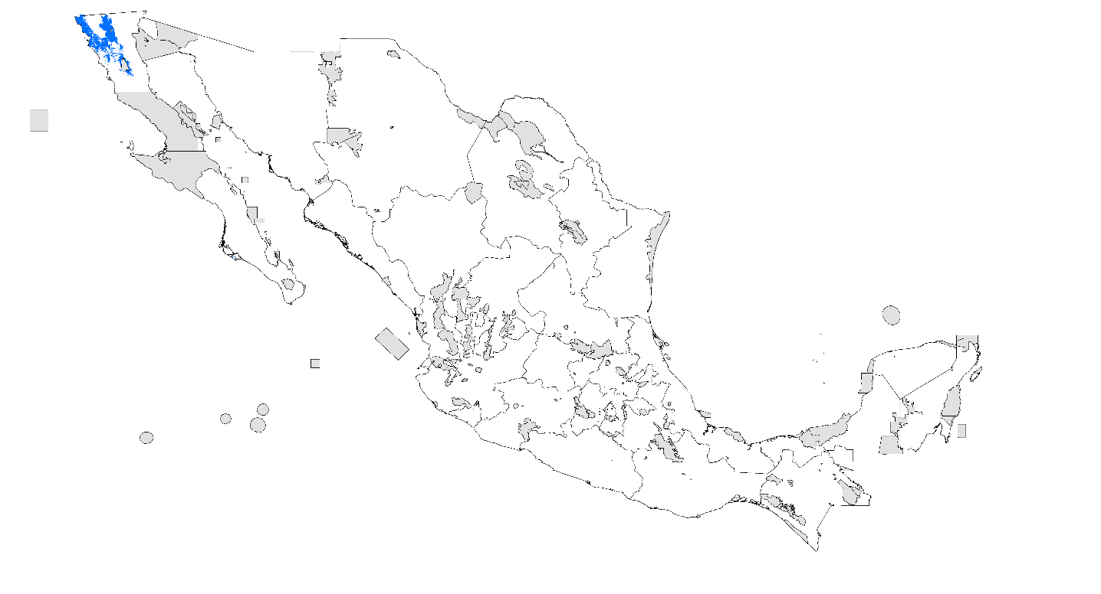

Thorellius cristimanus
- Records

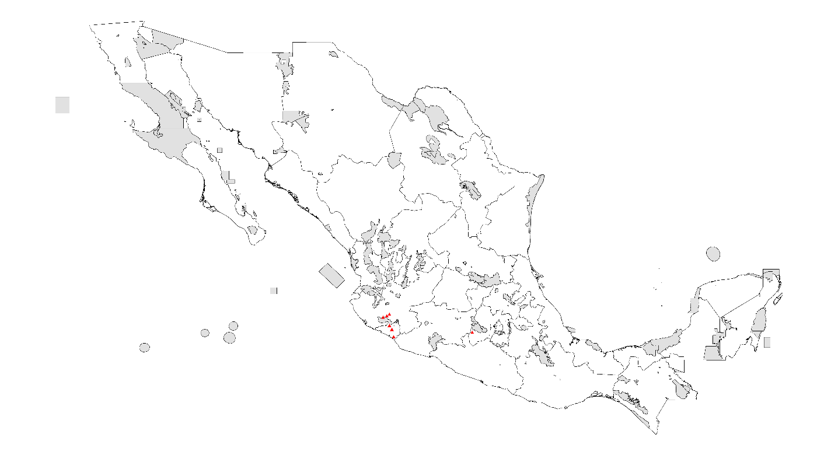

- PDA under current climatic conditions

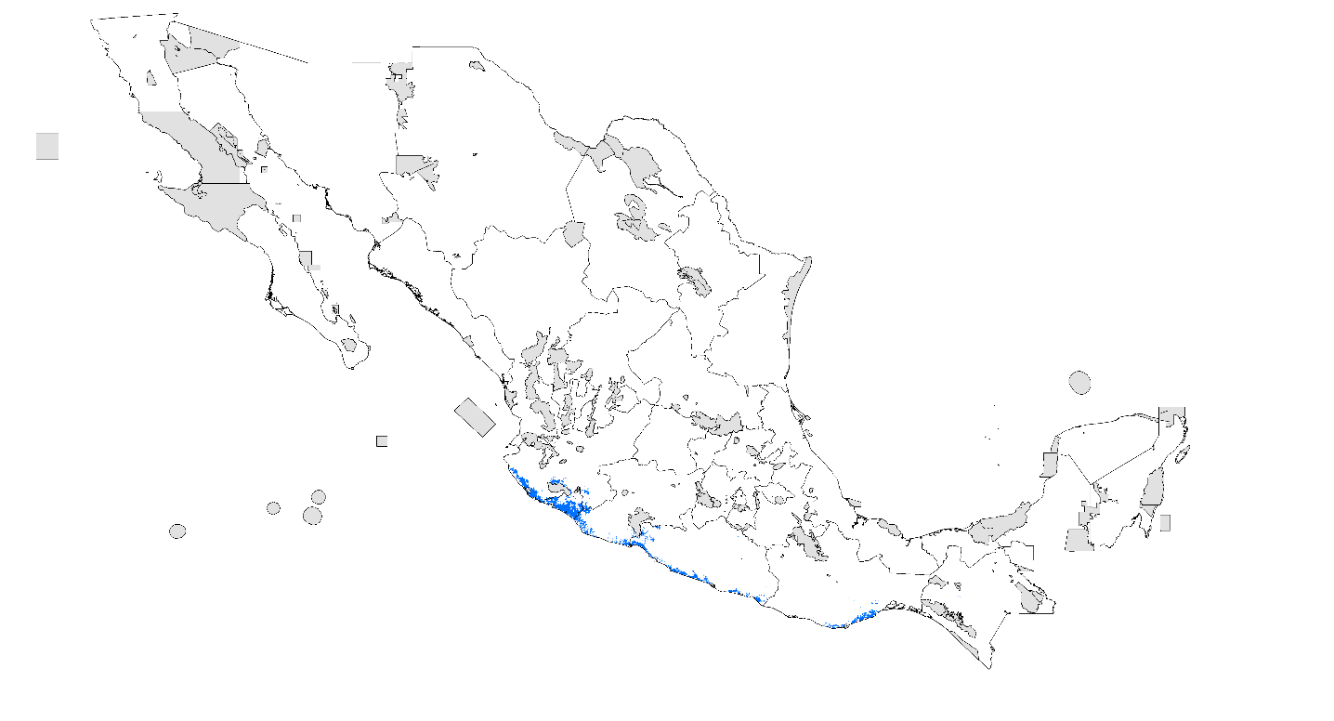

- PDA 2020 RCP 4.5 W/m²

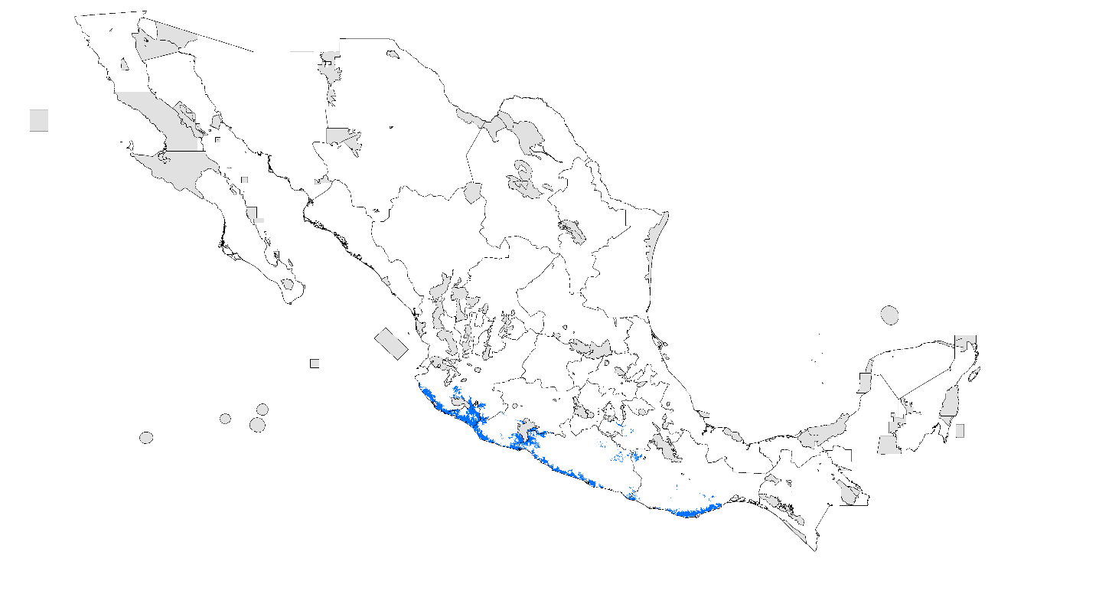

- PDA 2020 RCP 8.5 W/m²

- PDA 2080 RCP 4.5 W/m²

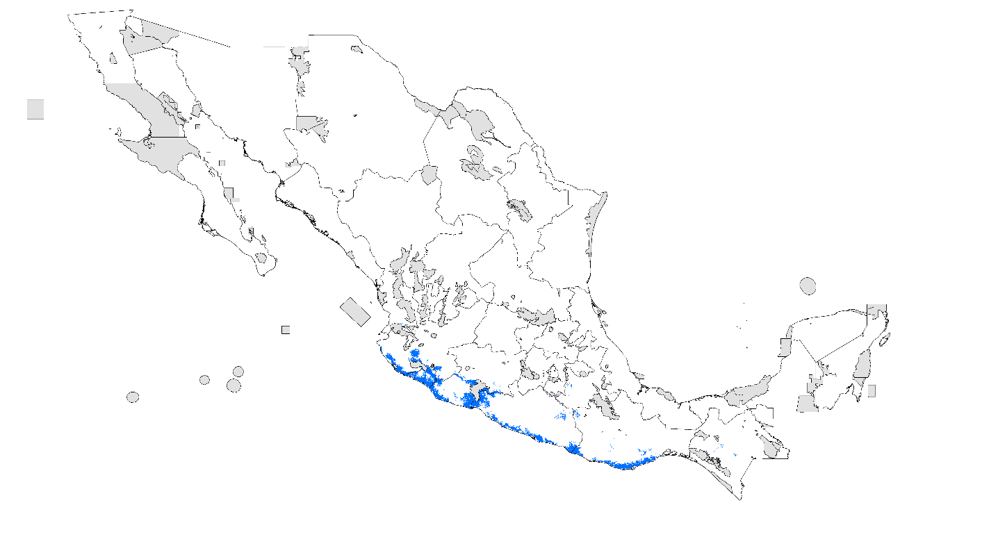

- PDA 2080 RCP 8.5 W/m²

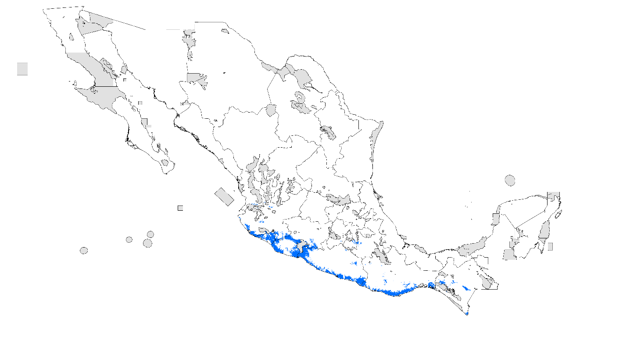
Thorellius intrepidus
- Records

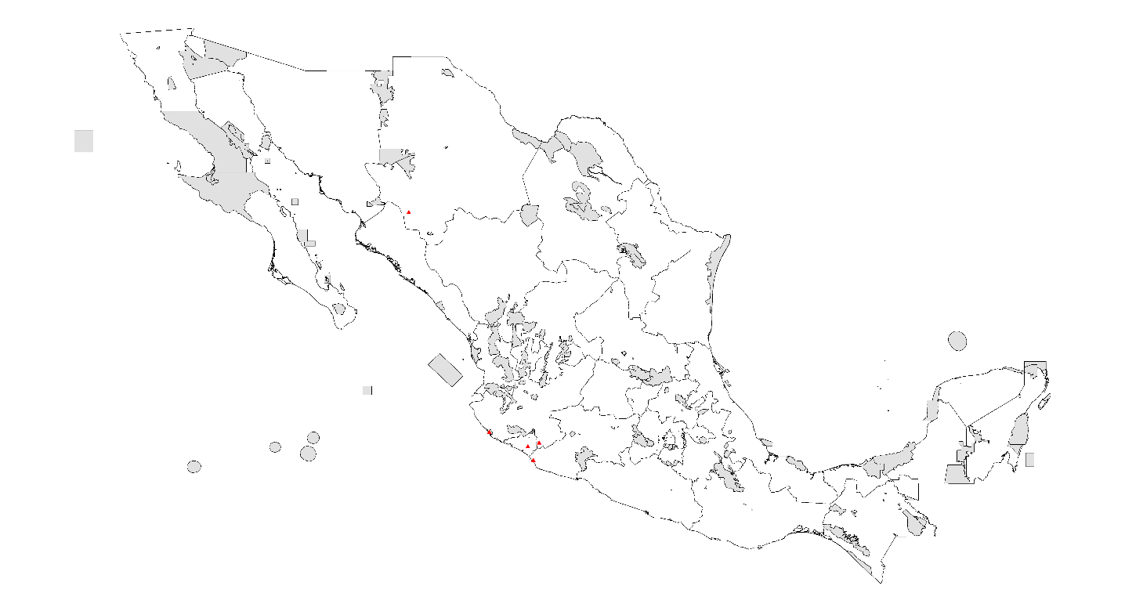

- PDA under current climatic conditions

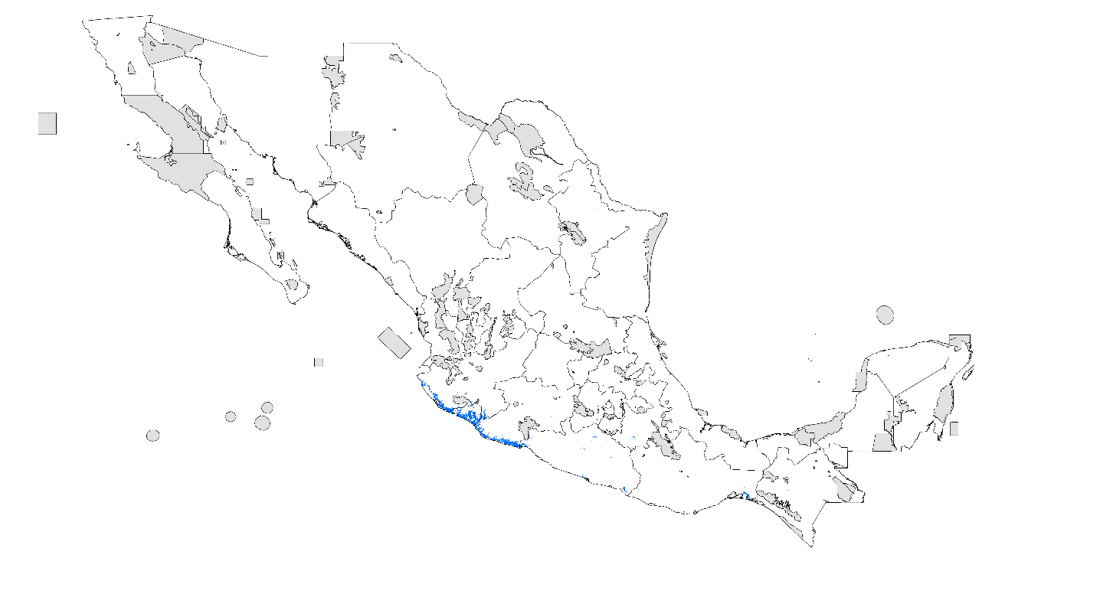

- PDA 2020 RCP 4.5 W/m²

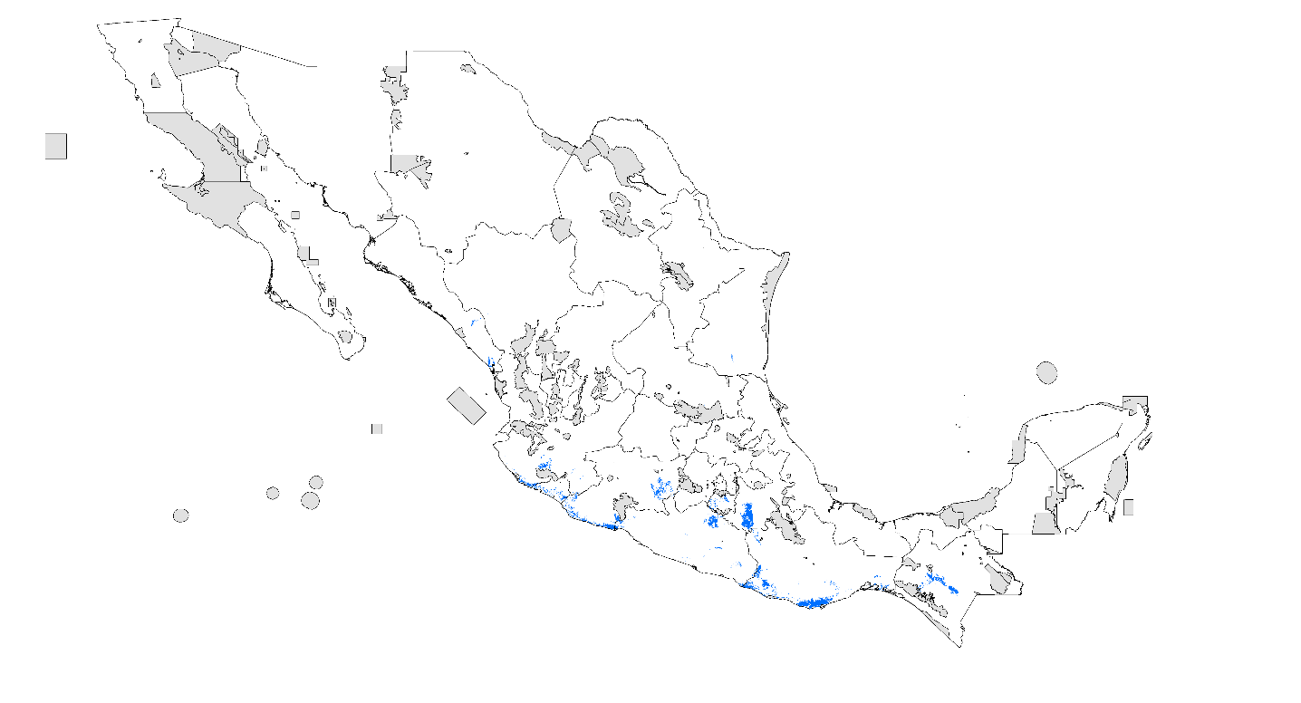

- PDA 2020 RCP 8.5 W/m²

- PDA 2080 RCP 4.5 W/m²

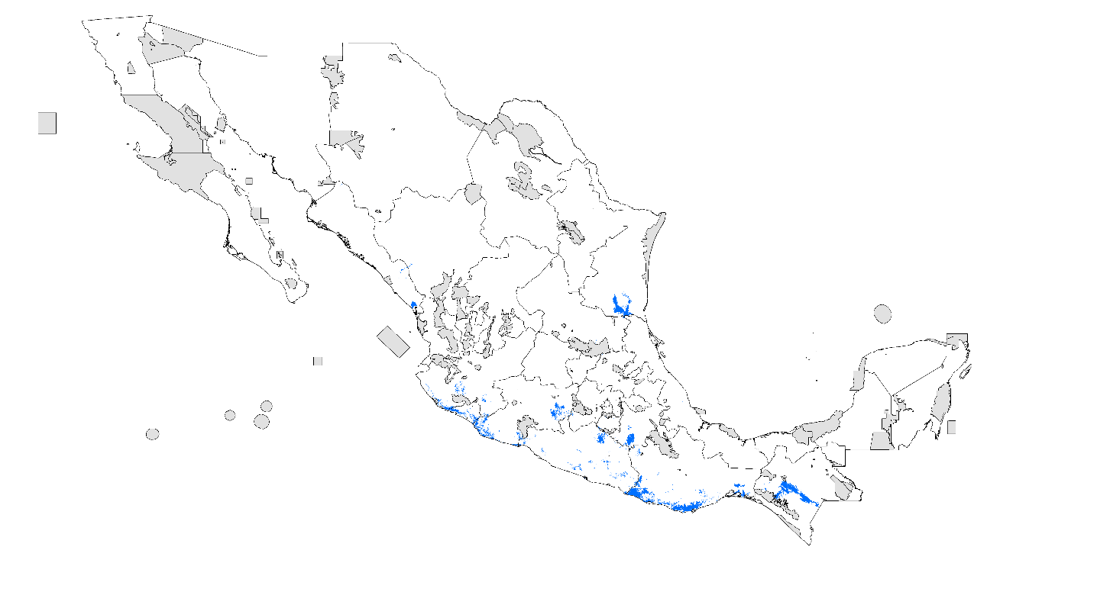

- PDA 2080 RCP 8.5 W/m²

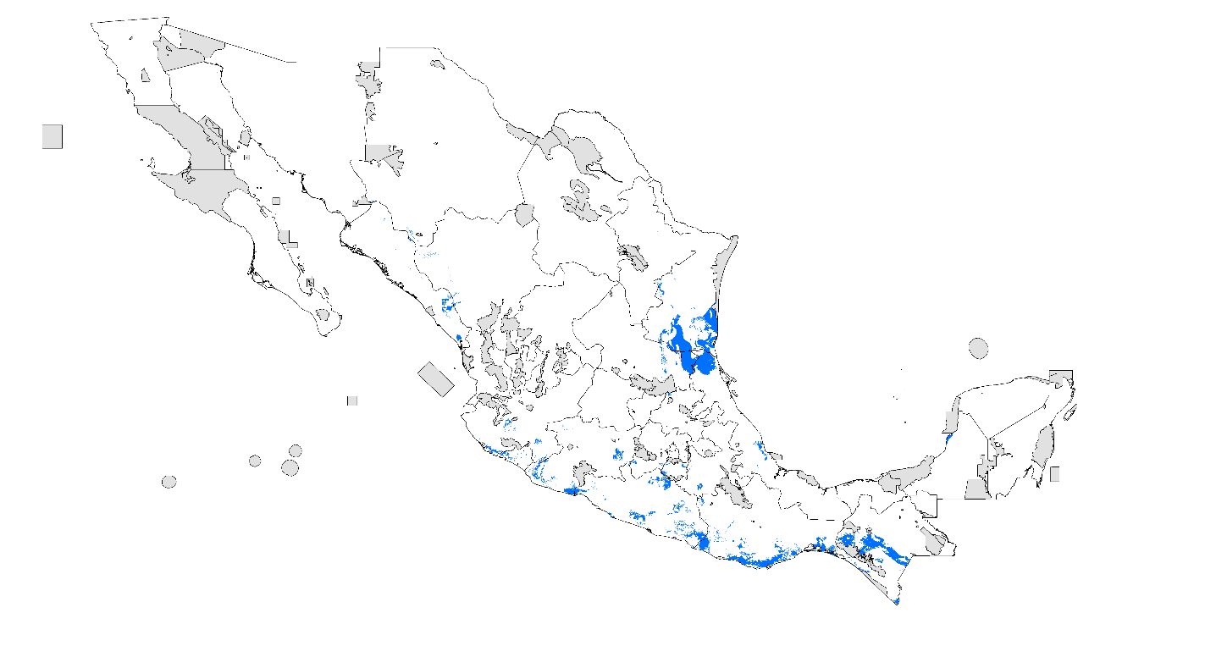

Vaejovis granulatus
- Records

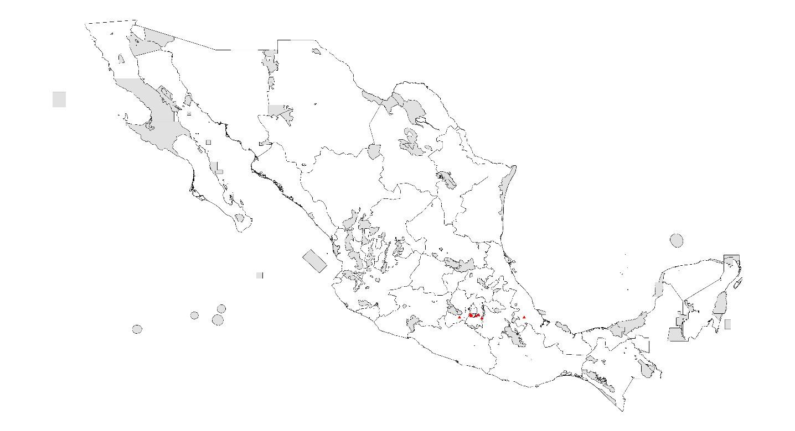

- PDA under current climatic conditions

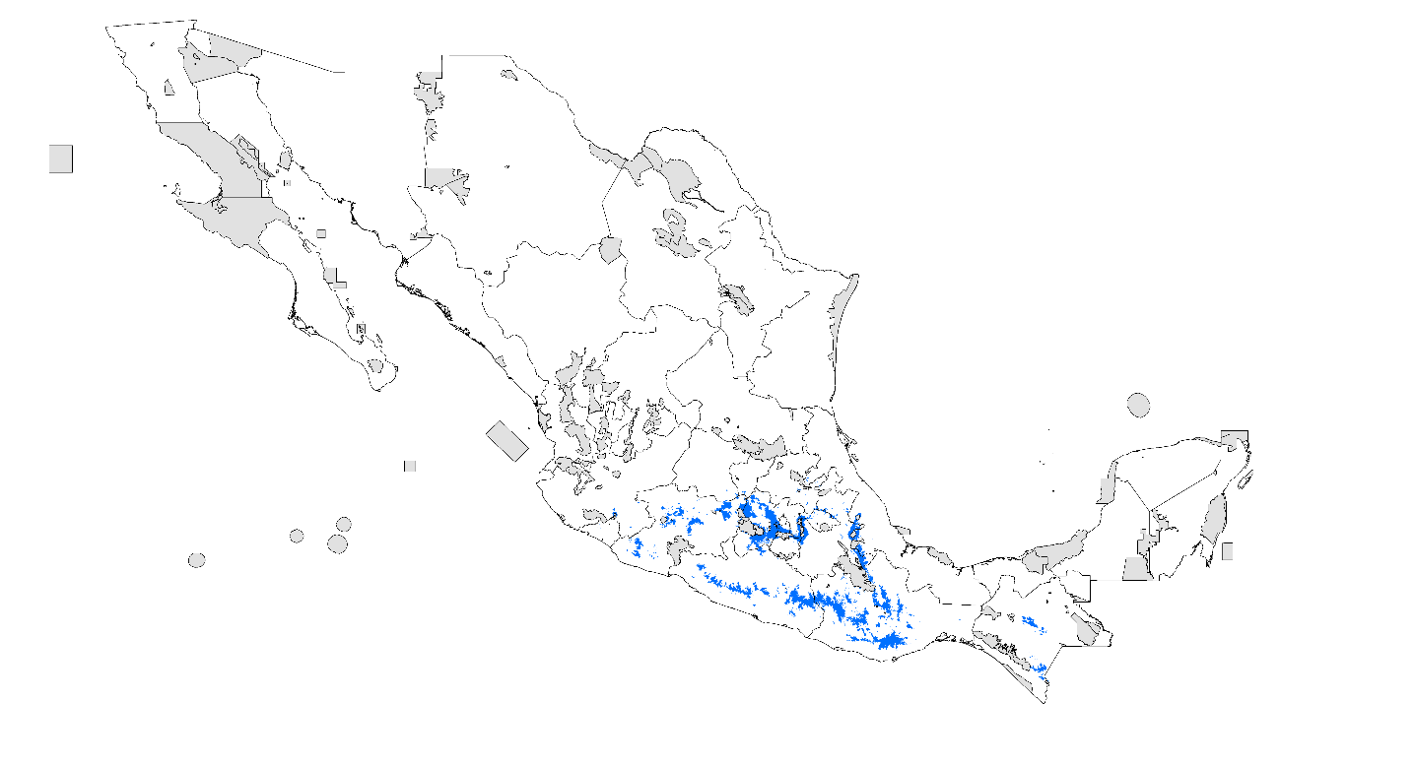

- PDA 2020 RCP 4.5 W/m²

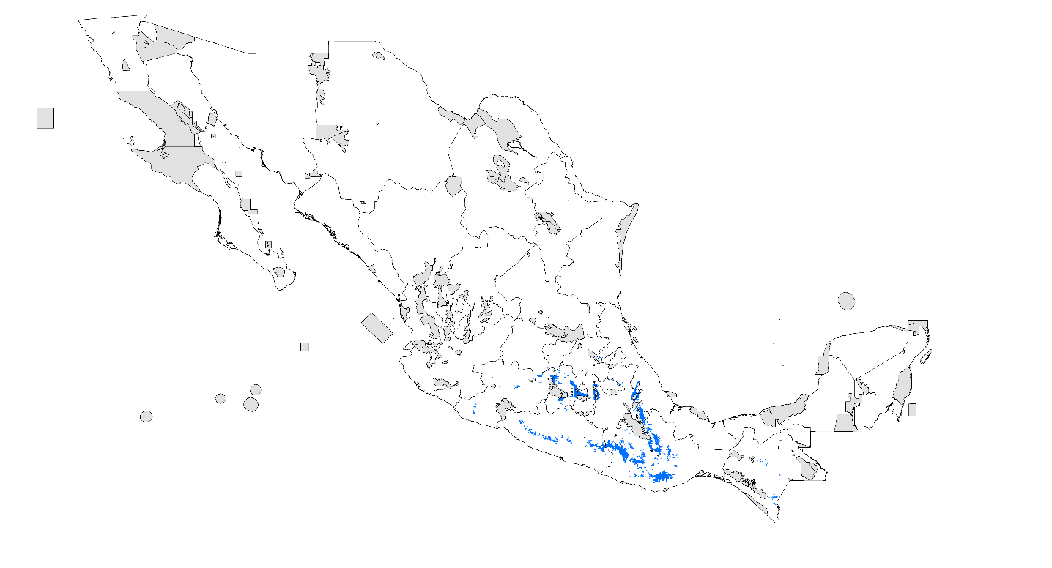
- PDA 2020 RCP 8.5 W/m²

- PDA 2080 RCP 4.5 W/m²

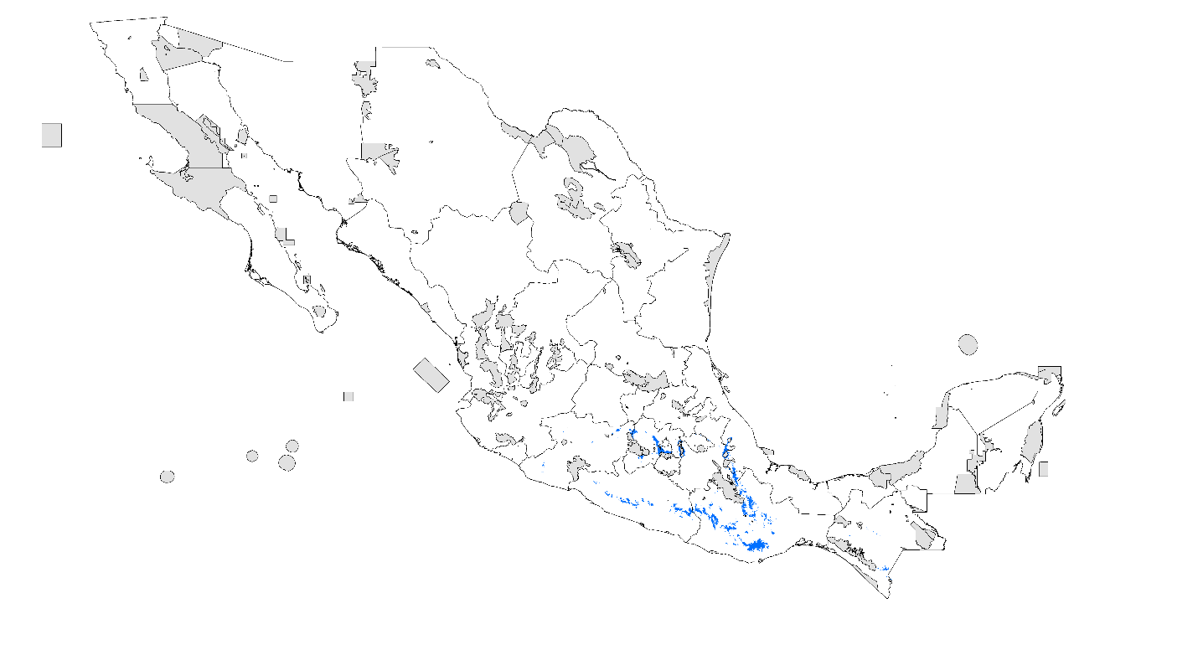

- PDA 2080 RCP 8.5 W/m²
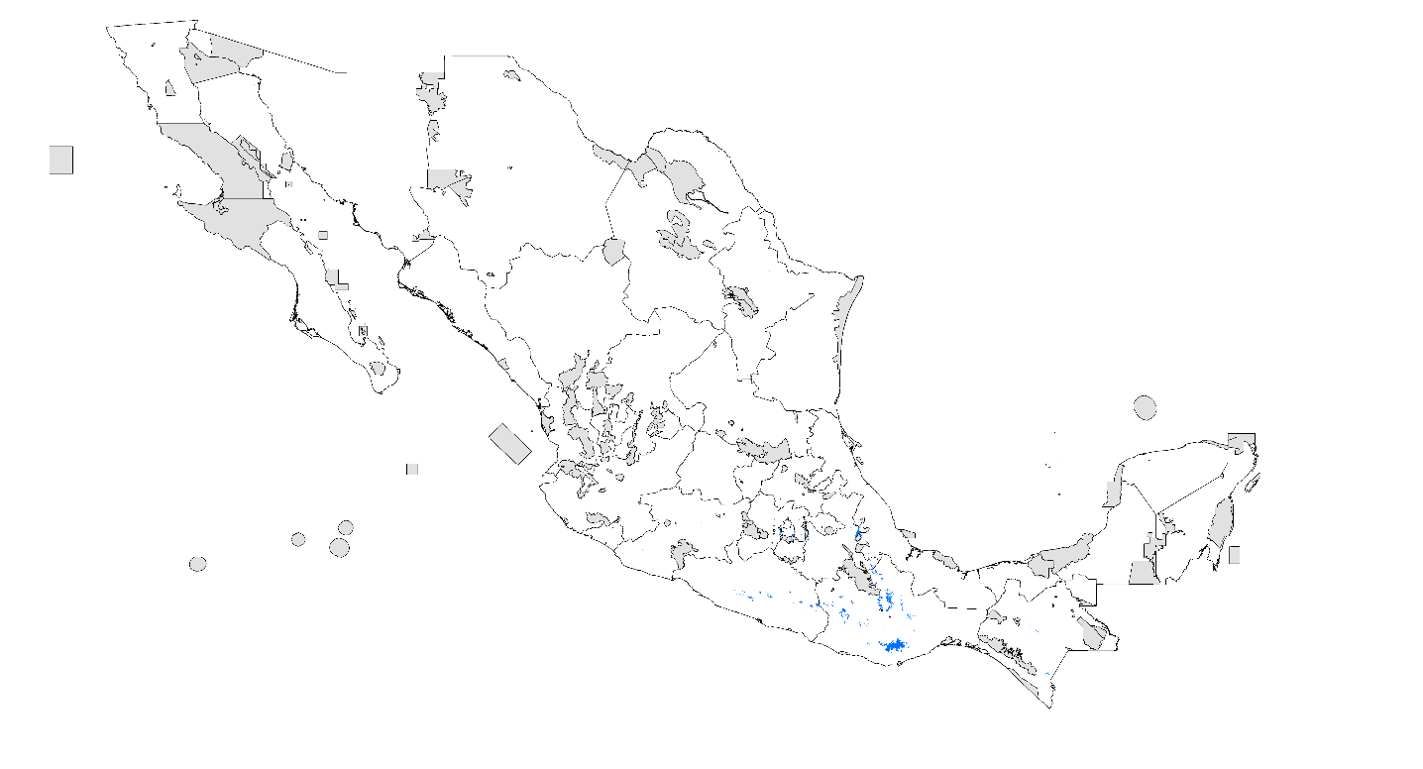

Vaejovis rossmanni
- Records

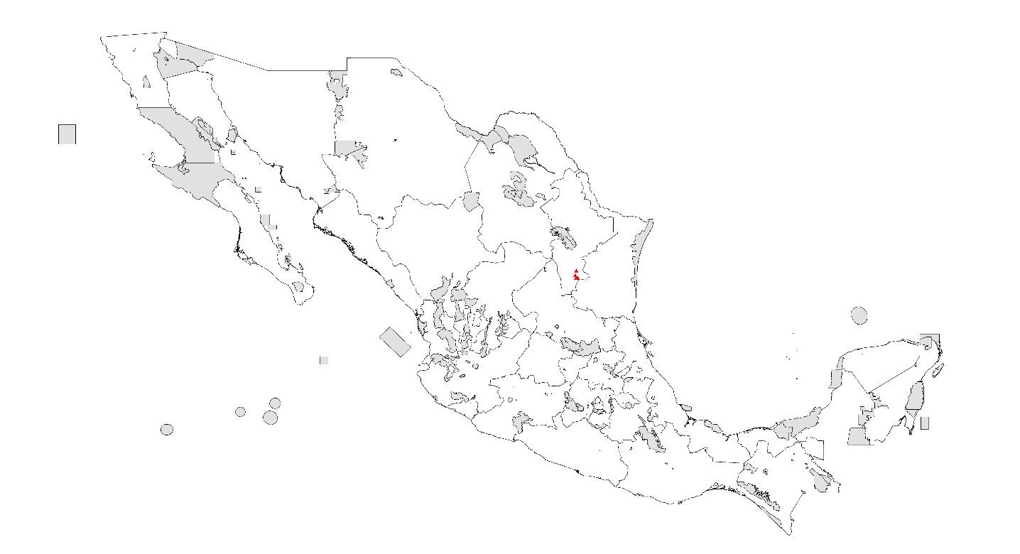

- PDA under current climatic conditions

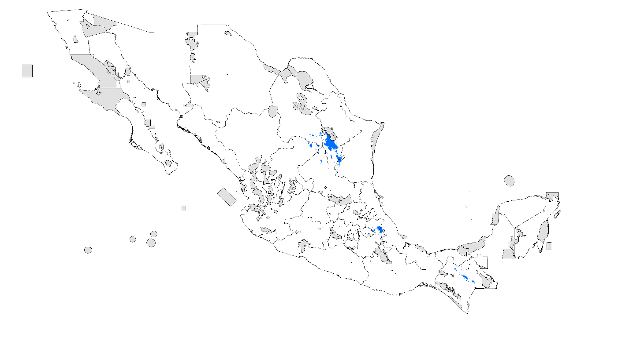

- PDA 2020 RCP 4.5 W/m²

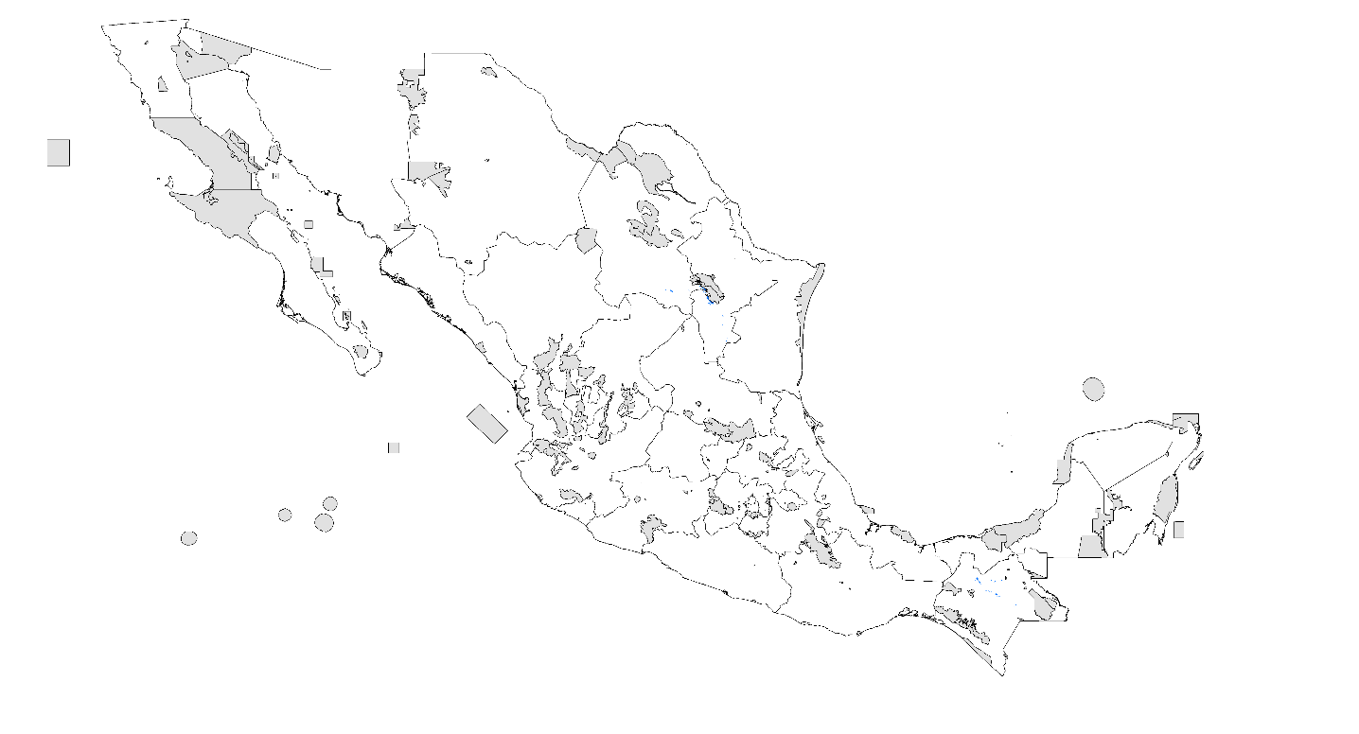

- PDA 2020 RCP 8.5 W/m²

- PDA 2080 RCP 4.5 W/m²

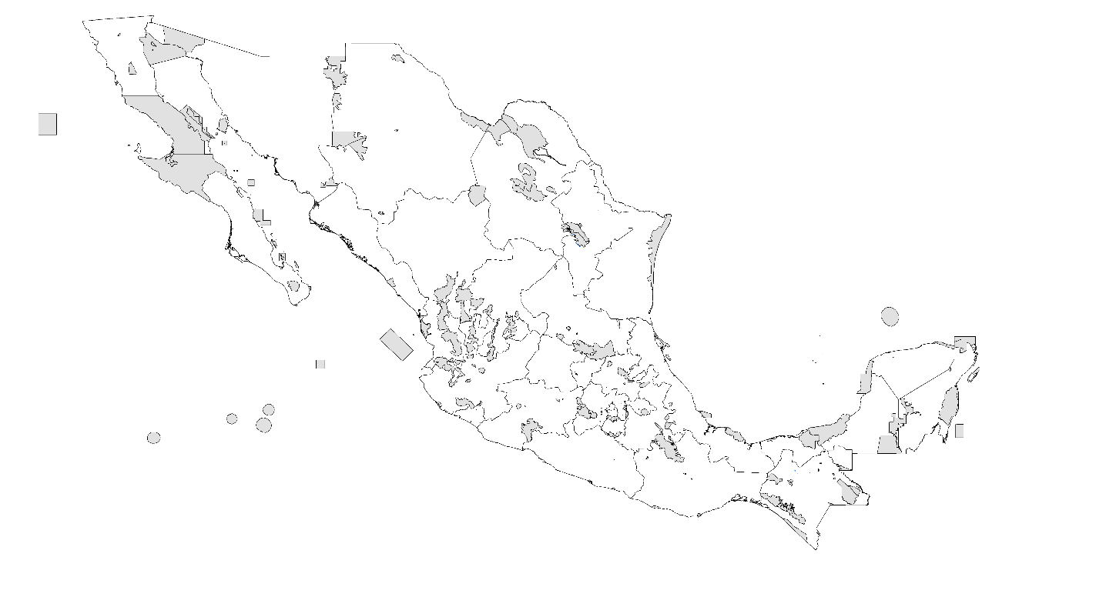

- PDA 2080 RCP 8.5 W/m²

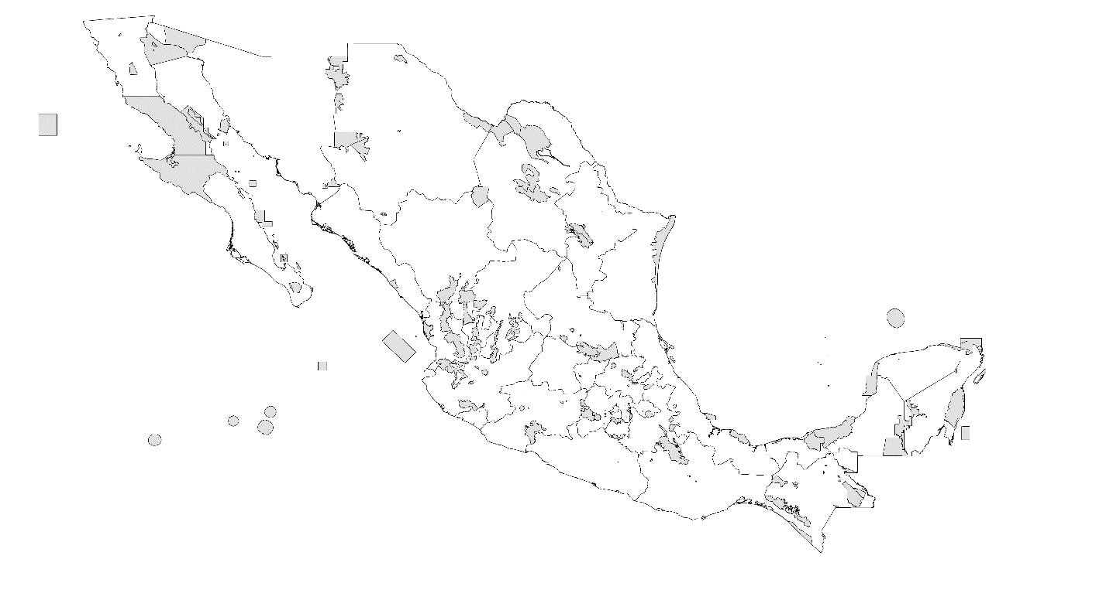
Vaejovis smithi
- Records

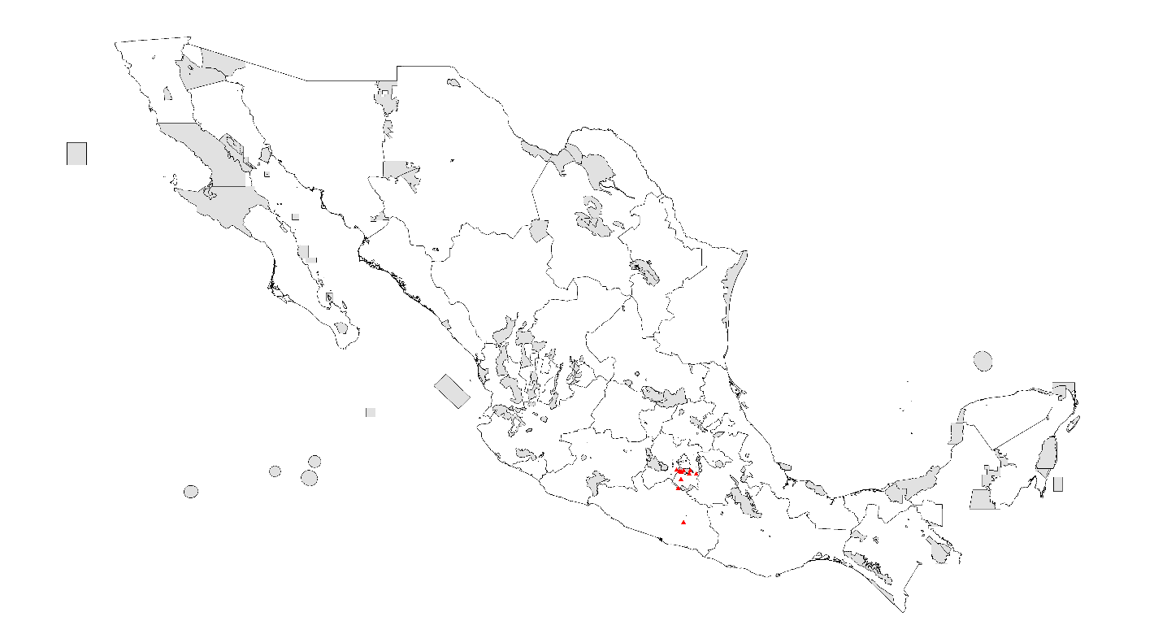

- PDA under current climatic conditions

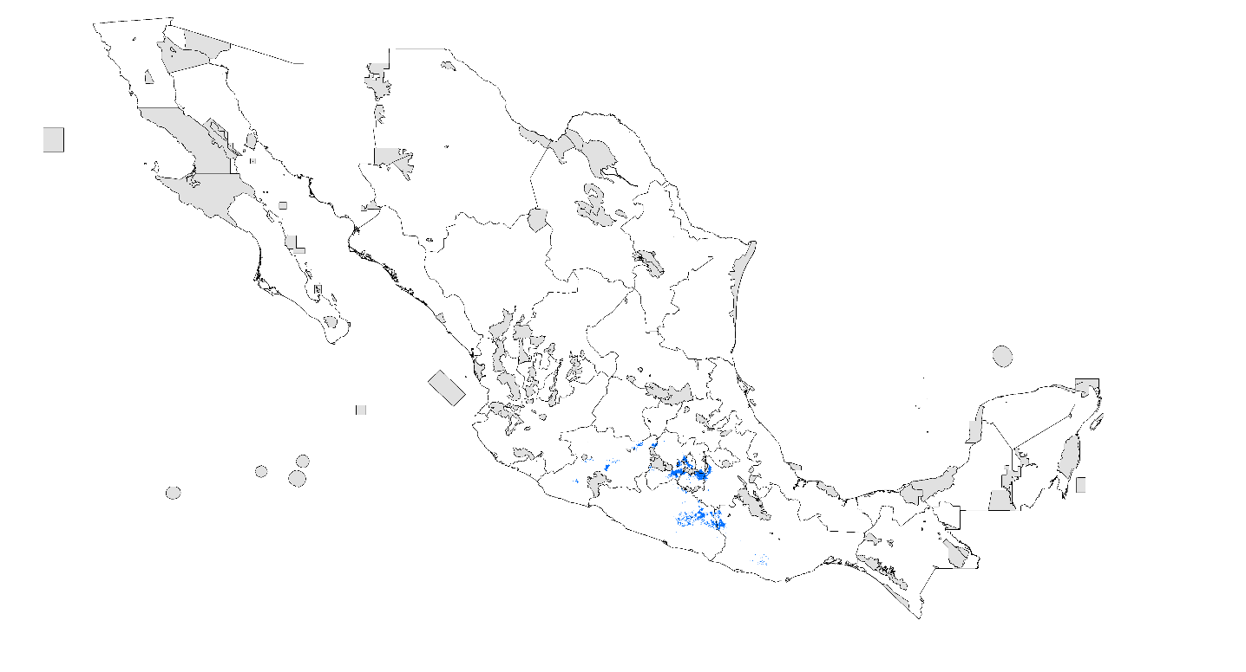

- PDA 2020 RCP 4.5 W/m²

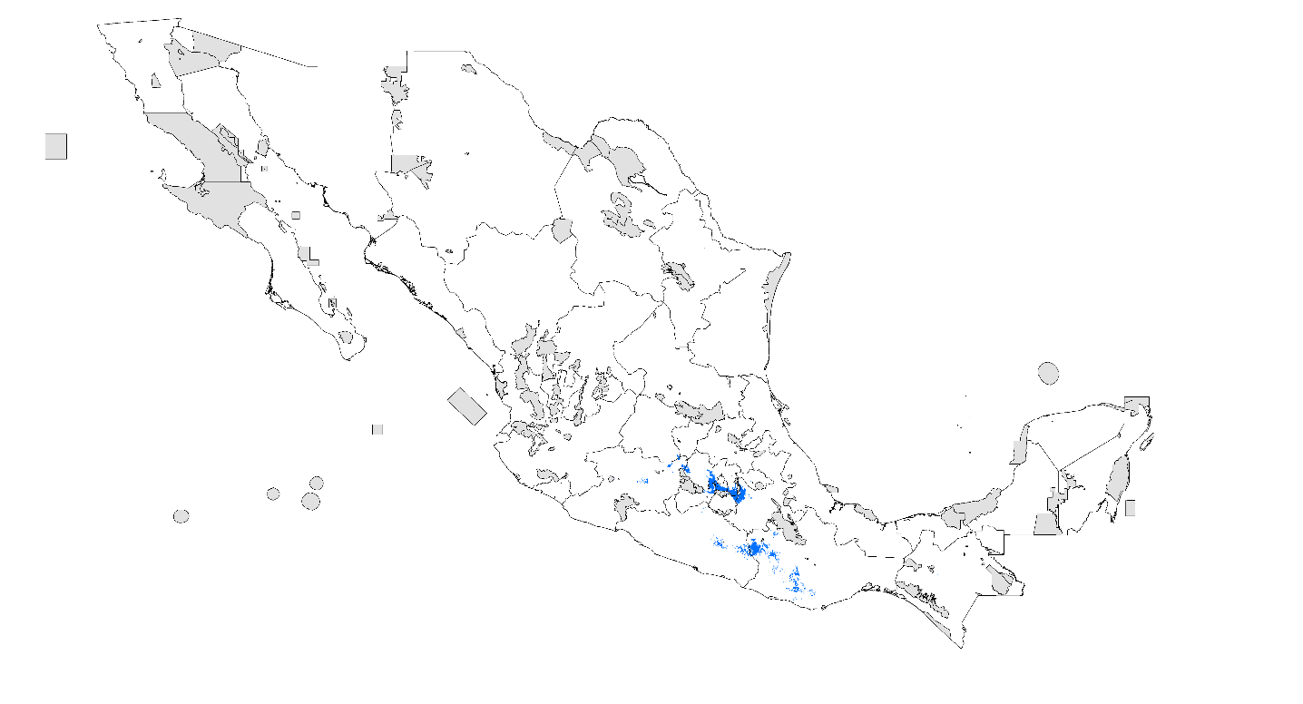

- PDA 2020 RCP 8.5 W/m²

- PDA 2080 RCP 4.5 W/m²

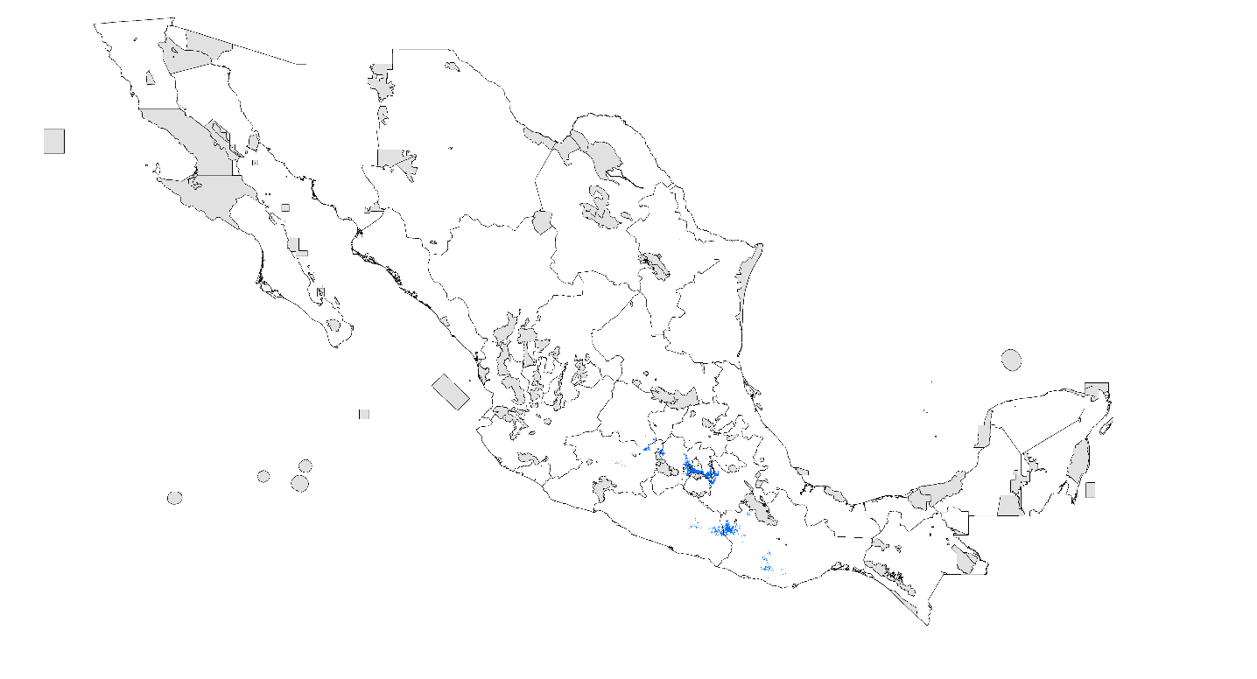

- PDA 2080 RCP 8.5 W/m²
