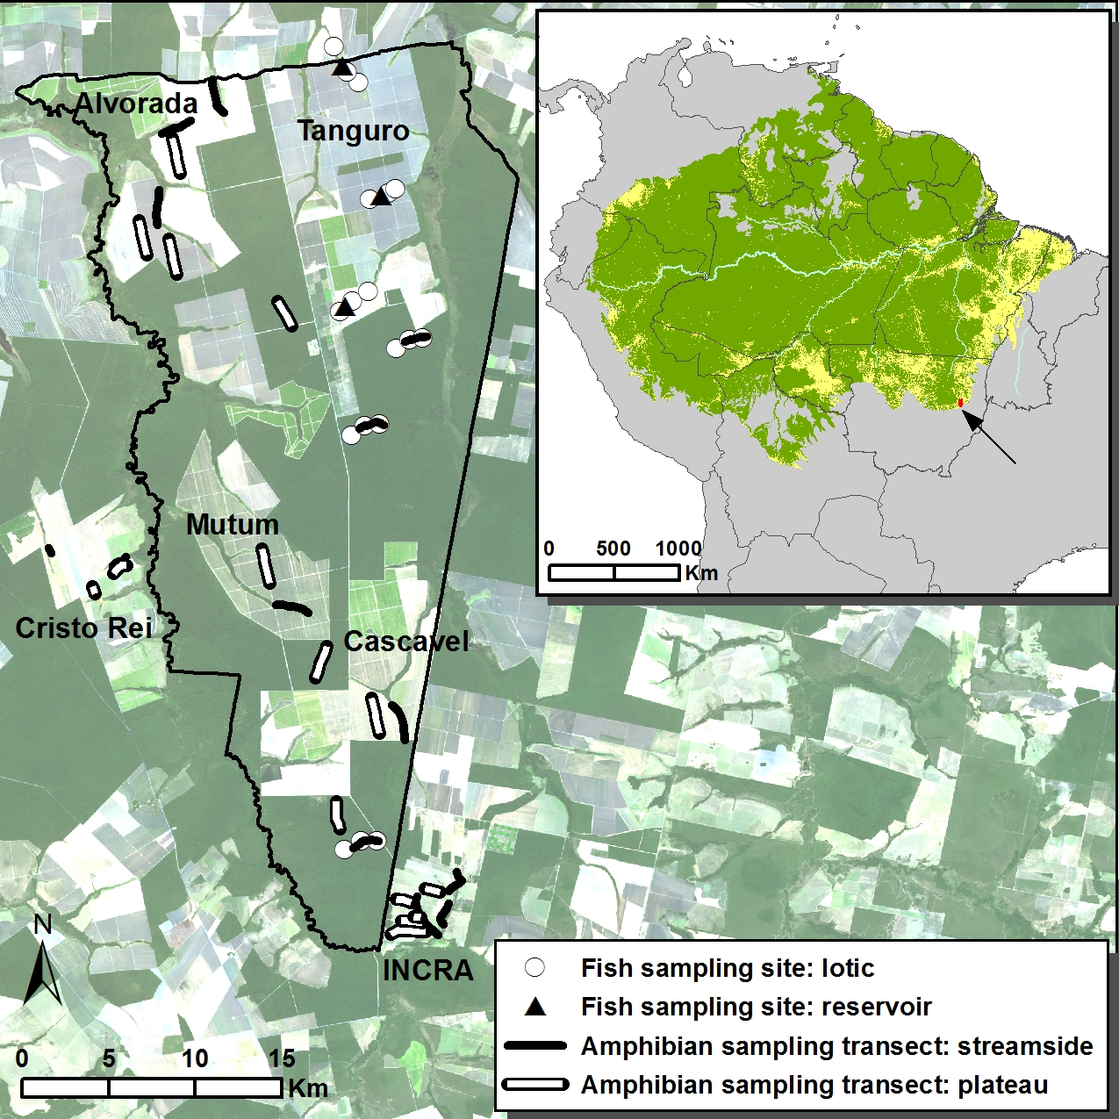

Appendix Figure 1. Fish sampling sites and amphibian sampling transects in Tanguro Ranch and surrounding farms (Landsat 8; July 2, 2013). Dark green represents primary closed canopy forests, light green represents deforested areas (soybean fields in Tanguro Ranch, pastures in Cristo Rei Ranch and in the INCRA settlement). From North to South, streams sampled for fish are Tanguro C, Tanguro B, Tanguro A, APP2, APP2A, and APPM; transects in forest plateaus are Seringal, AU and A1. Not represented is Lírio Branco Ranch, the third replicate pasture, located 27 km to the South. The inset shows the location of the study site in Southeastern Amazon. In the Amazon Basin, green represents closed-canopy forests, yellow represents deforested areas (according to Hansen et al. 2013) and uncolored areas represent native savannas. Savannas outside of the Amazon Basin are not represented but dominate the original vegetation cover a few tens of kilometers South and East of the study site. Note the position of the study site in the agricultural frontier known as ´the Amazonian Arc of Deforestation´.
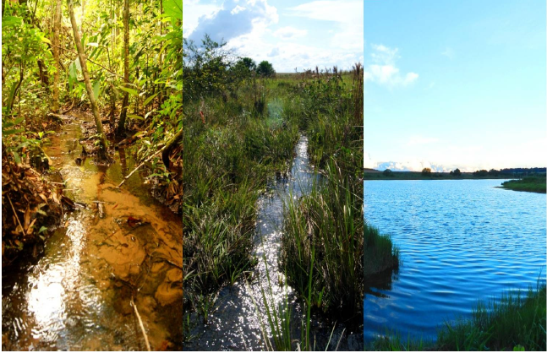

Appendix Figure 2. Streams in forested (a) and deforested (b,c) watersheds. (c) is a man-made reservoir. Pictures by Paulo Ilha.

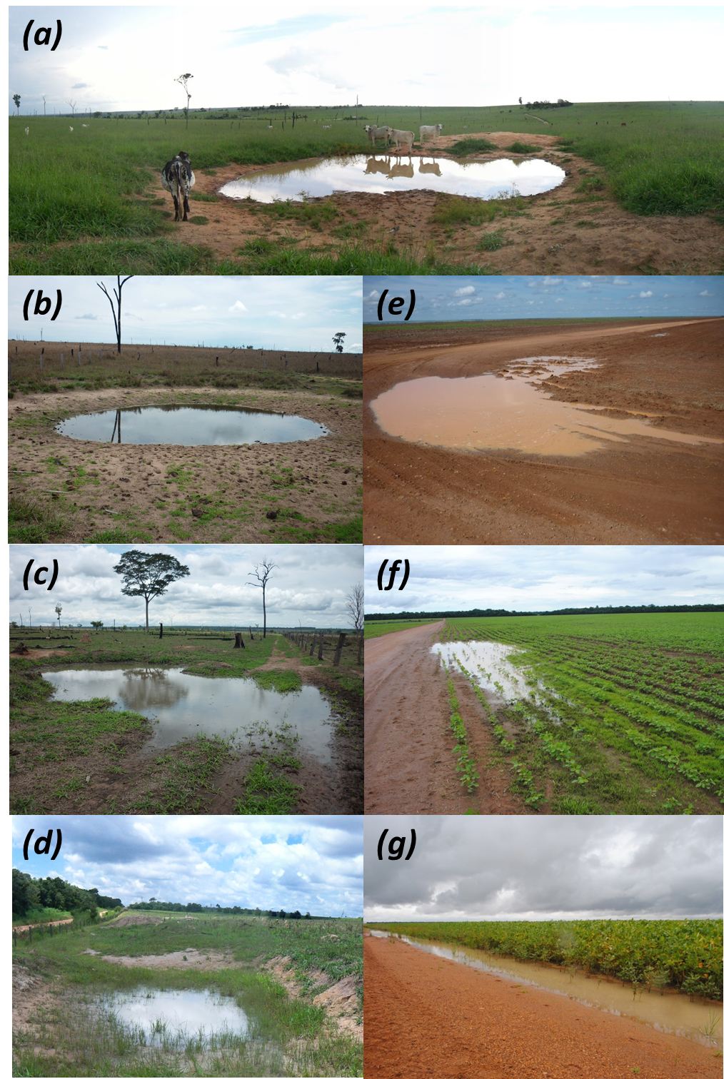

Appendix Figure 3. Ponds and puddles in interfluves converted to pastures (a-d) and soybean plantations (e-g). No ponds or puddles were found in forested interfluves. (a) and (b) are man-made cattle ponds; all other puddles (c-g) appear to be formed solely by soil compaction by cattle trampling, road construction and machinery traffic. At the peak of the rainy season ponds and puddles like these were inhabited by up to 5 and 3 species of amphibians in pastures and soybean fields, respectively. Pictures by Luis Schiesari and Victor Dimitrov.
Appendix Figure 4. Rarefaction curves of amphibian richness along streamside transects in forests, pastures and soybean fields. Symbols represent estimated means + 1 SD. Note that there were three streamside transects in forests (therefore 18 call sampling stations) but five in pastures and soybean fields (therefore 30 call sampling stations).
Appendix Figure 5. Rarefaction curves of amphibian richness along plateau transects in forests, pastures and soybean fields. Symbols represent estimated means + 1 SD. Note that there were three plateau transects in forests (therefore 18 call sampling stations) but five in pastures and soybean fields (therefore 18 call sampling stations). Note also that no amphibian calls were recorded in forests, where ponds and puddles are absent and where water bodies are invariably associated with streams and their floodplains.

Appendix Table 1. Pooled number of fishes sampled in lotic and lentic (i.e. reservoir) stream sections in three streams in deforested watersheds, ranked by abundance.

 |  | Lotic sections |  | Lentic sections (reservoirs)
Family | Species | Dipnet |  | Dipnet | Seine | Gillnet
Rivulidae | Melanorivulus megaroni | 923 |  | 171 | 0 | 0
Characidae | Astyanax multidens | 48 |  | 134 | 413 | 0
Cichlidae | Aequidens sp. | 151 |  | 116 | 182 | 17
Lebiasinidae | Pyrrhulina australis | 205 |  | 98 | 6 | 0
Characidae | Hyphessobrycon mutabilis | 186 |  | 0 | 0 | 0
Curimatidae | Steindachnerina sp. | 1 |  | 1 | 179 | 0
Characidae | Moenkhausia phaeonota | 83 |  | 0 | 0 | 0
Characidae | Hyphessobrycon sp. 2 | 9 |  | 1 | 50 | 0
Hypopomidae | Hypopygus lepturus | 15 |  | 11 | 2 | 0
Erythrinidae | Hoplias malabaricus | 1 |  | 1 | 5 | 14
Poecilidae | Pamphorichthys sp. | 21 |  | 0 | 0 | 0
Cichlidae | Laetacara sp. | 3 |  | 16 | 0 | 0
Cichlidae | Crenicichla rosemariae | 1 |  | 0 | 18 | 0
Loricariidae | Hisonotus sp. | 15 |  | 0 | 0 | 0
Erythrinidae | Hoplerythrinus unitaeniatus | 8 |  | 0 | 0 | 3
Characidae | Hyphessobrycon loweae | 10 |  | 0 | 0 | 0
Serrasalmidae | Myleus sp. | 0 |  | 0 | 8 | 1
Characidae | Hemigrammus cf levis | 0 |  | 0 | 8 | 0
Serrasalmidae | Metynnis sp. | 0 |  | 0 | 8 | 0
Cichlidae | Satanoperca cf papaterra | 0 |  | 0 | 3 | 5
Heptapteridae | Goeldiela sp. 1 | 5 |  | 0 | 0 | 0
Characidae | Moenkhausia collettii | 3 |  | 0 | 0 | 0
Crenuchidae | Characidium zebra | 3 |  | 0 | 0 | 0
Sternopygidae | Eigenmannia sp. | 3 |  | 0 | 0 | 0
Characidae | Thayeria boehlkei | 2 |  | 1 | 0 | 0
Cichlidae | Apistogramma sp. | 2 |  | 1 | 0 | 0
Gymnotidae | Gymnotus sp. | 2 |  | 0 | 0 | 0
Synbranchidae | Synbranchus marmoratus | 0 |  | 2 | 0 | 0
Rhamphicthyidae | Gymnorhamphichthys rondoni | 1 |  | 0 | 0 | 0
Heptapteridae | Goeldiela sp. 2 | 1 |  | 0 | 0 | 0
Characidae | Bryconops melanurus | 0 |  | 0 | 0 | 1
Characidae | Moenkhausia pirauba | 0 |  | 0 | 0 | 1
Callichthyidae | Megalechis picta | 1 |  | 0 | 0 | 0
Acestrorhynchidae | Acestrorhynchus sp. | 0 |  | 0 | 1 | 0

Appendix Table 2. Incidence matrix of amphibian species recorded in streamside and plateau transects in forests, pastures and soybean fields (1= calling, +=observed) .
 |  | Forest |  | Pasture |  | Soybean
 |  | Streamside | Plateau | Streamside | Plateau | Streamside | Plateau
Bufonidae | Rhinella schneideri | 0 | 0 | 1 | 1 | 0 | +
 | Rhinella sp. | + | 0 | 0 | 0 | 0 | 0
Hylidae | Dendropsophus melanargyreus | 0 | 0 | 1 | 1 | 0 | 0
 | Dendropsophus minutus | 0 | 0 | 1 | 1 | 1 | 1
 | Dendropsophus nanus | 1 | 0 | 1 | 0 | 1 | 0
 | Hypsiboas albopunctatus | 1 | 0 | 1 | 0 | 1 | 0
 | Hypsiboas sp. | 0 | 0 | 1 | 0 | 1 | 0
 | Hypsiboas cinerascens | 1 | 0 | 1 | 0 | 1 | 0
 | Hypsiboas geographicus | 0 | 0 | 0 | 0 | 1 | 0
 | Osteocephalus cf. taurinus | + | 0 | 1 | 0 | 0 | 0
 | Scinax fuscomarginatus | 0 | 0 | 1 | 1 | 1 | 0
 | Scinax fuscovarius | 0 | 0 | 1 | 1 | 1 | 1
 | Scinax nebulosus | 1 | 0 | 1 | 0 | 1 | 0
 | Scinax x-signatus | 0 | 0 | 0 | 0 | 1 | 0
 | Trachycephalus venulosus | 0 | 0 | 0 | 0 | 1 | 0
Phyllomedusidae | Phyllomedusa vaillanti | + | 0 | 0 | 0 | 0 | 0
Leiuperidae | Eupemphix nattereri | 0 | 0 | 1 | 1 | 0 | 0
 | Physalaemus cf. centralis | 0 | 0 | 1 | 1 | 1 | 0
 | Physalaemus cuvieri | 0 | 0 | 1 | 1 | 1 | 1
 | Pseudopaludicola mystacalis | 0 | 0 | 1 | 0 | 0 | 0
Leptodacylidae | Leptodactylus fuscus | 0 | 0 | 1 | 1 | 1 | 1
 | Leptodactylus labyrinthicus | + | 0 | 1 | 1 | 0 | 1
 | Leptodactylus mystaceus | 0 | 0 | 0 | 0 | 1 | 0
 | Leptodactylus pentadactylus | + | 0 | 0 | 0 | 0 | 0
 | Leptodactylus petersii | 1 | 0 | 1 | 0 | 1 | 0
 | Leptodactylus andreae | 0 | 0 | 1 | 1 | 1 | 0
 | Leptodactylus paraensis | 0 | 0 | 0 | 0 | + | 0
Microhylidae | Chiasmocleis albopunctata | 0 | 0 | 0 | 0 | 1 | 0
 | Elachistocleis ovalis | 0 | 0 | 1 | 1 | 1 | 0

