**Landscape changes decreases genetic diversity in** **the Pallas’ long-tongued bat**

Rosane G. Collevatti, Luciana C. Vitorino, Thiago B. Vieira, Monik Oprea, Mariana P. C. Telles

**Appendix S1 - Figures**

**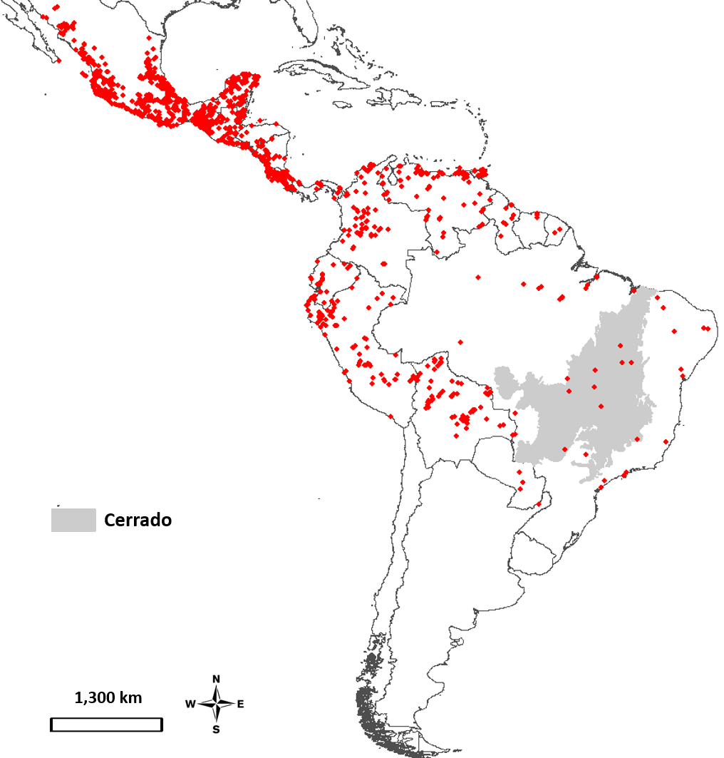**

**Figure S1.** Current geographical distribution of *Glosophaga soricina* across the Neotropics based on 13,069 occurrence records from the databases GBIF (Global Biodiversity Information Facility http://www.gbif.org/) and Species Link (<http://splink.cria.org.br/>), used in ecological niche modelling. Grey area corresponds to the distribution of the Cerrado Biome

Macintosh HD:Users:rosanecollevatti:Documents:GlossophagaLandscape:Glossophaga soricina_Microssatélites:Structure_archive:meanLnProb.pdf

a)

Macintosh HD:Users:rosanecollevatti:Documents:GlossophagaLandscape:Glossophaga soricina_Microssatélites:Structure_archive:lnPK.pdf

b)

**Macintosh HD:Users:rosanecollevatti:Documents:GlossophagaLandscape:Glossophaga soricina_Microssatélites:Structure_archive:deltaK.pdf**

**c)**

**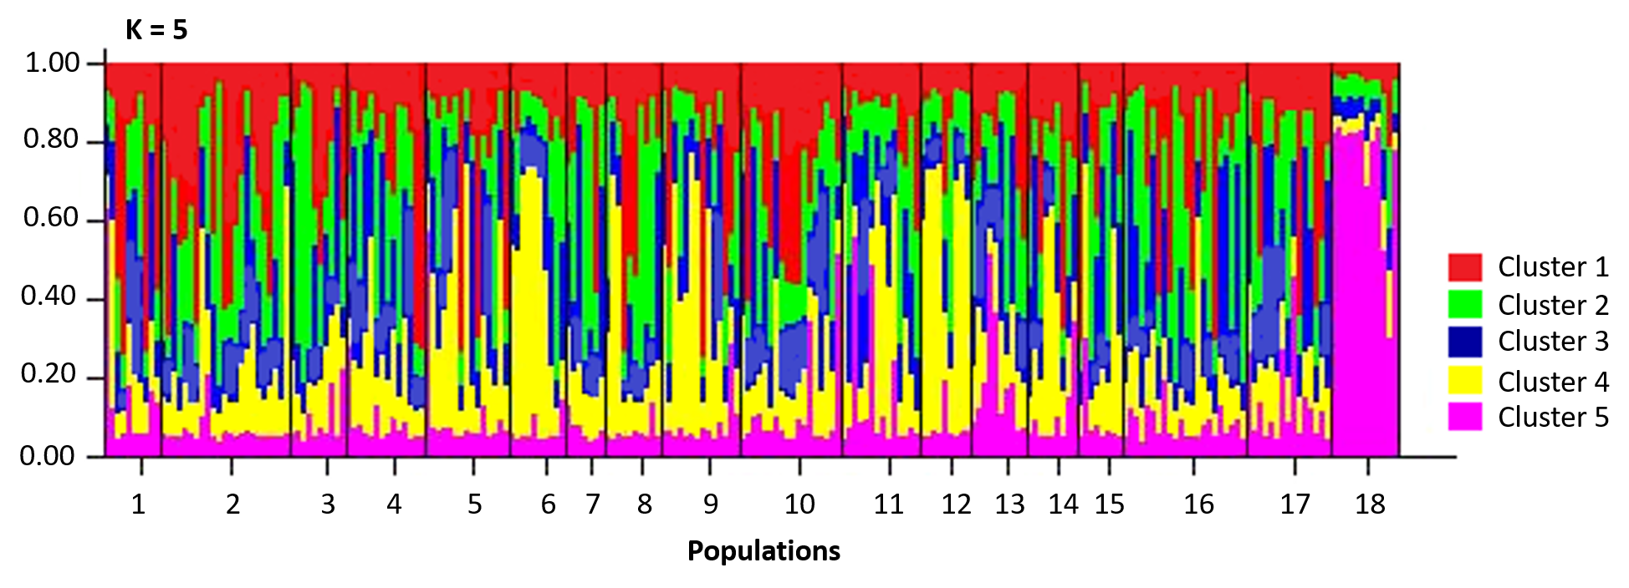**

**Figure S2.** Posterior probability of the Bayesian clustering simulation implemented in the software Structure 2.3.4 (Pritchard et al. 2000). (a) Rate of change of the likelihood distribution (mean); (b) Absolute value of the 2nd order rate of change of the likelihood distribution (mean); (c) Delta K = mean (|L”(K)|)/sd(L(K)); (e) coancestry plot for K = 5.

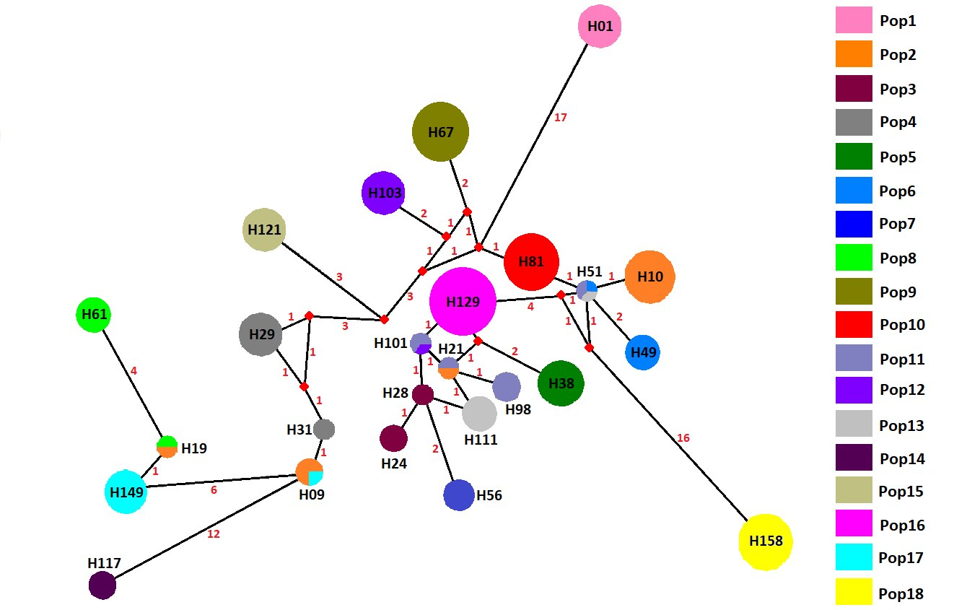

**Figure S3**. Median-joining network for mtDNA of *Glossophaga soricina* from 18 populations. Circumference size is proportional to the haplotype frequency. Number of mutations is shown in the network; small red circles are the median vectors. Different color patterns were assigned for each population following the legends. For correspondence between haplotypes in populations and in the network see Appendix S1, Table S11.

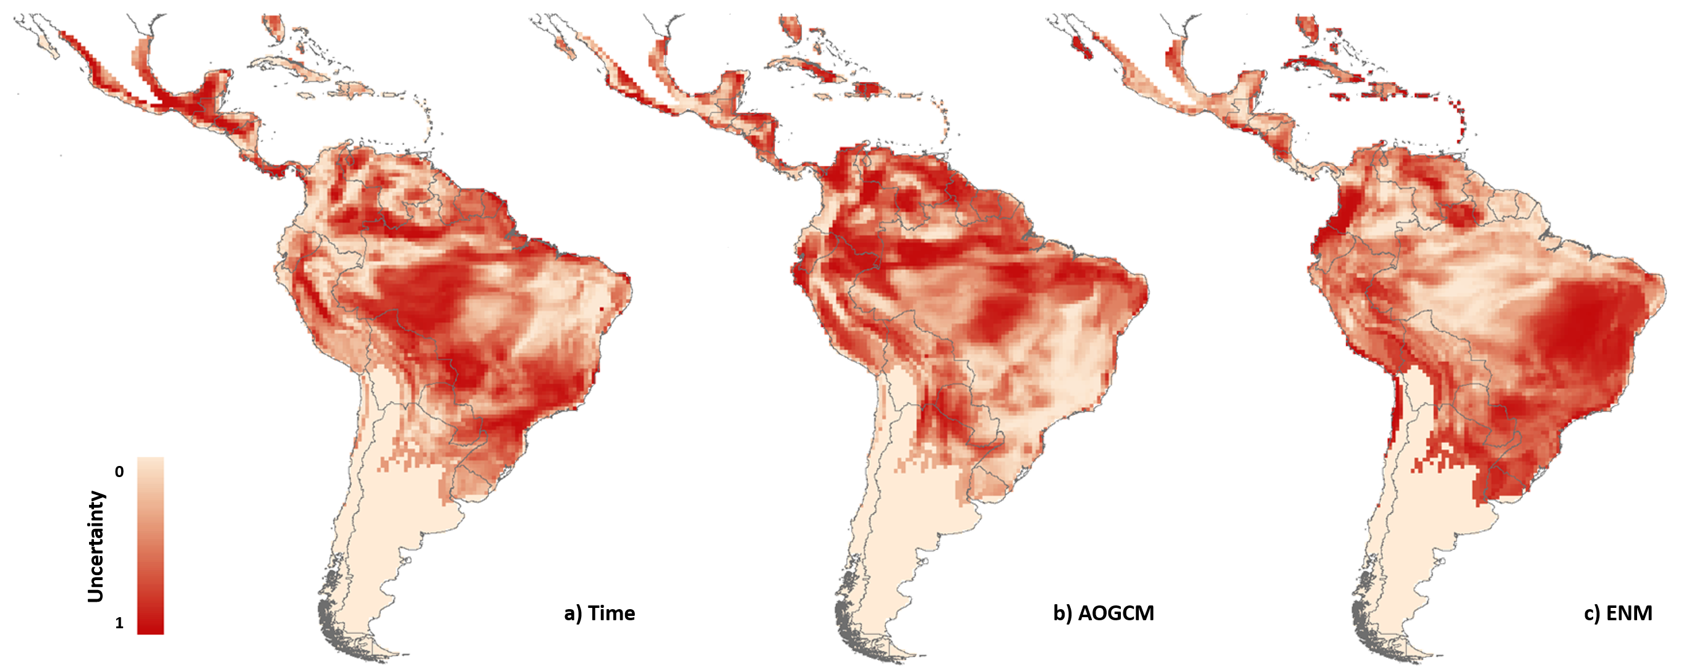

**Figure S4** Maps of uncertainty (relative sum of squares) for the modelling components of *Glossophaga soricina* **(a)** Time, **(b)** Atmosphere-Ocean Global Circulation Models (AOGCMs), **(c)** Ecological Niche Models (ENMs).

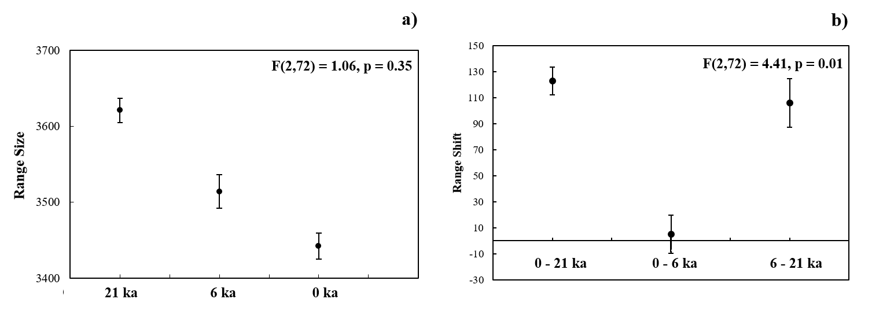

**Figure S5.** Mean and 0.95 confidence interval among the 75 maps of **(a)** range size (number of cells) and **(b)** range shift (difference of range size among time periods in number of cells) predicted for *Glossophaga soricina* at the LGM (21 ka), mid-Holocene (6 ka), and present-day (0 ka). Anova shows no difference in range size among time periods, but significant difference in range shift between time periods.



1. Microsatellite loci



1. *CYB*

**Figure S6** Model averaging results for each genetic parameter based on the genotyping of microsatellite loci and sequencing of *CYB* for 18 *Glossophaga soricina* in Brazilian Cerrado, for 5 km spatial scale. Panels show the relative importance of each variable based on wAICc (Akaike’s weight of evidence) and the model coefficients (β) for (A) microsatellite loci. (B) *CYB*. Error bar represents standard error (see Table S16 for p values). *He*, genetic diversity; *f*, inbreeding coefficient; *AR*, allelic richness; *k*, number of haplotypes; *h*, haplotype diversity; π, nucleotide diversity.

C:\Users\Avise\Desktop\Artigo_Morcegos\Analises de resistencia\ResistanceGA_definitivo\ResistanceGA\resultmicro\Results\Plots\adequability240_DiagnosticPlots.tif

**Figure S7**. Diagnostic plots of the optimization analysis of the resistance surface on the pairwise *FST* for *CYB*, for 18 populations of *Glossophaga soricina* sampled in the Brazilian Cerrado biome.

C:\Users\Avise\Desktop\Artigo_Morcegos\Analises de resistencia\ResistanceGA_definitivo\ResistanceGA\resultcytb\Results\Plots\adequability240_DiagnosticPlots.tif

**Figure S8**. Diagnostic plots of the optimization analysis of the resistance surface on the pairwise *FST* observed for microsatellites, for 18 populations of *Glossophaga soricina* sampled in the Brazilian Cerrado biome.

C:\Users\Avise\Desktop\Artigo_Morcegos\Analises de resistencia\ResistanceGA_definitivo\ResistanceGA\resultDJost\Results\Plots\adequability240_DiagnosticPlots.tif

**Figure S9**. Diagnostic plots of the optimization analysis of the resistance surface on the pairwise Jost’s *D*, for 18 populations of *Glossophaga soricina* sampled in the Brazilian Cerrado biome.

C:\Users\Avise\Desktop\Artigo_Morcegos\Analises de resistencia\ResistanceGA_definitivo\ResistanceGA\resultGst\Results\Plots\adequability240_DiagnosticPlots.tif

**Figure S10.** Diagnostic plots of the optimization analysis of the resistance surface on the pairwise *G’ST*, for 18 populations of *Glossophaga soricina* sampled in the Brazilian Cerrado biome.