SUPLEMENTARY MATERIAL for “EFFECTS OF RIPARIAN DEFORESTATION ON LEAF DECOMPOSITION AND THE INVERTEBRATE COMMUNITY IN ATLANTIC FOREST STREAMS”

Authors: Monalisa da Silva-Araújo, Eduardo F. Silva-Junior, Vinicius Neres-Lima, Rafael Feijó-Lima, Flavia Tromboni, Christine Lourenço-Amorim Steven A. Thomas, Timothy P. Moulton, Eugenia Zandonà

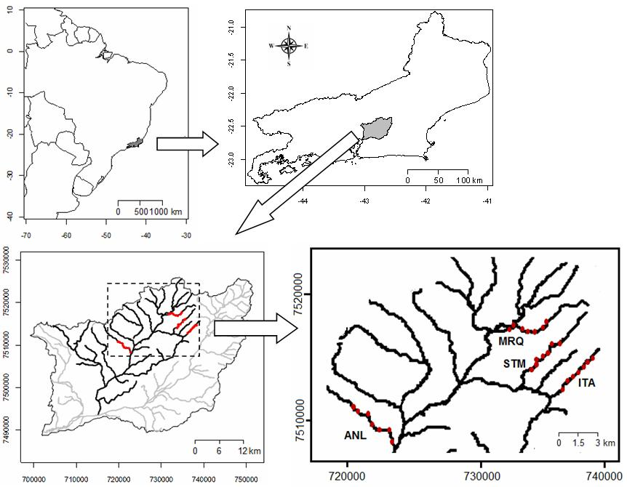

Figure S1. Location of studied catchment (Guapiaçu) and distribution of studied sites in each stream. Sites were numbered in increasing order from headwater to lower sections. ANL = Anil River; MRQ = Mariquita River; STM = Santa Maria River; ITA = Itaperiti River.

Table S1. Geographic coordinates, percent riparian deforestation, and environmental variables at the studied sites.
Site | Deforest-ation 30x300m (%) | Canopy cover (%) | Temperature (ºC) | pH | Current velocity (cm/s) | Discharge (L/s)
ANL1 | 6 | 82 | 20.2 | 6.2 | 0 | 200
ANL2 | 55 | 61.5 | 20.8 | 5.9 | 0 | 230.9
ANL3 | 50 | 15.4 | 20.3 | 5.6 | 2.5 | 246.1
ANL4 | 100 | 5.8 | 20.8 | 5.6 | 4 | 454.8
ANL5 | 40 | 82.6 | 21.3 | 5.5 | 1.5 | 241.8
ANL6 | 98 | 4.8 | 21.5 | 5.9 | 2 | 339.8
ANL8 | 100 | 30.4 | 23.5 | 5.3 | 1.5 | 318.4
ITA1 | 1 | 82.6 | 18.2 | 6.8 | 0 | 129.3
ITA2 | 44 | 5.6 | 20.3 | 6.6 | 1.8 | 284.1
ITA3 | 93 | 1.9 | 20.8 | 6.4 | 0.8 | 227.2
ITA4 | 10 | 82.2 | 20.6 | 7.9 | 2 | 253
ITA5 | 9 | 83.1 | 20.7 | 7.1 | 0.3 | 271.2
ITA6 | 40 | 3.8 | 18.9 | 6.6 | 1.3 | 256.6
ITA7 | 58 | 40.8 | 20.7 | 6 | 1.5 | 360.9
MRQ1 | 0 | 79.5 | 19.4 | 6.6 | 0 | 52.6
MRQ3 | 13 | 77.8 | 19.9 | 6.7 | 0.3 | 116.6
MRQ4 | 13 | 78.9 | 20.2 | 6.6 | 0 | 97.7
MRQ5 | 39 | 47.3 | 20.5 | 6.6 | 0.3 | 91.9
MRQ6 | 78 | 51.8 | 20.6 | 6.4 | 0.5 | 88.3
MRQ7 | 64 | 66.6 | 20.1 | 7.7 | 0 | 112.2
MRQ8 | 91 | 54.8 | 18.6 | 6.2 | 1.3 | 203.9
STM1 | 2 | 93.2 | 19.4 | 5.7 | 1.5 | 197.5
STM2 | 5 | 89.9 | 20.9 | 5.8 | 0.8 | 156.5
STM3 | 4 | 60.7 | 21.1 | 7.2 | 0.5 | 146.4
STM4 | 63 | 68.2 | 22.3 | 6.9 | 0.3 | 166.6
STM5 | 49 | 56.3 | 22.5 | 6 | 0.3 | 148.5
STM6 | 98 | 3.5 | 22.4 | 6.5 | 2.8 | 193.3
STM7 | 100 | 0.1 | 23.3 | 6.8 | 1.3 | 230.1
Site | Depth (cm) | Width (cm) | NH₄⁺ (µg L⁻¹) | SRP (µg L⁻¹) | Min O₂ Saturation (%) | Coordenates (S, W)
ANL1 | 18 | 594 | 2.5 | 20.2 | 93.3 | 22º29’43.49” | 42º51’42.38”
ANL2 | 25 | 507 | 5.9 | 25.6 | 81 | 22º29’51.88” | 42º51’42.38”
ANL3 | 28 | 333 | 10.4 | 26.5 | 85.7 | 22º29’59.17” | 42º51’5.14”
ANL4 | 48 | 200 | 11 | 29.9 | 83.1 | 22º30’16.14” | 42º50’58.09”
ANL5 | 29 | 500 | 12.1 | 30.1 | 78 | 22º30’29.81” | 42º50’47.91”
ANL6 | 36 | 303 | 9.3 | 29.9 | 64.1 | 22°30'49.73" | 42°49'59.31"
ANL8 | 18 | 559 | 14.7 | 25.7 | 50.1 | 22°31'20.67" | 42°49'52.00"
ITA1 | 17 | 217 | 1.3 | 32.4 | 96.7 | 22°27'23.99" | 22°27'23.99"
ITA2 | 17 | 223 | 1.7 | 38.8 | 97.2 | 22°27'32.51" | 42°41'4.43”
ITA3 | 19 | 287 | 1.8 | 36.3 | 97 | 22°27'40.22" | 42°41'10.51"
ITA4 | 20 | 370 | 2.1 | 37.6 | 96.8 | 22°27'51.04" | 42°41'18.66"
ITA5 | 18 | 630 | 1.8 | 42.4 | 98 | 22°28'0.98" | 42°41'32.05"
ITA6 | 24 | 288 | 2.8 | 45.3 | 96.2 | 22°28'16.48” | 42°41'46.34”
ITA7 | 20 | 407 | 2.7 | 46.3 | 99.2 | 22°28'29.10" | 42°42'2.28"
MRQ1 | 26 | 547 | 1.2 | 23 | 99 | 22°25'52.45" | 42°42'53.91"
MRQ3 | 29 | 425 | 1.3 | 23 | 98.9 | 22°26'15.88" | 42°43'26.04”
MRQ4 | 42 | 744 | 1.6 | 28.1 | 98.6 | 22°26'12.21" | 42°43'44.64"
MRQ5 | 31 | 664 | 1.9 | 31.3 | 96.2 | 22°26'5.90" | 42°44'3.01"
MRQ6 | 21 | 679 | 2.2 | 21.1 | 95 | 22°25'56.56" | 42°44'15.34"
MRQ7 | 30 | 816 | 2.7 | 18.3 | 85.4 | 22°26'3.14" | 42°44'27.42"
MRQ8 | 25 | 864 | 2.6 | 14.9 | 99.2 | 22°26'5.32" | 42°44'39.77"
STM1 | 23 | 650 | 1.1 | 10.4 | 98.8 | 22°26'40.23" | 42°42'21.10"
STM2 | 21 | 465 | 1.2 | 13.1 | 98.3 | 22°26'46.08" | 42°42'29.87"
STM3 | 19 | 700 | 1.2 | 18.3 | 97.6 | 22°27'3.72" | 42°42'42.82"
STM4 | 40 | 875 | 1.5 | 25.7 | 98.3 | 22°27'20.92" | 42°43'3.17"
STM5 | 32 | 502 | 1.6 | 23.7 | 96.6 | 22°27'25.89” | 42°43'19.59"
STM6 | 18 | 420 | 2.1 | 24.6 | 92.1 | 22°27'37.21" | 42°43'19.32"
STM7 | 35 | 390 | 3.9 | 24.4 | 91.4 | 22°27'49.32" | 42°43'28.81"

Measurements of environmental variables:
Deforestation was quantified using satellite imagery as described in the main text. Canopy cover (% shading) was measured in four directions at the middle of stream section with a spherical densiometer (Forest densiometer, Bartlesville, OK, EUA), water velocity using a flowmeter (FP111/211 Flow Probe, Global Water, Gold River, CA, EUA), depth (tape measure). Daily minimum O₂ saturation and daily average temperature were measured in the middle of the water column using an optical sensor (HOBO dissolved oxygen/temperature logger, U-26-001, Onset patent No US6.826.664 – Onset Instruments, USA). We analyzed soluble reactive phosphorus (SRP) and NH₄⁺ concentrations in triplicate water samples collected and filtered with glass fiber filter of 0.7 µm (GF/F, Whatman, Maidstone, Kent, UK). NH₄⁺ was measured by the OPA method using a fluorometer (Trilogy model, 7200-000, Turner Designs, Sunnyvale, CA, USA) (Taylor et al. 2007) and SRP was measured with the molybdenum blue technique with the same equipment (Murphy & Riley 1962).
References for measurements:
Murphy, J., and J. P. Riley. 1962. Determination of phosphate in natural waters. Analytica Chimica Acta 27:31-36.

Taylor, B. E., C. F. Keep, R. O. Hall, B. J. Koch, L. M. Tronstad, A. S. Flecker, and A. J. Ulseth. 2007. Improving the fluorometric ammonium method: Matrix effects, background fluorescence, and standard additions. Journal of the North American Benthological Society 26:167-177.

Figure S2. Leaf decay relationships in each studied site. % remaining leaf mass is plotted on log scale.
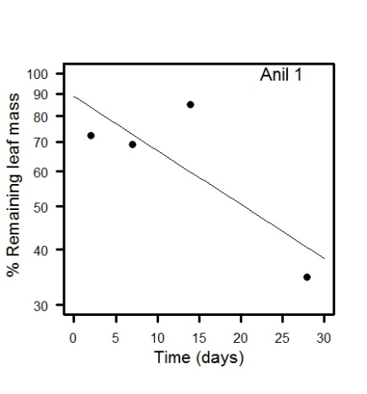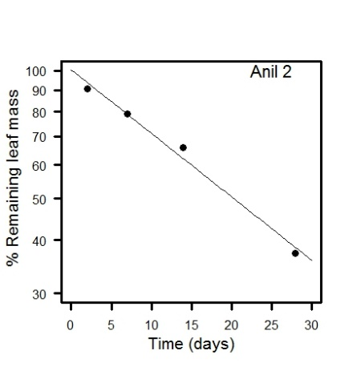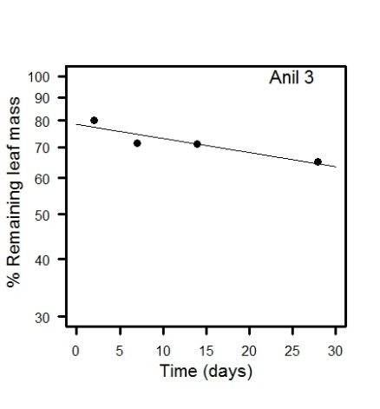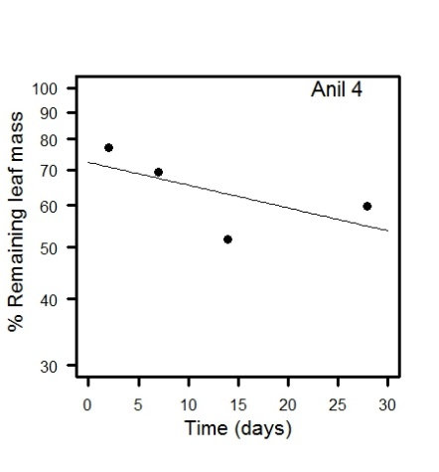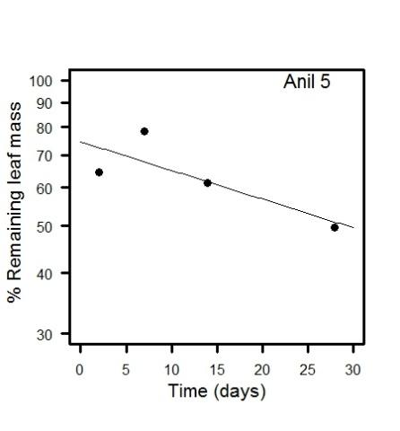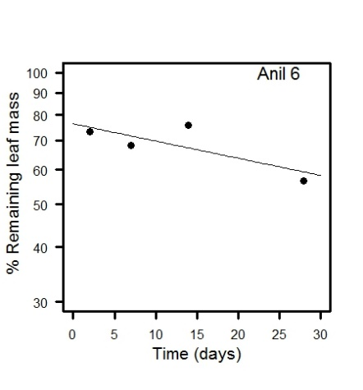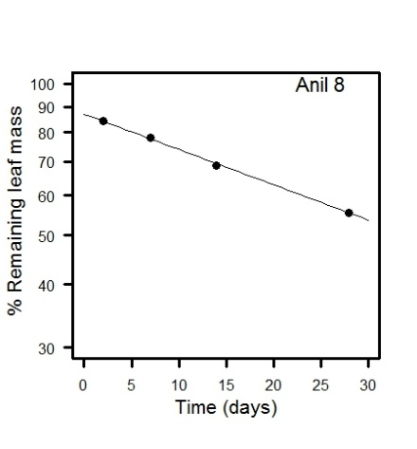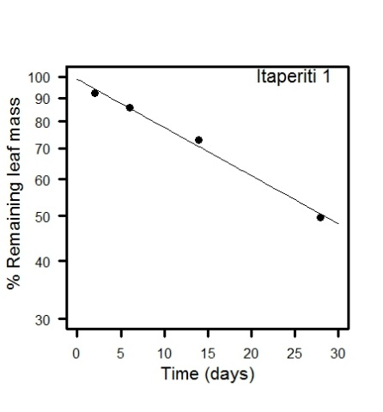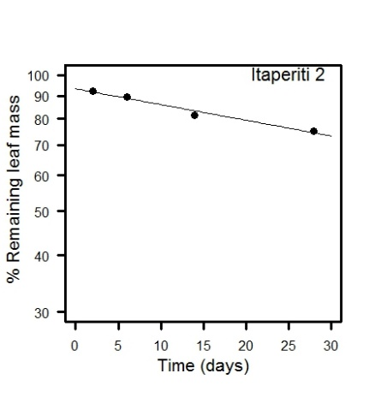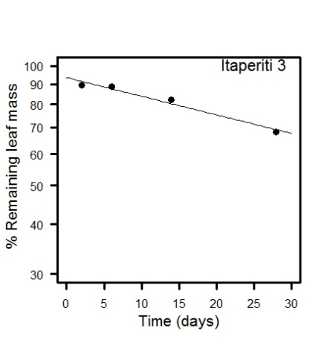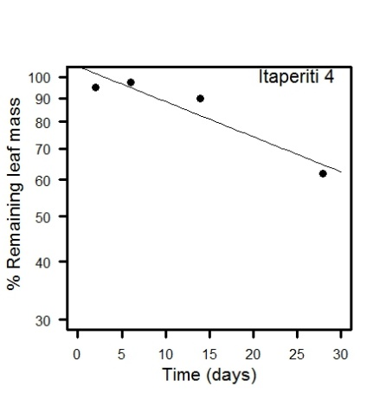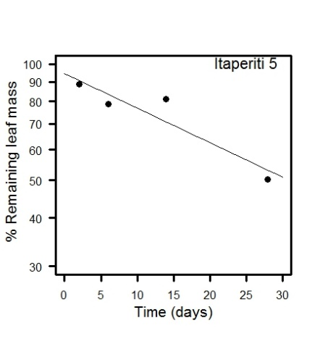

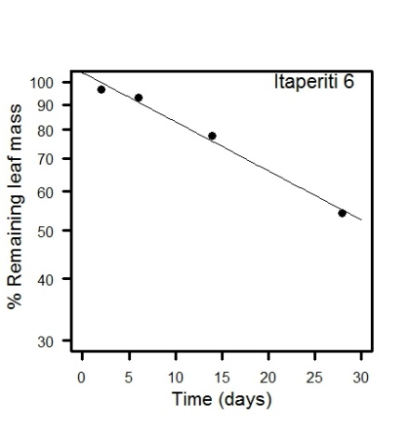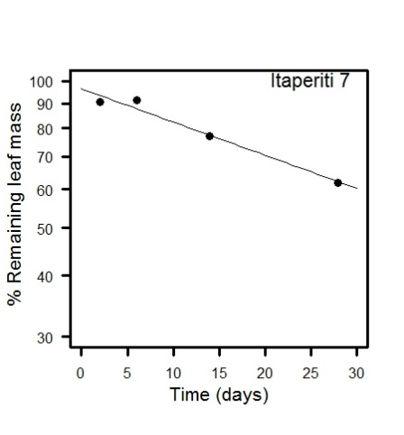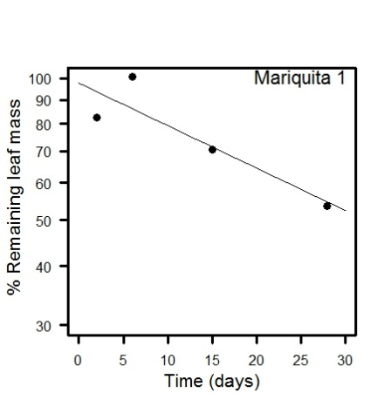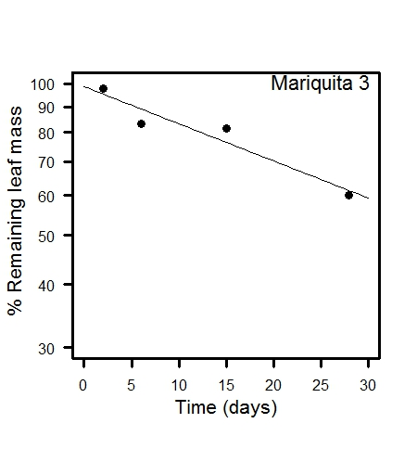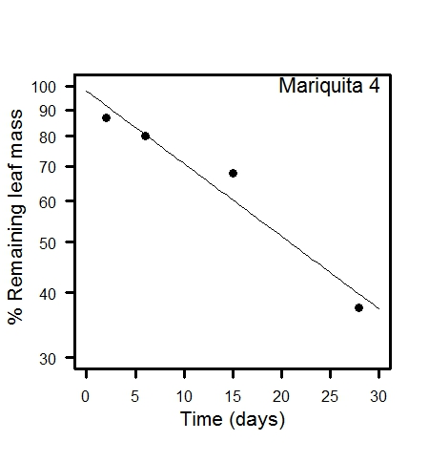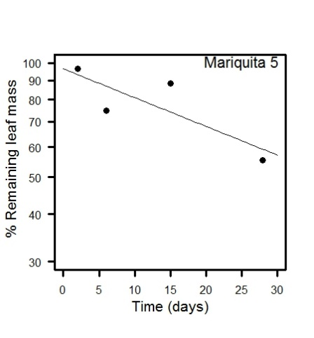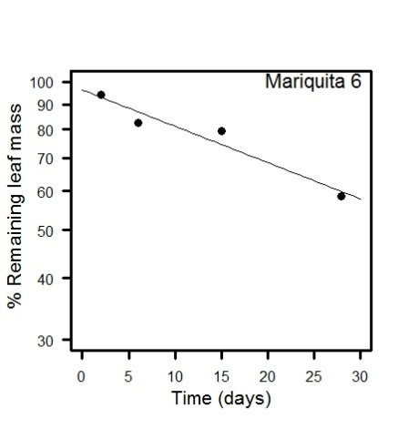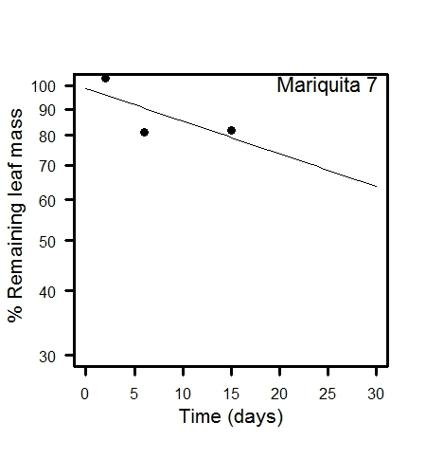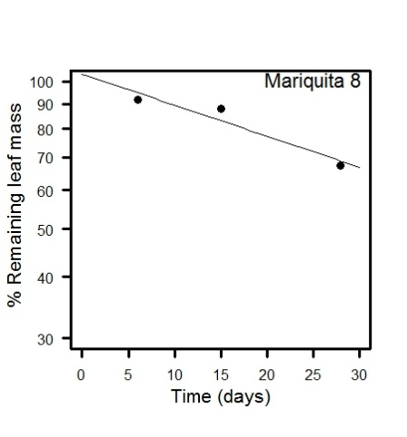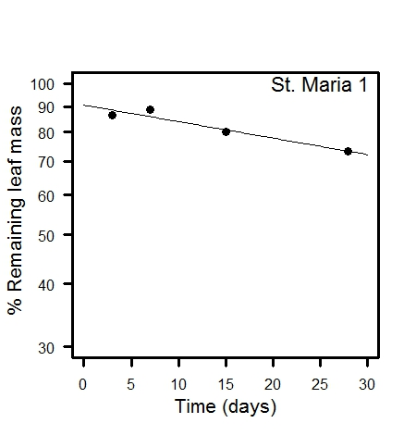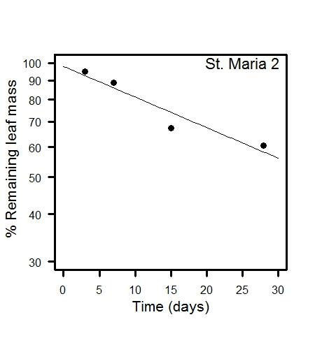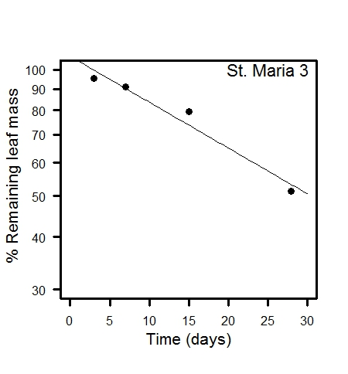
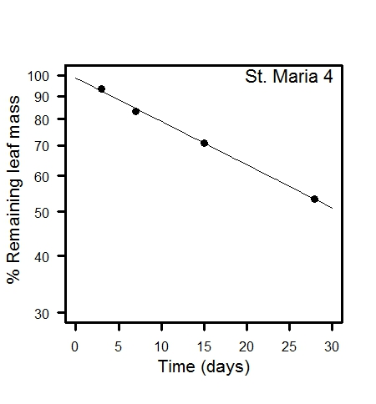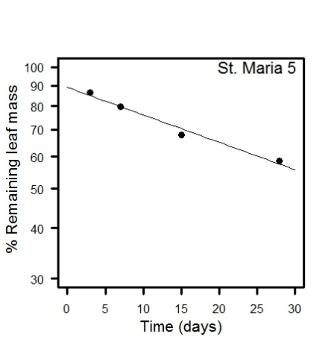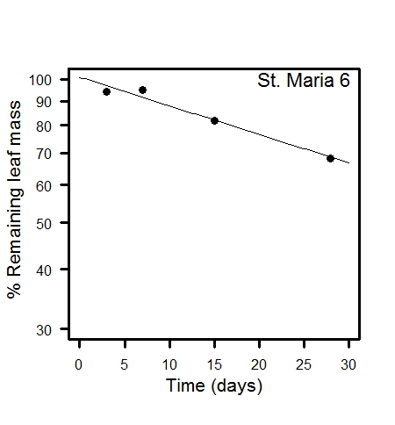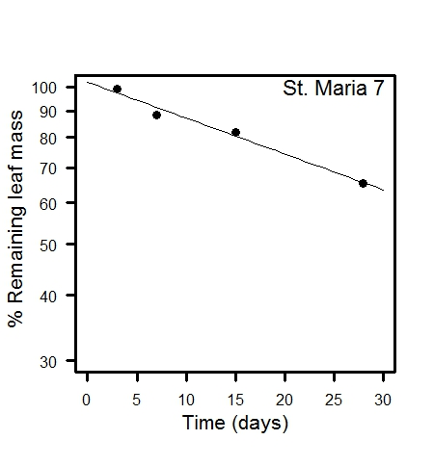
Table S2. Abundance and frequency of benthic invertebrates classified into functional feeding groups
Taxon | Functional feeding group | Abundance in sites | Frequency in sites
Chironomidae | Collector-gatherer | 18461 | 28
Leptohyphidae | Scraper | 9319 | 28
Baetidae | Scraper | 5834 | 27
Elmidae (larva) | Collector-gatherer | 5287 | 28
Simulidae | Filterer | 4678 | 25
Hydropsychidae | Scraper | 1754 | 27
Helicopsyche | Scraper | 1554 | 19
Leptophlebiidae | Collector-gatherer | 1370 | 22
Hydroptilidae | Filterer | 991 | 22
Stenochironomus | Shredder | 864 | 25
Elmidae (adult) | Shredder | 635 | 24
Ceratopogonidae | Predator | 506 | 25
Philopotamidae | Filterer | 348 | 18
Leptoceridae (Oecetis) | Predator | 285 | 14
Empididae | Predator | 273 | 20
Libellulidae | Predator | 204 | 15
Perlidae | Predator | 201 | 15
Psephenidae | Scraper | 132 | 13
Naucoridae | Predator | 127 | 15
Hydracarina | Predator | 126 | 9
Veliidae | Predator | 116 | 12
Nectopsyche | Scraper | 68 | 2
Calamoceratidae | Shredder | 60 | 9
Gripopterygidae | Scraper | 59 | 7
Pyralidae | Shredder | 50 | 8
Gomphidae | Predator | 49 | 10
Coenagrionidae | Predator | 41 | 6
Belostomatidae | Predator | 33 | 5
Calopterigidae | Predator | 32 | 7
Tipulidae | Shredder | 29 | 8
Collembola | Collector-gatherer | 29 | 4
Trichoptera (other) | Collector-gatherer | 28 | 4
Dixidae | Collector-gatherer | 28 | 6
Sericostomatidae | Predator | 28 | 3
Corydalus | Predator | 24 | 1
Aeshnidae | Predator | 20 | 3
Hemiptera (adult) | Predator | 18 | 3
Ecnomidae | Predator | 16 | 1
Psychodidae | Collector-gatherer | 4 | 1
Culicidae | Filterer | 4 | 1
Hydrophilidae | Predator | 2 | 2
Dytiscidae | Predator | 2 | 1
Hydrobiosidae | Predator | 2 | 1
Polycentropodidae | Filterer | 1 | 1
Megapodagrionidae | Predator | 1 | 1
Mesoveliidae | Predator | 1 | 1
Protoneuridae | Predator | 1 | 1
Staphylinidae | Predator | 1 | 1
Blephariceridae | Scraper | 1 | 1
 | Total | 53697

References for the classification into FFG:
Cummins, K. W., Merritt, R. W., & Andrade, P. C. N., 2005. The use of invertebrate functional groups to characterize ecosystem attributes in selected streams and rivers in South Brazil. Studies on Neotropical Fauna and Environment, 40(1), pp. 69–89.
Domínguez, E., & Fernández, H. R., 2009. Macroinvertebrados bentónicos sudamericanos: sistemática y biología. Tucumán: Fundación Miguel Lillo.
Henriques-Oliveira, A. L., & Nessimian, J. L., 2010. Spatial distribution and functional feeding groups of aquatic insect communities in Serra da Bocaina streams, southeastern Brazil. Acta Limnologica Brasiliensia, 22(4), pp. 424–441.
Merritt, R. W., & K. W. Cummins, 1996. An Introduction to the Aquatic Insects of North America, 3rd edn. Kendall/Hunt, Dubuque.

Table S3. ANCOVA of metrics of benthic invertebrates and deforestation.
Metric | Source | Sum of squares | df | Mean squares | F-ratio | Probability
Invertebrate family richness
 | Stream | 17.595 | 3 | 5.865 | 1.325 | 0.294
 | Deforestation | 25.126 | 1 | 25.126 | 5.678 | 0.027
 | Stream* Deforestation | 22.909 | 3 | 7.636 | 1.726 | 0.194
 | Error | 88.496 | 20 | 4.425
Shannon diversity
 | Stream | 0.051 | 3 | 0.017 | 0.323 | 0.809
 | Deforestation | 0.276 | 1 | 0.276 | 5.274 | 0.033
 | Stream* Deforestation | 0.407 | 3 | 0.136 | 2.591 | 0.081
 | Error | 1.047 | 20 | 0.052
%Shredders
 | Stream | 0.0017 | 3 | 0.0006 | 2.2683 | 0.1118
 | Deforestation | 0.0054 | 1 | 0.0054 | 21.6675 | 0.0002
 | Stream* Deforestation | 0.0012 | 3 | 0.0004 | 1.6817 | 0.2029
 | Error | 0.0049 | 20 | 0.0002
%EPT
 | Stream | 0.024 | 3 | 0.008 | 0.483 | 0.698
 | Deforestation | 0.091 | 1 | 0.091 | 5.432 | 0.030
 | Stream* Deforestation | 0.125 | 3 | 0.042 | 2.479 | 0.091
 | Error | 0.336 | 20 | 0.017
%Chironomidae among Diptera
 | Stream | 0.14 | 3 | 0.047 | 4.987 | 0.010
 | Deforestation | 0.047 | 1 | 0.047 | 4.981 | 0.037
 | Stream* Deforestation | 0.082 | 3 | 0.027 | 2.906 | 0.060
 | Error | 0.187 | 20 | 0.009
Deforestation = Arcsine (square-root(proportion deforested))

ANCOVA was carried out in SYSTAT 12, General Linear Model with Type III adjusted sums of squares

Table S4. Benthic invertebrate metrics for sites
Site | Abun-dance | Family richness | Shannon diversity | Shredder abundance | % Shredders | % EPT | % Chironomidae among Diptera | Deforest-ation % | Arcsine √(Deforest)
ANL1 | 2889 | 20 | 1.92 | 114 | 3.95% | 42.0% | 94.3% | 6 | 0.25
ANL2 | 1894 | 14 | 1.8 | 43 | 2.27% | 18.0% | 84.9% | 55 | 0.84
ANL3 | 200 | 11 | 1.49 | 9 | 4.50% | 15.5% | 89.9% | 50 | 0.79
ANL4 | 1345 | 13 | 1.54 | 1 | 0.07% | 36.7% | 90.3% | 100 | 1.57
ANL5 | 138 | 15 | 1.94 | 7 | 5.07% | 26.1% | 75.0% | 40 | 0.68
ANL6 | 1551 | 13 | 1.54 | 4 | 0.26% | 49.7% | 96.0% | 98 | 1.43
ANL8 | 850 | 10 | 0.68 | 0 | 0.00% | 8.9% | 100.0% | 100 | 1.57
ITA1 | 3154 | 19 | 1.79 | 282 | 8.94% | 19.9% | 58.2% | 1 | 0.10
ITA2 | 2137 | 19 | 1.92 | 11 | 0.51% | 54.6% | 61.5% | 44 | 0.73
ITA3 | 2635 | 16 | 1.59 | 1 | 0.04% | 63.3% | 86.4% | 93 | 1.30
ITA4 | 928 | 20 | 2.04 | 21 | 2.26% | 32.5% | 60.0% | 10 | 0.32
ITA5 | 2480 | 22 | 1.92 | 51 | 2.06% | 31.3% | 41.4% | 9 | 0.30
ITA6 | 1999 | 19 | 1.66 | 16 | 0.80% | 59.7% | 73.5% | 40 | 0.68
ITA7 | 2897 | 19 | 1.79 | 63 | 2.17% | 66.7% | 66.2% | 58 | 0.87
MRQ1 | 1338 | 18 | 1.72 | 45 | 3.36% | 20.5% | 73.3% | 0 | 0.00
MRQ3 | 2670 | 16 | 2.11 | 21 | 0.79% | 56.6% | 75.4% | 13 | 0.37
MRQ4 | 2619 | 18 | 2.18 | 29 | 1.11% | 52.2% | 89.7% | 13 | 0.37
MRQ5 | 940 | 17 | 1.99 | 16 | 1.70% | 49.4% | 72.8% | 39 | 0.67
MRQ6 | 3205 | 19 | 1.96 | 93 | 2.90% | 31.0% | 77.6% | 78 | 1.08
MRQ7 | 2025 | 19 | 2.05 | 22 | 1.09% | 31.4% | 54.8% | 64 | 0.93
MRQ8 | 1991 | 17 | 2.19 | 15 | 0.75% | 59.7% | 67.2% | 91 | 1.27
STM 1 | 1037 | 20 | 1.95 | 65 | 6.27% | 25.5% | 81.8% | 2 | 0.14
STM 2 | 1844 | 17 | 1.69 | 79 | 4.28% | 20.5% | 74.5% | 5 | 0.23
STM 3 | 1217 | 20 | 1.94 | 32 | 2.63% | 31.5% | 60.4% | 4 | 0.20
STM 4 | 2517 | 22 | 2.14 | 46 | 1.83% | 38.0% | 63.9% | 63 | 0.92
STM 5 | 3280 | 24 | 2.03 | 39 | 1.19% | 38.0% | 72.3% | 49 | 0.78
STM 6 | 2174 | 16 | 1.62 | 42 | 1.93% | 37.4% | 85.6% | 98 | 1.43
STM 7 | 1743 | 18 | 1.42 | 2 | 0.11% | 23.2% | 95.7% | 100 | 1.57
Total | 53697

Table S5. Remaining mass after 28 days and rate of leaf processing (k)
Site | % remaining mass day 28 | k (/day)
ANL1 | 34.7 | 0.028
ANL2 | 37.3 | 0.034
ANL3 | 65.1 | 0.007
ANL4 | 59.8 | 0.010
ANL5 | 49.7 | 0.014
ANL6 | 56.7 | 0.009
ANL8 | 55.5 | 0.016
ITA1 | 49.7 | 0.024
ITA2 | 75.2 | 0.008
ITA3 | 68.3 | 0.011
ITA4 | 61.9 | 0.017
ITA5 | 50.4 | 0.021
ITA6 | 54.3 | 0.023
ITA7 | 62.0 | 0.016
MRQ1 | 53.7 | 0.021
MRQ3 | 60.1 | 0.017
MRQ4 | 37.5 | 0.032
MRQ5 | 55.6 | 0.017
MRQ6 | 58.5 | 0.017
MRQ7 | 81.9 | 0.015
MRQ8 | 67.3 | 0.015
STM 1 | 73.2 | 0.008
STM 2 | 60.7 | 0.019
STM 3 | 51.3 | 0.025
STM 4 | 53.4 | 0.022
STM 5 | 58.5 | 0.016
STM 6 | 68.3 | 0.014
STM 7 | 65.4 | 0.016

Table S6. Pearson correlation ( r) of macroinvertebrate community metrics and physical and chemical variables. Probabilities of r (n = 28) are r > 0.36 p < 0.05; r > 0.46, p < 0.01; r > 0.57, p < 0.001.
 |  | Deforestation (Arcsine (sqr(prop))) | Canopy cover (Arcsine (sqr(prop))) | Temp. ºC | pH | Current velocity (cm/s) | Discharge (L/s)
Macroinvertebrate Community Metrics
 | Abundance | -0.05 | 0.06 | -0.12 | 0.24 | -0.46 | -0.24
 | Family Richness | -0.49 | 0.40 | -0.15 | 0.57 | -0.49 | -0.4
 | Shannon Diversity | -0.50 | 0.53 | -0.46 | 0.47 | -0.42 | -0.49
 | Shredder Abundance | -0.47 | 0.44 | -0.41 | 0.10 | -0.38 | -0.32
 | Shredders (PC) | -0.63 | 0.58 | -0.43 | -0.10 | -0.20 | -0.31
 | EPT (PC) | 0.13 | -0.28 | -0.26 | 0.16 | 0.03 | 0.12
 | Chironomidae in Diptera (PC) | 0.48 | -0.43 | 0.37 | -0.63 | 0.33 | 0.24
Decomposition Rate
 | k | -0.42 | 0.44 | -0.13 | 0.27 | -0.66 | -0.39
 |  | Depth (cm) | Width (cm) | NH₄ (ug/L) | SRP (ug/L) | Min O₂ (24h) (%Sat )
Macroinvertebrate Community Metrics
 | Abundance | -0.12 | 0.06 | -0.59 | 0.11 | 0.44
 | Family Richness | -0.14 | 0.33 | -0.79 | 0.04 | 0.72
 | Shannon Diversity | 0.13 | 0.45 | -0.65 | -0.11 | 0.71
 | Shredder Abundance | -0.36 | -0.07 | -0.35 | -0.07 | 0.28
 | Shredders (PC) | -0.34 | -0.02 | -0.13 | -0.22 | 0.22
 | EPT (PC) | 0.08 | -0.06 | -0.35 | 0.41 | 0.38
 | Chironomidae in Diptera (PC) | 0.30 | -0.24 | 0.52 | -0.24 | -0.52
Decomposition Rate
 | k | -0.04 | 0.34 | -0.31 | -0.01 | 0.19

