Supplementary Materials
Fig. S1. Bivariate map with the proportion of Threatened (T) vs Data Deficient (DD) bat species distributed across the Amazonian Indigenous Territories (ITs). To create this map, we classified ITs into three classes using quantile classification. See methods for the criteria used in the definition of the “Low”, “Mid” and “High” categories for both T and DD species.
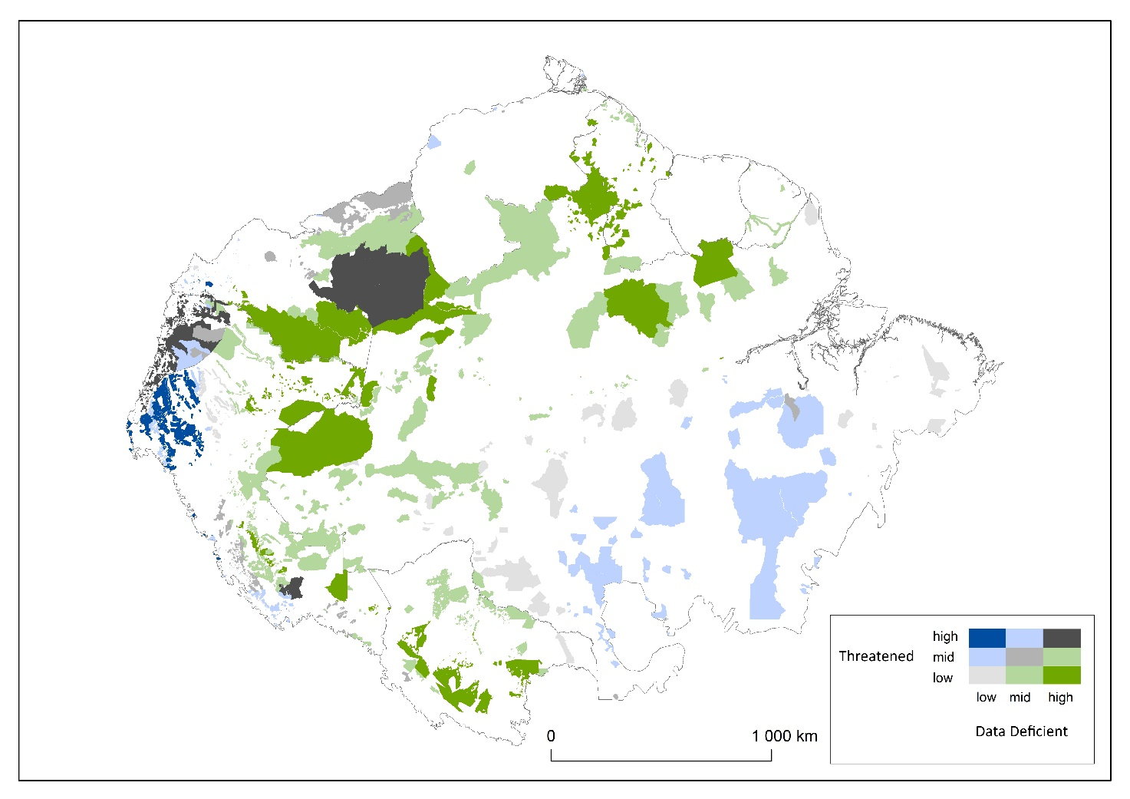

Fig. S2. Histogram describing the rarity distribution of the species across the ITs of the Amazon biome. The categories in the x-axis indicate the upper limit of the category (e.g., class 10 is for 0-10%)
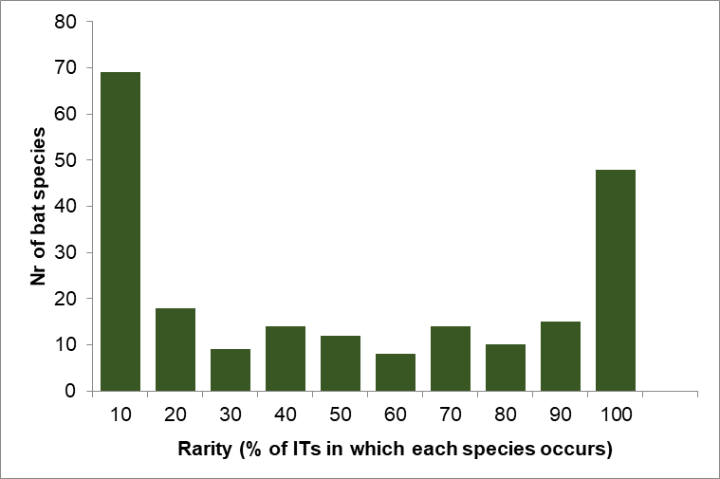

Fig. S3. Histogram describing the distribution of richness in rare bat species (i.e., cut off of 10%, see Fig. S5) across all ITs in the Amazon biome. Note: category 1 is for 0 rare species. The following categories are percentage bins (i.e., 1-5%, 5-10%, 10-15%, 20-25%).
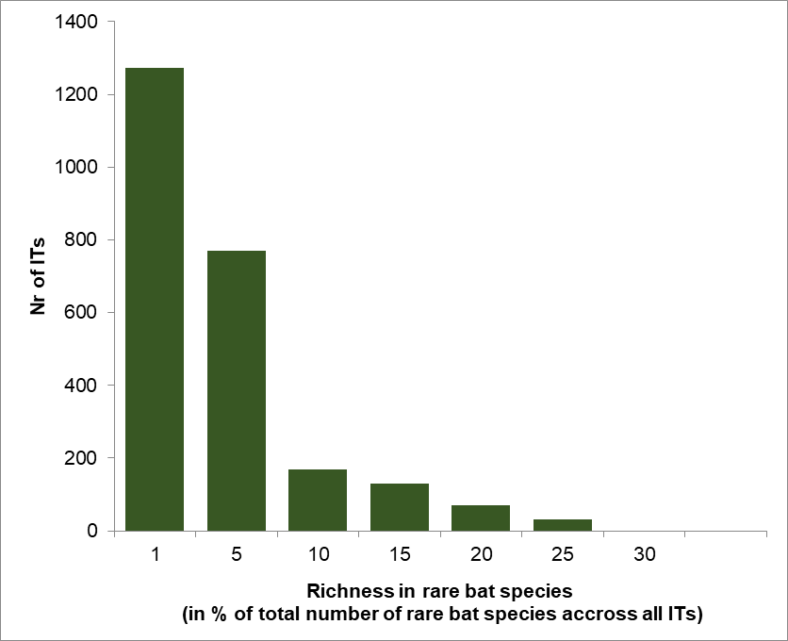

Fig S4. Effect of average altitude on bat species richness in each of the ITs across the Amazon biome.
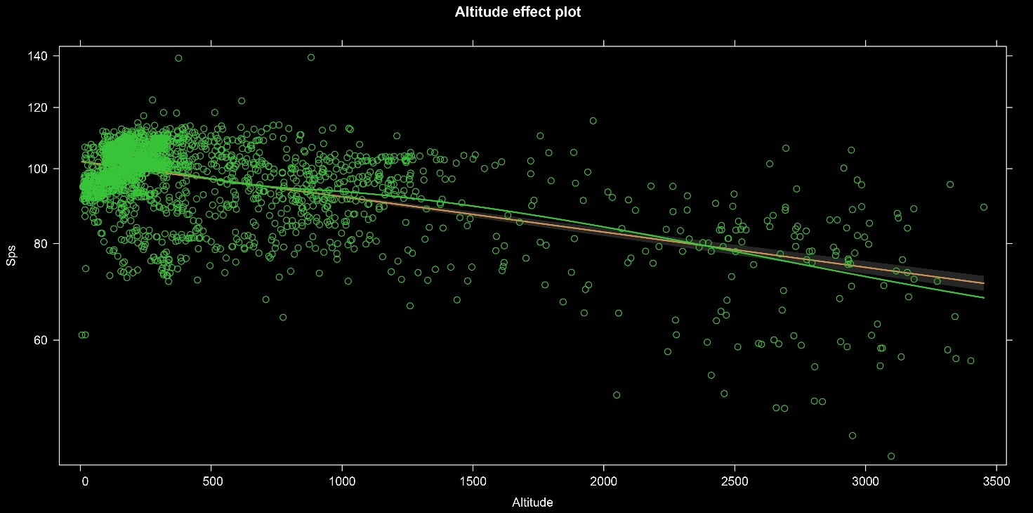

Fig. S5. Effect of average latitude on bat species richness in each of the ITs across the Amazon biome.
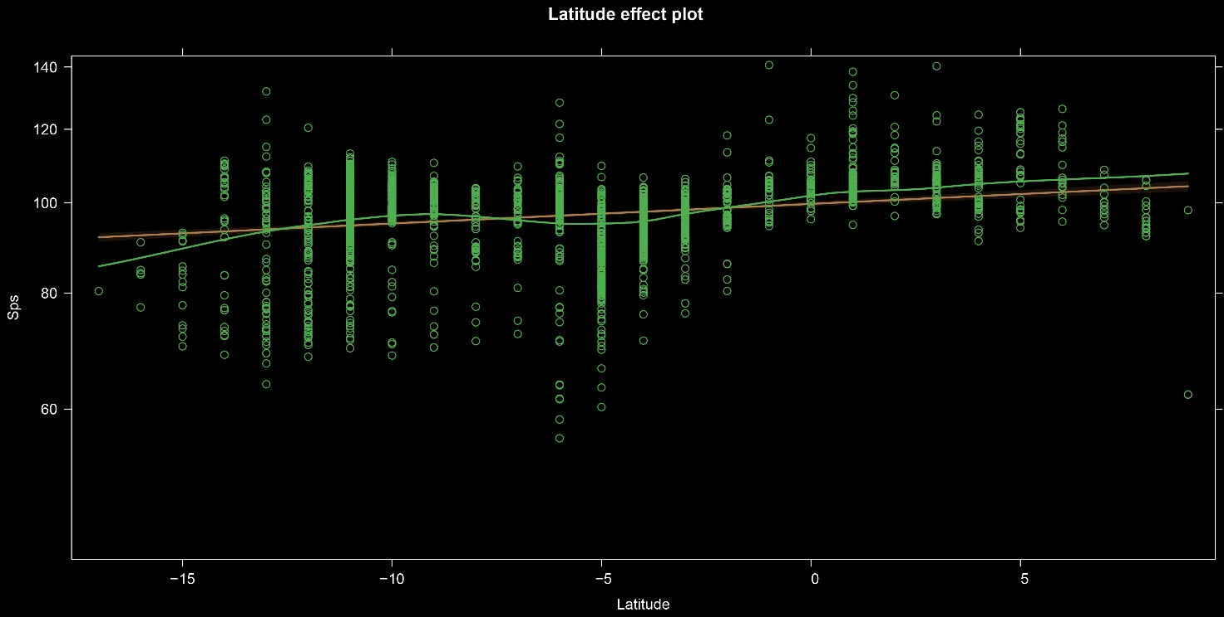

Fig S6. Effects of average IT size on bat species richness in each of the ITs across the Amazon biome.
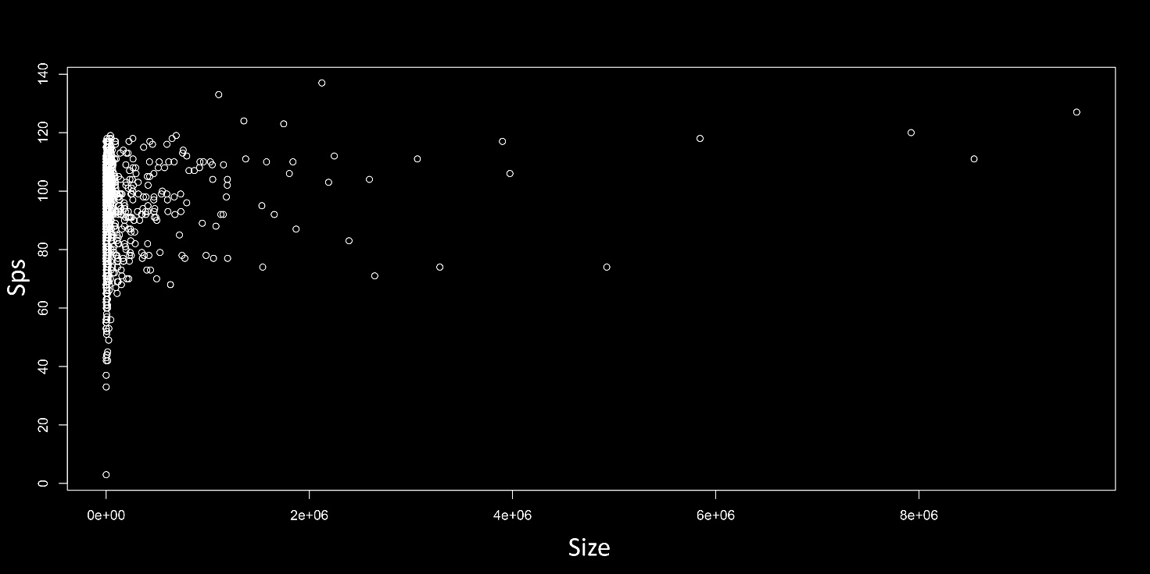

Table S1. Percentage of global known distribution range within each Amazonian country for each of the 22 bat species listed in Table 1.
Species | Percentage of global known distribution range within the Amazon (%) |  |  |  |  |  |  |  |  | Percentage of global known distribution range beyond the Amazon (%)
 | Bolivia | Brazil | Colombia | Ecuador | French Guiana | Guyana | Peru | Suriname | Venezuela
Peropteryx pallidoptera | 0.0 | 62.7 | 21.9 | 2.9 | 0.0 | 0.0 | 11.8 | 0.0 | 0.3 | 0.5
Cynomops mastivus | 0.0 | 62.4 | 7.6 | 2.5 | 2.2 | 5.8 | 7.3 | 4.0 | 6.4 | 1.8
Eumops maurus | 0.0 | 14.2 | 24.0 | 1.2 | 0.0 | 13.2 | 0.6 | 2.2 | 36.7 | 7.8
Eumops trumbulli | 2.1 | 66.4 | 8.7 | 0.0 | 1.8 | 4.1 | 4.2 | 3.0 | 7.4 | 2.2
Gardnerycteris koepckeae | 0.0 | 0.0 | 0.0 | 0.0 | 0.0 | 0.0 | 99.6 | 0.0 | 0.0 | 0.4
Glossophaga commissarisi | 0.0 | 25.0 | 13.0 | 2.7 | 0.0 | 0.6 | 20.7 | 0.0 | 0.0 | 37.8
Hsunycteris dashe | 0.0 | 0.0 | 0.0 | 0.0 | 0.0 | 0.0 | 100.0 | 0.0 | 0.0 | 0.0
Hsunycteris pattoni | 2.9 | 31.1 | 0.7 | 3.3 | 0.0 | 0.0 | 55.0 | 0.0 | 0.0 | 6.9
Lonchorhina mankomara | 0.0 | 0.8 | 98.9 | 0.0 | 0.0 | 0.0 | 0.3 | 0.0 | 0.0 | 0.0
Lonchorhina marinkellei | 0.0 | 5.0 | 95.0 | 0.0 | 0.0 | 0.0 | 0.0 | 0.0 | 0.0 | 0.0
Lonchorhina orinocensis | 0.0 | 1.4 | 50.3 | 0.0 | 0.0 | 0.0 | 0.0 | 0.0 | 11.9 | 36.4
Lophostoma carrikeri | 2.0 | 47.8 | 11.4 | 2.1 | 2.0 | 3.3 | 12.4 | 3.5 | 8.6 | 7.0
Micronycteris brosseti | 0.0 | 42.4 | 9.8 | 0.0 | 2.0 | 9.0 | 21.0 | 9.8 | 5.9 | 0.1
Neonycteris pusilla | 0.0 | 53.9 | 46.1 | 0.0 | 0.0 | 0.0 | 0.0 | 0.0 | 0.0 | 0.0
Phyllostomus latifolius | 0.0 | 70.7 | 4.5 | 0.0 | 5.4 | 5.2 | 0.0 | 8.4 | 3.7 | 2.1
Platyrrhinus ismaeli | 0.0 | 0.0 | 13.7 | 38.1 | 0.0 | 0.0 | 38.7 | 0.0 | 0.0 | 9.4
Rhinophylla fischerae | 0.0 | 59.3 | 9.8 | 1.5 | 0.0 | 0.0 | 13.8 | 0.0 | 3.6 | 11.9
Scleronycteris ega | 0.0 | 78.4 | 9.4 | 0.0 | 0.0 | 0.0 | 0.0 | 0.0 | 12.2 | 0.0
Sturnira magna | 5.7 | 0.3 | 22.3 | 6.1 | 0.0 | 0.0 | 45.5 | 0.0 | 0.0 | 20.2
Sturnira nana | 0.0 | 0.0 | 0.0 | 0.0 | 0.0 | 0.0 | 100.0 | 0.0 | 0.0 | 0.0
Vampyriscus brocki | 0.0 | 44.6 | 5.1 | 3.3 | 3.8 | 6.7 | 28.3 | 6.7 | 0.0 | 1.4
Thyroptera lavali | 0.0 | 50.7 | 13.0 | 3.0 | 0.0 | 4.6 | 19.6 | 0.4 | 8.4 | 0.3
Average | 0.6 | 32.6 | 21.1 | 3 | 0.8 | 2.4 | 26.3 | 1.7 | 4.8 | 6.6

Table S2. Results from the generalised linear model with Poisson distribution modelling the effect of the ITs’ size, their average altitude and latitudinal differences on bat diversity.

glm(formula = Sps ~ scale(Altitude) + scale(Size) + scale(Latitude), family = poisson, data = test

Deviance residuals
Min | 1Q | Median | 3Q | Max
-13.8265 | -0.4619 | 0.1950 | 0.5956 | 3.6905
Coefficients
 | Estimate | Std Error | z | Pr(>|z|)
(intercept) | 4.575342 | 0.002056 | 2225.193 | <2e-16 ***
scale(Altitude) | -0.067808 | 0.002372 | -28.588 | <2e-16 ***
scale(Size) | 0.002318 | 0.001981 | 1.171 | 0.242
scale(Latitude) | 0.024678 | 0.002153 | 11.463 | <2e-16 ***
Others
Signif. codes: 0.0001 ‘***’ 0.001 ‘**’ 0.01 ‘*’ 0.05 ‘.’
(Dispersion parameter for Poisson family taken to be 1)
Null deviance: 3899.2 on 2444 degrees of freedom
Residual deviance: 2534.5 on 2441 degrees of freedom
AIC: 18211
Number of Fisher Scoring iterations: 4

Table S3. Additional details regarding the 22 bat species with over 25% of their global known distribution range located within Indigenous Territories (ITs) across the Amazon Basin (more information in Table 1).
Species | Nr of ITs overlapped | Average size of ITs overlapped (ha) | Nr of countries where the species is found | Nr of countries where the species is found within ITs
Peropteryx pallidoptera | 578 | 139,362 | 5 | 5
Cynomops mastivus | 817 | 137,053 | 8 | 8
Eumops maurus | 265 | 208,975 | 8 | 6
Eumops trumbulli | 841 | 151,707 | 8 | 7
Gardnerycteris koepckeae | 440 | 8,491 | 1 | 1
Glossophaga commissarisi | 2058 | 49,638 | 6 | 5
Hsunycteris dashe | 1 | 1,379,498 | 1 | 1
Hsunycteris pattoni | 950 | 35,782 | 5 | 5
Lonchorhina mankomara | 12 | 1,751,053 | 3 | 2
Lonchorhina marinkellei | 3 | 4,266,145 | 2 | 2
Lonchorhina orinocensis | 69 | 335,799 | 3 | 3
Lophostoma carrikeri | 1385 | 86,913 | 9 | 8
Micronycteris brosseti | 293 | 161,654 | 7 | 5
Neonycteris pusilla | 2 | 5,937,918 | 2 | 2
Phyllostomus latifolius | 152 | 415,127 | 6 | 4
Platyrrhinus ismaeli | 343 | 27,054 | 3 | 3
Rhinophylla fischerae | 1875 | 71,949 | 5 | 5
Scleronycteris ega | 61 | 789,048 | 3 | 2
Sturnira magna | 1817 | 31,781 | 5 | 5
Sturnira nana | 26 | 31,270 | 1 | 1
Vampyriscus brocki | 1752 | 56,713 | 7 | 6
Thyroptera lavali | 1538 | 72,003 | 7 | 5

