APPENDIX A: Supplementary TABLES and FIGURES
Table S1. Species traits used in the habitat and connectivity analyses. Body mass data were extracted from Smith et al., (2003). Home range sizes were collected from the species literature [1 - (Emmos, 1997), 2 - (Dillon and Kelly, 2008), 3 - (Kasper et al., 2016), 4 - (Antonio De La Torre et al., 2017)]. Minimum area for a viable population (MinA), daily distance (DD) and natal dispersal (ND) data were derived applying allometric relationships relating these ecological characteristics to species’ body mass and diet (Carbone et al., 2005; Hendriks et al., 2009; Sutherland et al., 2000; Verboom et al., 2001). The width of the corridor corresponds to the radius limiting an area equivalent to the species home range distributed in a circular shape.

Species | English name | Body mass (kg) | Home range (ha) | MinA (ha) | DD (km) | ND (km) | Corridor width (km)
Eira barbara | Tayra | 3.9 | 1700¹ | 8326 | 1.4 | 3.0 | 2.0
Leopardus pardalis | Ocelot | 11.9 | 2200² | 19221 | 4.2 | 31.3 | 3.0
Leopardus wiedii | Margay | 3.2 | 1266³ | 7178 | 2.0 | 9.8 | 2.0
Puma concolor | Cougar | 46.0 | 5000⁴ | 52989 | 9.2 | 104.2 | 4.0

Table S2. Median values ​​of resistance to the movement of target species attributed by field and research experts for each land cover and use class. N refers to the number of assessments collected.
Species | N | Forest | Savanna | Forestry | Grassland | Pasture | Agriculture | Urban area | Water
Eira barbara | 13 | 1 | 1 | 20 | 25 | 65 | 60 | 95 | 50
Leopardus pardalis | 18 | 1 | 1 | 35 | 30 | 60 | 60 | 100 | 50
Leopardus wiedii | 15 | 1 | 5 | 70 | 70 | 80 | 70 | 100 | 50
Puma concolor | 18 | 1 | 1 | 25 | 10 | 40 | 50 | 95 | 30

Table S3. Variables retained in the best multiple logistic regression models used to predict the occurrence of four carnivores along forest remnants of the Atlantic Forest. The plus or minus sign before each variable indicates its positive or negative effect on species occurrence. For three scale-dependent variables (cohesion, core area and resistance), prior to model selection, we identified the spatial scale of species’ response based on their daily movement distance (DD) and 25%, 50% and 100% of their dispersal distance. Species for which any of these variables were kept in the best model, the scale of effect is shown as subscribed. Model comparisons were performed by Akaike information criteria corrected for small sample sizes (AICc) and the area under the receiver operating characteristic curve (AUC) is showed to provide a measure of model performance. A second measure of model performance (Hit rate) shows the percentage of records from an independent dataset (N_{valid}) that overlapped in the area identified as suitable for species occurrences. N_{1/0} refers to the number of presences and pseudoabsences used (see Appendix B). Variables: Area - patch area, CTS - patch climatic and topographic suitability, DUI - distance to the nearest urban infrastructure, Resistance - matrix resistance and Cohesion - immediate landscape cohesion (a measure of structural connectivity). The detailed description of each variable can be found in the Appendix B. The ST pairs column refers to the number of source-target pairs of patches or metapatches between which the dispersal was simulated.

Species | N_{1/0} | Best model variables | AICc | wAIC | AUC | N_{valid} | Hit rate% | ST pairs
Eira barbara | 56/56 | (+) Area (-) Resistance_{25%} (+) Cohesion_{DD} | 101.67 | 0.23 | 0.83 | 34 | 70 | 111
Leopardus pardalis | 67/69 | (+) DUI | 155.8 | 0.06 | 0.58 | 30 | 40 | 29
Leopardus wiedii | 50/49 | (+) Area (+) CTS | 76.28 | 0.33 | 0.86 | 16 | 87 | 147
Puma concolor | 55/54 | (+) CTS (+) Cohesion_{DD} | 122.5 | 0.07 | 0.67 | 28 | 75 | 8

Table S4. Number, total area and extent covered by protected areas (PAs) of forest patches used during the simulated dispersal trajectories for four carnivores in the Serra do Mar Biodiversity Corridor, located in the Brazilian Atlantic Forest.
Species | Patch size | Nº patches | Area (ha) | Area (%) | Total area inside PAs (%) |  |  |  |  |  | Total protected (%)
 |  |  |  |  | Integral Protection |  |  | Sustainable Use
 |  |  |  |  | Federal | State | Municipal | Federal | State | Municipal
Eira barbara | Large | 10 | 2,733,293.34 | 96.72 | 7.36 | 25.99 | 0.26 | 18.47 | 21.39 | 1.50 | 74.97
 | Medium | 11 | 38,867.13 | 1.38 | 0.00 | 16.21 | 0.00 | 21.11 | 19.16 | 4.37 | 60.85
 | Small | 406 | 53,749.89 | 1.90 | 0.21 | 5.84 | 1.09 | 8.94 | 5.49 | 5.87 | 27.44
 | All patches | 427 | 2,825,910.36 | 100.00 | 7.13 | 25.47 | 0.27 | 18.32 | 21.06 | 1.62 | 73.88
Leopardus wiedii | Large | 7 | 2,584,755.45 | 97.52 | 7.30 | 27.48 | 0.24 | 20.02 | 22.02 | 1.28 | 78.35
 | Medium | 7 | 19,115.01 | 0.72 | 0.00 | 34.42 | 4.51 | 46.05 | 0.26 | 0.00 | 85.24
 | Small | 1015 | 46,557.27 | 1.76 | 0.37 | 3.36 | 1.13 | 18.52 | 14.35 | 2.21 | 39.93
 | All patches | 1029 | 2,650,427.73 | 100.00 | 7.12 | 27.11 | 0.29 | 20.18 | 21.73 | 1.29 | 77.72
Leopardus pardalis | Large | 6 | 2,469,739.32 | 84.84 | 6.42 | 28.70 | 0.18 | 17.52 | 19.75 | 1.50 | 74.09
 | Medium | 14 | 58,614.48 | 2.01 | 0.00 | 14.90 | 0.00 | 16.45 | 4.55 | 7.24 | 43.14
 | Small | 9340 | 382,714.29 | 13.15 | 0.09 | 0.94 | 0.06 | 6.25 | 2.05 | 0.25 | 9.64
 | All patches | 9360 | 2,911,068.09 | 100 | 5.46 | 24.77 | 0.16 | 16.02 | 17.12 | 1.46 | 64.99
Puma concolor | Large | 6 | 2,610,195.57 | 88.56 | 7.23 | 28.46 | 0.24 | 19.94 | 22.71 | 1.27 | 79.85
 | Medium | 17 | 180,001.17 | 6.11 | 0.00 | 8.23 | 0.46 | 19.38 | 28.33 | 4.52 | 60.92
 | Small | 786 | 157,135.95 | 5.33 | 0.16 | 3.09 | 0.80 | 12.75 | 13.19 | 0.22 | 30.21
 | All patches | 809 | 2,947,332.69 | 100.00 | 6.41 | 25.87 | 0.28 | 19.53 | 22.55 | 1.41 | 76.05

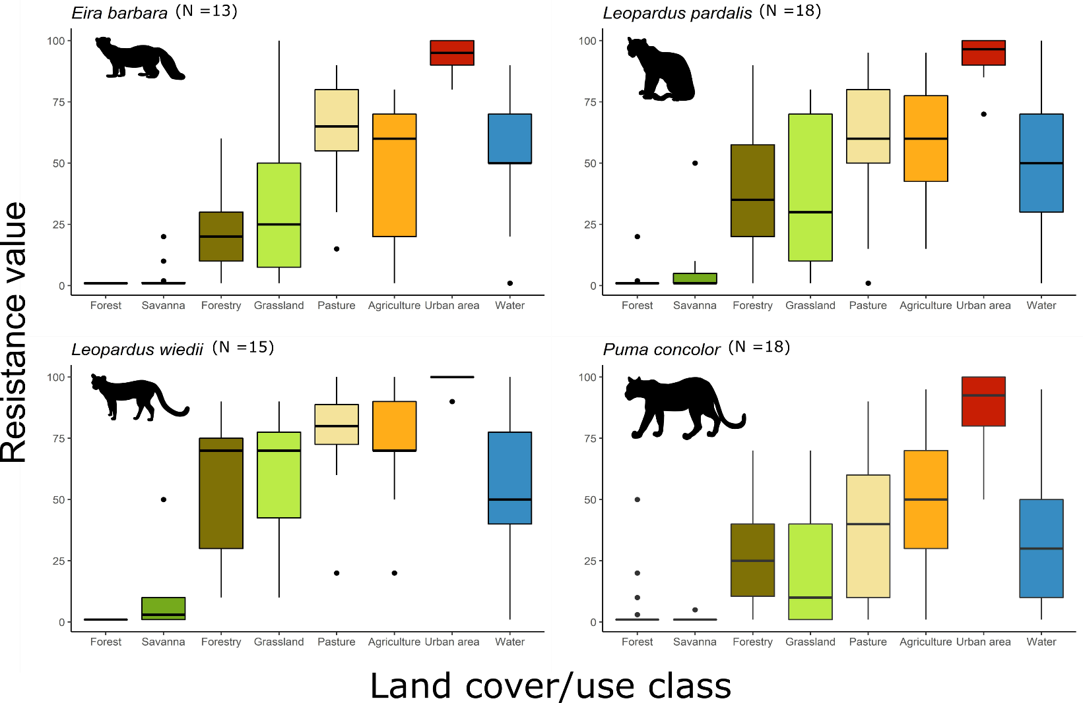

Figure S1. Boxplots of the resistance values assigned for each land cover/use class by 18 carnivore field and research experts. The number of responses by species is identified next to their respective scientific names.
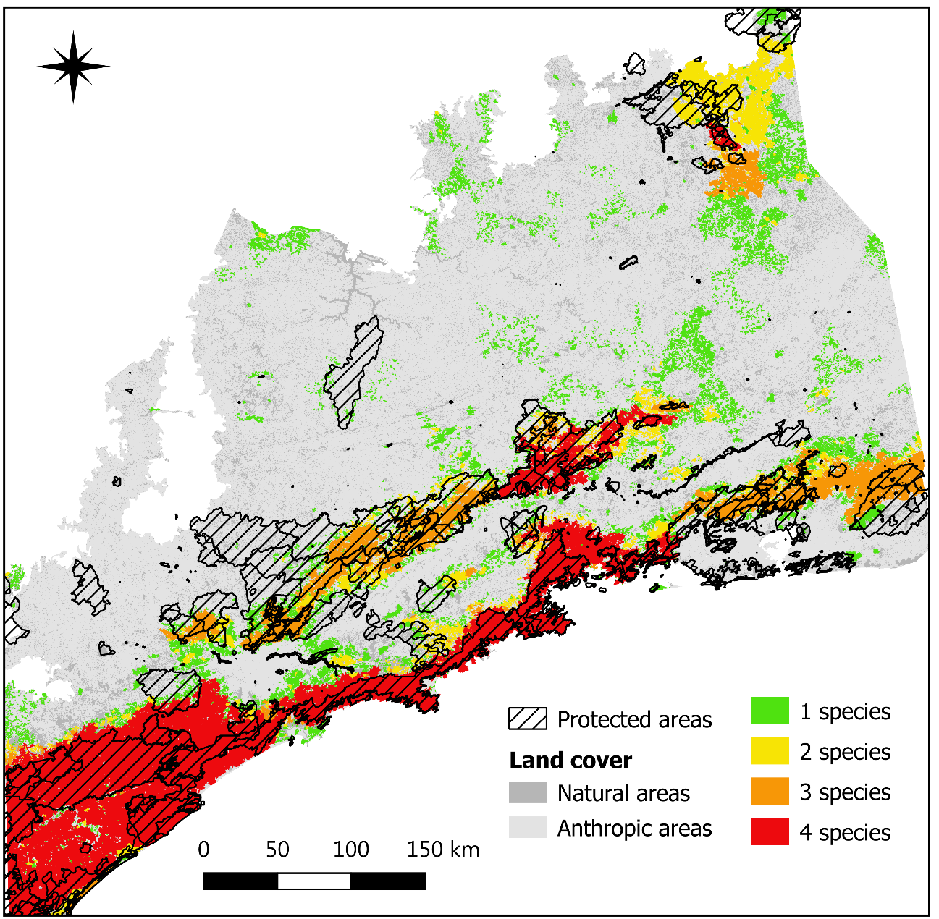
Figure S2. Spatial distributions of source-target (ST) patches among which least-cost routes were simulated. Patch colors indicate the intersection of these areas between the four carnivores. The hatched areas correspond to the Brazilian protected areas of different jurisdictions (municipal, state and federal) and uses (integral protection and sustainable use).

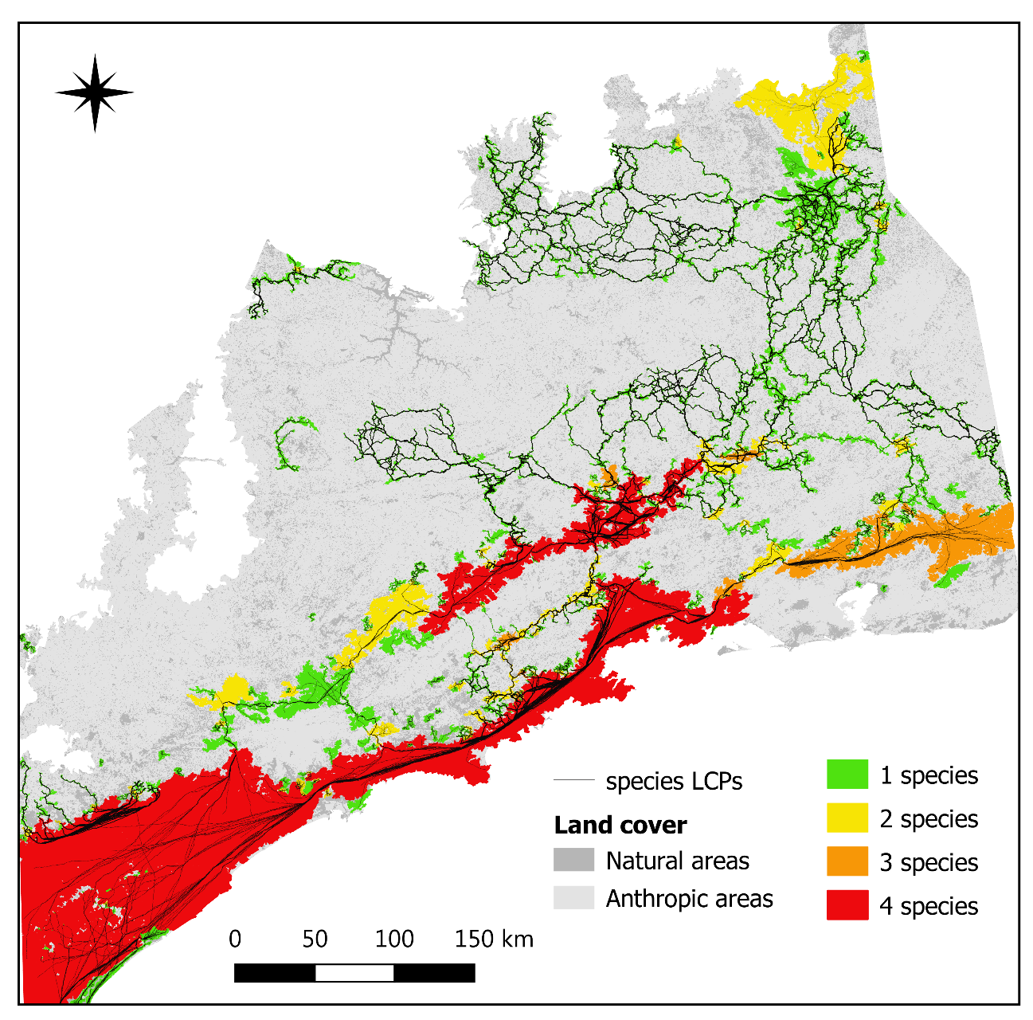

Figure S3. The least-cost routes (black lines) for the four target carnivores and the patches in the study area capable of sustaining the species' trajectories.

APPENDIX B: Supplementary METHODS
Selecting pseudoabsence points for the target species

First, we selected all study sites in Lima et al. (2017) that do not have records of the target species and excluded all points outside their distributional range (IUCN, 2020). Next, we identified the minimum sample effort required to capture each species using all presence data. Then, we defined as points of absence all the sites studied within the species’ range that presented sampling effort equal to or greater than the minimum effort able to detect the species, but that still did not record the species as present. For species in which the proportion between presence and absence data was discrepant (<0.45 or >0.55), we equated the number of points between the two groups by randomly sampling the excess set.

Why did we create resistance surfaces using expert opinion?

Resistance surfaces can be constructed through expert opinion, detection data, relocation data, pathway data or genetic data (Etherington, 2016; Zeller et al., 2012). Although measures of resistance derived from empirical approaches are preferable rather than expert opinion, in some situations this latter approach may be the only one available. We have decided to use expert opinion for two main reasons. First, the absence of other movement data for most species has prevented us from using more refined approaches. In addition, the detection data used here were mostly recorded along forest fragments and using them to construct resistance surfaces could underestimate the importance of matrix for species movement.

Extracting variables from the presence/absence points

After selecting the presence and pseudoabsence points for each species, we used the following strategy to obtain the variables used in the multiple logistic models. First, we identified the year when the presence or pseudoabsence records were obtained (for data that were collected in surveys that lasted more than one year we determined the median of the period as the year of study). We calculated the parameters using the land cover maps at a resolution of 30m from the MapBiomas database (MapBiomas, 2019) corresponding to the year of study for each record. For each occurrence point we established a buffer with a radius of 300 m (equivalent to 10 cells in the raster) and assumed as the focal fragment the one with largest area within the buffer. For each focal patch we accessed the following variables:

- Patch area: the area in hectares of the focal patch
- Climatic and topographic suitability of patch: the average climate and topographic suitability for each focal patch using the information extracted from species distribution models (see the section above).
- Distance to urban infrastructure: the minimum distance in meters between the focal patch edge and the nearest pixel of urban infrastructure (e.g., cities and roads).
- Matrix resistance: resistance offered by the matrix types surrounding the focal forest fragment to the species movement. The matrix resistance index (MRI) was calculated using the following formula:
$$MRI= \frac{Σ(RV_{s}*A_{s})}{A_{b}}$$
where RV_{s} is equal to the resistance value of land cover s; A_{s} is the area occupied by land cover s; and A_{b} is the total area of the buffer around the forest fragment b. The resistance values of land cover types for the movement of each species were attributed based on expert opinion (see the section Assessing species-specific resistance surfaces). The MRI is a modification of the Matrix Permeability Index presented in Goulart et al. (2015); however, instead of using permeability values, we used the median resistance values offered by the land cover types (assigned by the expert to each species). The higher the value of the index, the greater difficulty the species will have in crossing the matrix around the fragment. If the buffer was totally covered by forest (which has cost equal to 1 for all species of this study) or by any other class of landcover with resistance value equal to 1 (the lowest value between the types of landcover surveyed), the MRI value would be equal to 1. In this highly permeable scenario, the movement of individuals would be highly favored by the minimum resistance offered by the environment, and the extent of movement would depend only on their maximum dispersal distance.
- Immediate forest cohesion: a measure of the forest fragments’ physical connectedness in the immediate area to focal patches limited by a buffer extension. The cohesion index varies from 0 to 100, with higher values indicating greater aggregation in the distribution of forest fragments. The cohesion index is equal to 0 if there is a single non-background cell in the buffer.
- Surrounding core area: relative amount of core area habitat (defined from a 1-pixel edge, equivalent to 30m) within a buffer around the focal patch.

Modeling the climatic and topographic suitability

We modeled the climatic and topographic suitability of species by modeling species distribution through an Ecological Niche Model (ENM) that accounted for bioclimatic variables and altitude. We extracted the climatic information for our study region using the 19 bioclimatic and altitude variables available in the WorldClim database (Hijmans et al., 2005). The 19 bioclimatic and altitude variables were reduced into principal components (PCs) of a principal component analysis (PCAs) to overcome collinearity problems and reduce the number of predictive variables. We created an ENM for each species using Maxent, a modeling procedure that only requires presence data to fit the model (Phillips et al., 2006). Among presence-only algorithms, Maxent has a good performance (Elith et al., 2006) and is one of the most used algorithms. For each species, the model was built with species presence points and the PCs. To reduce sampling bias in the presence points we applied the home range size of each species as a geographical filter into the occurrence data, removing excessive points which are close to each other (See de Oliveira et al. 2014). The models were calibrated using 70% of the occurrence points as the training sample, and the remaining 30% as the testing data. Here, we used AUC to evaluate the model. On the one hand, an AUC value of 0.5 indicates that model’s prediction is equal to a random model. On the other hand, AUC values larger than 0.7 are considered accurate, with values between 0.7 and 0.9 indicating moderate models and values larger than 0.9 excellent models in their accuracy power. After running the models, we extracted species mean suitability for each forest patch. This variable represents the suitability of species in each location given the topographic and climatic conditions. The species suitability is then assumed as a predictor variable in the logistic models to give a more complete information of species requirements when predicting species occurrence at landscape scale (Hasui et al., 2017).

Building the logistic models

Because matrix resistance, immediate landscape cohesion, and percentage of surrounding core area are scale dependent, here we explored the spatial scale of species’ response to those variables. Fist, we ran simple logistic regression models in four species-specific scales equivalent to species daily movement distance and 25%, 50%, and 100% of the species’ dispersal distance. Next, we identified the response scale of the variable as the scale that obeyed the largest absolute regression coefficient (e.g., Zeller et al., 2016). The species’ dispersal capacity (Sutherland et al., 2000) as well as the daily movement distance (Carbone et al., 2005) were derived from allometric relationships using body mass (Smith et al., 2003) and diet (Wilman et al., 2014).

Finally, we developed a multiple logistic regression models for each species using as predictors the independent and the scale-dependent variables at their respective response scale. Because small sample sizes can bias model building with multiple parameters, here we restricted the maximum number of variables in the final models to three. For each species, we performed all possible combinations of three predictors using the six variables. To control the potential spatial dependence, we build buffers at all presence points for each species with a radius equivalent to that obtained by the species home rage arranged in a circular shape (Table 1) and exclude all points that intersect (e.g., Ashrafzadeh et al., 2020). To control high collinearity, we verified the correlation between the parameters using Pearson correlation test and retained only poorly correlated variables (r < 0.7). We compared the different models used to predict species occurrence through the Akaike Information Criterion corrected for small sample sizes (AICc).

We used the best model in predictive accuracy to estimate the species occurrence probability along the forest patches. Due to the large number of small habitat patches in the study area, we arbitrarily limited the models’ prediction to forest patches with area equal to or greater than 10 ha (N = 29,900). It is important to highlight, however, that we considered a minimum area of ​​1 ha (N = 214,361 patches) on the resistance surface to execute the connectivity model, since species with more extreme movement capabilities (tayra and cougar) were recorded in fragments of this size (Canale et al., 2012). The final probability map was truncated based on a threshold where the receiver operator curve (ROC) is closest to the perfect fit. We evaluated the performance of the predictions using area under the Total Operating Characteristic curve and the rate of overlap between patches with predicted occurrences and independent records (since 2000) in the Global Biodiversity Information Facility (GBIF) and Souza et al. (2019). To verify the overlap, we buffered the test records with radii equivalent to half the daily movement capacity of the respective species.

References

Antonio De La Torre, J., Núñez, J.M., Medellín, R.A., 2017. Spatial requirements of jaguars and pumas in Southern Mexico. Mamm. Biol. https://doi.org/10.1016/j.mambio.2017.01.006
Ashrafzadeh, M.R., Khosravi, R., Adibi, M.A., Taktehrani, A., Wan, H.Y., Cushman, S.A., 2020. A multi-scale, multi-species approach for assessing effectiveness of habitat and connectivity conservation for endangered felids. Biol. Conserv. 245, 108523. https://doi.org/10.1016/j.biocon.2020.108523
Canale, G.R., Peres, C.A., Guidorizzi, C.E., Gatto, C.A.F., Kierulff, M.C.M., 2012. Pervasive defaunation of forest remnants in a tropical biodiversity hotspot. PLoS One 7. https://doi.org/10.1371/journal.pone.0041671
Carbone, C., Cowlishaw, G., Isaac, N.J.B., Rowcliffe, J.M., 2005. How Far Do Animals Go? Determinants of Day Range in Mammals. Am. Nat. 165, 290–297. https://doi.org/10.1086/426790
da Silva, L.G., Ribeiro, M.C., Hasui, É., da Costa, C.A., da Cunha, R.G.T., 2015. Patch size, functional isolation, visibility and matrix permeability influences neotropical primate occurrence within highly fragmented landscapes. PLoS One 10, e0114025. https://doi.org/10.1371/journal.pone.0114025
de Oliveira, G., Rangel, T.F., Lima-Ribeiro, M.S., Terribile, L.C., Diniz-Filho, J.A.F., 2014. Evaluating, partitioning, and mapping the spatial autocorrelation component in ecological niche modeling: a new approach based on environmentally equidistant records. Ecography (Cop.). 37, 637–647. https://doi.org/10.1111/j.1600-0587.2013.00564.x
Dillon, A., Kelly, M.J., 2008. Ocelot home range, overlap and density: comparing radio telemetry with camera trapping. J. Zool. 275, 391–398. https://doi.org/10.1111/j.1469-7998.2008.00452.x
Elith, J., H. Graham, C., P. Anderson, R., Dudík, M., Ferrier, S., Guisan, A., J. Hijmans, R., Huettmann, F., R. Leathwick, J., Lehmann, A., Li, J., G. Lohmann, L., A. Loiselle, B., Manion, G., Moritz, C., Nakamura, M., Nakazawa, Y., McC. M. Overton, J., Townsend Peterson, A., J. Phillips, S., Richardson, K., Scachetti-Pereira, R., E. Schapire, R., Soberón, J., Williams, S., S. Wisz, M., E. Zimmermann, N., 2006. Novel methods improve prediction of species’ distributions from occurrence data. Ecography (Cop.). 29, 129–151. https://doi.org/10.1111/j.2006.0906-7590.04596.x
Emmos, L.H., 1997. Neotropical rainforest mammals: a field guide, 2nd ed.
Etherington, T.R., 2016. Least-Cost Modelling and Landscape Ecology: Concepts, Applications, and Opportunities. Curr. Landsc. Ecol. Reports 1–14. https://doi.org/10.1007/s40823-016-0006-9
Hasui, É., Silva, V.X., Cunha, R.G.T., Ramos, F.N., Ribeiro, M.C., Sacramento, M., Coelho, M.T.P., Pereira, D.G.S., Ribeiro, B.R., 2017. Additions of landscape metrics improve predictions of occurrence of species distribution models. J. For. Res. 1–12. https://doi.org/10.1007/s11676-017-0388-5
Hendriks, A.J., Willers, B.J.C., Lenders, H.J.R., Leuven, R.S.E.W., 2009. Towards a coherent allometric framework for individual home ranges, key population patches and geographic ranges. Ecography (Cop.). 32, 929–942. https://doi.org/10.1111/j.1600-0587.2009.05718.x
Hijmans, R.J., Cameron, S.E., Parra, J.L., Jones, P.G., Jarvis, A., 2005. Very high resolution interpolated climate surfaces for global land areas. Int. J. Climatol. 25, 1965–1978. https://doi.org/10.1002/joc.1276
IUCN, 2020. The IUCN red list of threatened Species [WWW Document]. URL http://www.iucnredlist.org/
Kasper, C.B., Schneider, A., Oliveira, T.G., 2016. Home range and density of three sympatric felids in the Southern Atlantic Forest, Brazil. Braz. J. Biol 76, 228–232. https://doi.org/10.1590/1519-6984.19414
Lima, F., Beca, G., Muylaert, R.L., Jenkins, C.N., Perilli, M.L.L., Paschoal, A.M.O., Massara, R.L., Paglia, A.P., Chiarello, A.G., Graipel, M.E., Cherem, J.J., Regolin, A.L., Oliveira Santos, L.G.R., Brocardo, C.R., Paviolo, A., Di Bitetti, M.S., Scoss, L.M., Rocha, F.L., Fusco-Costa, R., Rosa, C.A., Da Silva, M.X., Hufnagell, L., Santos, P.M., Duarte, G.T., Guimarães, L.N., Bailey, L.L., Rodrigues, F.H.G., Cunha, H.M., Fantacini, F.M., Batista, G.O., Bogoni, J.A., Tortato, M.A., Luiz, M.R., Peroni, N., De Castilho, P. V., Maccarini, T.B., Filho, V.P., Angelo, C. De, Cruz, P., Quiroga, V., Iezzi, M.E., Varela, D., Cavalcanti, S.M.C., Martensen, A.C., Maggiorini, E. V., Keesen, F.F., Nunes, A. V., Lessa, G.M., Cordeiro-Estrela, P., Beltrão, M.G., De Albuquerque, A.C.F., Ingberman, B., Cassano, C.R., Junior, L.C., Ribeiro, M.C., Galetti, M., 2017. ATLANTIC-CAMTRAPS: a dataset of medium and large terrestrial mammal communities in the Atlantic Forest of South America. Ecology 98, 2979–2979. https://doi.org/10.1002/ecy.1998
MapBiomas, 2019. Projeto MapBiomas – Coleção 4.0 da Série Anual de Mapas de Cobertura e Uso de Solo do Brasil [WWW Document]. URL http://mapbiomas.org/ (accessed 11.2.19).
Phillips, S.J., Anderson, R.P., Schapire, R.E., 2006. Maximum entropy modeling of species geographic distributions. Ecol. Modell. 190, 231–259. https://doi.org/10.1016/j.ecolmodel.2005.03.026
Smith, F.A., Lyons, S.K., Ernest, S.K.M., Jones, K.E., Kaufman, D.M., Dayan, T., Marquet, P.A., Brown, J.H., Haskell, J.P., 2003. Body mass of late Quaternary mammals. Ecology 84, 3403–3403. https://doi.org/10.1890/02-9003
Souza, Y., Gonçalves, F., Lautenschlager, L., Akkawi, P., Mendes, C., Carvalho, M.M., Bovendorp, R.S., Fernandes‐Ferreira, H., Rosa, C., Graipel, M.E., Peroni, N., Cherem, J.J., Bogoni, J.A., Brocardo, C.R., Miranda, J., Zago da Silva, L., Melo, G., Cáceres, N., Sponchiado, J., Ribeiro, M.C., Galetti, M., 2019. <scp>ATLANTIC MAMMALS</scp> : a data set of assemblages of medium‐ and large‐sized mammals of the Atlantic Forest of South America. Ecology 100. https://doi.org/10.1002/ecy.2785
Sutherland, G.D., Harestad, A.S., Price, K., Lertzman, K.P., 2000. Scaling of natal dispersal distances in terrestrial birds and mammals. Ecol. Soc. 4. https://doi.org/16\nArtn 16
Verboom, J., Foppen, R., Chardon, P., Opdam, P., Luttikhuizen, P., 2001. Introducing the key patch approach for habitat networks with persistent populations : an example for marshland birds 100.
Wilman, H., Belmaker, J., Simpson, J., de la Rosa, C., Rivadeneira, M.M., Jetz, W., 2014. EltonTraits 1.0: Species-level foraging attributes of the world’s birds and mammals. Ecology 95, 2027–2027. https://doi.org/10.1890/13-1917.1
Zeller, K.A., McGarigal, K., Cushman, S.A., Beier, P., Vickers, T.W., Boyce, W.M., 2016. Using step and path selection functions for estimating resistance to movement: pumas as a case study. Landsc. Ecol. 31, 1319–1335. https://doi.org/10.1007/s10980-015-0301-6
Zeller, K.A., McGarigal, K., Whiteley, A.R., 2012. Estimating landscape resistance to movement: a review. Landsc. Ecol. 27, 777–797. https://doi.org/10.1007/s10980-012-9737-0

