SUPPLEMENTARY DATA
Predicting the invasion of the acoustic niche: Potential distribution and call transmission efficiency of a newly introduced frog in Cuba

Sergio L. del Castillo Domínguez^{1,2}, Carlos A. Mancina González¹, Evelyn Bandera Fernández³, Leneidy Pérez Pelea³, Frank Cézilly⁴, and Roberto Alonso Bosch^{5*}

¹ Centro Nacional de Biodiversidad. Instituto de Ecología y Sistemática. La Habana, Cuba
² Caribaea Initiative, Université des Antilles, Guadeloupe
³Departamento de Biología Vegetal, Facultad de Biología, Universidad de La Habana. La Habana, Cuba
⁴ UMR CNRS 6282 Biogéosciences, Université de Bourgogne-Franche Comté, Dijon, France
⁵ Museo de Historia Natural “Felipe Poey”, Facultad de Biología, Universidad de La Habana. La Habana, Cuba
* Corresponding author:
E-mail: ralonso@fbio.uh.cu; alonsobosch1973@gmail.com
http://orcid.org/0000-0001-7804-8897

Appendix S1 Design of the audio file for the sound propagation experiment

The audio file for the experiment was designed using the software Adobe Audition CC 6.0 (Compilation 732, 64 bits). The 3-min long playback (44100 Hz and 16 bit) included sequences of pure tones of 1 kHz, and a series of three different stimuli: consecutive calls of one male, vocal interaction between two males, and a chorus of L. fragilis (Fig. S1). The sequence started with 10 s of silence, followed by 10 s of pure tone, and then again 10 s of silence, followed by 30s of the consecutive calls (Fig. S1), which included 35 advertisement calls of one male with call duration of 0.199 s, dominant frequency of 1597.2 Hz, and amplitude of 26800μ. The second part of the playback had the same structure of silence-pure tone-silence, and the interaction between two males lasting for 30s (Fig. S1), a dominant frequency of 2067.2 Hz and an amplitude of 32768μ. The sequence continued with silence-pure tone and silence and ended with a 30s-long chorus of the species (Fig 2), dominant frequency of 1808.8 Hz and amplitude of 32249μ. Sound pressure level (SPL) was standardized for all the stimuli at 0.5 m from the source.
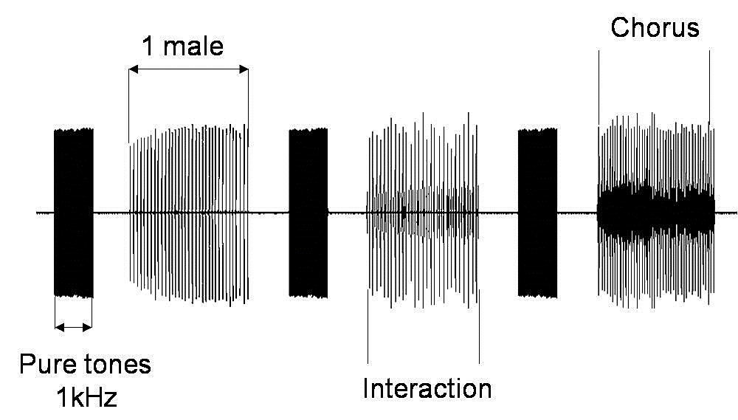
Figure S1. Structure of the sequence used on the sound propagation experiments of signals of Leptodactylus fragilis broadcasted at six localities of Peltophryne empusa distribution range

Appendix S2. Relative contributions and permutation importance of the bioclimatic variables

Table S1. Estimates of relative contributions and permutation importance of the six bioclimatic variables (bio) selected to build the ecological niche model for Leptodactylus fragilis.
Bioclimatic variables | Percent contribution | Permutation importance
Min. temperature of coldest month (bio 6) | 46.4 | 31.2
Temperature seasonality (bio 4) | 31 | 35.5
Mean diurnal range (bio 2) | 13.7 | 12.8
Precipitation of driest quarter (bio 17) | 3.7 | 14.4
Precipitation seasonality (bio 15) | 3.3 | 1.8
Annual precipitation (bio 12) | 2 | 4.4

Appendix S3. Results of statistical analysis of the signal degradation of the advertisement calls of Leptodactylus fragilis in six localities of western Cuba.
Table S2. Results of statistical analysis of the signal degradation of the advertisement calls (one male and interaction between males) of Leptodactylus fragilis in six localities of western Cuba. For each acoustic parameter, we show the results of two-way Analysis of Variance, in a generalized linear mixed model with PROC GLIMMIX,
Type III Tests of Fixed Effects
Dominant frequency (DF) of one male call
Effect | Num DF | Den DF | F Value | Pr > F
Dist | 4 | 270 | 36.31 | <.0001
Loc | 5 | 270 | 214.20 | <.0001
Dist*Loc | 20 | 270 | 9.36 | <.0001
Dominant frequency (DF) of interaction between males
Dist | 4 | 270 | 9.30 | <.0001
Loc | 5 | 270 | 352.29 | <.0001
Dist*Loc | 20 | 270 | 3.51 | <.0001
Call duration (CD) of one male call
Dist | 4 | 270 | 14.83 | <.0001
Loc | 5 | 270 | 2.68 | 0.0218
Dist*Loc | 20 | 270 | 1.46 | 0.0960
Call duration (CD) of interaction between males
Dist | 4 | 270 | 3.47 | 0.0087
Loc | 5 | 270 | 0.46 | 0.8027
Dist*Loc | 20 | 270 | 0.23 | 0.9998
Number of pulses (NP) of one male call
Dist | 4 | 270 | 160.31 | <.0001
Loc | 5 | 270 | 53.76 | <.0001
Dist*Loc | 20 | 270 | 17.12 | <.0001
Number of pulses (NP) of interaction between males
Dist | 4 | 270 | 38.48 | <.0001
Loc | 5 | 270 | 11.16 | <.0001
Dist*Loc | 20 | 270 | 3.15 | <.0001

Appendix S4. Summary of the results of sound propagation experiments showing the variation in three acoustic features of advertisement calls of one single male of Leptodactylus fragilis at five distances from the loudspeaker in six known localities of Peltophryne empusa distribution.
Figure S2. Summary of the results of sound propagation experiments showing the variation in three acoustic features of advertisement calls of one single male of Leptodactylus fragilis at five distances from the loudspeaker in six known localities of Peltophryne empusa distribution. Dominant frequency (a), Call duration (b) Number of pulses (c). Localities: Forest in Parque Metropolitano of Havana city (filled squares), Open area in Parque Metropolitano of Havana city (open squares), Campo Florido (filled triangles), Colony (filled circles), Nueva Gerona (open circles), Sandino (open triangles). For each locality means and standard errors are shown. Temperature: 21.8˚C; Humidity: 62.7%.

Appendix S5. Summary of the results of sound propagation experiments showing the variation in three acoustic features of advertisement calls of one interaction between males of Leptodactylus fragilis at five distances from the loudspeaker in six known localities of Peltophryne empusa distribution.

Figure S3. Summary of the results of sound propagation experiments showing the variation in three acoustic features of advertisement calls of one interaction between males of Leptodactylus fragilis at five distances from the loudspeaker in six known localities of Peltophryne empusa distribution. Dominant frequency (a), Call duration (b) Number of pulses (c). Localities: Forest in Parque Metropolitano of Havana city (filled squares), Open area in Parque Metropolitano of Havana city (open squares), Campo Florido (filled triangles), Colony (filled circles), Nueva Gerona (open circles), Sandino (open triangles). For each locality, means and standard errors are shown. Temperature: 21.8˚C; Humidity: 62.7%.

Appendix S6. Results of statistical analysis of the Excess of Attenuation of the advertisement calls of Leptodactylus fragilis in six localities of western Cuba
Table S3. Results of statistical analysis of the Excess of Attenuation of the advertisement calls of Leptodactylus fragilis in six localities of western Cuba. For each acoustic parameter, we show the results of two-way Analysis of Variance, in a generalized linear mixed model with PROC GLIMMIX, and Tukey-Kramer adjusted multiple comparison tests between all levels. Statistical results for two analyzed distances are shown.
Type III Tests of Fixed Effects
Distance 0.5-1.0m
Effect | Num DF | Den DF | F Value | Pr > F
Seq | 2 | 162 | 3.94 | 0.0214
Loc | 5 | 162 | 43.78 | <.0001
Seq*Loc | 10 | 162 | 3.67 | 0.0002
Distance 0.5-2.0m
Seq | 2 | 81 | 0.27 | 0.7614
Loc | 2 | 81 | 39.86 | <.0001
Seq*Loc | 4 | 81 | 3.76 | 0.0074

