Supplementary Information
Methods
To assess opinions and perceptions about the opportunities, unintended consequences, and potentialities of OECMs for the achievement of Aichi Target 11 and biodiversity conservation we applied semi-structured interviews with experts. We define experts as individuals who have specialized knowledge and who hold information about a certain area of knowledge that may have been acquired through training, research or personal experience (Burgman et al., 2011; Martin et al., 2018). Usually semi-structured interviews are useful for eliciting perceptions, judgments and sensitive information from a wide range of stakeholders, and rather than trying to achieve consensus, expert elicitation may aid decision-making by emphasizing different opinions within an expert community that may not have been discussed widely yet (Newing, 2011).
Our sampling technique consisted of key informant sampling followed by the snowball method. We initially actively searched for experts who were well informed about the topics related to this research. Criteria included demonstrated expertise and involvement in research or development of projects in the topic of AT11, particularly related to other effective area-based conservation measures (OECMs). Around 60 experts that contributed directly to the development of research, discussions or projects related to OECMs and that were found in peer-review articles, grey literature, conference participant lists, and project participants were selected. Out of those, we targeted the ones from different backgrounds, countries, and types of institutions to avoid biases and to assure a wide range of perspectives were gathered. We conducted an online review of each person’s resume and their publications to ensure they met our criteria. Thirty-eight people were contacted through email. In addition to this active search, we asked each interviewee to suggest names of relevant experts in the area. If not yet in the list, these were added and contacted.
During the interview process we have made a saturation analysis to identify whether collection of more data was producing new important information that was relevant to the work (Newing, 2011; Figure S1). When no additional data is being found, theoretical saturation has been reached (Glaser and Strauss 1967; Newing, 2011). Information was grouped into “concepts” (e.g. Key Biodiversity Areas in a monitoring context; recognition; connectivity) (Table S1). We are aware, however, that we may not have captured all potential views in the topic: even though interviewees had different viewpoints, most are based either in Europe or North America, and thus were representing viewpoints from the Global North predominantly. Most of the interviewees representing the Global South were based in Brazil and South Africa. This geographic bias may have limited context-specific information. Yet, it is important to emphasize that stakeholders interviewed in this research are a sample of the stakeholders currently involved in discussions in the area (predominantly men from the Global North).
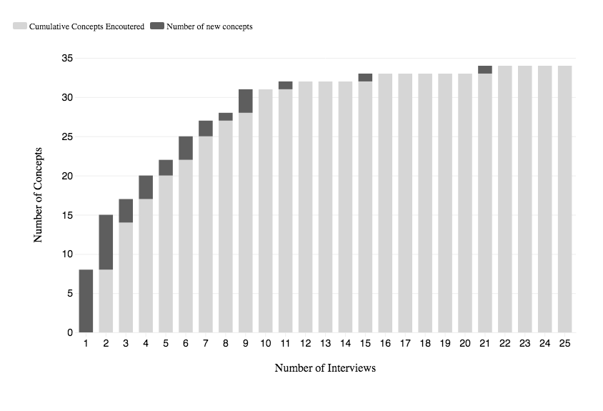
Figure S1. Cumulative number of concepts mentioned according to the number of interviews. Light grey is the cumulative number of concepts encountered, and dark grey is the number of new concepts.

Table S1. List of new concepts mentioned per interview.
Interview number | New concepts
1 | Recognition of areas
 | Effectiveness
 | Monitoring
 | Representativeness
 | Reporting
 | Equity
 | Biodiversity conservation
 | Governance
2 | Inclusion of OECMs in the target
 | Trade-off OECM vs protected areas
 | Indicators
 | Breaks “high and far” protected areas pattern
 | Guidelines
 | Land use prioritization
 | Ecosystem services
3 | Connectivity
 | Restoration
4 | Percentage element of the target
 | Qualitative element of the target
 | Half-Earth/Whole Earth
5 | Privately Protected Areas
 | National Biodiversity Strategies and Action Plans (NBSAP)
6 | Funding
 | Enforcement
 | Complement Protected Areas
7 | “Raise/reduce the bar” in conservation
 | Integrated network of area-based measures
8 | Key Biodiversity Areas (KBA)
9 | Context specificity
 | Godhart´s Law
 | Outcome oriented target
10 | None
11 | Ecosystem services
12 | None
13 | None
14 | None
15 | Protected Area downgrading, downsizing and degazettement (PADDD)
16 | None
17 | None
18 | None
19 | None
20 | None
21 | Regulatory mechanisms
22 | None
23 | None
24 | None
25 | None
26 | None
In total, twenty-six experts (19 men and 7 women) from the civil society (n = 9), academia (n = 4), government (n = 4), intergovernmental organizations (n = 4) and experts outside these categories (“other”; n = 5) were interviewed in person (n = 9) and via Skype or telephone (n = 17). The category “other” included experts that have been working in more than one type of environment. For instance, someone who has worked at the CBD, but that has also connections with governments and the academia; or works in academia and in non-governmental organizations. Interviews took approximately 1hr (the shortest took 35 minutes and the longest took 2h30).
Semi-structured interviews with open questions do not require a strict list of questions, or a fixed order of questions to be asked. Rather, semi-structured interviews are based on a wide range of interest topics that can or cannot be applied depending on the dynamics of the interview, and on the expert knowledge (Newing, 2011). Therefore, we have developed a set of questions that covered all the necessary topics of this research, and selected questions were applied to different experts. Questions related to the following themes: role of oecms; ecological representativeness; effectiveness and monitoring; indicators; equity, ecosystem services; connectivity; management and governance; long term; pitfalls and challenges; opportunities; post 2020. Three pilot interviews were made, after which we have adjusted the questionnaire and some new questions were included.
Interviews were conducted either in English or in Portuguese, and were either audio-recorded or written, according to the expert’s will. If audio-recorded, the interview was transcribed manually. All the responses were coded into three main themes, which were defined prior to the interviews: opportunities of OECMs, unintended consequences, and recommendations for the Post 2020. Ethical clearance was obtained (Reference Number 2.840.036 Plataforma Brasil), and we did not disclose information that allows experts to be associated to their responses.

References
Burgman M., Carr A., Godden L., Gregory R., Mcbride M., Flander L. & Maguire L. (2011) Redefining expertise and improving ecological judgment. Conservation Letters 4: 81-87
CBD. (2018). Decision adopted by the conference of the parties to the Convention on Biological Diversity: Protected Areas and other effective area-based measures (pp. 1-19). Sharm El-Sheikh, Egypt.
Charmaz K. (2006) Constructing Grounded Theory: A Practical Guide Through Qualitative Analysis. Thousand Oaks, California: Sage Publications Ltd
Glaser, B.G. and Strauss, A.L. (1967). The discover of grounded theory: Strategies of qualitative research. Rutgers-The State University, New Jersey ISBN: 0-202-30260-1 Printed in the United States of America.
Martin T. G., Burgman M. A., Fidler F., Kuhnert P. M., Low-choy S., Mcbride M., Mengersen K., Martin T. G., Burgman M. A., Fidler F., Д P. M. K., Low-choy S., Mcbride M. & Mengersentt K. (2018) Eliciting Expert Knowledge in Conservation Science. Conservation Biology 26: 29-38
Newing H. (2011) Conducting Research in Conservation. Social science methods and practice. ed. H. Newing London, UK and New York, USA: Routledge. Taylor and Francis Group

