**Appendix 3.** Results of the multiple regressions between species richness and land use classes, and a schematic illustration of the statistical analyses and the basic outputs from the Hierarchical Modelling of Species Communities (HMSC).

|  |  |  |  |
| --- | --- | --- | --- |
| **Table S4.** Coefficient of determination (adjusted R²) and their significance of multiple regressions between species richness of the 96 assemblages of medium- and large-sized mammals of the Atlantic Forest, Brazil, and land use classes calculated in different buffer sizes (see Appendix 1, and Appendix 2 – Tables S1 and S2). | | | |
| **Buffer radius (km)** | **Adjusted R²** | **F-statistic** | **p-value** |
| **0.5** | 0.35 | 15.96 | < 0.001 |
| **1** | 0.40 | 20.05 | < 0.001 |
| **2** | 0.41 | 20.33 | < 0.001 |
| **5** | 0.32 | 14.36 | < 0.001 |
| **10** | 0.23 | 9.379 | < 0.001 |

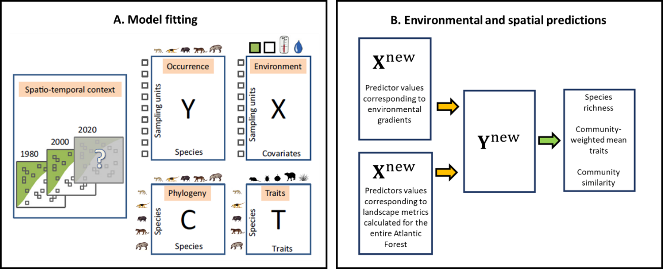

**Figure S2.** A schematic illustration of the statistical analyses performed by the Hierarchical Modelling of Species Communities (HMSC). Panel A [adapted from Ovaskainen et al. (2017)] illustrates that we fitted the HMSC to model species assemblages (the Y matrix) as a function of landscape metrics (the X matrix) and the spatial locations of the studies (the spatio-temporal context of the study). We estimated the responses of the species to environmental variation based on their traits, such as the ecological functions (the T matrix), but did not include phylogenetic information due to the small number of species included. Panel B illustrates that we used the fitted model (orange arrows) to generate simulated assemblages of medium- and large-sized mammals over the environmental gradients and to extrapolate the results for the entire Atlantic Forest, which simulated assemblages we further summarized (green arrow) in terms of species richness, community-weighted mean traits, and community similarity.

C:\LocalData\ovaskain\all stuff\manuscripts\Submitted\Marcelo Magioli\results\R2T-sample.tiff

**Figure S3.** The explanatory powers of the HMSC models for each of the included species. Each dot corresponds to one species, the x-axis shows the commonness of the species in terms of its average occurrence probability (fraction of occupied sampling units), and the y-axis shows the explanatory power in units of Tjur (2009) R2.



**Figure S4.** Decay in mammal assemblages’ similarity considering only the distance between study areas (red), and considering the distance between study areas and accounting for landscape structure (blue).



**Figure S5.** Estimates of species-to-species associations measured by residual correlation between pair species showing a positive (red) or negative (blue) association with a 95% posterior probability.



Latitude

Longitude

**Figure S6.** Regions of common profile grouped considering the similarity in assemblages’ composition. Dots with the same color represent assemblages with similar species composition.

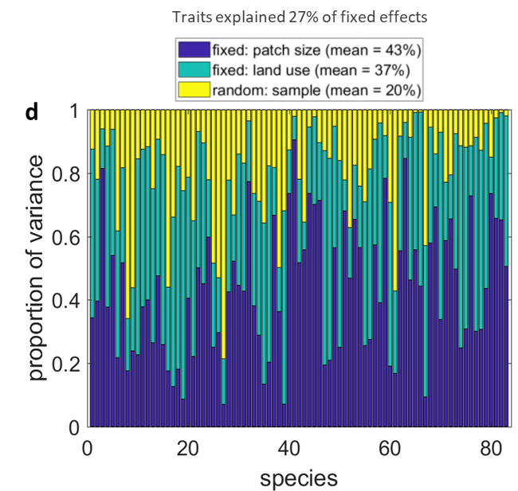

**Figure S7.** Variation in species occurrence partitioned by responses to patch size and landscape structure (percentages of forest cover, pasture, mixed land use, and urban areas), and random effects. Traits explained 27% of fixed effects.

**Reference**

Ovaskainen, O., Tikhonov, G., Norberg, A., Blanchet, F. G., Duan, L., Duan, L., Dunson, D., Roslin, T., Abrego, N. 2017. How to make more out of community data? A conceptual framework and its implementation as models and software. Ecol. Lett. 20, 561-576.

Tjur, T. 2009. Coefficients of Determination in Logistic Regression Models—A New Proposal: The Coefficient of Discrimination. Am. Stat. 6, 366-372.