Supplementary Material
(Perspectives in Ecology and Conservation)

Conservation biology: four decades of problem- and solution-based research
Carlos Roberto Fonseca^{a,*}, Gustavo B. Paternoª, Demétrio L. Guadagnin^{b}, Eduardo M. Venticinqueª, Gerhard E. Overbeck^{c}, Gislene Ganadeª, Jean Paul Metzger^{d}, Johannes Kollmann^{e}, Johannes Sauer^{e,f}, Márcio Zikán Cardosoª, Priscila F. M. Lopesª, Rafael Oliveira^{g}, Valério D. Pillar^{b} and Wolfgang W. Weisser^{e}

ª Departamento de Ecologia, Universidade Federal do Rio Grande do Norte, Natal, 59072-970, Brazil
^{b} Departamento de Ecologia, Universidade Federal do Rio Grande do Sul, Porto Alegre, 91501-970, Brazil
^{c} Departamento de Botânica, Universidade Federal do Rio Grande do Sul, Porto Alegre, 91501-970, Brazil
^{d} Departamento de Ecologia, Universidade de São Paulo, São Paulo, 05508-900, Brazil
^{e} Department of Life Science Systems, School of Life Sciences, Technical University of Munich, 85350 Freising, Germany
^{f} Chair for Production and Resource Economics, School of Management, Technical University of Munich, 85350 Freising, Germany
^{g} Departamento de Biologia Vegetal, Universidade Estadual de Campinas, Campinas, 13083-862, Brazil

Corresponding author: Carlos Roberto Fonseca, Departamento de Ecologia, Universidade Federal do Rio Grande do Norte, Natal, 59072-970, Brazil; Phone: +55 84 991131324, Email: fonseca.crsd@gmail.com

This Supplementary Material contains:
Figure S1–S5
Table S1–S5

Table S1. Alternative conservation biology models of the increase of the solution-to-problem ratio along 40 years (z-transformed) in the conservation biology literature (all drivers together, all): lin, linear model; wlin, weighted linear model; lin.tac, linear model adjusted for temporal autocorrelation; wlin.tac, weighted linear model adjusted for temporal autocorrelation; exp, exponential model; wexp, weighted exponential model; exp.tac, exponential model adjusted for temporal autocorrelation; and wexp.tac, weighted exponential model adjusted for temporal autocorrelation. The estimates of the intercept (a) and the slope (b), their standard error (se), t-value (t) and associated probabilities are provided. For each model, degrees of freedom (df), logLik, AICc, delta AICc (delta), and model weight (w) are provided. The best model (wexp, ∆AICc = 0) is highlighted in bold, but wexp.tac was also selected as an adequate model (∆AICc < 2).
Model | Coef. | Estimate | se | t | P | df | logLik | AICc | ∆AICc | w
lin.all | a | 0.25353 | 0.01626 | 15.593 | <0.0001 | 3 | 28.479 | -50.3 | 40.56 | 0.000
 | b | 0.12511 | 0.01647 | 7.595 | <0.0001
wlin.all | a | 0.23798 | 0.01644 | 14.475 | <0.0001 | 3 | 31.669 | -56.7 | 34.18 | 0.000
 | b | 0.15432 | 0.01598 | 9.658 | <0.0001
lin.tac.all | a | 0.25368 | 0.02051 | 12.370 | <0.0001 | 4 | 29.345 | -49.5 | 41.32 | 0.000
 | b | 0.12826 | 0.02030 | 6.319 | <0.0001
wlin.tac.all | a | 0.24699 | 0.03210 | 7.694 | <0.0001 | 4 | 37.593 | -66.0 | 24.82 | 0.000
 | b | 0.15768 | 0.02911 | 5.417 | <0.0001
exp.all | a | 0.21778 | 0.01792 | 12.151 | <0.0001 | 3 | 38.139 | -69.6 | 21.24 | 0.000
 | b | 0.55356 | 0.07200 | 7.688 | <0.0001
wexp.all | a | 0.19780 | 0.01402 | 14.112 | <0.0001 | 3 | 48.759 | -90.8 | 0.00 | 0.679
 | b | 0.63874 | 0.05601 | 11.405 | <0.0001
exp.tac.all | a | 0.21769 | 0.01803 | 12.071 | <0.0001 | 4 | 38.139 | -67.1 | 23.73 | 0.000
 | b | 0.55404 | 0.07243 | 7.649 | <0.0001
wexp.tac.all | a | 0.19752 | 0.01629 | 12.124 | <0.0001 | 4 | 49.256 | -89.3 | 1.50 | 0.321
 | b | 0.64118 | 0.06450 | 9.941 | <0.0001

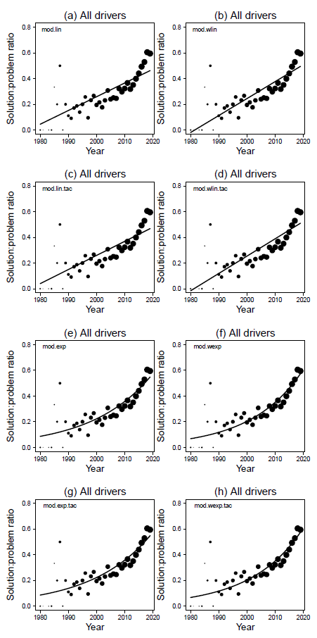
Figure S1. Alternative models on the increase of the solution-to-problem ratio along 40 years in the conservation biology literature (all drivers together): (a) linear model, (b) weighted linear model, (c) linear model adjusted for temporal autocorrelation, (d) weighted linear model adjusted for temporal autocorrelation, (e) exponential model, (f) weighted exponential model, (g) exponential model adjusted for temporal autocorrelation, and (h) weighted exponential model adjusted for temporal autocorrelation. The best model according the Akaike criteria was the weighted exponential model (cf. Table S1).
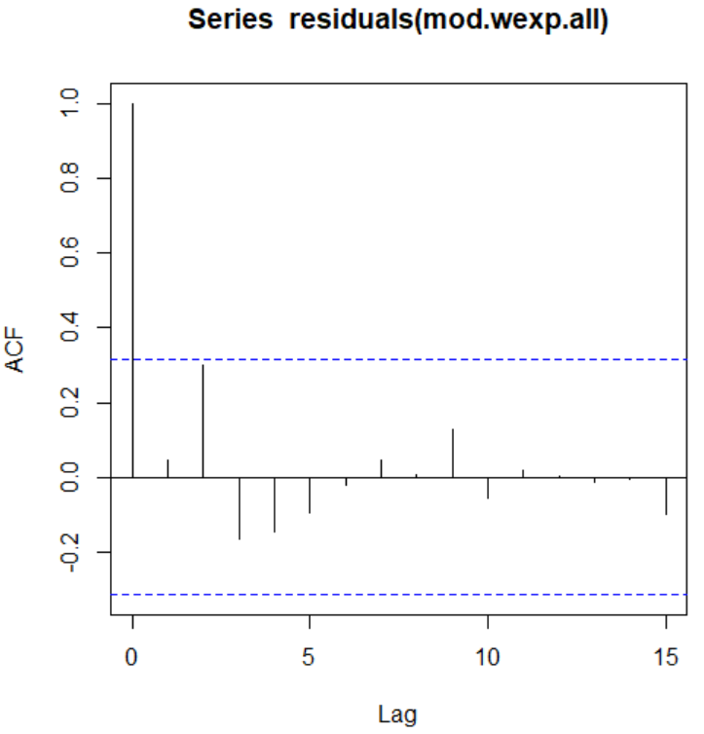
Figure S2. Temporal autocorrelation function plot for the best all drivers model; the weighted exponential regression model (Fig. S1f, Table S1).

Table S2. Alternative habitat fragmentation models of the increase of the solution-to-problem ratio along 40 years (z-transformed) of the habitat fragmentation literature (frag): lin, linear model; wlin, weighted linear model; lin.tac, linear model adjusted for temporal autocorrelation; wlin.tac, weighted linear model adjusted for temporal autocorrelation; exp, exponential model; wexp, weighted exponential model; exp.tac, exponential model adjusted for temporal autocorrelation; and wexp.tac, weighted exponential model adjusted for temporal autocorrelation. The estimates of the intercept (a) and the slope (b), their standard error (se), t-value (t) and associated probabilities are provided. For each model, degrees of freedom (df), logLik, AICc, delta AICc (delta), and model weight (w) are given. The best model (wexp, ∆AICc = 0) is highlighted in bold.
Model | Coef. | Estimate | se | t | P | df | logLik | AICc | ∆AICc | w
lin.frag | a | 0.27394 | 0.02665 | 10.280 | <0.0001 | 3 | 10.425 | -14.1 | 25.84 | 0.000
 | b | 0.10103 | 0.02702 | 3.740 | 0.0007
wlin.frag | a | 0.26079 | 0.02488 | 10.481 | <0.0001 | 3 | 14.542 | -22.4 | 17.60 | 0.000
 | b | 0.12340 | 0.02572 | 4.797 | <0.0001
lin.tac.frag | a | 0.28215 | 0.04615 | 6.114 | <0.0001 | 4 | 12.955 | -16.7 | 23.30 | 0.000
 | b | 0.11227 | 0.04307 | 2.607 | 0.0133
wlin.tac.frag | a | 0.26727 | 0.03985 | 6.706 | <0.0001 | 4 | 16.411 | -23.6 | 16.39 | 0.000
 | b | 0.12770 | 0.03934 | 3.246 | 0.0026
exp.frag | a | 0.24781 | 0.02959 | 8.375 | <0.0001 | 3 | 16.955 | -27.2 | 12.78 | 0.001
 | b | 0.43722 | 0.11074 | 3.948 | 0.0004
wexp.frag | a | 0.22131 | 0.02676 | 8.270 | <0.0001 | 3 | 23.343 | -40.0 | 0.00 | 0.741
 | b | 0.54507 | 0.10304 | 5.289 | <0.0001
exp.tac.frag | a | 0.24907 | 0.04174 | 5.967 | <0.0001 | 4 | 18.135 | -27.0 | 12.94 | 0.001
 | b | 0.45640 | 0.14957 | 3.051 | 0.0043
wexp.tac.frag | a | 0.22171 | 0.03106 | 7.138 | <0.0001 | 4 | 23.343 | -37.8 | 2.12 | 0.257
 | b | 0.54934 | 0.11800 | 4.655 | <0.0001

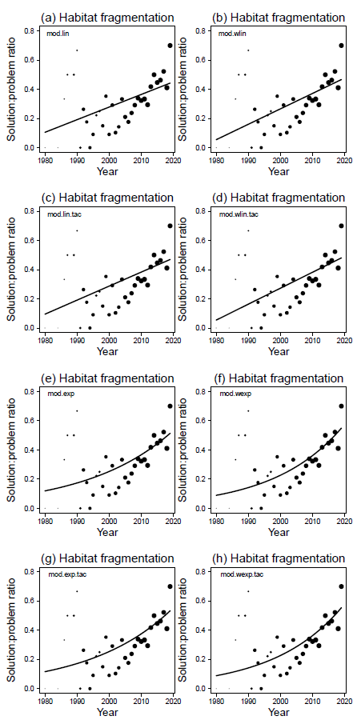
Figure S3. Alternative habitat fragmentation models of the increase of the solution-to-problem ratio along 40 years of the habitat fragmentation literature: (a) linear model, (b) weighted linear model, (c) linear model adjusted for temporal autocorrelation, (d) weighted linear model adjusted for temporal autocorrelation, (e) exponential model, (f) weighted exponential model, (g) exponential model adjusted for temporal autocorrelation, and (h) weighted exponential model adjusted for temporal autocorrelation. The best model according the Akaike criteria was the weighted exponential model (cf. Table S2).
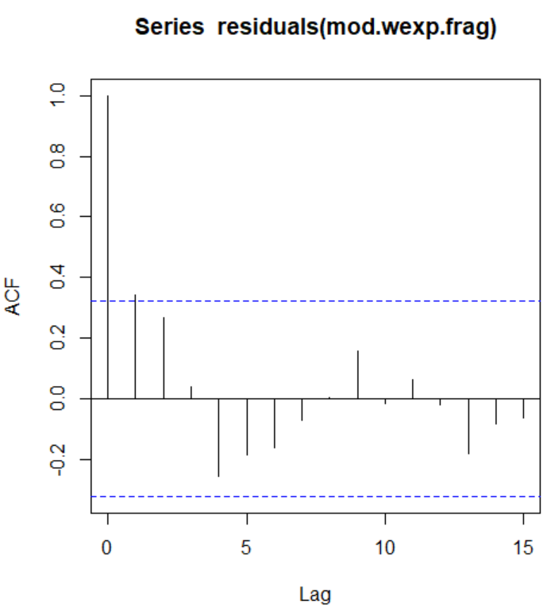

Figure S4. Temporal autocorrelation function plot for the best habitat fragmentation model; the weighted exponential regression model (Fig. S3f, Table S2).

Table S3. Alternative overexploitation models of the increase of the solution-to-problem ratio along 40 years (z-transformed) of the overexploitation literature (expl). lin, linear model; wlin, weighted linear model; lin.tac, linear model adjusted for temporal autocorrelation; wlin.tac, weighted linear model adjusted for temporal autocorrelation; exp, exponential model; wexp, weighted exponential model; exp.tac, exponential model adjusted for temporal autocorrelation; and wexp.tac, weighted exponential model adjusted for temporal autocorrelation. The estimates of the intercept (a) and the slope (b), their standard error (se), t-value (t) and associated probabilities are provided. For each model, degrees of freedom (df), logLik, AICc, delta AICc (delta), and model weight (w) are given. The best model (wexp, ∆AICc = 0) is highlighted in bold.
Model | Coef. | Estimate | se | t | P | df | logLik | AICc | ∆AICc | w
lin.expl | a | 0.26661 | 0.02548 | 10.464 | <0.0001 | 3 | 11.861 | 17.0 | 18.62 | 0.000
 | b | 0.12083 | 0.02581 | 4.681 | <0.0001
wlin.expl | a | 0.25647 | 0.02674 | 9.593 | <0.0001 | 3 | 11.744 | -16.8 | 18.86 | 0.000
 | b | 0.14514 | 0.02715 | 5.345 | <0.0001
lin.tac.expl | a | 0.26715 | 0.02967 | 9.006 | <0.0001 | 4 | 12.218 | -15.3 | 20.40 | 0.000
 | b | 0.12452 | 0.02961 | 4.205 | 0.0002
wlin.tac.expl | a | 0.25890 | 0.03747 | 6.909 | <0.0001 | 4 | 13.268 | -17.4 | 18.30 | 0.000
 | b | 0.15637 | 0.03697 | 4.230 | 0.0001
exp.expl | a | 0.23069 | 0.02908 | 7.934 | <0.0001 | 3 | 18.908 | -31.1 | 4.53 | 0.070
 | b | 0.52890 | 0.11125 | 4.754 | <0.0001
wexp.expl | a | 0.20295 | 0.02862 | 7.092 | <0.0001 | 3 | 21.173 | -35.7 | 0.00 | 0.671
 | b | 0.65508 | 0.11336 | 5.779 | <0.0001
exp.tac.expl | a | 0.23021 | 0.02993 | 7.693 | <0.0001 | 4 | 18.923 | -28.7 | 6.99 | 0.020
 | b | 0.53228 | 0.11438 | 4.653 | <0.0001
wexp.tac.expl | a | 0.20086 | 0.03172 | 6.332 | <0.0001 | 4 | 21.383 | -33.6 | 2.07 | 0.238
 | b | 0.66948 | 0.12560 | 5.330 | <0.0001

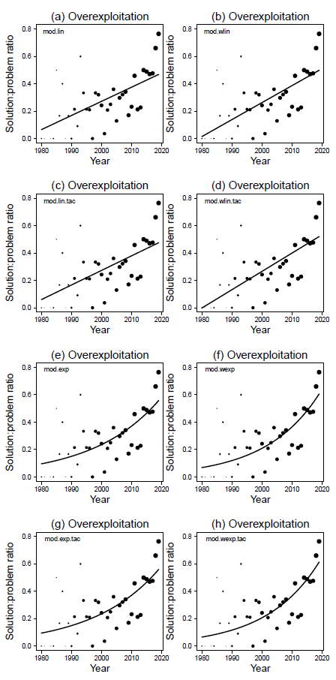
Figure S5. Alternative overexploitation models of the increase of the solution-to-problem ratio along 40 years of the overexploitation literature (all drivers together): (a) linear model, (b) weighted linear model, (c) linear model adjusted for temporal autocorrelation, (d) weighted linear model adjusted for temporal autocorrelation, (e) exponential model, (f) weighted exponential model, (g) exponential model adjusted for temporal autocorrelation, and (h) weighted exponential model adjusted for temporal autocorrelation. The best model according the Akaike criteria was the weighted exponential model (cf. Table S4).
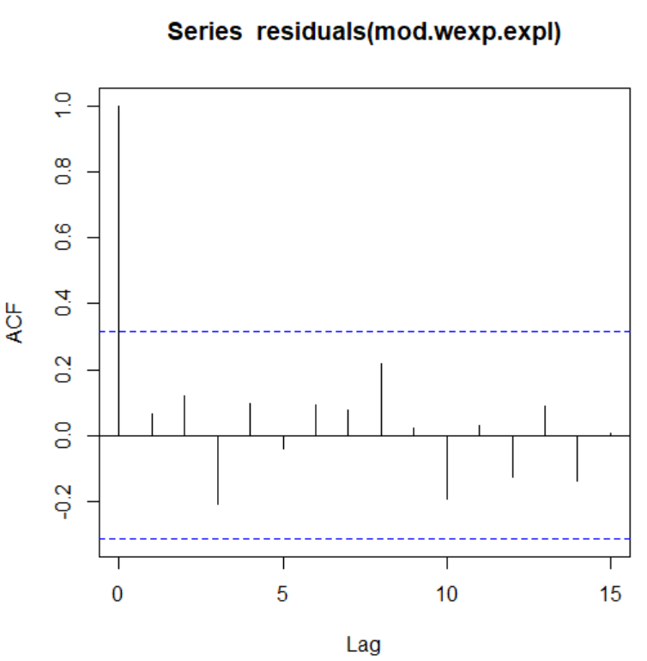
Figure S6. Temporal autocorrelation function plot for the best overexploitation model; the weighted exponential regression model (Fig. S5f, Table S3).

Table S4. Alternative biological invasion models of the increase of the solution-to-problem ratio along 40 years (z-transformed) of the biological invasion literature (inva): lin, linear model; wlin, weighted linear model; lin.tac, linear model adjusted for temporal autocorrelation; wlin.tac, weighted linear model adjusted for temporal autocorrelation; exp, exponential model; wexp, weighted exponential model; exp.tac, exponential model adjusted for temporal autocorrelation; and wexp.tac, weighted exponential model adjusted for temporal autocorrelation. The estimates of the intercept (a) and the slope (b), their standard error (se), t-value (t), and associated probabilities are provided. For each model, degrees of freedom (df), logLik, AICc, delta AICc (delta), and model weight (w) are given. The best model (wexp, ∆AICc = 0) is highlighted in bold but wexp.tac was also selected as an adequate model (∆AICc < 2).
Model | Coef. | Estimate | se | t | P | df | logLik | AICc | ∆AICc | w
lin.inva | a | 0.22920 | 0.03376 | 6.789 | <0.0001 | 3 | 3.649 | -0.4 | 42.03 | 0.000
 | b | 0.07978 | 0.03430 | 2.326 | 0.0270
wlin.inva | a | 0.22845 | 0.02291 | 9.973 | <0.0001 | 3 | 18.059 | -29.3 | 13.21 | 0.001
 | b | 0.10220 | 0.02286 | 4.470 | 0.0001
lin.tac.inva | a | 0.23793 | 0.04713 | 5.049 | <0.0001 | 4 | 3.765 | 2.0 | 44.42 | 0.000
 | b | 0.06254 | 0.04631 | 1.351 | 0.1869
wlin.tac.inva | a | 0.22635 | 0.02087 | 10.844 | <0.0001 | 4 | 18.109 | -26.7 | 15.74 | 0.000
 | b | 0.10475 | 0.02096 | 4.997 | <0.0001
exp.inva | a | 0.20820 | 0.03760 | 5.536 | <0.0001 | 3 | 9.289 | -11.7 | 30.75 | 0.000
 | b | 0.42660 | 0.16700 | 2.554 | 0.0160
wexp.inva | a | 0.21577 | 0.02506 | 8.608 | <0.0001 | 3 | 24.665 | -42.5 | 0.00 | 0.690
 | b | 0.41041 | 0.10057 | 4.081 | 0.0003
exp.tac.inva | a | 0.20176 | 0.02943 | 6.856 | <0.0001 | 4 | 9.616 | -9.8 | 32.72 | 0.000
 | b | 0.46500 | 0.13537 | 3.435 | 0.0018
wexp.tac.inva | a | 0.21207 | 0.01967 | 10.781 | <0.0001 | 4 | 25.172 | -40.9 | 1.61 | 0.309
 | b | 0.42961 | 0.08094 | 5.308 | <0.0001

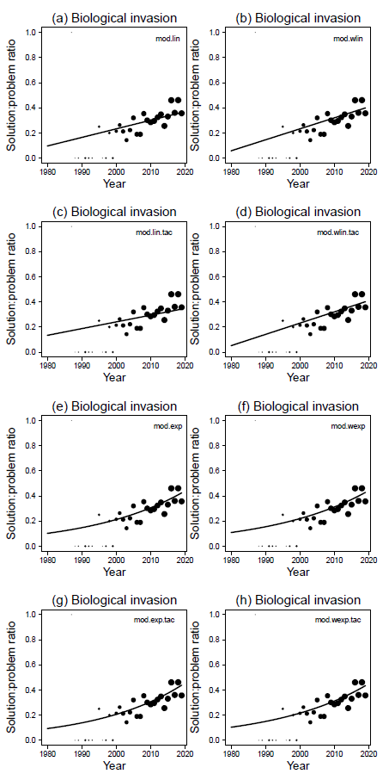
Figure S7. Alternative biological invasion models of the increase of the solution-to-problem ratio along 40 years of the biological invasion literature (all drivers together): (a) linear model, (b) weighted linear model, (c) linear model adjusted for temporal autocorrelation, (d) weighted linear model adjusted for temporal autocorrelation, (e) exponential model, (f) weighted exponential model, (g) exponential model adjusted for temporal autocorrelation, and (h) weighted exponential model adjusted for temporal autocorrelation. The best model according the Akaike criteria was the weighted exponential model (cf. Table S4).
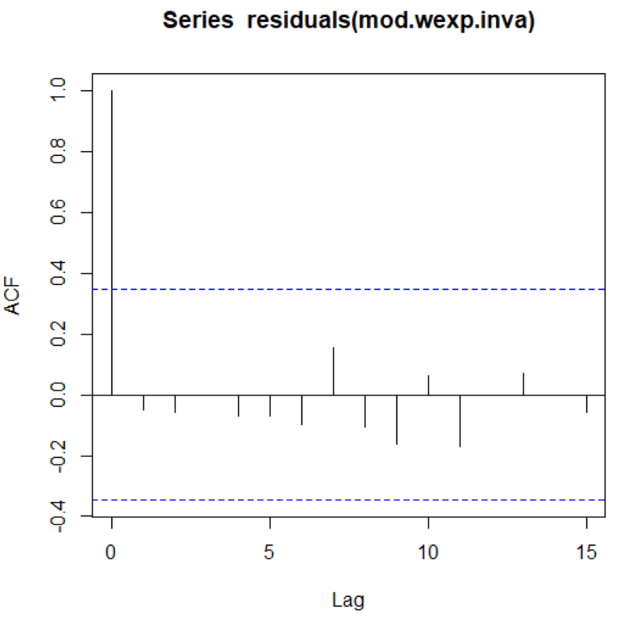
Figure S8. Temporal autocorrelation function plot for the best biological invasion model; the weighted exponential regression model (Fig. S7f, Table S4).

Table S5. Alternative climate change models of the increase of the solution-to-problem ratio along 40 years (z-transformed) of the climate change literature (clim): lin, linear model; wlin, weighted linear model; lin.tac, linear model adjusted for temporal autocorrelation; wlin.tac, weighted linear model adjusted for temporal autocorrelation; exp, exponential model; wexp, weighted exponential model; exp.tac, exponential model adjusted for temporal autocorrelation; and wexp.tac, weighted exponential model adjusted for temporal autocorrelation. The estimates of the intercept (a) and the slope (b), their standard error (se), t-value (t) and associated probabilities are provided. For each model, degrees of freedom (df), logLik, AICc, delta AICc (delta), and model weight (w) are given. The best model (∆AICc = 0) is highlighted in bold, but wexp.tac was also selected as an adequate model (∆AICc < 2).
Model | Coef. | Estimate | se | t | P | df | logLik | AICc | ∆AICc | w
lin | a | 0.29808 | 0.02241 | 13.299 | <0.0001 | 3 | 16.077 | -25.3 | 28.34 | 0.000
 | b | 0.15738 | 0.02276 | 6.914 | <0.0001
wlin | a | 0.2771294 | 0.02417208 | 11.464858 | <0.0001 | 3 | 17.044 | -27.3 | 26.40 | 0.000
 | b | 0.1931151 | 0.02327099 | 8.298537 | <0.0001
lin.tac | a | 0.29890 | 0.03112 | 9.605 | <0.0001 | 4 | 17.572 | -25.7 | 27.95 | 0.000
 | b | 0.16181 | 0.03028 | 5.345 | <0.0001
wlin.tac | a | 0.2796100 | 0.04737549 | 5.901998 | <0.0001 | 4 | 22.304 | -35.2 | 18.49 | 0.000
 | b | 0.2006245 | 0.04219032 | 4.755226 | <0.0001
exp | a | 0.25245 | 0.02525 | 10.000 | <0.0001 | 3 | 24.235 | -41.6 | 12.02 | 0.001
 | b | 0.58484 | 0.08665 | 6.749 | <0.0001
wexp | a | 0.2269371 | 0.02135682 | 10.62598 | <0.0001 | 3 | 30.246 | -53.7 | 0.00 | 0.603
 | b | 0.6743917 | 0.07359470 | 9.16359 | <0.0001
exp.tac | a | 0.2509683 | 0.02843722 | 8.825348 | <0.0001 | 4 | 24.474 | -39.5 | 14.15 | 0.001
 | b | 0.5908070 | 0.09702771 | 6.089054 | <0.0001
wexp.tac | a | 0.2270209 | 0.02634648 | 8.616745 | <0.0001 | 4 | 31.123 | -52.8 | 0.85 | 0.395
 | b | 0.6734090 | 0.08916056 | 7.552769 | <0.0001

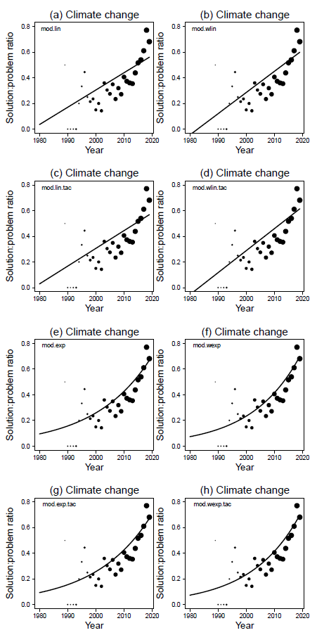
Figure S9. Alternative climate change models of the increase of the solution-to-problem ratio along 40 years of the climate change literature (clim): (a) linear model, (b) weighted linear model, (c) linear model adjusted for temporal autocorrelation, (d) weighted linear model adjusted for temporal autocorrelation, (e) exponential model, (f) weighted exponential model, (g) exponential model adjusted for temporal autocorrelation, and (h) weighted exponential model adjusted for temporal autocorrelation. The best model according the Akaike criteria the weighted exponential model (cf. Table S5).
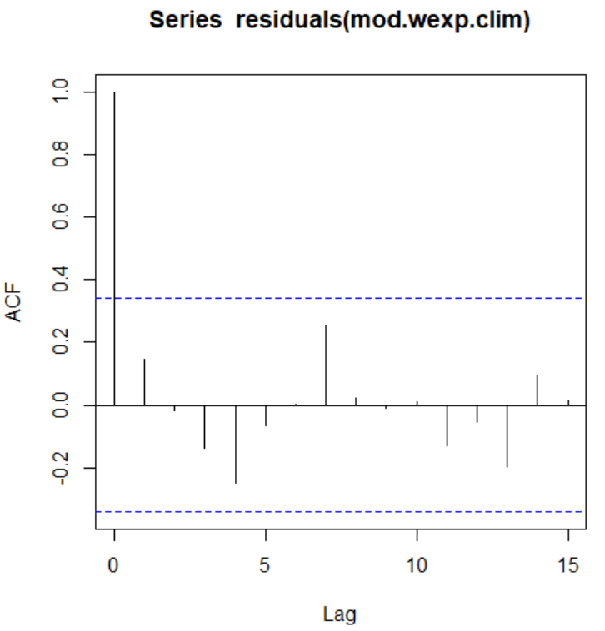
Figure S10. Temporal autocorrelation function plot for the best biological invasion model; the weighted exponential regression model (Fig. S9f, Table S3).

