Supplementary material

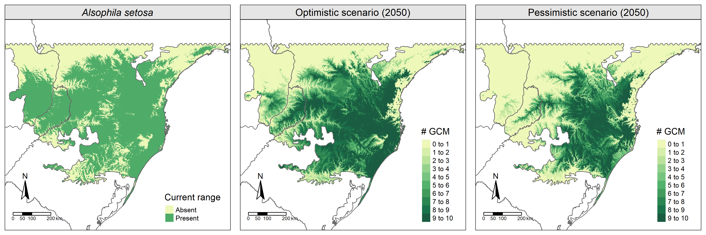
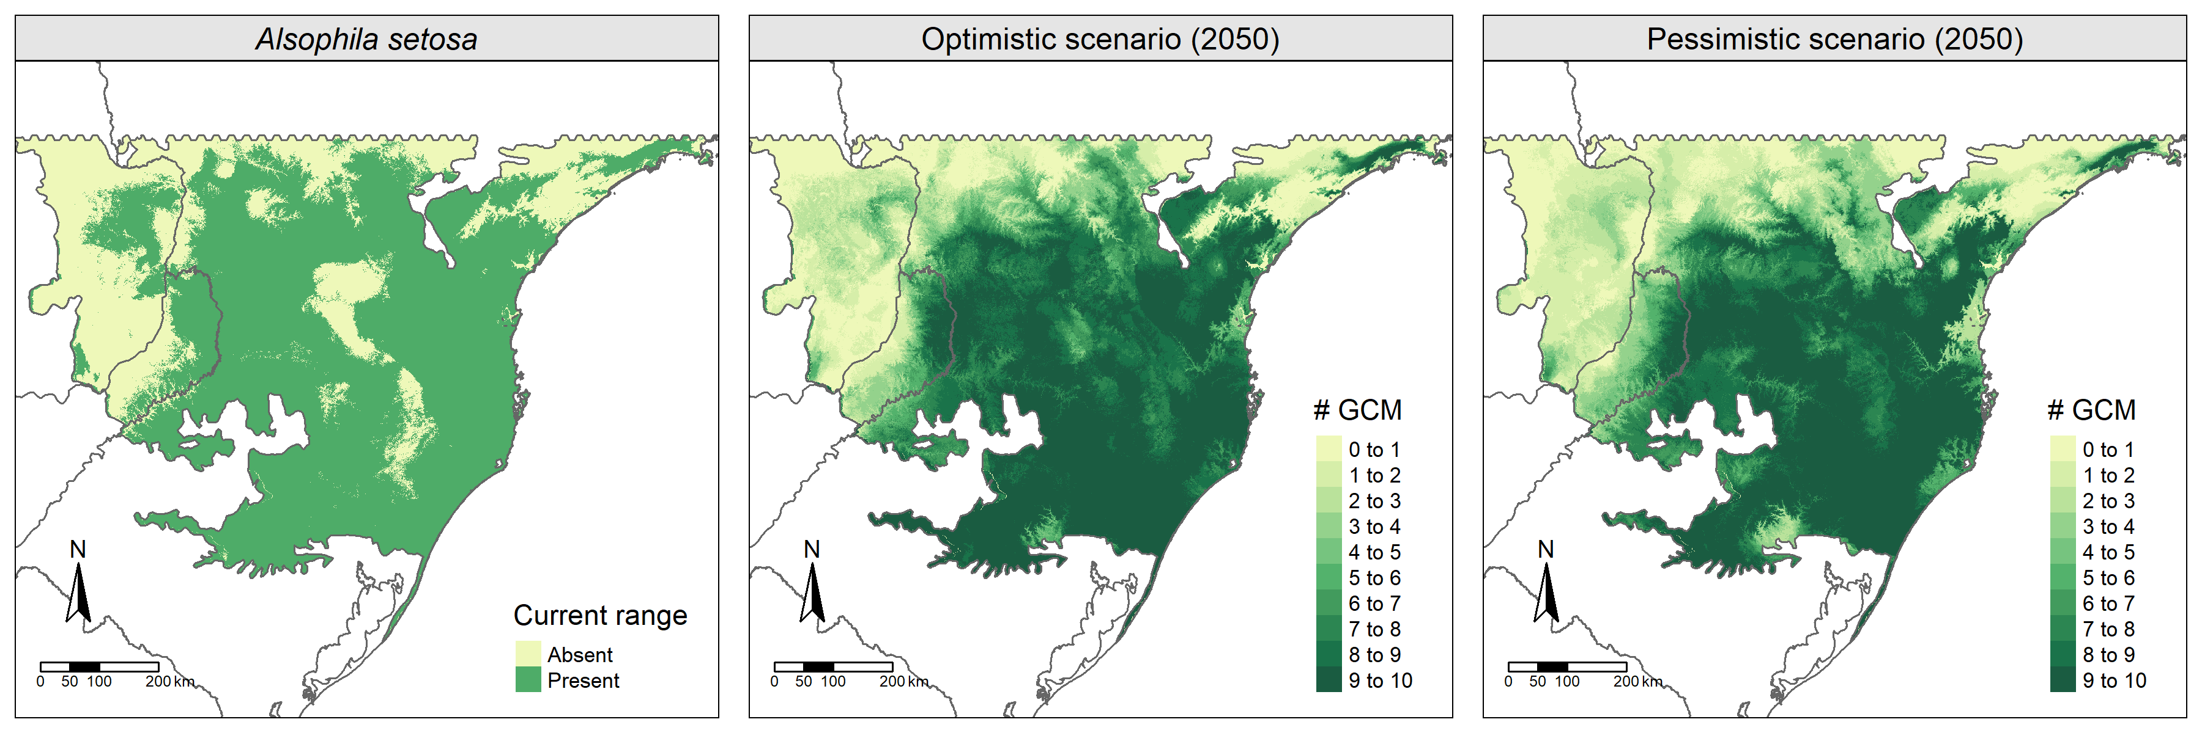
Figure S01. Alsophila setosa distribution based on modeled (current) and projected (future) scenarios. The legend indicates how many General Circulation Models (GCM) agree with the presence of the species in each raster cell from each scenario. The first line of maps refers to CHELSA´s predictions and the second refers to WorldClim´s predictions.

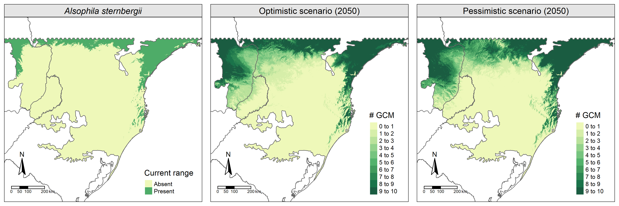
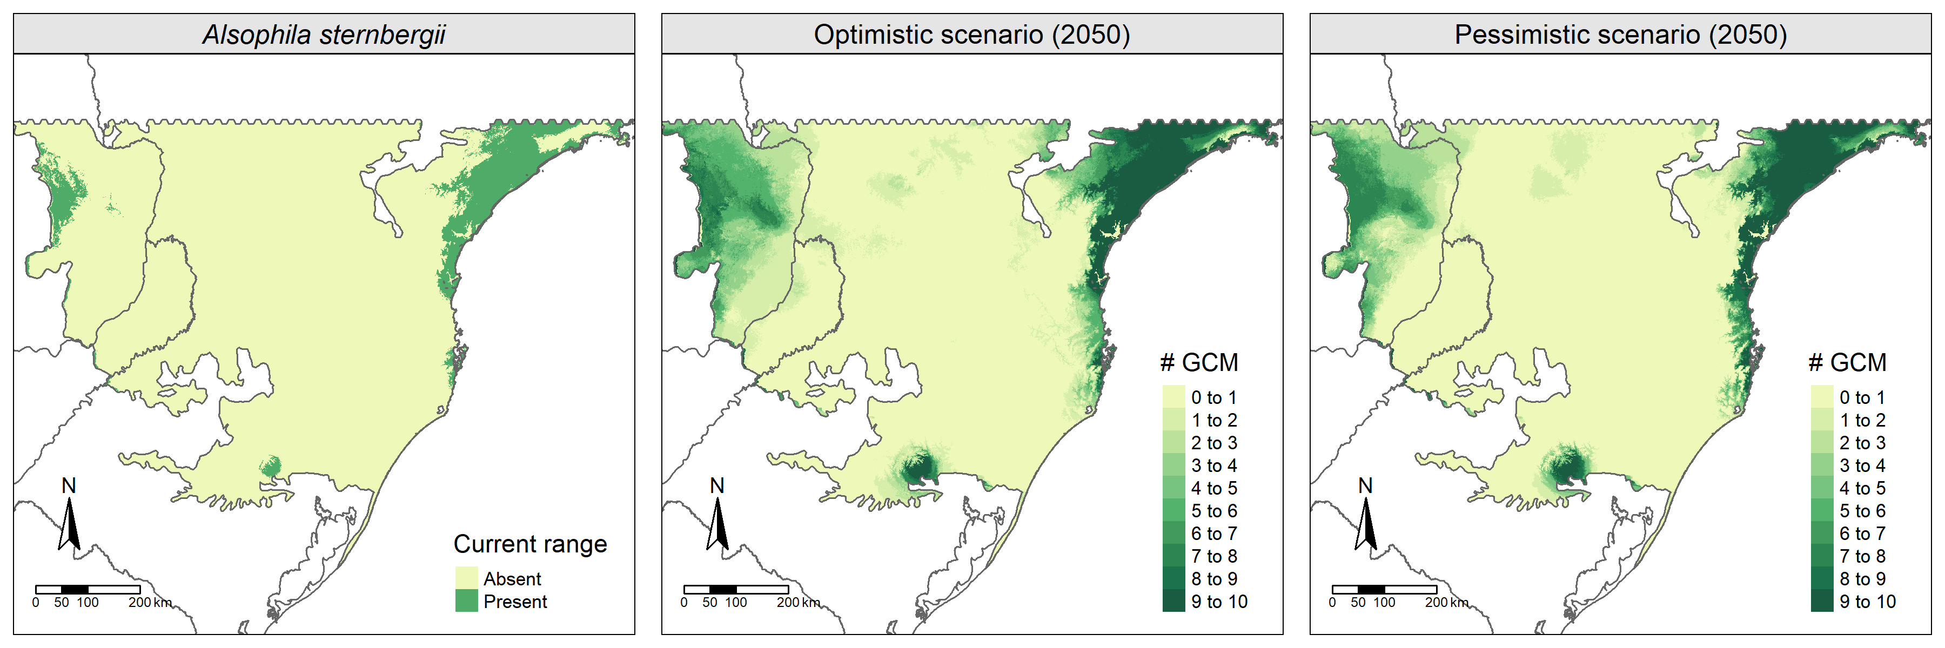
Figure S02. Alsophila sternbergii distribution based on modeled (current) and projected (future) scenarios. The legend indicates how many General Circulation Models (GCM) agree with the presence of the species in each raster cell from each scenario. The first line of maps refers to CHELSA´s predictions and the second refers to WorldClim´s predictions.

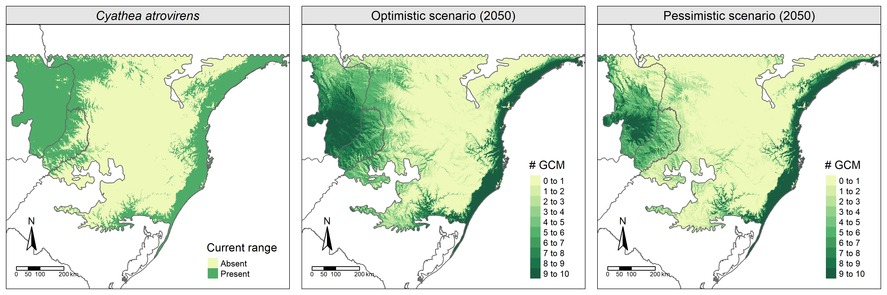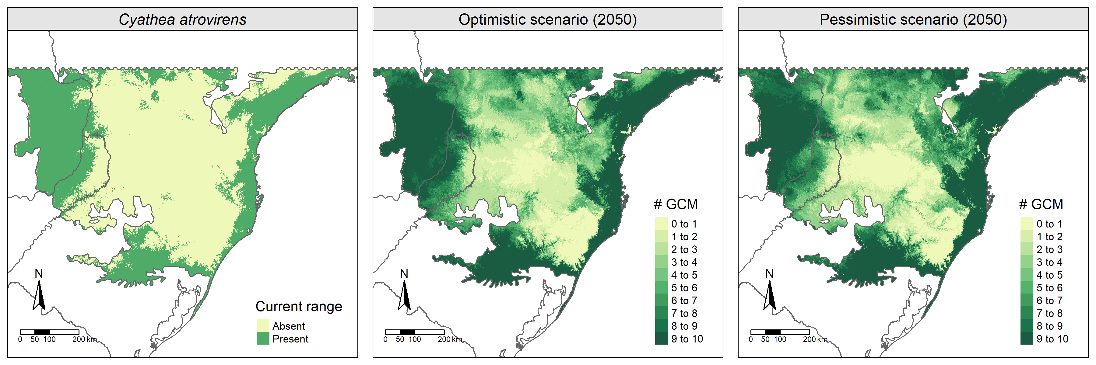
Figure S03. Cyathea atrovirens distribution based on modeled (current) and projected (future) scenarios. The legend indicates how many General Circulation Models (GCM) agree with the presence of the species in each raster cell from each scenario. The first line of maps refers to CHELSA´s predictions and the second refers to WorldClim´s predictions.

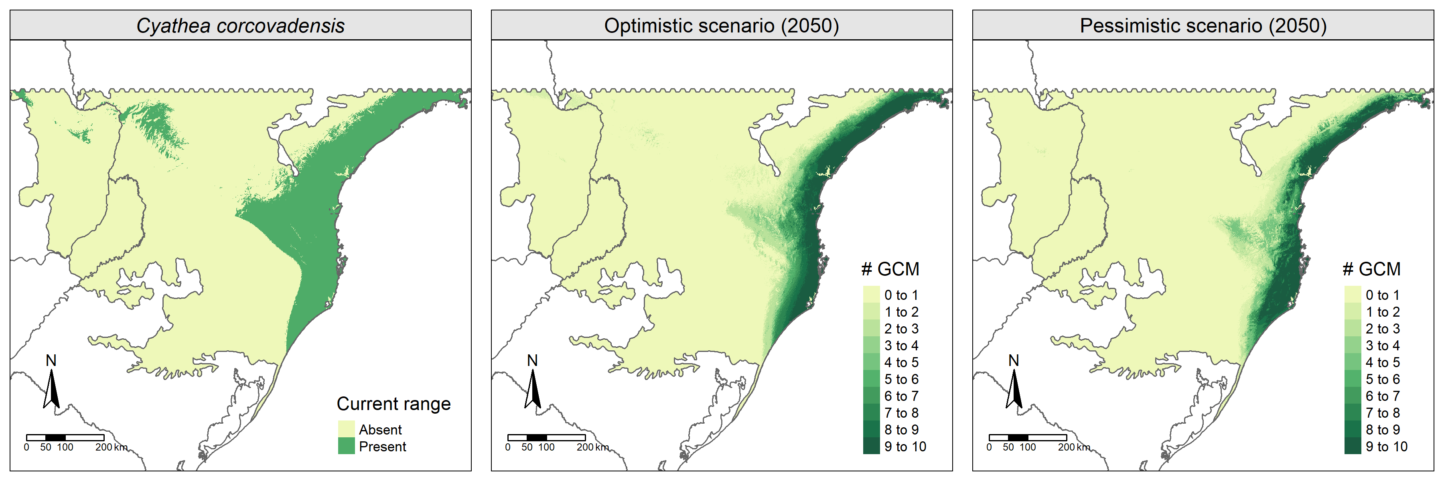
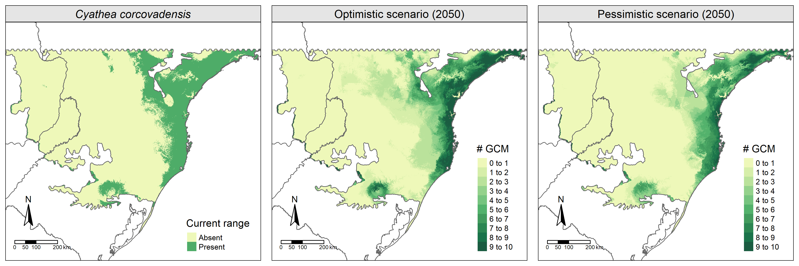
Figure S04. Cyathea corcovadensis distribution based on modeled (current) and projected (future) scenarios. The legend indicates how many General Circulation Models (GCM) agree with the presence of the species in each raster cell from each scenario. The first line of maps refers to CHELSA´s predictions and the second refers to WorldClim´s predictions.

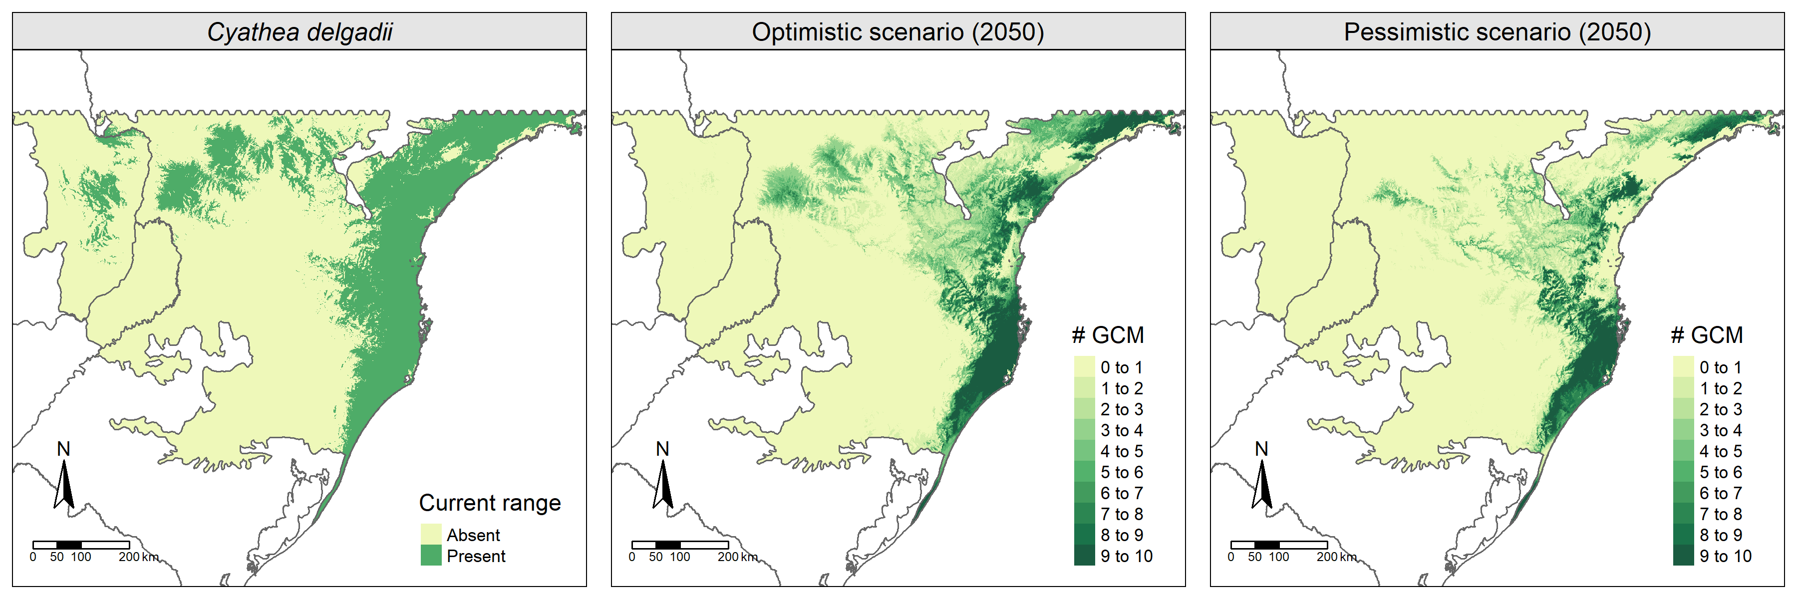
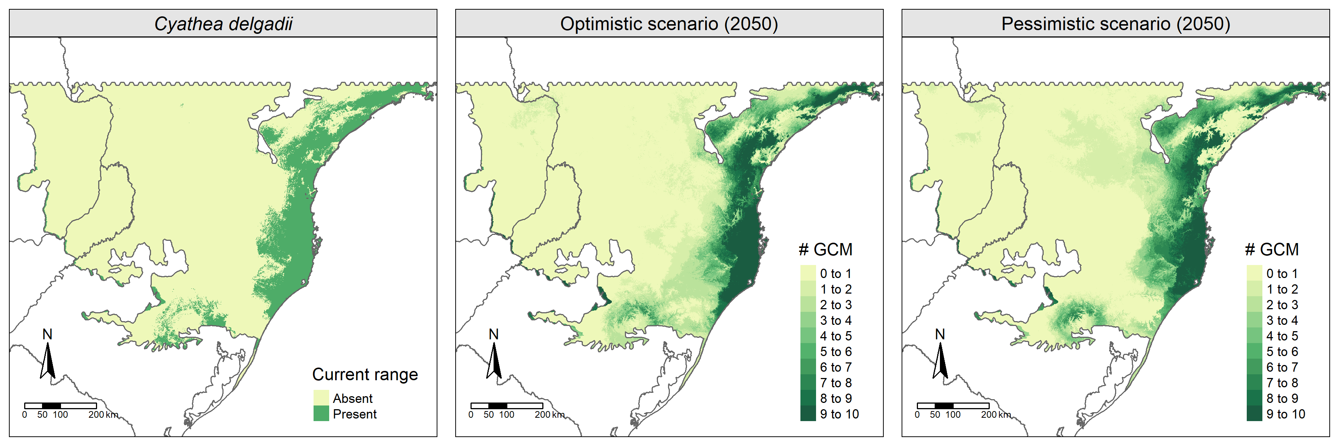
Figure S05. Cyathea delgadii distribution based on modeled (current) and projected (future) scenarios. The legend indicates how many General Circulation Models (GCM) agree with the presence of the species in each raster cell from each scenario. The first line of maps refers to CHELSA´s predictions and the second refers to WorldClim´s predictions.

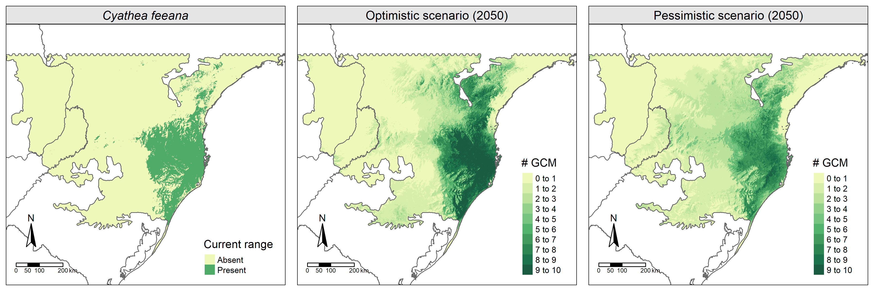
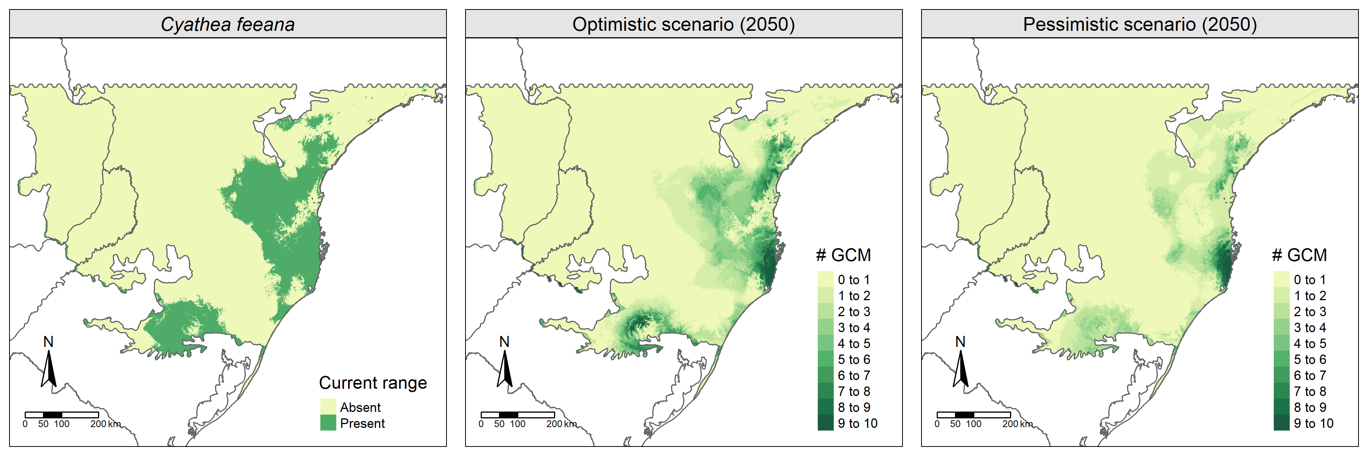
Figure S06. Cyathea feeana distribution based on modeled (current) and projected (future) scenarios. The legend indicates how many General Circulation Models (GCM) agree with the presence of the species in each raster cell from each scenario. The first line of maps refers to CHELSA´s predictions and the second refers to WorldClim´s predictions.

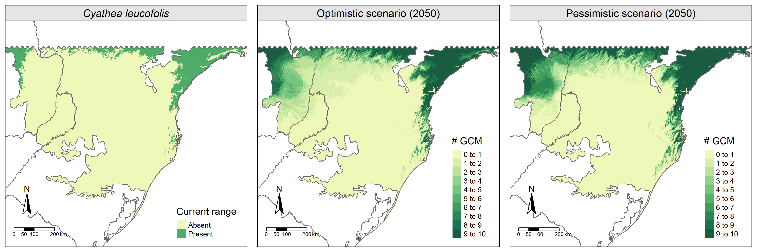
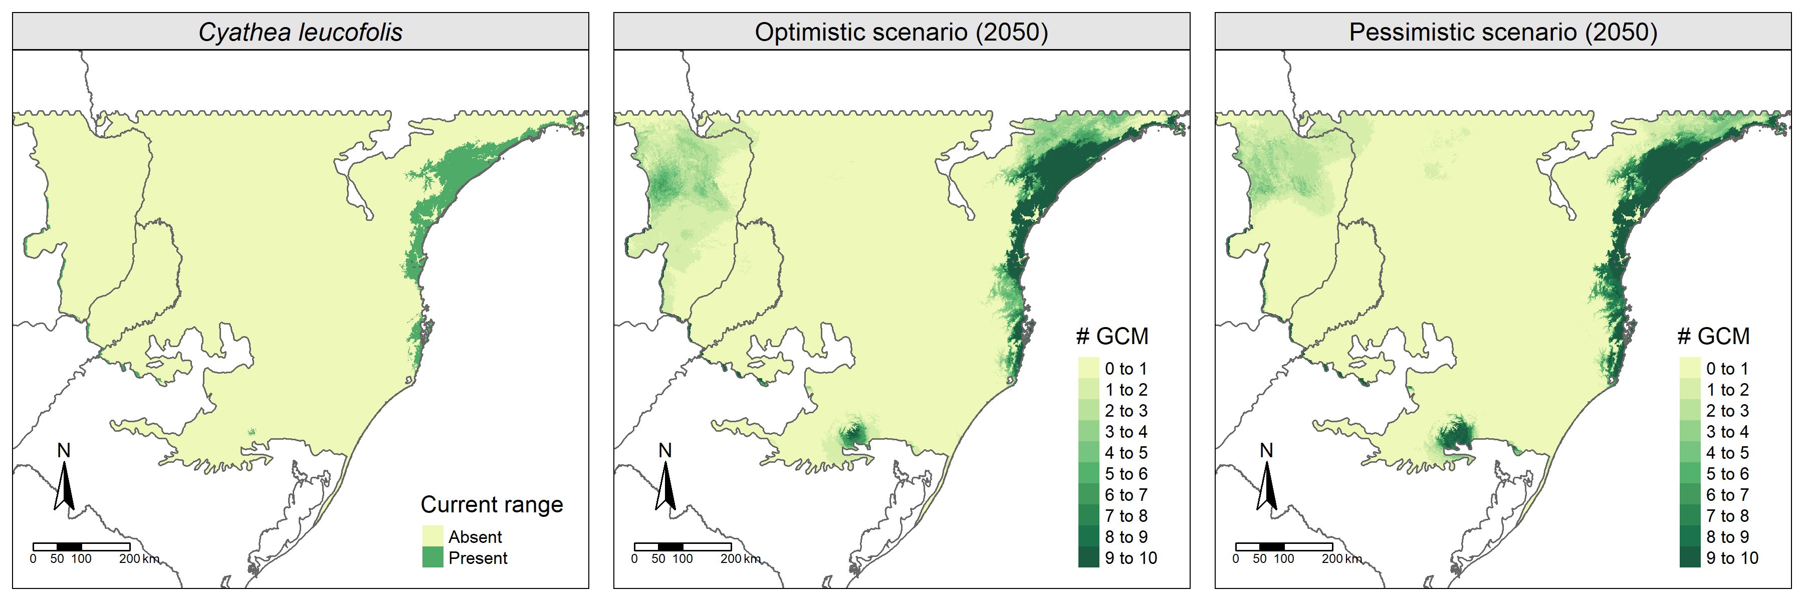

Figure S07. Cyathea leucofolis distribution based on modeled (current) and projected (future) scenarios. The legend indicates how many General Circulation Models (GCM) agree with the presence of the species in each raster cell from each scenario. The first line of maps refers to CHELSA´s predictions and the second refers to WorldClim´s predictions.

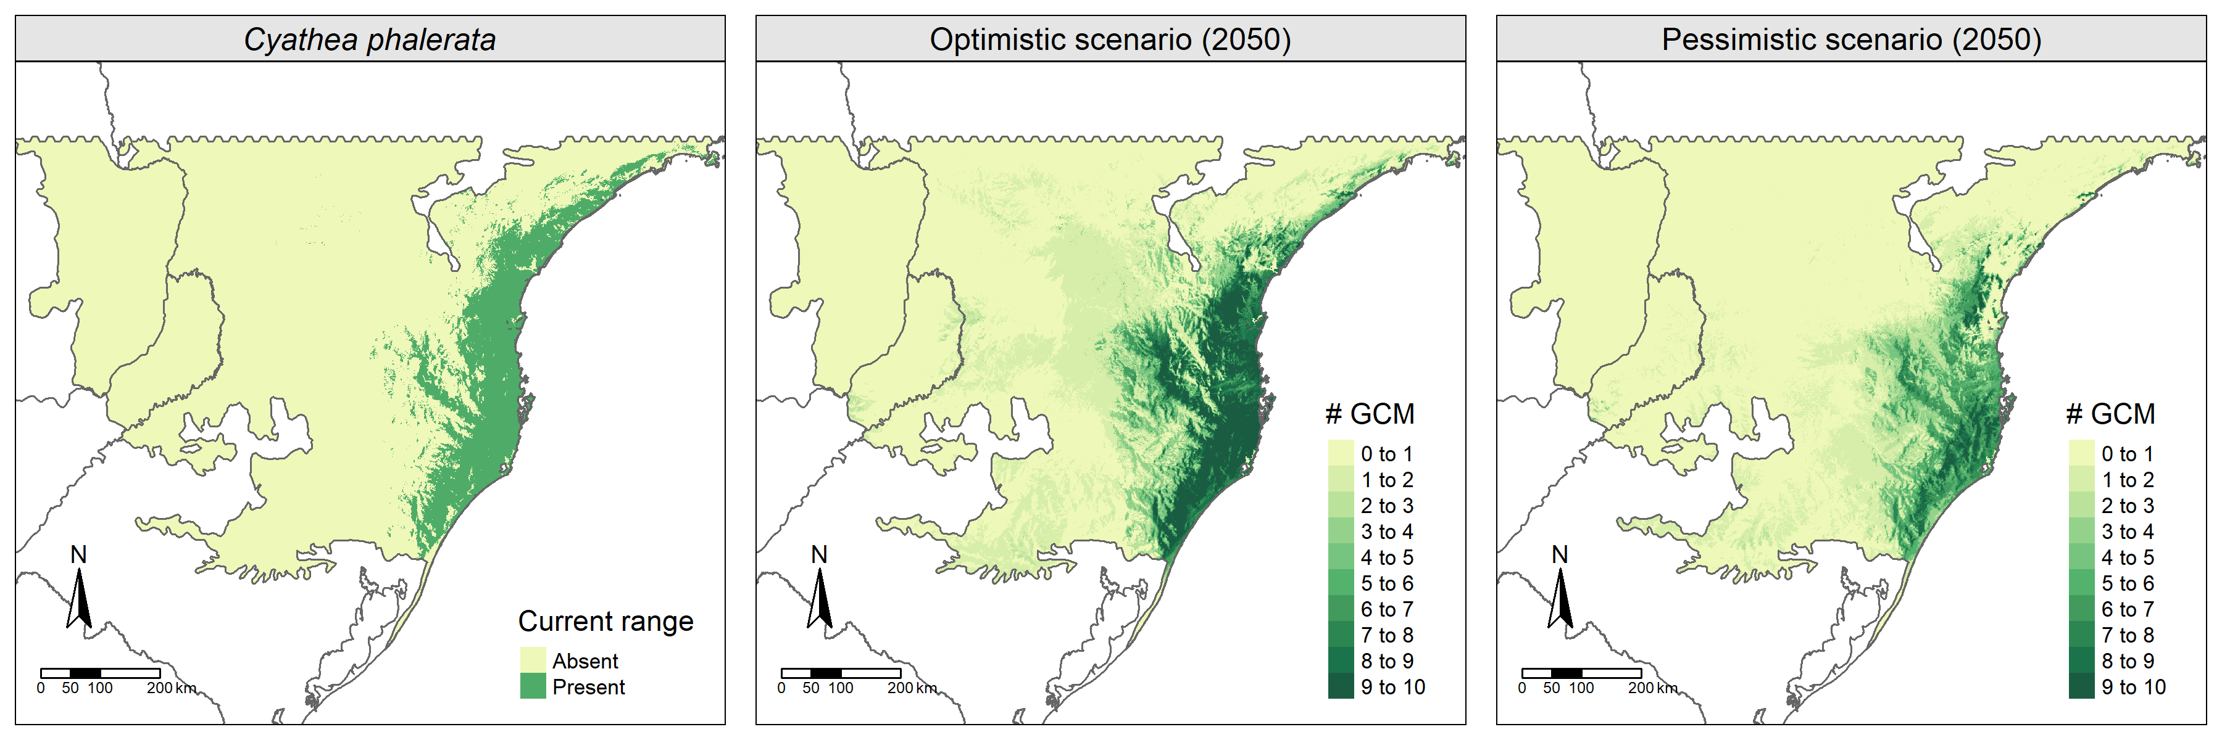
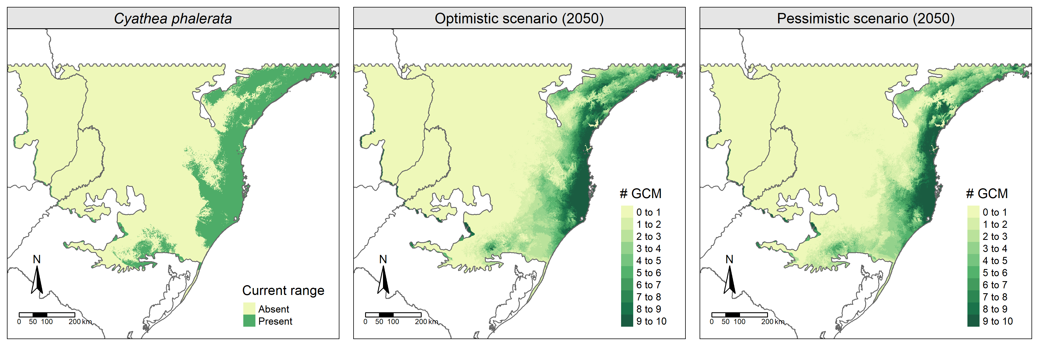
Figure S08. Cyathea phalerata distribution based on modeled (current) and projected (future) scenarios. The legend indicates how many General Circulation Models (GCM) agree with the presence of the species in each raster cell from each scenario. The first line of maps refers to CHELSA´s predictions and the second refers to WorldClim´s predictions.

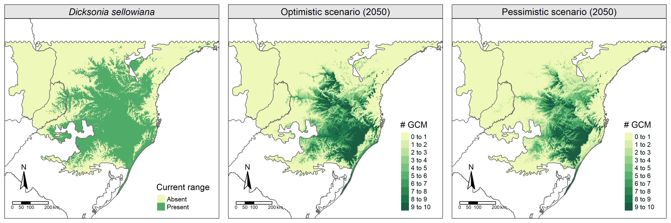
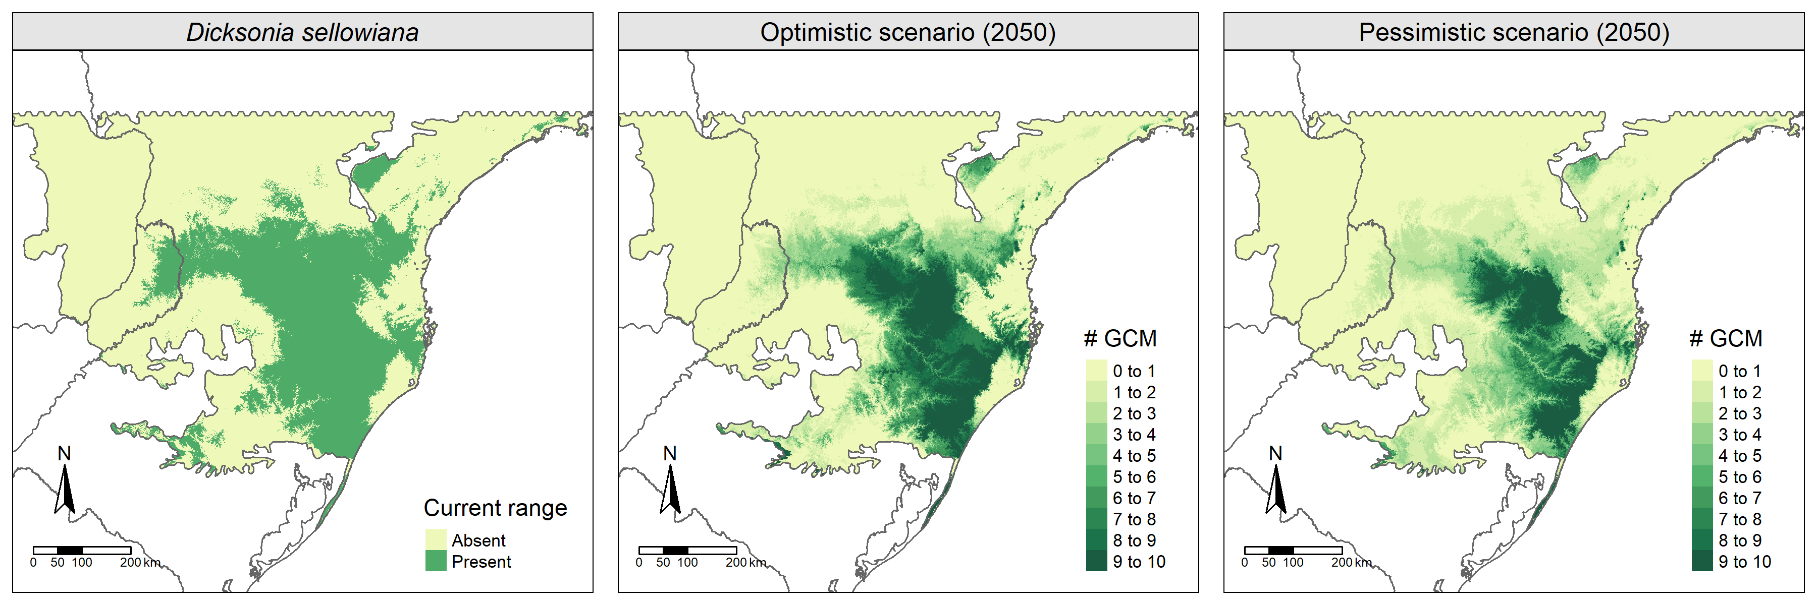
Figure S09. Dicksonia sellowiana distribution based on modeled (current) and projected (future) scenarios. The legend indicates how many General Circulation Models (GCM) agree with the presence of the species in each raster cell from each scenario. The first line of maps refers to CHELSA´s predictions and the second refers to WorldClim´s predictions.

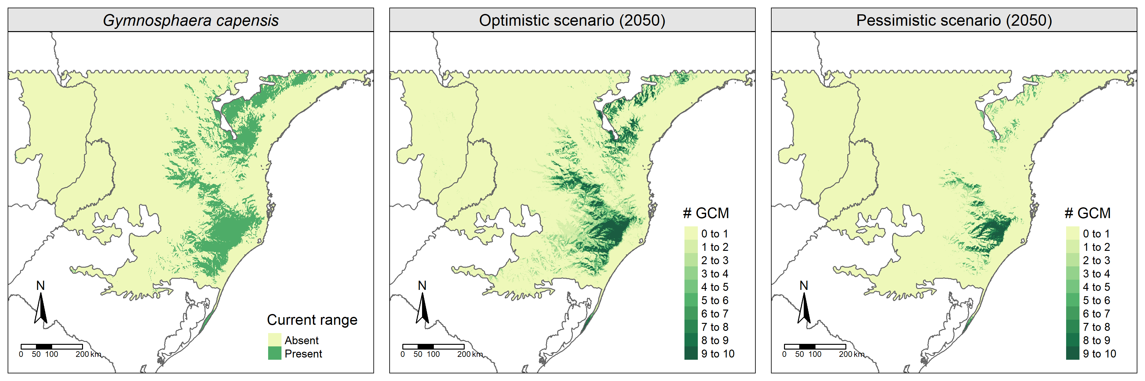
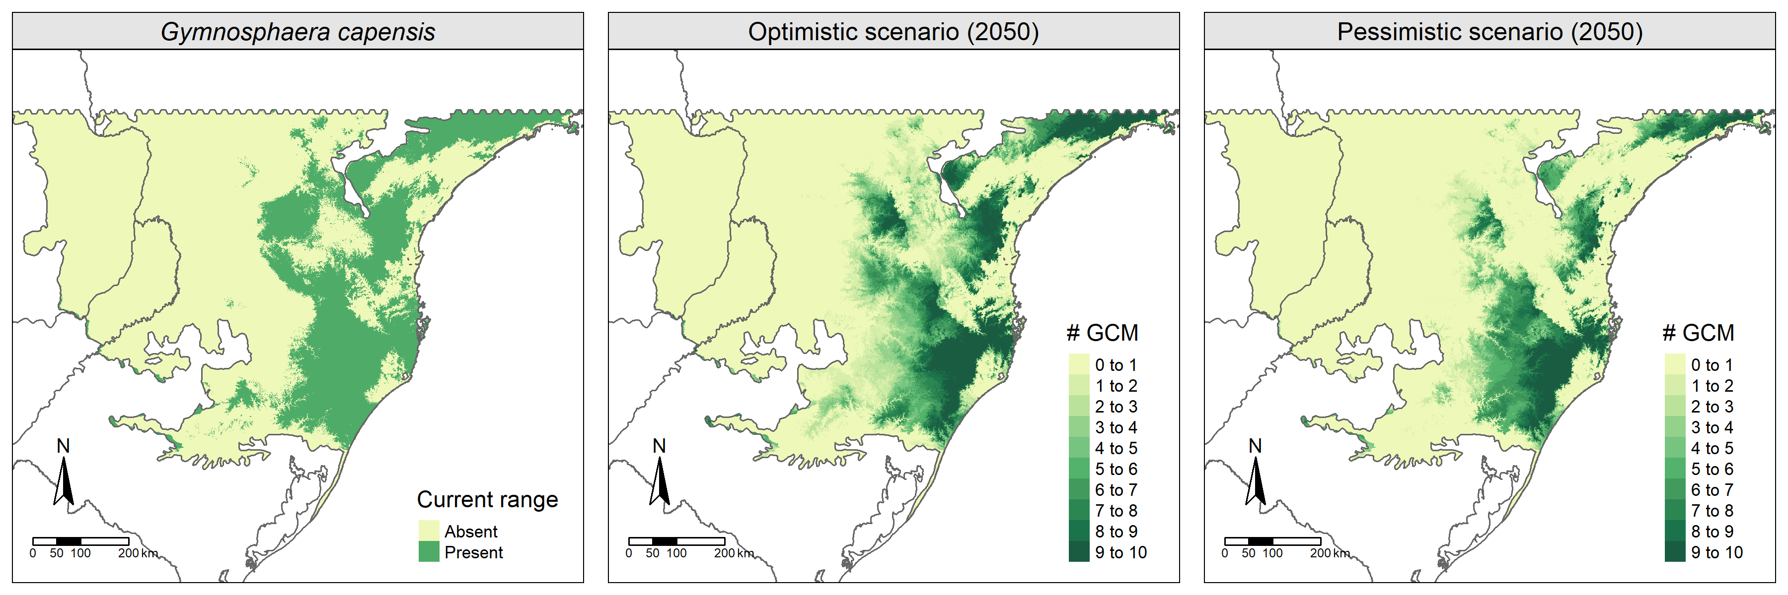
Figure S10. Gymnosphaera capensis distribution based on modeled (current) and projected (future) scenarios. The legend indicates how many General Circulation Models (GCM) agree with the presence of the species in each raster cell from each scenario. The first line of maps refers to CHELSA´s predictions and the second refers to WorldClim´s predictions.

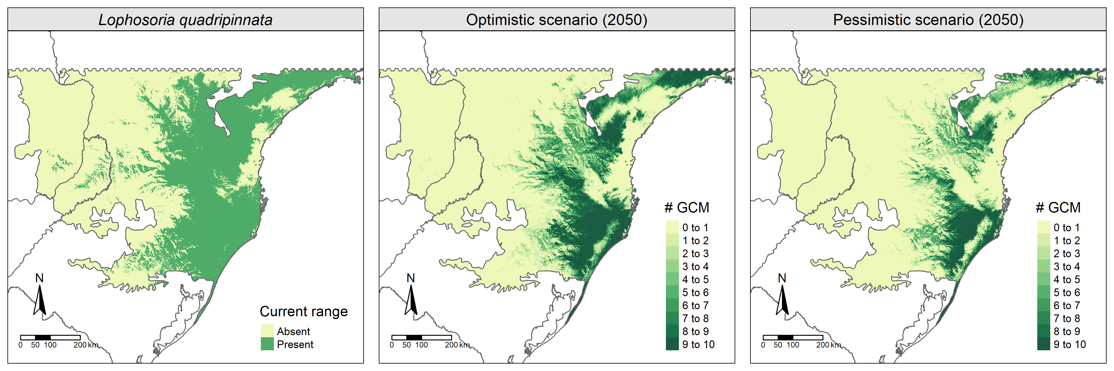
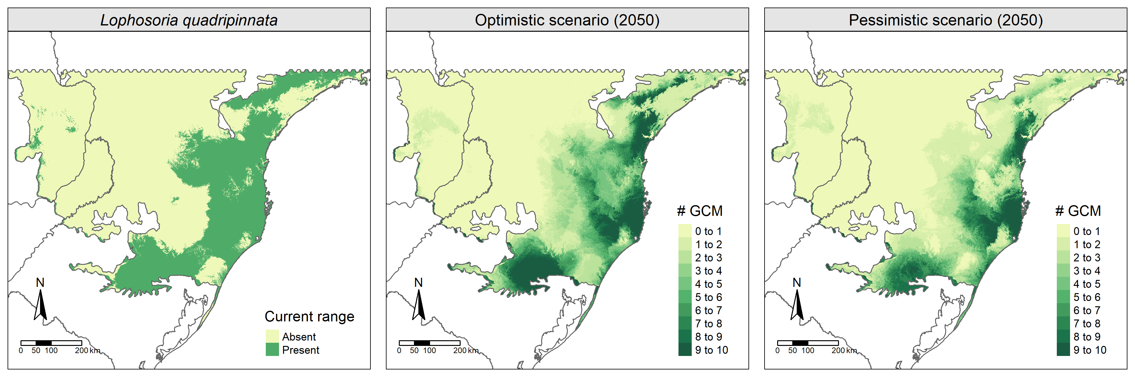

Figure S11. Lophosoria quadripinnata distribution based on modeled (current) and projected (future) scenarios. The legend indicates how many General Circulation Models (GCM) agree with the presence of the species in each raster cell from each scenario. The first line of maps refers to CHELSA´s predictions and the second refers to WorldClim´s predictions.

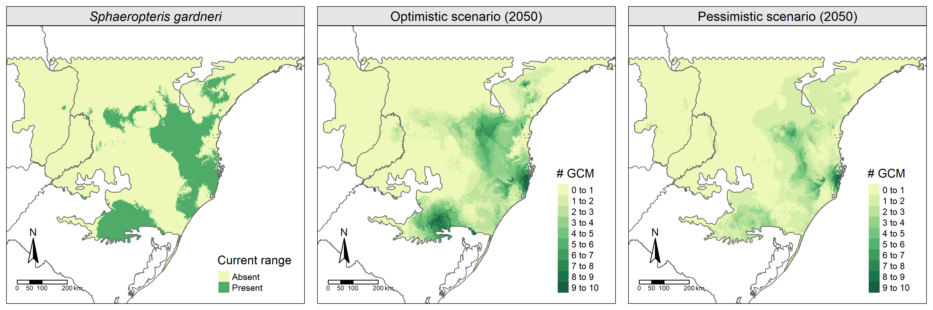

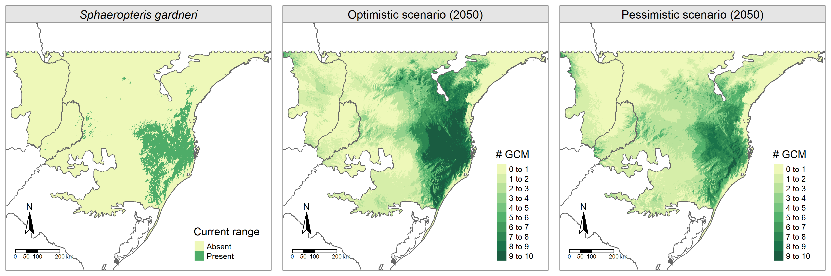

Figure S12. Sphaeropteris gardneri distribution based on modeled (current) and projected (future) scenarios. The legend indicates how many General Circulation Models (GCM) agree with the presence of the species in each raster cell from each scenario. The first line of maps refers to CHELSA’s predictions and the second refers to WorldClim’s predictions.

Table S01. Mean changes (%) in the distribution of species regarding the climatic data set, future scenario, and region. Negative values represent predicted loss in species−area, while positive values represent predicted gains. Omitted values are non-significant changes. SAF – All subtropical Atlantic Forest; PA – Only Protected Areas; OPT – optimistic future scenario; PES – pessimistic future scenario.
SPECIES | CHELSA |  |  |  | WorldClim
 | SAF |  | PA |  | SAF |  | PA
 | OPT | PES | OPT | PES | OPT | PES | OPT | PES
 | Cyatheaceae
Alsophila setosa | −38.31 | −54.51 | −41.13 | −60.83 | – | – | −20.49 | –
Alsophila sternbergii | 67.68 | 103.51 | 17.49 | 30.71 | 14.51 | – | 5.78 | –
Cyathea atrovirens | – | −39.74 | −27.90 | −39.64 | 24.55 | 39.03 | – | –
Cyathea corcovadensis | – | −46.57 | – | −48.38 | −27.63 | −34.21 | −20.96 | −36.68
Cyathea delgadii | −40.63 | −43.80 | −57.47 | −75.40 | – | – | 10.24 | –
Cyathea feeana | – | – | – | – | −50.03 | −70.05 | −73.67 | −81.79
Cyathea leucofolis | 116.77 | 178.19 | 30.60 | 55.19 | 41.04 | 82.50 | 28.99 | –
Cyathea phalerata | – | −46.49 | −28.69 | −60.27 | −30.26 | −38.97 | −17.30 | –
Gymnosphaera capensis | −41.30 | −64.04 | −42.22 | −63.49 | −25.54 | −40.16 | −27.47 | −41.49
Sphaeropteris gardneri | 137.33 | – | 138.11 | – | −41.14 | −62.21 | −68.45 | −78.66
 | Dicksoniaceae
Dicksonia sellowiana | −57.40 | −65.62 | −55.03 | −65.52 | – | −37.86 | – | −47.27
Lophosoria quadripinnata | −64.47 | −74.08 | −60.98 | −71.56 | −48.94 | −57.91 | −63.51 | −67.48

Table S02. Model parameters (RM and FC) chosen via AICc and evaluation for each species in each data set (CHELSA × WorldClim). As Cyathea hirsuta (red) obtained a evaluation lower than 0.5 we removed it from our analyses. RM = Regularization Multiplier; FC = Feature Classes; CBI = Continuous Boyce Index. L = Linear; Q = Quadratic; H = Hinge; P = Product; T = Threshold.
CHELSA
Species | RM | FC | CBI
Alsophila setosa | 0.5 | LQ | 0.916
Alsophila sternbergii | 2 | LQP | 0.553
Cyathea atrovirens | 0.5 | LQ | 0.659
Cyathea corcovadensis | 2.5 | LQHPT | 0.751
Cyathea delgadii | 3 | LQHP | 0.854
Cyathea feeana | 0.5 | LQ | 0.686
Cyathea hirsuta | 2 | LQH | 0.083
Cyathea leucofolis | 2.5 | LQP | 0.891
Cyathea phalerata | 0.5 | LQ | 0.825
Cyathea villosa | 2 | LQ | 0.555
Dicksonia sellowiana | 2 | LQP | 0.971
Gymnosphaera capensis | 0.5 | LQP | 0.888
Lophosoria quadripinnata | 1 | LQ | 0.739
Sphaeropteris gardneri | 0.5 | LQ | 0.698
WorldClim
Alsophila setosa | 1.5 | LQP | 0.879
Alsophila sternbergii | 1 | LQ | 0.646
Cyathea atrovirens | 2 | LQHP | 0.964
Cyathea corcovadensis | 1 | LQ | 0.883
Cyathea delgadii | 0.5 | LQ | 0.948
Cyathea feeana | 0.5 | LQP | 0.721
Cyathea hirsuta | 3 | H | 0.817
Cyathea leucofolis | 0.5 | LQP | 0.703
Cyathea phalerata | 2 | LQ | 0.903
Cyathea villosa | 1.5 | L | 0.814
Dicksonia sellowiana | 4 | LQH | 0.946
Gymnosphaera capensis | 1 | LQ | 0.818
Lophosoria quadripinnata | 1.5 | LQP | 0.767
Sphaeropteris gardneri | 0.5 | L | 0.694

