Appendix S11. a) Total occupancy of Amazonian manatee and b) detection probability of species by visit in the sample site.
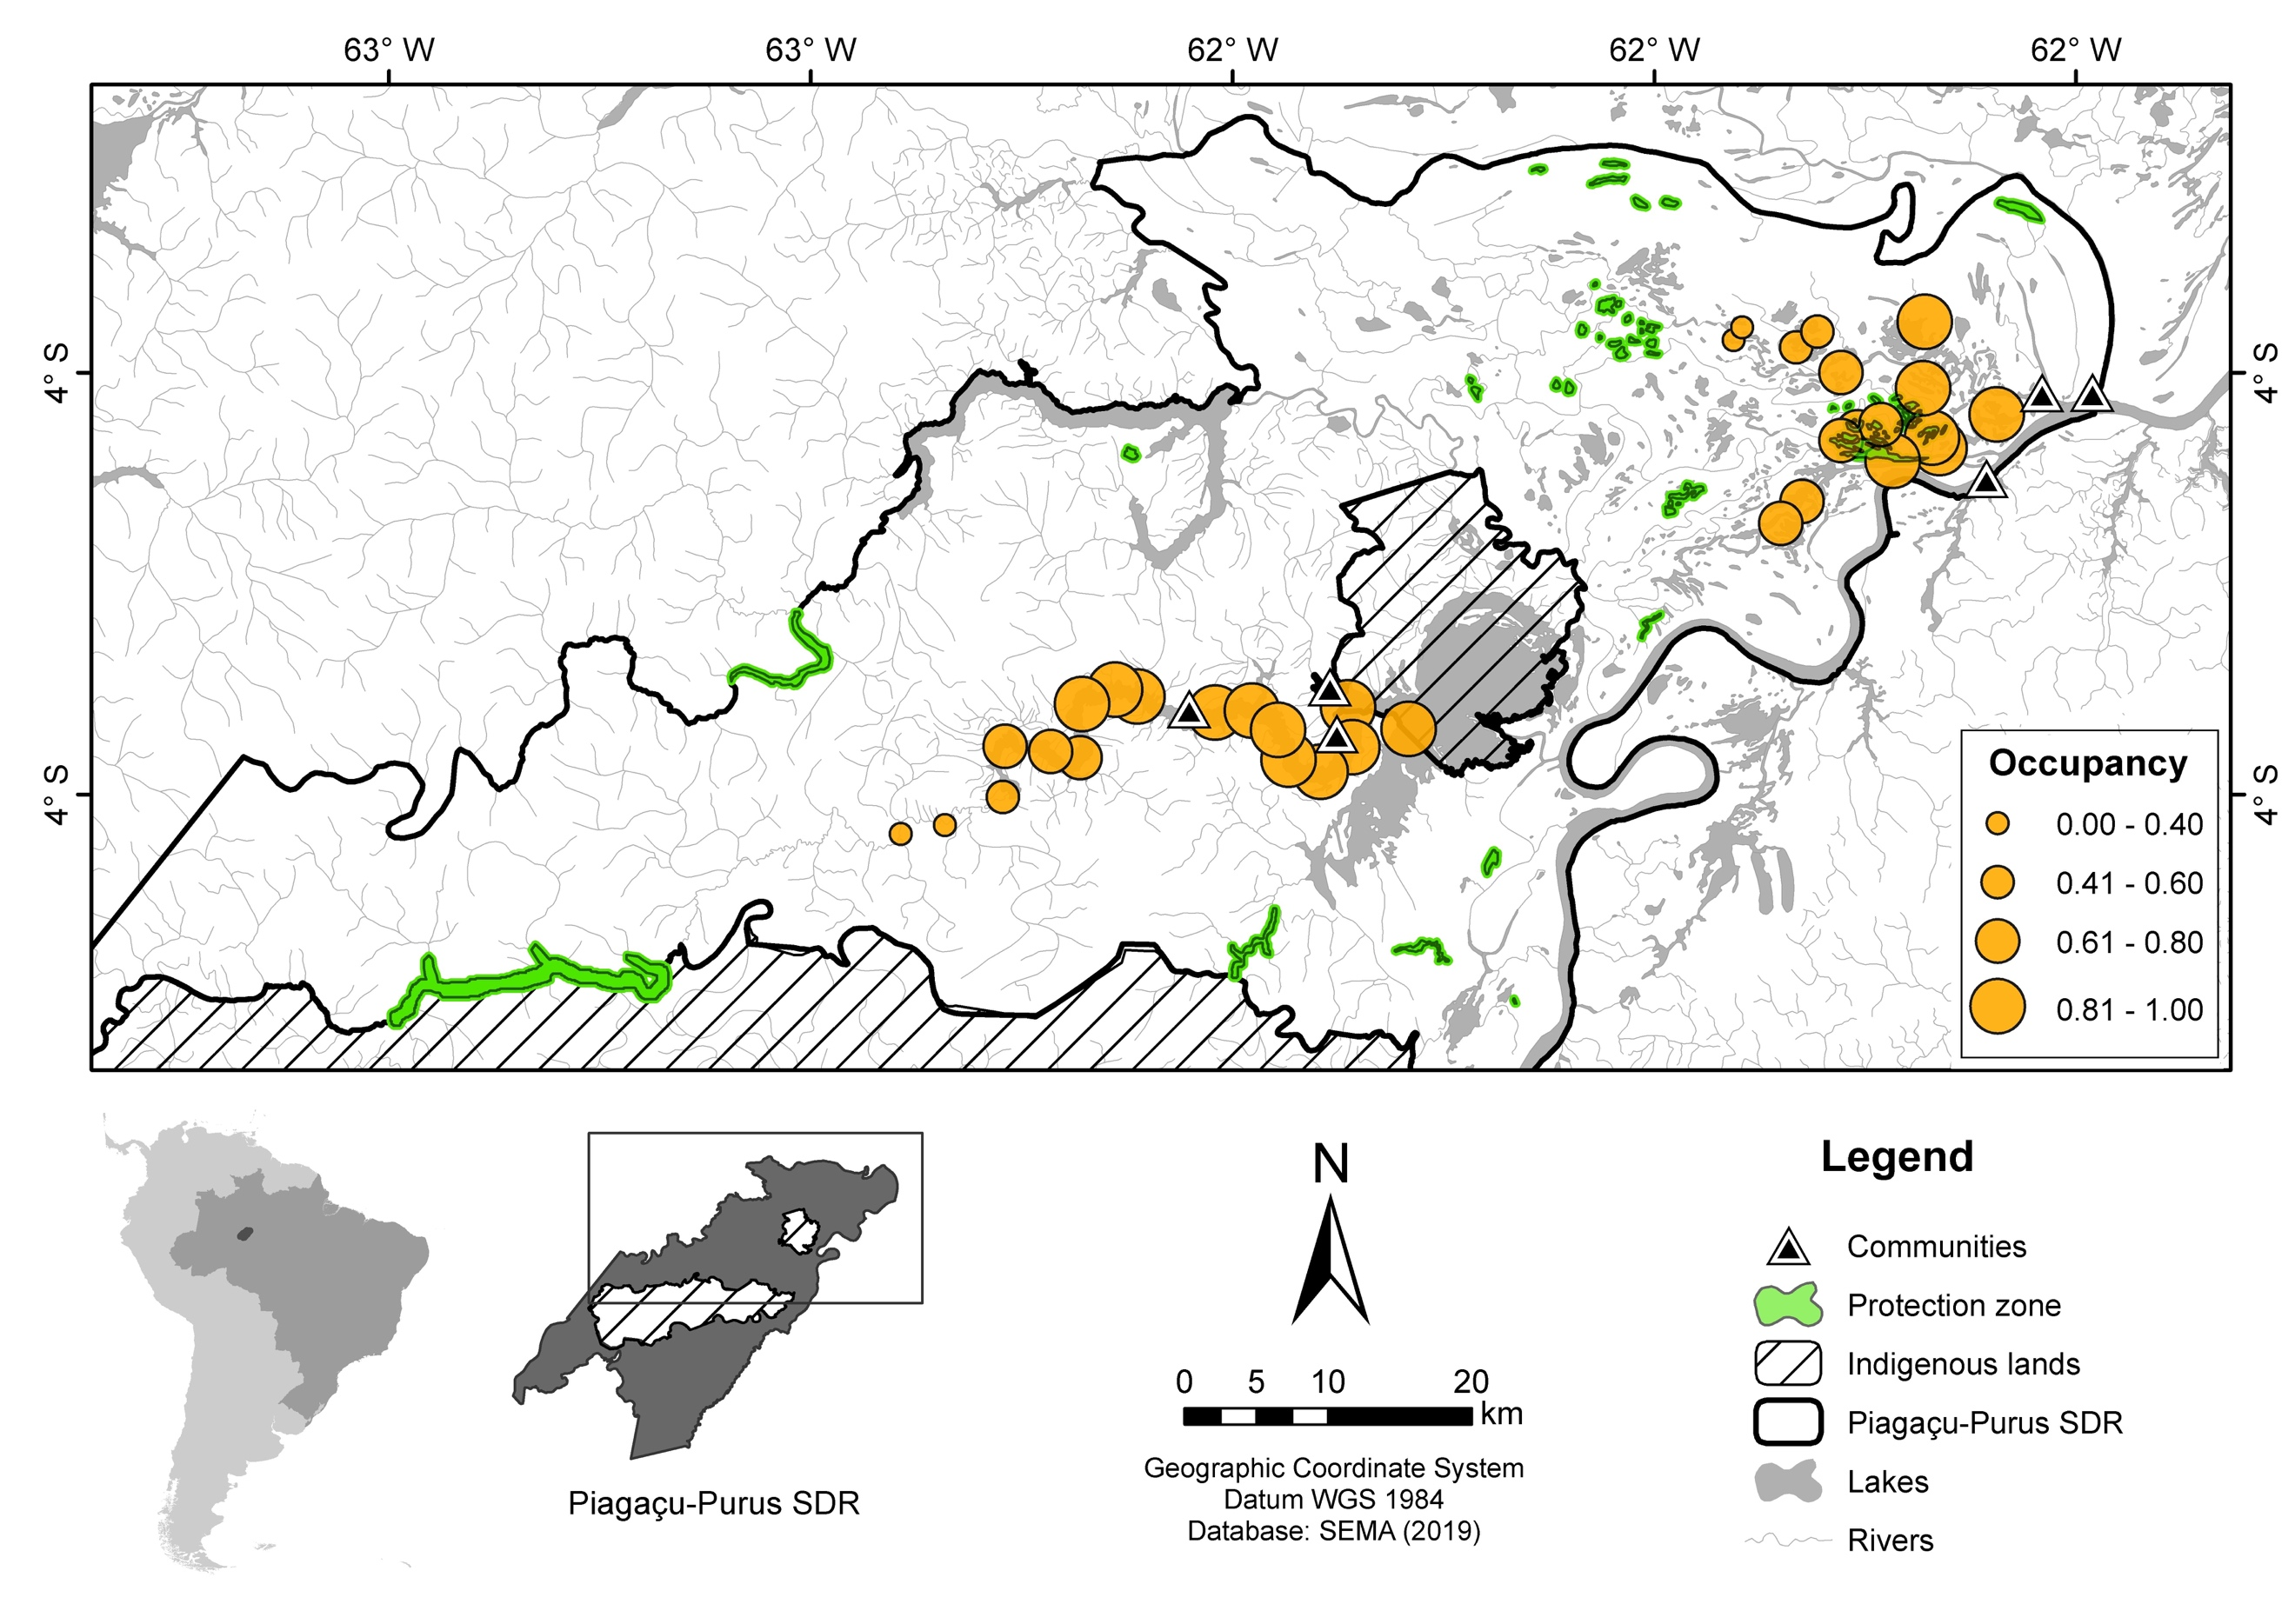
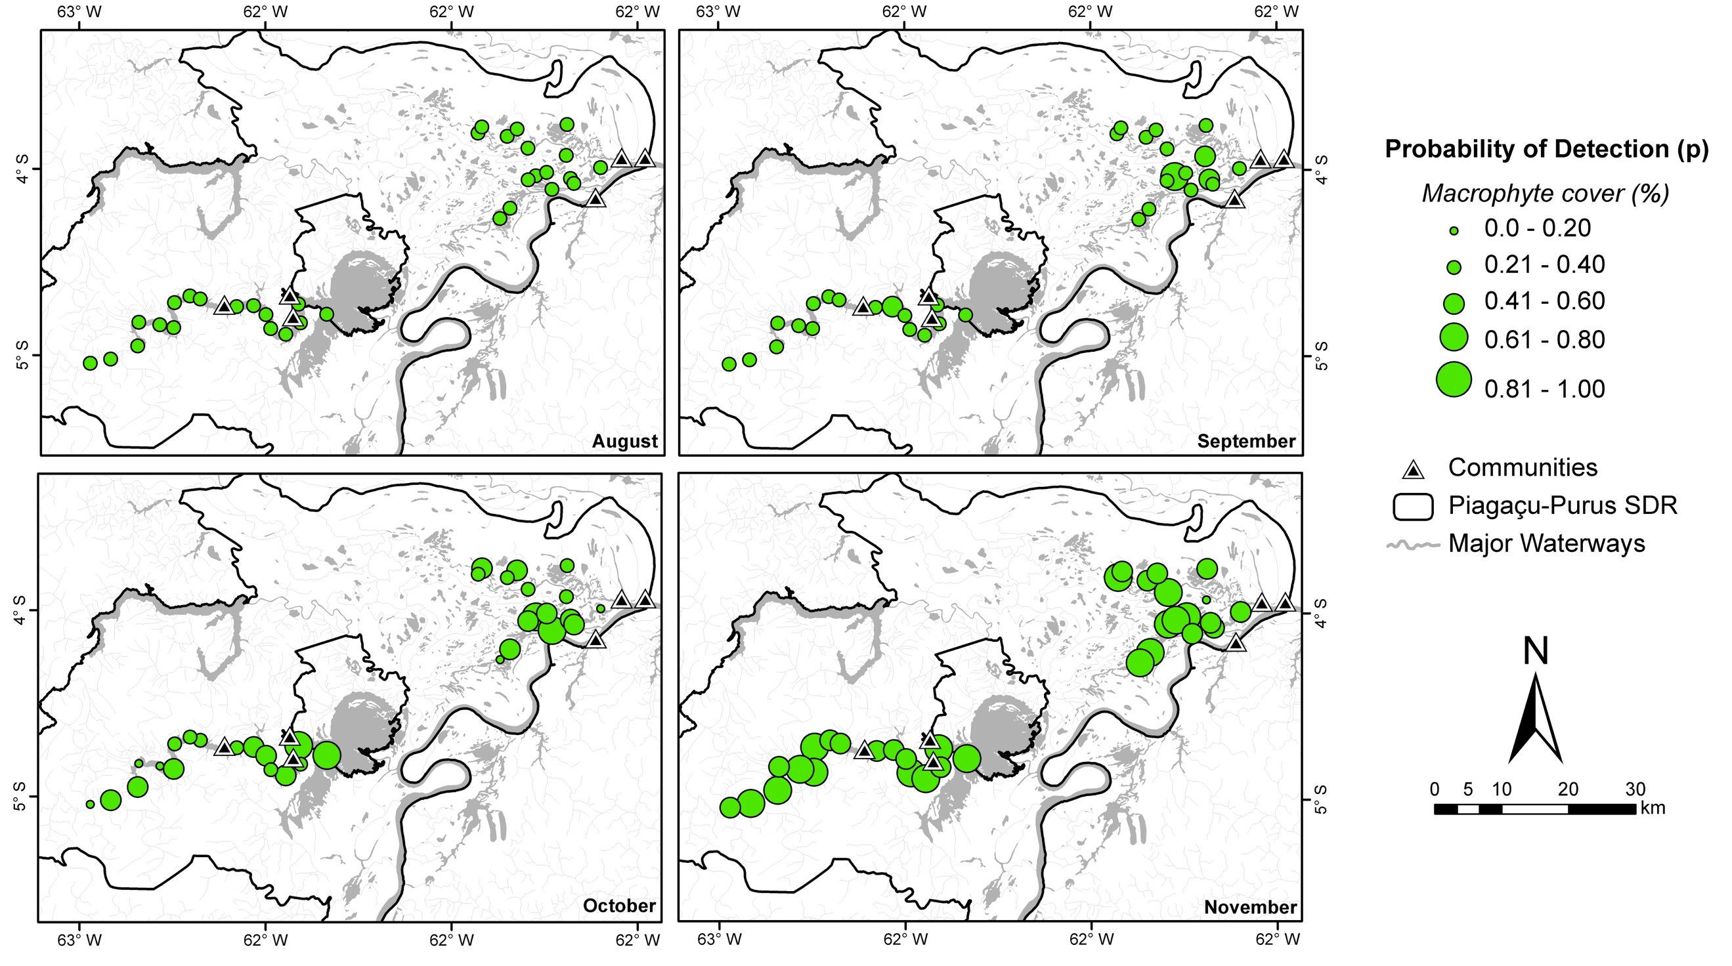
a)
b)

