Supplementary Material

Table S1. List of species of selected palms and their conservation status. Conservation status, National by: CNCFLORA: National Flora Conservation Center of Brazil (http://cncflora.jbrj.gov.br/portal). State by: ¹FZB/RS: The Zoobotany Foundation of the state of RS. ²CONSEMA/SC: Secretary of State for Sustainable Development in the state of Santa Catarina. ³SEMA/PR: State Secretary for Sustainable Development and Tourism of the State of Parana. Status: LC: Least Concern; NT: Near Threatened; VU: Vulnerable; EN: Endangered. CR: Critically Endangered. RR: Rare species with reduced population.

Species | Typical | Associated | Conservation status
 |  |  | National | State
Allagoptera campestris (Mart.) Kuntze* |  | X | ----- | -----
Butia eriospatha (Mart. ex Drude) Becc | X |  | VU | EN¹, CR²
Butia exilata Deble & Marchiori | X |  |  | CR¹
Butia lallemantii Deble & Marchiori | X |  |  | EN¹
Butia microspadix Burret | X |  | VU | RR³
Butia odorata (Barb.Rodr.) Noblick | X |  |  | EN¹
Butia pubispatha Noblick & Lorenzi | X |  | ----- | -----
Butia witeckii K. Soares & S. Longhi | X |  |  | CR¹
Butia yatay (Mart.) Becc | X |  | VU | EN¹
Butia paraguayensis (Barb.Rodr.)* |  | X | LC | CR¹, EN³
Trithrinax acanthocoma Drude** |  | X |  | CR¹
Trithrinax brasiliensis Mart*** |  | X | NT | CR¹
---- Species without conservation status assessment.
* Species also found in the Cerrado (Flora do Brasil 2020 em construção ; Morais, 1996).
** Species also found in the mixed Araucaria forest (Cano et al., 2013).
*** Species also occurs on rocky outcrops of the Pampa biome and along riparian forest edges (Cano et al., 2013).

References
Cano, Á., Perret, M., Stauffer, F.W., 2013. A revision of the genus Trithrinax (Cryosophileae, Coryphoideae, Arecaceae). Phytotaxa. 136, 1–53. https://doi.org/10.11646/phytotaxa.136.1.1.

CONSEMA, Conselho Estadual de Meio Ambiente., 2014. Lista Oficial das Espécies da Flora Ameaçada de Extinção no Estado de Santa Catarina e dá outras providências. Downloadable from https://www.ima.sc.gov.br/index.php/biodiversidade/biodiversidade/flora.
Flora do Brasil 2020 em construção. Jardim Botânico do Rio de Janeiro. Disponível em: < http://floradobrasil.jbrj.gov.br/ >. Acesso em: 18 fev. 2021
FZB, Fundação Zoo Botânica., 2014. Espécies da Flora nativa ameaçada de extinção no Estado do Rio Grande do Sul., 52.109. Downloadable from https://sema.rs.gov.br/inicial
Morais, M.R., 1996. Allagoptera (Palmae). Flora Neotropica. Nova York.
Sampaio, A.C.F., Velazco, S.J.E., Blum, C.T., Hoffmann, P.M., Bizarro, O.R., Gurski, E.M., 2020. Lista Vermelha da Flora Ameaçada no Estado do Paraná (SEMA, 1995) - Grafias atualizadas. Downloadable from https://www.sociedadechaua.org/publicacoes.

Appendix S1. Cleaning species occurrence.

Occurrences species names were checked and updated based on Brazilian Flora. We eliminated duplicate geographical coordinates, coordinates with no species name, located outside the continent, in botanical gardens or urbanized areas, and with <2 decimals. For species with <20 occurrences, coordinates of municipalities and synonymy occurrences were included, which occurred only for Butia lallemantii and Trithrinax acanthocoma. We selected occurrences that pertain to natural species distribution. Species distribution information was sourced by Brazilian Flora (http://reflora.jbrj.gov.br/), Flora de Argentina (http://www.floraargentina.edu.ar/), Flora del Cono Sur (http://www.darwin.edu.ar), Tropicos (http://www.tropicos.org/Project/Paraguay) and other references (Lorenzi et al., 2010).
Reference
Lorenzi, H., Kahn, F., Noblick, L.R., Ferreira, E., 2010. Flora Brasileira - Arecaceae (Palmeiras). Nova Odessa: Instituto Plantarum de Estudos da Flora, São Paulo.

Appendix S2. Performance measures.

We first evaluated each bivariate model by AUC, and then built an average of the models weighted by Somers’ D. We used the AUC index because it differentiates the places where the species is present from the places where the species is absent (Elith and Leathwick, 2007). AUC values <0.5 indicate that a model is worse than chance, equal to 0.5 indicate a random model, and >0.5 is a model that can discriminate presence and absence (Hirzel et al., 2006). We also evaluated each bivariate model with the Boyce index; this index measures how much model predictions differ from a random distribution of the observed presences across the prediction gradients (Di Cola et al., 2017). The Boyce index is analogous to a Spearman correlation and varies between –1 and 1 (Di Cola et al., 2017; Hirzel et al., 2006). Positive Boyce values indicate a model whose predictions are consistent with the real distribution; values equal to zero indicate a random model, and negative values indicate incorrect models, which predict areas of low quality where presences are more frequent (Hirzel et al., 2006). Finally, we used the Somers' D for weighting the bivariate models calculate as: AUC * 2-1 (Breiner et al., 2015), current and future models with a Somers’ D higher than 0 (i.e. AUC > 0.5) were selected to build the final ensemble.

References
Breiner, F.T., Guisan, A., Bergamini, A., Nobis, M.P., 2015. Overcoming limitations of modelling rare species by using ensembles of small models. Methods Ecol. Evol. 6, 1210–1218. https://doi.org/10.1111/2041-210X.12403
Di Cola, V., Broennimann, O., Petitpierre, B., Breiner, F.T., D’Amen, M., Randin, C., Engler, R., Pottier, J., Pio, D., Dubuis, A., Pellissier, L., Mateo, R.G., Hordijk, W., Salamin, N., Guisan, A., 2017. ecospat: an R package to support spatial analyses and modeling of species niches and distributions. Ecography (Cop.). 40, 774–787. https://doi.org/10.1111/ecog.02671
Elith, J., Leathwick, J., 2007. Predicting species distributions from museum and herbarium records using multiresponse models fitted with multivariate adaptive regression splines. Divers. Distrib. 13, 265–275. https://doi.org/10.1111/j.1472-4642.2007.00340.x
Hirzel, A.H., Le Lay, G., Helfer, V., Randin, C., Guisan, A., 2006. Evaluating the ability of habitat suitability models to predict species presences. Ecol. Modell. 199, 142–152. https://doi.org/10.1016/j.ecolmodel.2006.05.017

Table S2. Occurrence points used to model palm species native from South Brazilian grasslands. Herbarium: ALCB: Universidade Federal da Bahia (UFBA)- Instituto de Biologia. ASE: Herbário da Universidade Federal de Sergipe. BAB: Herbário do Instituto Nacional de Tecnologia Agropecuária, Buenos Aires Argentina. BHCB: Herbário do Instituto de Ciências Biológicas da Universidade Federal de Minas Gerais. BM: Herbário do Museu Britânico. CEN: Herbário da Embrapa Recursos Genéticos e Biotecnologia. CGMS: Herbário da Fundação Universidade Federal de Mato Grosso do Sul. CEPEC: Centro de Pesquisas do Cacau “Andre Mauricio Vieira de Carvalho”. CTES: Herbário do Instituto de Botânica do Nordeste, Missiones Argentina. ECT: Herbário da Embrapa Clima Temperado. ESA: O Herbário ESA, do Departamento de Ciências Biológicas da Escola Superior de Agricultura " Luiz de Queiroz ". EFC: Escola de Florestas Curitiba. FLOR: Herbário do Departamento de Botânica da Universidade Federal de Santa Catarina. FURB: Herbário Dr. Roberto Miguel Klein, Universidade Regional de Blumenau. FTG: Fairchild Tropical Botanic Garden Herbarium. G: Herbário de Geneva. HCF: Herbário da Universidade Tecnológica Federal do Paraná. HTSA: Centro de Pesquisa Agropecuária Trópico Semiárido /EMBRAPA. HDCF: Herbário do Departamento de Ciências Florestais, Universidade Federal de Santa Maria. HPL: Herbário do Jardim Botânico Plantarum. HUCS: Herbário da Universidade de Caxias do Sul. HRCB: Universidade Estadual Paulista. HEPH: Herbário Ezechias Paulo Heringer, Jardim Botânico de Brasília. HVAT: Herbário do Vale do Taquari, Universidade de Taquari. HUEM: Herbário da Universidade Estadual de Maringá. HUEFS: Herbário da Universidade Estadual de Feira de Santana. ICN: Herbário Universidade Federal do Rio Grande do Sul. IAC: Herbário Fanerogâmico e Criptogâmico do Instituto Agronômico. IRAI: Herbário do Parque da Ciência Newton Freire Maia. MBM: Museu Botânico Municipal, prefeitura de Curitiba. MBML: Herbário do Museu de Biologia Mello Leitão. MO: Herbário do Jardim Botânico de Missouri. ¡Naturalist projeto que tem como objetivo mapear a biodiversidade de todos o mundo. NYBG: Jardim Botânico de Nova York. PACA: Herbarium Anchieta, Instituto Anchietano de Pesquisas. RB: Jardim botânico Rio de Janeiro. UB: Herbário da Universidade de Brasília. Sinbiota: Herbário da Universidade de São Paulo. SI: Herbário do Instituto de Botánica Darwinion, Buenos Aires Argentina. SPF: Herbário Universidade de São Paulo. UFG: Herbário da Universidade Federal de Goiás. UNOP: Herbário da Universidade Estadual do Oeste do Paraná. UPCB: Universidade Federal do Paraná. US: Herbário do Museu Nacional de História Natural, do Smithsonian Institution. UEC: Herbário da Universidade Estadual de Campinas. Source: BIEN: Botanical Information and Ecology Network (https://biendata.org/). GBIF: Global Biodiversity Information Facility (https://www.gbif.org/). JABOT: Banco de Dados da Flora Brasileira (http://rb.jbrj.gov.br/v2/consulta.php). REFLORA: Virtual Herbarium of Brazilian plants (http://reflora.jbrj.gov.br/). SPECIESLINK: A distributed information system that integrates primary data from biological collections. (http://www.splink.org.br/).

Herbarium | Scientific Name | Latitude | Length | Syno-nyms | Muni-cipality | Source
RB | A. campestris | -14.557 | -46.449 |  |  | REFLORA
UPCB | A. campestris | -15.891 | -44.274 |  |  | REFLORA
UPCB | A. campestris | -24.238 | -49.723 |  |  | REFLORA
RB | A. campestris | -18.159 | -43.544 |  |  | REFLORA
RB | A. campestris | -18.228 | -43.342 |  |  | REFLORA
UPCB | A. campestris | -16.876 | -43.986 |  |  | REFLORA
RB | A. campestris | -17.892 | -43.806 |  |  | REFLORA
UPCB | A. campestris | -16.584 | -43.054 |  |  | REFLORA
UPCB | A. campestris | -16.522 | -43.048 |  |  | REFLORA
CGMS | A. campestris | -18.666 | -52.852 |  |  | REFLORA
RB | A. campestris | -18.012 | -57.506 |  |  | REFLORA
RB | A. campestris | -18.961 | -43.769 |  |  | REFLORA
FLOR | A. campestris | -25.906 | -50.123 |  |  | REFLORA
NY | A. campestris | -13.083 | -41.86 |  |  | REFLORA
NY | A. campestris | -6.338 | -47.399 |  |  | REFLORA
NY | A. campestris | -15.65 | -47.792 |  |  | REFLORA
NY | A. campestris | -18.325 | -43.69 |  |  | REFLORA
NY | A. campestris | -15.419 | -55.793 |  |  | REFLORA
NY | A. campestris | -15.97 | -47.98 |  |  | REFLORA
NY | A. campestris | -12.419 | -41.77 |  |  | REFLORA
NY | A. campestris | -16.019 | -48.065 |  |  | REFLORA
NY | A. campestris | -14.069 | -44.496 |  |  | REFLORA
NY | A. campestris | -17.796 | -47.563 |  |  | REFLORA
NY | A. campestris | -17.351 | -44.962 |  |  | REFLORA
NY | A. campestris | -14.034 | -47.602 |  |  | REFLORA
NY | A. campestris | -14.117 | -47.582 |  |  | REFLORA
NY | A. campestris | -24.251 | -49.706 |  |  | REFLORA
NY | A. campestris | -23.59 | -48.05 |  |  | REFLORA
NY | A. campestris | -17.4 | -51.75 |  |  | REFLORA
UB | A. campestris | -15.901 | -47.945 |  |  | REFLORA
UB | A. campestris | -16.787 | -47.575 |  |  | REFLORA
UB | A. campestris | -12.817 | -51.767 |  |  | REFLORA
ASE | A. campestris | -25.054 | -50.094 |  |  | REFLORA
ESA | A. campestris | -11.57 | -41.174 |  |  | REFLORA
HCF | A. campestris | -24.584 | -50.261 |  |  | REFLORA
UPCB | A. campestris | -24.322 | -48.987 |  |  | REFLORA
UB | A. campestris | -16.733 | -47.68 |  |  | REFLORA
UB | A. campestris | -15.85 | -47.817 |  |  | REFLORA
UB | A. campestris | -15.627 | -48.249 |  |  | REFLORA
HCF | A. campestris | -25.185 | -49.973 |  |  | REFLORA
UB | A. campestris | -15.37 | -45.332 |  |  | REFLORA
UB | A. campestris | -14.033 | -42.533 |  |  | REFLORA
UB | A. campestris | -15.924 | -48.809 |  |  | REFLORA
UB | A. campestris | -13.927 | -47.432 |  |  | REFLORA
HCF | A. campestris | -24.177 | -49.901 |  |  | REFLORA
CGMS | A. campestris | -20.558 | -54.398 |  |  | REFLORA
ESA | A. campestris | -12.428 | -41.479 |  |  | REFLORA
RB | A. campestris | -13.442 | -41.369 |  |  | REFLORA
UB | A. campestris | -16.769 | -47.614 |  |  | REFLORA
UB | A. campestris | -15.805 | -48.883 |  |  | REFLORA
UB | A. campestris | -15.097 | -45.668 |  |  | REFLORA
UB | A. campestris | -18.809 | -46.967 |  |  | REFLORA
US | A. campestris | -23.783 | -46.317 |  |  | REFLORA
 | A. campestris | -16.851 | -43.033 |  |  | JABOT
 | A. campestris | -17.638 | -43.251 |  |  | JABOT
ESA | A. campestris | -22.8 | -49.219 |  |  | GBIF
ESA | A. campestris | -13.272 | -41.301 |  |  | GBIF
ESA | A. campestris | -14.063 | -42.302 |  |  | GBIF
UEC | A. campestris | -18.216 | -43.216 |  |  | GBIF
UEC | A. campestris | -13.36 | -43.18 |  |  | GBIF
NY | A. campestris | -17.885 | -51.715 |  |  | GBIF
NY | A. campestris | -23.81 | -56.117 |  |  | GBIF
NY | A. campestris | -24.186 | -55.279 |  |  | GBIF
NY | A. campestris | -22.54 | -55.727 |  |  | GBIF
NY | A. campestris | -23.633 | -55.537 |  |  | GBIF
NY | A. campestris | -23.796 | -56.211 |  |  | GBIF
NY | A. campestris | -13.25 | -41.75 |  |  | GBIF
NY | A. campestris | -15.58 | -47.95 |  |  | GBIF
NY | A. campestris | -22.915 | -57.369 |  |  | GBIF
NY | A. campestris | -16.704 | -47.68 |  |  | GBIF
NY | A. campestris | -24.341 | -49.714 |  |  | GBIF
NY | A. campestris | -20.249 | -46.366 |  |  | GBIF
NY | A. campestris | -16.563 | -42.89 |  |  | GBIF
NY | A. campestris | -23.044 | -57.011 |  |  | GBIF
NY | A. campestris | -14.072 | -47.563 |  |  | GBIF
UFG | A. campestris | -17.971 | -52.079 |  |  | GBIF
UPCB | A. campestris | -24.442 | -50.337 |  |  | GBIF
MBM | A. campestris | -25.24 | -49.987 |  |  | GBIF
MPEG | A. campestris | -16.213 | -53.726 |  |  | GBIF
BHCB | A. campestris | -14.383 | -42.563 |  |  | GBIF
CGMS | A. campestris | -21.27 | -54.443 |  |  | GBIF
CGMS | A. campestris | -20.668 | -54.427 |  |  | GBIF
HEPH | A. campestris | -15.914 | -47.881 |  |  | GBIF
HEPH | A. campestris | -15.79 | -49.135 |  |  | GBIF
IF | A. campestris | -25.296 | -53.958 |  |  | GBIF
IF | A. campestris | -25.257 | -54.01 |  |  | GBIF
UFSJ | A. campestris | -17.868 | -48.383 |  |  | GBIF
UFPR | A. campestris | -17.704 | -44.191 |  |  | GBIF
MO | A. campestris | -22.633 | -56.067 |  |  | GBIF
MO | A. campestris | -27.267 | -55.583 |  |  | GBIF
MO | A. campestris | -27.317 | -55.533 |  |  | GBIF
MO | A. campestris | -22.286 | -57.448 |  |  | GBIF
MO | A. campestris | -22.664 | -56.322 |  |  | GBIF
UnB | A. campestris | -15.97 | -47.937 |  |  | GBIF
UnB | A. campestris | -13.715 | -42.305 |  |  | GBIF
UnB | A. campestris | -16.222 | -48.923 |  |  | GBIF
UnB | A. campestris | -14.117 | -47.517 |  |  | GBIF
G | A. campestris | -23.267 | -55.567 |  |  | GBIF
G | A. campestris | -23.767 | -55.483 |  |  | GBIF
G | A. campestris | -24.133 | -55.267 |  |  | GBIF
G | A. campestris | -23.9 | -55.45 |  |  | GBIF
G | A. campestris | -15.812 | -49.57 |  |  | GBIF
G | A. campestris | -24.433 | -56.417 |  |  | GBIF
IF | A. campestris | -23.01 | -48.826 |  |  | GBIF
UFMT | A. campestris | -25.111 | -49.582 |  |  | GBIF
UFMT | A. campestris | -11.184 | -50.706 |  |  | GBIF
IF | A. campestris | -25.26 | -53.992 |  |  | GBIF
MBM | A. campestris | -24.446 | -50.011 |  |  | GBIF
CEN | A. campestris | -15.486 | -42.48 |  |  | GBIF
CEN | A. campestris | -14.085 | -42.508 |  |  | GBIF
CEN | A. campestris | -16.286 | -48.168 |  |  | GBIF
CEN | A. campestris | -19.783 | -48.933 |  |  | GBIF
CEN | A. campestris | -15.467 | -55.783 |  |  | GBIF
CEN | A. campestris | -15.903 | -48.016 |  |  | GBIF
CEN | A. campestris | -15.592 | -47.708 |  |  | GBIF
UEFS | A. campestris | -14.381 | -44.667 |  |  | GBIF
UEFS | A. campestris | -12.467 | -41.516 |  |  | GBIF
UEFS | A. campestris | -11.598 | -41.063 |  |  | GBIF
UEFS | A. campestris | -12.432 | -41.456 |  |  | GBIF
UEFS | A. campestris | -11.763 | -37.854 |  |  | GBIF
CGMS | A. campestris | -22.036 | -53.363 |  |  | GBIF
CGMS | A. campestris | -22.062 | -53.389 |  |  | GBIF
CGMS | A. campestris | -20.532 | -54.406 |  |  | GBIF
UFG | A. campestris | -14.599 | -46.125 |  |  | GBIF
UFG | A. campestris | -16.333 | -48.967 |  |  | GBIF
UFG | A. campestris | -18.439 | -51.995 |  |  | GBIF
HRCB | A. campestris | -12.659 | -41.563 |  |  | GBIF
USP | A. campestris | -18.264 | -43.678 |  |  | GBIF
USP | A. campestris | -13.449 | -41.385 |  |  | GBIF
USP | A. campestris | -15.346 | -45.954 |  |  | GBIF
USP | A. campestris | -16.733 | -42.883 |  |  | GBIF
USP | A. campestris | -13.483 | -41.85 |  |  | GBIF
USP | A. campestris | -13.533 | -41.967 |  |  | GBIF
IAC | A. campestris | -21.555 | -47.704 |  |  | GBIF
CEPEC | A. campestris | -14.167 | -44.55 |  |  | GBIF
CEPEC | A. campestris | -13.833 | -44.467 |  |  | GBIF
CEPEC | A. campestris | -13.633 | -41.317 |  |  | GBIF
PNFM | A. campestris | -25.241 | -50.002 |  |  | GBIF
PNFM | A. campestris | -24.176 | -49.668 |  |  | GBIF
PNFM | A. campestris | -25.241 | -50.051 |  |  | GBIF
BHCB | A. campestris | -18.25 | -43.65 |  |  | GBIF
FZB-BH | A. campestris | -19.049 | -43.709 |  |  | GBIF
UFPE | A. campestris | -12.46 | -41.483 |  |  | GBIF
IF | A. campestris | -20.217 | -47.433 |  |  | GBIF
IF | A. campestris | -23.168 | -47.908 |  |  | GBIF
HTSA | A. campestris | -14.535 | -45.417 |  |  | GBIF
HTSA | A. campestris | -12.559 | -44.952 |  |  | GBIF
HTSA | A. campestris | -14.119 | -44.976 |  |  | GBIF
HTSA | A. campestris | -12.417 | -41.702 |  |  | GBIF
HTSA | A. campestris | -12.167 | -41.25 |  |  | GBIF
HTSA | A. campestris | -15.226 | -42.833 |  |  | GBIF
UPCB | A. campestris | -24.35 | -50.154 |  |  | GBIF
HCF | A. campestris | -15.726 | -41.096 |  |  | GBIF
HCF | A. campestris | -25.202 | -49.946 |  |  | GBIF
ALCB | A. campestris | -14.744 | -42.572 |  |  | GBIF
ALCB | A. campestris | -11.628 | -41.001 |  |  | GBIF
ALCB | A. campestris | -13.473 | -41.473 |  |  | GBIF
ALCB | A. campestris | -12.459 | -37.941 |  |  | GBIF
ALCB | A. campestris | -14.359 | -42.537 |  |  | GBIF
ALCB | A. campestris | -13.322 | -41.438 |  |  | GBIF
SinBiota | A. campestris | -22.323 | -48.96 |  |  | BIEN
SinBiota | A. campestris | -23.371 | -48.995 |  |  | BIEN
HTSA | A. campestris | -11.972 | -41.278 |  |  | BIEN
HTSA | A. campestris | -14.639 | -44.861 |  |  | BIEN
SinBiota | A. campestris | -21.457 | -49.82 |  |  | BIEN
SinBiota | A. campestris | -22.355 | -49.032 |  |  | BIEN
UB | A. campestris | -15.8 | -48.824 |  |  | SPECIESLINK
FURB | B. eriospatha | -26.47 | -52.571 |  |  | REFLORA
NY | B. eriospatha | -27.178 | -51.504 |  |  | REFLORA
HCF | B. eriospatha | -25.054 | -50.133 |  |  | REFLORA
HCF | B. eriospatha | -24.051 | -52.398 |  |  | REFLORA
 | B. eriospatha | -27.906 | -52.828 |  |  | BIEN
 | B. eriospatha | -25.352 | -51.468 |  |  | BIEN
 | B. eriospatha | -27.827 | -51.241 |  |  | BIEN
 | B. eriospatha | -28.67 | -50.941 |  |  | BIEN
 | B. eriospatha | -27.571 | -51.963 |  |  | BIEN
 | B. eriospatha | -28.387 | -52.038 |  |  | BIEN
 | B. eriospatha | -27.644 | -52.205 |  |  | BIEN
 | B. eriospatha | -27.484 | -50.38 |  |  | BIEN
 | B. eriospatha | -25.408 | -50.686 |  |  | BIEN
 | B. eriospatha | -27.001 | -51.932 |  |  | BIEN
 | B. eriospatha | -27.817 | -50.125 |  |  | BIEN
 | B. eriospatha | -24.251 | -49.487 |  |  | BIEN
 | B. eriospatha | -25.37 | -51.222 |  |  | BIEN
 | B. eriospatha | -26.514 | -51.384 |  |  | BIEN
 | B. eriospatha | -26.464 | -52.841 |  |  | BIEN
 | B. eriospatha | -26.191 | -50.491 |  |  | BIEN
 | B. eriospatha | -25.807 | -51.059 |  |  | BIEN
 | B. eriospatha | -25.241 | -52.406 |  |  | BIEN
 | B. eriospatha | -26.907 | -51.388 |  |  | BIEN
 | B. eriospatha | -26.373 | -50.766 |  |  | BIEN
 | B. eriospatha | -27.358 | -52.997 |  |  | BIEN
 | B. eriospatha | -27.836 | -50.816 |  |  | BIEN
 | B. eriospatha | -27.635 | -52.265 |  |  | BIEN
 | B. eriospatha | -25.221 | -50.033 |  |  | BIEN
 | B. eriospatha | -27.383 | -51.217 |  |  | BIEN
 | B. eriospatha | -27.481 | -51.91 |  |  | BIEN
 | B. eriospatha | -29.234 | -50.537 |  |  | BIEN
 | B. eriospatha | -26.208 | -53.95 |  |  | BIEN
 | B. eriospatha | -27.852 | -51.219 |  |  | BIEN
 | B. eriospatha | -27.179 | -51.613 |  |  | BIEN
 | B. eriospatha | -28.206 | -52.476 |  |  | BIEN
 | B. eriospatha | -27.512 | -52.549 |  |  | BIEN
 | B. eriospatha | -28.438 | -49.859 |  |  | BIEN
 | B. eriospatha | -27.194 | -50.618 |  |  | BIEN
 | B. eriospatha | -27.901 | -50.579 |  |  | BIEN
 | B. eriospatha | -24.111 | -49.719 |  |  | BIEN
 | B. eriospatha | -25.263 | -49.264 |  |  | BIEN
 | B. eriospatha | -26.82 | -52.017 |  |  | BIEN
 | B. eriospatha | -27.899 | -52.208 |  |  | BIEN
 | B. eriospatha | -27.361 | -50.234 |  |  | BIEN
 | B. eriospatha | -26.64 | -51.93 |  |  | BIEN
 | B. eriospatha | -27.382 | -51.178 |  |  | BIEN
 | B. eriospatha | -28.003 | -53.52 |  |  | BIEN
 | B. eriospatha | -29.023 | -51.201 |  |  | BIEN
 | B. eriospatha | -27.953 | -51.291 |  |  | BIEN
 | B. eriospatha | -25.193 | -51.896 |  |  | BIEN
 | B. eriospatha | -26.95 | -51.833 |  |  | BIEN
 | B. eriospatha | -27.853 | -52.452 |  |  | BIEN
 | B. eriospatha | -27.27 | -51.388 |  |  | BIEN
 | B. eriospatha | -27.089 | -50.671 |  |  | BIEN
 | B. eriospatha | -25.879 | -53.343 |  |  | BIEN
 | B. eriospatha | -28.041 | -52.211 |  |  | BIEN
 | B. eriospatha | -26.196 | -53.164 |  |  | BIEN
 | B. eriospatha | -25.851 | -51.991 |  |  | BIEN
 | B. eriospatha | -24.75 | -49.833 |  |  | BIEN
 | B. eriospatha | -25.325 | -49.31 |  |  | BIEN
 | B. eriospatha | -26.28 | -53.64 |  |  | BIEN
MBM | B. eriospatha | -26.583 | -53.833 |  |  | SPECIESLINK
MBM | B. eriospatha | -28.227 | -51.618 |  |  | SPECIESLINK
NY | B. eriospatha | -25.311 | -49.29 |  |  | SPECIESLINK
ECT | B. eriospatha | -27.875 | -51.172 |  |  | SPECIESLINK
UB | B. eriospatha | -28.241 | -52.315 |  |  | SPECIESLINK
HCF | B. eriospatha | -25.624 | -54.477 |  |  | SPECIESLINK
 | B. eriospatha | -26.371 | -51.67 |  |  | CHAUÁ*
 | B. eriospatha | -26.499 | -51.503 |  |  | CHAUÁ*
 | B. eriospatha | -26.318 | -51.503 |  |  | CHAUÁ*
 | B. eriospatha | -25.397 | -52.294 |  |  | CHAUÁ*
 | B. eriospatha | -26.407 | -51.503 |  |  | CHAUÁ*
 | B. eriospatha | -26.265 | -51.689 |  |  | CHAUÁ*
 | B. eriospatha | -26.429 | -51.56 |  |  | CHAUÁ*
 | B. eriospatha | -26.401 | -51.582 |  |  | CHAUÁ
 | B. eriospatha | -26.411 | -51.655 |  |  | CHAUÁ*
 | B. eriospatha | -26.372 | -51.454 |  |  | CHAUÁ*
 | B. eriospatha | -26.443 | -51.504 |  |  | CHAUÁ*
 | B. eriospatha | -27.905 | -50.439 |  |  | CHAUÁ*
 | B. eriospatha | -27.239 | -50.463 |  |  | CHAUÁ*
 | B. eriospatha | -27.065 | -50.427 |  |  | CHAUÁ*
 | B. eriospatha | -27.038 | -50.427 |  |  | CHAUÁ*
 | B. eriospatha | -26.996 | -50.403 |  |  | CHAUÁ*
 | B. eriospatha | -27.134 | -50.603 |  |  | CHAUÁ*
 | B. eriospatha | -27.258 | -50.611 |  |  | CHAUÁ*
 | B. eriospatha | -27.222 | -50.663 |  |  | CHAUÁ*
 | B. eriospatha | -27.207 | -50.689 |  |  | CHAUÁ*
 | B. eriospatha | -27.198 | -50.628 |  |  | CHAUÁ*
 | B. eriospatha | -27.147 | -50.628 |  |  | CHAUÁ*
 | B. eriospatha | -27.096 | -50.631 |  |  | CHAUÁ*
 | B. eriospatha | -27.06 | -50.654 |  |  | CHAUÁ*
 | B. eriospatha | -26.862 | -50.83 |  |  | CHAUÁ*
 | B. eriospatha | -26.86 | -50.838 |  |  | CHAUÁ*
 | B. eriospatha | -26.907 | -50.731 |  |  | CHAUÁ*
 | B. eriospatha | -26.896 | -50.753 |  |  | CHAUÁ*
RB | B. exilata | -279.719 | -529.058 |  |  | REFLORA
HDCF | B. exilata | -2.784 | -52.849 |  |  | SPECIESLINK
HDCF | B. exilata | -278.288 | -528.997 |  |  | REFLORA
RB | B. exilata | -278.83 | -527.594 |  |  | REFLORA
ECT | B. exilata | -28.08 | -52.6 |  |  | SPECIESLINK
UB | B. exilata | -27.864 | -52.768 |  |  | SPECIESLINK
 | B. exilata | -27.913 | -52.813 |  |  | CHAUÁ*
 | B. exilata | -27.925 | -52.854 |  |  | CHAUÁ*
 | B. exilata | -27.638 | -52.832 |  |  | CHAUÁ*
UNOP | B. lallemantii | -29.393 | -55.073 |  |  | REFLORA
HVAT | B. lallemantii | -29.664 | -55.396 |  |  | BIEN
HUCS | B. lallemantii | -29.564 | -55.093 |  |  | BIEN
HPL | B. lallemantii | -29.593 | -55.37 |  |  | BIEN
UNOP | B. lallemantii | -29.659 | -55.126 |  |  | SPECIESLINK
ECT | B. lallemantii | -29.927 | -55.481 |  |  | SPECIESLINK
UB | B. lallemantii | -29.595 | -55.128 |  |  | SPECIESLINK
NY | B. lallemantii | -30.998 | -55.661 |  |  | GBIF
HDCF | B. lallemantii | -29.55 | -55.131 |  | SIM | SPECIESLINK
HDCF | B. lallemantii | -29.589 | -55.483 |  | SIM | SPECIESLINK
ICN | B. lallemantii | -29.783 | -55.792 |  | SIM | SPECIESLINK
PACA | B. lallemantii | -30.388 | -56.451 |  | SIM | SPECIESLINK
NY | B. microspadix | -25.42 | -49.97 |  |  | REFLORA
HCF | B. microspadix | -24.581 | -50.254 |  |  | REFLORA
IRAI | B. microspadix | -25.241 | -50.051 |  |  | BIEN
EFC | B. microspadix | -25.135 | -49.593 |  |  | BIEN
MBM | B. microspadix | -25.906 | -50.123 |  |  | BIEN
UPCB | B. microspadix | -24.238 | -49.723 |  |  | BIEN
 | B. microspadix | -25.191 | -50.005 |  |  | CHAUÁ*
NY | B. microspadix | -24.251 | -49.706 |  |  | REFLORA
NY | B. microspadix | -25.08 | -50.15 |  |  | REFLORA
NY | B. microspadix | -24.113 | -49.463 |  |  | BIEN
IRAI | B. microspadix | -25.241 | -50.002 |  |  | SPECIESLINK
HCF | B. microspadix | -25.182 | -49.974 |  |  | SPECIESLINK
HUEM | B. microspadix | -25.231 | -49.993 |  |  | SPECIESLINK
RB | B. odorata | -30.523 | -51.36 |  |  | REFLORA
 | B. odorata | -31.733 | -52.884 |  |  | BIEN
 | B. odorata | -31.33 | -53.299 |  |  | BIEN
 | B. odorata | -32.508 | -53.049 |  |  | BIEN
 | B. odorata | -29.929 | -51.14 |  |  | BIEN
 | B. odorata | -30.539 | -52.965 |  |  | BIEN
 | B. odorata | -31.289 | -54.032 |  |  | BIEN
 | B. odorata | -30.436 | -51.404 |  |  | BIEN
 | B. odorata | -30.265 | -51.302 |  |  | BIEN
 | B. odorata | -30.491 | -52.68 |  |  | BIEN
 | B. odorata | -31.62 | -53.221 |  |  | BIEN
 | B. odorata | -31.531 | -52.678 |  |  | BIEN
 | B. odorata | -31.338 | -51.947 |  |  | BIEN
 | B. odorata | -31.448 | -52.473 |  |  | BIEN
 | B. odorata | -31.659 | -52.23 |  |  | BIEN
 | B. odorata | -30.064 | -51.125 |  |  | BIEN
 | B. odorata | -32.129 | -52.139 |  |  | BIEN
 | B. odorata | -30.248 | -53.673 |  |  | BIEN
 | B. odorata | -31.768 | -52.472 |  |  | BIEN
 | B. odorata | -30.625 | -51.408 |  |  | BIEN
 | B. odorata | -31.176 | -52.466 |  |  | BIEN
 | B. odorata | -29.702 | -52.365 |  |  | BIEN
 | B. odorata | -30.708 | -52.124 |  |  | BIEN
 | B. odorata | -30.815 | -53.882 |  |  | BIEN
 | B. odorata | -30.102 | -52.397 |  |  | BIEN
 | B. odorata | -32.514 | -52.492 |  |  | BIEN
 | B. odorata | -30.387 | -51.045 |  |  | BIEN
ICN | B. odorata | -30.326 | -51.832 |  |  | SPECIESLINK
ECT | B. odorata | -30.545 | -51.368 |  |  | SPECIESLINK
HUCS | B. odorata | -31.599 | -52.291 |  |  | SPECIESLINK
HUCS | B. odorata | -33.243 | -53.07 |  |  | SPECIESLINK
HUCS | B. odorata | -31.568 | -53.691 |  |  | SPECIESLINK
RB | B. paraguayensis | -23.842 | -56.394 |  |  | REFLORA
RB | B. paraguayensis | -27.973 | -52.906 |  |  | REFLORA
RB | B. paraguayensis | -23.796 | -56.211 |  |  | REFLORA
HCF | B. paraguayensis | -24.104 | -52.327 |  |  | REFLORA
CGMS | B. paraguayensis | -21.588 | -56.661 |  |  | REFLORA
RB | B. paraguayensis | -24.184 | -55.28 |  |  | REFLORA
NY | B. paraguayensis | -23.976 | -56.487 |  |  | GBIF
NY | B. paraguayensis | -24.321 | -57.078 |  |  | GBIF
NY | B. paraguayensis | -23.81 | -56.117 |  |  | GBIF
NY | B. paraguayensis | -22.632 | -56.027 |  |  | GBIF
NY | B. paraguayensis | -26.045 | -56.867 |  |  | GBIF
NY | B. paraguayensis | -23.806 | -56.079 |  |  | GBIF
NY | B. paraguayensis | -22.83 | -57.42 |  |  | GBIF
NY | B. paraguayensis | -27.407 | -56.78 |  |  | GBIF
NY | B. paraguayensis | -27.445 | -56.751 |  |  | GBIF
NY | B. paraguayensis | -23.82 | -56.27 |  |  | GBIF
NY | B. paraguayensis | -24.638 | -56.466 |  |  | GBIF
NY | B. paraguayensis | -27.449 | -56.823 |  |  | GBIF
NY | B. paraguayensis | -22.639 | -55.993 |  |  | GBIF
NY | B. paraguayensis | -24.138 | -55.424 |  |  | GBIF
HUEFS | B. paraguayensis | -27.613 | -56.507 |  |  | GBIF
CGMS | B. paraguayensis | -21.05 | -56.839 |  |  | GBIF
CTES | B. paraguayensis | -27.72 | -56.73 |  |  | GBIF
CTES | B. paraguayensis | -27.84 | -58.68 |  |  | GBIF
CTES | B. paraguayensis | -28.43 | -58.44 |  |  | GBIF
CTES | B. paraguayensis | -28.36 | -58.03 |  |  | GBIF
MO | B. paraguayensis | -24.333 | -56.483 |  |  | GBIF
MO | B. paraguayensis | -27.417 | -56.833 |  |  | GBIF
MO | B. paraguayensis | -22.833 | -57.417 |  |  | GBIF
MO | B. paraguayensis | -22.65 | -56.05 |  |  | GBIF
MO | B. paraguayensis | -25.25 | -55.917 |  |  | GBIF
MO | B. paraguayensis | -24.583 | -55.333 |  |  | GBIF
MO | B. paraguayensis | -22.174 | -57.519 |  |  | GBIF
MO | B. paraguayensis | -22.664 | -56.322 |  |  | GBIF
MO | B. paraguayensis | -27.445 | -56.75 |  |  | GBIF
MO | B. paraguayensis | -24.16 | -55.285 |  |  | GBIF
MO | B. paraguayensis | -22.792 | -56.287 |  |  | GBIF
MO | B. paraguayensis | -22.682 | -55.998 |  |  | GBIF
G | B. paraguayensis | -25.017 | -55.933 |  |  | GBIF
G | B. paraguayensis | -22.283 | -57.567 |  |  | GBIF
G | B. paraguayensis | -22.417 | -57.483 |  |  | GBIF
G | B. paraguayensis | -24.433 | -56.417 |  |  | GBIF
G | B. paraguayensis | -24.133 | -55.517 |  |  | GBIF
G | B. paraguayensis | -23.433 | -57.433 |  |  | GBIF
G | B. paraguayensis | -22.333 | -56.333 |  |  | GBIF
G | B. paraguayensis | -22.34 | -55.81 |  |  | GBIF
G | B. paraguayensis | -24.033 | -54.3 |  |  | GBIF
G | B. paraguayensis | -22.6 | -55.867 |  |  | GBIF
G | B. paraguayensis | -27.183 | -58.367 |  |  | GBIF
G | B. paraguayensis | -24.567 | -55.95 |  |  | GBIF
G | B. paraguayensis | -25.917 | -56.65 |  |  | GBIF
MBML | B. paraguayensis | -22.469 | -48.987 |  |  | GBIF
HPL | B. paraguayensis | -23.679 | -54.491 |  |  | GBIF
CEN | B. paraguayensis | -21.75 | -57.45 |  |  | GBIF
HUEFS | B. paraguayensis | -27.602 | -56.863 |  |  | GBIF
HUEFS | B. paraguayensis | -28.583 | -58.067 |  |  | GBIF
SPF | B. paraguayensis | -19.021 | -53.133 |  |  | GBIF
SPF | B. paraguayensis | -21.923 | -56.382 |  |  | GBIF
SPF | B. paraguayensis | -27.312 | -55.541 |  |  | GBIF
IAC | B. paraguayensis | -22.372 | -46.942 |  |  | GBIF
IAC | B. paraguayensis | -21.135 | -55.83 |  |  | GBIF
IF | B. paraguayensis | -22.819 | -49.218 |  |  | GBIF
CEN | B. paraguayensis | -21.24 | -56.449 |  |  | GBIF
ULM | B. paraguayensis | -22.75 | -48.417 |  |  | GBIF
SI | B. paraguayensis | -27.27 | -55.55 |  |  | GBIF
CTES | B. paraguayensis | -27.44 | -55.59 |  |  | GBIF
 | B. paraguayensis | -26.49 | -54.17 |  |  | BIEN
 | B. paraguayensis | -23.129 | -54.371 |  |  | BIEN
SinBiota | B. paraguayensis | -22.109 | -48.033 |  |  | BIEN
 | B. paraguayensis | -21.949 | -48.404 |  |  | BIEN
SinBiota | B. paraguayensis | -22.258 | -47.167 |  |  | BIEN
 | B. paraguayensis | -23.058 | -55.284 |  |  | BIEN
 | B. paraguayensis | -27.806 | -55.736 |  |  | BIEN
 | B. paraguayensis | -21.259 | -56.549 |  |  | BIEN
 | B. paraguayensis | -25.84 | -54.86 |  |  | BIEN
 | B. paraguayensis | -20.573 | -52.318 |  |  | BIEN
 | B. paraguayensis | -22.454 | -51.303 |  |  | BIEN
SinBiota | B. paraguayensis | -22.371 | -50.979 |  |  | BIEN
 | B. paraguayensis | -23.869 | -53.847 |  |  | BIEN
 | B. paraguayensis | -26.509 | -57.938 |  |  | BIEN
 | B. paraguayensis | -27.455 | -56.88 |  |  | BIEN
 | B. paraguayensis | -22.702 | -48.389 |  |  | BIEN
 | B. paraguayensis | -27.297 | -58.279 |  |  | BIEN
 | B. paraguayensis | -24.976 | -57.274 |  |  | BIEN
 | B. paraguayensis | -22.006 | -47.359 |  |  | BIEN
 | B. paraguayensis | -22.229 | -52.229 |  |  | BIEN
 | B. paraguayensis | -21.449 | -57.914 |  |  | BIEN
 | B. paraguayensis | -23.626 | -53.596 |  |  | BIEN
 | B. paraguayensis | -23.424 | -48.329 |  |  | BIEN
 | B. paraguayensis | -21.231 | -56.786 |  |  | BIEN
 | B. paraguayensis | -23.031 | -48.551 |  |  | BIEN
 | B. paraguayensis | -19.201 | -52.506 |  |  | BIEN
 | B. paraguayensis | -22.254 | -47.151 |  |  | BIEN
 | B. paraguayensis | -20.836 | -56.604 |  |  | BIEN
SinBiota | B. paraguayensis | -22.558 | -50.137 |  |  | BIEN
 | B. paraguayensis | -23.448 | -53.3 |  |  | BIEN
 | B. paraguayensis | -21.788 | -56.241 |  |  | BIEN
 | B. paraguayensis | -21.142 | -55.692 |  |  | BIEN
 | B. paraguayensis | -22.15 | -47.657 |  |  | BIEN
 | B. paraguayensis | -25.411 | -55.989 |  |  | BIEN
 | B. paraguayensis | -22.376 | -54.914 |  |  | BIEN
 | B. paraguayensis | -23.372 | -52.616 |  |  | BIEN
 | B. paraguayensis | -23.749 | -50.769 |  |  | BIEN
 | B. paraguayensis | -20.62 | -55.055 |  |  | BIEN
BM | B. paraguayensis | -24.08 | -55.42 |  |  | BIEN
 | B. paraguayensis | -23.765 | -54.728 |  |  | BIEN
 | B. paraguayensis | -22.105 | -50.583 |  |  | BIEN
 | B. paraguayensis | -22.142 | -53.189 |  |  | BIEN
SinBiota | B. paraguayensis | -22.222 | -51.044 |  |  | BIEN
G | B. paraguayensis | -25.217 | -57.367 |  |  | BIEN
 | B. paraguayensis | -22.603 | -50.381 |  |  | BIEN
 | B. paraguayensis | -23.077 | -52.791 |  |  | BIEN
SinBiota | B. paraguayensis | -22.187 | -47.904 |  |  | BIEN
 | B. paraguayensis | -20.111 | -51.293 |  |  | BIEN
 | B. paraguayensis | -26.595 | -54.225 |  |  | BIEN
 | B. paraguayensis | -22.235 | -47.834 |  |  | BIEN
 | B. paraguayensis | -24.017 | -52.36 |  |  | BIEN
 | B. paraguayensis | -27.715 | -57.581 |  |  | BIEN
Herbarium | B. paraguayensis | -22.689 | -56.007 |  |  | BIEN
 | B. paraguayensis | -25.34 | -55.19 |  |  | BIEN
 | B. paraguayensis | -24.091 | -54.279 |  |  | BIEN
 | B. paraguayensis | -26.528 | -57.049 |  |  | BIEN
 | B. paraguayensis | -20.36 | -51.403 |  |  | BIEN
 | B. paraguayensis | -27.111 | -56.917 |  |  | BIEN
 | B. paraguayensis | -27.273 | -57.539 |  |  | BIEN
SinBiota | B. paraguayensis | -23.371 | -48.995 |  |  | BIEN
 | B. paraguayensis | -22.371 | -54.93 |  |  | BIEN
 | B. paraguayensis | -19.324 | -51.381 |  |  | BIEN
SinBiota | B. paraguayensis | -23.353 | -48.518 |  |  | BIEN
 | B. paraguayensis | -22.546 | -50.057 |  |  | BIEN
 | B. paraguayensis | -22.273 | -53.509 |  |  | BIEN
 | B. paraguayensis | -22.359 | -56.981 |  |  | BIEN
 | B. paraguayensis | -24.123 | -57.003 |  |  | BIEN
 | B. paraguayensis | -22.432 | -55.667 |  |  | BIEN
 | B. paraguayensis | -25.71 | -56.605 |  |  | BIEN
 | B. paraguayensis | -21.651 | -57.858 |  |  | BIEN
 | B. paraguayensis | -24.001 | -55.479 |  |  | BIEN
 | B. paraguayensis | -20.193 | -47.423 |  |  | BIEN
 | B. paraguayensis | -22.678 | -54.642 |  |  | BIEN
 | B. paraguayensis | -21.466 | -56.519 |  |  | BIEN
 | B. paraguayensis | -18.809 | -52.487 |  |  | BIEN
 | B. paraguayensis | -19.027 | -51.993 |  |  | BIEN
 | B. paraguayensis | -27.537 | -58.648 |  |  | BIEN
 | B. paraguayensis | -21.001 | -55.939 |  |  | BIEN
 | B. paraguayensis | -21.627 | -47.625 |  |  | BIEN
 | B. paraguayensis | -22.266 | -48.04 |  |  | BIEN
 | B. paraguayensis | -20.425 | -55.103 |  |  | BIEN
CGMS | B. paraguayensis | -22.652 | -50.378 |  |  | SPECIESLINK
UB | B. paraguayensis | -29.028 | -55.331 |  |  | SPECIESLINK
ICN | B. witeckii | -29.22 | -54.0044 |  |  | REFLORA
HDCF | B. witeckii | -29.368 | -54.0125 |  |  | REFLORA
ECT | B. yatay | -28.0719 | -54.3336 |  |  | REFLORA
ECT | B. yatay | -28.0392 | -54.3206 |  |  | REFLORA
 | B. yatay | -28.7367 | -55.1522 |  |  | BIEN
 | B. yatay | -30.4539 | -56.3914 |  |  | BIEN
HUCS | B. yatay | -30.8655 | -53.6199 |  |  | BIEN
 | B. yatay | -27.4553 | -56.8800 |  |  | BIEN
 | B. yatay | -29.7756 | -56.0383 |  |  | BIEN
 | B. yatay | -28.2583 | -53.8711 |  |  | BIEN
BAB | B. yatay | -29.5500 | -57.3100 |  |  | BIEN
 | B. yatay | -32.1656 | -57.1506 |  |  | BIEN
 | B. yatay | -27.2514 | -54.1983 |  |  | BIEN
CTES | B. yatay | -27.7200 | -56.7300 |  |  | BIEN
 | B. yatay | -29.7994 | -59.3786 |  |  | BIEN
 | B. yatay | -27.2272 | -53.8819 |  |  | BIEN
 | B. yatay | -28.3483 | -53.5486 |  |  | BIEN
 | B. yatay | -27.3117 | -55.5406 |  |  | BIEN
HUCS | B. yatay | -30.4017 | -56.1850 |  |  | BIEN
 | B. yatay | -26.2561 | -60.0122 |  |  | BIEN
 | B. yatay | -29.3119 | -55.9889 |  |  | BIEN
HPL | B. yatay | -29.3668 | -54.0128 |  |  | BIEN
 | B. yatay | -29.9181 | -60.6225 |  |  | BIEN
 | B. yatay | -32.9200 | -58.1900 |  |  | BIEN
CTES | B. yatay | -27.7700 | -57.6300 |  |  | BIEN
 | B. yatay | -28.0233 | -58.0775 |  |  | BIEN
 | B. yatay | -27.8906 | -54.5522 |  |  | BIEN
 | B. yatay | -27.2667 | -55.5500 |  |  | BIEN
 | B. yatay | -29.4856 | -56.8544 |  |  | BIEN
 | B. yatay | -27.2969 | -58.2794 |  |  | BIEN
 | B. yatay | -30.2564 | -54.2758 |  |  | BIEN
 | B. yatay | -28.6606 | -53.6883 |  |  | BIEN
 | B. yatay | -28.5489 | -55.7853 |  |  | BIEN
 | B. yatay | -28.8072 | -54.2436 |  |  | BIEN
¡Naturalist | B. yatay | -31.8589 | -58.2813 |  |  | BIEN
 | B. yatay | -27.3678 | -54.6733 |  |  | BIEN
 | B. yatay | -28.0875 | -56.0619 |  |  | BIEN
 | B. yatay | -27.6508 | -54.4511 |  |  | BIEN
CTES | B. yatay | -28.2100 | -56.2300 |  |  | BIEN
 | B. yatay | -32.1592 | -53.2233 |  |  | BIEN
HUCS | B. yatay | -30.8655 | -53.7939 |  |  | BIEN
 | B. yatay | -29.0728 | -53.8164 |  |  | BIEN
 | B. yatay | -28.6514 | -54.6389 |  |  | BIEN
 | B. yatay | -27.5714 | -55.8064 |  |  | BIEN
 | B. yatay | -30.0492 | -55.6783 |  |  | BIEN
 | B. yatay | -29.9900 | -57.4500 |  |  | BIEN
 | B. yatay | -29.0997 | -56.5936 |  |  | BIEN
HUCS | B. yatay | -28.6667 | -54.7911 |  |  | BIEN
 | B. yatay | -29.7919 | -53.9736 |  |  | BIEN
BAB | B. yatay | -27.3695 | -55.5824 |  |  | BIEN
 | B. yatay | -26.7758 | -59.0181 |  |  | BIEN
 | B. yatay | -31.2892 | -54.0319 |  |  | BIEN
HUCS | B. yatay | -30.4233 | -56.1864 |  |  | BIEN
 | B. yatay | -30.0739 | -56.8797 |  |  | BIEN
HUCS | B. yatay | -28.1205 | -54.5577 |  |  | BIEN
CTES | B. yatay | -28.1900 | -58.5800 |  |  | BIEN
 | B. yatay | -29.3881 | -56.5731 |  |  | BIEN
SPF | B. yatay | -27.9867 | -57.9622 |  |  | BIEN
 | B. yatay | -28.1956 | -54.1719 |  |  | BIEN
 | B. yatay | -28.9422 | -54.8794 |  |  | BIEN
¡Naturalist | B. yatay | -31.8731 | -58.2379 |  |  | BIEN
SPF | B. yatay | -28.0978 | -58.2867 |  |  | BIEN
 | B. yatay | -32.1500 | -57.4700 |  |  | BIEN
 | B. yatay | -32.0544 | -53.6225 |  |  | BIEN
MBM | B. yatay | -28.0333 | -54.4167 |  |  | SPECIESLINK
¡Naturalist | B. yatay | -31.8776 | -58.2606 |  |  | GBIF
¡Naturalist | B. yatay | -31.8244 | -58.3295 |  |  | GBIF
HPL | B. pubispatha | -24.216 | -49.65 |  |  | (Soares, 2015)
NY | T. acanthocoma | -25.23 | -50.604 | SIM |  | REFLORA
FURB | T. acanthocoma | -28.934 | -49.364 |  |  | REFLORA
HCF | T. acanthocoma | -25.07 | -51.573 |  |  | REFLORA
MBM | T. acanthocoma | -25.394 | -52.301 |  |  | SPECIESLINK
ICN | T. acanthocoma | -29.196 | -51.414 | SIM |  | SPECIESLINK
NY | T. acanthocoma | -28.668 | -50.417 |  | SIM | SPECIESLINK
CEN | T. acanthocoma | -27.643 | -51.311 | SIM |  | SPECIESLINK
CEN | T. acanthocoma | -28.289 | -50.727 | SIM |  | SPECIESLINK
 | T. acanthocoma | -28.416 | -50.563 | SIM |  | BIEN
 | T. acanthocoma | -28.67 | -50.941 | SIM |  | BIEN
 | T. acanthocoma | -28.923 | -50.288 | SIM |  | BIEN
 | T. acanthocoma | -29.282 | -51.377 | SIM |  | BIEN
 | T. acanthocoma | -29.291 | -50.082 | SIM |  | BIEN
 | T. acanthocoma | -29.443 | -50.007 | SIM |  | BIEN
 | T. acanthocoma | -29.372 | -49.862 | SIM |  | BIEN
 | T. acanthocoma | -29.379 | -50.781 | SIM |  | BIEN
 | T. acanthocoma | -29.381 | -51.104 | SIM |  | BIEN
 | T. acanthocoma | -29.023 | -51.201 |  |  | BIEN
 | T. acanthocoma | -26.3 | -52.306 |  |  | CHAUÁ*
 | T. acanthocoma | -28.701 | -51.49 |  |  | CHAUÁ*
 | T. acanthocoma | -28.725 | -51.574 |  |  | CHAUÁ*
 | T. acanthocoma | -26.919 | -50.492 |  |  | CHAUÁ*
 | T. acanthocoma | -29.377 | -49.76 |  |  | CHAUÁ*
NY | T. brasiliensis | -30.834 | -53.516 |  |  | REFLORA
 | T. brasiliensis | -31.176 | -52.466 |  |  | BIEN
 | T. brasiliensis | -30.431 | -53.378 |  |  | BIEN
NY | T. brasiliensis | -31.332 | -54.107 |  |  | BIEN
 | T. brasiliensis | -30.539 | -52.965 |  |  | BIEN
 | T. brasiliensis | -30.491 | -52.68 |  |  | BIEN
HUCS | T. brasiliensis | -30.866 | -53.615 |  |  | SPECIESLINK
*Data provided by Sociedade Chauá, NGO focused on nature conservation.

References.
GBIF (2019) Allagoptera campestris (Mart.) Kuntze in GBIF Secretariat (2019). GBIF Backbone Taxonomy. Checklist dataset https://doi.org/10.15468/39omei accessed via GBIF.org on 2019-04-15.
GBIF (2019) Butia lallemantii Deble & Marchiori in GBIF Secretariat (2019). GBIF Backbone Taxonomy. Checklist dataset https://doi.org/10.15468/39omei accessed via GBIF.org on 2019-04-15.
GBIF (2019) Butia paraguayensis (Barb.Rodr.) L.H.Bailey in GBIF Secretariat (2019). GBIF Backbone Taxonomy. Checklist dataset https://doi.org/10.15468/39omei accessed via GBIF.org on 2019-04-15.
GBIF (2019) Butia yatay (Mart.) Becc. in GBIF Secretariat (2019). GBIF Backbone Taxonomy. Checklist dataset https://doi.org/10.15468/39omei accessed via GBIF.org on 2019-04-15.
Soares, K.P., 2015. Le genre Butia. Princeps - J. la Société Palmophile Francoph. 1, 12–57.

Table S3. Variables used to construct distribution models of palm species in South Brazilian grasslands.
Source | Abbreviation | Variable | Units
SOIL GRIDS | BDTICM_M | Absolute depth to bedrock (in cm) | cm
 | BLDFIE_M* | Bulk density (fine earth, oven dry) in kg / cubic-meter | kg / cubic-m
 | CLYPPT_M* | Clay content (0-2 micrometre) mass fraction in % | Percent
 | CRFVOL_M* | Coarse fragments volumetric in % | Percent
 | BDRLOG_M | Probability of occurrence of R horizon | Percent
 | SNDPPT_M* | Sand content (50-2000 micrometre) mass fraction in % | Percent
 | SLTPPT_M* | Silt content (2-50 micrometre) mass fraction in % | Percent
CHELSA | BIO1 | Annual Mean Temperature | ⁰ C/10
 | BIO2 | Mean Diurnal Range
 | BIO3 | Isothermality | ________
 | BIO4 | Temperature Seasonality | standard deviation
 | BIO5 | Max Temperature of Warmest Month | ⁰ C/10
 | BIO6 | Min Temperature of Coldest Month | ⁰ C/10
 | BIO7 | Temperature Annual Range | ⁰ C/10
 | BIO8 | Mean Temperature of Wettest Quarter | ⁰ C/10
 | BIO9 | Mean Temperature of Driest Quarter | ⁰⁰ C/10
 | BIO10 | Mean Temperature of Warmest Quarter | C/10
 | BIO11 | Mean Temperature of Coldest Quarter | ⁰ C/10
 | BIO12 | Annual Precipitation | mm/year
 | BIO13 | Precipitation of Wettest Month | mm/month
 | BIO14 | Precipitation of Driest Month | mm/month
 | BIO15 | Precipitation Seasonality | Coefficient of Variation
 | BIO16 | Precipitation of Wettest Quarter | mm/quarter
 | BIO17 | Precipitation of Driest Quarter | mm/quarter
 | BIO18 | Precipitation of Warmest Quarter | mm/quarter
 | BIO19 | Precipitation of Coldest Quarter | mm/quarter
*Environmental layer at seven different depths
Table S4. Proportion of variance explained by principal component from the PCA used in the distribution modeling of palm species from South Brazilian grasslands.
 | PC 1 | PC2 | PC3 | PC4 | PC5 | PC6 | PC7 | PC8 | PC9
Standard deviation | 4.50 | 3.53 | 2.53 | 2.21 | 1.67 | 1.58 | 1.27 | 1.10 | 1.01
Proportion of variance explained for each PCA | 0.36 | 0.22 | 0.11 | 0.08 | 0.05 | 0.05 | 0.03 | 0.02 | 0.02
Cumulative proportion of variance explained | 0.36 | 0.58 | 0.70 | 0.78 | 0.83 | 0.88 | 0.91 | 0.93 | 0.95

Table S5. Correlation between environmental variables and principal components used in the distribution modeling of palm species from South Brazilian grasslands. See abbreviation for each variable in table S3.
Variable Name | PC1 | PC2 | PC3 | PC4 | PC5 | PC6 | PC7 | PC8 | PC9
BDRLOG | 0.05 | -0.01 | 0.19 | -0.13 | 0.28 | -0.05 | 0.22 | -0.06 | 0.21
BDTICM | 0.03 | -0.12 | -0.07 | 0.19 | -0.13 | 0.07 | -0.18 | 0.06 | -0.32
BIO 10 | -0.14 | -0.01 | -0.16 | 0.14 | -0.11 | 0.06 | 0.32 | 0.29 | 0
BIO 11 | -0.18 | 0.1 | -0.04 | 0.16 | 0.14 | 0.07 | 0.11 | 0.02 | 0.05
BIO 12 | 0.01 | 0.19 | 0.06 | 0.15 | 0.09 | -0.27 | -0.2 | 0.26 | -0.09
BIO 13 | -0.06 | 0.16 | 0.1 | 0.18 | 0.14 | -0.07 | -0.32 | 0.27 | -0.15
BIO 14 | 0.12 | 0.12 | -0.02 | -0.06 | 0.01 | -0.38 | 0.16 | 0.12 | 0.05
BIO 15 | -0.13 | -0.05 | 0.06 | 0.1 | 0.11 | 0.37 | -0.15 | 0.07 | -0.08
BIO 16 | -0.06 | 0.16 | 0.1 | 0.18 | 0.14 | -0.07 | -0.32 | 0.27 | -0.15
BIO 17 | 0.12 | 0.13 | -0.02 | -0.06 | 0.01 | -0.38 | 0.15 | 0.12 | 0.06
BIO 18 | 0.11 | 0.1 | 0.1 | 0.06 | 0.02 | -0.15 | -0.24 | 0.29 | 0.4
BIO 19 | -0.02 | 0.08 | 0 | 0.03 | 0.08 | -0.24 | 0.34 | 0.03 | -0.65
BIO 1 | -0.18 | 0.07 | -0.08 | 0.17 | 0.06 | 0.08 | 0.19 | 0.14 | 0.1
BIO 2 | 0.04 | -0.12 | -0.03 | -0.17 | -0.22 | 0.18 | -0.02 | 0.33 | 0.04
BIO 3 | -0.14 | 0.11 | 0.04 | 0.09 | 0.27 | 0.12 | 0.01 | -0.14 | 0.08
BIO 4 | 0.14 | -0.14 | -0.05 | -0.13 | -0.25 | -0.07 | 0.06 | 0.15 | -0.06
BIO 5 | -0.15 | -0.03 | -0.15 | 0.11 | -0.11 | 0.11 | 0.27 | 0.3 | -0.06
BIO 6 | -0.17 | 0.11 | -0.04 | 0.16 | 0.15 | 0.05 | 0.15 | -0.02 | 0.02
BIO 7 | 0.12 | -0.15 | -0.05 | -0.14 | -0.27 | 0.01 | -0.02 | 0.23 | -0.06
BIO 8 | -0.13 | -0.02 | -0.1 | 0.16 | -0.08 | 0.16 | 0.15 | 0.3 | 0.29
BIO 9 | -0.17 | 0.11 | -0.05 | 0.13 | 0.14 | 0.02 | 0.2 | 0.01 | 0
BLDFIE M SL1 | -0.13 | -0.1 | -0.17 | -0.15 | 0.08 | 0.12 | -0.15 | -0.01 | -0.16
BLDFIE M SL2 | -0.14 | -0.09 | -0.21 | -0.14 | 0.1 | 0.06 | -0.15 | 0.03 | -0.13
BLDFIE M SL3 | -0.13 | -0.08 | -0.22 | -0.16 | 0.15 | 0.02 | -0.13 | 0.07 | -0.05
BLDFIE M SL4 | -0.12 | -0.06 | -0.23 | -0.21 | 0.18 | -0.05 | -0.11 | 0.07 | -0.01
BLDFIE M SL5 | -0.08 | -0.07 | -0.25 | -0.22 | 0.19 | -0.11 | -0.03 | 0.08 | 0.04
BLDFIE M SL6 | -0.08 | -0.06 | -0.25 | -0.22 | 0.19 | -0.12 | -0.01 | 0.09 | 0.07
BLDFIE M SL7 | -0.08 | -0.06 | -0.25 | -0.22 | 0.2 | -0.13 | -0.01 | 0.08 | 0.07
CLYPPT M SL1 | 0.11 | 0.21 | 0.04 | -0.14 | -0.01 | 0.18 | 0.02 | 0.1 | -0.03
CLYPPT M SL2 | 0.11 | 0.21 | 0.03 | -0.14 | -0.01 | 0.18 | 0.02 | 0.1 | -0.04
CLYPPT M SL3 | 0.11 | 0.21 | 0.03 | -0.14 | 0 | 0.18 | 0.01 | 0.09 | -0.03
CLYPPT M SL4 | 0.12 | 0.21 | -0.01 | -0.16 | 0 | 0.14 | 0.03 | 0.06 | -0.05
CLYPPT M SL5 | 0.08 | 0.24 | -0.02 | -0.14 | 0.04 | 0.1 | 0.04 | 0.01 | -0.05
CLYPPT M SL6 | 0.08 | 0.24 | -0.01 | -0.13 | 0.05 | 0.1 | 0.05 | 0.01 | -0.04
CLYPPT M SL7 | 0.07 | 0.24 | -0.01 | -0.13 | 0.05 | 0.11 | 0.04 | 0 | -0.04
CRFVOL M SL1 | 0.12 | -0.19 | 0.14 | -0.01 | 0.15 | 0.05 | 0.07 | 0.14 | -0.05
CRFVOL M SL2 | 0.12 | -0.19 | 0.14 | -0.01 | 0.15 | 0.04 | 0.07 | 0.14 | -0.05
CRFVOL M SL3 | 0.13 | -0.19 | 0.14 | -0.02 | 0.16 | 0.04 | 0.06 | 0.12 | -0.06
CRFVOL M SL4 | 0.12 | -0.18 | 0.15 | -0.02 | 0.17 | 0.04 | 0.06 | 0.12 | -0.04
CRFVOL M SL5 | 0.12 | -0.18 | 0.16 | -0.02 | 0.19 | 0.05 | 0.06 | 0.1 | -0.03
CRFVOL M SL6 | 0.11 | -0.18 | 0.16 | -0.02 | 0.2 | 0.06 | 0.08 | 0.09 | -0.02
CRFVOL M SL7 | 0.09 | -0.17 | 0.18 | -0.02 | 0.27 | 0.1 | 0.08 | 0.09 | -0.02
SLTPPT M SL1 | 0.17 | -0.07 | -0.18 | 0.17 | 0.05 | -0.03 | -0.01 | -0.06 | 0.02
SLTPPT M SL2 | 0.17 | -0.07 | -0.18 | 0.16 | 0.05 | -0.03 | -0.01 | -0.05 | 0.02
SLTPPT M SL3 | 0.17 | -0.07 | -0.18 | 0.16 | 0.05 | -0.03 | -0.01 | -0.05 | 0.02
SLTPPT M SL4 | 0.17 | -0.07 | -0.17 | 0.18 | 0.06 | -0.01 | -0.01 | -0.04 | 0.03
SLTPPT M SL5 | 0.16 | -0.09 | -0.17 | 0.18 | 0.05 | 0 | -0.01 | -0.03 | 0.03
SLTPPT M SL6 | 0.16 | -0.1 | -0.17 | 0.17 | 0.05 | 0 | -0.02 | -0.03 | 0.02
SLTPPT M SL7 | 0.16 | -0.09 | -0.17 | 0.17 | 0.05 | 0 | -0.02 | -0.04 | 0.02
SNDPPT M SL1 | -0.2 | -0.09 | 0.11 | -0.03 | -0.04 | -0.09 | 0 | -0.02 | 0.01
SNDPPT M SL2 | -0.2 | -0.09 | 0.11 | -0.03 | -0.03 | -0.09 | 0 | -0.03 | 0.01
SNDPPT M SL3 | -0.2 | -0.09 | 0.11 | -0.03 | -0.04 | -0.1 | 0 | -0.02 | 0
SNDPPT M SL4 | -0.2 | -0.09 | 0.12 | -0.02 | -0.04 | -0.09 | -0.01 | -0.01 | 0.01
SNDPPT M SL5 | -0.18 | -0.11 | 0.14 | -0.02 | -0.07 | -0.08 | -0.02 | 0.02 | 0.02
SNDPPT M SL6 | -0.18 | -0.12 | 0.14 | -0.02 | -0.07 | -0.08 | -0.02 | 0.02 | 0.01
SNDPPT M SL7 | -0.18 | -0.12 | 0.13 | -0.03 | -0.08 | -0.08 | -0.02 | 0.02 | 0.01

Table S6. Average of AUC and “Somers’D” of palm species distribution models from South Brazilian grasslands.
Species | AUC | Somers’D | Boyce
A. campestris | 0.87 | 0.77 | 0.96
Butia eriospatha | 0.96 | 0.92 | 0.95
Butia exilata | 0.99 | 0.99 | 0.70
Butia lallemantii | 0.96 | 0.90 | 0.79
Butia microspadix | 0.94 | 0.90 | 0.79
Butia odorata | 0.97 | 0.93 | 0.80
Butia paraguayensis | 0.93 | 0.86 | 0.94
Butia yatay | 0.92 | 0.85 | 0.80
Trithrinax acanthocoma | 0.92 | 0.84 | 0.71
Trithrinax brasiliensis | 0.96 | 0.94 | 0.77

Appendix S3. Information about Generalized additive models.

GAMLSS is a very flexible regression approach because a response variable can have any parametric distribution, and the distribution parameters like mean, variance, skewness, and kurtosis can be modeled as a linear, nonlinear, or smooth function (Rigby et al., 2019; Rigby and Stasinopoulos, 2005). We tested normal, log normal, exponential, gamma, and inverse gaussian families selected based on data characteristics (e.g. positive or negative skewness). We used residuals normality and homogeneity plot and Akaike Information Criterion to select the most appropriate distribution, which was inverse gaussian families. We considered species as a random effect to control the lack of data independence. Likelihood-ratio test was used to assess the significance of predictors, performing the sequential comparison of nested models from the most complex (i.e. with three predictors) to a null model (i.e. without predictor).

References
Rigby, R.A., Stasinopoulos, D.M., 2005. Generalized additive models for location, scale and shape (with discussion). J. R. Stat. Soc. Ser. C (Applied Stat. 54, 507–554. https://doi.org/10.1111/j.1467-9876.2005.00510.x
Rigby, R.A., Stasinopoulos, M.D., Heller, G.Z., De Bastiani, F., 2019. Distributions for Modeling Location, Scale, and Shape: Using GAMLSS in R., 1st ed. Chapman and Hall/CRC. https://doi.org/10.1201/9780429298547

Table S7. Results of generalized additive models for location, scale and shape (GAMLSS) modeling changes in species ranges according to different emission scenarios (RCPs 4.5 vs. 8.5), dispersal scenarios (dispersal vs. no dispersal), and species groups (typical grassland palm species vs. associated palm species).

Parameter | d.f. | AIC | LRT | P-value
Dispersal | 11.64 | 432.16 | 127.38 | 0
RCP | 1.01 | 326.22 | 0.18 | 0.67
Species group | 2.11 | 354.2 | 30.36 | 0
Random (species) | 9.64 | 380.01 | 71.24 | 0

Appendix S4. Programs and packages used for models construction and data analysis.

The software used to clean the occurrence records and build the maps was Qgis version 3.4 (https://www.qgis.org). We used the R program version 3.6.1 (R core Team, 2019) and we used rgdal (Bivand et al., 2019), sp (Pebesma et al., 2005), raster (Hijmans et al., 2019), and dismo R packages (Hijmans et al., 2017), to reduce sampling correction bias of occurrences and analyze the effect of land-use on palm distribution and effectiveness of protected areas. We also used ecospat (Di Cola et al., 2017), biomod2 (Thuiller et al., 2014), r -java (Urbaneck, 2019), and tidyverse packages (Wickham et al., 2019), for the construction of the bivariate models and the delimitation of the species distribution area. Finally, we used gamlss R package (Rigby and Stasinopoulos, 2005), to perform the Generalized additive models.

References

Bivand, R., Keitt, T., Rowlingson, B., (2019). rgdal: Bindings for the 'Geospatial' Data Abstraction Library. R package version 1.5-17. https://CRAN.R-project.org/package=rgdal
Di Cola, V., Broennimann, O., Petitpierre, B., Breiner, F.T., D’Amen, M., Randin, C., Engler, R., Pottier, J., Pio, D., Dubuis, A., Pellissier, L., Mateo, R.G., Hordijk, W., Salamin, N., Guisan, A., 2017. ecospat: an R package to support spatial analyses and modeling of species niches and distributions. Ecography (Cop.). 40, 774–787. https://doi.org/10.1111/ecog.02671
Hijmans, R.J., Phillips, S., Leathwick, J., Elith, J., (2017). dismo: Species Distribution Modeling. R package version 1.1-4. https://CRAN.R-project.org/package=dismo
Hijmans, R. J., (2019). raster: Geographic Data Analysis and Modeling. R package version 3.1-5. https://CRAN.R-project.org/package=raster
Pebesma, E.J., Bivand, R.S., (2005). sp: Classes and methods for spatial data in R. R News 5 (2), https://cran.r-project.org/doc/Rnews/.
R Core Team, 2019. R: A language and environment for statistical computing. R Foundation for Statistical Computing, Vienna, Austria. https://www.r-project.org/
Rigby, R.A., Stasinopoulos, D.M., 2005. Generalized additive models for location, scale and shape (with discussion). J. R. Stat. Soc. Ser. C (Applied Stat. 54, 507–554. https://doi.org/10.1111/j.1467-9876.2005.00510.x
Thuiller, W., Georges, D., Engler, R., Breiner, F., (2014). biomod2: Ensemble Platform for Species Distribution Modeling. R package version 3.4.6. https://CRAN.R-project.org/package=biomod2
Urbaneck, S., 2019. rJava: Low-Level R to Java Interface. R package version 0.9-12. https://CRAN.R-project.org/package=rJava
Wickham, H., Averick, M., Bryan, J., Chang, W., McGowan, LD., François, R., Grolemund, G., Hayes, A., Henry, L., Hester, J., Kuhn, M., Pedersen, TL., Miller, E., Bache, SM., Müller, K., Ooms, J., Robinson, D., Seidel, DP., Spinu, V., Takahashi, K., Vaughan, D., Wilke, C., Woo, K., Yutani, H., 2019. “Welcome to the tidyverse.” Journal of Open Source Software, 4(43), 1686. doi: 10.21105/joss.01686.

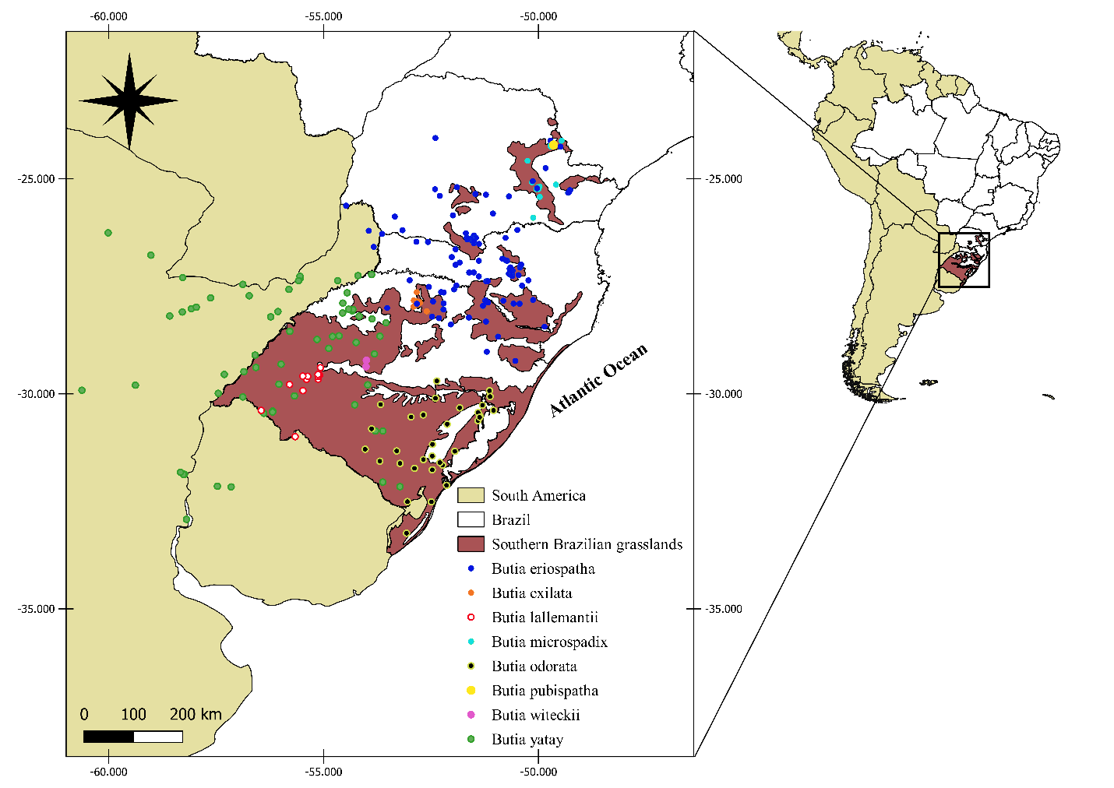
Fig. S1. Occurrences used in the distribution modeling for the typical palm species of South Brazilian grasslands.

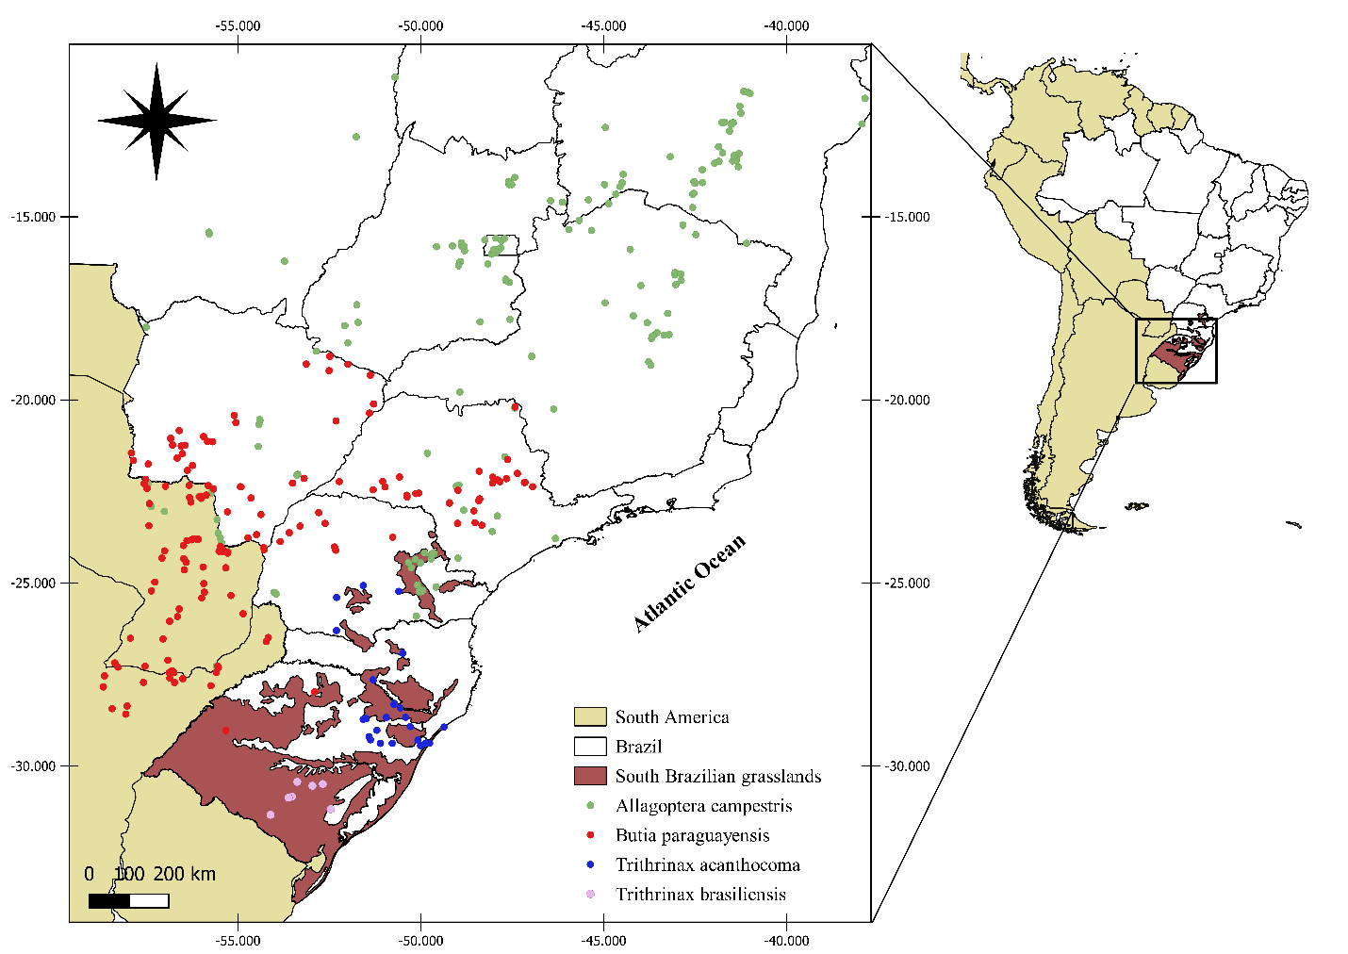
Fig. S2. Occurrences used in the distribution modeling for the associated palm species of South Brazilian grasslands.

Fig. S3. Percentage of species distribution in the future emission scenarios (RCPs 4.5 and 8.5) remaining, based on the current distribution (100%), for the typical and associated species of southern Brazilian grassland, considering the environment and land-use change under different dispersal scenarios for the future 2050. Butia pubispatha and Butia witeckii were not modeled due to the low number of occurrences found for them, that was respectively one and two (see table S2).

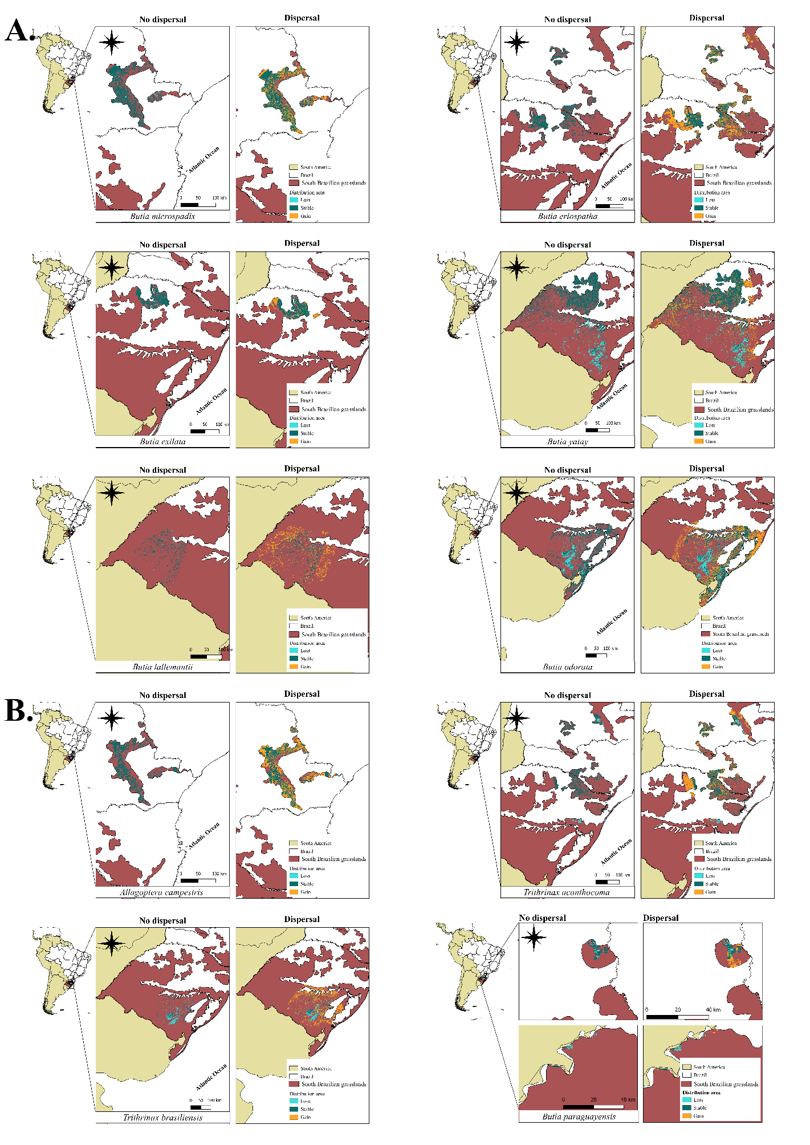
Fig. S4. Distribution of typical and associated palm species of South Brazilian grasslands (panel A and B respectively) in different future climate change scenarios 4.5 and 8.5 and land-use change under different future dispersal scenarios to 2050. The different colors represent the regions where the species distribution could be lost (orange), remain stable (light blue), or increase (dark blue).

The areas that would be stable when combining the effects of climate and land-use change under different dispersal scenarios for the typical palms species (Fig. S4-A) are located in the Campos Gerais (Eastern PR) for B. microspadix (Fig. S5); Campos de Palmas (South-center PR), Campos de Cima da Serra (Southeastern SC and Northeastern RS), Planalto Médio and Campos das Missões (North-Midwestern RS) for B. eriospatha (Fig. S5); Campos das Missões for B. exilata (Fig. S5); Planalto Médio, Serra do Sudeste (Southeastern RS) and Campanha Gaúcha (Southwestern RS) for B. yatay (Fig. S5); Campanha Gaúcha for B. lallemantii (Fig. S5); and Serra do Sudeste for B. odorata (Fig. S5). For associated palm species (Fig. S4-B)., the areas that are stable are located in the Campos Gerais for A. campestris (Fig. S5); Campos de Palmas, Campos de Cima da Serra (SC and RS) and Planalto Médio for T. acanthocoma (Fig. S5); Serra do Sudeste for T. brasiliensis (Fig. S5). Our results indicate that B. paraguayensis will lose area of distribution within grasslands of RS and gain a little area in Campos Gerais in Paraná (Fig. S5).

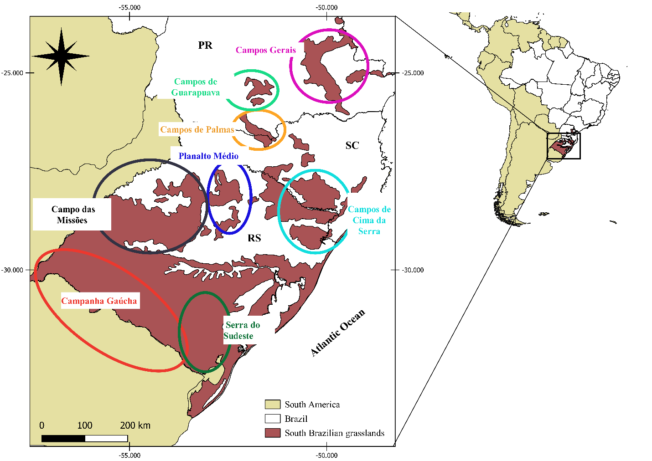
Fig. S5. Location by the state of the grassland that is part of the South Brazilian grasslands.

