Supplementary Material
Title: Environmental heterogeneity and sampling relevance areas in an Atlantic forest endemism region
Carolina da Silva Carvalho, Felipe Martello, Mauro Galetti, Fernando Pinto, Mercival Roberto Francisco, Luis Fábio Silveira, Pedro Manoel Galetti Jr.

Table S1: List of map and private reserves coordinates sources
Data | Source
Climatic map | www.worldclim.org
Soil type map | www.dpi.inpe.br/Ambdata
Drainage density map | www.dpi.inpe.br/Ambdata
Vegetation type map | www.dpi.inpe.br/Ambdata
Land use map | www.mapbiomas.org
Federal private reserves | http://sistemas.icmbio.gov.br/simrppn/publico/
State private reserves | http://www.ima.al.gov.br/servicos/downloads/download-de-dados-vetoriais/  http://www.meioambiente.al.gov.br/diretorias/diruc/rppn/rppns-estaduais  http://www.cprh.pe.gov.br/unidades_conservacao/Uso_Sustentavel/RPPN/40043%3B60280%3B223912%3B0%3B0.asp  https://sosgisbr.com/2011/07/11/shapes-disponibilizados-pelo-comite-da-bh-do-rio-sao-francisco/  https://pt.wikipedia.org/wiki/Lista_das_%C3%A1reas_naturais_protegidas_da_Para%C3%ADba  http://www.cnip.org.br/uc_arquivos/geral_estados.html

Table S2: Coordinates, Brazilian state, sampling relevance for amphibians, bats, birds, camera trap, large mammals, primates and small mammals, isolation degree in meters and percentage of forest cover of the private reserves in PEC area. Isolation degree and percentage of forest cover were estimated in a 2 km buffers.
Nome | Latitude | Longitude | State | Amphibians | Bats | Birds | Camera | Large mammals | Primates | Small mammals | Isolation (m) | Forest cover (%)
RPPN Bicho Homem | -8.610099 | -35.727132 | PE | 0.35 | 0.51 | 0.36 | 0.58 | 0.36 | 0.22 | 0.28 | 1628 | 48
RPPN Jussaral | -8.610099 | -35.727132 | PE | 0.35 | 0.51 | 0.36 | 0.58 | 0.36 | 0.22 | 0.28 | 1628 | 48
RPPN do Benedito | -8.29462006 | -35.5857585 | PE | 0.70 | 0.75 | 0.83 | 0.62 | 0.64 | 0.70 | 0.72 | 1717 | 42
RPPN Engenho Contestado | -8.842856 | -35.801123 | PE | 0.32 | 0.45 | 0.39 | 0.63 | 0.20 | 0.24 | 0.14 | 1677 | 29
RPPN EcoFazenda Morim | -8.868165 | -35.209326 | PE | 0.43 | 0.29 | 0.24 | 0.74 | 0.62 | 0.08 | 0.41 | 1203 | 78
RPPN Fazenda Santa Rita | -8.690612 | -35.485765 | PE | 0.41 | 0.32 | 0.18 | 0.69 | 0.58 | 0.07 | 0.36 | 1816 | 24
RPPN Fazenda Tabatinga | -7.604743 | -34.824006 | PE | 0.45 | 0.42 | 0.48 | 0.62 | 0.96 | 0.33 | 0.57 | 1121 | 29
RPPN Laje Bonita | -8.802213 | -36.016784 | PE | 0.53 | 0.72 | 0.74 | 0.63 | 0.33 | 0.60 | 0.45 | 1145 | 7
RPPN Pedra D'Antas | -8.693907 | -35.855875 | PE | 0.38 | 0.62 | 0.67 | 0.54 | 0.17 | 0.48 | 0.30 | 1526 | 50
RPPN Serro Azul | -8.13992 | -35.98936 | PE | 0.70 | 0.80 | 0.76 | 0.80 | 0.61 | 0.78 | 0.67 | 1861 | 7
RPPN Trapiche | -8.580142 | -35.062779 | PE | 0.67 | 0.58 | 0.47 | 0.90 | 0.88 | 0.25 | 0.65 | 1599 | 52
RPPN Reserva Gulandim | -9.977 | -36.34 | AL | 0.02 | 0.22 | 0.41 | 0.09 | 0.60 | 0.20 | 0.30 | 1524 | 15
RPPN Reserva Santa Tereza | -9.507 | -35.974 | AL | 0.28 | 0.21 | 0.08 | 0.55 | 0.52 | 0.04 | 0.26 | 1351 | 19
RPPN Fazenda São Pedro | -9.555 | -35.951 | AL | 0.31 | 0.23 | 0.11 | 0.58 | 0.67 | 0.08 | 0.36 | 1152 | 27
RPPN Fazenda Rosa do Sol | -9.832 | -35.905 | AL | 0.19 | 0.17 | 0.20 | 0.60 | 0.75 | 0.19 | 0.32 | 1724 | 8
RPPN Fazenda Pereira | -10.2502 | -36.3613 | AL | 0.16 | 0.16 | 0.24 | 0.33 | 0.59 | 0.23 | 0.35 | 942 | 6
RPPN Lula Lobo | -10.2910 | -36.3508 | AL | 0.16 | 0.17 | 0.27 | 0.30 | 0.64 | 0.23 | 0.38 | 1445 | 6
RPPN Vera Cruz | -9.256 | -36.293 | AL | 0.35 | 0.50 | 0.38 | 0.67 | 0.14 | 0.29 | 0.16 | 2086 | 1
RPPN Engenho Gargaú | -7.015575 | -34.95413 | PB | 0.12 | 0.18 | 0.26 | 0.21 | 0.56 | 0.11 | 0.35 | 833 | 85
RPPN Fazenda Pacatuba | -7.046346 | -35.15641 | PB | 0.11 | 0.41 | 0.49 | 0.16 | 0.53 | 0.24 | 0.43 | 1264 | 27
RPPN Reserva Calaça | -8.718715 | -36.22294 | PE | 0.69 | 0.81 | 0.82 | 0.80 | 0.54 | 0.78 | 0.69 | 1099 | 1
RPPN Serra do Contente | -8.26137 | -35.55289 | PE | 0.52 | 0.71 | 0.79 | 0.57 | 0.57 | 0.62 | 0.48 | 1550 | 50
RPPN Nossa Senhora do Oiteiro de Maracaípe | -8.523908 | -35.01678 | PE | 0.67 | 0.58 | 0.47 | 0.90 | 0.88 | 0.25 | 0.65 | 1747 | 21
RPPN Frei Caneca | -8.719293 | -35.84439 | PE | 0.46 | 0.65 | 0.71 | 0.54 | 0.25 | 0.54 | 0.40 | 1511 | 75
RPPN Reserva Cabanos | -8.499129 | -36.01042 | PE | 0.50 | 0.73 | 0.70 | 0.74 | 0.52 | 0.61 | 0.51 | 1625 | 3
RPPN Fazenda Santa Beatriz do Carnijó | -8.141504 | -35.0789 | PE | 0.06 | 0.03 | 0.19 | 0.41 | 0.47 | 0.07 | 0.10 | 1948 | 31
RPPN Mata Estrela | -6.404601 | -35.00043 | RN | 0.25 | 0.33 | 0.46 | 0.57 | 0.84 | 0.39 | 0.48 | 1311 | 69
RPPN Dunas Douradas | -5.625635 | -35.23917 | RN | 0.27 | 0.36 | 0.46 | 0.53 | 0.84 | 0.42 | 0.62 | 1246 | 10
RPPN Mata da Bela | -6.422534 | -35.11431 | RN | 0.10 | 0.27 | 0.46 | 0.37 | 0.79 | 0.32 | 0.42 | 1468 | 25
RPPN Triunfo | -9.051364 | -35.29175 | AL | 0.16 | 0.14 | 0.18 | 0.54 | 0.49 | 0.09 | 0.23 | 1752 | 20
RPPN Tobogã | -9.600775 | -35.77266 | AL | 0.36 | 0.26 | 0.13 | 0.60 | 0.66 | 0.04 | 0.36 | 1411 | 20
RPPN Santa Fé | -9.520888 | -36.44521 | AL | 0.15 | 0.34 | 0.34 | 0.51 | 0.24 | 0.24 | 0.18 | 1518 | 9
RPPN Placas | -9.4319 | -35.60659 | AL | 0.39 | 0.27 | 0.14 | 0.66 | 0.71 | 0.07 | 0.40 | 2021 | 68
RPPN Cachoeira | -9.533882 | -36.44492 | AL | 0.09 | 0.29 | 0.32 | 0.40 | 0.29 | 0.21 | 0.21 | 1198 | 28
RPPN Cachoeira | -8.973704 | -35.25073 | AL | 0.36 | 0.29 | 0.23 | 0.64 | 0.67 | 0.06 | 0.36 | 1513 | 7
RPPN Bosque | -8.949386 | -35.23164 | AL | 0.38 | 0.26 | 0.24 | 0.64 | 0.67 | 0.05 | 0.37 | 1709 | 52
RPPN Aldeia Verde | -9.572789 | -35.69592 | AL | 0.39 | 0.27 | 0.13 | 0.67 | 0.70 | 0.06 | 0.39 | 1740 | 20
RPPN Planalto | -10.169272 | -36.35151 | AL | 0.04 | 0.05 | 0.21 | 0.24 | 0.57 | 0.13 | 0.20 | 1662 | 14
RPPN Madeiras | -9.873782 | -36.33726 | AL | 0.06 | 0.29 | 0.38 | 0.24 | 0.46 | 0.22 | 0.24 | 1024 | 6
RPPN Estrela do Sul | -8.933375 | -35.70765 | AL | 0.08 | 0.12 | 0.13 | 0.33 | 0.25 | 0.04 | 0.07 | 1633 | 20
RPPN Porto Alegre | -8.93055 | -35.68117 | AL | 0.29 | 0.31 | 0.17 | 0.53 | 0.39 | 0.08 | 0.22 | 1787 | 17
RPPN Papa Mel | -8.930466 | -35.67948 | AL | 0.29 | 0.31 | 0.17 | 0.53 | 0.39 | 0.08 | 0.22 | 1771 | 17
RPPN Porto Seguro | -9.098864 | -35.51017 | AL | 0.13 | 0.03 | 0.08 | 0.50 | 0.40 | 0.03 | 0.14 | 1585 | 15
RPPN Canadá | -9.462559 | -36.37585 | AL | 0.40 | 0.49 | 0.46 | 0.65 | 0.24 | 0.37 | 0.21 | 1304 | 2
RPPN Vila d'Água | -9.29038 | -35.9415 | AL | 0.11 | 0.12 | 0.07 | 0.48 | 0.23 | 0.07 | 0.07 | 1469 | 11
RPPN Boa Sorte | -9.18714 | -35.92943 | AL | 0.48 | 0.53 | 0.44 | 0.83 | 0.37 | 0.33 | 0.33 | 1365 | 55
RPPN Osvaldo Timóteo | -9.029527 | -36.03271 | AL | 0.34 | 0.44 | 0.36 | 0.65 | 0.20 | 0.22 | 0.20 | 1847 | 1
RPPN Santa Maria | -9.355318 | -35.85299 | AL | 0.14 | 0.10 | 0.06 | 0.43 | 0.36 | 0.01 | 0.13 | 1516 | 20
RPPN Mata do Cedro | -9.523504 | -35.9069 | AL | 0.35 | 0.25 | 0.09 | 0.67 | 0.61 | 0.09 | 0.34 | 1449 | 72
RPPN Serra d'Água | -9.114295 | -35.57598 | AL | 0.13 | 0.06 | 0.12 | 0.46 | 0.48 | 0.06 | 0.19 | 1682 | 15
RPPN Garabu | -9.281195 | -35.58037 | AL | 0.30 | 0.20 | 0.12 | 0.64 | 0.59 | 0.18 | 0.28 | 1738 | 31
RPPN Saint Michel 1 | -9.803663 | -35.87679 | AL | 0.21 | 0.19 | 0.20 | 0.64 | 0.77 | 0.19 | 0.34 | 1259 | 20
RPPN Santa Cristina | -9.791454 | -35.95204 | AL | 0.12 | 0.03 | 0.06 | 0.51 | 0.57 | 0.07 | 0.16 | 715 | 47
RPPN Sereno | -9.097537 | -35.3806 | AL | 0.24 | 0.18 | 0.18 | 0.61 | 0.54 | 0.17 | 0.24 | 1495 | 25
RPPN Quebra Carro | -9.631234 | -36.10873 | AL | 0.29 | 0.31 | 0.14 | 0.53 | 0.54 | 0.13 | 0.27 | 1319 | 14
RPPN Saint Michel 2 | -9.798738 | -35.86372 | AL | 0.20 | 0.17 | 0.18 | 0.62 | 0.76 | 0.16 | 0.32 | 1226 | 16
RPPN Baixa Grande | -9.709802 | -36.18787 | AL | 0.06 | 0.11 | 0.14 | 0.34 | 0.41 | 0.10 | 0.11 | 1481 | 10
RPPN Conceição Lyra I | -10.209554 | -36.45797 | AL | 0.25 | 0.30 | 0.25 | 0.36 | 0.55 | 0.19 | 0.35 | 1760 | 29
RPPN Saint Michel 3 | -9.799359 | -35.86501 | AL | 0.20 | 0.17 | 0.18 | 0.62 | 0.76 | 0.16 | 0.32 | 1280 | 17
RPPN Conceição Lyra IV | -10.199345 | -36.45947 | AL | 0.26 | 0.40 | 0.36 | 0.28 | 0.53 | 0.23 | 0.39 | 1482 | 30
RPPN Salvador Lyra | -9.753468 | -36.02396 | AL | 0.14 | 0.09 | 0.08 | 0.49 | 0.60 | 0.10 | 0.14 | 70 | 16
RPPN Boca do Rio | -9.786278 | -35.985 | AL | 0.13 | 0.04 | 0.07 | 0.51 | 0.60 | 0.09 | 0.17 | 200 | 34
RPPN Riacho Seco | -10.092719 | -36.22481 | AL | 0.09 | 0.21 | 0.30 | 0.27 | 0.58 | 0.19 | 0.23 | 1060 | 21
RPPN Conceição Lyra II | -10.199707 | -36.45263 | AL | 0.26 | 0.31 | 0.25 | 0.36 | 0.56 | 0.19 | 0.35 | 1692 | 33
RPPN Oriente | -9.011843 | -35.45344 | AL | 0.29 | 0.19 | 0.19 | 0.63 | 0.55 | 0.18 | 0.26 | 1440 | 20
RPPN Conceição Lyra III | -10.163847 | -36.44832 | AL | 0.27 | 0.42 | 0.39 | 0.31 | 0.60 | 0.25 | 0.41 | 1123 | 34
RPPN Pindoba | -9.782983 | -35.99463 | AL | 0.13 | 0.05 | 0.06 | 0.50 | 0.59 | 0.09 | 0.15 | 496 | 26
RPPN Apolinário | -9.391 | -35.63923 | AL | 0.39 | 0.27 | 0.10 | 0.71 | 0.63 | 0.08 | 0.37 | 1668 | 47
RPPN Olho d’Água | -9.789299 | -35.97399 | AL | 0.14 | 0.05 | 0.07 | 0.52 | 0.61 | 0.09 | 0.17 | 824 | 42

Table S3: Legend of forest type, soil type and land use for the figures S1, S4, S6, S10, S12, S14 and S16.
Forest type |  | Soil type |  | Land use
Legend | Description | Legend | Description | Legend | Description
3 | Pioneer formation areas – Marine and fluvial influence | 71 | GZ2 - Gleissolo Salico - GZ Sodico | 3 | Forest Formation
9 | Ecological tension area - Savanna / Seasonal forest | 91 | LA22 - Latossolo Amarelo - LA Distrofico + PVA Distrofico + LV Eutrofico | 4 | Savanna Formation
13 | River and lakes | 108 | LA5 - Latossolo Amarelo - LA Distrofico + PVA Distrofico | 5 | Mangrove
21 | Dense rainforest - Secondary vegetation and agricultural activities | 114 | LA9 - Latossolo Amarelo - LA Distrofico + RQ Ortico | 9 | Forest Plantation
25 | Pioneer formation areas - Agricultural activities | 246 | LVA7 - Latossolo Vermelho-Amarelo - LVA Distrofico + PVA Distrofico | 12 | Grassland
26 | Open rainforest - Secondary vegetation and agricultural activities | 249 | Water | 13 | Other Non Forest Natural Formation
30 | Pioneer formation areas - Marine Influence | 307 | PAC - Argilossolo Acinzentado - PAC Distrofic + ES Hidromorfico + PVA Distrofico | 15 | Pasture
37 | Steppe - Agricultural activities | 321 | PV20 - Argilossolo Vermelho - PV Eutrofico + PVA Eutrofico | 19 | Annual and Perennial Crop
39 | Ecological tension area - Steppe / Seasonal forest | 371 | PVA16 - Argiolossolo Vermelho-Amarelo - PVA Distrofico + LA Distrofico + EK Hidromorfico | 20 | Semi-perennial Crop
40 | Seasonal semideciduous forest - Secondary vegetation and agricultural activities | 375 | PVA2 - Argilossolo Vermelho-Amarelo - PVA Distrofico + LA Distrofico | 21 | Mosaic of Agriculture and Pasture
 |  | 409 | PVA48 - Argilossolo Vermelho-Amarelo - PVA Distrofico + PVA Eutrofico + RQ Ortico | 23 | Beach and Dune
 |  | 412 | PVA5 - Argilossolo Vermelhor-Amarelo - PVA Distrofico + AC Argiluvico | 24 | Urban Infrastructure
 |  | 414 | PVA51 - Argilossolo Vermelho-Amarelo - PVA Distrofico +SG Eutrofico + RU Ta Eutrofico | 25 | Other Non Vegetated Area
 |  | 416 | PVA53- Argilossolo Vermelho-Amarelo - PVA Distrofico + SX Eutrofico + LA Distrofico | 31 | Aquaculture
 |  | 428 | PVA63 - Argilossolo Vermelho-Amarelo - PVA Distrofico + RQ Ortico + ES Hidromorfico | 32 | Salt Flat
 |  | 436 | PVA7 - Argilossolo Vermelho-Amarelo - PVA Distrofico + PVA Eutrofico | 33 | River, Lake and Ocean
 |  | 446 | PVA77 - Argilossolo Vermelho-Amarelo - PVA Eutrofico + RL Eutrofico
 |  | 451 | PVA81 - Argilossolo Vermelho-Amarelo - PVA Eutrofico + PV Eutrofico + RL Eutrofico
 |  | 455 | PVA85 - Argilossolo Vermelho-Amarelo - PVA Eutrofico + TC Ortico + RL Eutrofico
 |  | 468 | PVA95 - Argilossolo Vermelho-Amarelo - PVA Eutrofico + RL Eutrofico + LA DIstrofico
 |  | 510 | RL42- Neossolo Litolico - RL Eutrofico + PVA Eutrofico + TC Ortico
 |  | 518 | RL49- Neossolo Litolico - RL Eutrofico + SX Eutrodico + PVA Eutrofico
 |  | 541 | RQ13 - Neossolo Quartzarênico - RQ Ortico
 |  | 557 | RQ25 - Neossolo Quartzarênico - RQ Ortico + LA Distrofico + PVA Eutrofico
 |  | 578 | ES1 - Espodossolo Ferrocarbico - ES Hidromorfico
 |  | 602 | RR3 - Neossolo Regolitico - RR Eutrofico + SX Distrofico
 |  | 640 | SX10 - Planossolo Haplico - SX Eutrofico + PVA Distrofico + RL Eutrofico
 |  | 641 | SX11 - Planossolo Haplico - SX Eutrofico + PVA Eutrofico + RL Eutrofico
 |  | 648 | SX17 - Planossolo Haplico - SX Eutrofico + RL Eutrofico + TC Ortico
 |  | 672 | TC20 - Luvissolo Cromico - TC Ortico + RL Eutrofico + SG Eutrofico
 |  | 689 | ES19 - Espodossolo Ferrocarbico - ES Hiperespesso + RQ Hidromorfico + GZ Sodico

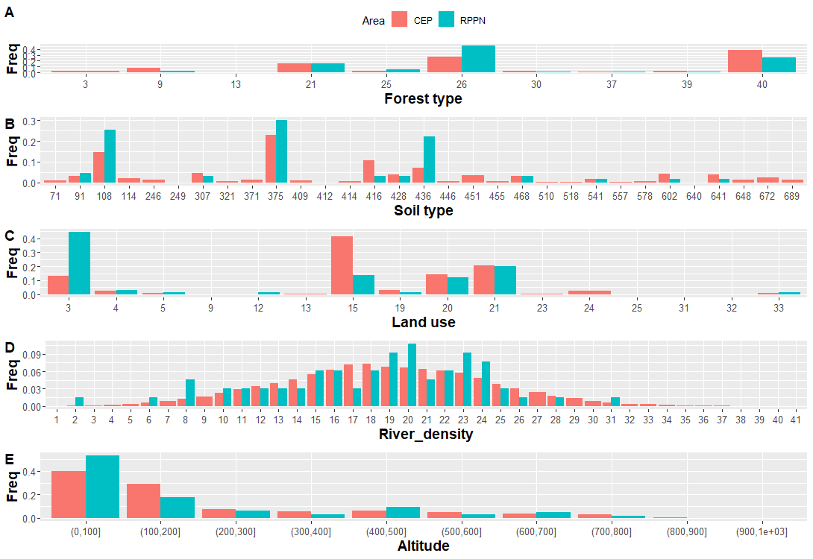
Figure S1: Barplot of the proportion of different forest (A), soil (B) and land use type (C), drainage density (D) and altitude (E) in the Pernambuco Endemism Center (PEC). See legend in the table S3.
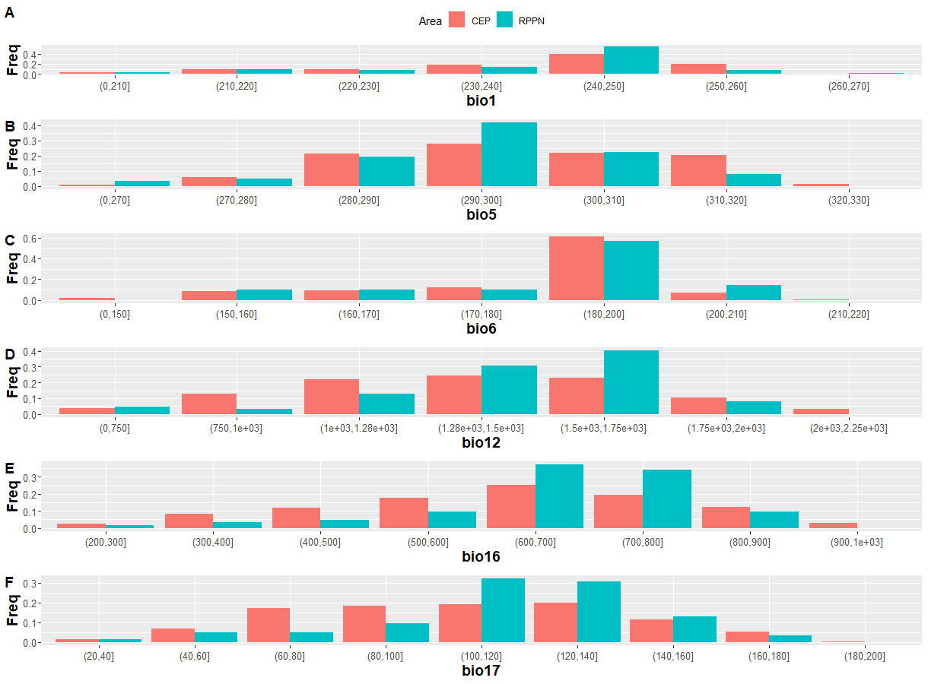
Figure S2: Barplot of the proportion of climatic variables in the Pernambuco Endemism Center (PEC). bio1, annual mean temperature; bio5, maximum temperature; bio6, minimum temperature; bio12, mean annual precipitation; bio16, precipitation in the wettest quarter; bio17, precipitation in the driest quarter.
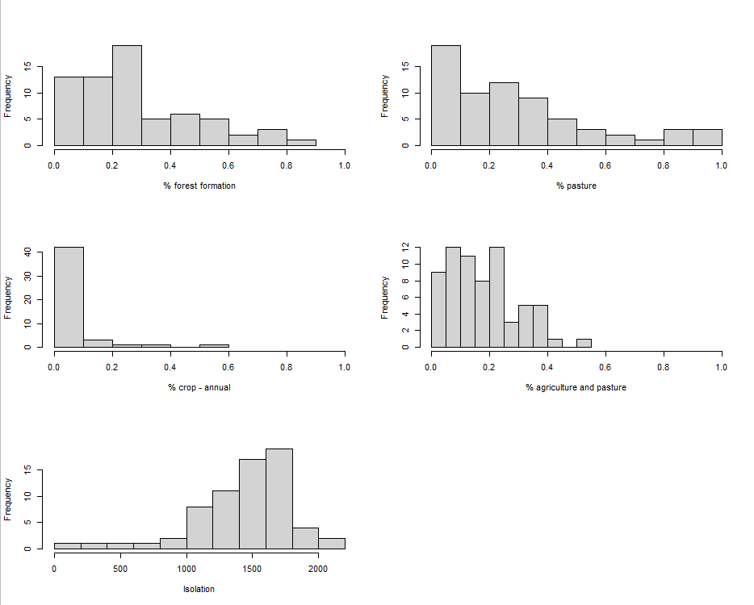
Figure S3: Histogram of the percentage of forest formation, pasture, annual crop and mosaic of agricultural and pasture field, and isolation degree (meters) around 2 km of the private reserves in the Pernambuco Endemism Center (PEC).

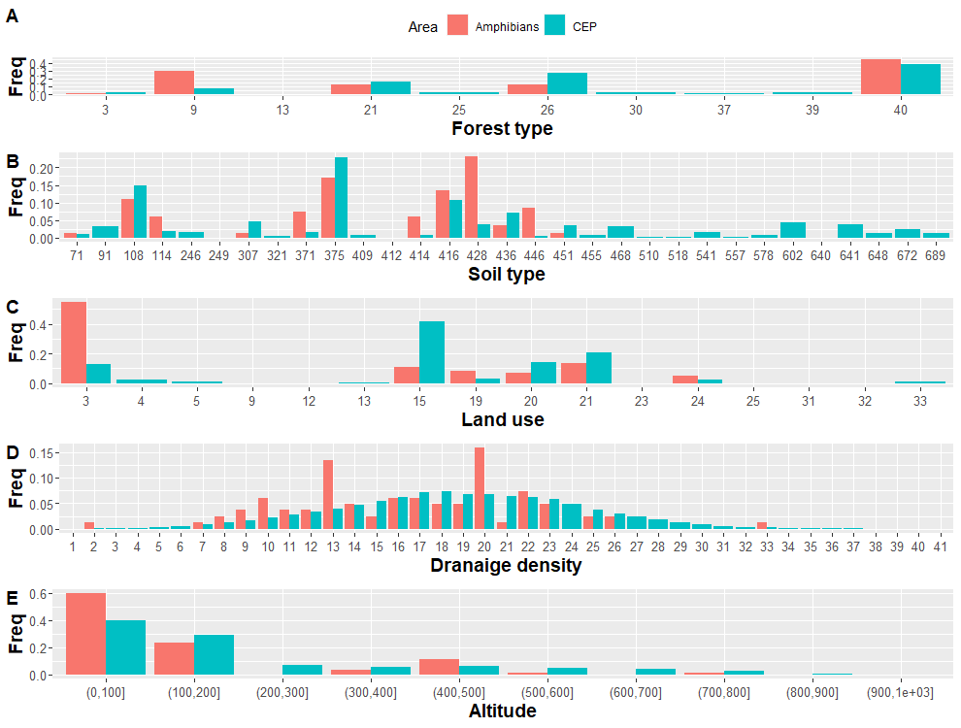
Figure S4: Barplot of the proportion of different forest (A), soil (B) and land use type (C), drainage density (D) and altitude (E) in the Pernambuco Endemism Center (PEC). See legend in the table S3.
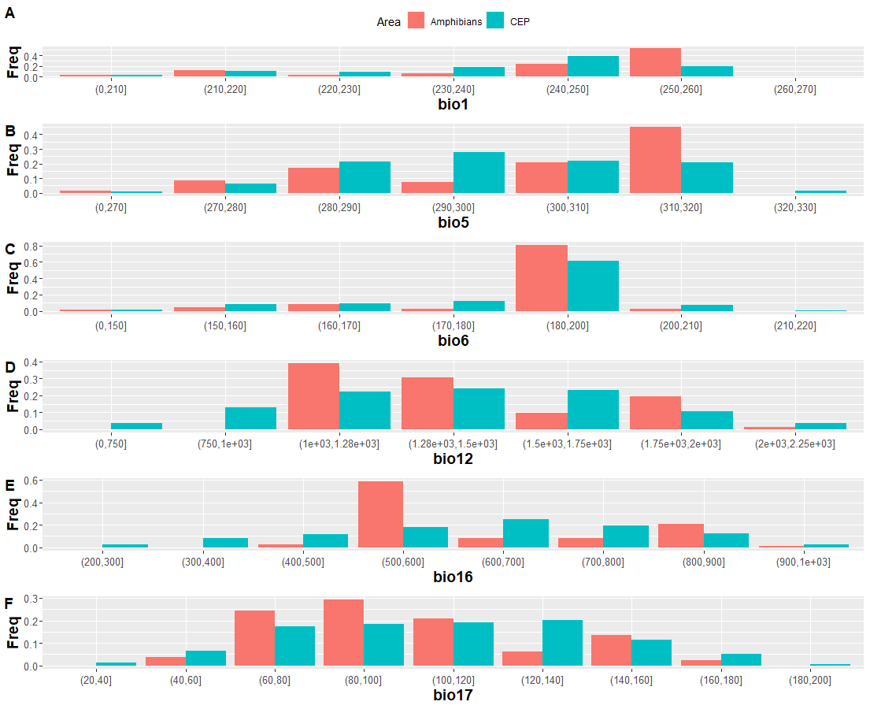
Figure S5: Barplot of the proportion of climatic variables in the Pernambuco Endemism Center (PEC). bio1, annual mean temperature; bio5, maximum temperature; bio6, minimum temperature; bio12, mean annual precipitation; bio16, precipitation in the wettest quarter; bio17, precipitation in the driest quarter.

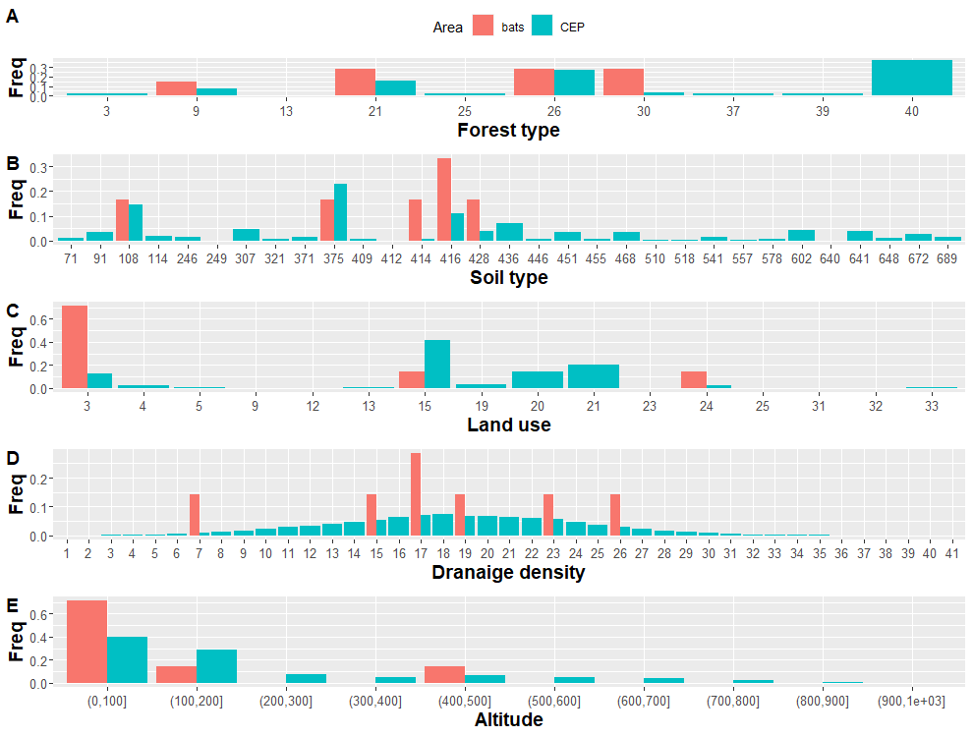
Figure S6: Barplot of the proportion of different forest (A), soil (B) and land use type (C), drainage density (D) and altitude (E) in the Pernambuco Endemism Center (PEC). See legend in the table S3.

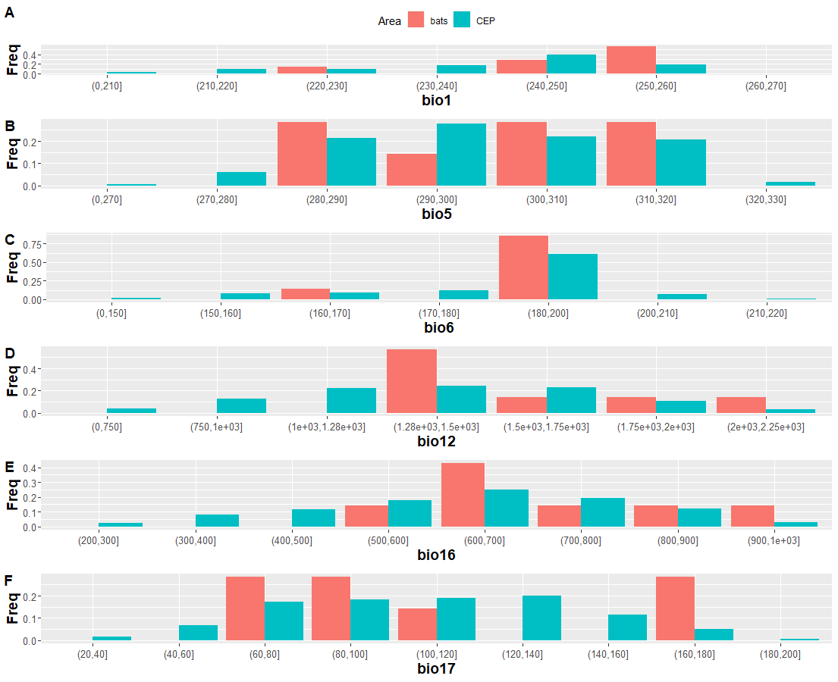
Figure S7: Barplot of the proportion of climatic variables in the Endemism Pernambuco Center (CEP). bio1, annual mean temperature; bio5, maximum temperature; bio6, minimum temperature; bio12, mean annual precipitation; bio16, precipitation in the wettest quarter; bio17, precipitation in the driest quarter.

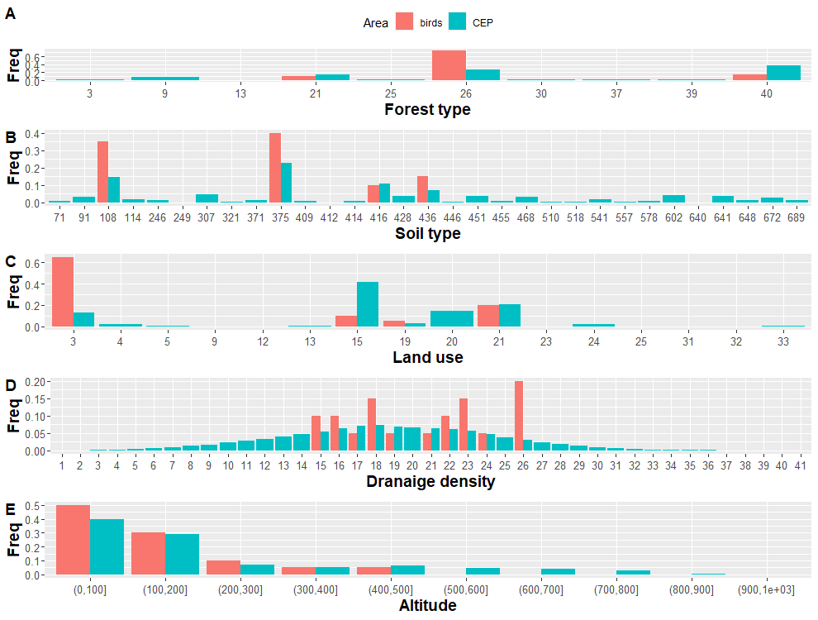
Figure S8: Barplot of the proportion of different forest (A), soil (B) and land use type (C), drainage density (D) and altitude (E) in the Pernambuco Endemism Center (PEC). See legend in the table S3.

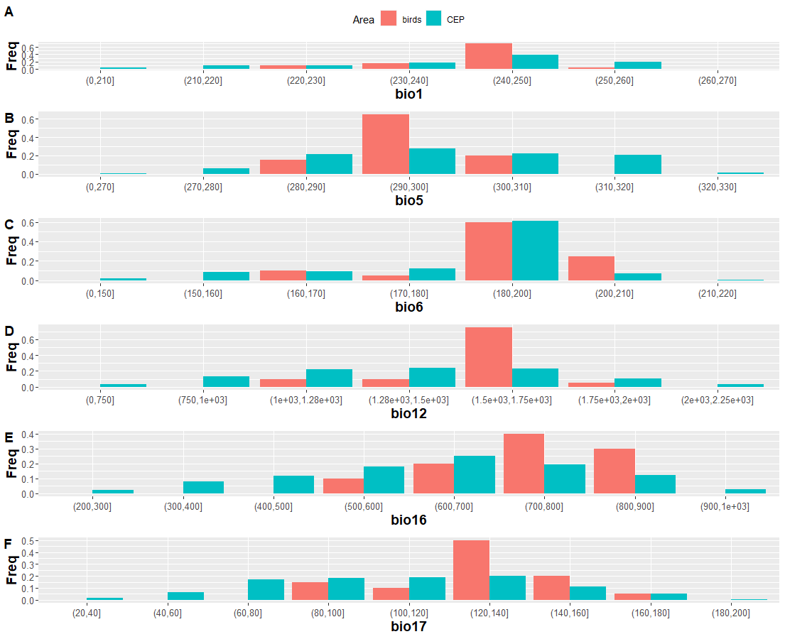
Figure S9: Barplot of the proportion of climatic variables in the Pernambuco Endemism Center (PEC). bio1, annual mean temperature; bio5, maximum temperature; bio6, minimum temperature; bio12, mean annual precipitation; bio16, precipitation in the wettest quarter; bio17, precipitation in the driest quarter.

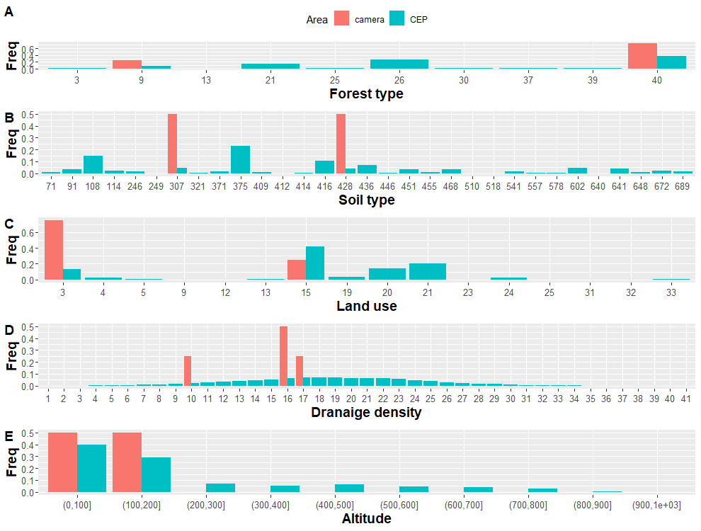
Figure S10: Barplot of the proportion of different forest (A), soil (B) and land use type (C), drainage density (D) and altitude (E) in the Pernambuco Endemism Center (PEC). See legend in the table S3.

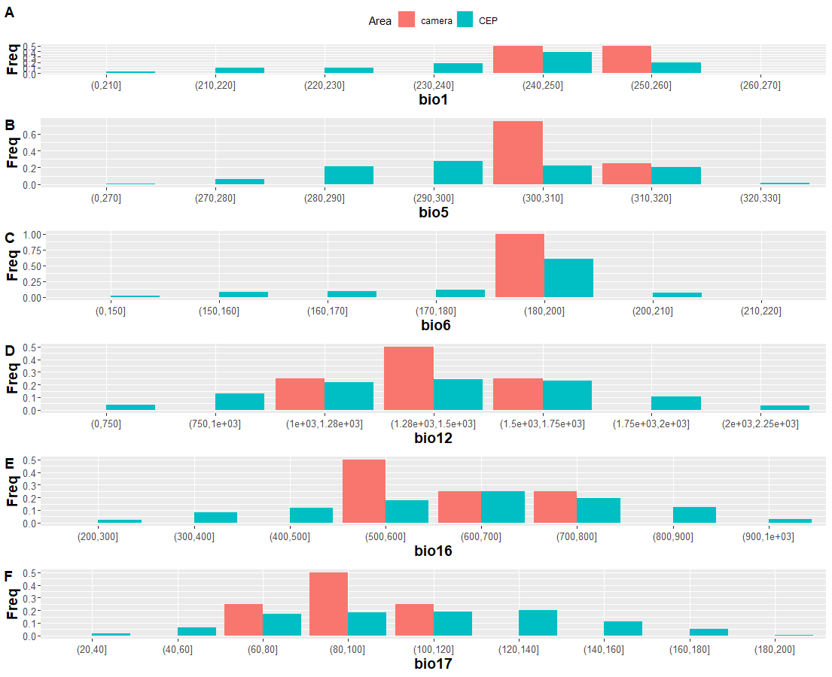
Figure S11: Barplot of the proportion of climatic variables in the Pernambuco Endemism Center (PEC). bio1, annual mean temperature; bio5, maximum temperature; bio6, minimum temperature; bio12, mean annual precipitation; bio16, precipitation in the wettest quarter; bio17, precipitation in the driest quarter.

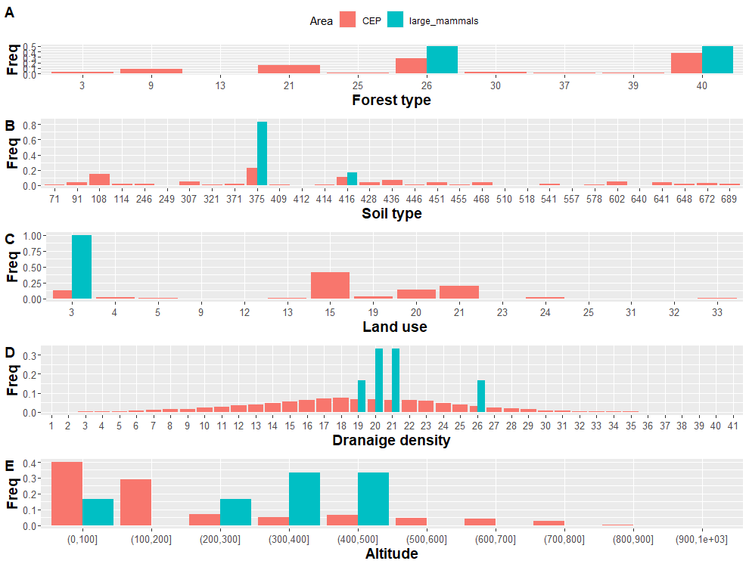
Figure S12: Barplot of the proportion of different forest (A), soil (B) and land use type (C), drainage density (D) and altitude (E) in the Pernambuco Endemism Center (PEC). See legend in the table S3.

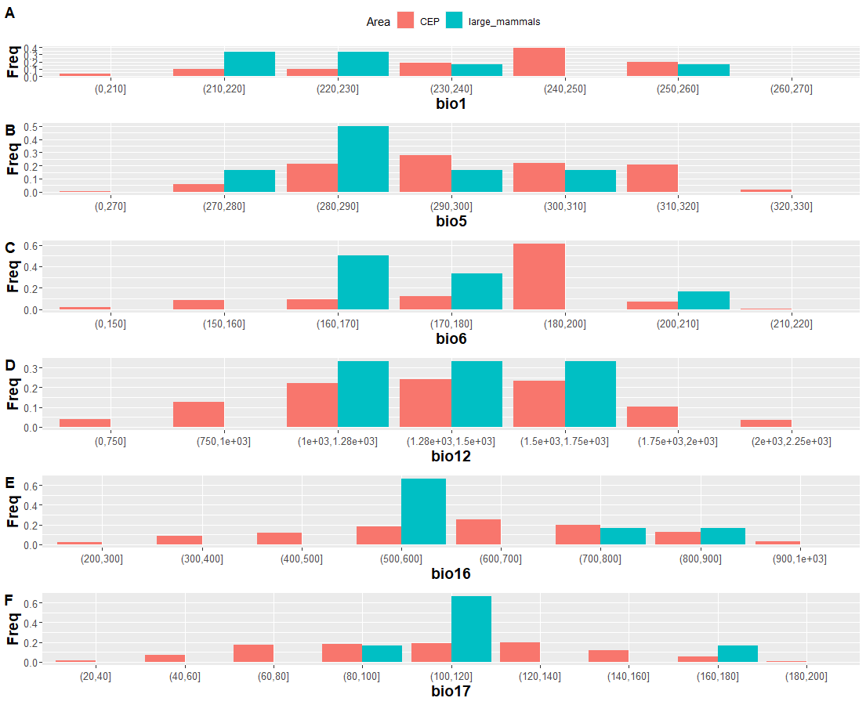
Figure S13: Barplot of the proportion of climatic variables in the Pernambuco Endemism Center (PEC). bio1, annual mean temperature; bio5, maximum temperature; bio6, minimum temperature; bio12, mean annual precipitation; bio16, precipitation in the wettest quarter; bio17, precipitation in the driest quarter.

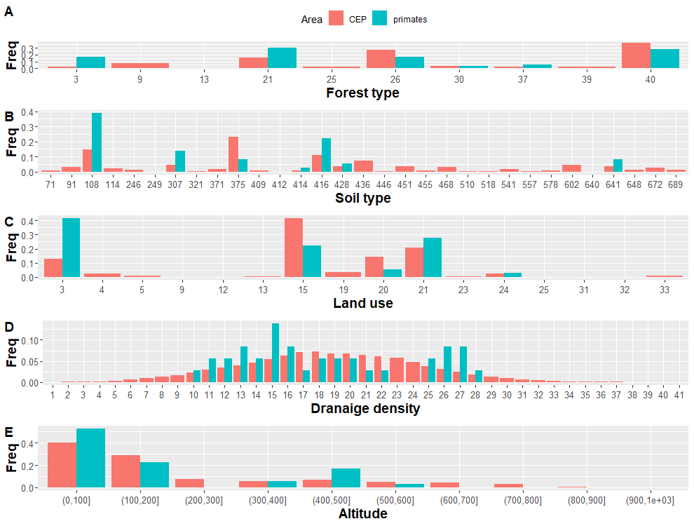
Figure S14: Barplot of the proportion of different forest (A), soil (B) and land use type (C), drainage density (D) and altitude (E) in the Pernambuco Endemism Center (PEC). See legend in the table S3.

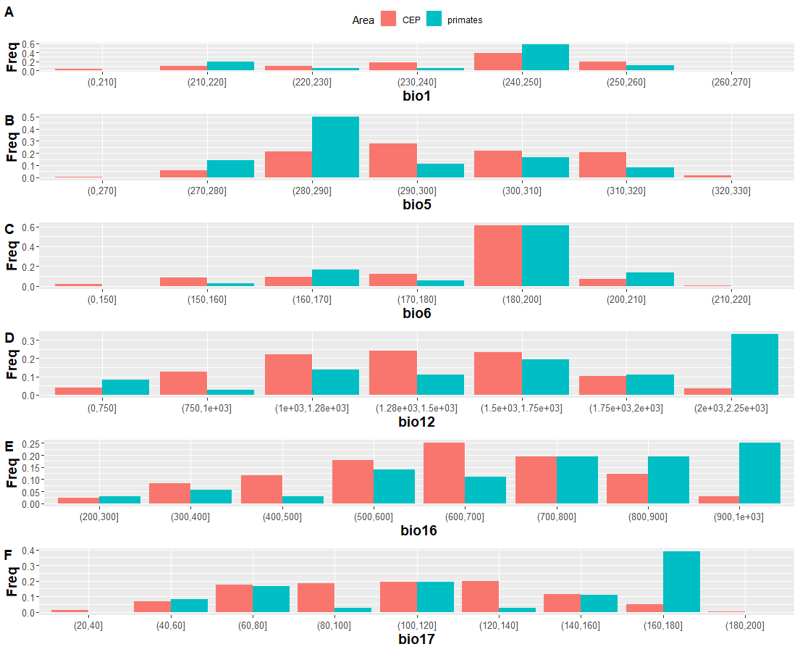
Figure S15: Barplot of the proportion of climatic variables in the Pernambuco Endemism Center (PEC). bio1, annual mean temperature; bio5, maximum temperature; bio6, minimum temperature; bio12, mean annual precipitation; bio16, precipitation in the wettest quarter; bio17, precipitation in the driest quarter.

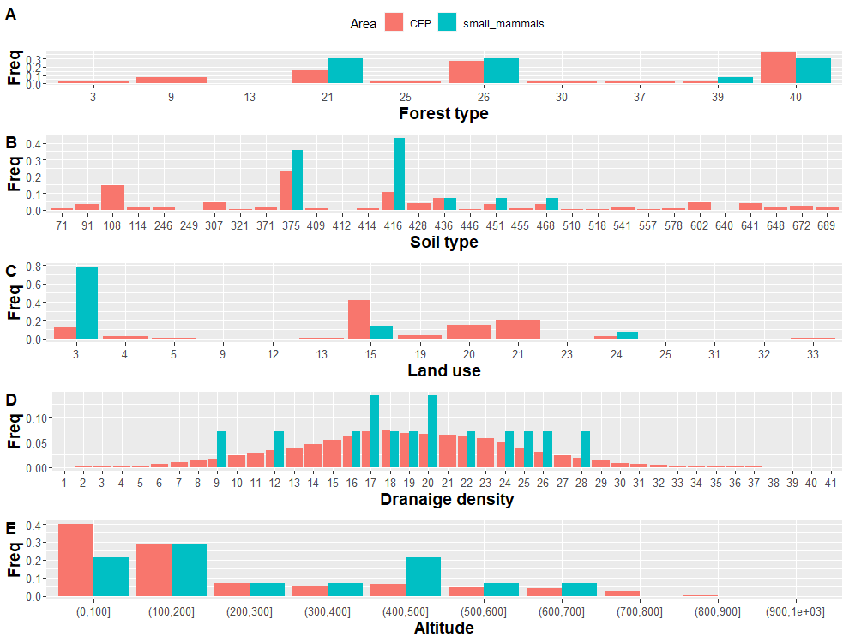
Figure S16: Barplot of the proportion of different forest (A), soil (B) and land use type (C), drainage density (D) and altitude (E) in the Pernambuco Endemism Center (PEC). See legend in the table S3.

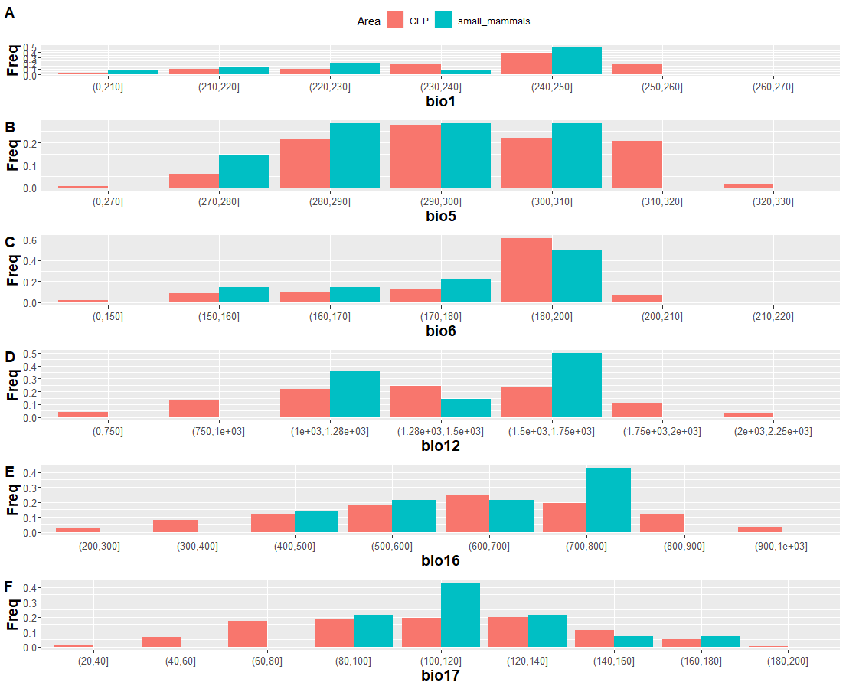
Figure S17: Barplot of the proportion of climatic variables in the Pernambuco Endemism Center (PEC). bio1, annual mean temperature; bio5, maximum temperature; bio6, minimum temperature; bio12, mean annual precipitation; bio16, precipitation in the wettest quarter; bio17, precipitation in the driest quarter.

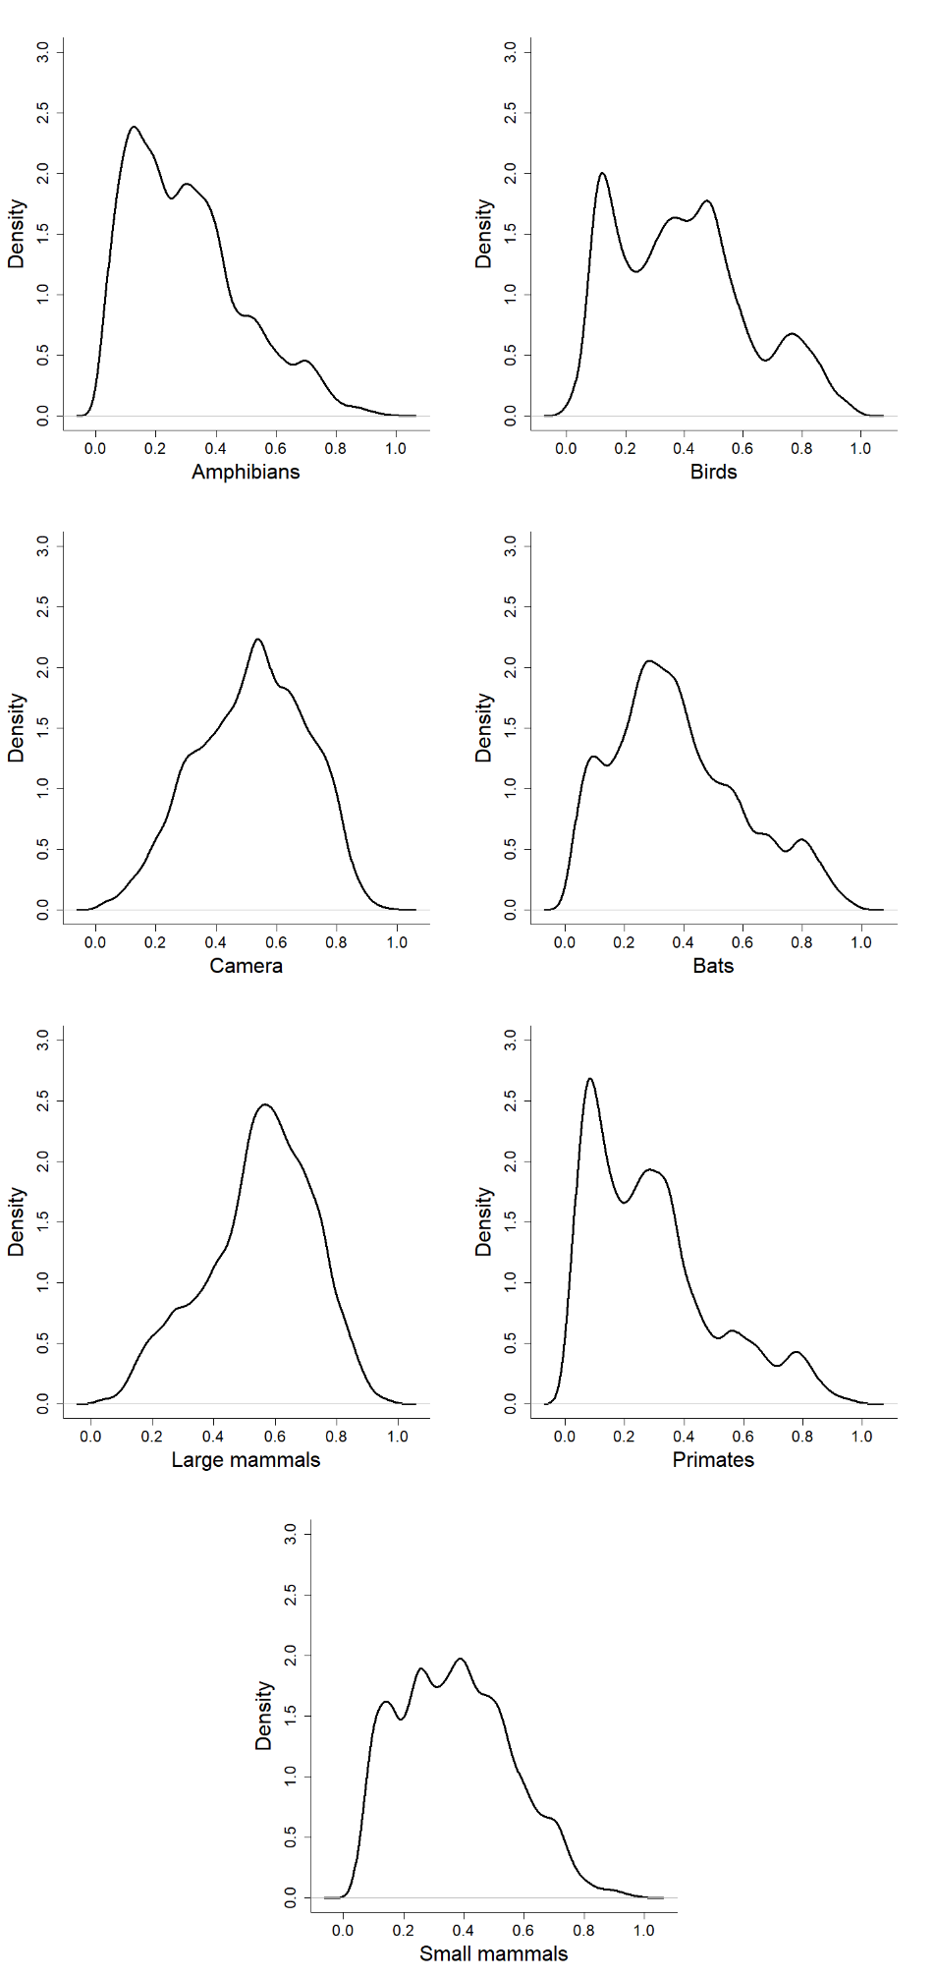
Figure S18: Density curves of sampling relevance values for different groups of vertebrates in the Endemism Pernambuco Center (CEP), Atlantic Forest, Brazil.

